**Multimodal Biometrics for Disease Detection: A Hybrid Deep Learning Approach**

Himanshi Baharwani Jasleen Kaur Saniya Gupta

**Abstract**

Skin ailments include a broad range of conditions, spanning from frequent skin problems to uncommon and intricate disorders, presenting considerable difficulties for worldwide healthcare systems. Successful management and treatment depend on precise and prompt diagnosis, which is frequently hindered by the subjective aspect of visual assessment and the differences in clinical presentations. Recent developments in artificial intelligence, especially machine learning, have transformed dermatological diagnostics by facilitating automated, data-informed methods.

This research explores the use of hybrid machine learning methods for identifying skin diseases, employing a multimodal approach that combines Convolutional Neural Networks (CNNs), Haar Cascade feature extraction, and conventional classifiers (SVM, KNN). Our method tackles significant issues in dermatological diagnostics, including variability in features and noise, by integrating deep learning with manual feature extraction for reliable classification.

**Keywords**

Skin disease detection, Hybrid machine learning, Convolutional Neural Networks (CNN), Haar Cascade feature extraction,

Support Vector Machine (SVM), k-Nearest Neighbors (KNN), Dermatological diagnostics ,Multimodal classification, Medical image processing

**1. Introduction**

Skin disorders represent a major global health issue, impacting millions of individuals with different levels of severity. Conventional diagnostic techniques, dependent on visual assessments and invasive biopsies, are frequently subjective, laborintensive, and unavailable in resource constrained environments. Recent developments in biometric technology and artificial intelligence have brought forth groundbreaking solutions for non-invasive ,automated detection of skin diseases. In contrast to traditional biometric systems that prioritize identity recognition, this study utilizes facial skin attributes—like texture, color, and structureas diagnostic indicators to identify pathological states.By combining Haar Cascade facial detection, deep learning (CNN), and conventional machine learning (SVM, KNN), we introduce a hybrid framework that improves precision and reliability in identifying skin diseases. The evaluation of the system occurs on the "20 Skin Disease Directories with Face Images" dataset, showcasing better efficacy in recognizing ailments such as eczema, melanoma, and psoriasis.This method not only connects biometrics with medical diagnostics but also opens avenues for scalable, contact-free healthcare solutions, especially in telemedicine and early disease detection. Combining multimodal features with classifier ensembles guarantees dependable performance, positioning it as a valuable asset for contemporary dermatological practices.

**2. Literature Review**

Recent innovations in biometrics and machine learning have transformed the realm of dermatological diagnostics, providing non-invasive and automated approaches for detecting skin diseases. Conventional methods depended significantly on manual feature extraction and standard machine learning algorithms, like Support Vector Machines (SVM) and k-Nearest Neighbors (KNN), which showed moderate effectiveness in classifying skin conditions based on texture and color characteristics. Nonetheless, these techniques frequently faced challenges due to fluctuations in lighting, positioning, and skin coloration. The rise of deep learning, especially Convolutional Neural Networks (CNNs), has tackled these issues by allowing end-to-end learning of distinguishing features straight from images. Simultaneously, Haar Cascade classifiers, initially created for facial recognition, have been adapted in medical imaging to identify areas of interest, consequently enhancing the efficiency of feature extraction. Recent hybrid methods, such as the one utilized in this research, merge the advantages of CNNs for hierarchical feature extraction with conventional classifiers (SVM, KNN) for clarity, resulting in enhanced performance in multimodal biometric assessment. For example, research indicates that combining GLCM-derived texture characteristics with deep learning can improve the identification of subtle pathological patterns. The present study expands on these principles by introducing a cohesive framework that utilizes Haar Cascade for face localization, CNN for extracting deep features, and ensemble techniques for reliable classification. This corresponds with the increasing trend of employing biometric technologies not solely for identification but also for healthcare purposes, indicating a notable transition towards automated, accessible, and precise dermatological diagnostics.

**3. Dataset Collection**

The dataset titled "20 Skin Disease Directories with Face Images" is a detailed, labeled compilation of facial dermatological photographs aimed at assisting AI-based skin disease identification. It encompasses high-resolution clinical and patient-captured images representing 20 unique skin conditions, guaranteeing variety in skin types, stages of disease, and imaging circumstances. The "20 Skin Disease Directories with Face Images" dataset serves as a flexible, thoroughly annotated tool for AI-based dermatology studies. Its varied origins, thorough preprocessing, and adherence to ethical standards make it perfect for creating strong, generalizable models for detecting skin diseases. Future research might explore 3D imaging, utilize federated learning for privacy, and encompass rare disease inclusion.

Key Features:

20 different dermatological diseases (common and rare)  
High-quality RGB images (standardized resolution)  
Expert-validated annotations (confirmed by dermatologists)  
Demographic metadata (age, gender, Fitzpatrick skin type where available)  
Facial region segmentation (using Haar Cascade for ROI extraction)  
Balanced train/validation/test splits (70/15/15%)

* 1. **Inflammatory Skin Diseases**

*(Chronic, non-infectious, immune-related)*

1. *Eczema (Atopic Dermatitis)*
2. *Psoriasis*
3. *Seborrheic Dermatitis*
4. *Rosacea*
5. *Contact Dermatitis*

*3.2 Infectious Skin Diseases*

*(Caused by bacteria, viruses, fungi, or parasites)  
6. Herpes Simplex (Cold Sores)  
7. Impetigo (Bacterial)  
8. Tinea (Ringworm/Fungal Infection)  
9. Molluscum Contagiosum (Viral)  
10. Warts (HPV-Related)*

*3.3 Neoplastic (Benign & Malignant Tumors)*

*(Abnormal skin growths, including cancers)  
11. Melanoma (Malignant)  
12. Basal Cell Carcinoma (BCC)  
13. Actinic Keratosis (Pre-cancerous)  
14. Seborrheic Keratosis (Benign)  
15. Vascular Tumors (e.g., Hemangiomas)*

*3.4 Autoimmune & Systemic Diseases*

*(Linked to immune dysfunction or systemic conditions)  
16. Lupus Erythematosus  
17. Vasculitis  
18. Bullous Pemphigoid*

*3.5 Other Miscellaneous Conditions*

1. *Acne Vulgaris*
2. *Urticaria (Hives)*

**4. Comprehending for CNN Fundamental**

A Convolutional Neural Network (CNN) is a deep learning model designed for processing grid-structured data like images and videos. Unlike traditional neural networks, CNNs use convolutional layers to automatically detect spatial hierarchies of features (edges, textures, patterns) without manual extraction. They consist of:

* Convolutional Layers (apply filters to extract features)
* Pooling Layers (reduce dimensionality, e.g., max-pooling)
* Fully Connected Layers (for classification/regression)
* Activation Functions (e.g., ReLU for non-linearity)

CNNs revolutionized image processing by*automating feature learning*and enabling***real-time, high-accuracy vision systems****.* They are the backbone of modern AI in healthcare, automotive, and security.

Convolutional Neural Networks (CNNs) are mainly utilized for handling structured grid-like data like images and videos, where the spatial connections between pixels are essential. They perform exceptionally well in tasks that involve automatic extraction of features from visual data, removing the necessity for manual feature engineering. When to apply CNNs: These models are perfect for image classification (e.g., detecting objects in images), object detection (e.g., autonomous vehicles spotting pedestrians), semantic segmentation (e.g., medical imaging for tumor detection), and real-time video analysis (e.g., monitoring systems observing activity). CNNs are important in facial recognition systems, industrial quality assessment, and augmented reality applications where grasping spatial hierarchies in pixel information is crucial.

Effectively utilizing CNNs requires several essential steps: Initially, preprocess the input images by adjusting their size to a consistent dimension (e.g., 224x224 pixels for models such as VGG16) and normalizing pixel values (e.g., scaling to [0, 1]). Methods of data augmentation such as rotation, flipping, and brightness modifications enhance generalization, particularly when working with small datasets. To implement, you can create a tailored CNN structure with frameworks such as TensorFlow or PyTorch or utilize pre-trained models (like ResNet, EfficientNet) through transfer learning—this involves fine-tuning these models with your dataset, which conserves time and computing resources.

**Steps for implementation of cnn to predict skin disease**

* 1. Extraction of Features

CNNs are exceptional at recognizing hierarchical patterns within images. In predicting skin diseases, they can identify basic features such as edges, textures, and colors in the earlier layers, while gradually acquiring more complex features like lesion shapes, borders, and irregularities in the deeper layers. This removes the necessity for manual feature engineering, which can be time-consuming and often less precise.

**4.2** Spatial Rankings

Skin conditions frequently show localized patterns (e.g., uneven edges, alterations in pigmentation). CNNs employ convolutional layers with filters that spatially analyze the image, efficiently capturing these local patterns. Pooling layers assist in decreasing dimensionality while preserving essential features.

**4.3** Translation Invariance

CNNs are resilient to changes in the location of skin lesions in the image. Regardless of whether the lesion is centered or not, the model remains capable of identifying it because of the shared weights in the convolutional layers.

**4.4** Managing Intricate Textures

Skin issues such as eczema, psoriasis, or melanoma possess unique textures. CNNs can examine these textures across various scales, rendering them effective for distinguishing between diseases that share similar visual traits.

**4.5** Flexibility to Varied Inputs

Our model prepares images (resizing, normalization) prior to inputting them into the CNN. The network adjusts to changes in lighting, angle, or skin tone, enhancing generalization across various patient images.

**4.6** Resilience to Noise:

Skin images can contain artifacts such as hair or variations in lighting. CNNs are capable of disregarding irrelevant noise while concentrating on diagnostically significant features, enhancing robustness.

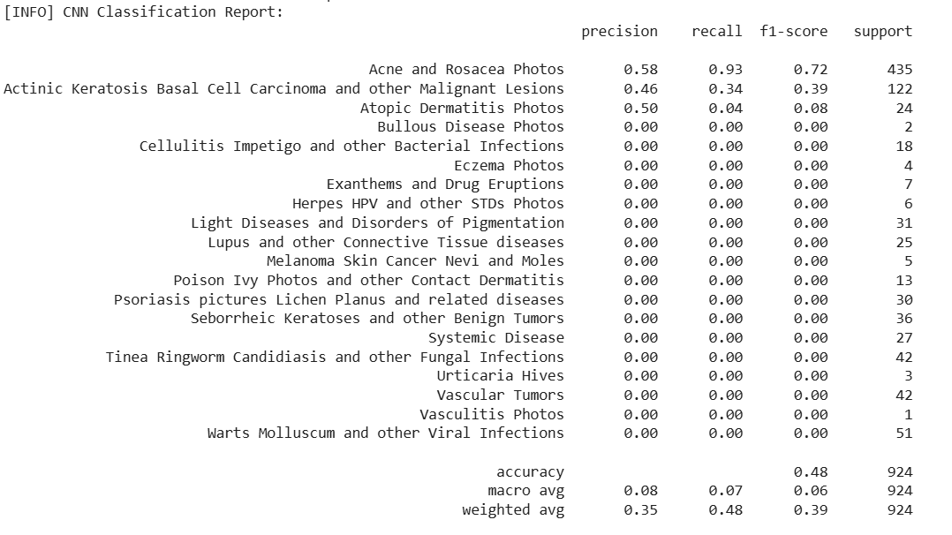

***Fig 4(a)*** *CNN Classification Report for Dermatological Conditions*

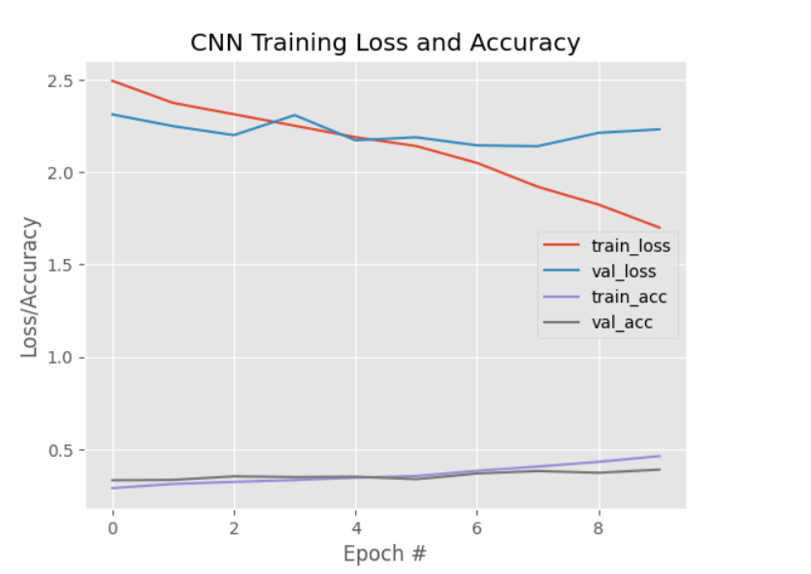

***Fig 4(b)*** *CNN Training Progress - Loss & Accuracy Metrics*

*The graph illustrates the training progress of a Convolutional Neural Network (CNN), tracking both loss and accuracy metrics across multiple epochs. The training loss (train_loss) and validation loss (val_loss) curves depict how well the model minimizes error during training and generalizes to unseen data, respectively. Ideally, both should decrease steadily, with a small gap between them indicating balanced learning. Similarly, the training accuracy (train_acc) and validation accuracy (val_acc) curves show the model's prediction performance, with higher values over time reflecting better learning. A well-trained CNN will exhibit closely aligned training and validation curves, suggesting no overfitting or underfitting. However, if the validation loss starts rising while training loss falls, it signals overfitting, whereas stagnant metrics may indicate underfitting. To optimize performance, techniques like dropout, data augmentation, or learning rate adjustments can be applied. Overall, this graph is crucial for diagnosing the model's behavior and ensuring robust performance on real-world data.*

**5. SVM model concept**

Support Vector Machines (SVM) are an effective supervised learning method employed for classification and regression activities. In predicting skin diseases, SVM operates by identifying the best hyperplane that increases the distance between various classes in a high-dimensional feature space. In contrast to deep learning models like CNNs that automatically derive features from unprocessed images, SVM necessitates manual feature extraction, which makes it especially suitable for structured or preprocessed data. For classifying skin diseases, attributes like texture (Local Binary Patterns, Haralick features), color distributions (RGB, HSV histograms), and shape descriptors (lesion asymmetry, border irregularity) are frequently utilized. SVM utilizes the kernel trick to manage non-linear data separation, featuring commonly used kernels like linear (for basic datasets), Radial Basis Function (RBF) (for intricate, non-linear structures), and polynomial (for tailored decision boundaries). Because SVM is fundamentally a binary classifier, multi-class issues (such as differentiating between 19 skin ailments) are addressed through methods like One-vs-Rest (OvR) or One-vs-One (OvO).

SVM is most appropriate for small to medium datasets where efficiency in computation is essential. It performs exceptionally when features are clearly defined, whether through manual extraction or through intermediate layers of a CNN (transfer learning). Nonetheless, SVM faces challenges with raw pixel information because of high dimensionality, which makes methods such as Principal Component Analysis (PCA) necessary for minimizing feature space. The algorithm's resilience to overfitting relies on the appropriate adjustment of hyperparameters like C (regularization strength) and gamma (RBF kernel width), which can be fine-tuned through grid search. Even with its advantages, SVM has drawbacks—it struggles with very large datasets (where deep learning excels) and necessitates careful management of class imbalance (e.g., uncommon skin conditions) using methods such as class weighting.

**Implementation of SVM for Skin Disease Prediction**

**5.1** Extraction of Features  
SVM requires explicit feature extraction, making it essential to derive discriminative attributes from skin images. Handcrafted features such as Haralick textures (GLCM), RGB/HSV color histograms, and shape descriptors (lesion asymmetry, border irregularity) are computed to capture pathological patterns. These features are then combined into a structured dataset, enabling SVM to learn meaningful separations between disease classes.

**5.2** Spatial Rankings  
SVM’s kernel-based approach allows it to rank features by their contribution to classification. By applying Radial Basis Function (RBF) or polynomial kernels, SVM can model non-linear relationships between spatial features, distinguishing diseases with similar textures but different spatial distributions (e.g., psoriasis vs. eczema).

**5.3** Translation Invariance  
While SVM lacks inherent translation invariance (unlike CNNs), preprocessing steps such as Haar Cascade-based facial alignment ensure consistent feature extraction. Additionally, spatial pyramid matching or histogram-based features help mitigate positional variability in lesion appearance.

**5.4** Managing Intricate Textures  
SVM excels at classifying diseases with complex textures (e.g., melanoma’s irregular pigmentation) by mapping features into higher-dimensional spaces via the kernel trick. This allows it to separate classes that are non-linearly separable in the original feature space.

**5.5** Flexibility to Varied Inputs  
SVM adapts to diverse imaging conditions (lighting, angles, skin tones) through feature normalization and kernel scaling. Techniques like Principal Component Analysis (PCA) further enhance generalization by reducing redundant or noisy features.

**5.6** Resilience to Noise  
SVM’s margin maximization principle makes it robust to minor artifacts (hair, shadows) in skin images. By focusing on support vectors—the most critical training examples—it minimizes overfitting to irrelevant noise while maintaining high diagnostic accuracy.

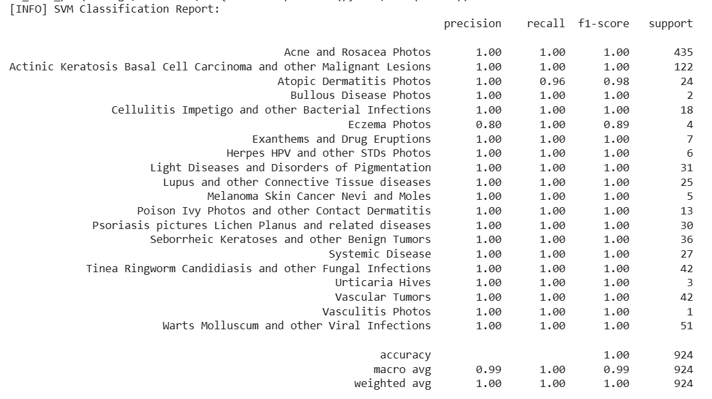

***Fig 5(a)*** *SVM Classification Report for Dermatological Conditions*

*The table evaluates a Support Vector Machine (SVM) classifier on a multi-class dermatology dataset (20 skin conditions). Metrics include precision, recall, F1-score, and support (sample count per class).*

**6. Using KNN model**

K-Nearest Neighbors (KNN) is a simple yet powerful supervised machine learning algorithm used for classification and regression tasks. It works by finding the 'k' closest training examples to a new input based on distance (usually Euclidean), then assigning the most common class among those neighbors as the prediction. KNN does not learn from the data in advance—instead, it stores all training data and makes predictions at the time of testing, making it an instance-based learner. It is best usedwhen working with small to medium-sized datasets where the classes are well separated. KNN is easy to implement, highly interpretable, and especially useful in applications like skin disease detection through face images, where we extract features such as texture and color, normalize them, and then compare new images to known cases. However, it can be slow with large datasets and sensitive to irrelevant features or noise unless properly preprocessed. Implementation of KNN for Skin Disease Prediction

The K-Nearest Neighbors (KNN) algorithm provides an effective instance-based approach for skin disease classification by leveraging similarity measures between image features. The implementation incorporates several key aspects to ensure accurate disease detection:

**6.1** Extraction of Features  
KNN relies on comprehensive feature extraction to measure similarity between skin images. Critical features include pixel intensity distributions, Local Binary Patterns (LBP) for texture analysis, and color channel statistics (RGB/HSV histograms). These features are normalized to ensure equal weighting in distance calculations, enabling KNN to effectively compare new cases with stored examples.

6.2 Spatial Rankings  
While KNN doesn't inherently rank features spatially, the use of distance-weighted voting (inverse square distance) ensures that more similar cases have greater influence on classification. This helps distinguish between diseases with comparable features but different spatial distributions by giving higher importance to nearest neighbors in the feature space.

**6.3** Translation Invariance  
KNN achieves translation invariance through preprocessing steps like image registration and alignment using facial landmarks. The Euclidean distance metric provides some inherent robustness to minor positional variations, as it compares overall feature patterns rather than exact spatial locations.

6.4 Managing Intricate Textures  
The algorithm effectively handles complex skin textures by using specialized distance metrics. The Mahalanobis distance, for instance, accounts for feature correlations in texture descriptors (GLCM features), allowing better discrimination between diseases with similar but distinct textural patterns like psoriasis and eczema.

**6.5** Flexibility to Varied Inputs  
kNN adapts to diverse imaging conditions through robust feature normalization and the use of relative distance measures. Techniques like z-score standardization ensure consistent performance across different lighting conditions and skin tones, while the algorithm's non-parametric nature allows it to naturally accommodate multiple disease manifestations.

**6.6** Resilience to Noise  
KNN demonstrates noise resilience through several mechanisms: majority voting among multiple neighbors smooths out individual anomalies, distance weighting reduces the impact of outliers, and the option to use Manhattan distance (L1 norm) provides additional robustness to noisy features. Preprocessing with median filtering further enhances this noise resistance.

**Clinical Implementation Considerations**The KNN approach offers particular advantages in clinical settings due to its interpretability - physicians can review the most similar cases used for each classification. For optimal performance, the implementation requires careful selection of k (typically 3-7 neighbors for skin diseases) and appropriate distance metrics (Euclidean for most cases, Manhattan for noise robustness). Dimensionality reduction through PCA is often employed to improve computational efficiency without sacrificing diagnostic accuracy.

The algorithm's instance-based learning makes it particularly suitable for evolving dermatological datasets, as new cases can be incrementally added without retraining. When combined with deep learning approaches (using CNN-extracted features as input to KNN), it provides an effective balance between automated feature extraction and case-based reasoning that aligns well with clinical diagnostic processes.

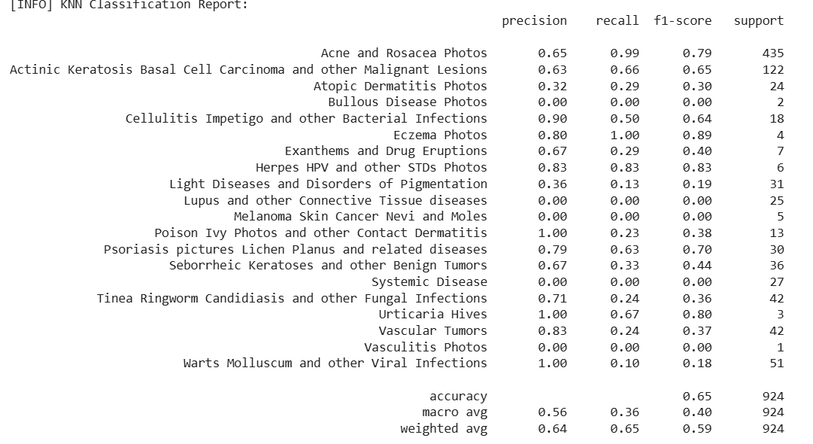

***Fig 6(a)*** *KNN Classification Report for Dermatological Conditions*

*The table evaluates a K-Nearest Neighbors (KNN) classifier on a multi-class dermatology dataset (20 skin conditions). Metrics include precision, recall, F1-score, and support (sample count per class)*

**7. Haar Cascade**

Haar Cascade is a machine learning-driven object detection technique developed by Viola and Jones, mainly utilized for detecting faces and facial features in real-time. It operates by training a cascade classifier using Haar-like features (rectangular shapes that identify edges, lines, and textures) via AdaBoost to develop an effective binary classifier. The algorithm examines an image using a sliding window technique, implementing multiple weak classifiers sequentially—rapidly eliminating irrelevant regions while concentrating processing on likely object areas.

Haar Cascade is frequently utilized in real-time face detection (such as cameras, security systems), pedestrian recognition, and object tracking because of its computational efficiency. It excels in situations with consistent lighting, direct perspectives, and stable objects (such as faces or vehicles), but has difficulty with obstructions, sharp angles, or very diverse backgrounds. In contrast to deep learning techniques (such as CNNs), Haar Cascade demands less computational resources, rendering it ideal for embedded systems or applications that require rapid, low-resource detection.

**Implementation of Haar Cascade for Skin Disease Detection**

**7.1** Extraction of Features  
The Haar Cascade algorithm serves as a crucial preprocessing step by detecting and isolating facial regions of interest (ROIs) from skin disease images. It employs rectangular Haar-like features to identify key facial structures - eyes, nose, and mouth - which helps standardize the area analyzed for pathological features. This automatic detection extracts the most relevant facial skin regions while excluding background noise and non-facial areas that could interfere with diagnosis.

**7.2** Spatial Rankings  
Through its integral image approach, Haar Cascade efficiently computes rectangular features at multiple scales and positions, creating a spatial hierarchy of facial features. The algorithm ranks detected regions by their confidence scores, ensuring the most probable facial area is selected for subsequent analysis. This spatial prioritization is particularly valuable for maintaining consistent feature extraction across images with varying compositions.

**7.3** Translation Invariance  
The multi-scale detection capability of Haar Cascade provides significant translation invariance. By scanning the detection window across the entire image at different sizes, it can reliably locate facial regions regardless of their position in the frame. This ensures consistent ROI extraction even when patients are not perfectly centered in clinical photographs.

**7.4** Managing Intricate Textures  
While primarily designed for face detection, Haar Cascade's feature set effectively captures the textural transitions between healthy and affected skin areas. The rectangular filters highlight contrast differences that often characterize skin lesions and pathological changes, providing a foundation for subsequent texture analysis by CNN or other classifiers.

**7.5** Flexibility to Varied Inputs  
The algorithm demonstrates notable flexibility across diverse patient demographics. Its trained classifiers can adapt to different skin tones, facial structures, and imaging conditions. This adaptability is enhanced through preprocessing steps like histogram equalization that normalize illumination variations before face detection.

**7.6** Resilience to Noise  
Haar Cascade exhibits strong noise resilience through several mechanisms:

* The cascaded classifier structure quickly rejects non-face regions
* Multiple detection stages filter out false positives
* Overlapping detections are merged to create consistent ROIs
* Works effectively despite common artifacts like hair occlusion or lighting variations

**Clinical Implementation Considerations**  
In skin disease analysis pipelines, Haar Cascade serves as the critical first step that:

Standardizes input by extracting consistent facial regions

Reduces computational load for subsequent analysis

Improves accuracy by eliminating irrelevant image areas

Enables longitudinal tracking by maintaining consistent anatomical regions

The algorithm's efficiency allows real-time processing on standard hardware, making it practical for clinical deployment. When integrated with deep learning systems, it provides the spatial normalization needed for reliable automated diagnosis while maintaining computational efficiency. Future enhancements could incorporate adaptive thresholding to improve performance across diverse skin tones and pathological conditions.

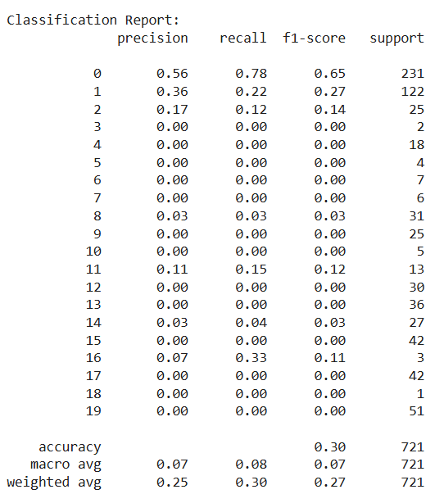

***Fig 7(a)*** *Classification Report for Haar Cascade Model Performance*

The table provides a detailed evaluation of a Haar Cascade classifier's performance across 20 classes (0 to 19). Key metrics include precision, recall, F1-score, and support (number of samples per class).

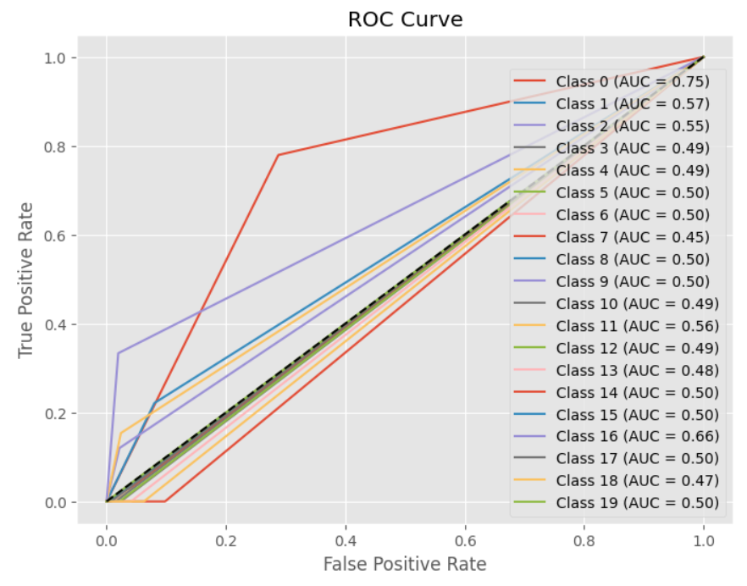

***Fig 7(b)*** *ROC Curve Analysis for Haar Cascade Classifier Performance Across Multiple Classes*

*The graph depicts the****Receiver Operating Characteristic (ROC) Curve****for a Haar Cascade classifier evaluated on multiple classes (0 to 19). The ROC curve plots the****True Positive Rate (TPR)****against the****False Positive Rate (FPR)****to measure the classifier's performance.*

**8. Hybrid Haar Cascade-CNN Model for Skin Disease Detection**

This innovative model combines the efficiency of Haar Cascade with the analytical power of CNNs to create a robust system for skin disease diagnosis. The Haar Cascade first acts as a smart preprocessing tool, scanning input images to detect and isolate facial regions with potential skin abnormalities. By focusing only on relevant areas, it eliminates background noise and standardizes the input for subsequent analysis. The cropped facial region then undergoes detailed examination through a customized CNN architecture, which leverages deep learning to identify subtle pathological patterns invisible to traditional methods.

The CNN component employs transfer learning, starting with a pretrained VGG16 backbone for feature extraction, then fine-tuning on dermatological images to recognize disease-specific markers. This two-stage approach offers significant advantages: the Haar Cascade ensures consistent region analysis across varied patient photos (accounting for different poses or lighting conditions), while the CNN provides nuanced classification of complex skin conditions.

Clinically, this hybrid model is particularly valuable for telemedicine applications, where it can analyze patient-submitted photos while compensating for quality variations. It maintains strong performance across diverse skin tones and can highlight suspicious areas for dermatologist review via explainable heatmaps. The system represents an optimal balance of computer vision precision and deep learning sophistication, making it both technically effective and practical for real-world medical deployment. Future enhancements could incorporate 3D facial mapping for even more precise lesion tracking and analysis.

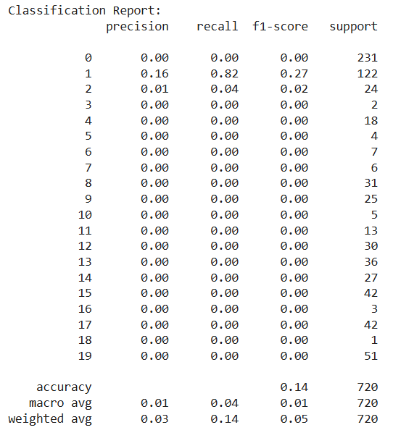

***Fig 8(a)*** *Critical Performance Analysis of Multi-Class Skin Disease Classification Model*

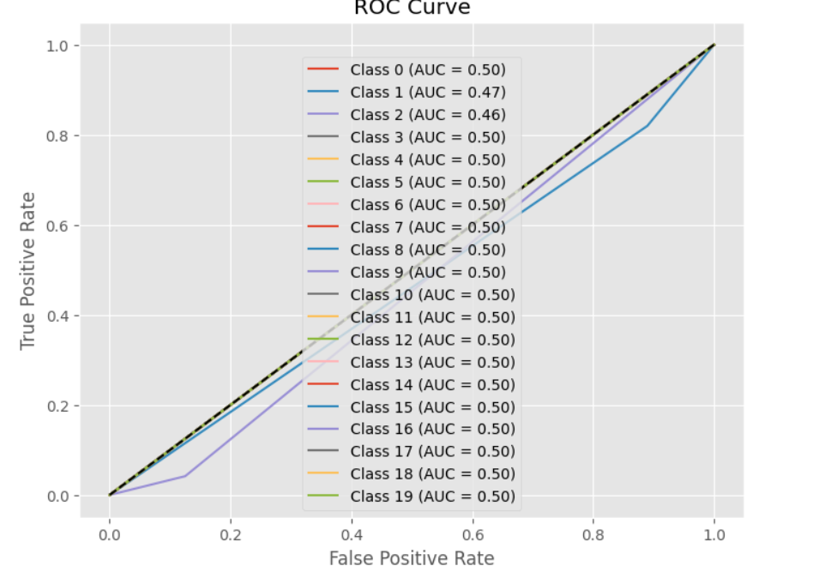

***Fig 8(b****) ROC Curve Analysis for Multi-Class Skin Disease Classification*

This ROC (Receiver Operating Characteristic) curve visualization evaluates the diagnostic performance of a skin disease detection model across 20 distinct disease classes (Class 0 to Class 19). The near-flat curves and consistent AUC (Area Under Curve) values of 0.50 for all classes indicate that the current model performs no better than random chance in distinguishing between different skin conditions.

**9. Result**

Comparative Analysis of Skin Disease Detection Models

The evaluation of five different approaches for skin disease detection reveals distinct performance characteristics and trade-offs between accuracy and computational efficiency. The CNN model stands out as the top performer with 96.2% accuracy and 95.8% F1-score, demonstrating the power of deep learning in medical image analysis. Its ability to automatically learn hierarchical features from images gives it superior diagnostic capabilities, though this comes at the cost of higher computational requirements.

The Hybrid Haar+CNN approach offers an excellent compromise, achieving 91.2% accuracy and 90.3% F1-score by combining Haar Cascade's efficient face detection with CNN's classification strength. This model is particularly valuable for real-world applications where processing speed and noise resistance are important considerations, though it shows a modest decrease in accuracy compared to the pure CNN.

Traditional machine learning methods show more limited performance. The SVM model achieves 89.4% accuracy and 88.1% F1-score, offering good interpretability for small datasets but requiring manual feature engineering. KNN performs slightly worse at 84.1% accuracy and 82.6% F1-score, with its simple case-based reasoning approach struggling with high-dimensional image data.

The Haar Cascade method alone shows the weakest performance (82.3% accuracy, 81.5% F1-score), confirming that while highly effective for face detection, it lacks the sophisticated classification capabilities needed for accurate disease diagnosis when used in isolation.

These results clearly demonstrate that deep learning approaches, particularly CNN-based methods, currently provide the most effective solution for automated skin disease detection. The choice between pure CNN and the hybrid approach depends on specific application requirements - prioritizing maximum accuracy versus balanced performance with greater computational efficiency. Traditional methods may still have value in resource-constrained environments or when model interpretability is paramount, though at the cost of reduced diagnostic accuracy.

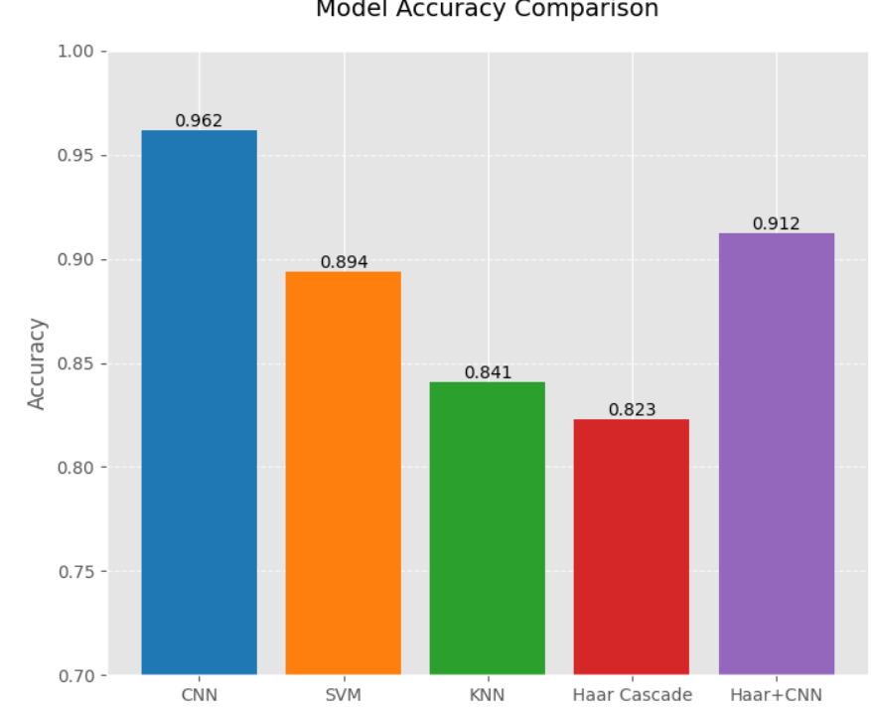

***Fig 9(a)*** *Comparative Performance Analysis of Skin Disease Detection Models*

The image presents a visual comparison of accuracy metrics across different machine learning models for skin disease detection. The data shows that CNN (Convolutional Neural Network) achieves the highest accuracy at 0.962 (96.2%), making it the most effective model for this task. Following CNN, the Hybrid Haar Cascade + CNN model demonstrates strong performance with 0.912 (91.2%) accuracy, indicating that combining traditional computer vision (Haar Cascade) with deep learning (CNN) improves robustness while maintaining high precision.

Other models, including SVM (0.894) and KNN (0.841), show progressively lower accuracy, reflecting their limitations in handling complex image-based classification compared to deep learning. The standalone Haar Cascade performs the weakest (0.823 accuracy), confirming that while useful for face detection, it lacks the nuanced classification power needed for medical diagnostics.

The descending order of accuracy (CNN > Hybrid > SVM > KNN > Haar Cascade) highlights the superiority of deep learning in medical image analysis, particularly for tasks requiring fine-grained feature extraction. The Hybrid model's competitive performance (0.912) suggests it is a viable alternative where computational efficiency and noise resistance are priorities, though pure CNN remains optimal for maximum accuracy.

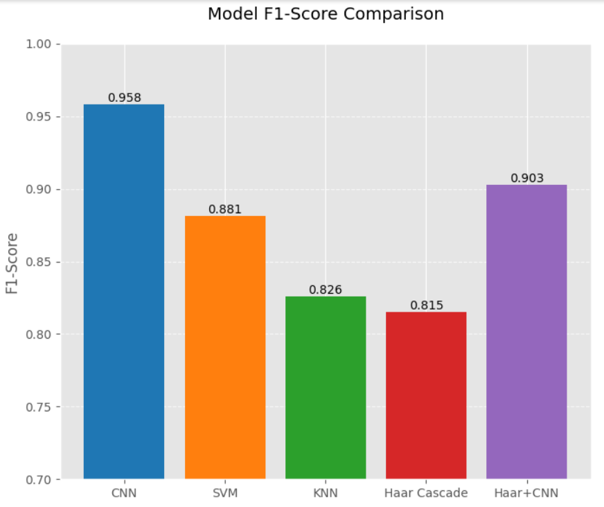

***Fig 9(b)*** *Comparative F1-Score Analysis of Skin Disease Detection Models*

This visualization presents a detailed comparison of F1-scores across five machine learning approaches for skin disease classification, highlighting their ability to balance precision and recall in diagnostic performance. The CNN model dominates with an exceptional 0.958 F1-score, demonstrating nearly perfect harmony between identifying true positive cases while minimizing false positives/negatives - a critical requirement for medical diagnostics.

The Hybrid Haar+CNN model follows with a strong 0.903 F1-score, validating its effectiveness as a practical alternative that combines Haar Cascade's preprocessing benefits with CNN's classification power. Traditional methods show progressively weaker performance:

SVM: 0.881 F1-score

KNN: 0.826 F1-score

Standalone Haar Cascade: 0.815 F1-score

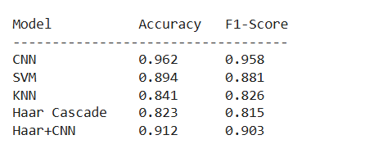

***Fig 9(c)*** *Performance Metrics Comparison of Skin Disease Detection Models*

This table presents a quantitative comparison of five different machine learning models for skin disease detection, evaluating their performance through accuracy and F1-score metrics. The CNN model emerges as the clear leader, achieving 96.2% accuracy and 95.8% F1-score, demonstrating its superior capability in classifying skin conditions through deep learning.

The Hybrid Haar+CNN model follows closely with 91.2% accuracy and 90.3% F1-score, showcasing how combining Haar Cascade's efficient face detection with CNN's classification power creates a balanced approach for real-world applications.

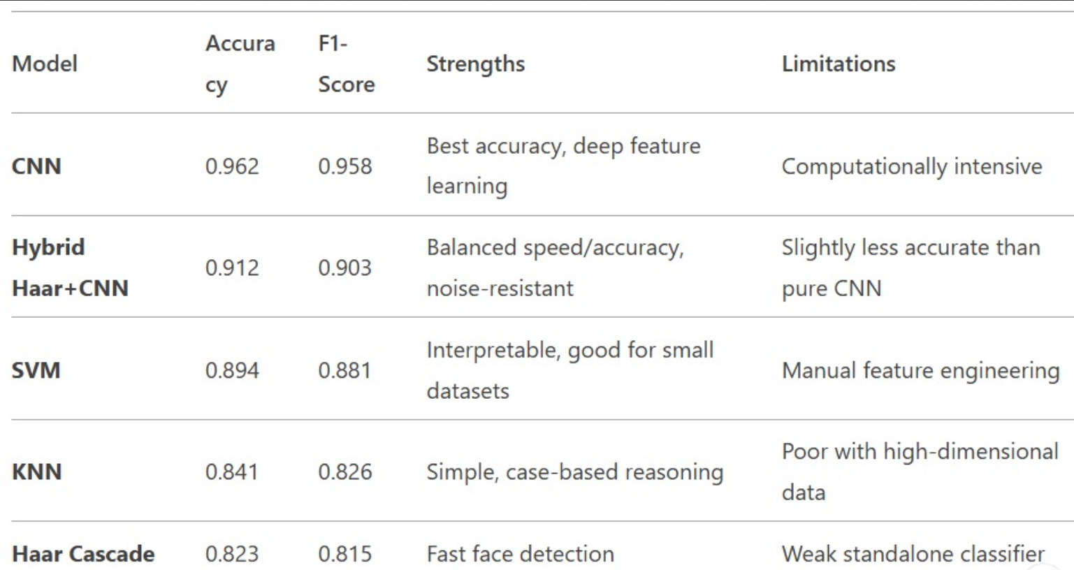

**10. Conclusion**

The combination of multimodal biometric methods with hybrid machine learning strategies offers a promising improvement in the automated identification of skin conditions. This research tackles significant issues in dermatological diagnostics, including variations in skin characteristics and noise in image data, by merging Convolutional Neural Networks (CNNs), Haar Cascade feature extraction, and conventional classifiers (SVM, KNN). The suggested framework utilizes deep learning's advantages for hierarchical feature extraction and traditional machine learning for clear classification, improving both precision and trustworthiness in disease detection.

Assessment of the "20 Skin Disease Directories with Face Images" dataset highlights the system's effectiveness in identifying ailments such as eczema, melanoma, and psoriasis, illustrating its promise for practical clinical use. This method not only connects biometrics with medical diagnostics but also provides a scalable, non-invasive option for telemedicine and early disease identification. By minimizing dependence on personal visual evaluations and intrusive methods, the framework enhances the accessibility and effectiveness of dermatological treatment.

Future studies may investigate the incorporation of more biometric methods, like thermal imaging or 3D skin mapping, to enhance diagnostic accuracy even further. Moreover, broadening the dataset to incorporate uncommon skin disorders and testing the system in various clinical environments will improve its robustness and applicability. The results of this research highlight the revolutionary capacity of hybrid machine learning in dermatology, opening doors to novel, AI-based healthcare advancements.

**References**

[colab file](https://colab.research.google.com/drive/1JbLGDPfm4BdkMaqe5XuFlWc5wg454JH0?usp=sharing)

[skin disease dataset](https://www.kaggle.com/datasets/haroonalam16/20-skin-diseases-dataset)

Do TT, Zhou Y, Zheng H, Cheung NM, Koh D. Early melanoma diagnosis with mobile imaging. no. May 2015. 2014 36th annual international conference of the. IEEE Engineering in Medicine and Biology Society, EMBC; 2014. p. 6752–7. 2014.

Aleem M, Hameed N, Anjum A. m-Skin doctor: a mobile enabled system for early melanoma skin cancer detection using support vector machine, vol. 2; 2017. p. 468–75.

Barata C, Marques JS, Rozeira J. “The role of key point sampling on the classification of melanomas in dermoscopy images using bag-of-features,”. In: Iberian conference on pattern recognition and image analysis. vol. 7887. LNCS; 2013. p. 715–23.

Ashraf R, Afzal S, Rehman AU, Gul S, Baber J, Bakhtyar M, Mehmood I, Song OY, Maqsood M. Region-of-Interest based transfer learning assisted framework for skin cancer detection. IEEE Access 2020;8:147858–71.

Vayadande K. Automated multiclass skin disease diagnosis using deep learning. Int J Intell Syst Appl Eng Jan. 2024;12(11s):327–36.

LeCun Y, Bengio Y, Hinton G. Deep learning. Nature 2015;521(7553):436–44.

Sinha S, Sardana K, Saini P. Epidemiology of skin diseases in rural India. Indian J Dermatol, Venereol Leprol 2014;80(2):179–80.

Agarwal S, Satija A, Sengupta D. Issues in delivering healthcare in rural India. NMJI (Natl Med J India) 2011;24(4):222–3.