ImageSleuth AI
Intelligent Digital Image Forensics and Tampering Analysis System

A Mini-Project Report
Python · Streamlit · OpenCV · Pillow · NumPy · ReportLab · pytest

Submitted by: Ashutosh
October 2026

Abstract
ImageSleuth AI is a locally run web application that examines JPEG and PNG images for forensic indicators of tampering. It explains each result, verifies file integrity, and produces a downloadable PDF report. The system records a SHA-256 fingerprint of the exact uploaded bytes before any analysis. It then extracts EXIF metadata and runs Error Level Analysis (ELA), keypoint-based copy-move analysis (ORB, ratio test and RANSAC) and exploratory consistency views (noise residual, edges, colour channels).
Results are reduced to one of three cautious states: Potential indicators found, No indicators detected by implemented checks or Analysis incomplete. The system deliberately gives no "real/fake" verdict and no confidence percentage, because no validated, calibrated model backs these checks.
The application needs no GPU, API key or internet connection after installation. A suite of 95 automated tests passes, covering hashing, validation, metadata, ELA, copy-move, reporting and the user interface. On synthetic demonstration images with known edits, every detector responded to the edit it targets and stayed quiet on the unedited image. These synthetic results demonstrate correct behaviour only, not real-world accuracy.
Keywords: digital image forensics, Error Level Analysis, copy-move forgery, ORB, RANSAC, SHA-256, EXIF, Streamlit.

Table of Contents
Abstract 2
Chapter 1: Introduction 6
1.1 Background 6
1.2 Digital image forensics 6
1.3 Motivation 6
1.4 Nature of the system 6
1.5 Organisation of the report 7
Chapter 2: Problem Statement, Objectives and Scope 8
2.1 Problem statement 8
2.2 Objectives 8
2.3 Scope 8
2.4 Intended users 9
Chapter 3: System Requirements 10
3.1 Hardware requirements 10
3.2 Software requirements 10
3.3 Functional requirements 10
3.4 Non-functional requirements 11
Chapter 4: System Design 12
4.1 System architecture 12
4.2 Module design 13
4.3 Data design 13
4.4 Processing workflow 13
4.5 User-interface design 14
Chapter 5: Security Design and Evidence Integrity 15
5.1 Integrity design with SHA-256 15
5.2 Input validation 15
5.3 Threat model 16
5.4 Privacy design 16
5.5 Evidence-handling limits 16
Chapter 6: Implementation 17
6.1 Project structure 17
6.2 Evidence intake 17
6.3 Metadata extraction 17
6.4 Error Level Analysis 17
6.5 Copy-move analysis 18
6.6 Consistency tools 19
6.7 Summary logic 19
6.8 Report generation 19
6.9 User interface 19
6.10 Synthetic demo generator 20
Chapter 7: Testing and Results 21
7.1 Testing strategy 21
7.2 Test suite summary 22
7.3 Representative test cases 23
7.4 Detection results on synthetic demo images 23
7.5 Effect of ELA quality and of the heuristic's design 24
7.6 Performance 24
7.7 Deployment test 24
7.8 Defect found during system testing 24
Chapter 8: Output Screens 26
8.1 Evidence intake: empty state 26
8.2 Graceful rejection of a corrupt file 27
8.3 Evidence loaded and all checks run 28
8.4 Metadata analysis 29
8.5 SHA-256 integrity verification 30
8.6 Error Level Analysis 31
8.7 Copy-move analysis 33
8.8 Consistency tools 34
8.9 Results dashboard and PDF report 35
8.10 About and limitations 36
Chapter 9: Advantages, Limitations, Future Scope and Conclusion 37
9.1 Advantages 37
9.2 Limitations 37
9.3 Future scope 38
9.4 Conclusion 38
9.5 References 38
Appendix: Important Source Code 40
A.1 Evidence intake: hash first (forensic/case.py) 40
A.2 SHA-256 and reference comparison (forensic/integrity.py) 40
A.3 Content-based upload validation (forensic/validation.py, core checks) 41
A.4 Error Level Analysis core (forensic/ela.py) 41
A.5 ELA tile-outlier heuristic (forensic/ela.py) 41
A.6 Copy-move: self-matching with the g2NN ratio test (forensic/copy_move.py) 42
A.7 Copy-move: iterative RANSAC clustering (forensic/copy_move.py) 42
A.8 Three-state summary (forensic/summary.py, decision rule) 43
A.9 Running the project 43

Chapter 1: Introduction
Digital images are now trivially easy to edit, and edited images spread faster than they can be checked. ImageSleuth AI gives students, investigators and journalists a transparent, offline tool for examining an image file with well-known forensic techniques whose behaviour they can explain.

1.1 Background
A digital photograph carries two kinds of evidence. The first is the file itself: its exact bytes, its container format and embedded metadata such as camera model and capture time. The second is the pixel content, which keeps statistical traces of how the image was captured, compressed and edited.
Common manipulations include:
- Copy-move: a region is copied and pasted elsewhere in the same image, for example to duplicate a crowd or hide an object.
- Splicing: content from a different image is pasted in.
- Retouching: local adjustments such as cloning, blurring or colour changes.
- Metadata editing: timestamps, camera fields or GPS location are altered or removed.

1.2 Digital image forensics
Passive (blind) image forensics looks for these traces without any watermark or prior knowledge of the image. This project implements four established, explainable families of technique:
Technique | What it looks at | Typical clue
Cryptographic hashing (SHA-256) | Exact file bytes | Bytes differ from a trusted reference
Metadata (EXIF) analysis | Embedded camera and software fields | Editing software named; timestamps disagree
Error Level Analysis (ELA) | JPEG recompression behaviour | A region responds differently from similar content
Copy-move analysis (ORB + RANSAC) | Repeated local features | Many matches share one geometric shift

1.3 Motivation
Online "fake detector" services often return a single percentage with no explanation. They also require uploading possibly sensitive images to a third party. For teaching and for responsible practice, a tool should show how it reached each observation, state its limitations, and keep the evidence on the user's own machine.

1.4 Nature of the system
ImageSleuth AI is an educational forensic-assistance tool. It reports indicators for a human examiner and never claims to prove that an image is authentic or manipulated. It does not maintain a formal chain of custody, and its reports are not legally admissible.

1.5 Organisation of the report
Chapter 2 states the problem, objectives and scope. Chapter 3 lists hardware, software, functional and non-functional requirements. Chapter 4 presents the architecture and module design. Chapter 5 covers security and evidence integrity. Chapter 6 explains the implementation of each algorithm. Chapter 7 reports testing and results, and Chapter 8 shows the output screens. Chapter 9 discusses advantages, limitations, future scope and conclusions. The Appendix lists key source code.

Chapter 2: Problem Statement, Objectives and Scope
The project builds a local web application that analyses an uploaded image for forensic indicators, explains every result, verifies file integrity and generates a PDF report, without ever claiming a definitive real/fake verdict.

2.1 Problem statement
The system must let a user upload an image and inspect it safely and transparently. It must:
- Treat the upload as untrusted data and protect its original bytes.
- Apply recognised forensic techniques whose working can be explained in plain English.
- Present observations separately from conclusions, with each method's limitations.
- Run without paid services, API keys, a GPU or an internet connection.
Existing free tools tend to fail on one of these points. Some give an unexplained score, some require uploading the image to a remote server, and some treat missing metadata or bright ELA regions as proof of forgery.

2.2 Objectives
1. Accept JPEG/JPG/PNG uploads and validate them by content (magic bytes and decoder), with size and pixel limits.
2. Compute SHA-256 over the exact uploaded bytes before any analysis, and compare it against an optional trusted reference hash.
3. Extract and explain EXIF metadata, reporting missing metadata as unavailable, not as suspicious. Hide GPS by default.
4. Implement reproducible Error Level Analysis with configurable JPEG quality and amplification.
5. Implement a genuine copy-move detector using ORB features, ratio filtering and RANSAC geometric verification.
6. Provide exploratory consistency views (noise residual, noise-level map, edges, colour channels), labelled as indicators.
7. Present a dashboard with a three-state summary and generate a PDF forensic report with parameters, visualisations, limitations and a disclaimer.
8. Verify behaviour with automated tests, keeping software tests separate from synthetic forensic sanity checks.

2.3 Scope
In scope | Out of scope
JPEG and PNG images up to 20 MB and 50 megapixels | HEIC, WebP, TIFF, RAW and video
One image per investigation, analysed on the user's machine | Batch processing, multi-user server deployment
Metadata, SHA-256, ELA, copy-move, consistency views | Deep-learning splicing detectors, PRNU camera fingerprinting
Indicators with explanations and limitations | Definitive authenticity verdicts or probability scores
Educational PDF report | Legally admissible evidence, formal chain of custody

2.4 Intended users
- Students and faculty learning digital forensics and computer vision.
- Journalists and fact-checkers making a first, explainable assessment of an image.
- Investigators who need a local, privacy-preserving triage aid before expert examination.

Chapter 3: System Requirements
ImageSleuth AI runs on an ordinary laptop with Python 3.10–3.12. It needs no GPU, database, Docker, API key or internet connection once dependencies are installed. It was developed and tested on Windows 11 with Python 3.11.4.

3.1 Hardware requirements
Component | Minimum | Recommended
Processor | Dual-core x86-64, 2 GHz | Quad-core or better
RAM | 4 GB | 8 GB (for 20–50 MP images)
Storage | 1 GB free (about 600 MB for dependencies) | 2 GB free
GPU | Not required | Not required
Display | 1280 × 720 | 1920 × 1080

3.2 Software requirements
Software | Version (pinned) | Purpose
Python | 3.11 (3.10–3.12 supported) | Programming language
Streamlit | 1.41.1 | Web user interface
opencv-python-headless | 4.10.0.84 | ORB features, matching, RANSAC, filters
Pillow | 10.4.0 | Image decoding, EXIF, JPEG recompression
NumPy | 2.1.3 | Array computation
ReportLab | 4.2.5 | PDF report generation
pytest | 8.3.3 | Automated testing
hashlib, hmac (standard library) | Python built-in | SHA-256 and constant-time comparison
Web browser | Chrome, Edge or Firefox (current) | Displays the Streamlit app
Operating system | Windows 10/11, macOS or Linux | Host platform

3.3 Functional requirements
ID | Requirement
FR1 | Upload JPEG/JPG/PNG files; reject other types, empty, oversized, corrupt or truncated files with a clear message.
FR2 | Display a preview, dimensions, format, file size, colour mode and a unique investigation ID.
FR3 | Compute SHA-256 of the original bytes at intake and compare it with an optional reference hash.
FR4 | Extract EXIF fields: make, model, timestamps, software, orientation and GPS (redacted unless the user opts in).
FR5 | Run ELA with configurable quality, amplification, tile size and threshold; show the difference map, heat map and outlier tiles.
FR6 | Run copy-move analysis with configurable parameters; visualise candidate duplicated regions.
FR7 | Generate noise-residual, noise-level, edge and colour-channel views.
FR8 | Show a results dashboard with a three-state summary, indicators, observations and check status.
FR9 | Generate and download a PDF report with all properties, parameters, visualisations, findings, limitations and a disclaimer.
FR10 | Provide a script that generates labelled synthetic demonstration images.

3.4 Non-functional requirements
Category | Requirement
Privacy | Runs on localhost; no third-party uploads; no image contents in logs; Streamlit telemetry disabled.
Security | Content-based validation; 20 MB and 50 MP limits; uploaded content never executed or written to disk.
Integrity | Original bytes kept immutable; hash re-verified at report time.
Explainability | Every method has a plain-English explanation, parameters and limitations in the UI and report.
Honesty | No real/fake verdict; no confidence percentage without a calibrated model.
Reproducibility | Fixed encoder settings for ELA; seeded RANSAC for copy-move.
Performance | Copy-move under 1 s and PDF report about 0.4 s for a 1024 × 768 image on a laptop CPU.
Usability | Dark, accessible dashboard; sidebar navigation; empty states; progress indicators.
Maintainability | Modular package independent of the UI; type hints and docstrings; 95 automated tests.

Chapter 4: System Design
The system is split into a thin Streamlit user interface (app.py) and a UI-independent forensic package. Every forensic function can therefore be tested without a browser, and the interface only calls those functions and displays their results.

4.1 System architecture
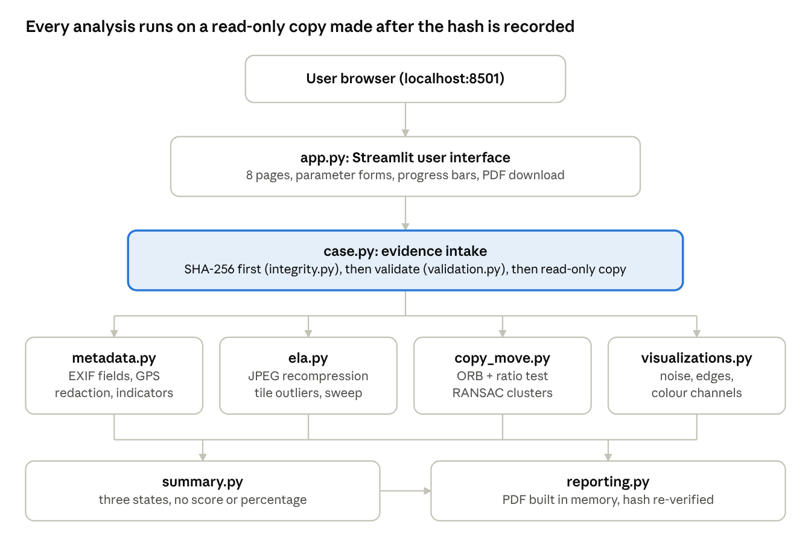
Figure 4.1: System architecture: UI layer, evidence intake, four analysis modules, summary and report.
The intake step (highlighted) is the heart of the evidence-handling design. The hash is computed before anything parses the file, and all four analyses receive only a read-only decoded copy.

4.2 Module design
Module | Responsibility | Key functions / classes
app.py | Pages, forms, progress, callouts, download button | page_intake, page_ela, run_all, render_sidebar
forensic/case.py | Evidence intake and per-investigation state | EvidenceCase, open_case
forensic/validation.py | Extension, magic-byte, decoder and size checks; safe decoding | validate_image_bytes, decode_to_rgb, ImageValidationError
forensic/integrity.py | SHA-256, reference comparison, re-verification | compute_sha256, compare_with_reference, verify_unchanged
forensic/metadata.py | EXIF IFD0, Exif IFD and GPS IFD parsing; observations | extract_metadata, MetadataResult, dms_to_decimal
forensic/ela.py | Error Level Analysis, tile outliers, quality sweep | perform_ela, ELAResult, quality_sweep
forensic/copy_move.py | ORB matching, g2NN filtering, RANSAC clustering | detect_copy_move, CopyMoveParams, MatchCluster
forensic/visualizations.py | Noise residual, noise map, Canny edges, channels | run_consistency_tools, ConsistencyResult
forensic/summary.py | Rule-based three-state summary | build_summary, AnalysisSummary, Indicator
forensic/reporting.py | ReportLab PDF generation, fully in memory | generate_pdf_report, ReportOptions
scripts/generate_demo_images.py | Synthetic demo images plus a ground-truth manifest | generate, make_scene

4.3 Data design
All state for one investigation lives in a single EvidenceCase object held in the Streamlit session (memory only, no database):
Field | Type | Meaning
investigation_id | str | ISA-YYYYMMDD-HHMMSS-XXXXXXXX, with 32 random bits
original_bytes | bytes (immutable) | Exact uploaded file
sha256 | str | Digest computed at intake
validated | ValidatedImage | Format, width, height, mode, size, warnings
rgb | NumPy array, write-protected | Decoded pixels used by every analysis
metadata, ela, copy_move, consistency | Result dataclasses | Outputs of each check
hash_comparison | HashComparison | Match, mismatch, invalid or not provided
test_status, errors | dict | Completed / not run / failed, per check

4.4 Processing workflow
1. The user uploads a file, or loads a synthetic demo image.
2. open_case hashes the bytes, validates them, creates a read-only RGB copy and extracts metadata.
3. The user runs each check from its page, or presses Run all checks (with a progress bar).
4. build_summary combines results into one of three states.
5. generate_pdf_report re-verifies the hash and builds the PDF in memory for download.

4.5 User-interface design
The interface is a dark cybersecurity dashboard (background #070B14, teal accent #2DD4BF) with eight sidebar pages: Evidence Intake, Metadata, Integrity (SHA-256), Error Level Analysis, Copy-Move Analysis, Consistency Tools, Results & Report, and About & Limitations.
Each analysis page follows the same pattern: a short explanation banner, a parameter form, results with visual evidence, a parameter table for reproducibility, and a collapsible limitations panel. Status callouts use consistent colours: teal for neutral or ok, amber for indicators, blue for information and rose for errors. There is never a red "FAKE" label.

Chapter 5: Security Design and Evidence Integrity
ImageSleuth AI uses no blockchain or smart contracts. Its tamper-evidence comes from a SHA-256 fingerprint recorded at intake and re-verified at report time, together with strict, content-based validation of every upload.
Note: the report template asked for "Smart Contract Design and Security". Because this project contains no smart contracts, this chapter covers the equivalent concerns for this system: integrity design, input security and privacy.

5.1 Integrity design with SHA-256
SHA-256 (FIPS 180-4) maps any byte sequence to a 256-bit digest. Changing one bit of the input changes about half of the output bits, and finding two inputs with the same digest is computationally infeasible.
1. Hash first. open_case computes hashlib.sha256 over the exact uploaded bytes before any parsing, decoding or metadata reading.
2. Immutable original. The upload is stored as a Python bytes object, which cannot be modified in place. Analyses receive a separate decoded NumPy array with its write flag turned off.
3. Reference comparison. The user may paste a trusted reference hash. Input is normalised (whitespace and an optional sha256: prefix removed, lowercased), validated as 64 hex characters, and compared with hmac.compare_digest (constant-time).
4. Re-verification. The Integrity page and the PDF report both re-hash the stored bytes and confirm they still match the intake hash.
What the hash proves is deliberately stated in the interface: a match means byte-level equality with whatever produced the reference. It does not prove the content is authentic. A forged image has a valid hash of its own, and an innocent re-save produces a different one.

5.2 Input validation
Check | Implementation | Attack or failure it prevents
File size ≤ 20 MB | Byte-length check plus Streamlit maxUploadSize | Memory exhaustion
Extension allow-list | .jpg, .jpeg, .png only | Executable or script uploads
Magic-byte signature | JPEG FF D8 FF, PNG 89 50 4E 47 0D 0A 1A 0A | Renamed non-image files
Structural verify | Pillow Image.verify() | Malformed containers
Full decode | Pillow Image.load() | Truncated or corrupt pixel data
Pixel limit ≤ 50 MP | Image.MAX_IMAGE_PIXELS; decompression-bomb warning raised as an error | Decompression bombs
Minimum 16 × 16 px | Dimension check | Degenerate inputs
Path stripping | os.path.basename on the client filename | Path traversal in names (e.g. ../../x.jpg)

Every rejection raises ImageValidationError with a user-safe message. The hash of a rejected file is still recorded, so even a rejected upload is identifiable.

5.3 Threat model
Threat | Mitigation | Residual risk
Malicious file disguised as an image | Content-based validation; nothing executed or written to disk | Undiscovered decoder bugs in Pillow/libjpeg
Oversized or bomb image | 20 MB and 50 MP limits | Very slow analysis just under the limits
Markup injection via filename or EXIF | html.escape before custom HTML; xml.sax.saxutils.escape before ReportLab paragraphs | None known
Leak of location data | GPS hidden on screen and in reports unless the user opts in | User may opt in carelessly
Image sent to third parties | No external API calls; Streamlit bound to localhost; telemetry off | Dependencies downloaded once at install
Evidence altered during analysis | Immutable bytes; read-only arrays; hash re-verified | None within the session
Over-claiming results | Three-state summary; no verdicts or percentages; limitations everywhere | User misreading indicators as proof

5.4 Privacy design
- The app binds to localhost and sends no image or metadata to any external service. No API keys are used.
- Uploaded bytes live only in the browser session's memory and are discarded on Clear evidence or when the session ends.
- The PDF is generated in an in-memory buffer (io.BytesIO), so no temporary file is written. A file reaches disk only when the user downloads it.
- Logs record events ("new evidence received", "report generated") with the investigation ID, never image bytes or metadata values.
- Streamlit usage-statistics collection is disabled in .streamlit/config.toml.

5.5 Evidence-handling limits
The application does not implement a formal chain of custody: there is no signed audit log, no access control and no trusted timestamping. Its outputs are therefore educational and must not be presented as certified or legally admissible forensic evidence. Chapter 9 lists the additions that would be needed.

Chapter 6: Implementation
The system is implemented in about 3,050 lines of Python (10 package modules, the Streamlit app and a demo-image generator), plus about 830 lines of tests in 9 test files. This chapter explains how each check works and the design decisions behind it.

6.1 Project structure
ImageSleuth-AI/
├── app.py Streamlit UI
├── forensic/ analysis package (no UI code)
│ ├── case.py validation.py integrity.py metadata.py
│ ├── ela.py copy_move.py visualizations.py
│ └── summary.py reporting.py utils.py
├── scripts/generate_demo_images.py
├── tests/ (+ tests/synthetic_benchmarks/)
├── assets/demo/ generated synthetic images
├── .streamlit/config.toml theme, upload limit, localhost, telemetry off
└── requirements.txt pytest.ini README.md

6.2 Evidence intake
open_case(data, filename) runs four steps in a fixed order:
1. Compute the SHA-256 of the raw bytes.
2. Validate them (Chapter 5.2).
3. Decode a write-protected RGB array.
4. Extract metadata.
It never raises for a bad upload. Instead the returned case carries validation_error, which the interface displays. Each case receives an ID such as ISA-20261014-091530-3FA9C2D1.
The analysis array keeps the image's stored orientation, so JPEG 8 × 8 block positions stay aligned for ELA. The preview alone applies the EXIF orientation. Transparency is discarded and 16-bit images are scaled to 8 bits.

6.3 Metadata extraction
Pillow's getexif() returns IFD0 (Make, Model, Software, DateTime, Orientation). get_ifd(0x8769) returns the Exif sub-IFD (DateTimeOriginal, DateTimeDigitized), and get_ifd(0x8825) returns the GPS sub-IFD. Binary values such as MakerNote are summarised (e.g. <binary data, 1234 bytes>) and long strings are truncated. GPS degrees, minutes and seconds are converted to signed decimal degrees:
decimal = ±( d + m / 60 + s / 3600 ), negative for S or W
Two weak indicators are raised: a Software tag naming a known editor (Photoshop, GIMP, Lightroom and 19 others), and DateTime differing from DateTimeOriginal. Missing EXIF produces only a neutral observation.

6.4 Error Level Analysis
The decoded image I is re-encoded in memory as JPEG at quality Q (default 90, 4:2:0 chroma subsampling, no optimisation), giving J. The difference image is then amplified for display:
E(x, y) = | I(x, y) − J_Q(x, y) |, A = min( 255, k · E )
In automatic mode, k maps the 99.5th percentile of E to full brightness (limited to between 1 and 100). The interface shows the original and amplified maps side by side, plus a colour heat map.
Tile outlier heuristic. Bright ELA regions usually just mean detail, so the system compares error with texture. For each 32 × 32 tile with mean Sobel gradient of at least 4, using luma (Y) only:
r = ln[ ( mean(E_Y) + 0.5 ) / ( mean(|∇Y|) + 1 ) ], z = ( r − median(r) ) / ( 1.4826 · MAD(r) )
A tile is flagged when z > 4, its mean error is at least 1.5, and at least one of its eight neighbouring tiles is also above the threshold. Three design choices remove most false alarms:
- Luma only: chroma subsampling makes coloured edges noisy.
- Dividing by texture: busy areas are not flagged simply for being busy.
- Neighbour rule: isolated single tiles are discarded.
An ELA indicator is raised only for JPEG inputs, and only when the flagged tiles cover at most 25% of the image. Larger flagged areas indicate a global pattern rather than a localised edit.
Quality sweep (JPEG ghosts). Testing showed that ELA reveals a splice most clearly when Q matches the quality at which the background was previously saved. The quality-sweep view, a simplified form of Farid's (2009) "JPEG ghost" method, therefore recompresses at Q = 60, 65, …, 95. It shows normalised, 9 × 9-averaged squared luma differences, in which a region previously saved at quality q turns dark at q. It is a visual aid only.

6.5 Copy-move analysis
The image is downscaled so its longest side is at most 1,600 px, then processed in five steps:
1. Feature detection: ORB finds up to 5,000 keypoints (8 pyramid levels, scale factor 1.2), each with a 256-bit binary descriptor.
2. Self-matching: brute-force Hamming k-nearest-neighbour matching of the image against itself (k = 3), discarding each point's match with itself.
3. Filtering: keep a match only if it passes the g2NN ratio test (best distance < 0.75 × second-best), the descriptor distance is at most 48 bits, and the two points are at least 40 px apart.
4. Geometric verification: both directions of every pair go into cv2.estimateAffinePartial2D with RANSAC (4 px threshold, 3,000 iterations), which fits a similarity transform:
[x′, y′]ᵀ = s · R(θ) · [x, y]ᵀ + [t_x, t_y]ᵀ, where R(θ) = [ cos θ −sin θ ; sin θ cos θ ]
5. Clustering: a fit with at least 8 inlier pairs, a scale between 0.5 and 2, and a median shift of at least 40 px becomes a candidate region pair. Its pairs are removed and the search repeats, up to 5 clusters.
The RNG is seeded (cv2.setRNGSeed(1234)), so results are reproducible. The visualisation draws each cluster's matches in its own colour with convex-hull outlines, and isolated matches in grey. A table lists each pair's bounding boxes, shift, rotation and scale. When there are too few keypoints (as in smooth images), the result is reported as insufficient features, never as a clean result.

6.6 Consistency tools
View | Computation | What a human looks for
Noise residual | abs(gray − median3×3(gray)) × amplification | A region whose grain differs from its surroundings
Noise-level map | Std. deviation of the residual per 16 px block, as a heat map | Blocks noticeably smoother or noisier
Canny edges | Thresholds = median × (1 ± 0.33) | Unnaturally sharp or soft object boundaries
Channels | R, G, B and Y, Cr, Cb | Colour or luma inconsistencies

6.7 Summary logic
build_summary applies fixed rules and produces no numeric score:
- Potential indicators found: at least one indicator from any check (hash mismatch, metadata, localised ELA outliers, or a copy-move cluster).
- Analysis incomplete: no indicators, but a core check (metadata, ELA, copy-move) has not run, failed, or had insufficient features.
- No indicators detected by implemented checks: every core check completed with no indicator. The explanation states that this does NOT establish authenticity.

6.8 Report generation
generate_pdf_report builds an A4 document with ReportLab Platypus in an io.BytesIO buffer, so no temporary files are created. It contains 12 sections:
1. Investigation and file details
2. Overall summary
3. Integrity, including re-verification
4. Metadata, with GPS redacted unless the user opts in
5. Tests performed
6. ELA, with parameters and three images
7. Copy-move, with its visualisation
8. Consistency views
9. Findings: indicators, observations and conclusions
10. Limitations
11. Evidence handling
12. Disclaimer
Illustrations are downscaled to 900 px and embedded as JPEG (quality 85), which keeps a typical report around 0.8 MB, generated in about 0.4 s. Every page carries a header with the investigation ID and a footer stating "Indicators only - not a determination of authenticity."

6.9 User interface
app.py injects a custom CSS theme and renders the page selected in the sidebar radio. Key Streamlit features used:
- st.file_uploader with a type allow-list.
- st.form so that parameter changes apply only on submit.
- st.progress and st.status for Run all checks.
- st.tabs for alternative views.
- st.expander for limitations and the quality sweep.
- st.download_button for the PDF.
All analysis calls are wrapped so that an exception marks that check as failed with its message, instead of crashing the app.

6.10 Synthetic demo generator
scripts/generate_demo_images.py procedurally renders a textured, non-repetitive 1024 × 768 scene and writes seven labelled files and a manifest.json of ground-truth edit locations:
File | Purpose
01_synthetic_original.jpg | Unedited baseline with synthetic EXIF
02_synthetic_copy_move.jpg | 200 × 160 block copied from (110, 470) to (690, 90)
03_synthetic_spliced.jpg | 224 × 192 foreign block pasted at (560, 400) into a quality-75 background, saved at 90; simulated "GIMP" Software tag
04_synthetic_no_metadata.png | Lossless PNG without EXIF
05_repetitive_pattern_unedited.jpg | Unedited tiled pattern: a known copy-move false positive
06_corrupt_truncated.jpg | Truncated JPEG
07_not_an_image.png | Text file with a .png extension

Chapter 7: Testing and Results
All 95 automated tests pass (pytest: 95 passed in about 18–28 s on a laptop CPU, Python 3.11.4). On the synthetic demo images, every detector flagged the edit it targets and nothing on the unedited baseline. These synthetic results show correct behaviour, not real-world accuracy.

7.1 Testing strategy
The tests are deliberately split into two kinds, so that software correctness is never confused with forensic accuracy:
- Software-behaviour tests (tests/test_*.py) check that the code does what it claims: hash test vectors, rejection of malformed files, EXIF parsing, determinism, parameter validation, PDF validity and evidence immutability.
- Synthetic sanity checks (tests/synthetic_benchmarks/, pytest marker synthetic) confirm each detector responds to the edit it was designed for on computer-generated images with known edits. Measuring real accuracy would need a labelled real-world dataset such as CASIA v2, Columbia or CoMoFoD.
- UI smoke tests (marker app) run app.py headlessly with streamlit.testing.v1.AppTest. They visit every page, press Run all checks, verify a hash, re-run ELA and generate a PDF.
The test images are generated in memory by fixtures in conftest.py, so the suite needs no image files on disk.

7.2 Test suite summary
Test file | Tests | Covers
test_validation.py | 19 | Valid JPEG/PNG; empty, oversized, wrong-extension, renamed, truncated and corrupted files; extension mismatch warning; tiny images; path stripping; RGBA/grayscale decoding; read-only analysis copy
test_ela.py | 14 | Output shapes, determinism, input unchanged, fixed amplification, flat image, PNG warning, invalid parameters, documented parameters, quality sweep
test_integrity.py | 13 | FIPS test vectors ("abc", empty string), one-bit change, normalisation, match/mismatch/invalid/not-provided, wording, bytes unchanged after analysis
test_copy_move.py | 11 | Blank image gives insufficient features, structured result, input unchanged, reproducibility, downscaling and coordinate mapping, invalid parameters
test_visualizations_and_summary.py | 9 | Consistency view shapes, flat-image residual, invalid parameters, all three summary states, no verdict words, ID format
test_metadata.py | 8 | No EXIF, camera fields, editor and timestamp indicators, GPS conversion and redaction, southern/western hemispheres, garbage bytes
test_reporting.py | 8 | Valid PDF, required sections present, minimal case, GPS opt-in, markup escaping, rejected case, evidence unchanged
synthetic_benchmarks/test_synthetic_detection.py | 8 | Detector responses on demo images (7.4)
test_app_smoke.py | 5 | Empty states on every page, rejected upload, full workflow, demo loader, copy-move cluster table (regression)
Total | 95 | 95 passed, 0 failed, 0 skipped

7.3 Representative test cases
ID | Input | Expected result | Actual result
TC01 | Bytes abc | SHA-256 = ba7816bf…f20015ad (FIPS 180-2 vector) | Pass
TC02 | Valid 320 × 240 JPEG named photo.jpg | Accepted; JPEG, 320 × 240, RGB | Pass
TC03 | Empty file | Rejected: "The uploaded file is empty." | Pass
TC04 | Text renamed fake.png | Rejected: signature does not match | Pass
TC05 | First third of a JPEG | Rejected: truncated or corrupt | Pass
TC06 | PNG content named .jpg | Accepted as PNG with a mismatch warning | Pass
TC07 | image.exe, image.jpg.bat | Rejected: unsupported extension | Pass
TC08 | Filename ../../etc/passwd.jpg | Stored as passwd.jpg | Pass
TC09 | Reference hash in upper case | Status MATCH | Pass
TC10 | 63-character reference | Status INVALID REFERENCE | Pass
TC11 | PNG without EXIF | has_exif = False; observation only, no indicator | Pass
TC12 | EXIF Software "Adobe Photoshop", different DateTime | Two metadata indicators | Pass
TC13 | GPS 48°51'29.52" N, 2°17'40.2" E | 48.8582, 2.2945; redacted in the PDF unless opted in | Pass
TC14 | Same image analysed twice by ELA | Identical difference maps | Pass
TC15 | ELA quality 10 or 100 | ValueError | Pass
TC16 | Uniform grey image, copy-move | Status insufficient features | Pass
TC17 | Filename <b>evil</b>&<script>.jpg in a report | Valid PDF; markup escaped | Pass
TC18 | Report for a rejected file | ValueError | Pass
TC19 | ELA, copy-move and report run on an image | Original bytes and SHA-256 unchanged | Pass
TC20 | Full UI workflow (AppTest) | No exceptions; PDF starts with %PDF- | Pass

7.4 Detection results on synthetic demo images
Each demo image was run through the full pipeline (ELA at quality 90, except quality 75 for the spliced image, as Chapter 6.4 explains).
Demo image | Ground truth | Copy-move | ELA outlier tiles | Metadata indicators | Overall summary
01 synthetic original | No edit | None found | 0 of 768 | 0 | No indicators detected
02 synthetic copy-move | Block copied | 1 cluster, 24 matches, shift 692 px, rotation −0.2°, scale 1.00 | 0 of 768 | 0 | Potential indicators (1)
03 synthetic spliced | Foreign block pasted | None found | 23 of 768, all 23 inside the pasted region | 2 (editor tag, timestamp) | Potential indicators (3)
04 PNG, no metadata | No edit | None found | Experiment only (PNG) | 0 | No indicators detected
05 repetitive pattern | No edit | 5 clusters (known false positive) | 0 of 768 | 0 | Potential indicators (5)
06 truncated JPEG | Corrupt | — | — | — | Rejected with message
07 text as PNG | Corrupt | — | — | — | Rejected with message

Image 05 is an honest negative result. A tiled pattern that was never edited is flagged by copy-move, which shows why every result is an indicator, not proof.

7.5 Effect of ELA quality and of the heuristic's design
The tile heuristic was refined during testing. The first version measured error on all three colour channels and flagged 73 of 768 tiles on the unedited original: chroma subsampling made coloured edges look anomalous. Switching to luma only, dividing by texture and adding the neighbour rule reduced this to 0 tiles on every unedited demo image.
Flagged tiles on the spliced image (background previously saved at quality 75) at four ELA qualities:
ELA quality | 75 | 85 | 90 | 95
Spliced image: flagged tiles | 23 (all inside the splice) | 0 | 0 | 0
Original image: flagged tiles | 0 | 0 | 0 | 0

ELA therefore depends strongly on the chosen quality. This finding motivated the quality-sweep view and is stated among ELA's limitations in both the interface and the report.

7.6 Performance
Measured on the development laptop (Windows 11, Python 3.11.4, CPU only) for 1024 × 768 demo images:
Operation | Time
Error Level Analysis (one quality) | 0.12–0.28 s
Copy-move analysis (5,000 ORB features) | 0.11–0.35 s
PDF report generation | about 0.4 s (report about 0.75–0.8 MB)
Full test suite (95 tests) | about 18–28 s

An early report version embedded PNG illustrations, producing 2.5–8 MB PDFs that took up to 47 s. Switching illustrations to JPEG fixed both problems. The evidence itself is never embedded.

7.7 Deployment test
streamlit run app.py started the server on http://localhost:8501. The health endpoint /_stcore/health returned ok, the root page returned HTTP 200, and the dashboard rendered correctly in Microsoft Edge.

7.8 Defect found during system testing
Capturing the output screens (Chapter 8) exposed a defect the automated tests had missed. When copy-move found a cluster, the "Candidate region pairs" table crashed with ImportError: pyarrow requires NumPy 2.0 or newer. Streamlit had installed pyarrow 26, which needs NumPy 2, while requirements.txt pinned NumPy 1.26.4. The UI test had used an image with no clusters, so the table never rendered.
The fix pinned NumPy 2.1.3, which is compatible with OpenCV 4.10, Pillow 10.4, pandas and Streamlit 1.41. A new regression test renders the table for the copy-move demo image, and the full suite (now 95 tests) passes. This shows why manual end-to-end testing is still needed alongside unit tests.

Chapter 8: Output Screens
The screens below were captured from the running application (streamlit run app.py, Microsoft Edge, 1440 px wide) using the synthetic demo images. Each figure shows real output, not a mock-up.

8.1 Evidence intake: empty state
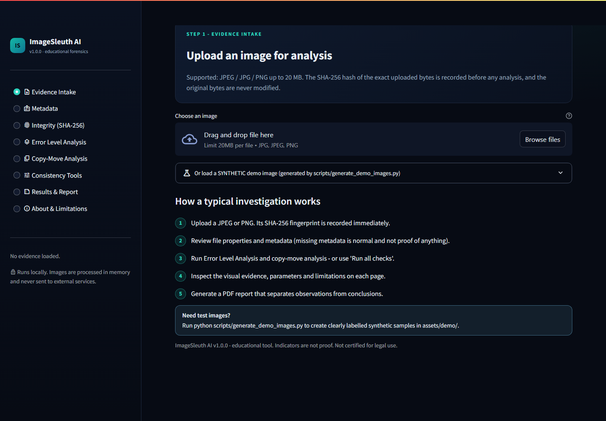
Figure 8.1: Landing page with sidebar navigation, upload area and the five-step investigation guide.

8.2 Graceful rejection of a corrupt file
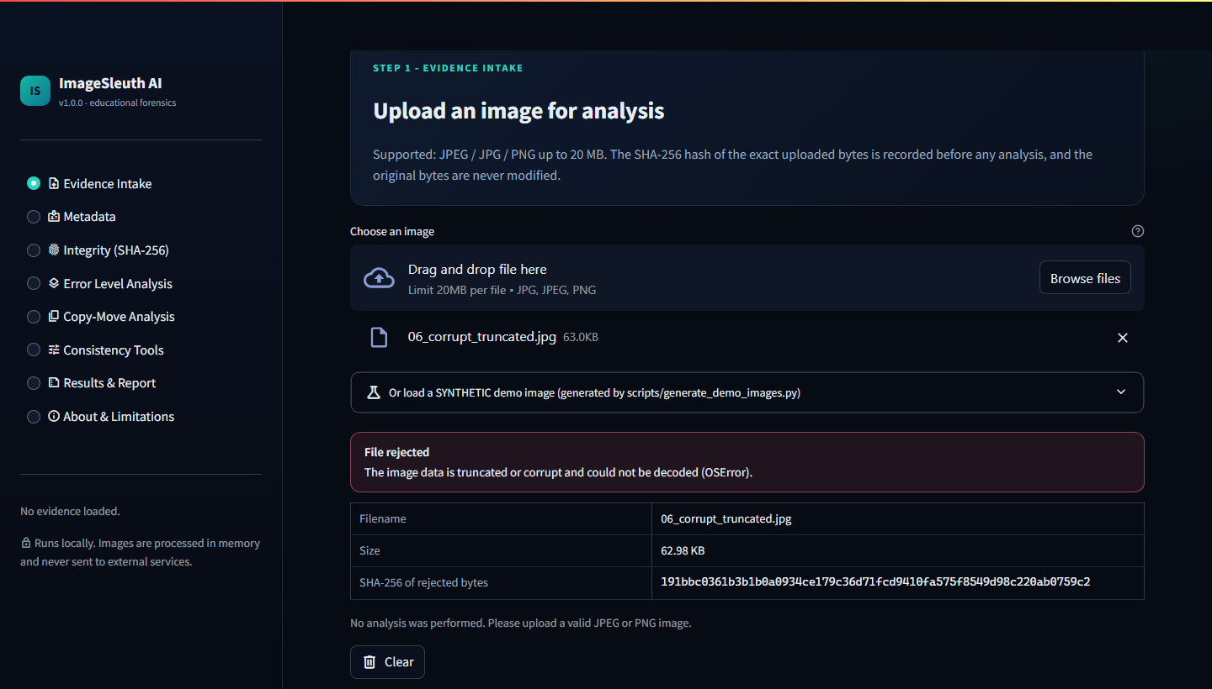
Figure 8.2: 06_corrupt_truncated.jpg is rejected with a clear reason. Its SHA-256 is still recorded and no analysis runs.

8.3 Evidence loaded and all checks run
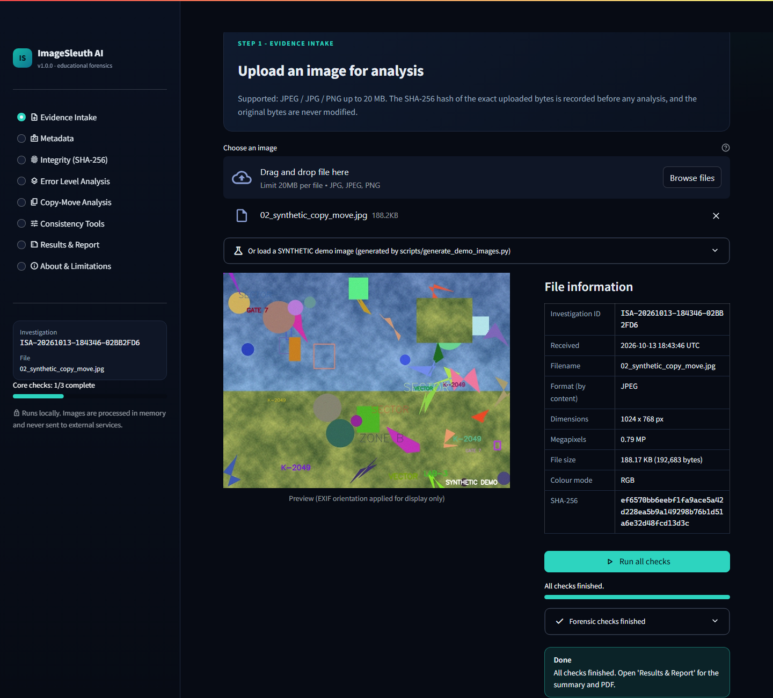
Figure 8.3: Preview, file properties, investigation ID and SHA-256, followed by "Run all checks" with its progress bar and status log.

8.4 Metadata analysis
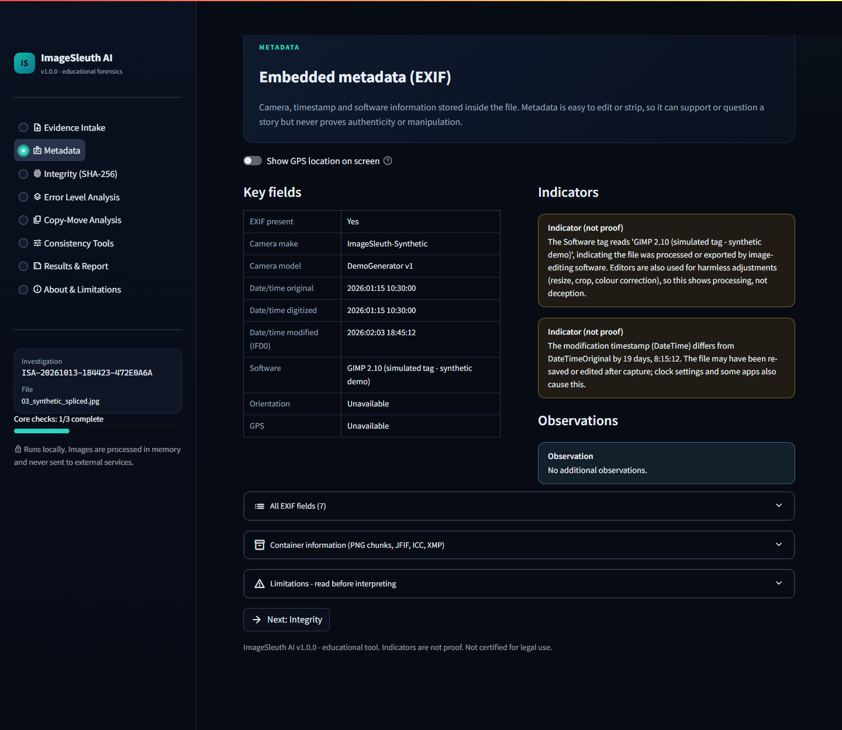
Figure 8.4: EXIF fields of 03_synthetic_spliced.jpg. The simulated "GIMP" Software tag and a 19-day timestamp difference appear as indicators, explicitly "not proof". GPS is hidden by default.

8.5 SHA-256 integrity verification
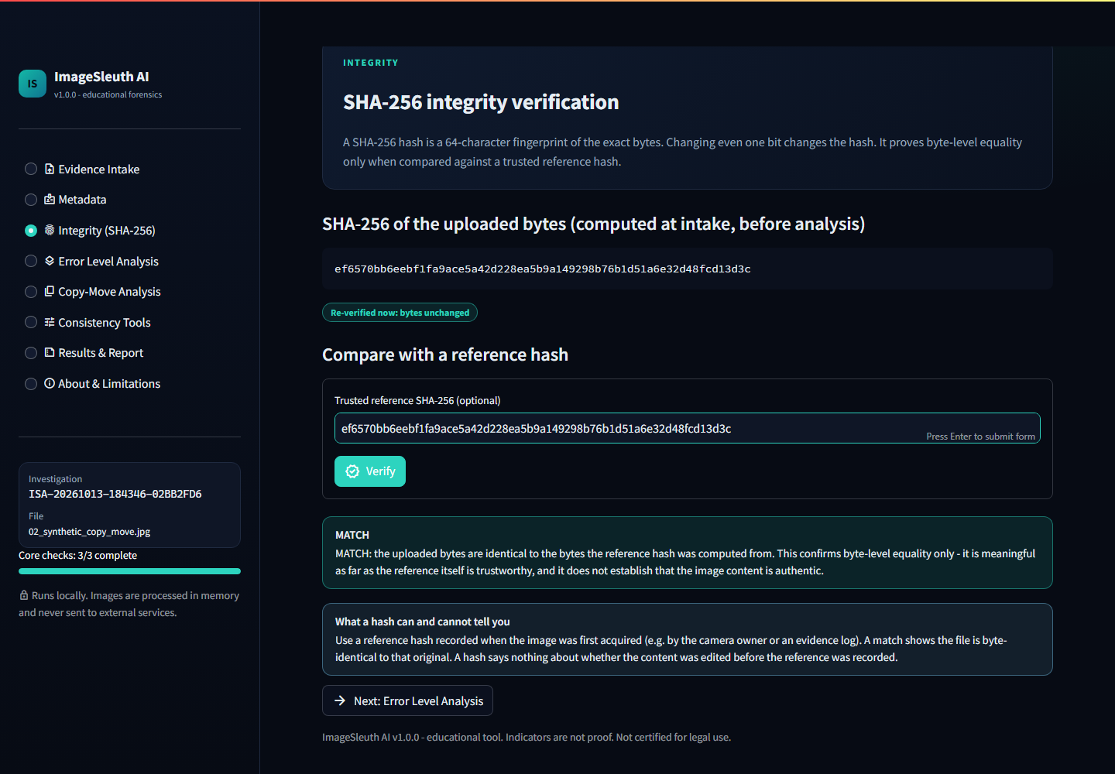
Figure 8.5: Hash computed at intake, re-verified as unchanged, and a MATCH against the pasted reference, with the reminder that a match does not establish authenticity.

8.6 Error Level Analysis
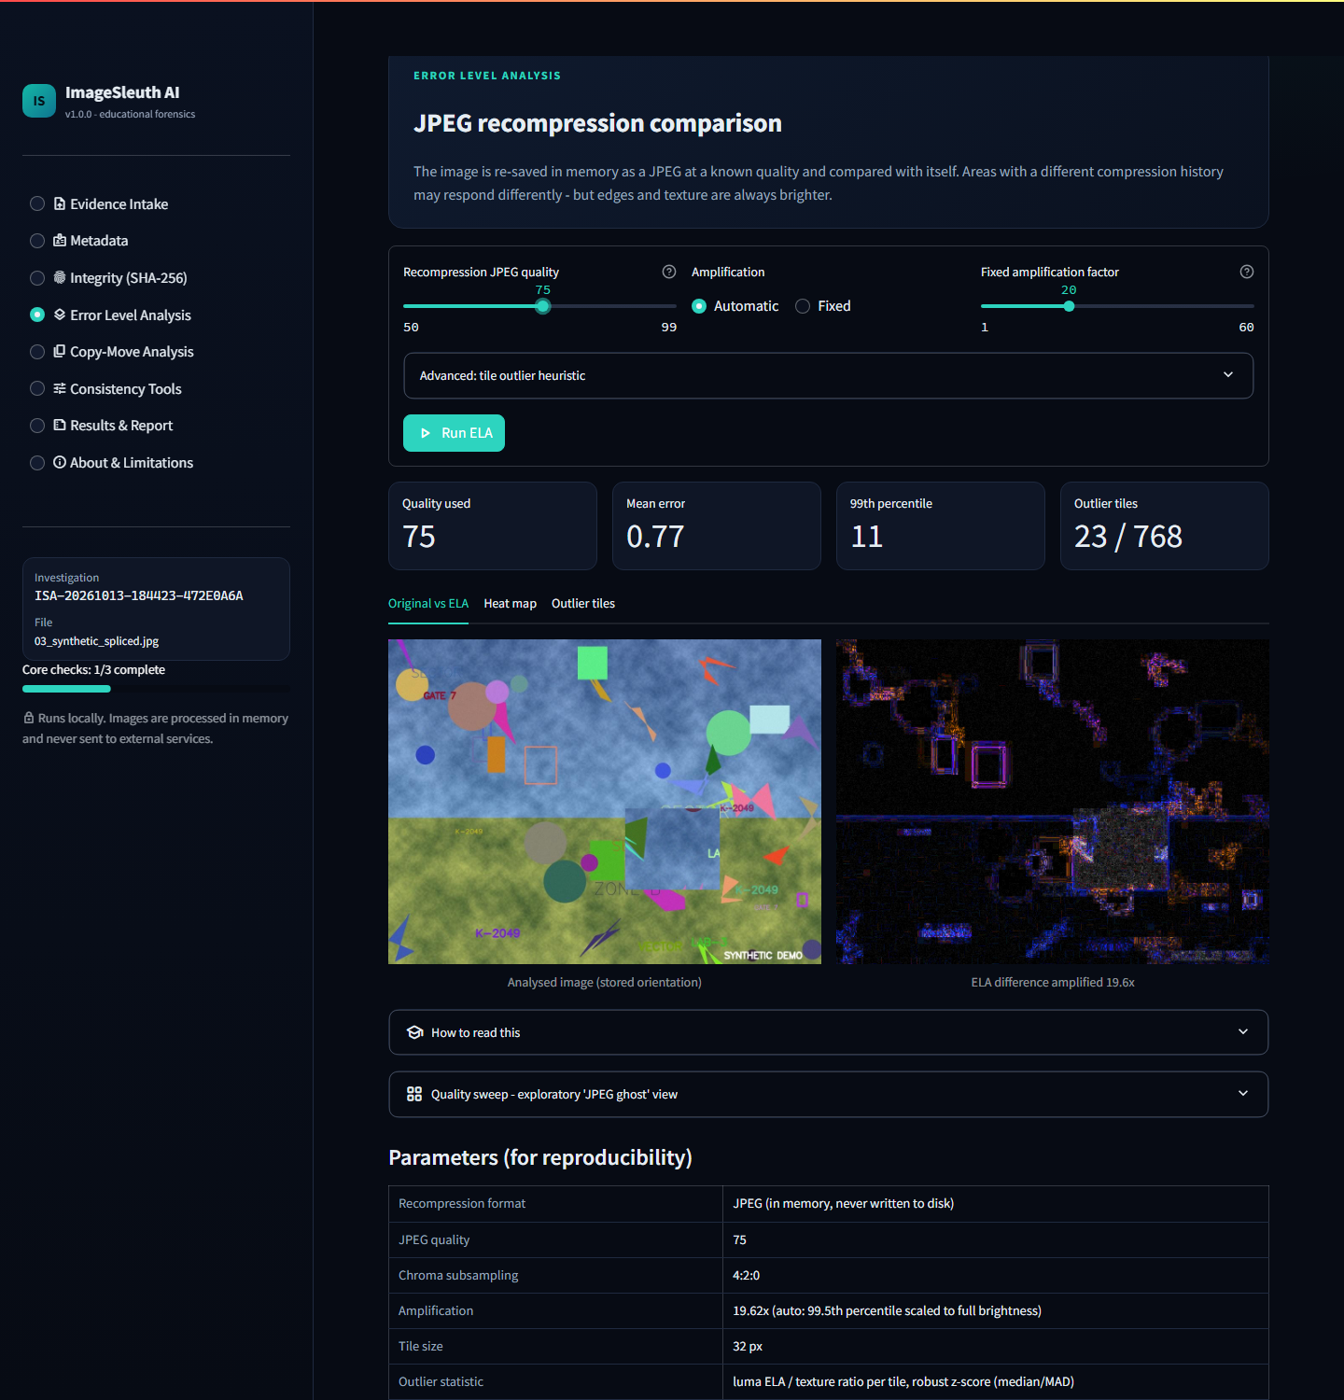
Figure 8.6: ELA at quality 75 on the spliced image: quality used, mean error, 99th percentile and 23 of 768 outlier tiles, plus the original and amplified difference map and the parameter table.
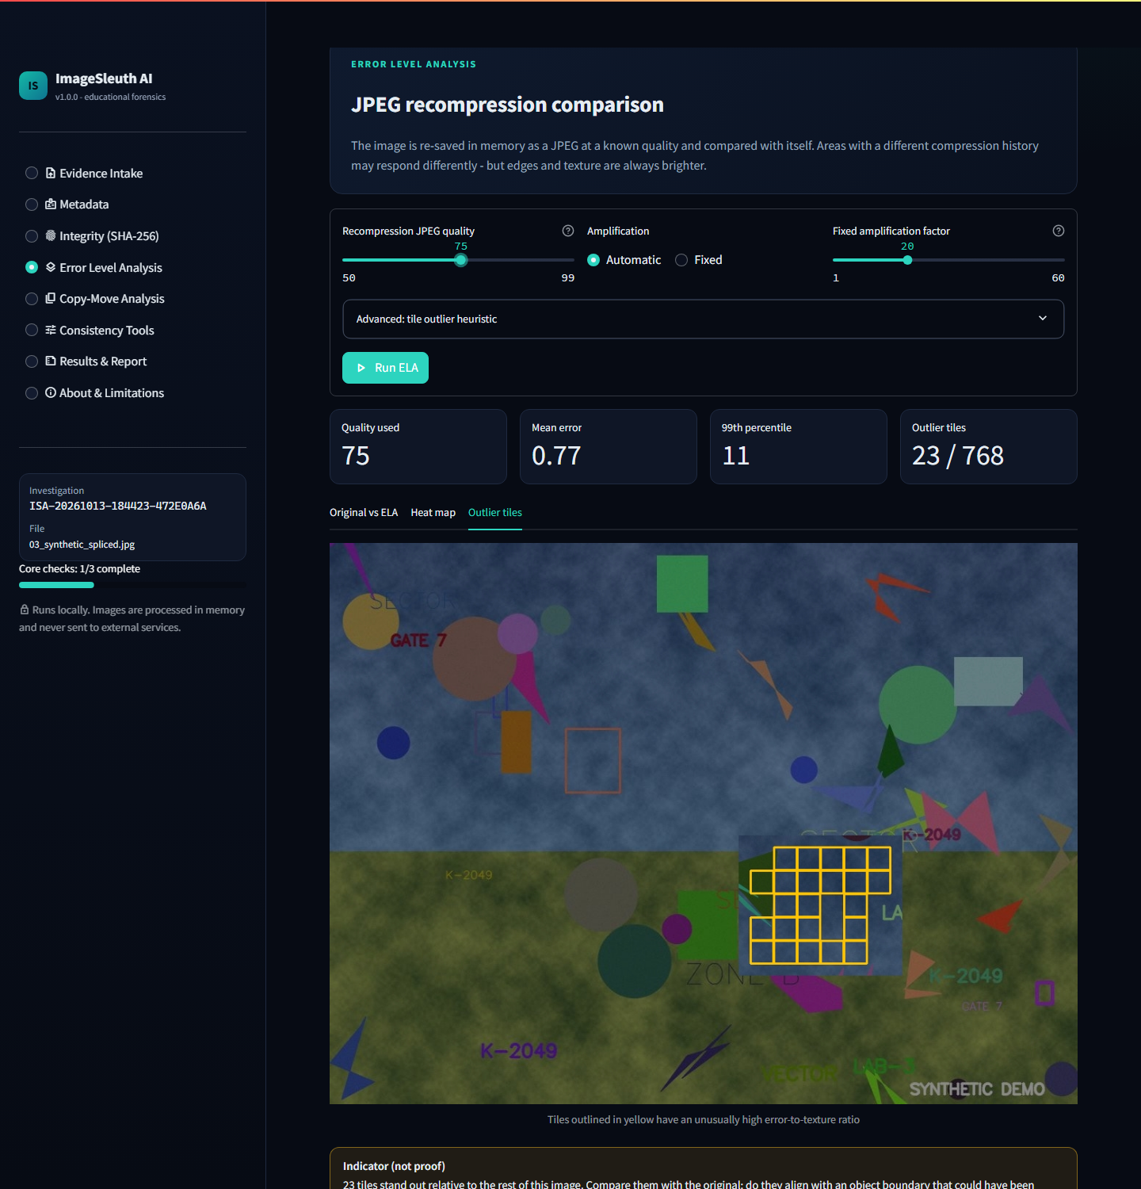
Figure 8.7: The outlier-tile view. All 23 flagged tiles fall inside the pasted region, reported as an "Indicator (not proof)".

8.7 Copy-move analysis
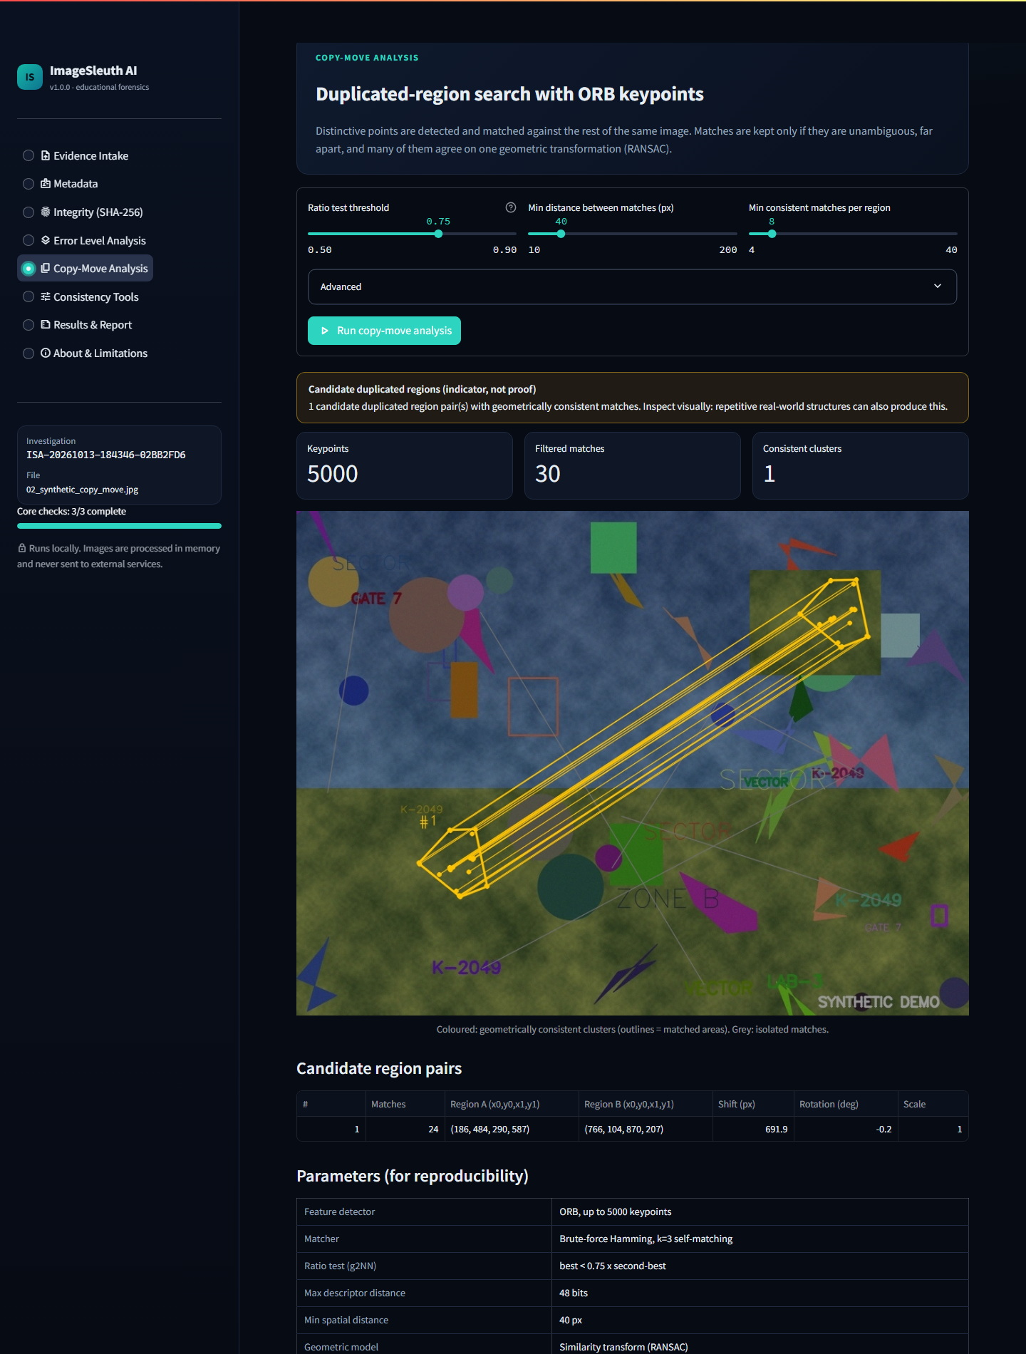
Figure 8.8: ORB/RANSAC result for 02_synthetic_copy_move.jpg: 5,000 keypoints, 30 filtered matches and 1 consistent cluster of 24 matches joining the original and copied blocks. The table lists the shift (691.9 px), rotation (−0.2°) and scale (1.0).

8.8 Consistency tools
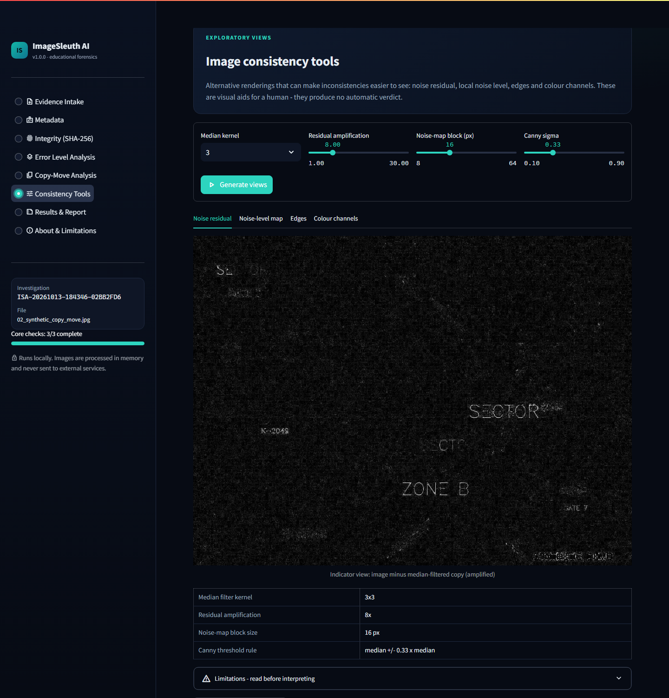
Figure 8.9: Noise-residual view (other tabs: noise-level map, Canny edges, colour channels), labelled as an indicator view.

8.9 Results dashboard and PDF report
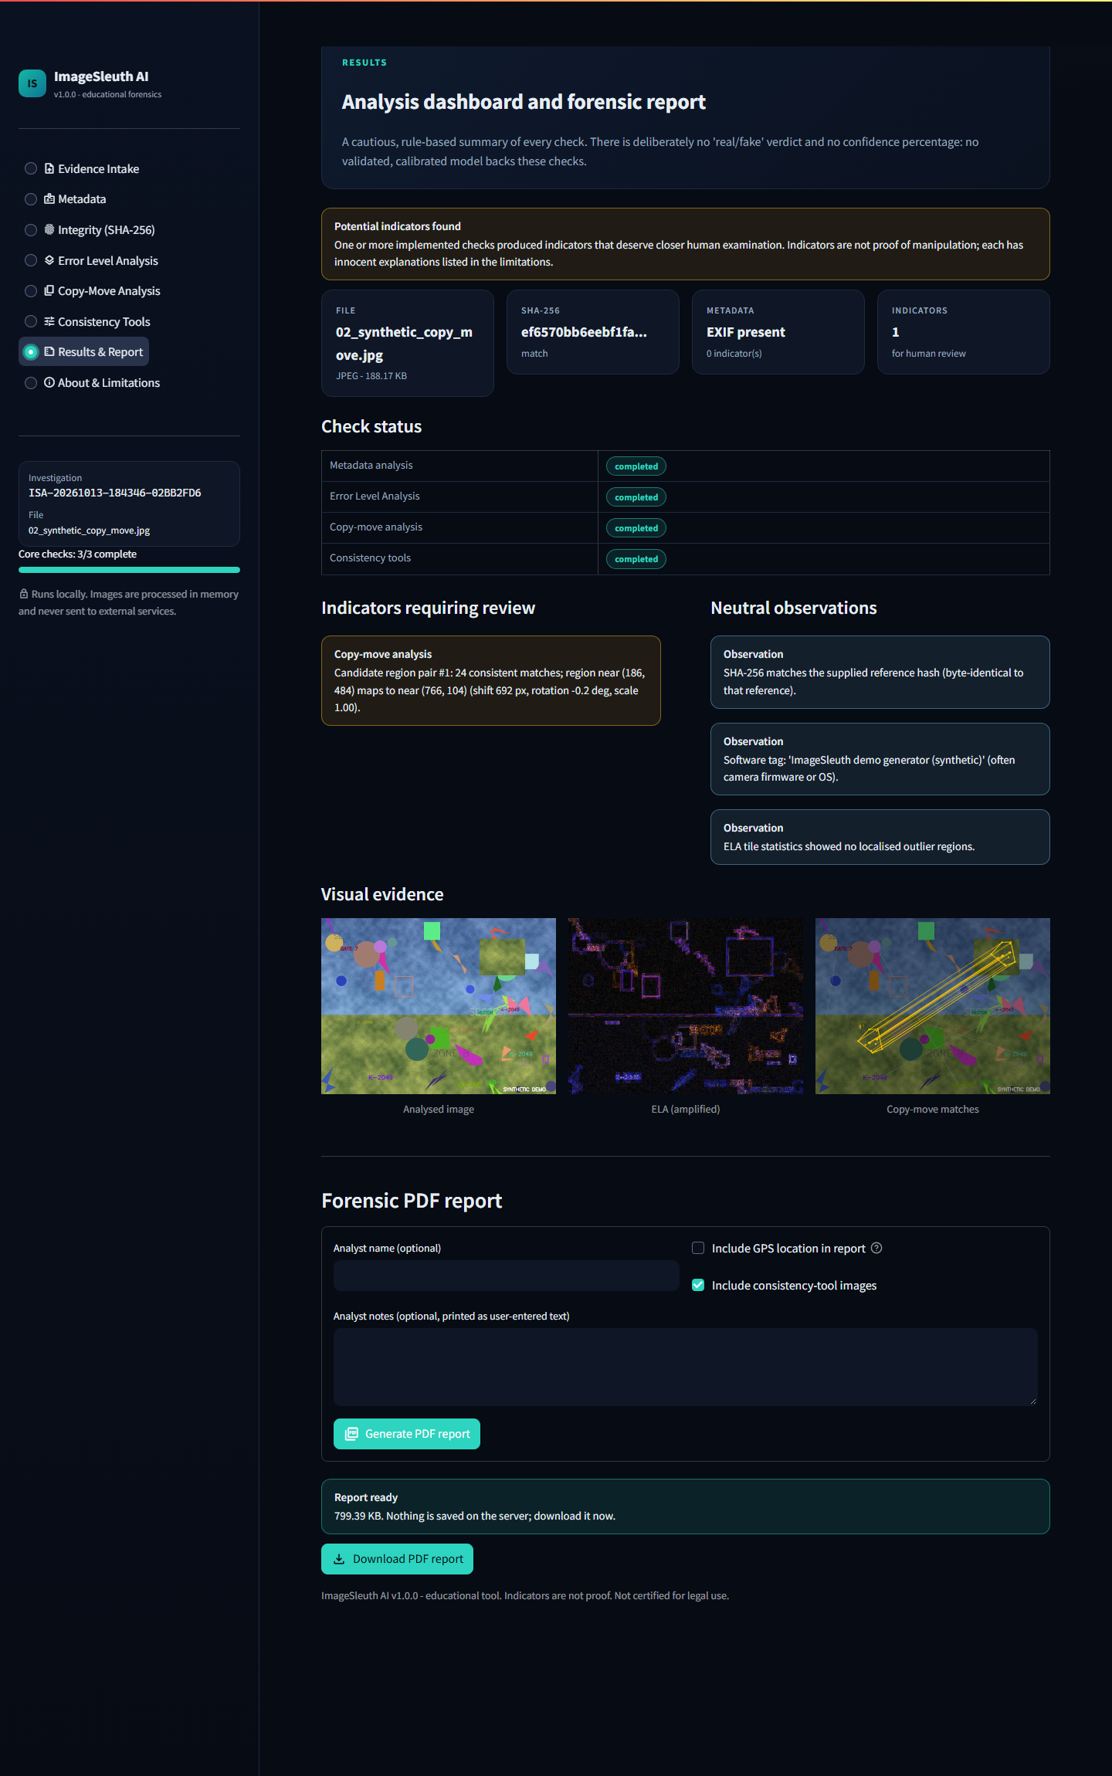
Figure 8.10: "Potential indicators found" summary, completed check status, indicator versus neutral observations, visual evidence, report options and a generated report (799 KB) ready for download.

8.10 About and limitations
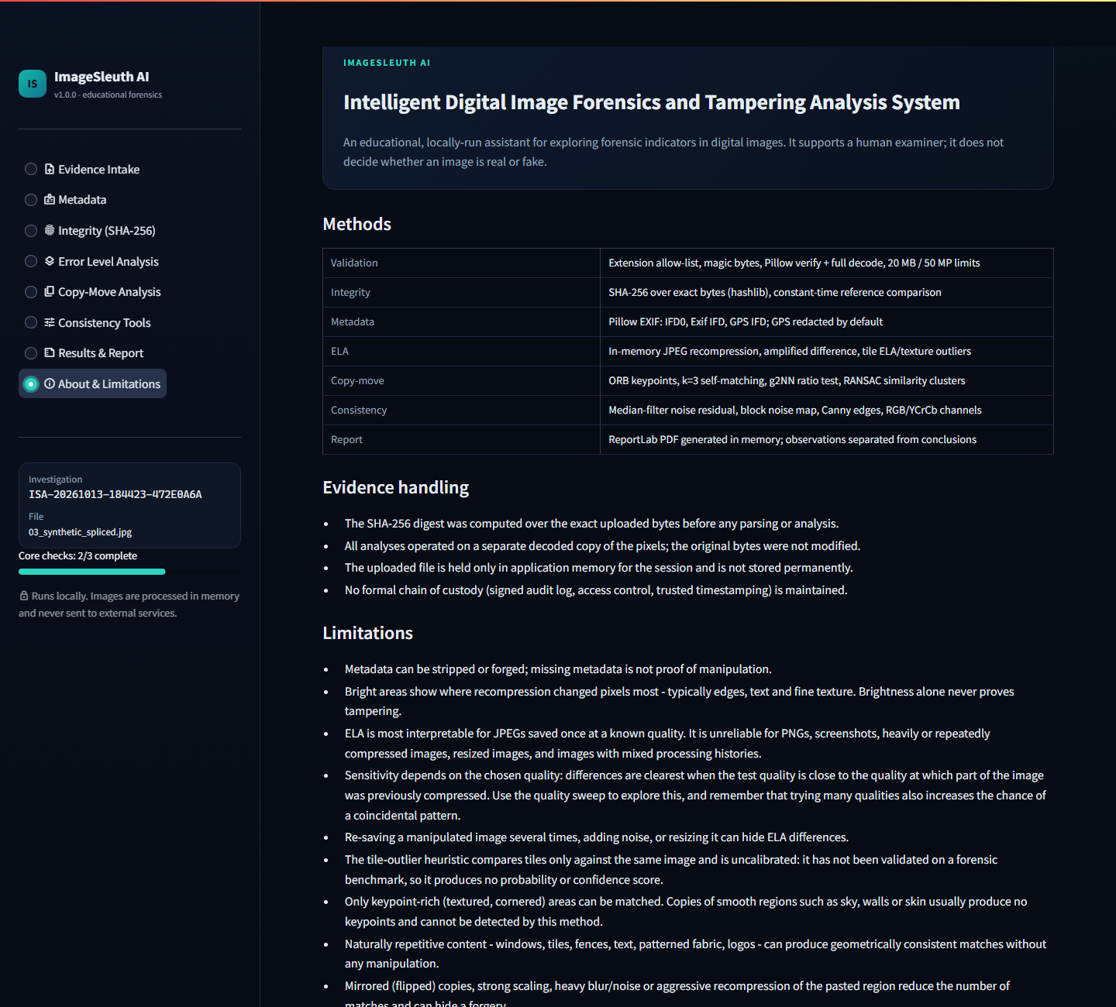
Figure 8.11: Methods, evidence-handling notes, limitations, privacy statement and disclaimer.

Chapter 9: Advantages, Limitations, Future Scope and Conclusion
ImageSleuth AI meets its objectives as an explainable, private, tested forensic assistant. Its main limits are inherent to the classical techniques it uses, and it is honest about them by design.

9.1 Advantages
- Explainable: every check has a plain-English explanation, visible parameters and a limitations panel. Nothing is a black box.
- Honest output: a three-state summary with no fabricated confidence score and no real/fake verdict.
- Private and offline: runs on localhost with no third-party APIs, keys or cloud. Nothing is stored permanently, and GPS is redacted by default.
- Evidence-aware: hash recorded first, immutable original bytes, read-only analysis copy, hash re-verified in the report.
- Robust input handling: content-based validation rejects corrupt, truncated, renamed and oversized files gracefully.
- Reproducible: fixed ELA encoder settings and seeded RANSAC give identical results for identical inputs.
- Lightweight: CPU-only. Each check takes well under a second on a 1024 × 768 image, and a full PDF report takes about 0.4 s.
- Well tested: 95 automated tests, with software tests kept separate from synthetic forensic checks.
- Easy to demonstrate: one-click synthetic demo images with known ground truth, including an honest false-positive example.

9.2 Limitations
- No technique here can prove authenticity or manipulation. All outputs require human interpretation.
- No calibrated model exists for these checks, so the system gives no probabilities or confidence scores.
- Metadata is easily stripped or forged. Its absence or presence proves nothing.
- ELA depends on compression history, image content and the chosen quality. In testing, a splice was visible at quality 75 but invisible at 85–95. ELA is unreliable for PNGs, screenshots and repeatedly saved images.
- Copy-move misses copies of smooth regions and mirrored copies, and it raises false alarms on repetitive patterns (demo image 05).
- Splicing is covered only by ELA and the visual consistency views; there is no learned detector.
- Accuracy has been demonstrated only on synthetic images, not on a labelled real-world benchmark.
- There is no formal chain of custody, so results are not legally admissible.
- Only JPEG and PNG are supported, one image at a time.

9.3 Future scope
Enhancement | Benefit
Evaluation on public benchmarks (CASIA v2, Columbia, CoMoFoD, MICC-F220) | Measured precision and recall instead of synthetic sanity checks
Block-based copy-move (Zernike or polar moments, PatchMatch) and mirror invariance | Detects copies of smooth regions and flipped copies
Full JPEG-ghost and double-quantisation (DCT histogram) analysis | Stronger, automatic splicing evidence for JPEGs
Camera sensor-noise (PRNU) fingerprinting | Links an image to a specific camera when reference images exist
Optional deep-learning localisation model (e.g. a TruFor- or ManTra-Net-style network, PyTorch) | Pixel-level tampering maps, shown only after calibration on a benchmark
Signed, append-only audit log and trusted timestamps | A step toward a real chain of custody
C2PA content-credential verification | Checks cryptographically signed provenance where cameras or apps provide it
HEIC, WebP and TIFF support; batch analysis | Wider applicability

9.4 Conclusion
ImageSleuth AI delivers a complete, runnable digital image forensics assistant. It validates uploads safely, fingerprints the evidence with SHA-256 before any analysis, and explains metadata. It implements genuine Error Level Analysis and ORB/RANSAC copy-move detection, offers exploratory consistency views, and produces a structured PDF report.
The project's central design choice is honesty. Results are framed as indicators, observations are separated from conclusions, and every method carries its limitations. Testing reinforced this choice: the system detected the synthetic copy-move and splice with zero false flags on the unedited baseline, but it also flagged an unedited repetitive pattern, and ELA proved highly sensitive to the chosen quality.
These results show that classical forensic tools are valuable aids for a trained examiner, but not oracles. The modular, tested codebase gives a sound foundation for the benchmark evaluation and stronger detectors listed above.

9.5 References
1. NIST, FIPS 180-4: Secure Hash Standard (SHS), 2015.
2. N. Krawetz, "A Picture's Worth: Digital Image Analysis and Forensics," Black Hat Briefings, 2007.
3. H. Farid, "Exposing Digital Forgeries From JPEG Ghosts," IEEE Transactions on Information Forensics and Security, 4(1), 2009.
4. I. Amerini, L. Ballan, R. Caldelli, A. Del Bimbo, G. Serra, "A SIFT-Based Forensic Method for Copy–Move Attack Detection and Transformation Recovery," IEEE TIFS, 6(3), 2011.
5. E. Rublee, V. Rabaud, K. Konolige, G. Bradski, "ORB: An Efficient Alternative to SIFT or SURF," ICCV, 2011.
6. M. A. Fischler, R. C. Bolles, "Random Sample Consensus," Communications of the ACM, 24(6), 1981.
7. Streamlit documentation
8. OpenCV documentation: ORB and feature matching
9. Pillow documentation
10. ReportLab documentation
11. Python hashlib documentation
12. pytest documentation

Appendix: Important Source Code
The excerpts below are copied from the project as tested. Docstrings are shortened in places; the full source is in the ImageSleuth-AI/ folder.

A.1 Evidence intake: hash first (forensic/case.py)
def open_case(data: bytes, filename: str, max_bytes: int = DEFAULT_MAX_FILE_BYTES) -> EvidenceCase:
"""Create an EvidenceCase from uploaded bytes. Never raises for bad uploads."""
data = bytes(data) # defensive immutable copy
case = EvidenceCase(
investigation_id=new_investigation_id(),
received_at=utc_now(),
filename=safe_filename(filename),
original_bytes=data,
sha256=compute_sha256(data), # step 1: hash before anything else touches the data
)
for test in (*CORE_TESTS, *OPTIONAL_TESTS):
case.test_status[test] = TEST_NOT_RUN

try:
case.validated = validate_image_bytes(data, filename, max_bytes)
rgb = decode_to_rgb(data)
rgb.setflags(write=False) # analysis code must work on copies
case.rgb = rgb
except ImageValidationError as exc:
case.validation_error = str(exc)
return case

try:
case.metadata = extract_metadata(data)
case.mark("Metadata analysis", TEST_COMPLETED if case.metadata.error is None else TEST_FAILED,
case.metadata.error)
except Exception as exc:
case.mark("Metadata analysis", TEST_FAILED, f"{type(exc).__name__}: {exc}")
return case

A.2 SHA-256 and reference comparison (forensic/integrity.py)
def compute_sha256(data: bytes) -> str:
"""Lowercase hex SHA-256 of the exact bytes supplied (no decoding first)."""
if not isinstance(data, (bytes, bytearray, memoryview)):
raise TypeError("compute_sha256 expects raw bytes")
return hashlib.sha256(bytes(data)).hexdigest()

def compare_with_reference(computed: str, reference: str | None) -> HashComparison:
"""Compare with an optional reference digest using constant-time comparison."""
if reference is None or not reference.strip():
return HashComparison(STATUS_NOT_PROVIDED, computed, None, "No reference hash supplied. ...")
normalized = normalize_hash(reference)
if not is_valid_sha256(normalized):
return HashComparison(STATUS_INVALID, computed, normalized,
"The reference value is not a valid SHA-256 digest ...")
if hmac.compare_digest(computed.lower(), normalized):
return HashComparison(STATUS_MATCH, computed, normalized,
"MATCH: ... it does not establish that the image content is authentic.")
return HashComparison(STATUS_MISMATCH, computed, normalized,
"MISMATCH: ... a mismatch alone does not reveal what changed or why.")

A.3 Content-based upload validation (forensic/validation.py, core checks)
name = safe_filename(filename)
if not data:
raise ImageValidationError("The uploaded file is empty.")
if len(data) > max_bytes:
raise ImageValidationError(f"The file is {len(data) / 1_048_576:.1f} MB; ...")

extension = os.path.splitext(name)[1].lower()
if extension not in ALLOWED_EXTENSIONS:
raise ImageValidationError(f"Unsupported file extension '{extension or '(none)'}'. ...")

sniffed = sniff_format(data) # magic bytes: FF D8 FF / 89 50 4E 47 0D 0A 1A 0A
if sniffed is None:
raise ImageValidationError("The file content is not a JPEG or PNG image ...")

# Pass 1: structural verification without decoding pixel data.
try:
with warnings.catch_warnings():
warnings.simplefilter("error", Image.DecompressionBombWarning)
with Image.open(io.BytesIO(data)) as probe:
probe.verify()
except (Image.DecompressionBombError, Image.DecompressionBombWarning) as exc:
raise ImageValidationError("The image dimensions exceed the safety limit ...") from exc
except Exception as exc:
raise ImageValidationError(f"The image structure is invalid or corrupt ({type(exc).__name__}).") from exc

# Pass 2: full decode (verify() does not decode pixels, so truncation is caught here).
try:
with Image.open(io.BytesIO(data)) as image:
image.load()
width, height = image.size
image_format, mode = image.format or sniffed, image.mode
except Exception as exc:
raise ImageValidationError("The image data is truncated or corrupt ...") from exc

A.4 Error Level Analysis core (forensic/ela.py)
def recompress_jpeg(rgb: np.ndarray, quality: int) -> np.ndarray:
"""Re-encode as JPEG in memory with fixed settings, then decode again."""
buffer = io.BytesIO()
Image.fromarray(rgb).save(buffer, format="JPEG", quality=int(quality), subsampling=2, optimize=False)
buffer.seek(0)
with Image.open(buffer) as recompressed:
return np.array(recompressed.convert("RGB"), dtype=np.uint8)

# inside perform_ela(...)
recompressed = recompress_jpeg(rgb, quality)
diff = cv2.absdiff(rgb, recompressed)
luminance = diff.max(axis=2)
if amplification is None:
reference = float(np.percentile(luminance, 99.5))
amp = 255.0 / reference if reference > 0 else 1.0
amp = float(min(max(amp, 1.0), 100.0))
else:
amp = float(amplification)
amplified = np.clip(diff.astype(np.float32) * amp, 0, 255).astype(np.uint8)
flagged, analysed = _tile_outliers(rgb, recompressed, tile_size, z_threshold)

A.5 ELA tile-outlier heuristic (forensic/ela.py)
def _tile_outliers(rgb, recompressed, tile, z_threshold):
luma = _luma(rgb)
error = np.abs(luma - _luma(recompressed))
texture = cv2.magnitude(cv2.Sobel(luma, cv2.CV_32F, 1, 0, ksize=3),
cv2.Sobel(luma, cv2.CV_32F, 0, 1, ksize=3))
height, width = luma.shape
cells, errors, textures = [], [], []
for row, y in enumerate(range(0, height - tile + 1, tile)):
for col, x in enumerate(range(0, width - tile + 1, tile)):
mean_texture = float(texture[y:y + tile, x:x + tile].mean())
if mean_texture < MIN_TILE_TEXTURE:
continue
cells.append((row, col))
errors.append(float(error[y:y + tile, x:x + tile].mean()))
textures.append(mean_texture)
if len(cells) < 8:
return [], len(cells)

error_arr = np.array(errors)
ratio = np.log((error_arr + 0.5) / (np.array(textures) + 1.0))
z_scores = _robust_z(ratio) # median / MAD
above = {cell for cell, z, err in zip(cells, z_scores, error_arr)
if z > z_threshold and err >= MIN_TILE_ERROR}
kept = [(r, c) for r, c in above
if any((r + dr, c + dc) in above for dr in (-1, 0, 1) for dc in (-1, 0, 1) if dr or dc)]
return [(c * tile, r * tile, tile, tile) for r, c in sorted(kept)], len(cells)

A.6 Copy-move: self-matching with the g2NN ratio test (forensic/copy_move.py)
def _candidate_pairs(keypoints, descriptors, params):
matcher = cv2.BFMatcher(cv2.NORM_HAMMING, crossCheck=False)
knn = matcher.knnMatch(descriptors, descriptors, k=3)
points = np.array([kp.pt for kp in keypoints], dtype=np.float32)
pairs = set()
for neighbours in knn:
others = [m for m in neighbours if m.trainIdx != m.queryIdx] # drop the self-match
if len(others) < 2:
continue
best, second = others[0], others[1]
if best.distance > params.max_hamming:
continue
if best.distance >= params.ratio * second.distance: # g2NN ratio test
continue
i, j = best.queryIdx, best.trainIdx
if float(np.linalg.norm(points[i] - points[j])) < params.min_distance_px:
continue
pairs.add((min(i, j), max(i, j)))
return sorted(pairs)

A.7 Copy-move: iterative RANSAC clustering (forensic/copy_move.py)
src = np.vstack([points[pair_arr[:, 0]], points[pair_arr[:, 1]]]).astype(np.float32)
dst = np.vstack([points[pair_arr[:, 1]], points[pair_arr[:, 0]]]).astype(np.float32) # both directions
pair_ids = np.concatenate([np.arange(len(pairs)), np.arange(len(pairs))])
active = np.ones(len(src), dtype=bool)

while len(clusters) < params.max_clusters and active.sum() >= params.min_inliers and attempts < params.max_clusters * 3:
attempts += 1
idx = np.flatnonzero(active)
matrix, mask = cv2.estimateAffinePartial2D(
src[idx], dst[idx], method=cv2.RANSAC, ransacReprojThreshold=params.ransac_threshold_px,
maxIters=3000, confidence=0.995, refineIters=10)
if matrix is None or mask is None:
break
inlier_idx = idx[mask.ravel().astype(bool)]
inlier_pairs = np.unique(pair_ids[inlier_idx])
if len(inlier_pairs) < params.min_inliers:
break
a, b = float(matrix[0, 0]), float(matrix[1, 0])
scale, rotation = math.hypot(a, b), math.degrees(math.atan2(b, a))
active &= ~np.isin(pair_ids, inlier_pairs) # remove the cluster in both directions
if not 0.5 <= scale <= 2.0:
continue
... # keep one direction per pair, check median shift
clusters.append(MatchCluster(source_pts, target_pts, (tx, ty), rotation, scale))

A.8 Three-state summary (forensic/summary.py, decision rule)
incomplete = [name for name in CORE_TESTS if test_status.get(name) != TEST_COMPLETED]
if copy_move is not None and copy_move.status == "insufficient_features":
incomplete.append("Copy-move analysis (insufficient features)")

if indicators:
status = POTENTIAL_INDICATORS # "Potential indicators found"
elif incomplete:
status = INCOMPLETE # "Analysis incomplete"
else:
status = NO_INDICATORS # "No indicators detected by implemented checks"

A.9 Running the project
cd ImageSleuth-AI
python -m venv .venv
.\.venv\Scripts\Activate.ps1
pip install -r requirements.txt
python scripts\generate_demo_images.py
streamlit run app.py # http://localhost:8501
pytest # 95 passed

