**Git Assignment 1**

1. git init (Intilized repository)

2. git add . (add all files in Staged Area)

3. git add FILE_NAME(add FILE_NAME in Stages Area)

4. git status (To Check Status of File)

5. git commit -m "message" (commit changes with meassage)

6. git show (Get detail of last commit)

7. git show COMMIT_ID (Get detail of COMMIT_ID)

8. git log (show all commits of particular branch)

9. git BRNACH_NAME(create branch with name BRNACH_NAME)

10. git checkout -b BRNACH_NAME(create and switch branch to BRNACH_NAME)

11. git checkout BRNACH_NAME(switched to branch BRNACH_NAME)

12. git reset --soft HEAD~1 (to undo last commit)

13. git reset --hard HEAD~1 (revert changes of file permenantly)

14. git stash (store in local pc as form of stack)

15. git stash list (show stack ist)

16. git remote add origin https://github.com/saniyaa7/git_command.git (add origin to github repository)

17. git push -u origin BRNACH_NAME(pushing BRNACH_NAMEto origin repository)

18. git diff branch_other ( Compare Currently Working Branch with Other Branch)

19. git branch -D BRNACH_NAME(Forcefully Delete BRNACH_NAMElocally)

20. git branch -d BRNACH_NAME(delte the BRNACH_NAME)

**Assignment Question**

**1.How to commit multiple line**

Ans: git commit -m "First message." -m "Detail description."

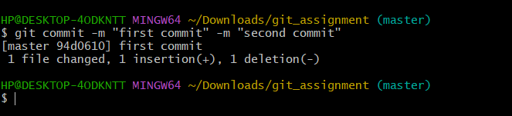

**2.How to change commit Message**

Ans: # Edit hello.py and main.py

git add hello.py

git commit -m “commit change”

# Realize you forgot to add the changes from main.py

git add main.py

git commit --amend --no-edit

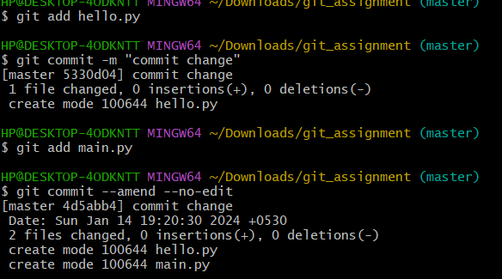

**3.How to get my code back if I do git stash**

Git stash study whole

Ans: git stash apply stash@{0}

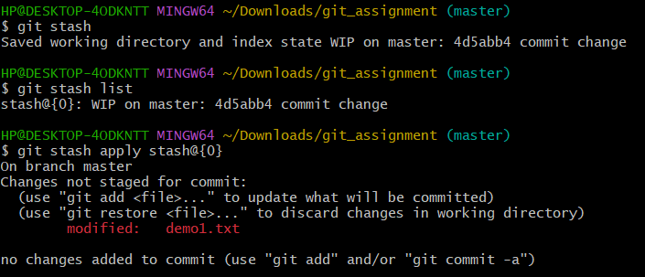

git stash pop stash@{1} 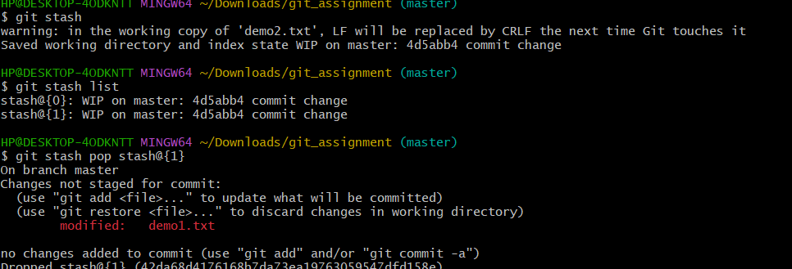

permenantly destroy stash@{1} when check with git command git stash list

