Foundations of Programming

Assignment No. : 06
PROBLEM STATEMENT:Write a C function to compute the factorial of a number with and without recursion.

OBJECTIVE:

To demonstrate two different approaches for calculating the factorial of a number: iterative (non-recursive) and recursive, showcasing the versatility of problem-solving methods in programming.

THEORY:
- Explain the difference between the iterative and recursive approaches to calculating the factorial of a number.
- What is the base case in the recursive function for computing factorials, and why is it necessary?
- How does the program handle invalid input, such as negative numbers, and why is this important?
PLATFORM: Linux

INPUT:

#include <stdio.h>
int main()
{
// Without recurssion
int n,f=1;
printf("Enter a number : ");
scanf("%d",&n);
for(int i=1;i<=n;i++)
f=f*i;
printf("%d",f);
return 0;
}

// With recursion
#include <stdio.h>
int fact(int n,int f);

int fact(int n,int f){
if (n > 0)
f=f*n;
else
return f;
return fact((n-1),(f));
}
int main()
{
int n,f=1;
printf("Enter a number : ");
scanf("%d",&n);

printf("%d",fact(n,f));
return 0;
}

OUTPUT:
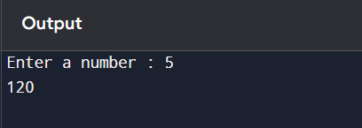
CONCLUSION: Thus, we have successfully executed factorial of a number with and without recursion.

FAQs:
1. What is the purpose of calculating factorial in programming?
2. What is the difference between recursive and non-recursive (iterative) methods?

