CUSTOMER BEHAVIOUR
ANALYSIS
A Data Analytics Project using Python, SQL and Power BI

PREPARED BY:
SANIYA KULSUM H

1. Executive Summary
This project analyses customer purchasing behaviour using a dataset containing 3,900 customer records and 16 original fields. The workflow combines Python-based data inspection and preparation in Jupyter Notebook, storage and analytical querying in PostgreSQL, and an interactive Power BI dashboard for communicating key metrics. The analysis explores customer demographics, product categories, spending, review ratings, subscription status, discount usage, previous purchases and purchase frequency.
The dashboard reports 3.9K customers, an average review rating of 3.75, and an average purchase amount of approximately $59.76. Clothing is the largest category by revenue and sales in the displayed category charts. The dashboard also shows that approximately 27% of customers are subscribers and 73% are non-subscribers.

2. Business Problem and Objectives
Retail businesses need to understand who their customers are, what they buy, how much they spend, and which engagement mechanisms are associated with purchasing. Without a consolidated view, it is difficult to identify high-performing categories, compare customer segments, and develop targeted marketing or retention strategies.
The project objectives were to:
- Inspect and prepare the customer dataset for analysis.
- Load the prepared data into PostgreSQL and use SQL aggregations to answer business questions.
- Compare purchasing patterns across gender, product category, age group and subscription status.
- Examine discount usage, review ratings, repeat-purchase behaviour and purchase frequency.
- Build a Power BI dashboard with KPI cards, category charts, age-group comparisons and interactive filters.

3. Dataset Overview
The dataset contains 3,900 rows and 16 original columns. The fields describe customer identity and demographics, purchases, product attributes, payment behaviour and engagement.
Field group | Example columns | Analytical use
Customer profile | customer_id, age, gender, location | Demographic and geographic comparisons
Purchase details | item_purchased, category, purchase_amount | Revenue, sales and product performance
Product attributes | size, color, season | Product preference analysis
Customer feedback | review_rating | Customer satisfaction proxy
Engagement | subscription_status, discount_applied | Subscription and promotion comparisons
Purchase history | previous_purchases, frequency_of_purchases | Customer segmentation and repeat behaviour
Payment | payment_method | Payment-method distribution
Data-quality checks shown in the notebook indicate that all 3,900 rows had non-null values across the 16 original fields. The descriptive statistics show customer ages from 18 to 70, purchase amounts from $20 to $100, and review ratings from 2.5 to 5.0. The mean age is approximately 44.07 years, mean purchase amount is $59.76, mean review rating is 3.75, and mean previous purchases is 25.35.

4. Tools and Workflow

4.1 Python and Jupyter Notebook
- Used Pandas to inspect the dataset with info(), describe(include='all') and isnull().sum().
- Standardised column names to lowercase snake_case and renamed purchase_amount_(usd) to purchase_amount.
- Created age_group categories using pandas.qcut with four labels: Young Adults, Adult, Middle-Aged and Senior.
- Mapped purchase-frequency labels to approximate day intervals, for example Weekly = 7, Fortnightly/Bi-Weekly = 14, Monthly = 30, Quarterly/Every 3 Months = 90 and Annually = 365.
- Loaded the cleaned DataFrame into PostgreSQL using SQLAlchemy and the PostgreSQL driver.
Data-preparation note: the frequency mapping is an analytical assumption, not a measured date interval. It should be documented and checked for consistent source labels before it is used in further modelling.

4.2 PostgreSQL and SQL
The prepared data was loaded into the customer table in the customer_behaviour database. SQL was then used to aggregate records and answer questions relevant to retail performance.
- Total revenue by gender using SUM(purchase_amount) grouped by gender.
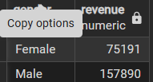
- Customers who used a discount and whose purchase amount was above the overall average.
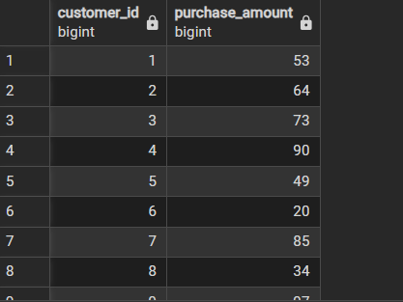
- Top five products by average review rating.
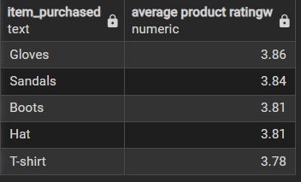
- Customer count, average spend and total revenue by subscription status.
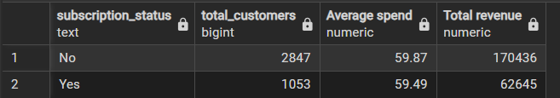
- Top five products by the percentage of purchases with discounts applied.
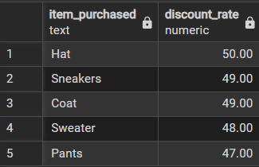
- Customer segmentation into New, Returning and Loyal groups using previous_purchases.
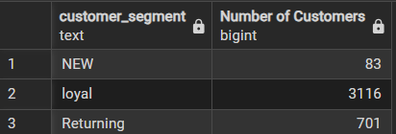
SQL logic review: the query intended to find customers who used a discount and spent above average should combine both conditions with AND, not OR, if both conditions must be true. A suitable pattern is:
WHERE discount_applied = 'Yes'
AND purchase_amount > (SELECT AVG(purchase_amount) FROM customer);
Also verify that the source column names and text values match the SQL table exactly. For product-level discount rates, use a consistent denominator and handle any null or unexpected discount labels.

4.3 Power BI Dashboard
The dashboard combines KPI cards, a subscription-status donut chart, revenue and sales by category, and revenue/sales by age group. Slicers allow users to filter by subscription status, gender, category and location. This gives a high-level overview while supporting interactive exploration of customer segments.
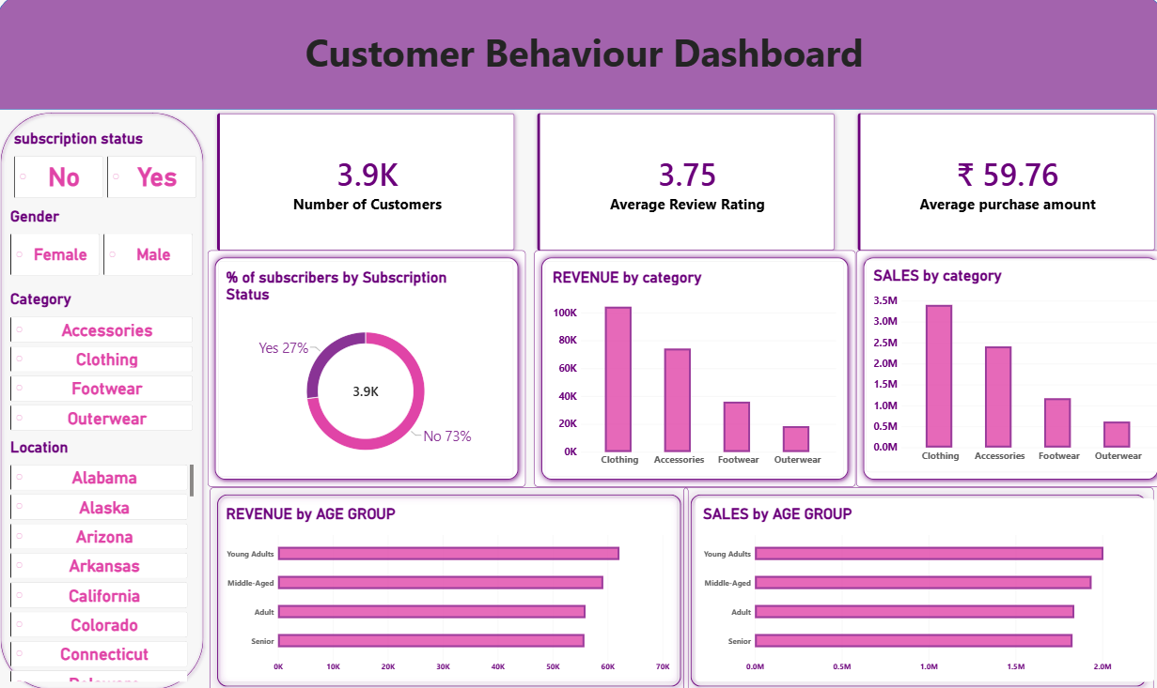
Figure 1. Customer Behaviour Dashboard created in Power BI.

5. Key Findings
- Dataset coverage: The analysis covers 3,900 customer records, with no missing values reported in the displayed null-count check.
- Average transaction value: The mean purchase amount is approximately $59.76; the median is $60. The middle 50% of purchase amounts range from $39 to $81.
- Customer ratings: The average review rating is approximately 3.75 out of 5, suggesting generally moderate-to-positive ratings in this dataset.
- Category performance: Clothing is the leading category in the dashboard's revenue and sales charts, followed by Accessories, Footwear and Outerwear.
- Subscription mix: The dashboard indicates roughly 27% subscribers and 73% non-subscribers. This creates an opportunity to investigate subscription conversion and retention.
- Age-group comparisons: The dashboard compares revenue and sales across four age groups. The displayed values are relatively close, so segment-level differences should be quantified before making strong claims.
Important interpretation limitation: the screenshots show chart shapes and rounded KPI values, but not the complete underlying result tables. Accordingly, this report does not invent exact category totals, gender revenue values, subscriber average spend, or the names/rankings of the top five products. Those should be inserted after exporting the corresponding SQL query outputs.

6. Business Recommendations
- Prioritise the leading category: Review Clothing's margin, inventory availability, returns and product-level performance. High revenue alone does not guarantee high profitability.
- Test subscription offers: Since non-subscribers form the larger group, test a clearly defined subscription benefit and measure conversion, repeat purchase rate and customer lifetime value.
- Personalise campaigns by segment: Compare category preferences and average spend by age group and gender before designing targeted campaigns. Use observed differences rather than assumptions.
- Measure promotion effectiveness: Compare discount and non-discount purchases on revenue, margin, basket value and repeat behaviour. A high discount rate may indicate promotion dependence rather than success.
- Use reviews to improve products: Investigate low-rated items and compare ratings with category, price and repeat purchasing. Prioritise recurring product or service issues.
- Develop retention measures: Use the New, Returning and Loyal segments to design onboarding, replenishment reminders and loyalty campaigns. Validate the segment thresholds with stakeholders.
- Improve dashboard usability: Add a date or reporting-period filter if dates become available, plus explicit total revenue, subscriber count, category share and average spend by subscription status.

7. Limitations and Quality Considerations
- The available dataset fields shown do not include a transaction date or order identifier, limiting time-series, basket-level and cohort analysis.
- The available screenshots do not expose every SQL output, so some questions are described as analysis performed rather than reported with exact numeric results.
- The New/Returning/Loyal segmentation uses previous_purchases = 1, 2–10 and greater than 10. These thresholds are project-defined and should be validated.
- The age groups created by qcut are quantile-based groups; their boundaries can change if the dataset changes.
- The frequency-to-days mapping approximates labels and needs validation for spelling variants and business meaning.
- The dashboard displays rounded figures (for example, 3.9K). Exact values should be verified against the model or source table before publication.

8. Conclusion
This project demonstrates an end-to-end analytics workflow: data inspection and preparation with Python, business-focused querying with SQL, and visual storytelling with Power BI. The current dashboard highlights category performance, customer ratings, average spend and subscription mix. The next step is to add verified SQL result tables and additional measures such as conversion rate, repeat-purchase rate, discount uplift and customer lifetime value where the available data supports them. These additions would make the project more actionable for retail decision-makers.

