**Assignment 06**

**Create Hello World Spring Boot Web application**

Step 1: Create Spring Boot Project Using Spring Initializer Go to: [https://start.spring.io](https://start.spring.io/)

Select following options:

* **Project**: Maven
* **Language**: Java
* **Spring Boot**: Choose latest stable version
* **Group**: com.example
* **Artifact**: helloworld
* **Name**: helloworld
* **Description**: Hello World Spring Boot Web App
* **Packaging**: Jar
* **Java**: 17+

**Dependencies:** Spring Web

Click **"Generate"** → Extract the zip → Open in Eclipse IDE as **Maven project**.

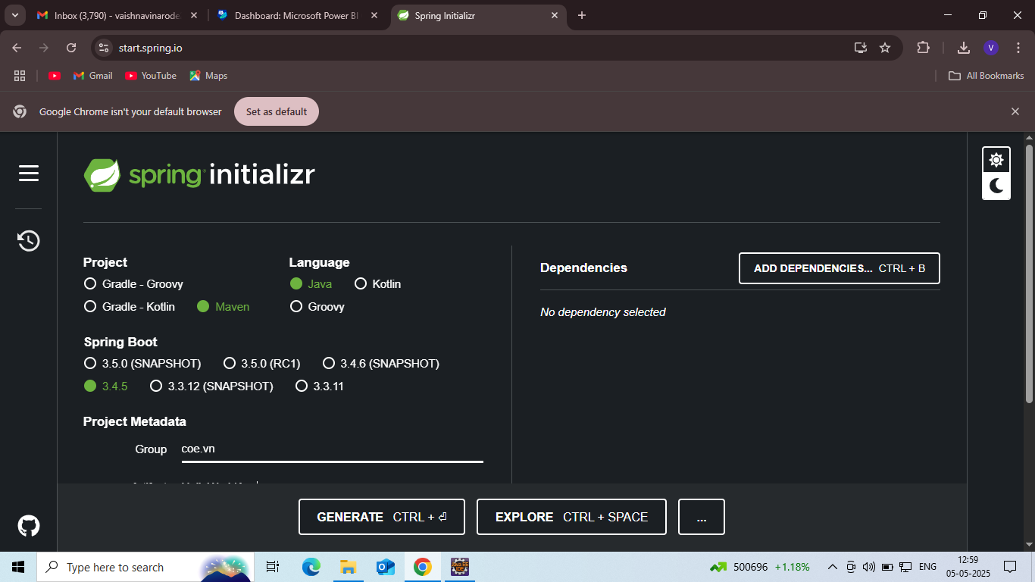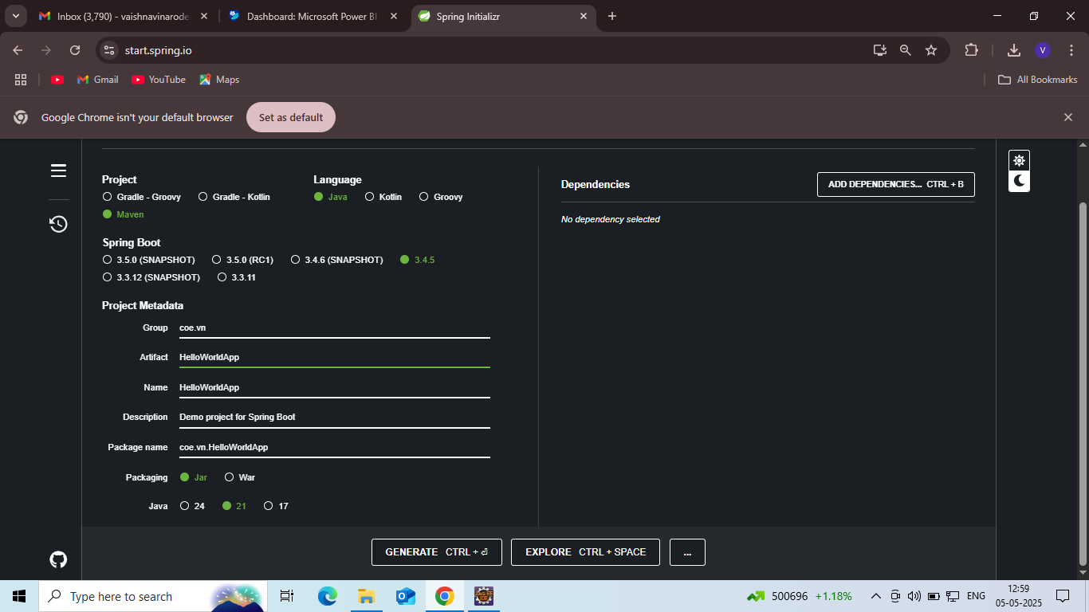

Step2: Add dependencies Spring Web and click on Generate button. The project will get generated and downloaded the project

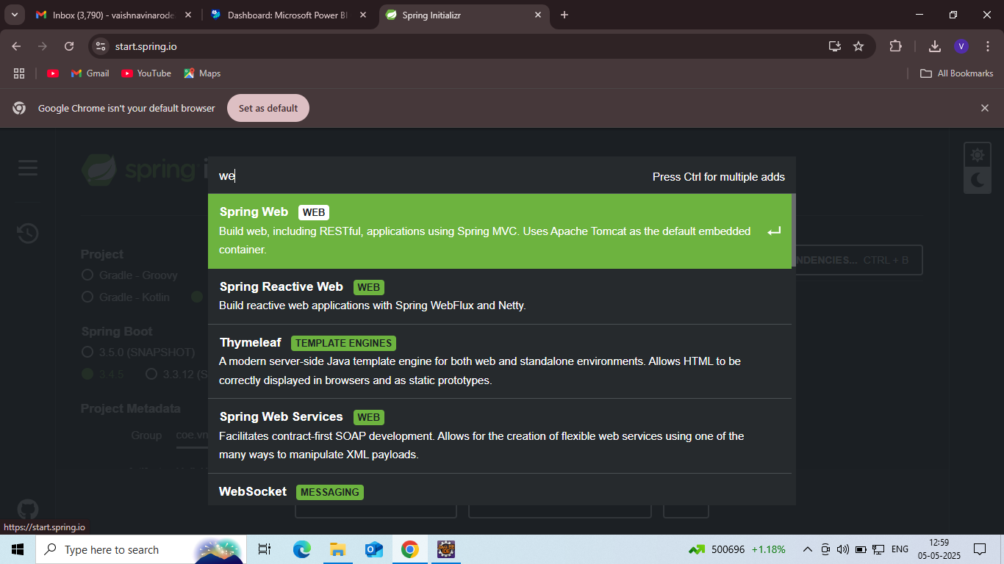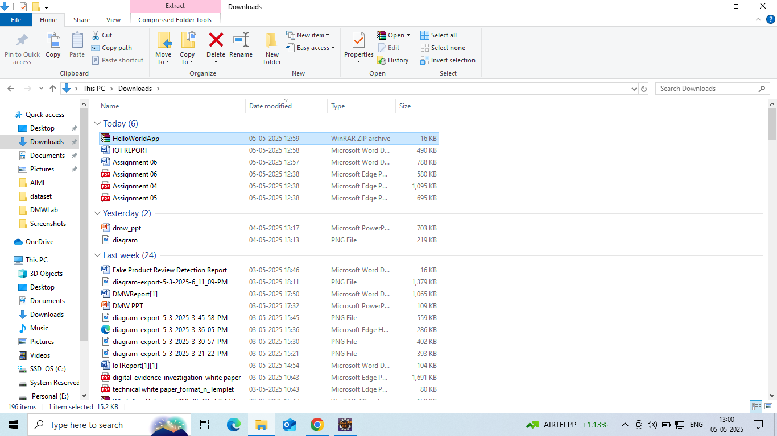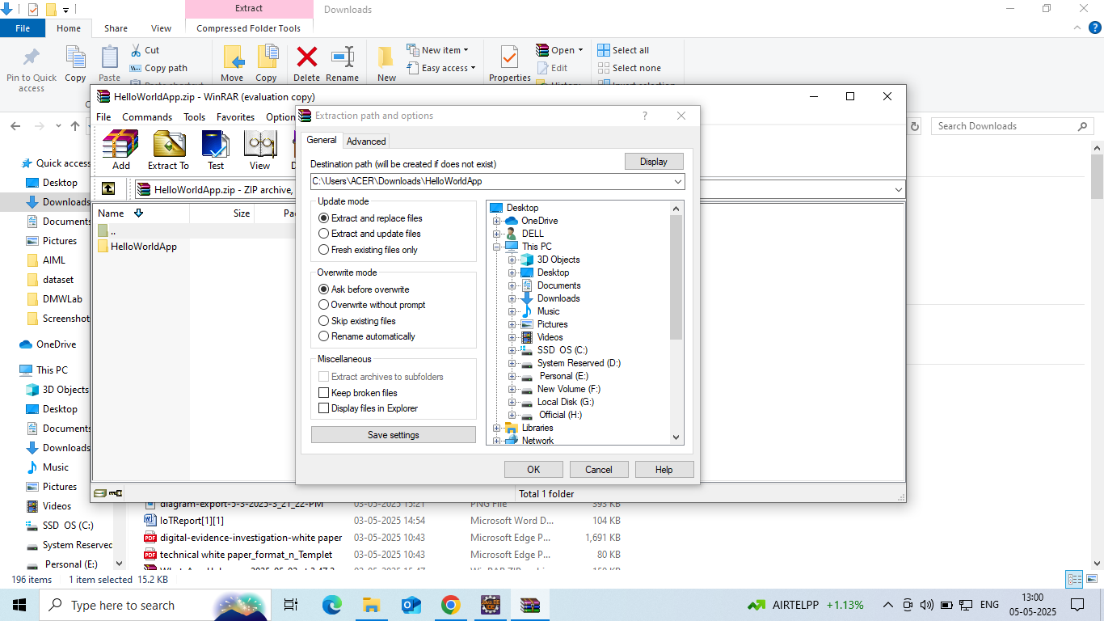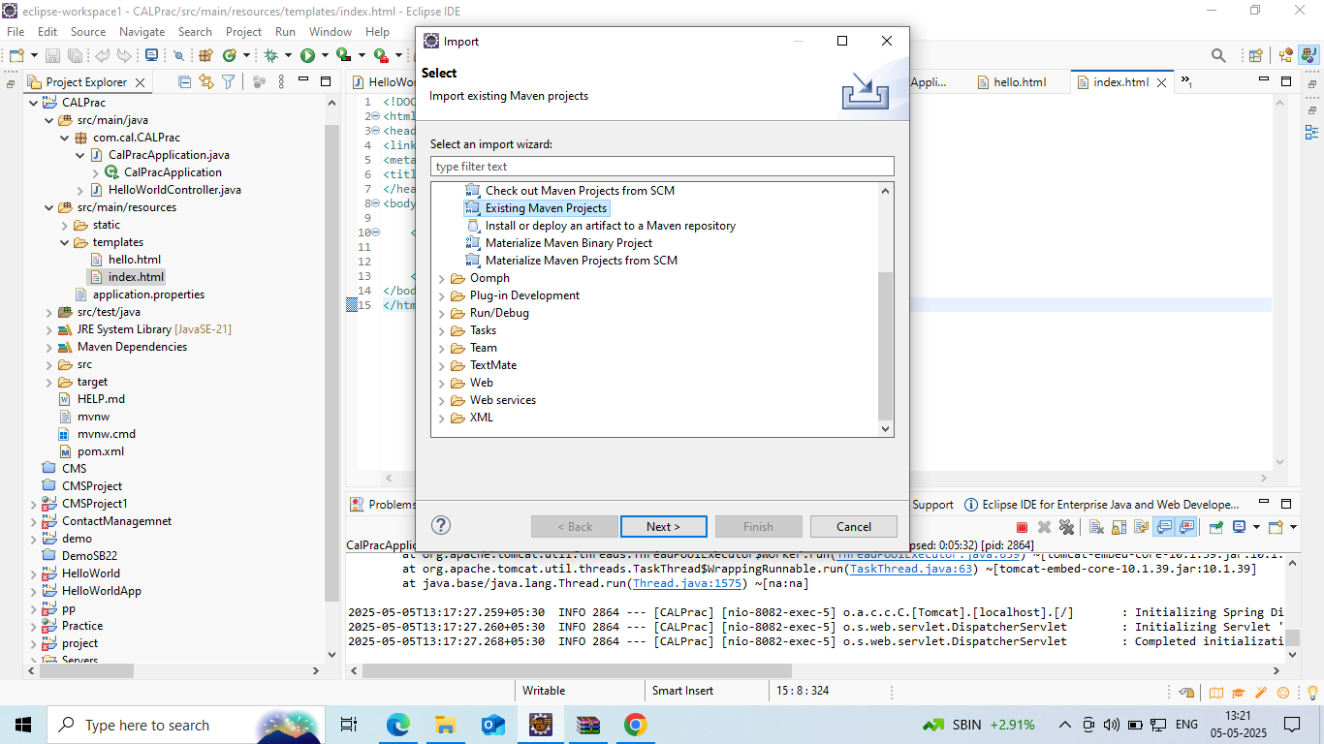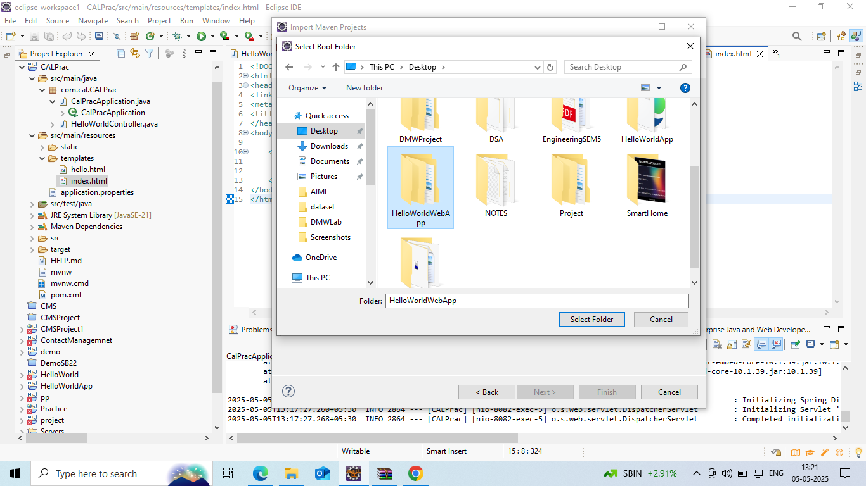

Step 3: Extract the downloaded file and open it in Eclipse IDE as Import external maven project

Step 4: After opening the project add required dependencies in pom.xml file

<?xml version="1.0" encoding="UTF-8"?>

<project xmlns="<http://maven.apache.org/POM/4.0.0>" xmlns:xsi="<http://www.w3.org/2001/XMLSchema-instance>" xsi:schemaLocation="<http://maven.apache.org/POM/4.0.0> <http://maven.apache.org/xsd/maven-4.0.0.xsd>">

<modelVersion>4.0.0</modelVersion>

<parent>

<groupId>org.springframework.boot</groupId>

<artifactId>spring-boot-starter-parent</artifactId>

<version>3.4.4</version>

<relativePath/> <!-- lookup parent from repository -->

</parent>

<groupId>com.ks</groupId>

<artifactId>SampleSpringProjectApplication</artifactId>

<version>0.0.1-SNAPSHOT</version>

<name>SampleSpringProjectApplication</name>

<description>Demo project for Spring Boot</description>

<url/>

<licenses>

<license/>

</licenses>

<developers>

<developer/>

</developers>

<scm>

<connection/>

<developerConnection/>

<tag/>

<url/>

</scm>

<properties>

<java.version>21</java.version>

</properties>

<dependencies>

<dependency>

<groupId>org.springframework.boot</groupId>

<artifactId>spring-boot-starter-web</artifactId>

</dependency>

<dependency>

<groupId>org.springframework.boot</groupId>

<artifactId>spring-boot-starter-test</artifactId>

<scope>test</scope>

</dependency>

<dependency>

<groupId>org.springframework.boot</groupId>

<artifactId>spring-boot-starter-data-jpa</artifactId>

</dependency>

<dependency>

<groupId>com.mysql</groupId>

<artifactId>mysql-connector-j</artifactId>

<scope>runtime</scope>

</dependency>

</dependencies>

<build>

<plugins>

<plugin>

<groupId>org.springframework.boot</groupId>

<artifactId>spring-boot-maven-plugin</artifactId>

</plugin>

</plugins>

</build>

</project>

Step 5: Now create one java file in src folder named as SampleSpringProjectApplication

package com.ks.SampleSpringProjectApplication;

import org.springframework.boot.SpringApplication;

import org.springframework.boot.autoconfigure.SpringBootApplication;

import org.springframework.boot.autoconfigure.jdbc.DataSourceAutoConfiguration;

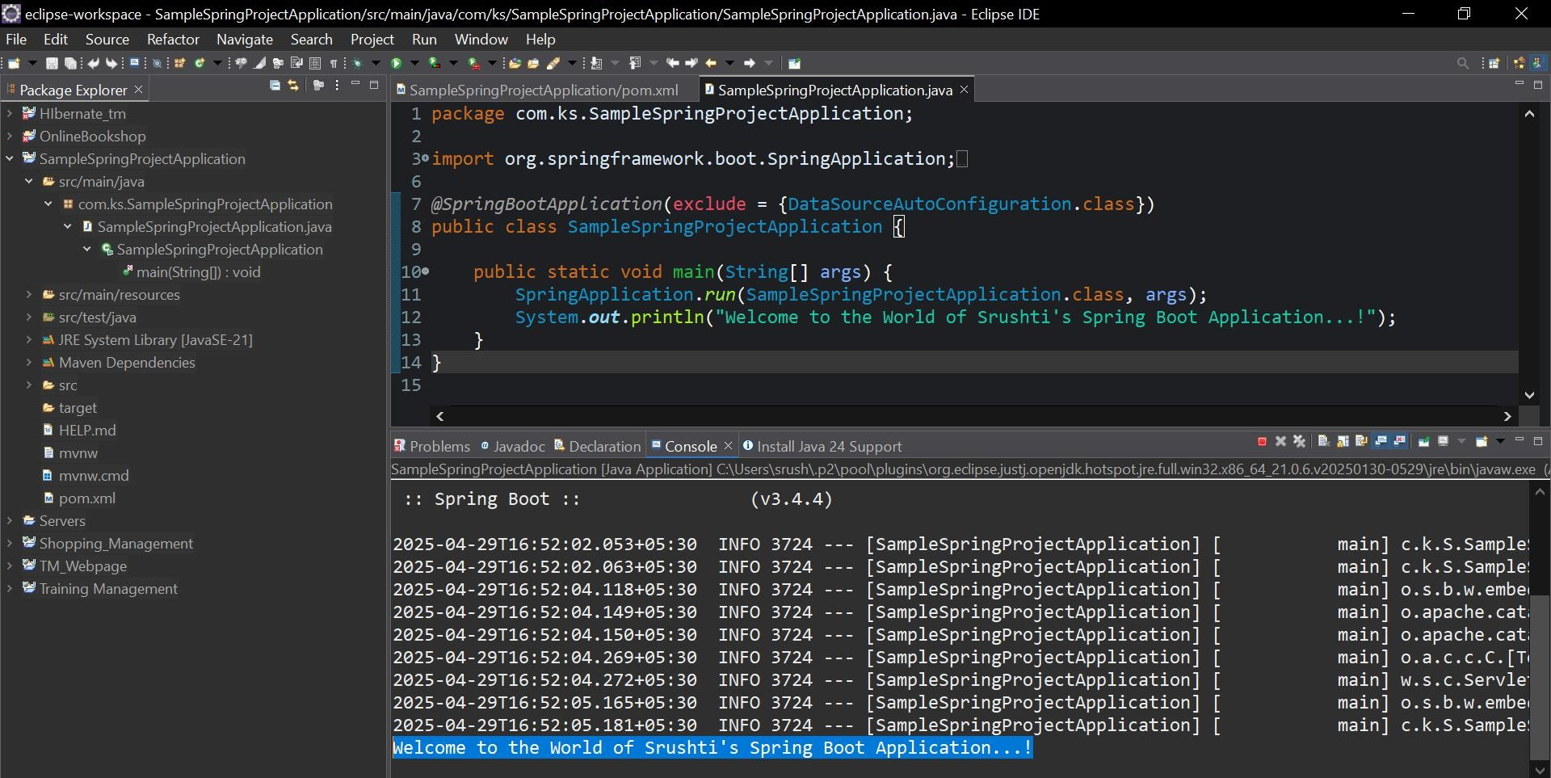@SpringBootApplication(exclude = {DataSourceAutoConfiguration.class}) public class SampleSpringProjectApplication {

public static void main(String[] args) { SpringApplication.run(SampleSpringProjectApplication.class, args); System.out.println("Welcome to the World of Srushti's Spring Boot

Application...!");

}

}

Step 6: Run the Code by right clicking on Run as Java Application