NXT Studio
IOT Data Analytics Internship
Week 9 Report

Submitted By
Name: Saniya Syed
Course: B.Tech CSE (INTERNET OF Internship)
Collage: Jain (Deemed-to-be University)

Submitted To
NXT Studio

Internship Duration
12 Weeks

Report
Week 9 - Time-Series Analysis and Forecasting

Table of Contents
- Introduction
- Objective
- Dataset Description
- Tools and Libraries Used
- Methodology
  - 5.1 Data Loading
  - 5.2 Data Preprocessing
  - 5.3 Moving Average
  - 5.4 Trend Analysis
  - 5.5 Forecasting using Linear Regression
- Results and Visualizations
  - Temperature with 7-Day Moving Average
  - Temperature Trend Over Time
  - Temperature Forecast using Linear Regression
- Observations
- Conclusion

1. Introduction
Time-series analysis is used to study data collected over a period of time. In IoT systems, sensor readings such as temperature and humidity are continuously recorded. Analyzing these readings helps identify trends, smooth fluctuations, and forecast future values. In this project, moving average, trend analysis, and Linear Regression were used to analyze and predict temperature values.

2. Objective
The objective of this project is to analyze IoT sensor data over time, identify trends using moving averages, and forecast future temperature values using a Linear Regression model.

3. Dataset Description
The dataset used in this project is Better_Dataset.csv, which contains IoT sensor readings collected over time.
Dataset Features:
- date – Date and time of the sensor reading.
- temperature – Recorded temperature value (°C).
- humidity – Recorded humidity value (%).
- verdict – Sensor status label.
The dataset contains 2311 records without missing values.
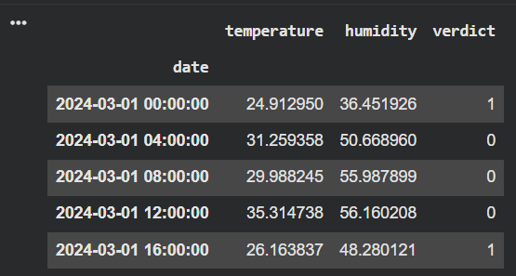
Figure 1: Dataset Preview
Explanation
The first five records of the IoT sensor dataset are displayed after setting the date column as the index. The dataset contains temperature, humidity, and verdict values recorded at different timestamps, making it suitable for time-series analysis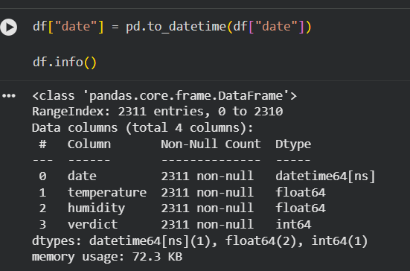
Figure 2: Dataset Information
Explanation:
The dataset contains 2311 records and 4 columns. There are no missing values, making the dataset suitable for time-series analysis.
4. Tools and Libraries Used
The implementation was carried out using Python and the following libraries:
- Python – Programming language used for implementation.
- Pandas – Used for loading, cleaning, and manipulating the dataset.
- NumPy – Used for numerical computations.
- Matplotlib – Used for plotting graphs.
- Scikit-learn – Used for implementing Linear Regression.
- Jupyter Notebook / Google Colab – Development environment.

5. Methodology

5.1 Data Loading

The IoT sensor dataset was imported into the Python environment for analysis. After loading the dataset, the first few records were examined to ensure that the data had been imported correctly and that all the required columns were available for further processing.

5.2 Data Preprocessing

Before performing the analysis, the dataset was preprocessed to prepare it for time-series analysis. The date column was converted into a proper date and time format, allowing the dataset to be organized chronologically. The date column was then used as the index of the dataset to simplify time-based analysis. Dataset information and statistical summaries were also examined to understand the data structure and identify the range of values in each feature.
5.3 Moving Average Analysis
A 7-day moving average was calculated to smooth short-term fluctuations in the temperature readings. This method reduces random noise in the data and highlights the long-term trend, making it easier to observe overall temperature variations throughout the observation period.
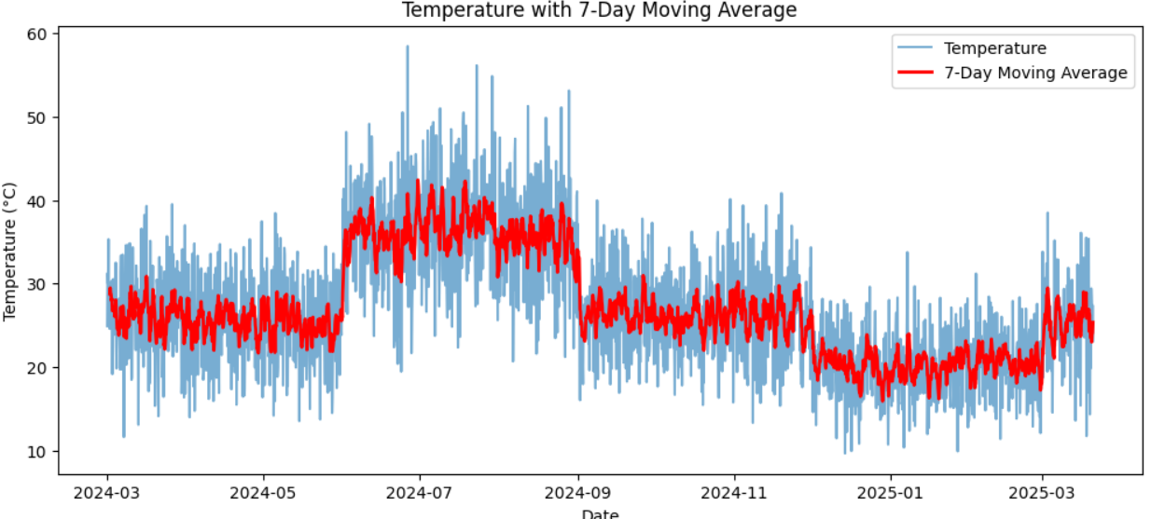
Figure 3: Temperature with 7-Day Moving Average
Explanation
The graph compares the original temperature values with the calculated 7-day moving average. The moving average smooths sudden fluctuations and clearly highlights the long-term temperature trend, making seasonal variations easier to observe.
5.4 Trend Analysis
Trend analysis was performed to study how temperature changed over time. By plotting the temperature values against the observation period, it became possible to identify periods of increasing and decreasing temperature as well as seasonal variations in the sensor readings.
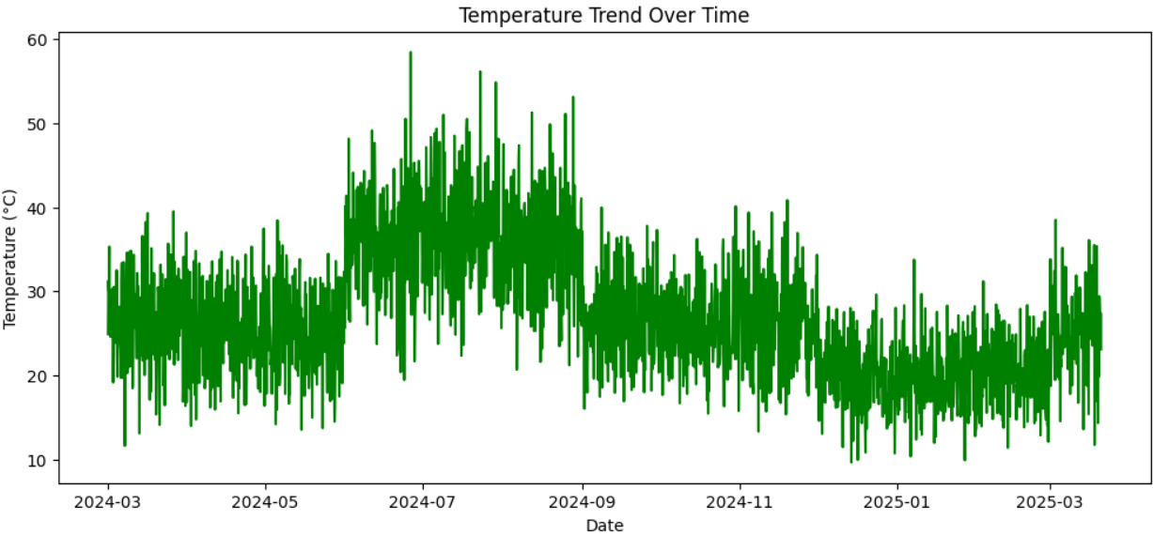
Figure 4: Temperature Trend Over Time
Explanation
The graph illustrates the variation in temperature throughout the observation period. It clearly shows
seasonal changes and overall trends in the sensor data, helping to understand the behavior of the monitored environment.
5.5 Forecasting using Linear Regression
A Linear Regression model was developed to forecast temperature values based on historical observations. The model generated a trend line representing the predicted temperature over time, providing a simple approach for estimating future temperature behavior.
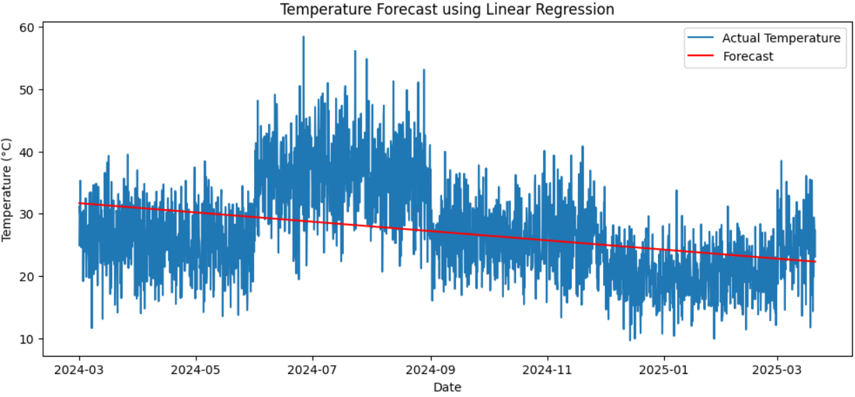
Figure 5: Temperature Forecast using Linear Regression
Explanation
The graph compares the actual temperature values with the predicted trend generated by the Linear Regression model. The forecast line represents the overall direction of temperature changes and demonstrates how machine learning can be applied for basic time-series forecasting in IoT applications.
6. Results and Visualizations
The Moving Average successfully reduced short-term fluctuations in the temperature readings, making long-term trends easier to interpret.
Trend Analysis showed that temperature varied across different months, indicating seasonal behavior.
The Linear Regression model generated a forecast line that closely followed the overall direction of the temperature data. Although Linear Regression is a simple forecasting technique, it effectively demonstrates how future sensor values can be estimated using historical observations.
The visualizations provide valuable insights into temperature behavior and help understand how forecasting techniques can support IoT monitoring systems.
7. Observations
- The dataset contains continuous temperature readings collected over time.
- No missing values were found in the dataset.
- The Date column was successfully converted into datetime format.
- The 7-Day Moving Average reduced short-term fluctuations.
- Trend Analysis revealed noticeable seasonal variations.
- Linear Regression generated a simple forecast based on historical data.
- The forecast line captured the overall temperature trend effectively.
- Time-series analysis provides useful insights for IoT monitoring and predictive maintenance applications.
8.conclusion
This project successfully demonstrated Time-Series Analysis and Forecasting using an IoT sensor dataset.
The dataset was preprocessed and analyzed using various visualization techniques. Moving Average analysis effectively smoothed noisy sensor readings, while Trend Analysis highlighted seasonal changes in temperature over time. A Linear Regression model was implemented to forecast future temperature values based on historical observations.
The results show that time-series analysis is a powerful technique for understanding IoT sensor behavior and making future predictions. These methods can assist in smart monitoring systems, predictive maintenance, environmental analysis, and intelligent decision-making. Overall, the project provided practical experience in applying time-series forecasting techniques to real-world IoT data.

