NXT Studio
IOT Data Analytics Internship
Week 5 Report
_________________________________________________
Submitted By
Name: Saniya Syed
Course: B.Tech CSE ( INTERNET OF THINGS)
Collage: Jain (Deemed-to-be University)
______________________________________________________
Submitted To
NXT Studio
______________________________________________________
Internship Duration
12 weeks
______________________________________________________
Report
Week 5 - Exploratory Data Analysis (EDA) on IoT Sensor Dataset

Table of Contents
- Objective
- Dataset Description
- Dataset Preview (df.head())
- Dataset Information (df.info())
- Statistical Summary (df.describe())
- Missing Value Analysis
- Correlation Analysis (Heatmap)
- Histogram Analysis
- Box Plot Analysis
10. Scatter Plot Analysis
11. Time-Series Analysis (Temperature Over Time)
12. Temperature & Humidity Analysis
13. Insights
14. Conclusion

1. Objective
The objective of this experiment is to perform Exploratory Data Analysis (EDA) on the IoT sensor dataset. The analysis aims to understand the dataset structure, examine the statistical properties of the data, identify missing values, analyze relationships between variables, and visualize sensor behavior using different graphs such as heatmaps, histograms, box plots, scatter plots, and time-series plots. This analysis helps in gaining meaningful insights and preparing the dataset for further machine learning applications.

2. Dataset Description
The dataset used for this analysis is an IoT Sensor Dataset containing environmental sensor readings collected over time. It consists of 2311 records and 4 columns:
- Date – The date on which the sensor reading was recorded.
- Temperature – The recorded temperature in degrees Celsius (°C).
- Humidity – The recorded humidity percentage (%).
- Verdict – A binary value indicating the sensor status or classification.
The dataset is clean and complete, with no missing values, making it suitable for Exploratory Data Analysis (EDA) and further machine learning applications.

3. Dataset Preview (df.head())
The df.head() function displays the first five rows of the dataset, providing a quick overview of its structure and contents. It helps verify that the dataset has been loaded successfully and shows the column names along with sample values for each attribute. The dataset contains four columns: date, temperature, humidity, and verdict.
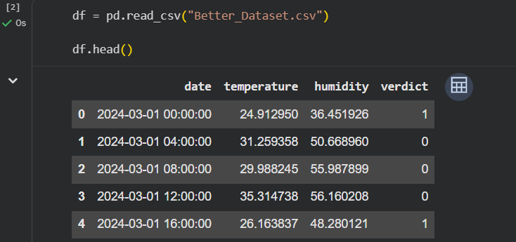

Figure 1: Preview of the first five rows of the IoT sensor dataset.

4. Dataset Information (df.info())
The df.info() function provides detailed information about the dataset, including the total number of rows and columns, the names of each column, their data types, and the number of non-null values. This helps verify the dataset's structure and confirms whether there are any missing values.
From the output, the dataset contains 2311 entries and 4 columns. The columns include date, temperature, humidity, and verdict. The date column is of object data type, while temperature and humidity are floating-point (float64) values, and verdict is an integer (int64). All columns contain 2311 non-null values, indicating that the dataset is complete.
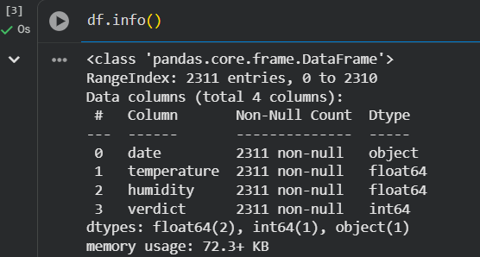

Figure 2: Dataset information showing the number of records, column names, data types, and non-null values.
5. Statistical Summary (df.describe())
The df.describe() function generates a statistical summary of the numerical columns in the dataset. It provides important statistical measures such as the count, mean, standard deviation, minimum, maximum, and quartile values (25%, 50%, and 75%). These statistics help in understanding the distribution and spread of the data.
The statistical summary shows that the dataset contains 2311 sensor readings. The average temperature is approximately 27°C, while the average humidity is around 53%. The summary also indicates the range of values for each numerical attribute, providing a clear understanding of the dataset before further analysis.
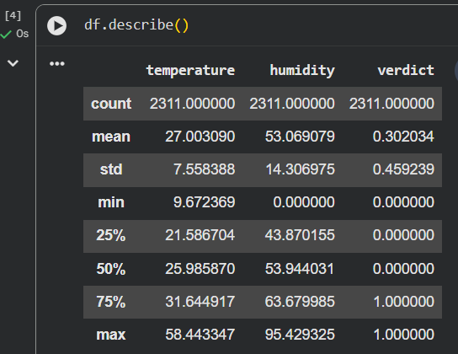

Figure 3: Statistical summary of the numerical attributes in the IoT sensor dataset.
6. Missing Value Analysis
The df.isnull().sum() function is used to identify missing or null values in each column of the dataset. Missing value analysis is an important step in Exploratory Data Analysis (EDA) because it helps determine the quality and completeness of the dataset before performing further analysis.
The output shows that all columns contain 0 missing values, which means the dataset is complete and does not require any data cleaning or imputation. This ensures that the dataset is reliable for visualization, statistical analysis, and machine learning tasks.
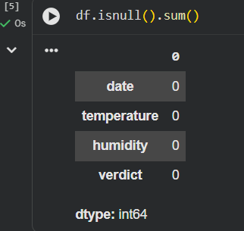

Figure 4: Missing value analysis showing that there are no missing values in the dataset.
7.Correlation Analysis (Heatmap)
The correlation heatmap is used to measure the relationship between numerical variables in the dataset. Correlation values range from -1 to +1, where +1 indicates a strong positive relationship, -1 indicates a strong negative relationship, and 0 indicates no significant relationship.
The heatmap shows that temperature and humidity have a moderate negative correlation of -0.61, indicating that humidity generally decreases as temperature increases. The verdict column has a very weak correlation with both temperature and humidity, suggesting that it is not strongly influenced by these variables. 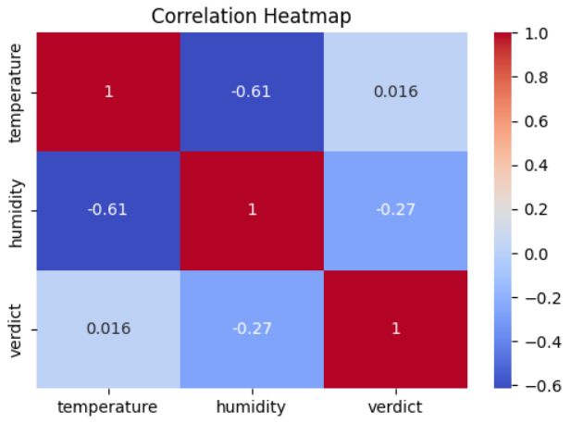
Figure 5: Correlation heatmap showing the relationship between temperature, humidity, and verdict.

8. Histogram Analysis
A histogram is used to visualize the distribution of numerical data. It helps identify the frequency of values, the overall shape of the data, and any skewness or unusual patterns.
The histogram shows that temperature values are mainly concentrated between 20°C and 35°C, while humidity values are mostly distributed between 40% and 70%. The verdict column contains more 0 values than 1 values, indicating that one class appears more frequently in the dataset.
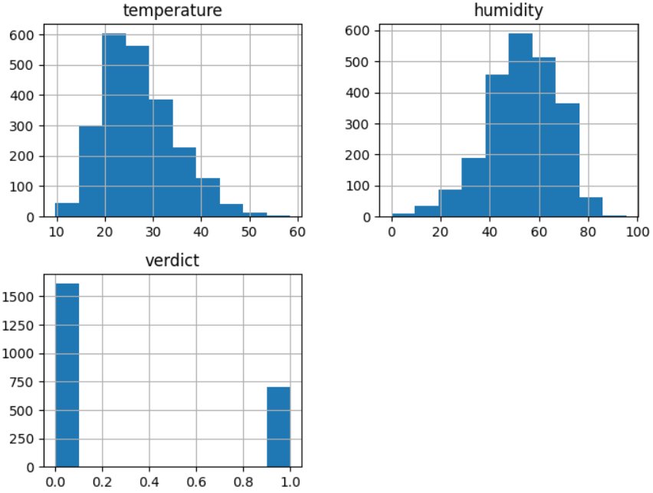
Figure 6: Histogram showing the distribution of temperature, humidity, and verdict values.
9. Box Plot Analysis
A box plot is used to visualize the distribution of numerical data and identify the presence of outliers. It displays the minimum, first quartile (Q1), median, third quartile (Q3), and maximum values of the dataset.
The box plot shows that most temperature and humidity readings are concentrated within a normal range. A few outliers are present, which are common in real-world IoT sensor data. These outliers may represent unusual environmental conditions or sensor variations.
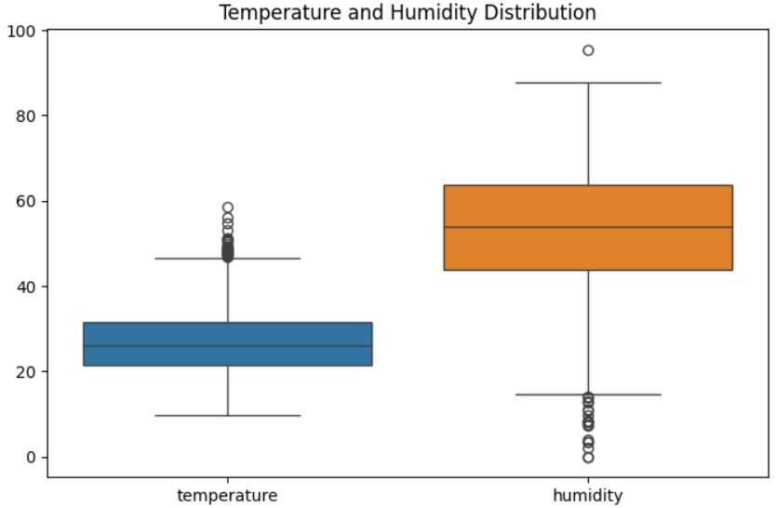

Figure 7: Box plot showing the distribution of temperature and humidity values.
10. Scatter Plot Analysis
A scatter plot is used to examine the relationship between two numerical variables. It helps identify trends, patterns, and correlations within the dataset.
The scatter plot shows a negative relationship between temperature and humidity. As the temperature increases, the humidity generally decreases. This observation supports the findings from the correlation heatmap.
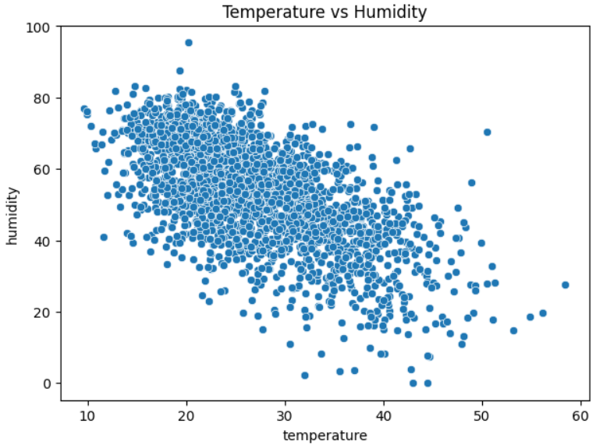

Figure 8: Scatter plot showing the relationship between temperature and humidity.
11. Time-Series Analysis
Time-series analysis is performed to observe how temperature changes over time. It helps identify trends, seasonal variations, and fluctuations in the sensor readings.
The graph shows that the temperature changes continuously over time with normal fluctuations. There are no sudden abnormal spikes or long periods of missing data, indicating consistent sensor readings.
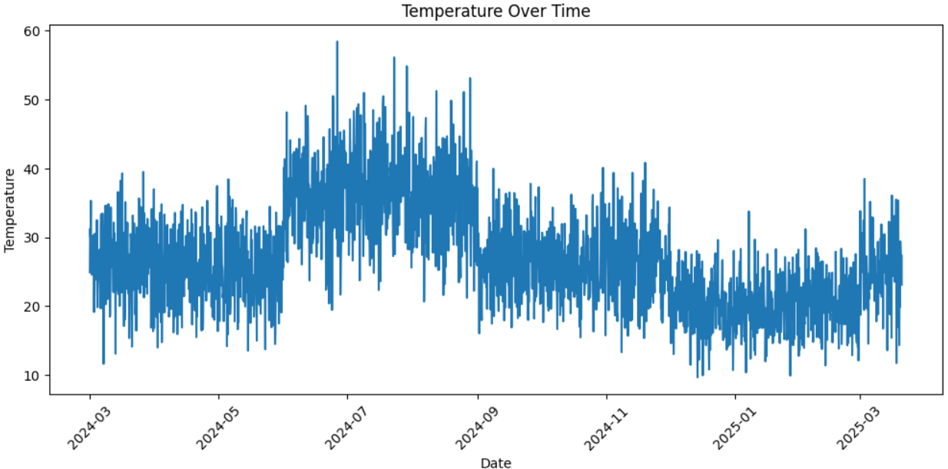

Figure 9: Temperature variation over time.
12. Temperature & Humidity Analysis
The combined time-series graph displays both temperature and humidity over the same time period. This comparison helps understand how the two variables change together.
The graph shows that temperature and humidity vary over time. Generally, when the temperature increases, the humidity decreases, demonstrating a moderate negative relationship between the two variables.
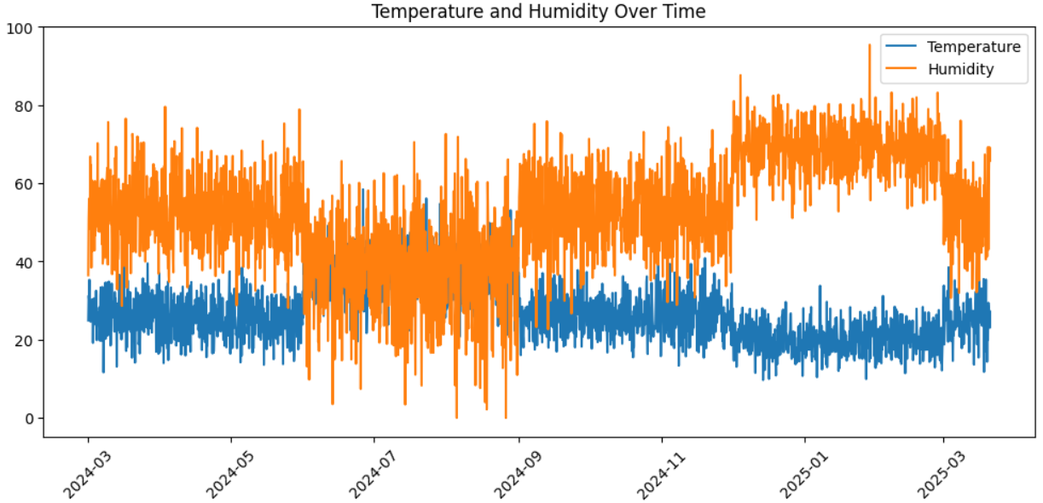

Figure 10: Combined temperature and humidity variation over time.
13. Insights
- The dataset contains 2311 IoT sensor records.
- The dataset has no missing values, indicating good data quality.
- Temperature and humidity show a moderate negative correlation (-0.61).
- Temperature values are mostly between 20°C and 35°C.
- Humidity values are mainly between 40% and 70%.
- A few outliers are present in the data, which is expected in real-world sensor datasets.
- Time-series analysis shows normal fluctuations in sensor readings over time.
- The dataset is suitable for further machine learning and predictive analysis.

14. Conclusion
Exploratory Data Analysis (EDA) was successfully performed on the IoT sensor dataset. The dataset was found to be clean, complete, and free of missing values. Statistical analysis and visualizations provided valuable insights into the distribution and relationship of the sensor data. The heatmap and scatter plot revealed a moderate negative correlation between temperature and humidity, while the time-series analysis showed normal fluctuations over time. Overall, the dataset is well-prepared for further machine learning, predictive analytics, and IoT-based applications.

