NXT Studio
IOT Data Analytics Internship
Week 7 Report

Submitted By
Name: Saniya Syed
Course: B.Tech CSE (INTERNET OF THINGS)
Collage: Jain (Deemed-to-be University)

Submitted To
NXT Studio

Internship Duration
12 Weeks

Report
Week 7 Anomaly Detection in IoT Data

Table of Contents
1. Objective
2. Dataset Description
3. Threshold-Based Detection
4. Threshold Detection Results
5. Isolation Forest
6. Isolation Forest Results
7. Local Outlier Factor (LOF)
8. LOF Results
9. Comparison of Methods
10. Observations
11. Conclusion

Objective
The objective of this experiment is to detect unusual sensor behavior in an IoT dataset using different anomaly detection techniques. Three methods—Threshold-Based Detection, Isolation Forest, and Local Outlier Factor (LOF)—are applied to identify abnormal sensor readings and compare their performance.

Dataset Description
The dataset used in this experiment is an IoT sensor dataset containing 2311 sensor records. It includes the following columns:
- Date
- Temperature
- Humidity
- Verdict
The dataset records environmental sensor readings over time and is used to identify abnormal or unusual observations using anomaly detection algorithms.

Threshold-Based Detection
Threshold-Based Detection is a simple anomaly detection technique where predefined limits are used to identify abnormal values. In this experiment, temperature values below 15°C or above 40°C are considered anomalies.
Explanation:
The Threshold-Based Detection method identified 2105 normal sensor readings and 206 anomalous readings based on predefined temperature limits.

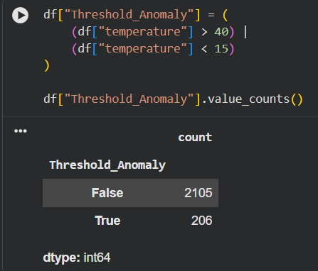
Figure 1: Threshold-Based Anomaly Detection Results
Explanation:
The scatter plot displays normal sensor readings in blue and anomalous readings in red, making it easy to identify unusual temperature values over time.
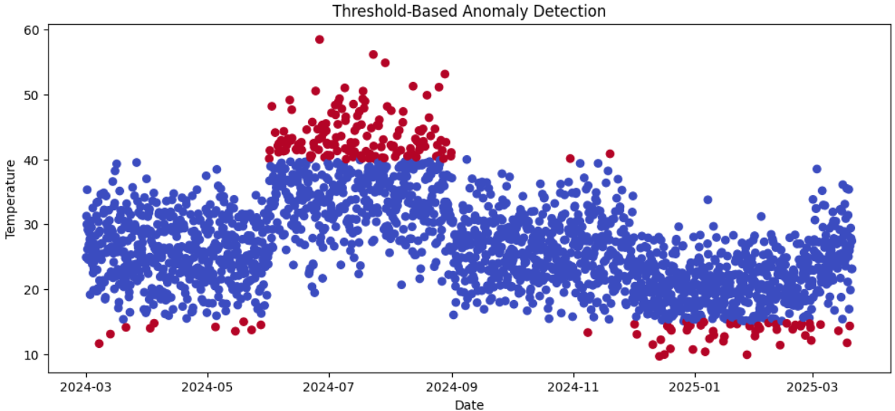Figure 2: Threshold-Based Anomaly Detection Visualization.

Isolation Forest
Isolation Forest is an unsupervised machine learning algorithm that detects anomalies by isolating unusual observations. It identifies data points that differ significantly from the majority of the dataset.
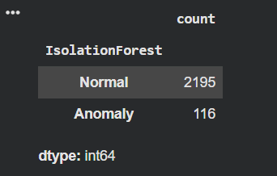
Figure 3: Isolation Forest Detection Results
Explanation:
The Isolation Forest algorithm identified 2195 normal sensor readings and 116 anomalous readings by analyzing the overall data distribution.

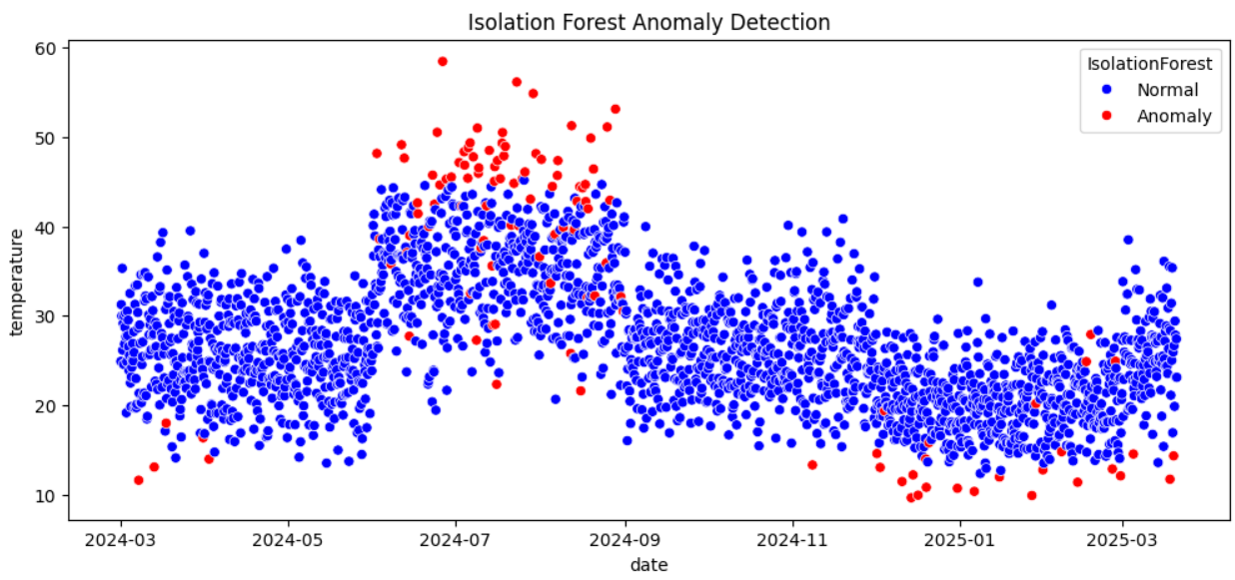
Figure 4: Isolation Forest Anomaly Detection Visualization
Explanation:
The scatter plot highlights normal sensor readings in blue and detected anomalies in red, showing the abnormal temperature values identified by the Isolation Forest algorithm.

Local Outlier Factor (LOF)
Local Outlier Factor (LOF) is an unsupervised anomaly detection algorithm that identifies abnormal data points by comparing the local density of each observation with that of its neighboring points. Points with significantly lower density are classified as anomalies.
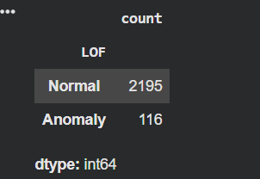
Figure 5: Local Outlier Factor (LOF) Detection Results
Explanation:
The LOF algorithm identified 2195 normal sensor readings and 116 anomalous readings by analyzing the local density of the dataset.
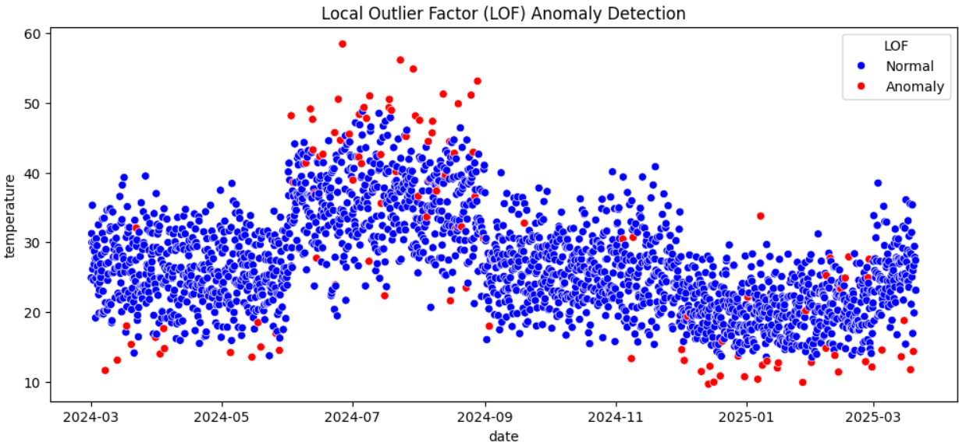
Figure 6: Local Outlier Factor (LOF) Anomaly Detection Visualization
Explanation:
The scatter plot displays the anomaly detection results using the LOF algorithm. Blue points represent normal sensor readings, while red points indicate anomalous readings detected based on differences in local data density.

Comparison of Anomaly Detection Methods
Method | Normal | Anomaly
Threshold-Based Detection | 2105 | 206
Isolation Forest | 2195 | 116
Local Outlier Factor (LOF) | 2195 | 116

Observations
- Threshold-Based Detection identified anomalies using predefined temperature limits (>40°C or <15°C).
- Isolation Forest detected anomalies by identifying unusual patterns in the dataset.
- Local Outlier Factor (LOF) detected anomalies based on the local density of neighboring data points.
- Isolation Forest and LOF detected fewer anomalies than the Threshold-Based method, indicating more selective and pattern-based detection.

Conclusion
This experiment successfully applied three anomaly detection techniques to an IoT sensor dataset. Threshold-Based Detection used fixed temperature limits, while Isolation Forest and Local Outlier Factor (LOF) used machine learning algorithms to identify unusual sensor behavior. The analysis demonstrated that machine learning methods provide more intelligent and reliable anomaly detection, making them suitable for real-world IoT monitoring systems.

