 Q1 What does Html stands for and its purpose?

HTML stands for Hypertext Markup Language and is a language used by web browsers to interpret and represent text, images, videos, audio and other mediums for people on web pages. HTML defines the structure of a website while other technologies their appearance (CSS) and behaviour (JavaScript). "Hypertext" describes the links between pages of content on the web that you can access immediately by clicking on said link. "Markup" refers to the method by which text, images, and other content is annotated to then be displayed. Examples of the these markup elemetns include <head>, <title>, <body>, <header>, <footer>, <article>, <section>, <p>, <video>, <ul>, <ol>, <li> and many more.

HTML was first developed by physicist Tim Berners-Lee at CERN, the European Organization for Nuclear Research in 1990 when looking for a way that researchers could share documents with each other. This was the foundation of the World Wide Web. HTML allows people to create and design web pages using elements such as paragraphs, headings, links, quotes, images etc. It is not a programming language, so doesn't have a dynamic functionality, rather it helps to organize and format a page. It uses simple coding to denote how each part of the page should look. For example, you could create a paragraph by placing the relevant text within 2 tags <p> and </p>. HTML is now an official web standard which is monitored and developed by the World Wide Web Consortium (W3C)

Q2.Describe the structure of an html document?

* **DOCTYPE Declaration (`<!DOCTYPE HTML>`):**It specifies the HTML version; typically indicates [HTML5](https://www.geeksforgeeks.org/html5-introduction/).
* **<html>:**The root element that encompasses the entire HTML document structure. It serves as the parent to both the <head> and <body> tags.
* **lang attribute:** Specifies the language using the “lang” attribute (e.g., lang=”en” for English
* **<head>:**Container for metadata, title, [CSS](https://www.geeksforgeeks.org/css-syntax/), scripts, etc.
* **Content:** While not directly displayed, it serves informational and structural purposes.
* **<body>:** A body tag is used to enclose all the data which a web page has from texts to links. All the content that you see rendered in the browser is contained within this element.
* 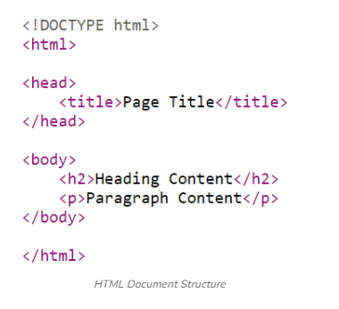

Q3 What do doctype and html lang attribute do?

All HTML documents must start with a <!DOCTYPE> declaration.The declaration is not an HTML tag. It is an "information" to the browser about what document type to expect.

<!DOCTYPE html>

The lang attribute specifies the language of the element's content.Common examples are "en" for English, "es" for Spanish, "fr" for French, and so on.

<p lang="fr">Ceci est un paragraphe.</p>

Q4 Difference between Head tag and body tag.

1. <head> contains meta-information and resources necessary for the document, while <body> contains the visible content.
2. Content in <head> is not displayed directly on the web page, whereas content in <body> is.
3. <head> includes metadata, links to stylesheets and scripts, and document title, whereas <body> includes text, images, links, and other elements that users interact with.
4. Browsers first load and parse <head> to gather necessary information before rendering the <body> content.

Q5 Can you explain the purpose of meta tags in html.

The <meta> tag defines metadata about an HTML document. Metadata is data (information) about data.<meta> tags always go inside the <head> element, and are typically used to specify character set, page description, keywords, author of the document, and viewport settings.Metadata will not be displayed on the page, but is machine parsable.Metadata is used by browsers (how to display content or reload page), search engines (keywords), and other web services.

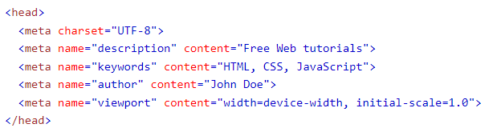

Q6 How do you link css file to html document?

CSS can be added to HTML documents in 3 ways:

* **Inline** - by using the style attribute inside HTML elements
* **Internal** - by using a <style> element in the <head> section
* **External** - by using a <link> element to link to an external CSS file

Using inline :

An inline CSS is used to apply a unique style to a single HTML element.An inline CSS uses the style attribute of an HTML element.The following example sets the text color of the <h1> element to blue, and the text color of the <p> element to red

<h1 style="color:blue;">A Blue Heading</h1>  
  
<p style="color:red;">A red paragraph.</p>

## Using Internal CSS

An internal CSS is used to define a style for a single HTML page.An internal CSS is defined in the <head> section of an HTML page, within a <style> element.The following example sets the text color of ALL the <h1> elements (on that page) to blue, and the text color of ALL the <p> elements to red. In addition, the page will be displayed with a "powderblue" background color:

<!DOCTYPE html>  
<html>  
<head>  
<style>  
body {background-color: powderblue;}  
h1   {color: blue;}  
p    {color: red;}  
</style>  
</head>  
<body>  
<h1>This is a heading</h1>  
<p>This is a paragraph.</p>  
</body>  
</html>

## **External CSS**

## An external style sheet is used to define the style for many HTML pages.To use an external style sheet, add a link to it in the <head> section of each HTML page:

<!DOCTYPE html>  
<html>  
<head>  
  <link rel="stylesheet" href="styles.css">  
</head>  
<body>  
<h1>This is a heading</h1>  
<p>This is a paragraph.</p>  
</body>  
</html>

Q7 How do you link JavaScript to html?

The src attribute specifies the URL of an external script file.If you want to run the same JavaScript on several pages in a web site, you should create an external JavaScript file, instead of writing the same script over and over again. Save the script file with a .js extension, and then refer to it using the src attribute in the <script> tag.The external script file cannot contain the <script> tag.Point to the external script file exactly where you would have written the script.

<script src="myscripts.js"></script>

Q8 How to add comment in html and why do you use them?

The comment tag is used to insert comments in the source code. Comments are not displayed in the browsers.

You can use comments to explain your code, which can help you when you edit the source code at a later date. This is especially useful if you have a lot of code.

<!--This is a comment. Comments are not displayed in the browser-->  
  
<p>This is a paragraph.</p>

Q9 How do you serve your page in multiple languages?