|  |  |
| --- | --- |
| Nama | Ruhul Hardiana Sari |
| NIM | 150533600512 |
| Prodi | S1 Pendidikan Teknik Informatika |

**Informed Search**

**(Menggunakan A* Search)**

**Jarak Peta dari Google map**

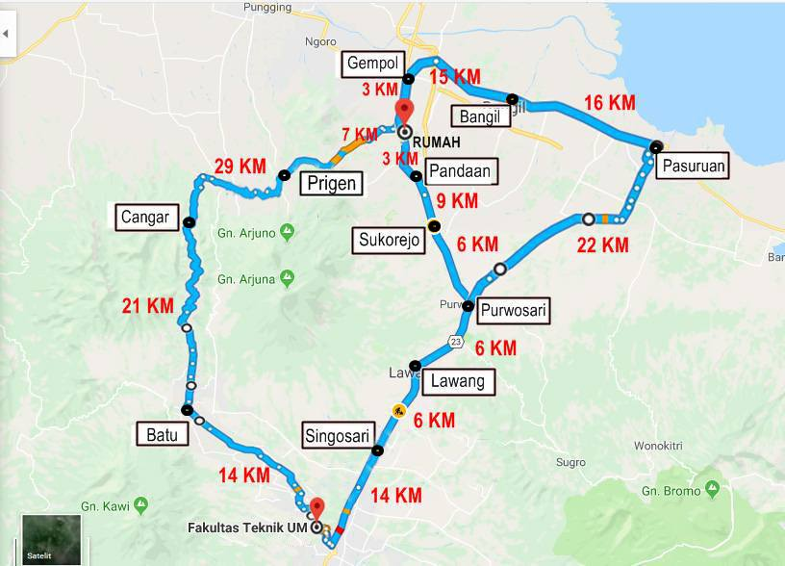

7 KM

21 KM

**Straight-Line Distance**

H5 : 38 KM

Singosari : 29 KM

Lawang : 23 KM

Purwosari : 16 KM

Sukorejo : 10 KM

Pasuruan : 25 KM

Bangil : 12 KM

Gempol : 2 KM

Batu : 29 KM

Cangar : 21 KM

Prigen : 9 KM

**Penerapan A\***

73 = 14+21+29+9

56 = 14+21+21

43 = 14 + 29

76 = 14+6+6+22+16+12

73 = 14+6+6+22+25

43 = 14+6+6+6+9+3++0

43 = 14+6+6+6+9+2

42 = 14+6+6+6+10

42 = 14 + 6 + 6 + 16 15

43 = 14 + 6 + 23 15

43 = 14 + 29

81 = 14+6+6+22+16+15+2