Experiment No: 1
Comparative Study of Low-Code Development versus Traditional Application Development Approaches

1. Aim
To study and compare low-code development and traditional application development approaches, and to analyze their respective stages, workflows, advantages, and limitations.

2. Introduction to Traditional Approach
Traditional application development follows a structured, code-centric process in which developers write source code manually using programming languages and frameworks. It typically follows models such as Waterfall or Agile, and involves distinct phases of requirement analysis, design, coding, testing, deployment, and maintenance. This approach offers high flexibility and control but requires significant technical expertise and development time.

3. Introduction to Low-Code
Low-code development is a visual approach to software development that enables developers to build applications with minimal hand-coding, using drag-and-drop components, pre-built templates, and visual modeling tools. It accelerates the development process, reduces dependency on specialized programming skills, and is widely used for rapid prototyping, internal tools, and business applications.

4. Diagram: Stages in Traditional Approach
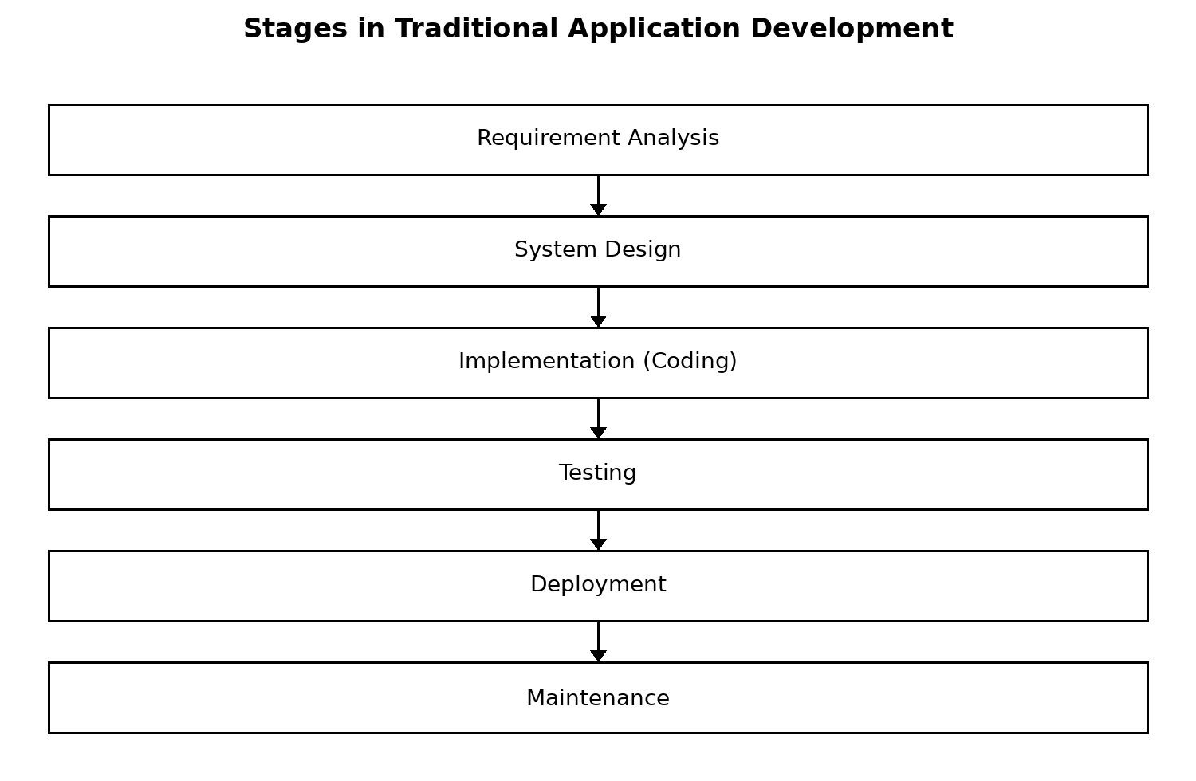

5. Diagram: Steps in Low-Code
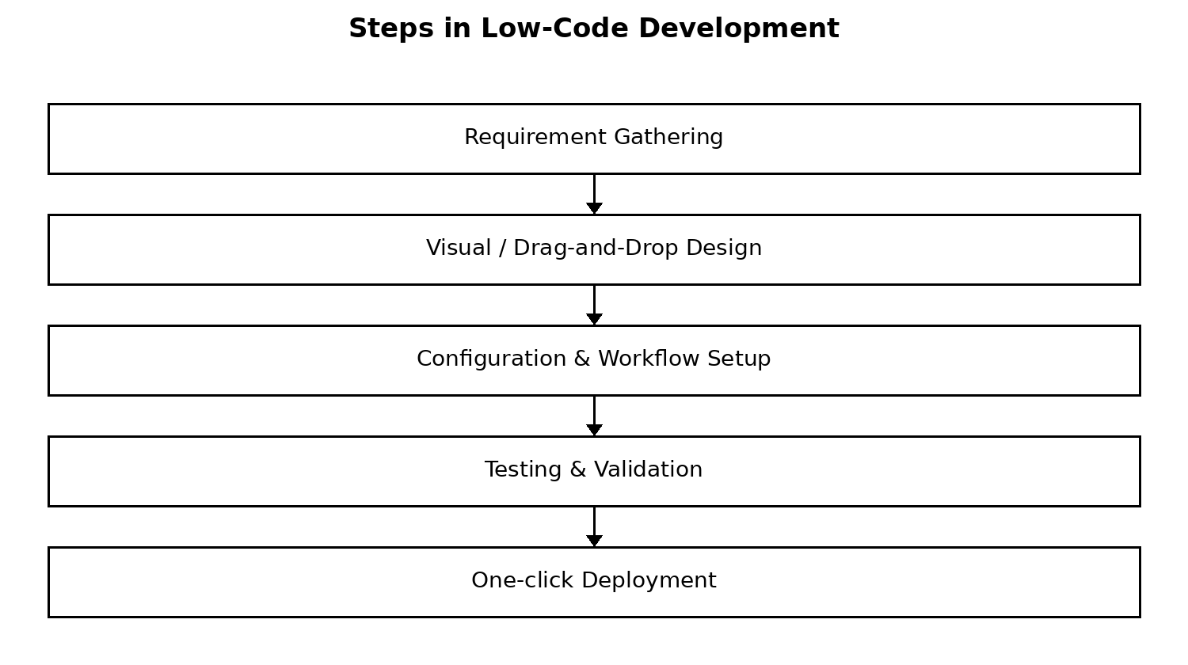

6. Comparative Analysis
Parameter | Traditional Development | Low-Code Development
Development Speed | Slower; code written line by line | Faster; visual/drag-and-drop components
Coding Skill Required | High — strong programming expertise needed | Low to moderate — minimal hand-coding
Customization | Very high; full control over logic and design | Limited by platform capabilities
Cost | Higher due to longer development time | Lower; reduced developer hours
Scalability | Highly scalable, architecture fully controlled | Scalable within platform constraints
Maintenance | Manual; requires dedicated dev effort | Easier; platform handles much of the upkeep
Best Suited For | Complex, large-scale, highly custom systems | Rapid prototyping, internal tools, MVPs

7. Result
The comparative study shows that traditional development offers greater flexibility, customization, and scalability, making it suitable for complex, large-scale systems, while low-code development offers significantly faster build times and lower technical barriers, making it ideal for rapid prototyping, MVPs, and internal business applications. The choice between the two approaches depends on project complexity, timeline, budget, and the required degree of customization.

