CE6002 CONCRETE TECHNOLOGY

Unit –I

CONSTITUENT MINERALS

Part-A (2 Marks)

- What is the common classification of aggregates?

The most common classification of aggregates on the basis of bulk specific gravity is

- Lightweight

- Normal-weight

- Heavy weight aggregates.

- What is Light weight aggregates?

Light weight concrete contains aggregate that is natural or synthetic which weighs less than 1100 kg/m³. The lightweight is due to the cellular or high internal porous microstructure, which gives this type of aggregate a low bulk specific gravity. The most important aspect of lightweight aggregate is the porosity. They have high absorption values, which require a modified approach to concrete proportioning.

- Define Heavyweight aggregates.

Heavyweight concrete contains aggregates that are natural or synthetic which typically weigh more than 2,080 kg/m³ and can range up to 4,485 kg/m³. Heavy weight aggregate is most commonly used for radiation shielding, counterweights and other applications where a high mass-to-volume ratio is desired.

- Define Aggregate.

Aggregates are defined as inert, granular, and inorganic materials that normally consist of stone or stone-like solids. Aggregates can be used alone (in road bases and various types of fill) or can be used with cementing materials (such as Portland cement or asphalt cement) to form composite materials or concrete.

- Mention the Classification of aggregate In accordance with size.

Coarse aggregate: Aggregates predominately retained on the No. 4 (4.75 mm) sieve. For mass concrete, the maximum size can be as large as 150 mm.

Fine aggregate (sand): Aggregates passing No.4 (4.75 mm) sieve and predominately retained on the No. 200 (75 µm) sieve.

6. Mention the Classification of aggregate In accordance with source. Natural aggregates: This kind of aggregate is taken from natural deposits

without changing their nature during the process of production such as crushing and grinding. Some examples in this category are sand, crushed limestone, and gravel.

Manufactured (synthetic) aggregates: This is a kind of man-made materials produced as a main product or an industrial by-product. Some examples are blast furnace slag, lightweight aggregate (e.g. expanded perlite), and heavy weight aggregates (e.g. iron ore or crushed steel).
7. What are the properties of Aggregate? Moisture conditions

The moisture condition of aggregates refers to the presence of water in the pores and on the surface of aggregates.

Density and specific gravity

Density (D): weight per unit volume (excluding the pores inside a single aggregate) Solid Vs weight D= Bulk density: the volume includes the pores inside a single aggregate.

- Give the Grading of aggregates.

Grading is size distribution

The particle size distribution of aggregates is called grading. The grading determine the paste requirement for a workable concrete since the amount of void requires needs to be filled by the same amount of cement paste in a concrete mixture.

- Define Fineness modulus of aggregate.

To characterize the overall coarseness or fineness of an aggregate, a concept of fineness modulus is developed.

To calculate the fineness modulus, the sum of the cumulative percentages retained on a definitely specified set of sieves needs to be determined, and the result is then divided by 100. The sieves specified for the determination of fineness modulus are No. 100, No. 50, No. 30, No. 16, No. 8, No. 4, 3/8", 3/4", 1.5", 3", and 6".

10. Define Fineness modulus for blending of aggregates.

Blending of aggregates is undertaken for a variety of purposes, for instance, to remedy deficiencies in grading. The fineness modulus of blended aggregates can be calculated if the values for the component aggregates are known.

11. What are the Physical Quality requirements Of aggregates.

These requirements can be divided into five distinct groups as follows:

  - Absorption;

  - Abrasion-resistance;

  - Soundness;

  - Restrictions on deleterious constituents;

  - Special requirements.

- What are the various tests which are to be done on aggregates?

Various test which are done on aggregates are listed below

    - Sieve Analysis

    - Water Absorption

    - Aggregate Impact Value

    - Aggregate Abrasion Value

    - Aggregate Crushing Value 13. What is the chemical composition of cement?

Chemical composition of cement is lime, silica, alumina, calcium sulphate Iron oxide Magnesium oxide Sulphur trioxide Alkali oxides.

- List various types of cement.

  - Ordinary Portland cement

  - High alumina cement

  - Portland-Pozzolana cement

  - Quick setting cement

- What is grade of cement?

List any three grades of cement with their strengths. Grade of cement represents the specific 28 days compressive strength. The following three grades are given along with their compressive strengths

33 Grade OPC –33 MPa

43 Grade OPC – 43 MPa

53 Grade OPC – 53 MPa

- Give step by step method of manufacture of cement by wet process.

  - Limestone is first crushed Mixed with clay or shale and ground.

  - The ground material is corrected and mixed with water

  - Corrected slurry is sprayed on to the upper end of a rotary kiln Slurry looses moisture and forms as flakes Clinker forms

  - Clinker is cooled and gypsum is formed

- What is meant by proportioning of concrete?

Proportioning concrete is use of certain quantity of cement, sand and coarse aggregate and specific water cement ratio.

18. Can sea water be used for making concrete? Explain.

In general any potable water is suitable for concreting. To be specific pH of water should be between 6&8. Sea water contains sodium chloride whose pH does not fall in the above limit.

19. What is meant by curing of concrete?

In order to prevent the loss of water from the surface due to evaporation or otherwise it has to be retained for which certain measures are taken which is called curing.

20. What is mean by controlled concrete?

Controlled concrete is made by selecting the required ingredients of concrete. And finding their relative proportions with the aim of producing an economical concrete of certain strength and durability.

21. What is a slump test?

It is the most commonly used method of measuring consistency of concrete. This test can be conducted in the field or in laboratory. This test is not suitable for very wet or dry climate.

22. What is meant by hydration of cement?

Cements used for making concrete have the property of reacting chemically with water in an exothermic process called hydration that results in water treatment products.

- What are the two process of manufacturing of cement?

Wet process

Dry process

- Describe the importance of the quality of water used for concreting. (MAY/JUNE 2016)
- Water is an important ingredient of concrete as itactively participates in the chemical reaction with cement.
- Since it helps to form the strength giving cement gel, the quantity and quality of water isrequired to be looked into very carefully.
- Since quality of water affects the strength, it is necessary for us to go into the purity and quality of water.
- List the major composition of OPC. (MAY/JUNE 2016)

Lime (CaO) | 60 to 67%
Silica (SiO2) | 17 to 25%
Alumina (Al2O3) | 3 to 8%
Iron oxide (Fe2O3) | 0.5 to 6%
Magnesia (MgO) | 0.1 to 4%

Part – B (16 Marks)

- Describe the importance of the quality of water used for concreting.

Water is an important ingredient of concrete as itactively participates in the chemical reaction
with cement. Since it helps to form the strength giving cement gel, the quantity and quality of water isrequired to be looked into very carefully. It has been discussed enough in chapter 1 about the quantity ofmixing water but so far the quality of water has not been discussed. In practice, very often great control on properties of cement and aggregate is exercised, but the control on the quality of water is often neglected. Since quality of water affects the strength, it is necessary for us to go into the purity and quality of water.

Qualities of Water
A popular yard-stick to the suitability of water for mixing concrete is that, if water is fit for drinking it is fit for making concrete. This does not appear to be a true statement for all conditions. Some waters containing a small amount of sugar would be suitable for drinking but not for mixing concrete and conversely water suitable for making concrete may not necessarily be fit for drinking. Some specifications require that if the water is not obtained from source that has proved satisfactory, the strength of concrete or mortar made with questionable water should be compared with similar concrete or mortar made with pure water. Some specification also accept water for making concrete if the pH value of water lies between 6 and 8 and the water is free from organic matter. Instead of depending upon pH value and other chemical composition, the best course to find out whether a particular source of water is suitable for concrete making or not, is to make concrete with this water and compare its 7 days’ and 28 days’ strength with companion cubes made with distilled water.
If the compressive strength is upto 90 per cent, the source of water may be accepted. This criteria may be safely adopted in places like coastal area of marshy area or in other places where the available water is brackish in nature and of doubtful quality. However, it is logical to know what harm the impurities in water do to the concrete and what degree of impurity is permissible is mixing concrete and curing concrete.

Carbonates and bi-carbonates of sodium and potassium effect the setting time of cement. While sodium carbonate may cause quick setting, the bi-carbonates may either accelerate or retard the setting. The other higher concentrations of these salts will materially reduce the concrete strength. If some of these salts exceeds 1,000 ppm, tests for setting time and 28 days strength should be carried out. In lower concentrations they may be accepted.
Brackish water contains chlorides and sulphates. When chloride does not exceed 10,000 ppm and sulphate does not exceed 3,000 ppm the water is harmless, but water with even higher salt content has been used satisfactorily.
Salts of Manganese, Tin, Zinc, Copper and Lead cause a marked reduction in strength of concrete. Sodium iodate, sodium phosphate, and sodium borate reduce the initial strength of concrete to an extra-ordinarily high degree. Another salt that is detrimental to concrete is sodium sulphide and even a sulphide content of 100 ppm warrants testing.
Silts and suspended particles are undesirable as they interfere with setting, hardening and bond characteristics. A turbidity limit of 2,000 ppm has been suggested. Table 4.1 shows the tolerable concentration of some impurities in mixing water.

The following guidelines should also be taken into consideration regarding the quality of water.
(a) To neutralize 100 ml sample of water using phenoplhaline as an indicator, it should not require more than 5 ml of 0.02 normal NaOH.
(b) To neutralise 100 ml of sample of water, using mixed indicator, it should not require
more than 25 ml of 0.02 normal H2So4.
(c) Permissible limits for solids has to be limited

- How does increasing the quantity of water influence the properties of fresh and hardened concrete?

Water/Cement Ratio

Strength of concrete primarily depends upon the strength of cement paste. It has been shown in Chapter I that the strength of cement paste depends upon the dilution of paste or in other words, the strength of paste increases with cement content and decreases with air and water content. In 1918 Abrams presented his classic law in the form:
S = A/ B^{x}
where x =water/cement ratio by volume and for 28 days results the constants A and B are 14,000 lbs/sq. in. and 7 respectively.

Abrams water/cement ratio law states that the strength of concrete is only dependent upon water/cement ratio provided the mix is workable. In the past many theories have been propounded by many research workers. Some of them held valid for some time and then underwent some changes while others did not stand the test of time and hence slowly disappeared. But Abrams’ water/cement ratio law stood the test of time and is held valid even today as a fundamental truth in concrete-making practices. No doubt some modifications have been suggested but the truth of the statement could not be challenged.

- Classify the various concrete chemical based on their use.

Admixture is defined as a material, other than cement, water and aggregates, that is used as an ingredient of concrete and is added to the batch immediately before or during mixing. Additive is a material which is added at the time of grinding cement clinker at the cement factory.
These days concrete is being used for wide varieties of purposes to make it suitable in different conditions. In these conditions ordinary concrete may fail to exhibit the required quality performance or durability. In such cases, admixture is used to modify the properties of ordinary concrete so as to make it more suitable for any situation.

Classification of admixtures
Admixtures
- Plasticizers

- Superplasticizers

- Retarders and Retarding Plasticizers

- Accelerators and Accelerating Plasticizers

- Air-entraining Admixtures

- Pozzolanic or Mineral Admixtures

- Damp-proofing and Waterproofing Admixtures

- Gas forming Admixtures

- Air-detraining Admixtures

- Alkali-aggregate Expansion Inhibiting Admixtures

- Workability Admixtures

- Grouting Admixtures

- Corrosion Inhibiting Admixtures

- Bonding Admixtures

- Fungicidal, Germicidal, Insecticidal Admixtures

- Colouring Admixtures

Construction Chemicals and water proofing
- Concrete Curing Compounds

- Polymer Bonding Agents

- Polymer Modified Mortar for Repair and Maintenance

- Mould Releasing Agents

- Protective and Decorative Coatings

- Installation Aids

- Floor Hardeners and Dust-proofers

- Non-shrink High Strength Grout

- Surface Retarders

- Bond-aid for Plastering

- Ready to use Plaster

- Guniting Aid

- Integral Water-proofing Compounds

- Membrane Forming Coatings

- Polymer Modified Mineral Slurry Coatings

- Protective and Decorative Coatings

- Chemical DPC

- Silicon Based Water-repellent Material

- Waterproofing Adhesive for Tiles, Marble and Granite

- Injection Grout for Cracks

- Joint Sealants

- Discuss in detail about plasticizers and superplasticizers. (MAY/JUNE 2016)

Plasticizers (Water Reducers)
Requirement of right workability is the essence of good concrete. Concrete in different situations require different degree of workability. A high degree of workability is required in situations like deep beams, thin walls of water retaining structures with high percentage of steel reinforcement, column and beam junctions, tremie concreting, pumping of concrete, hot weather concreting, for concrete to be conveyed for considerable distance and in ready mixed concrete industries. The conventional methods followed for obtaining high workability is by improving the gradation, or by the use of relatively higher percentage of fine aggregate or by increasing the cement content. There are difficulties and limitations to obtain high workability in the field for a given set of conditions. The easy method generally followed at the site in most of the conditions is to use extra water unmindful of the harm it can do to the strength and durability of concrete. It is an abuse, a criminal act, and unengineering to use too much water than necessary in concrete. At the same time, one must admit that getting required workability for the job in hand with set conditions and available materials is essential and is often difficult. Therefore, engineers at the site are generally placed in conflicting situations. Often he follows the easiest path and that is adding extra water to fluidise the mix. This addition of extra water to satisfy the need for workable concrete is amounting to sowing the seed of cancer in concrete.

Today we have plasticizers and superplasticizers to help an engineer placed in intriguing situations. These plasticizers can help the difficult conditions for obtaining higher workability without using excess of water. One must remember that addition of excess water, will only improve the fluidity or the consistency but not the workability of concrete. The excess water will not improve the inherent good qualities such as homogeneity and cohesiveness of the mix which reduces the tendency for segregation and bleeding. Whereas the plasticized concrete will improve the desirable qualities demanded of plastic concrete. The practice all over the world now is to use plasticizer or superplasticizer for almost all the reinforced concrete and even for mass concrete to reduce the water requirement for making concrete of higher workability or flowing concrete. The organic substances or combinations of organic and inorganic substances, which allow a reduction in water content for the given workability, or give a higher workability at the same water content, are termed as plasticizing admixtures. The advantages are considerable in both cases : in the former, concretes are stronger, and in the latter they are more workable.
The basic products constituting plasticizers are as follows:
(i) Anionic surfactants such as lignosulphonates and their modifications and derivatives, salts of sulphonates hydrocarbons.
(ii ) Nonionic surfactants, such as polyglycol esters, acid of hydroxylated carboxylic acids and their modifications and derivatives.
(iii) Other products, such as carbohydrates etc.
Among these, calcium, sodium and ammonium lignosulphonates are the most used. Plasticizers are used in the amount of 0.1% to 0.4% by weight of cement. At these doses, at constant workability the reduction in mixing water is expected to be of the order of 5% to 15%. This naturally increases the strength. The increase in workability that can be expected, at the same w/c ratio, may be anything from 30 mm to 150 mm slump, depending on the dosage, initial slump of concrete, cement content and type.
A good plasticizer fluidizes the mortar or concrete in a different manner than that of the air-entraining agents. Some of the plasticizers, while improving the workability, entrains air also. As the entrainment of air reduces the mechanical strength, a good plasticizer is one which does not cause air-entrainment in concrete more than 1 or 2%.
One of the common chemicals generally used, as mentioned above is Lignosulphonic acid in the form of either its calcium or sodium salt. This material is a natural product derived from wood processing industries. Admixtures based on lignosulphonate are formulated from purified product from which the bulk of the sugars and other interfering impurities are removed to low levels. Such a product would allow adsorption into cement particles without any significant interferences with the hydration process or hydrated products. Normal water reducing admixtures may also be formulated from wholly synthetic raw materials. It is also observed that at a recommended dose, it does not affect the setting time significantly. However, at higher dosages than prescribed, it may cause excessive retardation. It must be noted that if unrefined and not properly processed lignosulphonate is used as raw material, the behaviour of plasticizer would be unpredictable. It is some times seen that this type of admixture has resulted in some increase in air-entrainment. It is advised that users should follow the instructions of well established standard manufacturers of plasticizers regarding dosage.
Action of Plasticizers
The action of plasticizers is mainly to fluidify the mix and improve the workability of concrete, mortar or grout. The mechanisms that are involved could be explained in the following way:
Dispersion. Portland cement, being in fine state of division, will have a tendency to flocculate in wet concrete. These flocculation entraps certain amount of water used in the mix and thereby all the water is not freely available to fluidify the mix.
When plasticizers are used, they get adsorbed on the cement particles. The adsorption of charged polymer on the particles of cement creates particle-to-particle repulsive forces which overcome the attractive forces. This repulsive force is called Zeta Potential, which depends on the base, solid content, quantity of plasticizer used. The overall result is that the cement particles are deflocculated and dispersed. When cement particles are deflocculated, the water trapped inside the flocs gets released and now available to fluidify the mix. Fig. 5.1 explains the mechanism.
When cement particles get flocculated there will be interparticles friction between particle to particle and floc to floc. But in the dispersed condition there is water in between the cement particle and hence the interparticle friction is reduced.
Retarding Effect. It is mentioned earlier that plasticizer gets adsorbed on the surface of cement particles and form a thin sheath. This thin sheath inhibits the surface hydration reaction between water and cement as long as sufficient plasticizer molecules are available at the particle/solution interface. The quantity of available plasticizers will progressively decrease as the polymers become entrapped in hydration products.
- Reduction in the surface tension of water.

- Induced electrostatic repulsion between particles of cement.

- Lubricating film between cement particles.

- Dispersion of cement grains, releasing water trapped within cement flocs.

- Inhibition of the surface hydration reaction of the cement particles, leaving more water to fluidify the mix.

- Change in the morphology of the hydration products.

- Induced steric hindrance preventing particle-to-particle contact.

It may be noted that all plasticizer are to some extent set retarders, depending upon the base of plasticizers, concentration and dosage used.
Superplasticizers (High Range Water Reducers)
Superplasticizers constitute a relatively new category and improved version of plasticizer. They are chemically different from normal plasticiszers. Use of superplasticizers permit the reduction of water to the extent upto 30 per cent without reducing workability in contrast to the possible reduction up to 15 per cent in case of plasticizers.
The use of superplasticizer is practiced for production of flowing, self levelling, self compacting and for the production of high strength and high performance concrete.
The mechanism of action of superplasticizers are more or less same as explained earlier in case of ordinary plasticizer. Only thing is that the superplasticizers are more powerful as dispersing agents and they are high range water reducers. They are called High Range Water Reducers in American literature. It is the use of superplasticizer which has made it possible to use w/c as low as 0.25 or even lower and yet to make flowing concrete to obtain strength of the order 120 Mpa or more. It is the use of superplasticizer which has made it possible to use fly ash, slag and particularly silica fume to make high performance concrete.
The use of superplasticizer in concrete is an important milestone in the advancement of concrete technology. Since their introduction in the early 1960 in Japan and in the early 1970 in Germany, it is widely used all over the world. India is catching up with the use of superplasticizer in the construction of high rise buildings, long span bridges and the recently become popular Ready Mixed Concrete Industry. Common builders and Government departments are yet to take up the use of this useful material.
Superplasticizers can produce:
- at the same w/c ratio much more workable concrete than the plain ones,

- for the same workability, it permits the use of lower w/c ratio,

- as a consequence of increased strength with lower w/c ratio, it also permits a reduction of cement content.

The superplasticizers also produce a homogeneous, cohesive concrete generally without any tendency for segregation and bleeding.
Classification of Superplasticizer
Following are a few polymers which are commonly used as base for superplasticizers.
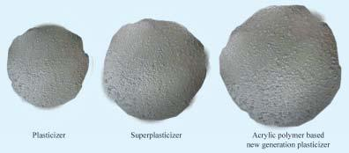

lignosulphonate (LS) based admixtures, which have an effective fluidizing action, but at the relatively high dosages, they can produce undesirable effects, such as accelerations or delay in setting times. Moreover, they increase the air-entrainment in concrete.
Plasticizers and superplasticizers are water based. The solid contents can vary to any extent in the products manufactured by different companies. Cost should be based on efficiencies and solid content, but not on volume or weight basis. Generally in projects cost of superplasticizers should be worked for one cubic meter of concrete. Consistency in the quality of superplasticizers supplied over a period of time can be tested and compared by “Infrared Spectrometry”.
Effects of Superplasticizers on Fresh Concrete
It is to be noted that dramatic improvement in workability is not showing up when plasticizers or superplasticizers are added to very stiff or what is called zero slump concrete at nominal dosages. A mix with an initial slump of about 2 to 3 cm can only be fluidised by plasticizers or superplasticizers at nominal dosages. A high dosage is required to fluidify no slump concrete. An improvement in slump value can be obtained to the extent of 25 cm or more depending upon the initial slump of the mix, the dosage and cement content. It is often noticed that slump increases with increase in dosage. But there is no appreciable increase in slump beyond certain limit of dosage. As a matter of fact, the overdosage may sometime harm the concrete.
Compatibility of Superplasticizers and Cement
It has been noticed that all superplasticizers are not showing the same extent of improvement in fluidity with all types of cements. Some superplasticizers may show higher fluidizing effect on some type of cement than other cement. There is nothing wrong with either the superplasticizer or that of cement. The fact is that they are just not compatible to show maximum fluidizing effect. Optimum fluidizing effect at lowest dosage is an economical consideration. Giving maximum fluidizing effect for a particular superplasticizer and a cement is very complex involving many factors like composition of cement, fineness of cement etc.
Although compatibility problem looks to be very complex, it could be more or less solved by simple rough and ready field method. Incidentally this simple field test shows also the optimum dose of the superplasticizer to the cement. Following methods could be adopted

- Explain in detail of any three tests for Fresh Concrete.

TESTS ON FRESH CONCRETE
Measurement of Workability
It is discussed earlier that workability of concrete is a complex property. Just as it eludes all precise definition, it also eludes precise measurements. Numerous attempts have been made by many research workers to quantitatively measure this important and vital property of concrete. But none of these methods are satisfactory for precisely measuring or expressing this property to bring out its full meaning. Some of the tests, measure the parameters very close to workability and provide useful information. The following tests are commonly employed to measure workability.

(a) | Slump Test | (b) | Compaction factor test
(c) | Flow Test | (d) | Kelly Ball Test
(e) | Vee Bee Consistometer
Slump Test
Slump test is the most commonly used method of measuring consistency of concrete which can be employed either in laboratory or at site of work. It is not a suitable method for very wet or very dry concrete. It does not measure all factors contributing to workability, nor is it always representative of the placeability of the concrete. However, it is used conveniently as a control test and gives an indication of the uniformity of concrete from batch to batch. Repeated batches of the same mix, brought to the same slump, will have the same water content and water cement ratio, provided the weights of aggregate, cement and admixtures are uniform and aggregate grading is within acceptable limits. Additional information on workability and quality of concrete can be obtained by observing the manner in which concrete slumps. Quality of concrete can also be further assessed by giving a few tappings or blows by tamping rod to the base plate. The deformation shows the characteristics of concrete with respect to tendency for segregation.
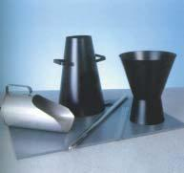
The appartus for conducting the slump test essentially consists of a metallic mould in the form of a frustum of a cone having the internal dimensions as under:

Bottom diameter | : | 20cm
Top diameter | : | 10cm
Height | : | 30cm

The thickness of the metallic sheet for the mould should not be thinner than 1.6 mm. Sometimes the mould is provided with suitable guides for lifting vertically up. For tamping the concrete, a steel tamping rod 16 mm dia, 0.6 meter along with bullet end is used. Fig. 6.1, shows the details of the slump cone appartus. The internal surface of the mould is thoroughly cleaned and freed from superfluous moisture and adherence of any old set concrete before commencing the test. The mould is placed on a smooth, horizontal, rigid and non-absorbant surface The mould is then filled in four layers, each approximately 1/ 4 of the height of the mould. Each layer is tamped 25 times by the tamping rod taking care to distribute the strokes evenly over the cross section. After the top layer has been rodded, the concrete is struck off level with a trowel and tamping rod. The mould is removed from the concrete immediately by raising it slowly and carefully in a vertical direction. This allows the concrete to subside. This subsidence is referred as SLUMP of concrete. The difference in level between the height of the mould and that of the highest point of the subsided concrete is measured. This difference in height in mm. is taken as Slump of Concrete. ASTM measure the centre of the slumped concrete as the difference in height. ASTM also specifies 3 layers.
The pattern of slump is shown in Figure. It indicates the characteristic of concrete in addition to the slump value. If the concrete slumps evenly it is called true slamp. If one half of the cone slides down, it is called shear slump. In case of a shear slump, the slump value is measured as the difference in height between the height of the mould and the average value of the subsidence. Shear slump also indicates that the concrete is non-cohesive and shows the characteristic of segregation.
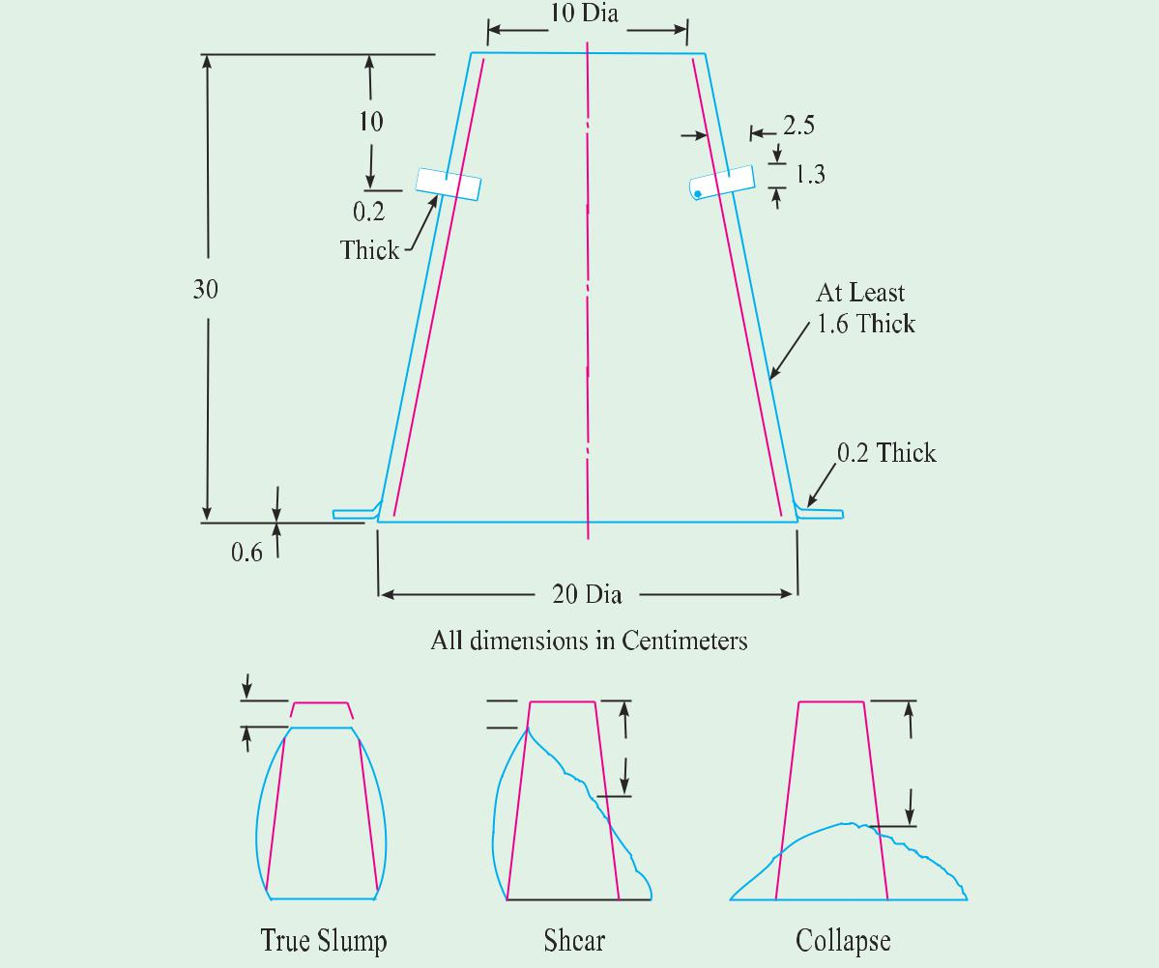
It is seen that the slump test gives fairly good consistent results for a plastic-mix. This test is not sensitive for a stiff-mix. In case of dry-mix, no variation can be detected between mixes of different workability. In the case of rich mixes, the value is often satisfactory, their slump being sensitive to variations in workability. IS 456 of 2000 suggests that in the “very low” category of workability where strict control is necessary, for example, pavement quality concrete, (PQC) measurement of workability by determination of compacting factor will be more appropriate than slump and a value of 0.75 to 0.80 compacting factor is suggested.

Flow Test
This is a laboratory test, which gives an indication of the quality of concrete with respect to consistency, cohesiveness and the proneness to segregation. In this test, a standard mass of concrete is subjected to jolting. The spread or the flow of the concrete is measured and this flow is related to workability.
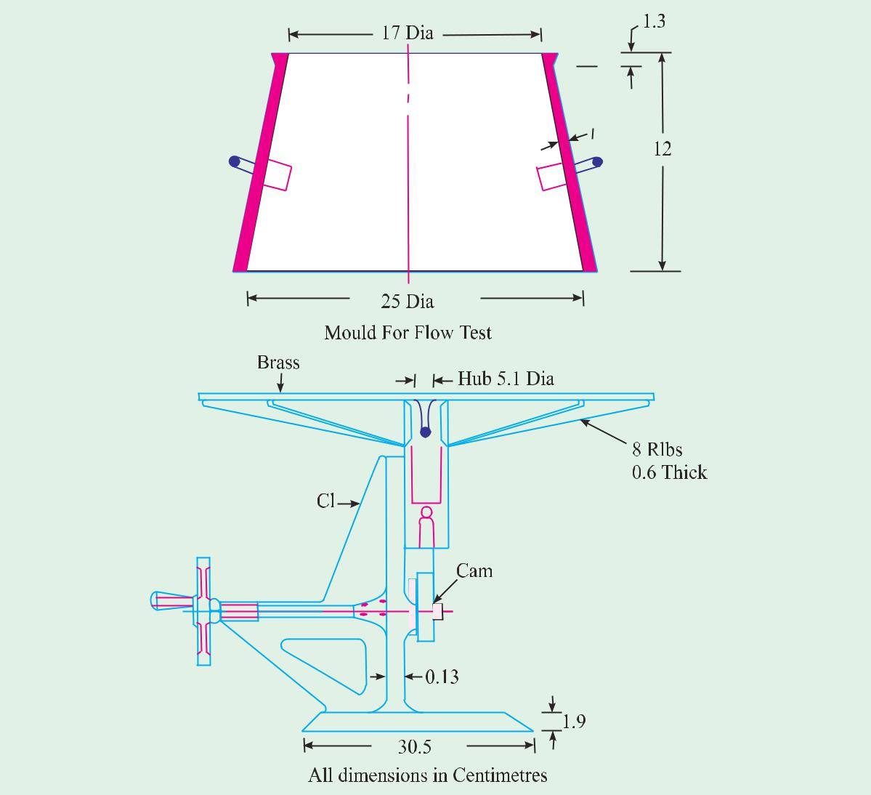

Figure shows the details of apparatus used. It can be seen that the apparatus consists of flow table, about 76 cm. in diameter over which concentric circles are marked. A mould made from smooth metal casting in the form of a frustum of a cone is used with the following internal dimensions. The base is 25 cm. in diameter, upper surface 17 cm. in diameter, and height of the cone is 12 cm.
The table top is cleaned of all gritty material and is wetted. The mould is kept on the centre of the table, firmly held and is filled in two layers. Each layer is rodded 25 times with a tamping rod 1.6 cm in diameter and 61 cm long rounded at the lower tamping end and the top layer is rodded evenly, the excess of concrete which has overflowed the mould is removed. The mould is lifted vertically upward and the concrete stands on its own without support. The table is then raised and dropped 12.5 mm 15 times in about 15 seconds. The diameter of the spread concrete is measured in about 6 directions to the nearest 5 mm and the average spread is noted. The flow of concrete is the percentage increase in the average diameter of the spread concrete over the base diameter of the mould
Flow percent = ( ( Spread diameter in cm – 25 ) / 25 ) x 100
The value could range anything from 0 to 150 per cent.
A close look at the pattern of spread of concrete can also give a good indication of the characteristics of concrete such as tendency for segregation.
Flow Table Apparatus
The BIS has recently introduced another new equipment for measuring flow value of concrete. This new flow table test is in the line with BS 1881 part 105 of 1984 and DIN 1048 part I. The apparatus and method of testing is described below.
The flow table apparatus is to be constructed from a flat metal of minimum thickness 1.5 mm. The top is in plan 700 mm x 700 mm. The centre of the table is marked with a cross, the lines which run paralled to and out to the edges of the plate, and with a central circle 200 mm in diameter. The front of the flow table top is provided with a lifting handle as shown in Figure. The total mass of the flow table top is about 16 ± 1 kg.
The flow table top is hinged to a base frame using externally mounted hinges in such a way that no aggregate can become trapped easily between the hinges or hinged surfaces. The front of the base frame shall extend a minimum 120 mm beyond the flow table top in order to provide a top board. An upper stop similar to that shown in Figure is provided on each side of the table so that the lower front edge of the table can only be lifted 40 ± 1 mm.
The lower front edge of the flow table top is provided with two hard rigid stops which transfer the load to the base frame. The base frame is so constructed that this load is then transferred directly to the surface on which the flow table is placed so that there is minimal tendency for the flow table top to bounce when allowed to fall.
Accessory Apparatus
Mould: The mould is made of metal readily not attacked by cement paste or liable to rust and of minimum thickness 1.5 mm. The interior of the mould is smooth and free from projections, such as protruding rivets, and is free from dents. The mould shall be in the form of a hollow frustum of a cone having the internal dimensions as shown in Fig. 6.7. The base and the top is open and parallel to each other and at right angles to the axis of the cone. The mould is provided with two metal foot pieces at the bottom and two handles above them.
Tamping Bar: The tamping bar is made of a suitable hardwood and having dimensions as shown in Figure.

Sampling: The sample of freshly mixed concrete is obtained.

Procedure: The table is made level and properly supported. Before commencing the test, the table-top and inner surface of the

mould is wiped with a damp cloth. The slump cone is placed centrally on the table. The slump cone is filled with concrete in two equal layers, each layer tamped lightly 10 times with the wooden tamping bar. After filling the mould, the concrete is struck off flush with the upper edge of the slump cone and the free area of the table-top cleaned off.
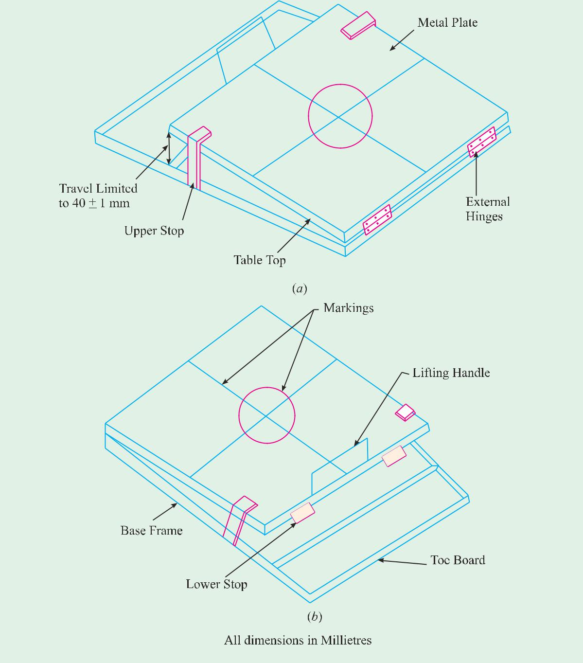

Half a minute after striking off the concrete, the cone is slowly raised vertically by the handles. After this, the table-top raised by the handle and allowed to fall 15 times in 15 seconds. The concrete spreads itself out. The diameter of the concrete spread shall then be measured in two directions, parallel to the table edges. The arithmetic mean of the two diameters shall be the measurement of flow in millimeters.
Kelly Ball Test
This is a simple field test consisting of the measurement of the indentation made by 15 cm diameter metal hemisphere weighing 13.6 kg. when freely placed on fresh concrete.
The test has been devised by Kelly and hence known as Kelly Ball Test. This has not been covered by Indian Standards Specification. The advantages of this test is that it can be performed on the concrete placed in site and it is claimed that this test can be performed faster with a greater precision than slump test.
The disadvantages are that it requires a large sample of concrete and it cannot be used when the concrete is placed in thin section.
The minimum depth of concrete must be at least 20 cm and the minimum distance from the centre of the ball to nearest edge of the concrete 23 cm.The surface of the concrete is struck off level, avoiding excess working, the ball is lowered gradually on the surface of the concrete. The depth of penetration is read immediately on the stem to the nearest 6 mm. The test can be performed in about 15 seconds and it gives much more consistent results than Slump Test
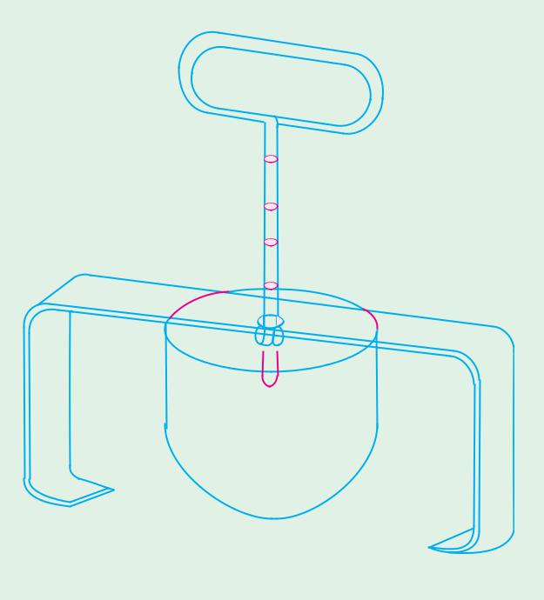



Kelly ball apparatus

- Explain in detail of any three tests for Hardened Concrete.

The Flexural Strength of Concrete
Concrete as we know is relatively strong in compression and weak in tension. In reinforced concrete members, little dependence is placed on the tensile strength of concrete since steel reinforcing bars are provided to resist all tensile forces. However, tensile stresses are likely to develop in concrete due to drying shrinkage, rusting of steel reinforcement, temperature gradients and many other reasons. Therefore, the knowledge of tensile strength of concrete is of importance.
A concrete road slab is called upon to resist tensile stresses from two principal sources– wheel loads and volume change in the concrete. Wheel loads may cause high tensile stresses.
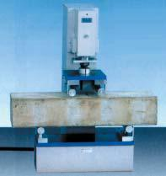

Flextural testing machine
due to bending, when there is an inadequate subgrade support. Volume changes, resulting from changes in temperature and moisture, may produce tensile stresses, due to warping and due to the movement of the slab along the subgrade.
Stresses due to volume changes alone may be high. The longitudinal tensile stress in the bottom of the pavement, caused by restraint and temperature warping, frequently amounts to as much as 2.5 MPa at certain periods of the year and the corresponding stress in the transverse direction is approximately 0.9 MPa. These stresses are additive to those produced by wheel loads on unsupported portions of the slab.
Determination of Tensile Strength
Direct measurement of tensile strength of concrete is difficult. Neither specimens nor testing apparatus have been designed which assure uniform distribution of the “pull” applied to the concrete. While a number of investigations involving the direct measurement of tensile strength have been made, beam tests are found to be dependable to measure flexural strength property of concrete. The value of the modulus of rupture (extreme fibre stress in bending) depends on the dimension of the beam and manner of loading. The systems of loading used in finding out the flexural tension are central point loading and third point loading. In the central point loading, maximum fibre stress will come below the point of loading where the bending moment is maximum. In case of symmetrical two point loading, the critical crack may appear at any section, not strong enough to resist the stress within the middle third, where the bending moment is maximum. It can be expected that the two point loading will yield a lower value of the modulus of rupture than the centre point loading.
Compression Test
Compression test is the most common test conducted on hardened concrete, partly because it is an easy test to perform, and partly because most of the desirable characteristic properties of concrete are qualitatively related to its compressive strength.
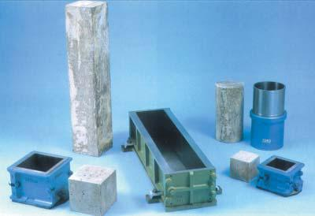

Cube beam and cylinder moulding
The compression test is carried out on specimens cubical or cylindrical in shape. Prism is also sometimes used, but it is not common in our country. Sometimes, the compression strength of concrete is determined using parts of a beam tested in flexure. The end parts of beam are left intact after failure in flexure and, because the beam is usually of square cross section, this part of the beam could be used to find out the compressive strength.
The cube specimen is of the size 15 x 15 x 15 cm. If the largest nominal size of the aggregate does not exceed 20 mm, 10 cm size cubes may also be used as an alternative. Cylindrical test specimens have a length equal to twice the diameter. They are 15 cm in diameter and 30 cm long. Smaller test specimens may be used but a ratio of the diameter of the specimen to maximum size of aggregate, not less than 3 to 1 is maintained.

- Explain in detail about workability and various factors which affect the workability of concrete.

Fresh concrete or plastic concrete is a freshly mixed material which can be moulded into any shape. The relative quantities of cement, aggregates and water mixed together, control the properties of concrete in the wet state as well as in the hardened state.
Water/cement ratio more than this, will result in capillary cavities; and less than this, will result in incomplete hydration and also lack of space in the system for the development of gel.
While making mortar for concrete, the quantity of water used will get altered at site either due to the presence of free surface moisture in the aggregates or due to the absorption characteristics of dry and porous aggregates.
Workability

A theoretical water/cement ratio calculated from the considerations discussed above is not going to give an ideal situation for maximum strength. Hundred per cent compaction of concrete is an important parameter for contributing to the maximum strength. Lack of compaction will result in air voids whose demaging effect on strength and durability is equally or more predominant than the presence of capillary cavities.
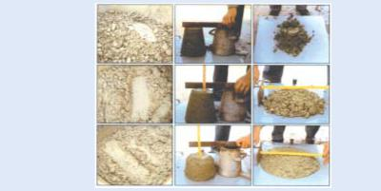
Harsh concrete
Unworkable

Medium workability
Generally workable

Highly workable
concrete

Degree of workability
To enable the concrete to be fully compacted with given efforts, normally a higher water/ cement ratio than that calculated by theoretical considerations may be required. That is to say the function of water is also to lubricate the concrete so that the concrete can be compacted with specified effort forthcoming at the site of work. The lubrication required for handling concrete without segregation, for placing without loss of homogeneity, for compacting with the amount of efforts forth-coming and to finish it sufficiently easily, the presence of a certain quantity of water is of vital importance.
The quality of concrete satisfying the above requirements is termed as workable concrete. The word “workability” or workable concrete signifies much wider and deeper meaning than the other terminology “consistency” often used loosely for workability. Consistency is a general term to indicate the degree of fluidity or the degree of mobility. A concrete which has high consistency and which is more mobile, need not be of right workability for a particular job. Every job requires a particular workability. A concrete which is considered workable for mass concrete foundation is not workable for concrete to be used in roof construction, or even in roof construction, concrete considered workable when vibrator is used, is not workable when concrete is to be compacted by hand. Similarly a concrete considered workable when used in thick section is not workable when required to be used in thin sections. Therefore, the word workability assumes full significance of the type of work, thickness of section, extent of reinforcement and mode of compaction.
For a concrete technologist, a comprehensive knowledge of workability is required to design a mix. Workability is a parameter, a mix designer is required to specify in the mix design process, with full understanding of the type of work, distance of transport, loss of slump, method of placing, and many other parameters involved. Assumption of right workability with proper understanding backed by experience will make the concreting operation economical and durable.
Many research workers tried to define the word workability. But as it signifies much wider properties and qualities of concrete, and does not project any one particular meaning, it eludes all precise definitions. Road Research laboratory, U.K., who have extensively studied the field of compaction and workability, defined workability as “the property of concrete which determines the amount of useful internal work necessary to produce full compaction.” Another definition which envelopes a wider meaning is that, it is defined as the “ease with which concrete can be compacted hundred per cent having regard to mode of compaction and place of deposition.” Without dwelling much on the merits and demerits of various definitions of workability, having explained the importance and full meaning of the term workability, we shall see the factors affecting workability.
Factors Affecting Workability
Workable concrete is the one which exhibits very little internal friction between particle and particle or which overcomes the frictional resistance offered by the formwork surface or reinforcement contained in the concrete with just the amount of compacting efforts forthcoming. The factors helping concrete to have more lubricating effect to reduce internal friction for helping easy compaction are given below:
(a) | Water Content | (b) | Mix Proportions
(c) | Size of Aggregates | (d) | Shape of Aggregates
(e) Surface Texture of Aggregate |  | (f ) | Grading of Aggregate
(g) Use of Admixtures.
(a) Water Content: Water content in a given volume of concrete, will have significant influences on the workability. The higher the water content per cubic meter of concrete, the higher will be the fluidity of concrete, which is one of the important factors affecting workability. At the work site, supervisors who are not well versed with the practice of making good concrete, resort to adding more water for increasing workability. This practice is often resorted to because this is one of the easiest corrective measures that can be taken at site. It should be noted that from the desirability point of view, increase of water content is the last recourse to be taken for improving the workability even in the case of uncontrolled concrete. For controlled concrete one cannot arbitrarily increase the water content. In case, all other steps to improve workability fail, only as last recourse the addition of more water can be considered. More water can be added, provided a correspondingly higher quantity of cement is also added to keep the water/cement ratio constant, so that the strength remains the same.
(b) Mix Proportions: Aggregate/cement ratio is an important factor influencing workability. The higher the aggregate/cement ratio, the leaner is the concrete. In lean concrete, less quantity of paste is available for providing lubrication, per unit surface area of aggregate and hence the mobility of aggregate is restrained. On the other hand, in case of rich concrete with lower aggregate/cement ratio, more paste is available to make the mix cohesive and fatty to give better workability.
(c ) Size of Aggregate: The bigger the size of the aggregate, the less is the surface area and hence less amount of water is required for wetting the surface and less matrix or paste is required for lubricating the surface to reduce internal friction. For a given quantity of water and paste, bigger size of aggregates will give higher workability. The above, of course will be true within certain limits.
(d ) Shape of Aggregates: The shape of aggregates influences workability in good measure. Angular, elongated or flaky aggregate makes the concrete very harsh when compared to rounded aggregates or cubical shaped aggregates. Contribution to better workability of rounded aggregate will come from the fact that for the given volume or weight it will have less surface area and less voids than angular or flaky aggregate. Not only that, being round in shape, the frictional resistance is also greatly reduced. This explains the reason why river sand and gravel provide greater workability to concrete than crushed sand and aggregate.
The importance of shape of the aggregate will be of great significance in the case of present day high strength and high performance concrete when we use very low w/c in the order of about 0.25. We have already talked about that in the years to come natural sand will be exhausted or costly. One has to go for manufactured sand. Shape of crushed sand as available today is unsuitable but the modern crushers are designed to yield well shaped and well graded aggregates.
(e ) Surface Texture: The influence of surface texture on workability is again due to the fact that the total surface area of rough textured aggregate is more than the surface area of smooth rounded aggregate of same volume. From the earlier discussions it can be inferred that rough textured aggregate will show poor workability and smooth or glassy textured aggregate will give better workability. A reduction of inter particle frictional resistance offered by smooth aggregates also contributes to higher workability.

(f ) Grading of Aggregates: This is one of the factors which will have maximum influence on workability. A well graded aggregate is the one which has least amount of voids in a given volume. Other factors being constant, when the total voids are less, excess paste is available to give better lubricating effect. With excess amount of paste, the mixture becomes cohesive and fatty which prevents segregation of particles. Aggregate particles will slide past each other with the least amount of compacting efforts. The better the grading, the less is the void content and higher the workability. The above is true for the given amount of paste volume.
(g) Use of Admixtures: Of all the factors mentioned above, the most import factor which affects the workability is the use of admixtures. In Chapter 5, it is amply described that the plasticizers and superplasticizers greatly improve the workability many folds. It is to be noted that initial slump of concrete mix or what is called the slump of reference mix should be about 2 to 3 cm to enhance the slump many fold at a minimum doze. One should manupulate other factors to obtain initial slump of 2 to 3 cm in the reference mix. Without initial slump of 2 – 3 cm, the workability can be increased to higher level but it requires higher dosage – hence uneconomical.
Use of air-entraining agent being surface-active, reduces the internal friction between the particles. They also act as artificial fine aggregates of very smooth surface. It can be viewed that air bubbles act as a sort of ball bearing between the particles to slide past each other and give easy mobility to the particles. Similarly, the fine glassy pozzolanic materials, inspite of increasing the surface area, offer better lubricating effects for giving better workability.
Measurement of Workability
It is discussed earlier that workability of concrete is a complex property. Just as it eludes all precise definition, it also eludes precise measurements. Numerous attempts have been made by many research workers to quantitatively measure this important and vital property of concrete. But none of these methods are satisfactory for precisely measuring or expressing this property to bring out its full meaning. Some of the tests, measure the parameters very close to workability and provide useful information. The following tests are commonly employed to measure workability.
(a) | Slump Test | (b) | Compacting Factor Test
(c) | Flow Test | (d) | Kelly Ball Test
(e) | Vee Bee Consistometer Test.

- Describe the hydration reaction of important Bogue compounds indicating the products of hydration. (MAY/JUNE 2016)

Hydration
The setting and hardening of concrete are the result of chemical and physical processes that take place between Portland cement and water, i.e. hydration. To understand the properties and behaviour of cement and concrete some knowledge of the chemistry of hydration is necessary.
A) Hydration reactions of pure cement compounds The chemical reactions describing the hydration of the cement are complex. One approach is to study the hydration of the individual compounds separately. This assumes that the hydration of each compound takes place independently of the others.
I.Calcium silicates
Hydration of the two calcium silicates gives similar chemical products, differing only in the amount of calcium hydroxide formed, the heat released, and reaction rate.
2 C3S + 7 H → C3S2H4 + 3 CH 2 C2S + 5 H → C3S2H4 + CH
The principal hydration product is C3S2H4, calcium silicate hydrate, or C-S-H (non-stoichiometric). This product is not a well-defined compound. The formula C3S2H4 is only an approximate description. It has amorphous structure making up of poorly organized layers and is called glue gel binder. C-S-H is believed to be the material governing concrete strength. Another product is CH - Ca(OH)2, calcium hydroxide. This product is a hexagonal crystal often forming stacks of plates. CH can bring the pH value to over 12 and it is good for corrosion protection of steel.
II. Tricalcium aluminate
Without gypsum, C3A reacts very rapidly with water:
C3A + 6 H → C3AH6
The reaction is so fast that it results in flash set, which is the immediate stiffening after mixing, making proper placing, compacting and finishing impossible. With gypsum, the primary initial reaction of C3A with water is :
C3A + 3 (C S H2) + 26 H → C6A S 3H32
The 6-calcium aluminate trisulfate-32-hydrate is usually called ettringite. The formation of ettringite slows down the hydration of C3A by creating a diffusion barrier around C3A. Flash set is thus avoided. Even with gypsum, the formation of ettringite occurs faster than the hydration of the calcium silicates. It therefore contributes to the initial stiffening, setting and early strength development. In normal cement mixes, the ettringite is not stable and will further react to form monosulphate (C4A S H18).

B) Kinetics and Reactivities
The rate of hydration during the first few days is in the order of C3A > C3S > C4AF >C2S.

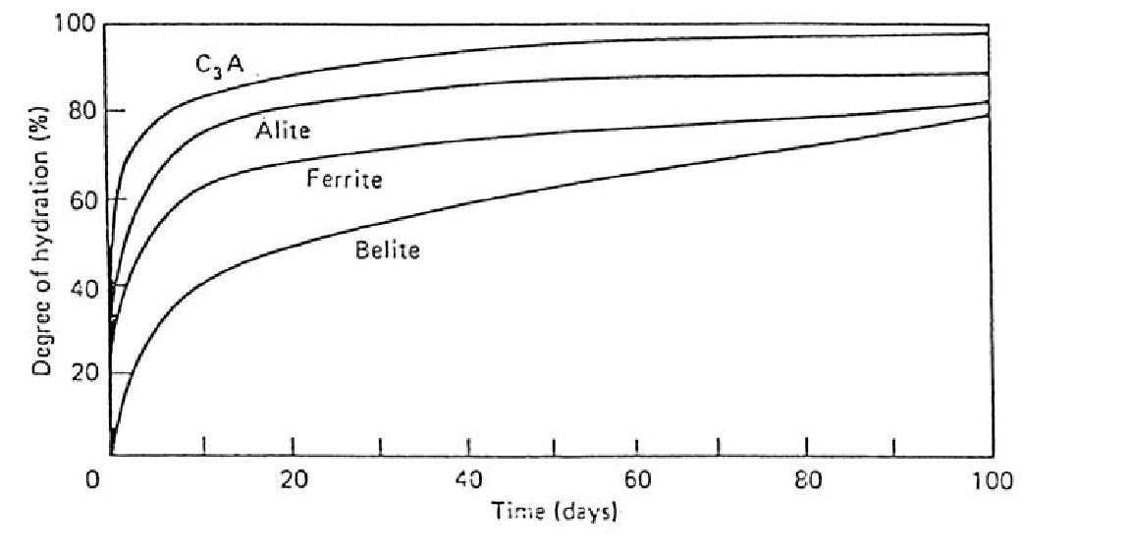
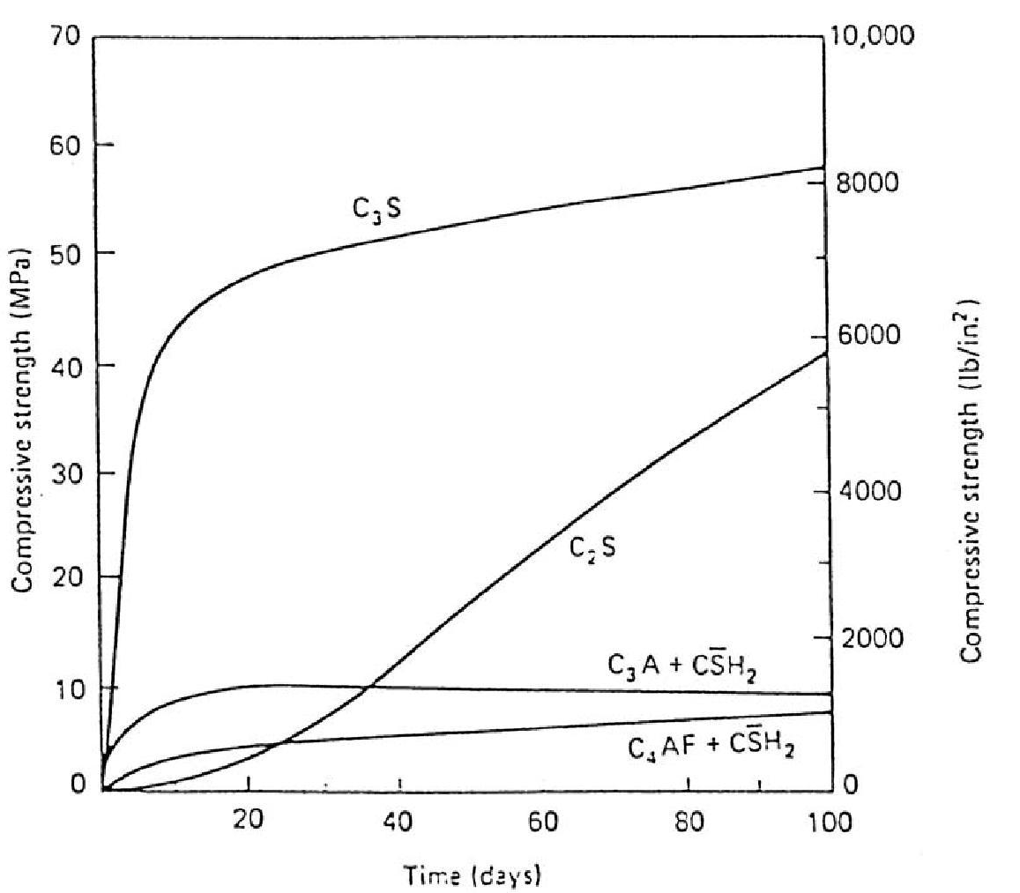

C) Calorimetric curve of Portland cement
A typical calorimetric curve of Portland cement is shown in the following figure. The second heat peaks of both C3S and C3A can generally be distinguished, although their order of occurrence can be reversed.

From the figure, five stages can be easily identified. Since C3S is a dominating component in cement, the five stages above can be explained using the reaction process of C3S by the following table.

On first contact with water, calcium ions and hydroxide ions are rapidly released from the surface of each C3S grain; the pH values rises to over 12 within a few minutes. This hydrolysis slows down quickly but continues throughout the induction period. The induction (dormant) period is caused by the need to achieve a certain concentration of ions in solution before crystal nuclei are formed for the hydration products to grow from. At the end of dormant period, CH starts to crystallize from solution with the concomitant formation of C-S-H and the reaction of C3S again proceeds rapidly (the third stage begin). CH crystallizes from solution, while C-S-H develops from the surface of C3S and forms a coating covering the grain. As hydration continues, the thickness of the hydrate layer increases and forms a barrier through which water must flow to reach the unhydrated C3S and through which ions must diffuse to reach the growing crystals. Eventually, movement through the C-S-H layer determines the rate of reaction. The process becomes diffusion controlled.
D) Setting and Hydration
Initial set of cement corresponds closely to the end of the induction period, 2-4 hours after mixing. Initial set indicates the beginning of forming of gel or beginning of solidification. It represents approximately the time at which fresh concrete can no longer be properly mixed, placed or compacted. The final set occurs 5-10 hours after mixing, within the acceleration period. It represents approximately the time after which strength develops at a significant rate. In practice, initial and final set are determined in a rather arbitrary manner with the penetration test. While the determination of initial and the final set has engineering significance, there is no fundamental
change in hydration process for these two different set conditions.

- Describe the process of manufacture of cement by wet process. (MAY/JUNE 2016)

In the wet process, the limestone brought from the quarries is first crushed to smaller fragments. Then it is taken to a ball or tube mill where it is mixed with clay or shale as the case may be and ground to a fine consistency of slurry with the addition of water. The slurry is a liquid of creamy consistency with water content of about 35 to 50 per cent, wherein particles, crushed to the fineness of Indian Standard Sieve number 9, are held in suspension. The slurry is pumped to slurry tanks or basins where it is kept in an agitated condition by means of rotating arms with chains or blowing compressed air from the bottom to prevent settling of limestone and clay particles. The composition of the slurry is tested to give the required chemical composition and corrected periodically in the tube mill and also in the slurry tank by blending slurry from different storage tanks. Finally, the corrected slurry is stored in the final storage tanks and kept in a homogeneous condition by the agitation of slurry.
The corrected slurry is sprayed on to the upper end of a rotary kiln against hot heavy hanging chains. The rotary kiln is an important component of a cement factory. It is a thick steel cylinder of diameter anything from 3 metres to 8 metres, lined with refractory materials, mounted on roller bearings and capable of rotating about its own axis at a specified speed. The length of the rotary kiln may vary anything from 30 metres to 200 metres. The slurry on being sprayed against a hot surface of flexible chain loses moisture and becomes flakes. These flakes peel off and fall on the floor. The rotation of the rotary kiln causes the flakes to move from the upper end towards the lower end of the kiln subjecting itself to higher and higher temperature. The kiln is fired from the lower end. The fuel is either powered coal, oil or natural gas. By the time the material rolls down to the lower end of the rotary kiln, the dry material undergoes a series of chemical reactions until finally, in the hottest part of the kiln, where the temperature is in the order of 1500°C, about 20 to 30 per cent of the materials get fused. Lime, silica and alumina get recombined.
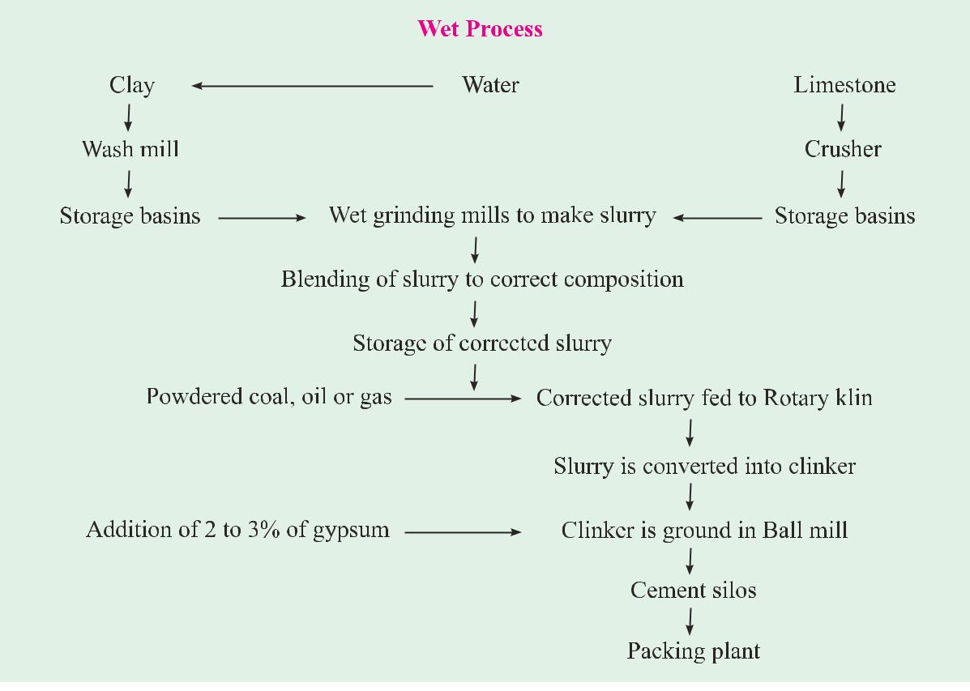

The fused mass turns into nodular form of size 3 mm to 20 mm known as clinker. The clinker drops into a rotary cooler where it is cooled under controlled conditions The clinker is stored in silos or bins. The clinker weighs about 1100 to 1300 gms per litre. The litre weight of clinker indicates the quality of clinker.
The cooled clinker is then ground in a ball mill with the addition of 3 to 5 per cent of gypsum in order to prevent flash-setting of the cement. A ball mill consists of several compartments charged with progressively smaller hardened steel balls. The particles crushed to the required fineness are separated by currents of air and taken to storage silos from where the cement is bagged or filled into barrels for bulk supply to dams or other large work sites.
In the modern process of grinding, the particle size distribution of cement particles are maintained in such a way as to give desirable grading pattern. Just as the good grading of aggregates is essential for making good concrete, it is now recognized that good grading pattern of the cement particles is also important.

- Describe the process of manufacture of cement by dry process.

Dry Process
In the dry and semi-dry process the raw materials are crushed dry and fed in correct proportions into a grinding mill where they are dried and reduced to a very fine powder. The dry powder called the raw meal is then further blended and corrected for its right composition and mixed by means of compressed air. The aerated powder tends to behave almost like liquid and in about one hour of aeration a uniform mixture is obtained.
The blended meal is further sieved and fed into a rotating disc called granulator. A quantity of water about 12 per cent by wright is added to make the blended meal into pellets. This is done to permit air flow for exchange of heat for further chemical reactions and conversion of the same into clinker further in the rotary kiln.
The equipments used in the dry process kiln is comparatively smaller. The process is quite economical. The total consumption of coal in this method is only about 100 kg when compared to the requirement of about 350 kg for producing a ton of cement in the wet process. During March 1998, in India, there were 173 large plants operating, out of which 49 plants used wet process, 115 plants used dry process and 9 plants used semi-dry process.
Since the time of partial liberalisation of cement industry in India (1982), there has been an upgradation in the quality of cement. Many cement companies upgraded their plants both in respect of capacity and quality. Many of the recent plants employed the best equipments, such as cross belt analyser manufactured by Gamma-Metrics of USA to find the composition of limestone at the conveyor belts, high pressure twin roller press, six stage preheater, precalciner and vertical roller mill. The latest process includes stacker and reclaimer, on-line X-ray analyser, Fuzzy Logic kiln control system and other modern process control. In one of the recently built cement plant at Reddypalayam near Trichy, by Grasim Indistries, employed Robot for automatic collection of hourly samples from 5 different places on the process line and help analyse the ame, throughout 24 hours, untouched by men, to avoid human errors in quality control. With all the above sophisticated equipments and controls, consistent quality of clinker is produced. The methods are commonly employed for direct control of quality of clinker. The first method involves reflected light optical microscopy of polished and etched section of clinker, followed by point count of areas occupied by various compounds. The second method, which is also applicable to powdered cement, involves X-ray diffraction of powder specimen. Calibration curves based on known mixtures of pure compounds, help to estimate the compound composition. As a rough and ready method, litre weight (bulk density) of clinker is made use of to ascertain the quality. A litre weight of about 1200 gms. is found to be satisfactory.It is important to note that the strength properties of cement are considerably influenced by the cooling rate of clinker. This fact has of late attracted the attention of both the cement manufacturers and machinery producers. By moderate cooling it is implied that from about 1200°C, the clinker is brought to about 500°C in about 15 minutes and from the 500°C the temperature is brought down to normal atmospheric temperature in about 10 minutes.

The rate of cooling influences the degree of crystallisation, the size of the crystal and the amount of amorphous materials present in the clinker. The properties of this amorphous material for similar chemical composition will be different from the one which is crystallined.

- Explain in detail of any three tests for cement.

TESTING OF CEMENT
Testing of cement can be brought under two categories
(a) Field testing
(b) Laboratory testing.

Field Testing
It is sufficient to subject the cement to field tests when it is used for minor works. The following are the field tests:
(a) Open the bag and take a good look at the cement. There should not be any visible lumps. The colour of the cement should normally be greenish grey.
(b) Thrust your hand into the cement bag. It must give you a cool feeling. There should not be any lump inside.
(c) Take a pinch of cement and feel-between the fingers. It should give a smooth and not a gritty feeling.
(d) Take a handful of cement and throw it on a bucket full of water, the particles should float for some time before they sink.
(e) Take about 100 grams of cement and a small quantity of water and make a stiff paste. From the stiff paste, pat a cake with sharp edges. Put it on a glass plate and slowly take it under water in a bucket. See that the shape of the cake is not disturbed while taking it down to the bottom of the bucket. After 24 hours the cake should retain its original shape and at the same time it should also set and attain some strength.
If a sample of cement satisfies the above field tests it may be concluded that the cement is not bad. The above tests do not really indicate that the cement is really good for important works. For using cement in important and major works it is incumbent on the part of the user to test the cement in the laboratory to confirm the requirements of the Indian Standard specifications with respect to its physical and chemical properties. No doubt, such confirmations will have been done at the factory laboratory before the production comes out from the factory. But the cement may go bad during transportation and storage prior to its use in works. The following tests are usually conducted in the laboratory.
(a) Fineness test. (b) Setting time test.
(c) Strength test. (d ) Soundness test.
(e) Heat of hydration test. (f ) Chemical composition test.
Fineness Test
The fineness of cement has an important bearing on the rate of hydration and hence on the rate of gain of strength and also on the rate of evolution of heat. Finer cement offers a greater surface area for hydration and hence faster the development of strength, (Fig. 2.5). The fineness of grinding has increased over the years. But now it has got nearly stabilised. Different cements are ground to different fineness.
The disadvantages of fine grinding is that it is susceptible to air-set and early deterioration. Maximum number of particles in a sample of cement should have a size less than about 100 microns. The smallest particle may have a size of about 1.5 microns. By and large an average size of the cement particles may be taken as about 10 micron. The particle size fraction below 3 microns has been found to have the predominant effect on the strength at one day while 3-25 micron fraction has a major influence on the 28 days strength. Increase in fineness of cement is also found to increase the drying shrinkage of concrete. In commercial cement it is suggested that there should be about 25-30 per cent of particles of less than 7 micron in size.
Fineness of cement is tested in two ways :
(a) By seiving.
(b) By determination of specific surface (total surface area of all the particles in one gram of cement) by air-premeability appartus. Expressed as cm²/gm or m²/kg. Generally Blaine Airpermeability appartus is used.
Sieve Test
Weigh correctly 100 grams of cement and take it on a standard IS Sieve No. 9 (90 microns). Break down the air-set lumps in the sample with fingers. Continuously sieve the sample giving circular and vertical motion for a period of 15 minutes. Mechanical sieving devices may also be used. Weigh the residue left on the sieve. This weight shall not exceed 10% for ordinary cement. Sieve test is rarely used.

Standard Consistency Test
For finding out initial setting time, final setting time and soundness of cement, and strength a parameter known as standard consistency has to be used. It is pertinent at this stage to describe the procedure of conducting standard consistency test. The standard consistency of a cement paste is defined as that consistency which will permit a Vicat plunger having 10 mm diameter and 50 mm length to penetrate to a depth of 33-35 mm from the top of the mould shown in Fig. 2.8. The appartus is called Vicat Appartus. This appartus is used to find out the percentage of water required to produce a cement paste of standard consistency. The standard consistency of the cement paste is some time called normal consistency (CPNC).
The following procedures is adopted to find out standard consistency. Take about 500 gms of cement and prepare a paste with a weighed quantity of water (say 24 per cent by weight of cement) for the first trial. The paste must be prepared in a standard manner and filled into the Vicat mould within 3-5 minutes. After completely filling the mould, shake the mould to expel air. A standard plunger, 10 mm diameter, 50 mm long is attached and brought down to touch the surface of the paste in the test block and quickly released allowing it to sink into the paste by its own weight. Take the reading by noting the depth of penetration of the plunger. Conduct a 2nd trial (say with 25 per cent of water) and find out the depth of penetration of plunger. Similarly, conduct trials with higher and higher water/cement ratios till such time the plunger penetrates for a depth of 33-35 mm from the top. That particular percentage of water which allows the plunger to penetrate only to a depth of 33-35 mm from the top is known as the percentage of water required to produce a cement paste of standard consistency. This percentage is usually denoted as ‘P’. The test is required to be conducted in a constant temperature (27° + 2°C) and constant humidity (90%).
Setting Time Test
An arbitraty division has been made for the setting time of cement as initial setting time and final setting time. It is difficult to draw a rigid line between these two arbitrary divisions.
For convenience, initial setting time is regarded as the time elapsed between the moment that the water is added to the cement, to the time that the paste starts losing its plasticity. The final setting time is the time elapsed between the moment the water is added to the cement, and the time when the paste has completely lost its plasticity and has attained sufficient firmness to resist certain definite pressure.
In actual construction dealing with cement paste, mortar or concrete certain time is required for mixing, transporting, placing, compacting and finishing. During this time cement paste, mortar, or concrete should be in plastic condition. The time interval for which the cement products remain in plastic condition is known as the initial setting time. Normally a minimum of 30 minutes is given for mixing and handling operations. The constituents and fineness of cement is maintained in such a way that the concrete remains in plastic condition for certain minimum time. Once the concrete is placed in the final position, compacted and finished, it should lose its plasticity in the earliest possible time so that it is least vulnerable to damages from external destructive agencies. This time should not be more than 10 hours which is often referred to as final setting time.
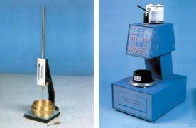

Vicat Appartus
The Vicat Appartus shown in Figure is used for setting time test also. The following procedure is adopted. Take 500 gm. of cement sample and guage it with 0.85 times the water required to produce cement paste of standard consistency (0.85 P). The paste shall be guaged and filled into the Vicat mould in specified manner within 3-5 minutes. Start the stop watch the moment water is added to the cement. The temperature of water and that of the test room, at the time of gauging shall be within 27°C ± 2°C.
Initial Setting Time
Lower the needle (C) gently and bring it in contact with the surface of the test block and quickly release. Allow it to penetrate into the test block. In the beginning, the needle will completely pierce through the test block. But after some time when the paste starts losing its plasticity, the needly may penetrate only to a depth of 33-35 mm from the top. The period elapsing between the time when water is added to the cement and the time at which the needle penetrates the test block to a depth equal to 33-35 mm from the top is taken as initial setting time.
Final Setting Time
Replace the needle (C) of the Vicat appartus by a circular attachment (F) shown in the Fig 2.8. The cement shall be considered as finally set when, upon, lowering the attachment gently cover the surface of the test block, the centre needle makes an impression, while the circular cutting edge of the attachment fails to do so. In other words the paste has attained such hardness that the centre needle does not pierce through the paste more than 0.5 mm.
- Explain in detail of any three tests for aggregates. (MAY/JUNE 2016)

Aggregatte Crushing Value
Strength of rock is found out by making a test specimen of cylindrical shape of size 25 mm diameter and 25 mm height. This cylinder is subjected to compressive stress. Different rock samples are found to give different compressive strength varying from a minimum of about 45 MPa to a maximum of 545 MPa. As said earlier, the compressive strength of parent rock does not exactly indicate the strength of aggregate in concrete. For this reason assessment of strength of the aggregate is made by using a sample of bulk aggregate in a standardised manner. This test is known as aggregate crushing value test. Aggregate crushing value gives a relative measure of the resistance of an aggregate sample to crushing under gradually applied compressive load. Generally, this test is made on single sized aggregate passing 12.5 mm and retained on 10 mm sieve. The aggregate is placed in a cylindrical mould and a load of 40 ton is applied through a plunger. The material crushed to finer than 2.36 mm is separated and expressed as a percentage of the original weight taken in the mould. This percentage is referred as aggregate crushing value. The crushing value of aggregate is restricted to 30 per cent for concrete used for roads and pavements and 45 per cent may be permitted for other structures.
The crushing value of aggregate is rather insensitive to the variation in strength of weaker aggregate. This is so because having been crushed before the application of the full load of 40 tons, the weaker materials become compacted, so that the amount of crushing during later stages of the test is reduced. For this reason a simple test known as “10 per cent fines value” is introduced. When the aggregate crushing value become 30 or higher, the result is likely to be inaccurate, in which case the aggregate should be subjected to “10 per cent fines value” test which gives a better picture about the strength of such aggregates.
This test is also done on a single sized aggregate as mentioned above. Load required to produce 10 per cent fines (particles finer than 2.36 mm) is found out by observing the penetration of plunger. The 10 per cent fines value test shows a good correlation with the standard crushing value test for strong aggregates while for weaker aggregates this test is more sensitive and gives a truer picture of the differences between more or less weak samples.
It should be noted that in the 10 per cent fines value test unlike the crushing value test, a higher numerical result denotes a higher strength of the aggregate. The detail of this test is given at the end of this chapter under testing of aggregate.
Aggregate Impact Value
With respect to concrete aggregates, toughness is usually considered the resistance of the material to failure by impact. Several attempts to develop a method of test for aggregates impact value have been made. The most successful is the one in which a sample of standard aggregate kept in a mould is subjected to fifteen blows of a metal hammer of weight 14 Kgs. falling from a height of 38 cms. The quantity of finer material (passing through 2.36 mm) resulting from pounding will indicate the toughness of the sample of aggregate. The ratio of the weight of the fines (finer than 2.36 mm size) formed, to the weight of the total sample taken is expressed as a percentage. This is known as aggregate impact value IS 283-1970 specifies that aggregate impact value shall not exceed 45 per cent by weight for aggregate used for concrete other than wearing surface and 30 per cent by weight, for concrete for wearing surfaces, such as run ways, roads and pavements.
Aggregate Abrasion Value
Apart from testing aggregate with respect to its crushing value, impact resistance, testing the aggregate with respect to its resistance to wear is an important test for aggregate to be used for road constructions, ware house floors and pavement construction. Three tests are in common use to test aggregate for its abrasion resistance. (i) Deval attrition test (ii) Dorry abrasion test (iii) Los Angels test
Los Angeles Test
Los Angeles test was developed to overcome some of the defects found in Deval test. Los Angeles test is characterised by the quickness with which a sample of aggregate may be tested. The applicability of the method to all types of commonly used aggregate makes this method popular. The test involves taking specified quantity of standard size material along with specified number of abrasive charge in a standard cylinder and revolving if for certain specified revolutions. The particles smaller than 1.7 mm size is separated out. The loss in weight expressed as percentage of the original weight taken gives the abrasion value of the aggregate. The abrasion value should not be more than 30 per cent for wearing surfaces and not more than 50 per cent for concrete other than wearing surface. Table 3.4 gives average values of crushing strength of rocks, aggregate crushing value, abrasion

Unit –II

CHEMICAL AND MINERAL ADMIXTURES

Part-A (2 Marks)

- What are admixtures?

A material other than water, aggregates, or cement that is used as an ingredient of concrete or mortar to control setting and early hardening, workability, or to provide additional cementing properties.

- What are the reasons behind the usage of admixture?

    - To obtain concrete with certain desired characteristics such as high compressive strength, high workability, and high performance and durability parameters to meet the requirement of complexity of modern structures.

    - The properties commonly modified are the heat of hydration, accelerate or retard setting time, workability, water reduction, dispersion and air-entrainment, impermeability and durability factors.

- What are the types of Admixtures?

    - Chemical admixtures - Accelerators, Retarders, Water-reducing agents, Super plasticizers, Air entraining agents etc.

    - Mineral admixtures - Fly-ash Blast-furnace slag, Silica fume and Rice husk Ash etc

  - What are plasticizers?

Plasticizers are water-reducing admixtures, which helps in the production of high strength concrete with less usage of water.

  - Explain the purpose of using admixtures in concrete?

- To achieve a higher strength by decreasing the water cement ratio at the same workability as an admixture free mix.

- To achieve the same workability by decreasing the cement content so as to reduce the heat of hydration in mass concrete.

- To increase the workability so as to ease placing in accessible locations

- Water reduction more than 5% but less than 12%

- The commonly used admixtures are Ligno-sulphonates and hydrocarbolic acid salts.

- Plasticizers are usually based on lignosulphonate, which is a natural polymer, derived from wood processing in the paper industry.

- Explain the term dispersion

Surface active agents alter the physic chemical forces at the interface. They are adsorbed on the cement particles, giving them a negative charge which leads to repulsion between the particles. Electrostatic forces are developed causing disintegration and the free water become available for workability.

- Explain the term Lubrication.

As these agents are organic by nature, thus they lubricate the mix reducing the friction and increasing the workability.

- Explain the term Retardation:

A thin layer is formed over the cement particles protecting them from hydration and increasing the setting time. Most normal plasticizers give some retardation, 30–90 minutes

9. What are Super Plasticizers? (MAY/JUNE 2016)

These are more recent and more effective type of water reducing admixtures also known as high range water reducer.

10. What are the benefits of super plasticizers?

- Increased fluidity:
- Flowing

- Self-leveling

- Self-compacting concrete

- Penetration and compaction round dense reinforcement Reduced W/C ratio:

- Very high early strength, >200% at 24 hours or earlier

- Very high later age strengths, >100 MPa or 15000 psi.

- Reduced shrinkage, especially if combined with reduced cement content.

- Improved durability by removing water to reduce permeability and diffusion.

- List the commonly used Super Plasticizers

- Sulphonated melamine formaldehyde condensates (SMF)

- Sulphonated naphthalene formaldehyde condensates (SNF)

- Polycarboxylate ether superplasticizers (PCE)

12. What are accelerators:

An admixture which, when added to concrete, mortar, or grout, increases the rate of hydration of hydraulic cement, shortens the time of set in concrete, or increases the rate of hardening or strength development.

Accelerating admixtures can be divided into groups based on their performance and application.

12. Explain how accelerators are divided?

- Set Accelerating Admixtures

- Hardening Accelerators

- What are Set retarders?

- The function of retarder is to delay or extend the setting time of cement paste in concrete.

- These are helpful for concrete that has to be transported to long distance, and helpful in placing the concrete at high temperatures

- The commonly known retards are Calcium Ligno-sulphonates and Carbohydrates derivatives used in fraction of percent by weight of cement.
- What is dormant period?

When water is first added to cement there is a rapid initial hydration reaction, after which there is little formation of further hydrates for typically 2–3 hours. The exact time depends mainly on the cement type and the temperature. This is called the dormant

period when the concrete is plastic and can be placed.

15. What are Air Entrained Admixtures? (MAY/JUNE 2016)

An addition for hydraulic cement or an admixture for concrete or mortar which causes air, usually in small quantity, to be incorporated in the form of minute bubbles in the concrete or mortar during mixing, usually to increase its workability and frost resistance. Air-entraining admixtures are surfactants that change the surface tension of the water..

16. What are the effects of air entrainment? (MAY/JUNE 2016)

Air entrainment is used to produce a number of effects in both the plastic and the hardened concrete. These include:

- Resistance to freeze – thaw action in the hardened concrete.

- Increased cohesion, reducing the tendency to bleed and segregation in the plastic concrete.

- Compaction of low workability mixes including semi - dry concrete.

- Stability of extruded concrete.

- Cohesion and handling properties in bedding mortars.

- List the types of mineral admixtures.

    - Cementitious

These have cementing properties themselves. For example:

Ground granulated blast furnace slag (GGBFS)

    - Pozzolanic. Examples are:

      - Fly ash

      - Silica Fume

      - Rice Husk Ash

      - Metakaolin

- Explain the term pozzolano? (MAY/JUNE 2016)

  - A pozzolano is a material which, when combined with calcium hydroxide (lime), exhibits cementitious properties.

  - Pozzolanos are commonly used as an addition (the technical term is "cement extender") to Portland cement concrete mixtures to increase the long-term strength and other material properties of Portland cement concrete and in some cases reduce the material cost of concrete

- Explain pozzolanic action. (MAY/JUNE 2016)

The additive act in three ways

  - Filler

  - Nucleating

  - Pozzolanic

- Explain the action of Filler in concrete?

These additives/admixtures are finer than cement, so when added to concrete they occupy the small pores previously left vacant.

21. Explain the action of Nucleating in concrete?

These fine particles accelerate the rate of hydration and precipitation starts.

- Explain the action of Pozzolanic in concrete? (MAY/JUNE 2016)

When cementing material reacts with water the following reaction take place:

C₂S + H CSH + CH

C₃S + H CSH + CH

CSH is responsible for strength while CH is a soluble material reacts and dissolves in water leaving behind pores. So when admixture is added

SiO₃ or Al₂O₃+ CH CSH

Thus, it reduces the amount of CH & increase CSH

23. What is GGBFS?

Ground granulated blast-furnace slag is the granular material formed when molten iron blast furnace slag (a by-product of iron and steel making) is rapidly chilled (quenched) by immersion in water. It is a granular product, highly cementitious in nature and, ground to cement fineness, hydrates like Portland cement.

24. What are the benefits of GGBFS?

- Durability

  - GGBFS cement is routinely specified in concrete to provide protection against both sulphate attack and chloride attack

  - GGBFS is also routinely used to limit the temperature rise in large concrete pours. The more gradual hydration of GGBFS cement generates both lower peak and less total overall heat than Portland cement.

- Appearance

  - In contrast to the stony grey of concrete made with Portland cement, the near-white color of GGBFS cement permits architects to achieve a lighter colour for exposed fair-faced concrete finishes, at no extra cost.

- Strength

Concrete containing GGBFS cement has a higher ultimate strength than concrete made with Portland cement. It has a higher proportion of the strength-enhancing calcium silicate hydrates (CSH) than concrete made with Portland cement only, and a reduced content of free lime, which does not contribute to concrete strength.
Concrete made with GGBFS continues to gain strength over time, and has been shown to double its 28 day strength over periods of 10 to 12 years.

  - Explain the use of fly Ash in concrete.

- The finely divided residue resulting from the combustion of ground or powdered coal.

- Fly ash is generally captured from the chimneys of coal-fired power plants; it has POZZOLANIC properties, and is sometimes blended with cement for this reason.

- Fly ash includes substantial amounts of silicon dioxide (SiO2) (both amorphous and crystalline) and calcium oxide (CaO).

- Toxic constituents include arsenic, beryllium, boron, cadmium, chromium, cobalt, lead, manganese, mercury, molybdenum, selenium, strontium, thallium, and vanadium.

- List the classes in flyash.
    - Class F Fly Ash

    - Class C Fly Ash:

  - What is the role of Rice Husk Ash in concrete.

This is a bio waste from the husk left from the grains of rice. It is used as a pozzolanic material in cement to increase durability and strength.

The silica is absorbed from the ground and gathered in the husk where it makes a structure and is filled with cellulose. When cellulose is burned, only silica is left which is grinded to fine powder which is used as pozzolana.

PART-B (16 Marks)

- Explain mineral admixtures in detail.

Pozzolanic or Mineral Admixtures
The use of pozzolanic materials is as old as that of the art of concrete construction. It was recognised long time ago, that the suitable pozzolans used in appropriate amount, modify certain properties of fresh and hardened mortars and concretes. Ancient Greeks and Romans used certain finely divided siliceous materials which when mixed with lime produced strong cementing material having hydraulic properties and such cementing materials were employed in the construction of acquaducts, arch, bridges etc. One such material was consolidated volcanic ash or tuff found near Pozzuoli (Italy) near Vesuvius. This came to be designated as Pozzuolana, a general term covering similar materials of volcanic origin found in other deposits in Italy, France and Spain. Later, the term pozzolan was employed throughout Europe to designate any materials irrespective of its origin which possessed similar properties.
Specimens of concrete made by lime and volcanic ash from Mount Vesuvius were used in the construction of Caligula Wharf built in the time of Julius Caesar nearly 2000 years ago is now existing in a fairly good condition. A number of structures stand today as evidence of the superiority of pozzolanic cement over lime. They also attest the fact that Greeks and Romans made real advance in the development of cementitious materials.
After the development of natural cement during the latter part of the 18th century, the Portland cement in the early 19th century, the practice of using pozzolans declined, but in more recent times, Pozzolans have been extensively used in Europe, USA and Japan, as an ingredient of Portland cement concrete particularly for marine and hydraulic structures.
It has been amply demonstrated that the best pozzolans in optimum proportions mixed with Portland cement improves many qualities of concrete, such as:
(a) Lower the heat of hydration and thermal shrinkage;
(b) Increase the watertightness;
(c ) Reduce the alkali-aggregate reaction;
(d ) Improve resistance to attack by sulphate soils and sea water;
(e) Improve extensibility;
(f ) Lower susceptibility to dissolution and leaching;
(g) Improve workability;
(h) Lower costs.
In addition to these advantages, contrary to the general opinion, good pozzolans will not unduly increase water requirement or drying shrinkage.
Pozzolanic Materials
Pozzolanic materials are siliceous or siliceous and aluminous materials, which in themselves possess little or no cementitious value, but will, in finely divided form and in the presence of moisture, chemically react with calcium hydroxide liberated on hydration, at ordinary temperature, to form compounds, possessing cementitious properties.
It has been shown in Chapter I that on hydration of tri-calcium silicate and di-calcium silicate, calcium hydroxide is formed as one of the products of hydration. This compound has no cementitious value and it is soluble in water and may be leached out by the percolating water. The siliceous or aluminous compound in a finely divided form react with the calcium hydroxide to form highly stable cementitious substances of complex composition involving water, calcium and silica. Generally, amorphous silicate reacts much more rapidly than the crystalline form. It is pointed out that calcium hydroxide, otherwise, a water soluble material is converted into insoluble cementitious material by the reaction of pozzolanic materials.
The reaction can be shown as
Pozzolan + Calcium Hydroxide + Water → C – S – H (Gel)
This reaction is called pozzolanic reaction. The characteristic feature of pozzolanic reaction is firstly slow, with the result that heat of hydration and strength development will be accordingly slow. The reaction involves the consumption of Ca(OH)₂ and not production of Ca(OH)₂. The reduction of Ca(OH)₂ improves the durability of cement paste by making the paste dense and impervious.
Pozzolanic materials can be divided into two groups: natural pozzolana and artificial pozzolana.
Natural Pozzolans
- Clay and Shales

- Opalinc Cherts

- Diatomaceous Earth

- Volcanic Tuffs and Pumicites.

- Describe about the role of accelerators and retarders in concrete.

Retarders
A retarder is an admixture that slows down the chemical process of hydration so that concrete remains plastic and workable for a longer time than concrete without the retarder. Retarders are used to overcome the accelerating effect of high temperature on setting properties of concrete in hot weather concreting. The retarders are used in casting and consolidating large number of pours without the formation of cold joints. They are also used in grouting oil wells. Oil wells are sometimes taken upto a depth of about 6000 meter deep where the temperature may be about 200°C. The annular spacing between the steel tube and the wall of the well will have to be sealed with cement grout. Sometimes at that depth stratified or porous rockstrata may also require to be grouted to prevent the entry of gas or oil into some other strata. For all these works cement grout is required to be in mobile condition for about 3 to 4 hours, even at that high temperature without getting set. Use of retarding agent is often used for such requirements.
Sometimes concrete may have to be placed in difficult conditions and delay may occur in transporting and placing. In ready mixed concrete practices, concrete is manufactured in central batching plant and transported over a long distance to the job sites which may take considerable time. In the above cases the setting of concrete will have to be retarded, so that concrete when finally placed and compacted is in perfect plastic state.
Retarding admixtures are sometimes used to obtain exposed aggregate look in concrete. The retarder sprayed to the surface of the formwork, prevents the hardening of matrix at the interface of concrete and formwork, whereas the rest of the concrete gets hardened. On removing the formwork after one day or so, the unhardened matrix can be just washed off by a jet of water which will expose the aggregates. The above are some of the instances where a retarding agent is used.

Perhaps the most commonly known retarder is calcium sulphate. It is interground to retard the setting of cement. The appropriate amount of gypsum to be used must be determined carefully for the given job. Use of gypsum for the purpose of retarding setting time is only recommended when adequate inspection and control is available, otherwise, addition of excess amount may cause undesirable expansion and indefinite delay in the setting of concrete.
In addition to gypsum there are number of other materials found to be suitable for this purpose. They are: starches, cellulose products, sugars, acids or salts of acids. These chemicals may have variable action on different types of cement when used in different quantities. Unless experience has been had with a retarder, its use as an admixture should not be attempted without technical advice. Any mistake made in this respect may have disastrous consequences.
Common sugar is one of the most effective retarding agents used as an admixture for delaying the setting time of concrete without detrimental effect on the ultimate strength. Addition of excessive amounts will cause indefinite delay in setting. At normal temperatures addition of sugar 0.05 to 0.10 per cent have little effect on the rate of hydration, but if the quantity is increased to 0.2 per cent, hydration can be retarded to such an extent that final set may not take place for 72 hours or more. Skimmed milk powder (casein) has a retarding effect mainly due to sugar content.
Other admixtures which have been successfully used as retarding agents are Ligno sulphonic acids and their salts, hydroxylated carboxylic acids and their salts which in addition to the retarding effect also reduce the quantity of water requirement for a given workability.
This also increases 28 days compressive strength by 10 to 20 per cent. Materials like mucic acid, calcium acetate and a commercial products by name “Ray lig binder” are used for set retarding purposes. These days admixtures are manufactured to combine set retarding and water reducing properties. They are usually mixtures of conventional water reducing agents plus sugars or hydroxylated carboxylic acids or their salts. Both the setting time and the rate of strength build up are effected by these materials.
Retarding Plasticizers
It is mentioned earlier that all the plasticizers and superplasticizers by themselves show certain extent of retardation. Many a time this extent of retardation of setting time offered by admixtures will not be sufficient. Instead of adding retarders separately, retarders are mixed with plasticizers or superplasticizers at the time of commercial production. Such commercial brand is known as retarding plasticizers or retarding superplasticizers. ASTM type D is retarding plasticizers and ASTM type G is retarding superplasticizer. In the commercial formulation we have also retarding and slump retaining version.
Retarding plasticizers or superplasticizers are important category of admixtures often used in the Ready mixed concrete industry for the purposes of retaining the slump loss, during high temperature, long transportation, to avoid construction or cold joints, slip form construction and regulation of heat of hydration.
One must be careful in the selection of such ready made retarding admixtures. On account of heterogeneous nature and different molecular weight of retarders used with plasticizers, they tend to separate out. It happens when sugar solution is used as cheap retarders. When retarders like gluconate is used such separation or settlement of retarders do not happen. It is cautioned that such retarding plasticizers should always be shaken thoroughly or well stirred before use. There are cases that settlement of retarders from rest of the ingredients causing excessive retardation and failure of structures.
Accelerators
Accelerating admixtures are added to concrete to increase the rate of early strength development in concrete to
- permit earlier removal of formwork;

- reduce the required period of curing;

- advance the time that a structure can be placed in service;

- partially compensate for the retarding effect of low temperature during cold weather concreting;

- in the emergency repair work.

Accelerating Plasticizers
Certain ingredients are added to accelerate the strength development of concrete to plasticizers or superplasticizers. Such accelerating superplasticizers, when added to concrete result in faster development of strength. The accelerating materials added to plasticizers or superplasticizers are triethenolamine chlorides, calcium nutrite, nitrates and flousilicates etc. The accelerating plasticizers or accelerating superplasticizers manufactured by well known companies are chloride free.

- What is the role of Fly ash as mineral admixtures?

Fly Ash:
Fly ash is finely divided residue resulting from the combustion of powdered coal and transported by the flue gases and collected by electrostatic precipitator. In U.K. it is referred as pulverised fuel ash (PFA). Fly ash is the most widely used pozzolanic material all over the world.

Fly ash was first used in large scale in the construction of Hungry Horse dam in America in the approximate amount of 30 per cent by weight of cement. Later on it was used in Canyon and Ferry dams etc. In India, Fly ash was used in Rihand dam construction replacing cement upto about 15 per cent.
In the recent time, the importance and use of fly ash in concrete has grown so much that it has almost become a common ingredient in concrete, particularly for making high strength and high performance concrete. Extensive research has been done all over the world on the benefits that could be accrued in the utilisation of fly ash as a supplementary cementitious material. High volume fly ash concrete is a subject of current interest all over the world.
The use of fly ash as concrete admixture not only extends technical advantages to the properties of concrete but also contributes to the environmental pollution control. In India alone, we produce about 75 million tons of fly ash per year, the disposal of which has become a serious environmental problem. The effective utilisation of fly ash in concrete making is, therefore, attracting serious considerations of concrete technologists and government departments.
Secondly, cement is the backbone for global infrastructural development. It was estimated that global production of cement is about 1.3 billion tons in 1996. Production of every tone of cement emits carbon dioxide to the tune of about 0.87 ton. Expressing it in another way, it can be said that 7% of the world’s carbon dioxide emission is attributable to Portland cement industry. Because of the significant contribution to the environmental pollution and to the high consumption of natural resources like limestone etc., we can not go on producing more and more cement. There is a need to economise the use of cement. One of the practical solutions to economise cement is to replace cement with supplementary cementitious materials like fly ash and slag.
There are two ways that the fly ash can be used: one way is to intergrind certain percentage of fly ash with cement clinker at the factory to produce Portland pozzolana cement (PPC) and the second way is to use the fly ash as an admixture at the time of making concrete at the site of work. The latter method gives freedom and flexibility to the user regarding the percentage addition of fly ash.
ASTM broadly classify fly ash into two classes.
Class F: Fly ash normally produced by burning anthracite or bituminous coal, usually has less than 5% CaO. Class F fly ash has pozzolanic properties only.
Class C: Fly ash normally produced by burning lignite or sub-bituminous coal. Some class C fly ash may have CaO content in excess of 10%. In addition to pozzolanic properties, class C fly ash also possesses cementitious properties.
Durability of Concrete
Sufficiently cured concrete containing good quality fly ash shows dense structure which offers high resistivity to the infiltration of deleterious substances.
A point for consideration is that the pozzolanic reactivity reduces the calcium hydroxide content, which results in reduction of passivity to the steel reinforcement and at the same time the additional secondary cementitious material formed makes the paste structure dense, and thereby gives more resistance to the corrosion of reinforcement. Which one will have an overriding effect on the corrosion of reinforcement will be a point in question. Published data reports that concrete with fly ash shows similar depth of carbonation as that of concrete without fly ash, as long as the compressive strength level is same.
It is also recognised that the addition of fly ash contributes to the reduction of the expansion due to alkali-aggregate reaction. The dilution effect of alkali and reduction of the water permeability due to dense texture may be one of the factors for reduction of alkali-aggregate reaction.
In conclusion it may be said that although fly ash is an industrial waste, its use in concrete significantly improve the long term strength and durability and reduce heat of hydration. In other words good fly ash will be an indispensable mineral admixture for high performance concrete.
High Volume Fly Ash Concrete (HVFA)
In India, the generation of fly ash is going to have a quantum jump in the coming decade. It is tentatively estimated that currently (2000 AD), we produce about 100 million tons of fly ash and out of which only about 5% is utilised, in making blended cements and in a few cases as mineral admixture. The disposal of remaining fly ash has become a serious problem. There will also be greater need to economise and to conserve the cement for more than one reasons.
One of the practical methods for conserving and economising cement and also to reduce the disposal problem of fly ash is to popularise the high volume fly ash concrete system.High volume fly ash concrete is a concrete where in 50 to 60% fly ash is incorporated. It was first developed for mass concrete application where low heat of hydration was of primary consideration. Subsequent work has demonstrated that this type of concrete showed excellent mechanical and durability properties required for structural applications and pavement constructions. Some investigations have also shown the potential use of the high volume fly ash system for shotcreting, light weight concrete and roller compacted concrete.
In Canada, considerable work is going on the development of blended cement incorporating high volume fly ash. The use of this type of cement permits to overcome the problem of additional quality control and storage facilities at the ready-mixed concrete batching plants.
Due to very low water content of high volume fly ash concrete, the use of superplasticizer becomes necessary for obtaining workable concrete. Use of air-entraining admixtures is also concurrently used.
- What is the role of silica fume as mineral admixtures? (MAY/JUNE 2016)

Silica Fume
Silica fume, also referred to as microsilica or condensed silica fume, is another material that is used as an artificial pozzolanic admixture. It is a product resulting from reduction of high purity quartz with coal in an electric arc furnace in the manufacture of silicon or ferrosilicon alloy. Silica fume rises as an oxidised vapour. It cools, condenses and is collected in cloth bags. It is further processed to remove impurities and to control particle size. Condensed silica fume is essentially silicon dioxide (more than 90%) in noncrystalline form. Since it is an airborne material like fly ash, it has spherical shape. It is extremely fine with particle size less than 1 micron and with an average diameter of about 0.1 micron, about 100 times smaller than average cement particles. Silica fume has specific surface area of about 20,000 m²/kg, as against 230 to 300 m²/kg.
Silica fume as an admixture in concrete has opened up one more chapter on the advancement in concrete technology. The use of silica fume in conjunction with superplasticizer has been the backbone of modern High performance concrete. In one article published in 1998 issue of ‘Concrete International’ by Michael Shydlowski, President, Master Builder, Inc states “Twenty five years ago no one in the concrete construction industry could even imagine creating and placing concrete mixes that would achieve in place compressive strengths as high as 120 MPa . The structures such as Key Tower in Cleaveland with a design strength of 85 MPa, and Wacker Tower in Chicago with specified concrete strength of 85 MPa, and two Union Square in Seattle with concrete that achieved 130 MPa strength – are testaments to the benefits of silica fume technology in concrete construction”.
It should be realised that silica fume by itself, do not contribute to the strength dramatically, although it does contribute to the strength property by being very fine pozzolanic material and also creating dense packing and pore filler of cement paste. Really speaking, the high strengths of high performance concrete containing silica fume are attributable, to a large degree, to the reduction in water content which becomes possible in the presence of high dose of superplasticizer and dense packing of cement paste.
Indian Scenario
Silica fume has become one of the necessary ingredients for making high strength and high performance concrete. In India, silica fume has been used very rarely. Nuclear Power Corporation was one of the first to use silica fume concrete in their Kaiga and Kota nuclear power projects.
Silica fume was also used for one of the flyovers at Mumbai where, for the first time in India 75 MPa concrete was used (1999). Silica fume is also now specified for the construction of proposed Bandra-Worli sea link project at Mumbai.
At present, India is not producing silica fume of right quality. Recently, Steel Authority of India has provided necessary facilities to produce annually about 3000 tons of silica fume at their Bhadravathi Complex. It appears that the quality of silica fume produced by them needs upgradation.
Since silica fume or microsilica is an important new material, let us see this material in some detail.
- microsilica is initially produced as an ultrafine undensified powder
- at least 85% SiO₂ content

- mean particle size between 0.1 and 0.2 micron

- minimum specific surface area is 15,000 m²/kg

- spherical particle shape.

Available forms
Microsilica is available in the following forms:
- Undensified forms with bulk density of 200–300 kg/m³

- Densified forms with bulk density of 500–600 kg/m³

- Micro-pelletised forms with bulk density of 600–800 kg/m³

- Slurry forms with density 1400 kg/m³.
- Slurry is produced by mixing undensified microsilica powder and water in equal proportions by weight. Slurry is the easiest and most practical way to introduce microsilica into the concrete mix
- Surface area 15–20 m²/g

- Standard grade slurry pH value 4.7, specific gravity 1.3 to 1.4, dry content of microsilica 48 to 52%.

Pozzolanic Action
Microsilica is much more reactive than fly ash or any other natural pozzolana. The reactivity of a pozzolana can be quantified by measuring the amount of Ca(OH)₂ in the cement paste at different times. In one case, 15% of microsilica reduced the Ca(OH)₂ of two samples of cement from 24% to 12% at 90 days and from 25% to 11% in 180 days. Most research workers agree that the C – S – H formed by the reaction between microsilica and Ca(OH)₂ appears dense and amorphous.^{5.14}
Influence on Fresh Concrete
Water demand increases in proportion to the amount of microsilica added. The increase in water demand of concrete containing microsilica will be about 1% for every 1% of cement substituted. Therefore, 20 mm maximum size aggregate concrete, containing 10% microsilica, will have an increased water content of about 20 litres/m³. Measures can be taken to avoid this increase by adjusting the aggregate grading and using superplasticizers. The addition of microsilica will lead to lower slump but more cohesive mix. The microsilica make the fresh concrete sticky in nature and hard to handle. It was also found that there was large reduction in bleeding and concrete with microsilica could be handled and transported without segregation.
It is reported that concrete containing microsilica is vulnerable to plastic shrinkage cracking and, therefore, sheet or mat curing should be considered. Microsilica concrete produces more heat of hydration at the initial stage of hydration. However, the total generation of heat will be less than that of reference concrete.
Influence on Hardened Concrete
Concrete containing microsilica showed outstanding characteristics in the development of strength. Fig. 5.30 shows that 60 to 80 MPa can be obtained relatively easily. It has been also found out that modulus of elasticity of microsilica concrete is less than that of concrete without microsilica at the same level of compressive strength.
As regards, the improvement in durability aspects many published reports, of this investigation carried out, indicate improvement in durability of concrete with microsilica. There are some investigations indicating contradiction, particularly with reference to resistance against frost damage.
With regard to whether or not, silica fume is effective for alkali-aggregate reaction, some research workers report that it is effective, others conclude that while it is effective, addition of silica fume in small quantities actually increases the expansion.
Mixing
By far the most popular application of microsilica is in the 50 : 50 slurry form; as it is easy to store and dispense. There are conflicting views on whether microsilica is best added in powder or slurry form. The work by Hooton among others showed that, for equivalent microsilica additions, slurry produced significantly higher compressive and tensile strengths.
Curing
Curing is probably the most important aspect of microsilica concrete as the material undergoes virtually zero bleeding. If the rate of evaporation from the surface is faster than the rate of migration of water from interior to the surface, plastic shrinkage takes place. In the absence of bleeding and slow movement of water from interior to the surface, early curing by way of membrane curing is essential.

- Explain the characteristics of GGBS and how it enhances the chemical properties of concrete. (MAY/JUNE 2016)

Ground Granulated Blast Furnace Slag (GGBS)
Ground granulated blast-furnace slag is a nonmetallic product consisting essentially of silicates and aluminates of calcium and other bases. The molten slag is rapidly chilled by quenching in water to form a glassy sand like granulated material. The granulated material when further ground to less than 45 micron will have specific surface of about 400 to 600 m²/ kg (Blaine). The chemical composition of Blast Furnace Slag (BFS) is similar to that of cement clinker. The performance of slag largely depends on the chemical composition, glass content and fineness of grinding.
In India, we produce about 7.8 million tons of blast furnace slag. All the blast furnace slags are granulated by quenching the molten slag by high power water jet, making 100% glassy slag granules of 0.4 mm size. Indian blast furnace slag has been recently evaluated by Banerjee A.K. and the summary of the same has been reproduced in Table 5.20.

The blast furnace slag is mainly used in India for manufacturing slag cement. There are two methods for making Blast Furnace Slag Cement. In the first method blast furnace slag is interground with cement clinker alongwith gypsum. In the second method blast furnace slag is separately ground and then mixed with the cement.

Clinker is hydraulically more active than slag. It follows then that slag should be ground finer than clinker, in order to fully develop its hydraulic potential. However, since slag is much harder and difficult to grind compared to clinker, it is ground relatively coarser during the process of inter-grinding. This leads to waste of hydraulic potential of slag. Not only that the inter-grinding seriously restricts the flexibility to optimise slag level for different uses.

The hydraulic potential of both the constituents – clinker and slag can be fully exploited if they are ground separately. The level of fineness can be controlled with respect to activity, which will result in energy saving. The present trend is towards separate grinding of slag and clinker to different levels. The clinker and gypsum are generally ground to the fineness of less than 3000 cm² /g (Blaine) and slag is ground to the level of 3000–4000 cm²/g (Blaine) and stored separately. They are blended after weigh batching, using paddle wheel blenders, or pneumatic blenders. Pneumatic blenders give better homogeneity when compared to mechanical blenders.
Just as fly ash is used as an admixture in making concrete Ground Granulated Blast-furnace Slag popularly called GGBS is used as an admixture in making concrete. In other countries its use as an admixture is more common than its use as slag cement. Now in India, since it is available separately as ground granulated blast-furnace slag (GGBS), its use as admixture should become more common. Recently for marine outfall work at Bandra, Mumbai, GGBS has been used as an admixture to replace cement to the tune of 70%. Presently in India, with the growing popularity of RMC, the scope for using GGBS for customer’s tailor made requirements should also become popular.
Performance of GGBS in Concrete
Fresh Concrete: The replacement of cement with GGBS will reduce the unit water content necessary to obtain the same slump. This reduction of unit water content will be more pronounced with increase in slag content and also on the fineness of slag. This is because of the surface configuration and particle shape of slag being different than cement particle. In addition, water used for mixing is not immediately lost, as the surface hydration of slag is slightly slower than that of cement.
Reduction of bleeding is not significant with slag of 4000 cm²/g fineness. But significant beneficial effect is observed with slag fineness of 6000 cm²/g and above.
Hardened Concrete: Exclusive research works have shown that the use of slag leads to the enhancement of intrinsic properties of concrete in both fresh and hardened conditions. The major advantages recognised are
- Reduced heat of hydration

- Refinement of pore structures

- Reduced permeabilities to the external agencies

- Increased resistance to chemical attack.

Unit –III

PROPORTIONING OF CONCRETE MIX

Part-A (2 Marks)

- Define Concrete Durability.

“Durability of concrete is the ability of concrete to withstand the harmful effects

of environment to which it will be subjected to, during its service life, without undergoing into deterioration beyond acceptable limits”.

- Define concrete mix design. (MAY/JUNE 2016)

Concrete mix design is defined as the appropriate selection and proportioning of

constituents to produce a concrete with pre-defined characteristics in the fresh and hardened states.

- What are the factors influencing the selection of materials?

The selection and proportioning of materials depend on:

  - the structural requirements of the concrete

  - the environment to which the structure will be exposed

  - the job site conditions, especially the methods of concrete production, transport, placement, compaction and finishing

  - the characteristics of the available raw materials

- Write the Factors Influencing Consistency.

The consistency of fresh concrete depends on many factors, the main ones being:

  - Water Content (kg/m3) W/c Ratio

  - Fineness Modulus of the Aggregate

  - Use of Water Reducers (Plasticizers / Super plasticizers)

  - Type and shape of Aggregate

  - Entrained Air Content

- What are the Factors affecting Strength of Hardened concrete?

The strength of hardened concrete depends on many factors, the main ones being:

  - W/C Ratio

  - Strength of the Cement

  - Type and shape of Aggregate

  - Entrained Air Content

- What are the sequence of steps should be followed in ACI method?

    - determine the job parameters - aggregate properties,

    - maximum aggregate size, slump, w/c ratio, admixtures,

    - calculation of batch weight, and

    - Adjustments to batch weights based on trial mix.

- What are the principal properties of “good” concrete?

  - cement

  - w/c ratio

  - aggregate

  - cement paste and aggregate mixing

  - placement and handling of fresh concrete

  - curing

- Mention the Maximum aggregate size to be used in Mix Design as per ACI.

Maximum size should not be larger than 1/5 the minimum dimension of structural

members, 1/3 the thickness of a slab, or 3/4 the clearance between reinforcing rods and forms. These restrictions limit maximum aggregate size to 1.5 inches,

- What are the Requirements of concrete mix design as per BIS?

    - The minimum compressive strength required from structural consideration

    - The adequate workability necessary for full compaction with the compacting equipment available.

    - Maximum water-cement ratio and/or maximum cement content to give adequate durability for the particular site conditions

    - Maximum cement content to avoid shrinkage cracking due to temperature cycle in mass concrete

- Give the types of concrete mixes.

  - Nominal mixes

  - Standard mixes

  - Design mixes

- Define Nominal Mixes (MAY/JUNE 2016)

In the past the specifications for concrete prescribed the proportions of cement,

fine and coarse aggregates. These mixes of fixed cement-aggregate ratio which ensures adequate strength are termed nominal mixes. These offer simplicity and under normal circumstances, have a margin of strength above that specified. However, due to the variability of mix ingredients the nominal concrete for a given workability varies widely in strength.

12. Define Standard mixes(MAY/JUNE 2016)

The nominal mixes of fixed cement-aggregate ratio (by volume) vary widely in strength and may result in under- or over-rich mixes. For this reason, the minimum compressive strength has been included in many specifications. These mixes are termed standard mixes.

IS 456-2000 has designated the concrete mixes into a number of grades as M10, M15, M20, M25, M30, M35 and M40. In this designation the letter M refers to the mix

and the number to the specified 28 day cube strength of mix in N/mm². The mixes of grades M10, M15, M20 and M25 correspond approximately to the mix proportions (1:3:6), (1:2:4), (1:1.5:3) and (1:1:2) respectively.
- What is Designed Mixes? (MAY/JUNE 2016)

In these mixes the performance of the concrete is specified by the designer but the

mix proportions are determined by the producer of concrete, except that the minimum cement content can be laid down. This is most rational approach to the selection of mix proportions with specific materials in mind possessing more or less unique characteristics. The approach results in the production of concrete with the appropriate properties most economically. However, the designed mix does not serve as a guide since this does not guarantee the correct mix proportions for the prescribed performance.

14 . What are the Factors affecting the choice of mix proportions ?

The various factors affecting the mix design are:

  - Compressive strength

  - Workability

  - Durability

  - Maximum nominal size of aggregate

  - Grading and type of aggregate

  - Quality Control

- What is batching of concrete?

Batching is the process of measuring concrete mix ingredients by either mass or

volume and introducing them into the mixer. To produce concrete of uniform quality, the ingredients must be measured accurately for each batch

16. Define weigh batching.

Weigh batching is defined as measuring the constituent materials for mortar or concrete by weight.

17. What is volume batching?

Volume batching is defined as the measuring of the constituent materials for mortar or concrete by volume.

18. What is the use of chute in concreting?

Concrete chutes put your concrete where you want it. Maintain quality and strength and eliminate segregation. Get your concrete forming work done faster with our concrete cement chutes. Many different sizes and lengths available for your job and there are lightweight aluminum and easy to handle.

19. What are belt conveyors?

A conveyor belt (or belt conveyor) consists of two or more pulleys, with a continuous loop of material - the conveyor belt - that rotates about them. One or both of the pulleys are powered, moving the belt and the material on the belt forward. The powered pulley is called the drive pulley while the unpowered pulley is called the idler. There are two main industrial classes of belt conveyors; Those in

general material handling such as those moving boxes along inside a factory and bulk material handling such as those used to transport industrial and agricultural materials, such as grain, coal, ores, etc. generally in outdoor locations.

20. Define mixing time of concrete.

The various components of a mix are proportioned so that the resulting concrete has adequate strength, proper workability for placing and cost effective. To achieve such properties the mixing should such that it produce an intimate mixture of cement, water, fine and coarse aggregate and suitable admixture of uniform consistency throughout each batch. The average strength of concrete increases with an increase in mixing time as it improves uniformity of mix.

21. What is retempering?

Retempering is typically done to restore concrete slump back to specified limits. The practice is known to result in some loss of strength which is proportional to the amount of water added. When retempering of concrete is done only to restore slump as per ACI 116 definition, it causes a loss incompressive strength of 7 to 10 percent, but it can be much higher depending on the amount of retempering water added

22. State any two uses of wheel barrow.
Wheelbarrow is a small hand-propelled vehicle, usually with just one wheel, designed to be pushed and guided by a single person using two handles to the rear or by a sail to push the ancient wheelbarrow by wind. The term "wheelbarrow" is made of two words: "wheel" and "barrow." "Barrow" is a derivation of the Old English "bearwe" which was a device used for carrying loads

23. What is hoist?

Hoist or winder[ is used to raise and lower conveyances within the mine shaft. Modern hoists are normally powered using electric motors, historically with direct current drives utilizing solid-state converters (thyristors), however modern large hoists utilize alternating current drives that are variable frequency controller

24. Define revibration.

Vibration done some time after the concrete has been placed and consolidated is known as revibration. When properly done, revibration can be beneficial. It is most effective when the running vibrator will just barely sink from its own weight and energy, which may in some circumstances be several hours after casting. Revibrated concrete may be considerably stronger and more free of bug holes than ordinary concrete, but care must be taken, especially with architectural concrete, not to allow the vibrator to penetrate into a layer of hardened

Part-B (16 Marks)

- Explain the Design Procedure for IS method of Concrete Mix Design. (MAY/JUNE 2016)

Procedure for Concrete Mix Design – IS456:2000
Step1. Determine the mean target strength ft from the specified characteristic compressive strength
at 28-day fck and the level of quality control.
ft = fck + 1.65 S
Where, S is the standard deviation obtained from the Table of approximate contents given
after the design mix.
Step 2.Obtain the water cement ratio for the desired mean target using the empirical relationship
between compressive strength and water cement ratio so chosen is checked against the limiting water cement ratio. The water cement ratio so chosen is checked against the limiting water cement ratio for the requirements of durability given in table and adopts the lower of the two values.
Step 3.Estimate the amount of entrapped air for maximum nominal size of the aggregate from the
table.
Step 4. Select the water content, for the required workability and maximum size of aggregates (for
aggregates in saturated surface dry condition) from table.
Step 5. Determine the percentage of fine aggregate in total aggregate by absolute volume from table
for the concrete using crushed coarse aggregate.
Step 6.Adjust the values of water content and percentage of sand as provided in the table for any
difference in workability, water cement ratio, grading of fine aggregate and for rounded aggregate the values are given in table.
Step 7.Calculate the cement content form the water-cement ratio and the final water content as arrived after adjustment. Check the cement against the minimum cement content from the requirements of the durability, and greater of the two values is adopted.
Step 8.From the quantities of water and cement per unit volume of concrete and the percentage of
sand already determined in steps 6 and 7 above, calculate the content of coarse and fine aggregates per unit volume of concrete from the following relations:
Where, V = absolute volume of concrete = gross volume (1m3) minus the volume of
entrapped air
Sc = specific gravity of cement
W = Mass of water per cubic metre of concrete, kg
C = mass of cement per cubic metre of concrete, kg
p = ratio of fine aggregate to total aggregate by absolute volume
fa, Ca = total masses of fine and coarse aggregates, per cubic metre of concrete,respectively, kg, and
Sfa, Sca = specific gravities of saturated surface dry fine and coarse aggregates, respectively
Step 9. Determine the concrete mix proportions for the first trial mix.
Step 10. Prepare the concrete using the calculated proportions and cast three cubes of 150 mm size
and test them wet after 28-days moist curing and check for the strength.
Step 11. Prepare trial mixes with suitable adjustments till the final mix proportions are arrived at.

- Describe about the Sampling and Acceptance criteria

Sampling and Acceptance Criteria

A random sampling procedure should be adopted to ensure that each concrete batch will have reasonable chance of being tested. It means that sampling and cube casting should be spread over the entire period of concreting. In case of more than one mixing units or batching plants are used for a concrete construction, the sampling should cover all the mixing units.

Frequency of Sampling:
The minimum frequency of sampling of concrete of each grade will be as shown in Table

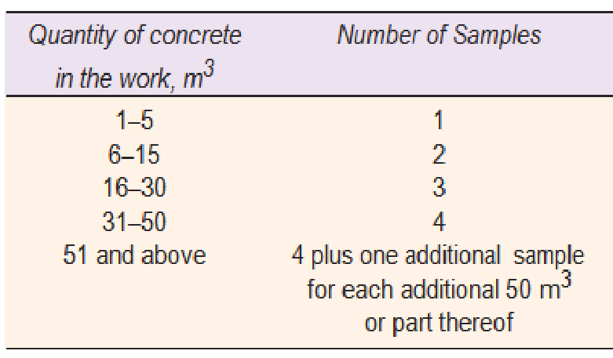

Test Specimen: Three test specimens should be made for each sample for testing at 28 days. Additional samples may be required for 7 days strength or for finding out the strength for striking the formwork etc.
Test Results: The test result of sample is the overage of the strength of three specimen. The individual variation should not be more than ± 15 per cent of the overage. If more, the test result of the sample is rejected.
In a major construction site a register is maintained showing the test results of the samples of concrete taken. Possibly samples should denote the time and part of the structure to which the concrete represented by this samples has been used, so that the strength of test specimen and the part of the structure can be matched, if need be. The test register is an important legal document and should be kept in safe custody. When the number of samples tested becomes more than 30 or at a pre determined interval of time, standard deviation is worked out to see that the mix design adopted is neither very conservative nor too liberal. If so, using the standard deviation actually worked out from the kind of quality control exercised at site, a fresh mix design is worked out and the proportions of materials are recast. In other words mix design is not a one time job. It should be reviewed continuously to make the whole concreting operation safe and economical.
Earlier it was said that 5 per cent of test results are allowed to fall below the characteristic strength. But it was not mentioned that this 5 per cent is how much below the characteristic strength. IS 456 of 2000 has simplified the earlier version of acceptance criteria of concrete used in a major work site.

Acceptance Criteria
Compressive strength
The concrete is deemed to comply with the compressive strength requirements when both the following conditions are met,
(a) The mean strength determined from any group of four consecutive test results complies with the appropriate limits in column 2 of Table 11.29.
(b) Any individual test result complies with the appropriate limits in column 3 of Table 11.29
Flexural strength
When both the following conditions are met, the concrete complies with the specified flexural strength.
(a) The mean strength determined from any group of four consecutive test results exceeds the specified characteristic strength by at least 0.3 N/mm²
(b) The strength determined from any test result is not less than the specified characteristic strength less 0.3 N/mm²

- Design the concrete mix for grade M50 with suitable conditions. Find the quantities of constituents of the mix for a bag of cement. (MAY/JUNE 2016)

CONCRETE MIX DESIGN EXAMPLE – M50 GRADE CONCRETE
Grade Designation = M-50
Type of cement = O.P.C-43 grade
Brand of cement = Vikram ( Grasim )
Admixture = Sika [Sikament 170 ( H ) ]
Fine Aggregate = Zone-II
Sp. Gravity
Cement = 3.15
Fine Aggregate = 2.61
Coarse Aggregate (20mm) = 2.65
Coarse Aggregate (10mm) = 2.66
Minimum Cement (As per contract) =400 kg / m3
Maximum water cement ratio (As per contract) = 0.45

Mix Calculation: –
1. Target Mean Strength = 50 + (5 X 1.65 ) = 58.25 Mpa
2. Selection of water cement ratio:-
Assume water cement ratio = 0.35
3. Calculation of water: –
Approximate water content for 20mm max. Size of aggregate = 180 kg /m3 (As per Table No.5, IS : 10262 ). As plasticizer is proposed we can reduce water content by 20%.
Now water content = 180 X 0.8 = 144 kg /m3
4. Calculation of cement content:-
Water cement ratio = 0.35
Water content per cum of concrete = 144 kg
Cement content = 144/0.35 = 411.4 kg / m3
Say cement content = 412 kg / m3 (As per contract Minimum cement content 400 kg / m3)
Hence O.K.

5. Calculation for C.A. & F.A.: –
Volume of concrete = 1 m3
Volume of cement = 412 / (3.15 X 1000) = 0.1308 m3
Volume of water = 144 / (1 X 1000) = 0.1440 m3
Volume of Admixture = 4.994 / (1.145 X 1000) = 0.0043 m3
Total weight of other materials except coarse aggregate = 0.1308 + 0.1440 +0.0043 = 0.2791m3
Volume of coarse and fine aggregate = 1 – 0.2791 = 0.7209 m3
Volume of F.A. = 0.7209 X 0.33 = 0.2379 m3 (Assuming 33% by volume of total aggregate)
Volume of C.A. = 0.7209 – 0.2379 = 0.4830 m3
Therefore weight of F.A. = 0.2379 X 2.61 X 1000 = 620.919 kg/ m3
Say weight of F.A. = 621 kg/ m3
Therefore weight of C.A. = 0.4830 X 2.655 X 1000 = 1282.365 kg/ m3
Say weight of C.A. = 1284 kg/ m3
Considering, 20 mm: 10mm = 0.55: 0.45
20mm = 706 kg.
10mm = 578 kg.
Hence Mix details per m3
Increasing cement, water, admixture by 2.5% for this trial
Cement = 412 X 1.025 = 422 kg
Water = 144 X 1.025 = 147.6 kg
Fine aggregate = 621 kg
Coarse aggregate 20 mm = 706 kg
Coarse aggregate 10 mm = 578 kg
Admixture = 1.2 % by weight of cement = 5.064 kg.

Water: cement: F.A.: C.A. = 0.35: 1: 1.472: 3.043

Observations from Concrete Mix Design: –
A. Mix was cohesive and homogeneous.
B. Slump = 120 mm
C. No. of cube casted = 9 Nos.
7 days average compressive strength = 52.07 MPa.
28 days average compressive strength = 62.52 MPa which is greater than 58.25MPa
Hence the mix accepted.

- Explain the factors that influence the choice of mix design. (MAY/JUNE 2016)

Factors to be considered for mix design
• The grade designation giving the characteristic strength requirement of concrete.
• The type of cement influences the rate of development of compressive strength of concrete.
• Maximum nominal size of aggregates to be used in concrete may be as large as possible within the limits prescribed by IS 456:2000.
• The cement content is to be limited from shrinkage, cracking and creep.
• The workability of concrete for satisfactory placing and compaction is related to the size and shape of section, quantity and spacing of reinforcement and technique used for transportation, placing and compaction.

- What type of equipment is used for placing concrete? In what way does this equipment avoid segregation during placing?
Placing Concrete
It is not enough that a concrete mix correctly designed, batched, mixed and transported, it is of utmost importance that the concrete must be placed in systematic manner to yield optimum results. The precautions to be taken and methods adopted while placing concrete Concrete is invariably laid as foundation bed below the walls or columns. Before placing the concrete in the foundation, all the loose earth must be removed from the bed. Any root of trees passing through the foundation must be cut, charred or tarred effectively to prevent its further growth and piercing the concrete at a later date. The surface of the earth, if dry, must be just made damp so that the earth does not absorb water from concrete. On the other hand if the foundation bed is too wet and rain-soaked, the water and slush must be removed completely to expose firm bed before placing concrete. If there is any seepage of water taking place into the foundation trench, effective method for diverting the flow of water must be adopted before concrete is placed in the trench or pit.
Construction of road slabs, airfield slabs and ground floor slabs in buildings, concrete is placed in bays. The ground surface on which the concrete is placed must be free from loose earth, pool of water and other organic matters like grass, roots, leaves etc. The earth must be properly compacted and made sufficiently damp to prevent the absorption of water from concrete. If this is not done, the bottom portion of concrete is likely to become weak. Sometimes, to prevent absorption of moisture from concrete, by the large surface of earth, in case of thin road slabs, use of polyethylene film is used in between concrete and ground. Concrete is laid in alternative bays giving enough scope for the concrete to undergo sufficient shrinkage. Provisions for contraction joints and dummy joints are given. It must be remembered that the concrete must be dumped and not poured. It is also to be ensured that concrete must be placed in just required thickness. The practice of placing concrete in a heap at one place and then dragging it should be avoided.
When concrete is laid in great thickness, as in the case of concrete raft for a high rise building or in the construction of concrete pier or abutment or in the construction of mass concrete dam, concrete is placed in layers. The thickness of layers depends upon the mode of compaction. In reinforced concrete, it is a good practice to place concrete in layers of about 15 to 30 cm thick and in mass concrete, the thickness of layer may vary anything between 35 to 45 cm. Several such layers may be placed in succession to form one lift, provided they follow one another quickly enough to avoid cold joints. The thickness of layer is limited by the method of compaction and size and frequency of vibrator used.
Before placing the concrete, the surface of the previous lift is cleaned thoroughly with water jet and scrubbing by wire brush. In case of dam, even sand blasting is also adopted. The old surface is sometimes hacked and made rough by removing all the laitance and loose material. The surface is wetted. Sometimes, a neat cement slurry or a very thin layer of rich mortar with fine sand is dashed against the old surface, and then the fresh concrete is placed

The whole operation must be progressed and arranged in such a way that, cold joints are avoided as far as possible. When concrete is laid in layers, it is better to leave the top of the layer rough, so that the succeeding layer can have a good bond with the previous layer. Where the concrete is subjected to horizontal thrust, bond bars, bond rails or bond stones are provided to obtain a good bond between the successive layers. Of course, such arrangements are required for placing mass concrete in layers, but not for reinforced concrete

- Describe the various aspects of pumping concrete.

Pumps and Pipeline
Pumping of concrete is universally accepted as one of the main methods of concrete transportation and placing. Adoption of pumping is increasing throughout the world as pumps become more reliable and also the concrete mixes that enable the concrete to be pumped are also better understood.
Development of Concrete Pump: The first patent for a concrete pump was taken in USA in the year 1913. By about 1930 several countries developed and manufactured concrete pump with sliding plate valves. By about 1950s and 1960s concrete pumping became widely used method in Germany. Forty per cent of their concrete was placed by pumping. The keen rivalry between the leading German manufacturers, namely, Schwing, Putzmeister and Elba, has boosted the development of concrete pump and in particular the valve design which is the most important part of whole system.

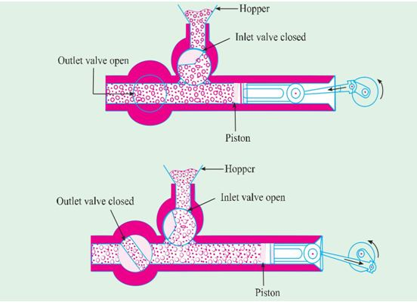

Pumpable Concrete : A concrete which can be pushed through a pipeline is called a pumpable concrete. It is made in such a manner that its friction at the inner wall of the pipeline does not become very high and that it does not wedge while flowing through the pipeline. A clear understanding of what happens to concrete when it is pumped through pipeline is fundamental to any study of concrete pumping. Pumpable concrete emerging from a pipeline flows in the form of a plug which is separated from the pipe wall by a thin lubricating layer consisting of cement paste. The water in the paste is hydraulically linked with the interparticle water layer in the plug. Fig. 6.17 shows the concrete flow under pressure.
For continuous plug movement, the pressure generated by the flow resistance must not be greater than the pump pressure rating. However, if the concrete is too saturated at higher w/c ratio, the concrete at certain pump pressures may be such that water is forced out of the mix, creating an increase in flow resistance and a possible blockage. Fig. 6.18 illustrates such a condition. In other words, a very stiff concrete is not pumpable and also a concrete with high w/c ratio is also not pumpable. It is interesting to note that if a concrete is pumpable, it is implied that it is a good concrete.
Choosing the Correct Pump

For choosing the correct pump one must know the following factors
- Length of horizontal pipe

- Length of vertical pipe

- Number of bends

- Diameter of pipeline

- Length of flexible hose

- Changes in line diameter
- Slump of Concrete

- What are the precautions to be taken while adopting the steam curing method?

We have discussed in Chapter I the hydration aspect of cement. Concrete derives its strength by the hydration of cement particles. The hydration of cement is not a momentary action but a process continuing for long time. Of cource, the rate of hydration is fast to start with, but countinues over a very long time at a decreasing rate. The quantity of the product of hydration and consequently the amount of gel formed depends upon the extent of hydration. It has been mentioned earlier that cement requires a water/cement ratio about 0.23 for hydration and a water/cement ratio of 0.15 for filling the voids in the gel pores. In other words, a water/cement ratio of about 0.38 would be required to hydrate all the particles of cement and also to occupy the space in the gel pores. Theoretically, for a concrete made and contained in a sealed container a water cement ratio of 0.38 would satisfy the requirement of water for hydration and at the same time no capillary vavities would be left. However, it is seen that practically a water/cement ratio of 0.5 will be required for complete hydration in a sealed container for keeping up the desirable relative humidity level.
In the field and in actual work, it is a different story. Even though a higher water/cement ratio is used, since the concrete is open to atmosphere, the water used in the concrete evaporates and the water available in the concrete will not be sufficient for effective hydration to take place particularly in the top layer. Fig. 5.33 on page 173, Chapter 5, shows the drying behaviour of concrete. If the hydration is to continue unbated, extra water must be added to replenish the loss of water on account of absorption and evaporation. Alternatively, some measures must be taken by way of provision of impervious covering or application of curing compounds to prevent the loss of water from the surface of the concrete. Therefore, the curing can be considered as creation of a favourable environment during the early period for uninterrupted hydration. The desirable conditions are, a suitable temperature and ample moisture.
Curing can also be described as keeping the concrete moist and warm enough so that the hydration of cement can continue. More elaborately, it can be described as the process.
Curing is being given a place of increasing importance as the demand for high quality concrete is increasing. It has been recognized that the quality of concrete shows all round improvement with efficient uninterrupted curing. If curing is neglected in the early period of hydration, the quality of concrete will experience a sort of irreparable loss. An efficient curing in the early period of hydration can be compared to a good and wholesome feeding given to a new born baby
Curing Methods
Curing methods may be divided broadly into four categories:
(a) Water curing
(b) Membrane curing
(c ) Application of heat
(d) Miscellaneous
Water Curing
This is by far the best method of curing as it satisfies all the requirements of curing, namely, promotion of hydration, elimination of shrinkage and absorption of the heat of hydration. It is pointed out that even if the membrane method is adopted, it is desirable that a certain extent of water curing is done before the concrete is covered with membranes. Water curing can be done in the following ways:
(a) | Immersion | (b) | Ponding
(c) | Spraying or Fogging | (d ) | Wet covering

The precast concrete items are normally immersed in curing tanks for a certain duration. Pavement slabs, roof slab etc. are covered under water by making small ponds. Vertical retaining wall or plastered surfaces or concrete columns etc. are cured by spraying water. In some cases, wet coverings such as wet gunny bags, hessian cloth, jute matting, straw etc., are wrapped to vertical surface for keeping the concrete wet. For horizontal surfaces saw dust,
Membrane Curing
Sometimes, concrete works are carried out in places where there is acute shortage of water. The lavish application of water for water curing is not possible for reasons of economy.It has been pointed out earlier that curing does not mean only application of water, it means also creation of conditions for promotion of uninterrupted and progressive hydration. It is also pointed out that the quantity of water, normally mixed for making concrete is more than sufficient to hydrate the cement, provided this water is not allowed to go out from the body of concrete. For this reason, concrete could be covered with membrane which will effectively seal off the evaporation of water from concrete. It is found that the application of membrane or a sealing compound, after a short spell of water curing for one or two days is sometimes beneficial.
Sometimes, concrete is placed in some inaccessible, difficult or far off places. The curing of such concrete cannot be properly supervised. The curing is entirely left to the workmen, who do not quite understand the importance of regular uninterrupted curing. In such cases, it is much safer to adopt membrane curing rather than to leave the responsibility of curing to workers.
Large number of sealing compounds have been developed in recent years. The idea is to obtain a continuous seal over the concrete surface by means of a firm impervious film to prevent moisture in concrete from escaping by evaporation. Sometimes, such films have been used at the interface of the ground and concrete to prevent the absorption of water by the ground from the concrete. Some of the materials, that can be used for this purpose are bituminous compounds, polyethylene or polyester film, waterproof paper, rubber compounds etc.
Bituminous compound being black in colour, absorbs heat when it is applied on the top surface of the concrete. This results in the increase of temperature in the body of concrete which is undesirable. For this purpose, other modified materials which are not black in colour are in use. Such compounds are known as “Clear Compounds”. It is also suggested that a lime wash may be given over the black coating to prevent heat absorption.
Membrane curing is a good method of maintaining a satisfactory state of wetness in the body of concrete to promote continuous hydration when original water/cement ratio used is not less than 0.5. To achieve best results, membrane is applied after one or two days’ of actual wet curing. Since no replenishing of water is done after the membrane has been applied it should be ensured that the membrane is of good quality and it is applied effectively. Two or three coats may be required for effective sealing of the surface to prevent the evaporation of water.
Enough has been written in Chapter 5 on the modern curing compounds that are available today. Increase in volume of construction, shortage of water and need for conservation of water, increase in cost of labour and availability of effective curing compounds have encouraged the use of curing compounds in concrete construction. Curing compound is an obvious choice for curing canal lining, sloping roofs and textured surface of concrete pavements.
It is seen that there are some fear and apprehension in the mind of builders and contractors regarding the use of membrane forming curing compounds. No doubt that curing compounds are not as efficient and as ideal as water curing. The efficiency of curing compounds can be at best be 80% of water curing. But this 80% curing is done in a foolproof manner. Although water curing is ideal in theory, it is often done intermittently and hence, in reality the envisaged advantage is not there, in which case membrane curing may give better results.
For further details refer Chapter 5 where more information about curing compounds. Method for determining the efficiency of curing compounds etc., are given.
When waterproofing paper or polyethylene film are used as membrane, care must be taken to see that these are not punctured anywhere and also see whether adequate laping is given at the junction and this lap is effectively sealed.
Application of heat
The development of strength of concrete is a function of not only time but also that of temperature. When concrete is subjected to higher temperature it accelerates the hydration process resulting in faster development of strength. Concrete cannot be subjected to dry heat to accelerate the hydration process as the presence of moisture is also an essential requisite. Therefore, subjecting the concrete to higher temperature and maintaining the required wetness can be achieved by subjecting the concrete to steam curing.
A faster attainment of strength will contribute to many other advantages mentioned below.
(a) Concrete is vulnerable to damage only for short time.
(b) Concrete member can be handled very quickly.
(c ) Less space will be sufficient in the casting yerd.
(d ) A smaller curing tank will be sufficient.
(e ) A higher outturn is possible for a given capital outlay.
(f ) The work can be put on to service at a much early time,
(g) A fewer number of formwork will be sufficient or alternatively with the given number of formwork more outturn will be achieved.
(h) Prestressing bed can be released early for further casting.
From the above mentioned advantages it can be seen that steam curing will give not only economical advantages, but also technical advantages in the matter of prefabrication of concrete elements.
The exposure of concrete to higher temperature is done in the following manner:
(a) Steam curing at ordinary pressure.
(b) Steam curing at high pressure.
(c) Curing by Infra-red radiation.
(d) Electrical curing.
Steam curing at ordinary pressure
This method of curing is often adopted for pefabricated concrete elements. Application of steam curing to in situ construction will be a little difficult task. However, at some places it has been tried for in situ construction by forming a steam jacket with the help of tarpaulin or thick polyethylene sheets. But this method of application of steam for in situ work is found to be wasteful and the intended rate of development of strength and benefit is not really achieved.
High Pressure Steam Curing

In the steam curing at atmospheric pressure, the temperature of the steam is naturally below 100°C. The steam will get converted into water, thus it can be called in a way, as hot water curing. This is done in an open atmosphere.

The high pressure steam curing is something different from ordinary steam curing, in that the curing is carried out in a closed chamber. The superheated steam at high pressure and high temperature is applied on the concrete. This process is also called “Autoclaving”. The autoclaving process is practised in curing precast concrete products in the factory, particularly, for the lightweight concrete products. In India, this high pressure steam curing is practised in the manufacture of cellular concrete products, such as Siporex, Celcrete etc. The following advantages are derived from high pressure steam curing process:
(a) High pressure steam cured concrete develops in one day, or less the strength as much as the 28 days’ strength of normally cured concrete. The strength developed does not show retrogression.
(b) High pressure steam cured concrete exhibits higher resistance to sulphate attack, freezing and thawing action and chemical action. It also shows less efflorescence.
(c) High pressure steam cured concrete exhibits lower drying shrinkage, and moisture movement.

Curing by Infra-red Radiation
Curing of concrete by Infra-red Radiation has been practised in very cold climatic regions in Russia. It is claimed that much more rapid gain of strength can be obtained than with steam curing and that rapid initial temperature does not cause a decrease in the ultimate strength as in the case of steam curing at ordinary pressure. The system is very often adopted for the curing of hollow concrete products. The normal operative temperature is kept at about 90°C.
Electrical Curing
Another method of curing concrete, which is applicable mostly to very cold climatic regions is the use of electricity. This method is not likely to find much application in ordinary climate owing to economic reasons.
Concrete can be cured electrically by passing an alternating current (Electrolysis trouble will be encountered if direct current is used) through the concrete itself between two electrodes either buried in or applied to the surface of the concrete. Care must be taken to prevent the moisture from going out leaving the concrete completely dry. As this method is not likely to be adopted in this country, for a long time to come, this aspect is not discussed in detail.
Miscellaneous Methods of Curing
Calcium chloride is used either as a surface coating or as an admixture. It has been used satisfactorily as a curing medium. Both these methods are based on the fact that calcium chloride being a salt, shows affinity for moisture. The salt, not only absorbs moisture from atmosphere but also retains it at the surface. This moisture held at the surface prevents the mixing water from evaporation and thereby keeps the concrete wet for a long time to promote hydration.
Formwork prevents escaping of moisture from the concrete, particularly, in the case of beams and columns. Keeping the formwork intact and sealing the joint with wax or any other sealing compound prevents the evaporation of moisture from the concrete. This procedure of promoting hydration, can be considered as one of the miscellaneous methods of curing.

- Explain the batching process of concrete.

Batching
The measurement of materials for making concrete is known as batching. There are two methods of batching:
- Volume batching

- Weigh batching
- Volume batching:
Volume batching is not a good method for proportioning the material because of the difficulty it offers to measure granular material in terms of volume.
Volume of moist sand in a loose condition weighs much less than the same volume of dry compacted sand. The amount of solid granular material in a cubic metre is an indefinite quantity.
Because of this, for quality concrete material have to be measured by weight only. However, for unimportant concrete or for any small job, concrete may be batched by volume.
Cement is always measured by weight. It is never measured in volume. Generally, for each batch mix, one bag of cement is used. The volume of one bag of cement is taken as thirty five (35) litres. Gauge boxes are used for measuring the fine and coarse aggregates.
The typical sketch of a guage box is shown in Figure. The volume of the box is made equal to the volume of one bag of cement i.e., 35 litres or multiple thereof.
The gauge boxes are made comparatively deeper with narrow surface rather than shallow with wider surface to facilitate easy estimation of top level. Sometimes bottomless gauge-boxes are used. This should be avoided. Correction to the effect of bulking should be made to cater for bulking of fine aggregate, when the fine aggregate is moist and volume batching is adopted.

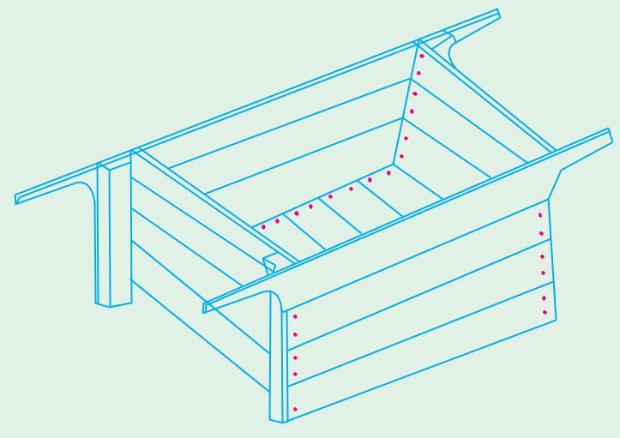
Gauge boxes are generally called farmas. They can be made of timber or steel plates. Often in India volume batching is adopted even for large concreting operations. In a major site it is recommended to have the following gauge boxes at site to cater for change in Mix Design or bulking of sand. The volume of each gauge box is clearly marked with paint on the external surface
Weigh Batching
Weigh batching is the correct method of measuring the materials. For important concrete, invariably, weigh batching system should be adopted. Use of weight system in batching, facilitates accuracy, flexibility and simplicity. Different types of weigh batchers are available, The particular type to be used, depends upon the nature of the job. Large weigh batching plants have automatic weighing equipment. The use of this automatic equipment for batching is one of sophistication and requires qualified and experienced engineers. In this, further complication will come to adjust water content to cater for the moisture content in the aggregate.
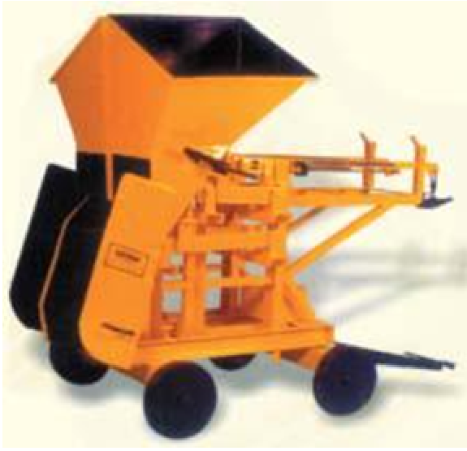
In smaller works, the weighing arrangement consists of two weighing buckets, each connected through a system of levers to spring-loaded dials which indicate the load. The weighing buckets are mounted on a central spindle about which they rotate. Thus one can be loaded while the other is being discharged into the mixer skip. A simple spring balance or the common platform weighing machines also can be used for small jobs.
On large work sites, the weigh bucket type of weighing equipments are used. This fed from a large overhead storage hopper and it discharges by gravity, straight into the mixer. The weighing is done through a lever-arm system and two interlinked beams and jockey weights. The required quantity of say, coarse aggregate is weighed, having only the lower beam in operation. After balancing, by turning the smaller lever, to the left of the beam, the two beams are interlinked and the fine aggregate is added until they both balance. The final balance is indicated by the pointer on the scale to the right of the beams. Discharge is through the swivel gate at the bottom.
Automatic batching plants are available in small or large capacity. In this, the operator has only to press one or two buttons to put into motion the weighing of all the different materials, the flow of each being cut off when the correct weight is reached. In their most advanced forms, automatic plants are electrically operated on a punched card system. This type of plant is particularly only suitable for the production of ready-mixed concrete in which very frequent changes in mix proportion have to be made to meet the varying requirements of different customers.
In some of the recent automatic weigh batching equipments, recorders are fitted which record graphically the weight of each material, delivered to each batch. They are meant to record, and check the actual and designed proportions.
Aggregate weighing machines require regular attention if they are to maintain their accuracy. Check calibrations should always be made by adding weights in the hopper equal to the full weight of the aggregate in the batch. The error found is adjusted from time to time.

- What are the methods of transportation of concrete?

Transporting Concrete
Concrete can be transported by a variety of methods and equipments. The precaution to be taken while transporting concrete is that the homogeneity obtained at the time of mixing should be maintained while being transported to the final place of deposition.
The methods adopted for transportation of concrete are:
(a) | Mortar Pan | (b) | Wheel barrow, Hand Cart
(c) | Crane, Bucket and Rope way | (d ) | Truck Mixer and Dumpers
(e) | Belt Conveyors | (f ) | Chute
(g) | Skip and Hoist | (h) | Tansit Mixer
(i ) | Pump and Pipe Line
( j ) Helicoptor.
Mortar Pan: Use of mortar pan for transporation of concrete is one of the common methods adopted in this country. It is labour intensive. In this case, concrete is carried in small quantities. While this method nullifies the segregation to some extent, particularly in thick members, it suffers from the disadvantage that this method exposes greater surface area of concrete for drying conditions. This results in greater loss of water, particularly, in hot weather concreting and under conditions of low humidity. It is to be noted that the mortar pans must be wetted to start with and it must be kept clean during the entire operation of concreting. Mortar pan method of conveyance of concrete can be adopted for concreting at the ground level, below or above the ground level without much difficulties.
Wheel Barrow: Wheel barrows are normally used for transporting concrete to be placed at ground level. This method is employed for hauling concrete for comparatively longer distance as in the case of concrete road construction. If concrete is conveyed by wheel barrow over a long distance, on rough ground, it is likely that the concrete gets segregated due to vibration. The coarse aggregates settle down to the bottom and matrix moves to the top surface. To avoid this situation, sometimes, wheel barrows are provided with pneumatic wheel to reduce vibration. A wooden plank road is also provided to reduce vibration and hence segregation.
Crane, Bucket and Rope Way: A crane and bucket is one of the right equipment for transporting concrete above ground level. Crane can handle concrete in high rise construction projects and are becoming a familiar sites in big cities. Cranes are fast and versatile to move concrete horizontally as well as vertically along the boom and allows the placement of concrete at the exact point. Cranes carry skips or buckets containing concrete. Skips have discharge door at the bottom, whereas buckets are tilted for emptying. For a medium scale job the bucket capacity may be 0.5 m³.
Rope way and bucket of various sizes are used for transporting concrete to a place, where simple method of transporting concrete is found not feasible. For the concrete works in a valley or the construction work of a pier in the river or for dam construction, this method of transporting by rope way and bucket is adopted. The mixing of concrete is done on the bank or abutment at a convenient place and the bucket is brought by a pulley or some other arrangement. It is filled up and then taken away to any point that is required. The vertical movement of the bucket is also controlled by another set of pullies. Sometimes, cable and car arrangement is also made for controlling the movement of the bucket. This is one of the methods generally adopted for concreting dam work or bridge work. Since the size of the bucket is considerably large and concrete is not exposed to sun and wind there would not be much change in the state of concrete or workability.
For discharging the concrete, the bucket may be tilted or sometimes, the concrete is made to discharge with the help of a hinged bottom. Discharge of concrete may also be through a gate system operated by compressed air. The operation of controlling the gate may be done manually or mechanically. It should be practised that concrete is discharged from the smallest height possible and should not be made to freely fall from great height.
Truck Mixer and Dumpers: For large concrete works particularly for concrete to be placed at ground level, trucks and dumpers or ordinary open steel-body tipping lorries can be used. As they can travel to any part of the work, they have much advantage over the jubilee wagons, which require rail tracks.
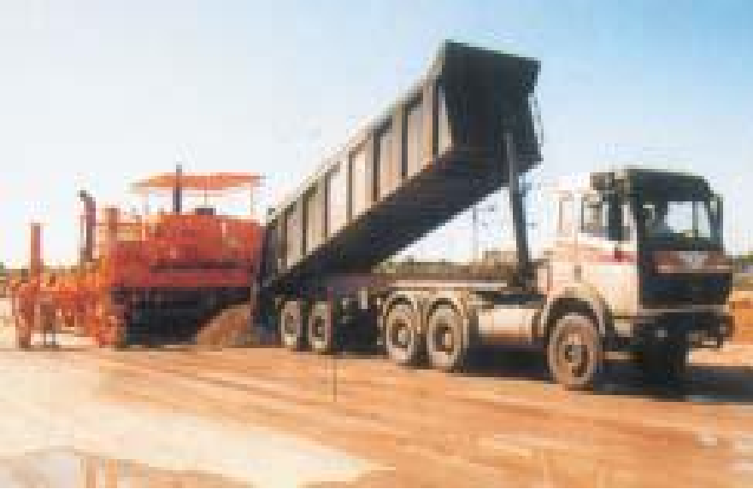
Dumpers are of usually 2 to 3 cubic metre capacity, whereas the capacity of truck may be 4 cubic metre or more. Before loading with the concrete, the inside of the body should be just wetted with water. Tarpaulins or other covers may be provided to cover the wet concrete during transit to prevent evaporation. When the haul is long, it is advisable to use agitators which prevent segregation and stiffening. The agitators help the mixing process at a slow speed.
For road construction using Slip Form Paver large quantity of concrete is required to be supplied continuously. A number of dumpers of 6 m³ capacity are employed to supply concrete. Small dumper called Tough Riders are used for factory floor construction.
Belt Conveyors: Belt conveyors have very limited applications in concrete construction. The principal objection is the tendency of the concrete to segregate on steep inclines, at transfer points or change of direction, and at the points where the belt passes over the rollers. Another disadvantage is that the concrete is exposed over long stretches which causes drying and stiffening particularly, in hot, dry and windy weather. Segregation also takes place due to the vibration of rubber belt. It is necessary that the concrete should be remixed at the end of delivery before placing on the final position.
Modern Belt Conveyors can have adjustable reach, travelling diverter and variable speed both forward and reverse. Conveyors can place large volumes of concrete quickly where access is limited. There are portable belt conveyors used for short distances or lifts. The end discharge arrangements must be such as to prevent segregation and remove all the mortar on the return of belt. In adverse weather conditions (hot and windy) long reaches of belt must be covered.
Chute: Chutes are generally provided for transporting concrete from ground level to a lower level. The sections of chute should be made of or lined with metal and all runs shall have approximately the same slope, not flatter than 1 vertical to 2 1/2 horizontal. The lay-out is made in such a way that the concrete will slide evenly in a compact mass without any separation or segregation. The required consistency of the concrete should not be changed in order to facilitate chuting. If it becomes necessary to change the consistency the concrete mix will be completely redesigned.
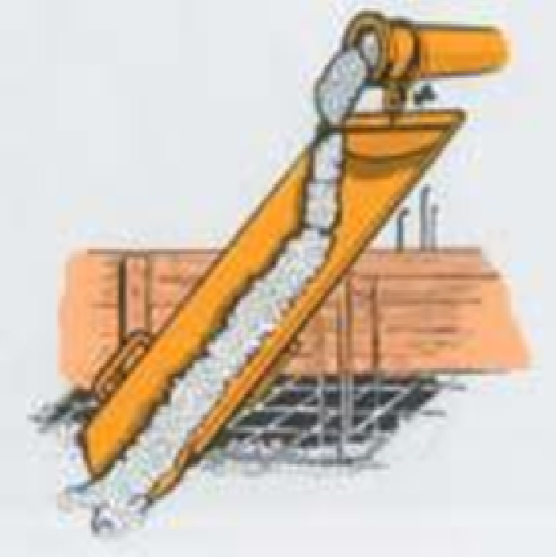
Chute

- Explain the slip form technique in detail.

Slip-Form Technique
There are special methods of placement of concrete using slip-form technique. Slip-forming can be done both for vertical construction or horizontal construction.
Slip-forming of vertical construction is a proven method of concrete construction generally adopted for tall structures. In this method, concrete is continuously placed, compacted and formwork is pulled up by number of hydraulic Jacks, giving reaction, against jack rods or main reinforcements. The rate of slipping the formwork will vary depending upon the temperature and strength development of concrete to withstand without the support of formwork. In India number of tall structures like chimneys and silos have been built by this technique. Although this method of construction is suitable for uniform shapped structures it was adopted for the core construction of stock exchange building at Bombay having irregular shape and number of openings. The core of 380 feet tall structure was completed in about 38 days. The formwork was slipped at the rate of about 12.5 cm per hour.

The horizontal slip-form construction is rather a new technique in India. It is adopted for road pavement construction. For the first time the slip-form paving method was adopted in Delhi-Mathura concrete Road construction during mid 1990’s.

The slip-form pavers were used by many contracting firms in the construction of Mumbai-Pune six lane express highway. The state-of the art method of slip form pavement construction has come to India in a big way.
Slip-form paver is a major equipment, capable of spreading the concrete dumped in front of the machine by tippers or dumpers, compacting the concrete through number of powerful internal needle vibrators and double beam surface vibrators. The pavers carries out the smooth finishing operation to the highest accuracy and then texture the surface with nylon brush operating across the lane. The equipment also drops the tie bar at the predetermined interval and push them through and places them at the predetermined depth and recompact the concrete to cover up the gap that are created by the dowel bars. Generally no bleeding takes place because of the stiff consistency of the concrete (2 cm slump) that is designed for placing by slip-form paver. If at all any little bleeding water is there, upon its disappearance, membrane forming curing compound is sprayed on to the textured surface of concrete.
All the above operations are continuously carried out and the slip-form paver crawls continuously on tracked wheel, guided by laser control. Proper alignment to cater for straight line, or curve of any degree with calculated super elevation, or upward or downward gradients are controlled by laser application. Computerized laser control is the backbone of this state-of- the art slip-form paver equipment. The speed of construction i.e., the speed of continuous movement of paver is around 1 meter per minute and in a day of 16 hours working, this equipment can complete about one km of one lane road of width 3.75 m and depth 35 cm.
In the Mumbai-Pune express highway construction, they have used two types of paving equipments namely wirtgen SP 500 and CMI.They are used for lane by lane construction. Whereas in Europe and the other advanced countries, slip-form pavers capable of completing two or three lanes in one operation are used.
To feed such a paver, large quantity of concrete of uniform quality is required. In India today, the capacity of batching is a limitation. In Europe continuous batching plants which can supply consistent quality of concrete at a rate of 150 to 250 m³/hr are available. This rate will make it possible to supply extra wide slip-form paver. Sophistication in road construction has just started in India. With the experience gained, we will be able to produce large quantities of manufactured fine and coarse aggregate of right quality needed for high rate of production of concrete to meet the requirement of multi lane slip-form paver.

- Describe the compaction method of concrete.

Compaction of Concrete
Compaction of concrete is the process adopted for expelling the entrapped air from the concrete. In the process of mixing, transporting and placing of concrete air is likely to get entrapped in the concrete. The lower the workability, higher is the amount of air entrapped. In other words, stiff concrete mix has high percentage of entrapped air and, therefore , would need higher compacting efforts than high workable mixes.
If this air is not removed fully, the concrete loses strength considerably. Therefore, it is imperative that 100 per cent compaction of concrete is one of the most important aim to be kept in mind in good concrete-making practices.It must be borne in mind that 100 per cent compaction is important not only from the point of view of strength, but also from the point of durability. In recent time, durability becomes more important than strength.Insufficient compaction increases the permeability of concrete resulting in easy entry for aggressive chemicals in solutin, which attack concrete and reinforcement to reduce the durability of concrete. Therefore, 100 per cent compaction of concrete is of paramount importance.

In order to achieve full compaction and maximum density, with reasonable compacting efforts available at site, it is necessary to use a mix with adequate workability. It is also of common knowledge that the mix should not be too wet for easy compaction which also reduces the strength of concrete. For maximum strength, driest possible concrete should be compacted 100 per cent. The overall economy demands 100 per cent compaction with reasonable compacting efforts available in the field.
The following methods are adopted for compacting the concrete:

(a) | Hand Compaction
 | (i ) | Rodding | (ii ) Ramming | (iii ) Tamping
(b) | Compaction by Vibration
 | (i ) | Internal vibrator (Needle vibrator)
 | (ii ) | Formwork vibrator (External vibrator)
 | (iii ) | Table vibrator
 | (iv ) | Platform vibrator
 | (v ) | Surface vibrator (Screed vibrator)
 | (vi) | Vibratory Roller.
(c ) | Compaction by Pressure and Jolting
(d) | Compaction by Spinning.

Hand Compaction:
Hand compaction of concrete is adopted in case of unimportant concrete work of small magnitude. Sometimes, this method is also applied in such situation, where a large quantity of reinforcement is used, which cannot be normally compacted by mechanical means. Hand compaction consists of rodding, ramming or tamping. When hand compaction is adopted, the consistency of concrete is maintained at a higher level. The thickness of the layer of concrete is limited to about 15 to 20 cm. Rodding is nothing but poking the concrete with about 2 metre long, 16 mm diameter rod to pack the concrete between the reinforcement and sharp corners and edges. Rodding is done continuously over the complete area to effectively pack the concrete and drive away entrapped air. Sometimes, instead of iron rod, bamboos or cane is also used for rodding purpose.
Ramming should be done with care. Light ramming can be permitted in unreinforced foundation concrete or in ground floor construction. Ramming should not be permitted in case of reinforced concrete or in the upper floor construction, where concrete is placed in the formwork supported on struts. If ramming is adopted in the above case the position of the reinforcement may be disturbed or the formwork may fail, particularly, if steel rammer is used.
Tamping is one of the usual methods adopted in compacting roof or floor slab or road pavements where the thickness of concrete is comparatively less and the surface to be finished smooth and level. Tamping consists of beating the top surface by wooden cross beam of section about 10 x 10 cm. Since the tamping bar is sufficiently long it not only compacts, but also levels the top surface across the entire width.
Compaction by Vibration
It is pointed out that the compaction by hand, if properly carried out on concrete with sufficient workability, gives satisfactory results, but the strength of the hand compacted concrete will be necessarily low because of higher water cement ratio required for full compaction. Where high strength is required, it is necessary that stiff concrete with low water/cement ratio be used. To compact such concrete, mechanically operated vibratory equipment, must be used. The vibrated concrete with low water/cement ratio will have many advantages over the hand compacted concrete with higher water/cement ratio.
The modern high frequency vibrators make it possible to place economically concrete which is impracticable to place by hand. A concrete with about 4 cm slump can be placed and compacted fully in a closely spaced reinforced concrete work, whereas, for hand compaction, much higher consistency say about 12 cm slump may be required. The action of vibration is to set the particles of fresh concrete in motion, reducing the friction between them and affecting a temporary liquefaction of concrete which enables easy settlement.

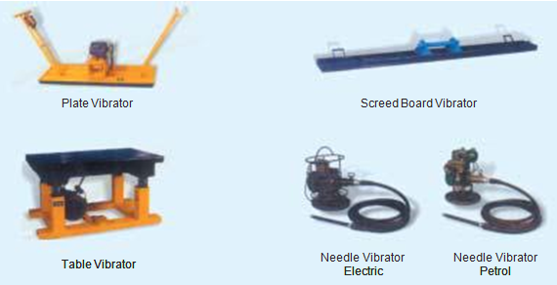

While vibration itself does not affect the strength of concrete which is controlled by the water/cement ratio, it permits the use of less water. Concrete of higher strength and better quality can, therefore, be made with a given cement factor with less mixing water. Where only a given strength is required, it can be obtained with leaner mixes than possible with hand compaction, making the process economical. Vibration, therefore, permits improvement in the quality of concrete and in economy.
Compaction of concrete by vibration has almost completely revolutionised the concept of concrete technology, making possible the use of low slump stiff mixes for production of high quality concrete with required strength and impermeability. The use of vibration may be essential for the production of good concrete where the congestion of the reinforcement or the inaccessibility of the concrete in the formwork is such that hand compaction methods are not practicable. Vibration may also be necessary if the available aggregates are of such poor shape and texture which would produce a concrete of poor workability unless large amount of water and cement is used. In normal circumstances, vibration is often adopted to improve the compaction and consequently improve the durability of structures. In this way, vibration can, under suitable conditions, produce better quality concrete than by hand compaction. Lower cement content and lower water-cement ratio can produce equally strong concrete more economically than by hand compaction.
Although vibration properly applied is a great step forward in the production of quality concrete, it is more often employed as a method of placing ordinary concrete easily than as a method for obtaining high grade concrete at an economical cost. All the potential advantages of vibration can be fully realised only if proper control is exercised in the design and manufacture of concrete and certain rules are observed regarding the proper use of different types of vibrators.
Internal Vibrator
Of all the vibrators, the internal vibrator is most commonly used. This is also called, “Needle Vibrator”, “Immersion Vibrator”, or “Poker Vibrator”. This essentially consists of a power unit, a flexible shaft and a needle. The power unit may be electrically driven or operated by petrol engine or air compressor. The vibrations are caused by eccentric weights attached to the shaft or the motor or to the rotor of a vibrating element. Electromagnet, pulsating equipment is also available. The frequency of vibration varies upto 12,000 cycles of vibration per minute. The needle diameter varies from 20 mm to 75 mm and its length varies from 25 cm to 90 cm. The bigger needle is used in the construction of mass concrete dam. Sometimes, arrangements are available such that the needle can be replaced by a blade of approximately the same length. This blade facilitates vibration of members, where, due to the congested reinforcement, the needle would not go in, but this blade can effectively vibrate. They are portable and can be shifted from place to place very easily during concreting operation. They can also be used in difficult positions and situations.
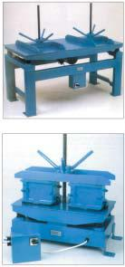
Formwork Vibrator (External Vibrator)
Formwork vibrators are used for concreting columns, thin walls or in the casting of precast units. The machine is clamped on to the external wall surface of the formwork. The vibration is given to the formwork so that the concrete in the vicinity of the shutter gets vibrated. This method of vibrating concrete is particularly useful and adopted where reinforcement, lateral ties and spacers interfere too much with the internal vibrator. Use of formwork vibrator will produce a good finish to the concrete surface. Since the vibration is given to the concrete indirectly through the formwork, they consume more power and the efficiency of external vibrator is lower than the efficiency of internal vibrator.

Table Vibrator:
This is the special case of formwork vibrator, where the vibrator is clamped to the table. or table is mounted on springs which are vibrated transferring the vibration to the table. They are commonly used for vibrating concrete cubes. Any article kept on the table gets vibrated. This is adopted mostly in the laboratories and in making small but precise prefabricated R.C.C. members.

Platform Vibrator:
Platform vibrator is nothing but a table vibrator, but it is larger in size. This is used in the manufacture of large prefabricated concrete elements such as electric poles, railway sleepers, prefabricated roofing elements etc. Sometimes, the platform vibrator is also coupled with jerking or shock giving arrangements such that a thorugh compaction is given to the concrete.
Surface Vibrator:
Surface vibrators are sometimes knows as, “Screed Board Vibrators”. A small vibrator placed on the screed board gives an effective method of compacting and levelling of thin concrete members, such as floor slabs, roof slabs and road surface. Mostly, floor slabs and roof slabs are
so thin that internal vibrator or any other type of vibrator cannot be easily employed. In such cases, the surface vibrator can be effectively used. In general, surface vibrators are not effective beyond about 15 cm. In the modern construction practices like vaccum dewatering technique, or slip-form paving technique, the use of screed board vibrator are common feature. In the above situations double beam screed board vibrators are often used.
Compaction by Pressure and Jolting:
This is one of the effective methods of compacting very dry concrete. This method is often used for compacting hollow blocks, cavity blocks and solid concrete blocks. The stiff concrete is vibrated, pressed and also given jolts. With the combined action of the jolts vibrations and pressure, the stiff concrete gets compacted to a dense form to give good strength and volume stability. By employing great pressure, a concrete of very low water cement ratio can be compacted to yield very high strength.
Compaction by Spinning:
Spinning is one of the recent methods of compaction of concrete. This method of compaction is adopted for the fabrication of concrete pipes. The plastic concrete when spun at a very high speed, gets well compacted by centrifugal force. Patented products such a “Hume Pipes”, “spun pipes” are compacted by spinning process.

Vibratory Roller:
One of the recent developments of compacting very dry and lean concrete is the use of Vibratory Roller. Such concrete is known as Roller Compacted Concrete. This method of concrete construction originated from Japan and spread to USA and other countries mainly for the construction of dams and pavements. Heavy roller which vibrates while rolling is used for the compaction of dry lean concrete. Such roller compacted concrete of grade M 10 has been successfully used as base course, 15 cm thick, for the Delhi-Mathura highway and Mumbai-Pune express highways.

Unit –IV

FRESH AND HARDENED PROPERTIES OF CONCRETE

Part-A (2 Marks)

- Mention the Properties of concrete at Early Ages.

    - Workability

    - Slump Loss

    - Segregation/Bleeding

    - Plastic Shrinkage

    - Time of Set Temperature

- What are the Causes of bleeding and segregation?

    - Improper slump

    - Excessive amount of coarse aggregate

    - Lack of fines

    - Inappropriate placing and compacting

- What are the Methods for Control of Bleeding?

  - Reduction of water

  - Introduction of fines and air

  - Proper Compaction (too much compaction Causes bleeding)

- Define Workability (MAY/JUNE 2016)

Effort required manipulating a concrete mixture with a minimum of segregation. It is not a fundamental property of concrete consistency (slump) --> how easy to flow cohesiveness --> tendency to bleed and segregate.

5. Is Concrete Really Elastic?

In a word, yes. But the elasticity is a way to characterize the mechanical response of the material body for applied stresses that stay within the linear regime. Very large stresses, which are high enough to fracture the material, cause non-linear deformations.

6. Why is Elastic Moduli Important for Concrete?

The elastic moduli prediction code is set up to compute the elastic moduli of an arbitrary material. As long as the microstructure can be represented by a 3-D digital image, and the individual phase elastic moduli are known, the program can be used to compute the overall moduli.

The overall elastic moduli are functions of the microstructure as well as of the elastic moduli of the individual chemical phases in the cement paste. These can be as many as 20 or 30, since cement paste by itself is a chemically complex material.

7. Define concrete Expansion and shrinkage.

Concrete has a very low coefficient of thermal expansion. However, if no
provision is made for expansion, very large forces can be created, causing cracks in parts of the structure not capable of withstanding the force or the repeated cycles of expansion and contraction. The coefficient of thermal expansion of Portland cement concrete is 0.000008 to 0.000012 (per degree Celsius) (8 to 12 microstrains/°C)(8-12 1/MK)

- Define Shrinkage cracking

Shrinkage cracks occur when concrete members undergo restrained volumetric changes (shrinkage) as a result of either drying, autogenous shrinkage or thermal effects. Restraint is provided either externally (i.e. supports, walls, and other boundary conditions) or internally (differential drying shrinkage, reinforcement).

9. Define Plastic Shrinkage cracking

Plastic-shrinkage cracks are immediately apparent, visible within 0 to 2 days of cement, while drying-shrinkage cracks develop over time. Autogenously shrinkage also occurs when the concrete is quite young and results from the volume reduction resulting from the chemical reaction of the Portland cement.

10. Define Tension cracking

Concrete members may be put into tension by applied loads. This is most common in concrete beams where a transversely applied load will put one surface into compression and the opposite surface into tension due to induced bending. The portion of the beam that is in tension may crack. The size and length of cracks is dependent on the magnitude of the bending moment and the design of the reinforcing in the beam at the point under consideration. Reinforced concrete beams are designed to crack in tension rather than in compression. This is achieved by providing reinforcing steel which yields before failure of the concrete in compression occurs and allowing remediation, repair, or if necessary, evacuation of an unsafe area.

- Define Creep.

Creep is the permanent movement or deformation of a material in order to relieve stresses within the material. Concrete that is subjected to long-duration forces is prone to creep. Short-duration forces (such as wind or earthquakes) do not cause creep. Creep can sometimes reduce the amount of cracking that occurs in a concrete structure or element, but it also must be controlled. The amount of primary and secondary reinforcing in concrete structures contributes to a reduction in the amount of shrinkage, creep and cracking.

- What is setting?

Setting is the stiffening of the concrete after it has been placed. A concrete can be

'set' in that it is no longer fluid, but it may still be very weak; you may not be able to walk on it, for example.

Setting is due to early-stage calcium silicate hydrate formation and to ettringite formation. The terms 'initial set' and 'final set' are arbitrary definitions of early and later set; there are laboratory procedures for determining these using weighted needles penetrating into cement paste.

- What is Hardening?

Hardening is the process of strength growth and may continue for weeks or months after the concrete has been mixed and placed. Hardening is due largely to the formation of calcium silicate hydrate as the cement continues to hydrate.The rate at which concrete sets is independent of the rate at which it hardens. Rapid-hardening cement may have similar setting times to ordinary Portland cement.

- How the concrete strength has measured? (MAY/JUNE 2016)

Measurement of concrete strengths: Traditionally, this is done by preparing concrete

cubes or prisms, then curing them for specified times. Common curing times are 2, 7, 28 and 90 days. The curing temperature is typically 20 degrees Centigrade. After reaching the required age for testing, the cubes/prisms are crushed in a large press. The SI unit for concrete strength measurement is the Mega Pascal, although 'Newton per square millimeter'

16. What are the Factors affecting concrete strength?

There are many relevant factors; some of the more important follow:

- Concrete porosity

- Water/cement ratio

- Soundness of aggregate:

- Aggregate-paste bond

- Cement-related parameters

  - Define Concrete porosity.

Voids in concrete can be filled with air or with water. Air voids are an obvious and

easily-visible example of pores in concrete. Broadly speaking, the more porous the concrete, the weaker it will be. Probably the most important source of porosity in concrete is the ratio of water to cement in the mix, known as the 'water to cement' ratio. This parameter is so important it will be discussed separately below.

18. Define Water/cement ratio. (MAY/JUNE 2016)

This is defined as the mass of water divided by the mass of cement in a mix. For example, a concrete mix containing 400 kg cement and 240 litres (=240 kg) of water will have a water/cement ratio of 240/400=0.6.

The water/cement ratio may be abbreviated to 'w/c ratio' or just 'w/c'. In mixes where the w/c is greater than approximately 0.4, all the cement can, in theory, react with water to form cement hydration products. At higher w/c ratios it follows that the space occupied by the additional water above w/c=0.4 will remain as pore space filled with water, or with air if the concrete dries out.

19. What do you mean by Soundness of aggregate?

If the aggregate in concrete is weak, the concrete will also be weak. Rocks with low intrinsic strength, such as chalk, are clearly unsuitable for use as aggregate.

- What is surface treatment of concrete?

- Concrete curing membranes and other products to enhance the concrete surface.

- Ease of formwork release

- Producing exposed aggregate finishes

- Enhanced curing of freshly placed concrete

21. What is meant by proportioning of concrete?

Proportioning concrete is use of certain quantity of cement, sand and coarse aggregate and specific water cement ratio

22. Define curing.

The process in which an adhesive undergoes a chemical reaction and becomes a solid. Curing requires pressure, heat, UV light, water, or some other means to initiate the chemical reaction and form the bonded joint.

Part –B (16 Marks)

- Explain how you would determine the various elastic moduli for concrete.

The modulus of elasticity can also be determined by subjecting a concrete beam to bending and then using the formulae for deflection and substituting other parameters. The modulus of elasticity so found out from actual loading is called static modulus of elasticity. It is seen that even under short term loading concrete does not behave as an elastic material. However, up to about 10-15% of the ultimate strength of concrete, the stress-strain graph is not very much curved and hence can give more accurate value. For higher stresses the stress-strain relationship will be greatly curved and as such it will be inaccurate. Figure shows stress-strain relationship for various concrete mixes.

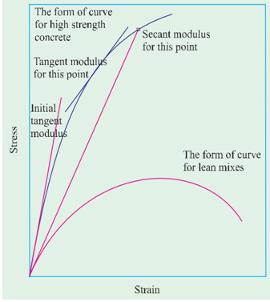
In view of the peculiar and complex behaviour of stress-strain relationship, the modulus of elasticity of concrete is defined in somewhat arbitrary manner. The modulus of elasticity of concrete is designated in various ways and they have been illustrated on the stress-strain curve in Figure 8.2. The term Young’s modulus of elasticity can strictly be applied only to the straight part of stress-strain curve. In the case of concrete, since no part of the graph is straight, the modulus of elasticity is found out with reference to the tangent drawn to the curve at the origin. The modulus found from this tangent is referred as initial tangent modulus. This gives satisfactory results only at low stress value. For higher stress value it gives a misleading picture.
Tangent can also be drawn at any other point on the stress-strain curve. The modulus of elasticity calculated with reference to this tangent is then called tangent modulus. The tangent modulus also does not give a realistic value of modulus of elasticity for the stress level much above or much below the point at which the tangent is drawn. The value of modulus of elasticity will be satisfactory only for stress level in the vicinity of the point considered.
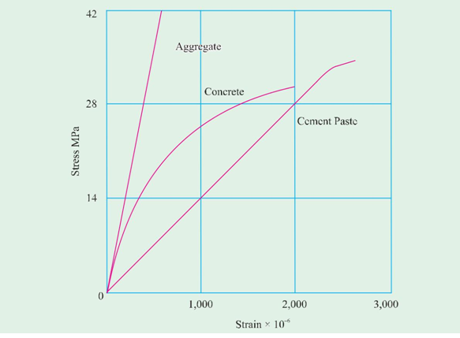
A line can be drawn connecting a specified point on the stress-strain curve to the origin of the curve. If the modulus of elasticity is calculated with reference to the slope of this line, the modulus of elasticity is referred as secant modulus. If the modulus of elasticity is found out with reference to the chord drawn between two specified points on the stress-strain curve then such value of the modulus of elasticity is known as chord modulus.
The modulus of elasticity most commonly used in practice is secant modulus. There is no standard method of determining the secant modulus. Sometime it is measured at stresses ranging from 3 to 14 MPa and sometime the secant is drawn to point representing a stress level of 15, 25, 33, or 50 per cent of ultimate strength. Since the value of secant modulus decreases with increase in stress, the stress at which the secant modulus has been found out should always be stated.
Modulus of elasticity may be measured in tension, compression or shear. The modulus in tension is usually equal to the modulus in compression.
It is interesting to note that the stress-strain relationship of aggregate alone shows a fairly good straight line. Similarly, stress-strain relationship of cement paste alone also shows a fairly good straight line. But the stress-strain relationship of concrete which is combination of aggregate and paste together shows a curved relationship. Perhaps this is due to the development of micro cracks at the interface of the aggregate and paste. Because of the failure of bond at the interface increases at a faster rate than that of the applied stress, the stress-strain curve continues to bend faster than increase of stress.

- What do you understand by carbonation of concrete? How is it tested?

Carbonation
Carbonation of concrete is a process by which carbon dioxide from the air penetrates into concrete and reacts with calcium hydroxide to form calcium carbonates. We have seen earlier that the conversion of Ca(OH)₂ into CaCO₃ by the action of CO₂ results in a small shrinkage.
Now we shall see another aspect of carbonation. CO₂ by itself is not reactive. In the presence of moisture, CO₂ changes into dilute carbonic acid which attacks the concrete and also reduces alkalinity of concrete.
Air contains CO₂. The concentration of CO₂ in rural air may be about 0.03 per cent by volume. In large cities the content may go up to 0.3 per cent or exceptionally it may go up to even 1.0 per cent. In the tunnel, if not well ventilated the intensity may be much heigher.
The pH value of pore water in the hardened concrete is generally between 12.5 to 13.5 depending upon the alkali content of cement. The high alkalinity forms a thin passivating layer around steel reinforcement and protect it from action of oxygen and water. As long as steel is placed in a highly alkaline condition, it is not going to corrode. Such condition is known as passivation.
In actual practice CO₂ present in atmosphere in smaller or greater concentration, permeates into concrete and carbonates the concrete and reduces the alkalinity of concrete. The pH value of pore water in the hardened cement paste which was around 13 will be reduced to around 9.0. When all the Ca(OH)₂ has become carbonated, the pH value will reduce upto about 8.3. ^{9.19} In such a low pH value, the protective layer gets destroyed and the steel is exposed to corrosion.
The carbonation of concrete is one of the main reasons for corrosion of reinforcement. Of course, oxygen and moisture are the other components required for corrosion of embedded steel.
Rate of Carbonation:
The rate of carbonation depends on the following factors.
  - The level of pore water i.e., relative humidity. Grade of concrete

  - Permeability of concrete

  - Whether the concrete is protected or not depth of cover

  - Time

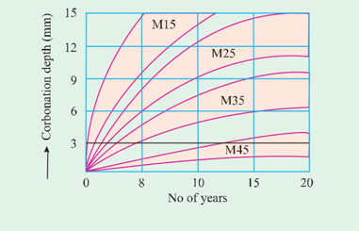

Depth of carbonation with respect to strength (grade) of concrete
It is interesting to know that if pore is filled with water the diffusion of CO₂ is very slow. But whatever CO₂ is diffused into the concrete, is readily formed into dilute carbonic acid reduces the alkalinity.
On the other hand if the pores are rather dry, that is at low relative humidity the CO₂ remains in gaseous form and does not react with hydrated cement.
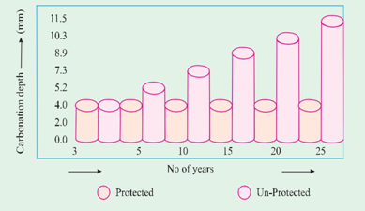

Depth of carbonation for protected and unprotected concrete

The moisture penetration from external source is necessary to carbonate the concrete.
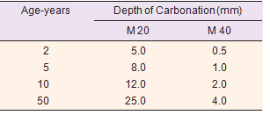
Depth of carbonation with age and grade of concrete
The highest rate of carbonation occurs at a relative humidity of between 50 and 70 percent
The rate of carbonation depth will be slower in case of stronger concrete for the obvious reason that stronger concrete is much denser with lower W/C ratio. It again indicates that the permeability of the concrete, particularly that of skin concrete is much less at lower W/C and as such the diffusion of CO₂ does not take place faster, as in the case of more permeable concrete with higher W/C ratio. Fig. 9.21 and table 9.12 show the depth of carbonation in various grades of concretes.
It is now well recognised that concrete needs protection for longer durability. Protective coating is required to be given for long span bridge girders, flyovers, industrial structures and chimneys. The fig. 9.22 shows carbonation depth of protected and unprotected concrete.
Depth of cover plays an important role in protecting the steel from carbonation. The table shows relationships between W/C, depth of cover and time in years for carbonation depth to reach the reinforcement.

- What are the various types of chemical attacks encountered by concrete?

Chemical Action
When we are dealing with the durability of concrete, chemical attack which results in volume change, cracking of concrete and the consequent deterioration of concrete becomes an important part of discussion.
Under chemical attack, we shall discuss about sulphate attack, alkali-aggregate reaction, carbonation, deicing effect of salt, acid attack and effect of sea water.
Sulphate Attack
Most soils contain some sulphate in the form of calcium, sodium, potassium and magnesium. They occur in soil or ground water. Because of solubility of calcium sulphate is low, ground waters contain more of other sulphates and less of calcium sulphate. Ammonium sulphate is frequently present in agricultural soil and water from the use of fertilizers or from sewage and industrial effluents. Decay of organic matters in marshy land, shallow lakes often leads to the formation of H₂S, which can be transformed into sulphuric acid by bacterial action. Water used in concrete cooling towers can also be a potential source of sulphate attack on concrete. Therefore sulphate attack is a common occurrence in natural or industrial situations.
Solid sulphates do not attack the concrete severely but when the chemicals are in solution, they find entry into porous concrete and react with the hydrated cement products. Of all the sulphates, magnesium sulphate causes maximum damage to concrete. A characteristic whitish appearance is the indication of sulphate attack.
The term sulphate attack denote an increase in the volume of cement paste in concrete or mortar due to the chemical action between the products of hydration of cement and solution containing sulphates. In the hardened concrete, calcium aluminate hydrate (C-A-H) can react with sulphate salt from outside. The product of reaction is calcium sulphoaluminate, forming within the framework of hydrated cement paste. Because of the increase in volume of the solid phase which can go up to 227 per cent, a gradual disintegration of concrete takes place.
The reactions of the various sulphates with hardened cement paste is shown below
Let us take the example of Sodium Sulphate attacking Ca(OH)₂
Ca(OH)₂ + Na₂SO₄ . 10H₂O CaSO₄ . 2H₂O + 2NaOH + 8H₂O.
The reaction with calcium aluminate hydrate is as follows
2(3CaO . Al₂O₃ . 12H₂O) + 3(Na₂SO₄ . 10H₂O)
3CaO . Al₂O₃ . 3CaSO₄ . 31H₂O + 2Al(OH)₃ + 6NaOH + 17 H₂O
Calcium sulphate attacks only calcium aluminate hydrate producing calcium sulpho aluminate
(3CaO .Al₂O₃ . 3CaSO₄ . 32H₂O) known as ettringite. Molecules of water may be 32 or 31.
On the other hand magnesium sulphate has a more far reaching action than other sulphates because it reacts not only with calcium hydroxide and hydrated calcium aluminates like other sulphates but also decomposes the hydrated calcium silicates completely and makes it a friable mass.
The rate of sulphate attack increases with the increase in the strength of solution. A saturated solution of magnesium sulphate can cause serious damage to concrete with higher water cement ratio in a short time. However, if the concrete is made with low water cement ratio, the concrete can withstand the action of magnesium sulphate for 2 or 3 years. The concentration of sulphates is expressed as the number of parts by weight of SO₃ per million parts. 1000 PPM is considered moderately severe and 2000 PPM is considered very severe, especially if MgSO₄ is the predominant constituent.
Another factor influencing the rate of attack is the speed in which the sulphate gone into the reaction is replenished. For this it can be seen that when the concrete is subjected to the pressure of sulphate bearing water on one side the rate of attack is highest. Similarly, alternate wetting and drying due to tidal variation or spraying leads to rapid attack.
Methods of Controlling Sulphate Attack
Having studied the mechanism of sulphate attack on concrete it will be easy for us to deal with the methods for controlling the sulphate attack.
(a) Use of Sulphate Resisting Cement
The most efficient method of resisting the sulphate attack is to use cement with the low C₃ A content. This has been discussed in detail earlier in chapter I. In general, it has been found that a C₃ A content of 7% gives a rough division between cements of good and poor performance in sulphate waters.
(b) Quality Concrete
A well designed, placed and compacted concrete which is dense and impermeable exhibits a higher resistance to sulphate attack. Similarly, a concrete with low water/cement ratio also demonstrates a higher resistance to sulphate attack.
(c) Use of air-entrainment
Use of air-entrainment to the extent of about 6% (six per cent) has beneficial effect on the sulphate resisting qualities of concrete. The beneficial effect is possibly due to reduction of segregation, improvement in workability, reduction in bleeding and in general better impermeability of concrete.
(d) Use of pozzolana
Incorporation of or replacing a part of cement by a pozzolanic material reduces the sulphate attack. Admixing of pozzolana converts the leachable calcium hydroxide into insoluble non-leachable cementitious product. This pozzolanic action is responsible for impermeability of concrete. Secondly, the removal of calcium hydroxide reduces the susceptibility of concrete to attack by magnesium sulphate.
(e) High Pressure Steam Curing
High pressure steam curing improve the resistance of concrete to sulphate attack. This improvement is due to the change of C₃ AH₆ into a less reactive phase and also to the removal or reduction of calcium hydroxide by the reaction of silica which is invariably mixed when high pressure steam curing method is adopted.
(f) Use of High Alumina Cement
The cause of great resistance shown by high alumina cement to the action of sulphate is still not fully understood. However, it is attributed in part to the absence of any free calcium hydroxide in the set cement, in contrast to Portland cement. High alumina cement contains approximately 40% alumina, a compound very susceptible to sulphate attack, when in normal portland cement. But this percentage of alumina present in high alumina cement behaves in a different way. The primary cause of resistance is attributed to formation of protective films which inhibit the penetration or diffusion of sulphate ions into the interior. It should be remembered that high alumina cement may not show higher resistance to sulphate attack at higher temperature.
A comprehensive study of concrete exposed to natural sulphate soils and to pure sulphate solution in the laboratory for periods ranging upto 25 years, was reported by Miller and Manson. The conclusions derived from this extensive study is given below.

(a ) There was a definite correlation between the sulphate resistance of Portland cement and the amount of tricalcium aluminate (C₃ A) it contained. High resistance was found for Portland cements containing not more than 5.5 per cent C₃ A.
(b ) There was no indication that the finer grinding of the cements had any influence on sulphate resistance.
(c ) The resistance of seven Portland-pozzolana cements varied over nearly as wide a range as was observed for the 122 Portland cements.
(d ) Four calcium aluminate cements (Cement Fondu or similar-non Portland cement) consistently showed a very high resistance to the sulphate bearing water. There was however, some indication that these cements are not completely stable at temperatures above 21 to 38°C.
(e ) Specimens cured in steam at temperatures of 100°C and especially at 176°C were highly resistant. The degree of improvement was greatest for those cements originally not highly resistant, that is, those with relatively high C₃ A.
(f ) Few of the 40 admixtures tried gave markedly improved resistance; many had no effect and some were deleterious. The most effective were linseed, soyabean, and tung oils.A large scale study of resistance of concrete to sulphate soils formed a part of the long-time study of cement performance in concrete. This was carried out by the Portland Cement Association (USA) under the general supervision of an Advisory committee. About 1000 concrete beams of size 15 x 13 x 86 cm were embedded horizontally to half their 15 cm depth in soils containing about 10 per cent soluble sulphates. For half of the specimens the sulphate was principally sodium sulphate. For the other half, 2/3 number of specimen it was sodium sulphate and 1/3 magnesium sulphate. The soil in each basin was alternately made wet and dry. The prevailing temperature was above 0°C.
(a ) The resistance of concrete to attack by solutions of sulphate salts increases with reduction of C₃ A content in the cement. At 6 years, a C₃ A content of 7% as calculated without correction for minor oxides provided a good separation between cements of good and poor sulphates resistance. After 20 years, it was concluded that a C₃ A content of 5.5 per cent as corrected for minor oxides and about 3.5 per cent as determined by X-ray analysis, were fairly good values for separating superior and poor resistance in the richest mix. It is interesting to note that the 10 year report (1953) observed that beams in the soil containing MgSO₄ as well Na₂SO₄ were less attacked than those in the soil containing mainly Na₂SO₄. This result is contrary to expectations based on some studies conducted with concretes and mortars continually immersed in sulphate solutions. It was tentatively ascribed to differences in the nature of the salt deposit on the beams resulting from evaporation.

- What precautions can be taken to ensure good quality concrete in coastal structures?

Concrete in Sea Water
Large number of concrete structures are exposed to sea water either directly or indirectly. For several reasons, effect of sea water on concrete deserves special attention. The coastal and offshore structures are exposed to simultaneous action of a number of physical and chemical deterioration process. The concrete in sea water is subjected to chloride induced corrosion of steel, freezing and thawing, salt weathering, abrasion by sand held in water and other floating bodies.
Sea water generally contains 3.5 per cent of salt by weight. The ionic concentration of Na⁺ and Cl– are the highest, typically 11,000 and 20,000 mg/litre respectively. It also contains Mg²⁺ and SO₄^{2–}, typically 1400 and 2700 mg/litre respectively. The PH of sea water varies between 7.5 and 8.4. The average value is 8.2. Sea water also contains some amount of CO₂.

We have already seen earlier in this chapter that magnesium sulphate reacts with free calcium hydroxide in set Portland cement to form calcium sulphate, at the same time precipitating magnesium hydroxide. MgSO₄ also reacts with the hydrated calcium aluminate to form calcium sulpho aluminate. These have often been assumed to be the actions primarily responsible for the chemical attack of concrete by sea water.

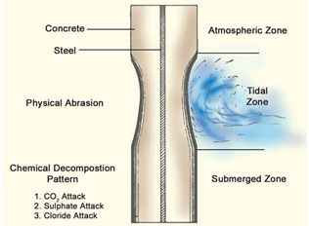
Diagrammatic representation of deterioration of concrete exposed to seawater.
It is commonly observed that deterioration of concrete in sea water is often not characterised by the expansion found in concrete exposed to sulphate action, but takes more the form of erosion or loss of constituents from the parent mass without exhibiting undue expansion. It is inferred that the presence of chlorides in sea water may have retarded the swelling of concrete in sulphate solution. It is also found that concrete will have lost some part of lime content due to leaching. Both calcium hydroxide and calcium sulphate are considerably more soluble in sea water and this, will result in increased leaching action. To put it briefly, concrete undergoes several reactions concurrently when subjected to sea water. A concrete of not too massive dimensions exposed to sea water is more likely to show the effects of leaching than expansion, whereas massive structures like dock walls etc. may show the effects of expansion also. The rate of chemical attack is increased in temperate zones

Experience has shown that most severe attack of sea water on concrete occurs just above the level of high water. The portion between low and high water marks is less affected and the parts below the water level which are continuously remain immersed are least affected. The crystallisation of salt in the portion of concrete above high water level is responsible for disruption of concrete. In place of cold climatic region, the freezing of water in pores at the spray level of concrete is responsible for causing lack of durability in concrete. Freezing of water may also take place between the tidal variation level.
It is to be admitted that concrete is not 100% impervious. The water that permeates into the concrete causes corrosion of steel. The product of corrosion being of higher volume than the material they replace, exert pressure which results in lack of durability to reinforced concrete. It is also seen that the lack off durability is more in case of reinforced concrete than the identical plain concrete.
Sea water holds certain quantity of sand and silt particularly in the shallow end. The velocity of wave action causes abrasion of concrete. The impact and the mechanical force of wave action also contributes to the lack of durability of concrete.
From the foregoing discussion it will be easy to formulate steps to improve the durability of concrete in sea water.
Apart from the right type of cement with low C₃A content, the other factor to be considered is the use of rich concrete with low water/cement ratio.
The rich concrete with low water/cement ratio mainly makes the concrete impervious to the attack of sea water, and also having very little capillary pores does not hold water, to cause expansion either by freezing or by crystallisation of salt.
Provision of adequate cover is another desirable step for increasing durability of reinforced concrete.
Use of pozzolanic material is yet another desirable step that could be taken to improve durability against sea water. A good compaction, well made construction joints etc. are other points helping the durability of concrete in sea water. Whenever possible, high pressure steam-cured prefabricated concrete elements should be used for better durability

- What are the physical deteriorating influences on concrete?

Deterioration of Concrete by Abrasion, Erosion and Cavitation
Concrete used in certain situations is required to exhibit good abrasion and erosion properties. Abrasion refers to wearing away of the surface by friction. Erosion refers to the same action by fluids. The cavitation refers to the damage due to non-linear flow of water at velocities more than 12 metres per second. The concrete used in the roads, floors and pavements and the concrete used in the hydraulic structures should exhibit resistance against abrasion, erosion and cavitation.
The resistance against these is closely connected with the compressive strength of concrete. The more the compressive strength the higher is the resistance to abrasion. Hardness of aggregate, particularly the coarse aggregate is important to abrasion resistance. Although for concrete of strength of 56 MPa and above, the effect of aggregate hardness is not so important.
The shape and surface texture of aggregate also plays an important part in the abrasion resistance of concrete. A smooth rounded aggregate, when subjected to lateral load, may get dislodged due to lack of bond and interlocking effect of the aggregate. Once the aggregate is dislodged and removed, the paste does not withstand the abrasion action. Rough and angular aggregate with better bond and interlocking effect stands up well against abrasion. If the aggregates are firmly embedded in the matrix, the wearing out of the surface will be uniform without pitting. A placing of homogeneous unsegregated concrete will also exhibit better abrasion resistance. In closed conduits or in a sheet of water flowing over a weir, vapour bubbles are formed in running water whenever the pressure at a point in the water is reduced to its vapour pressure at the existing temperature. Vapour bubbles flow downstream with the water and when they enter a region of higher pressure, they collapse with great impact. The formation of vapour bubbles and their subsequent collapse is called cavitation. The energy given up on their collapse causes “cavitation damage”. At higher velocities, the forces of cavitation may be strong enough to damage the concrete surface in a very serious manner.
The method adopted for avoiding cavitation, apart from careful designing of the structure, making smooth surface free from irregularities is other effective step. The concrete should be of high strength, well cured and finished smooth. Epoxy screeding and polymer application to the surface is said to be effective against cavitation.
Effects of Some Materials on Durability
Action of mineral oils
Mineral such as petrol, and petroleum distillates in general, do not attack hardened concrete though they seriously affect hardening process of fresh concrete. Creosotes which contain phenols may have some effects on concretes. Lubricating oils which are entirely of mineral origin do not attack concrete. As a matter of fact, often concrete tanks are used as a storage tanks for mineral oils. To reduce permeability, rich concrete is used and also some kind of surface treatment such a four coats of sodium silicate is applied.
Action of Organic Acids
There are a number of organic acids which sometimes come into contact with concrete and cause deleterious effect on it. Acetic acid, lactic acid and butyric acid attack concrete with severity depending upon concentration and temperature. Fresh milk has so little lactic acid that it does not harm concrete. Formic acid is corrosive to concrete. Tannic acid and phenols are only mildly corrosive. Oleic, stearic acids occurring in various oils and fats, though insoluble in water have some corrosive action on concrete.
Vegetables and Animal Oils and Fats
Many vegetable oils contain small amounts of free fatty essence and produce a slow deterioration of concrete surfaces. Most fresh animal oils contain little acid but rancid animal oils contain considerably more acid and therefore are corrosive. Some fish oils are said to be more corrosive than other animal oils. Laboratory tests show that Portland cements concrete are rapidly attacked by cotton-seed oils.
Action of Sugar on Concrete
Sugar is a powerful retarding agent, but its action on hardened concrete is not of much consequence, though it may gradually corrode the concrete. Concrete tanks have been used for the storage of molasses with satisfactory results. It should be noted that concrete tanks should be well cured for at least 28 days before being charged with syrups and molasses. It is also recommended that the surface of concrete tanks may be treated with sodium silicate solution or tar or asphalt.
Action of Sewage
Domestic sewage has not got detrimental effect on good concrete. As such, concrete pipes are used for conveying sewage; also concrete is used for constructing sewage treatment plants. Hydrogen sulphide gas which may be evolved from septic sewage in sewer or sludge digestion tank, though by itself is not harmful, may promote the formation of sulphuric acid which can attack the concrete surface above the liquid level. Concrete sewers running full are not attacked.
If the sewage contains more than 150 ppm of soluble sulphate salts (as SO₄), sulphate attack may take place. Domestic sewage rarely contains this amount of sulphate salts but discharge of certain industrial wastes into sewer could increase the concentration of sulphate salts.
Concrete pipes to carry sewage should be of low permeability to minimise penetration of liquid. This could be done by rich concrete, low water cement ratio and good compaction to increase the durability of the sewer. It should be seen that formation of sulphuric acid is avoided by keeping sufficient quantity of flow, proper ventilation of sewer and by avoiding the stagnation or septicity of sewage.

- Explain the factors which influence corrosion?

Corrosion of Steel (Chloride induced)
Corrosion of steel in concrete is an electrochemical process. When there is a difference in electrical potential along the steel reinforcement in concrete, an electrochemical cell is set up. In the steel, one part becomes anode and other part becomes cathode connected by electrolyte in the form of pore water in the hardened cement paste. The positively charged ferrous ions Fe⁺⁺ at the anode pass into solution while the negatively charged free electrons e– pass through the steel into cathode where they are absorbed by the constituents of the electrolyte and combine with water and oxygen to form hydroxyl ions (OH)–.
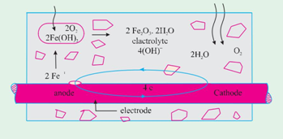
Simplified model representing corrosion mechanism

through the electrolyte and combine with the ferrous ions to form ferric hydroxide which is converted by further oxidation to rust.
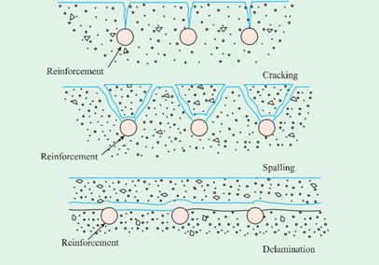
Diagrammatic representation of damage induced by
corrosion cracking spalling, and delamination

Cathodic reaction
4e– + O₂ + H₂O 4(OH)–

It can be noted that no corrosion takes place if the concrete is dry or probably below relative humidity of 60 percent because enough water is not there to promote corrosion. It can also be noted that corrosion does not take place if concrete is fully immersed in water because diffusion of oxygen does not take place into the concrete. Probably the optimum relative humidity for corrosion is 70 to 80 per cent.
The products of corrosion occupy a volume as many as six times the original volume of steel depending upon the oxidation state. Fig. 9.24 shows the increase in volume of steel depending upon the oxidation state.
The increased volume of rust exerts thrust on cover concrete resulting in cracks, spalling or delamination of concrete. Refer Fig. 9.25. With this kind of situations concrete loses its integrity. The cross section of reinforcement progressively reduces and the structure is sure to collapse.
Corrosion Control
From the literature survey and case studies it has been reported that 40% of failure of structures is on account of corrosion of embedded steel reinforcement in concrete. Therefore corrosion control of steel reinforcement is a subject of paramount importance.
First and foremost for corrosion control is the good quality of concrete through good construction practices. It is a very vast subject touches the fundamentals of choosing constituent material and good rules to be followed during various stages of production of concrete. In particular the use of lowest possible water/cement ratio having regard to workability. In view of the general availability of superplasticizers, it should be used to cut down the W/C ratio to make dense concrete.
In short it can be said that if we make good concrete with low permeability and improved microstructure, it will be durable by itself and also it can take care of the reinforcement contained in it to a great extent. It is always not possible to make such ideal concrete, particularly, in view of the complex environmental and exposure conditions. Further, the inherent long term drying shrinkage and microcracks in concrete, the problems become more serious. This demands certain other measures to control the corrosion of steel reinforcement.
Metallurgical Methods:
Steel can be made more corrosion resistant by altering its structure through metallurgical processes. Different methods such as rapid quenching of the hot bars by series of water jets, or by keeping the hot steel bars for a short time in a water bath, and by such other process the mechanical properties and corrosion resistance property of steel can be improved. There are many situations where stainless steel reinforcements are used for long term durability of concrete structures.
Corrosion inhibitors:
Corrosion can be prevented or delayed by chemical method by using certain corrosion inhibiting chemicals such as nitrites, phosphates, benzoates etc. Of the available materials, the most widely used admixture is based on calcium nitrite. It is added to the concrete during mixing of concrete. The typical dosage is of the order of 10-30 litres per m³ of concrete depending on chloride levels in concrete.
As mentioned earlier, in the high pH of concrete, the steel is protected by a passivating layer of ferric oxide on the surface of steel. However, the passivating layer also contain some

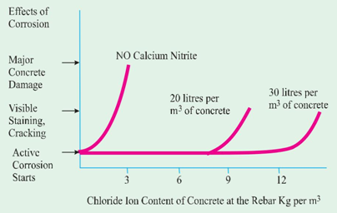
ferrous oxide which can initiate corrosion when the chloride ions reach the steel. The nitrite ions present in the corrosion inhibiting admixture will oxidise the ferrous oxide to ferric oxide, thus stabalising the passivating layer even in the presence of chlorides. The concentration of nitrite must by sufficient to cope up with the continuing ingress of chloride ions.
Calcium nitrite corrosion inhibitor comes in a liquid from containing about 30 per cent calcium nitrite solids by weight. The more corrosion inhibitor is added, the longer the onset of corrosion will be delayed. Since most structures in a chloride environment reach a level of about 7 kg of chloride iron per m³ during their service life, use of less than 18 litres/m³ of calcium nitrite solution is not recommended.
Figure shows that without an inhibitor the reinforcing steel starts to corrode when the chloride content at the rebar reaches a threshold level of 0.7 kg/m³. Although the corrosion process starts when the threshold level is reacted, it may take several years for staining, cracking and spalling to become apparent and several more years before deterioration occurs. Adding calcium nitrite increases this corrosion threshold. When you add 20 litres/ m³, corrosion will not begin until over 7.7 kg/ m³ of chloride is present in the concrete at the rebar.
Coatings to rein-forcement: The object of coating to s teel bar is to provide a durable barrier to aggressive materials, such as chlorides. The coatings should be robust to withstand fabrication of reinforcement cage, and pouring of concrete and compaction by vibrating needle.
Simple cement slurry coating is a cheap method for temporary protection against rusting of reinforcement in storage.
Central Electro Chemical Research Institute, (CECRI) Karaikudi have suggested a method for prevention of corrosion in steel reinforcement in concrete. The steps involved in this process are
Derusting: The reinforcements are cleaned with a derusting solution. This is followed without delay by cleaning the rods with wet waste cloth and cleaning powder. The rods are then rinsed in running water and air dried.
Phosphating: Phosphate jelly is applied to the bars with fine brush. The jelly is left for 45-60 minutes and then removed by wet cloth. An inhibitor solution is then brushed over the phosphated surface.
Cement coating: A slurry is made by mixing the inhibitor solution with portland cement and applied on the bar. A sealing solution is brushed after the rods are air cured. The sealing solution has an insite curing effect. Thesecond coat of slurry is then applied and the bars are air dried.Therefore, it is pointed out that the expoxy coating which does not allow the concrete to breathe should not be used for coating concrete members.
Instead, the protective coating should be based on acrylics which retains the breathing property of concrete, while protecting the concrete from other harmful environmental agencies, in particular entry of water and carbonation.
In addition, epoxy based coating material is not resistant to ultra violet rays when exposed to sunlight and also it is not flexible. Whereas the coating material based on acrylic polymer is resistant to ultra violet rays of sun and is flexible.
Coating is not only required for bridges, flyovers and industrial structures, it is also required for very thin members like fins, facade, sunbreakers and other delicate concrete structures where specified amount of cover can not be given. Therefore, acrylic based protective cum decorative coatings can be given for additional durability of such concrete members.
Design and Detailing
The structural designer should take all precautions in designing and detailing, with respect to spacing between bars for the concrete to flow between reinforcements, to facilitate vibration of concrete, to give proper cover to the steel reinforcements, to restrict the crack width etc.
Nominal Cover to Reinforcement: The nominal cover is applicable to all steel reinforcement including links.

- What is cathodic protection and when is it applied?

Cathodic Protection: Cathodic protection is one of the effective, well known, and extensively used methods for prevention of corrosion in concrete structures in more advanced countries. Due to high cost and long term monitoring required for this method, it is not very much used in India.
The cathodic protection comprises of application of impressed current to an electrode laid on the concrete above steel reinforcement. This electrode serves as anode and the steel reinforcement which is connected to the negative terminal of a DC source acts as a cathode. In this process the external anode is subjected to corrode and the cathodic reinforcement is protected against corrosion and hence the name “Cathodic protection”.In this process the negative chloride ions which are responsible for the damage of the passivating film, are drawn away from the vicinity of steel towards the anode where they are oxidised to form chlorine gas. The environment around the steel reinforcement reverts back to alkaline condition which protects the steel.
The other recent development in corrosion control methods are Realkalisation and Desalination.
The realkalisation process allows to make the concrete alkaline again and passivate the reinforcing steel by electrochemical method. This brings back the lost alkalinity of concrete to sufficiently high level to reform and maintain the passive layer on the steel.
In the desalination process the chloride ions are removed from the concrete, particularly from the vicinity of the steel reinforcement by certain electrical method to re-establish the passive layer on the steel.

- Write short notes on the following: Sulphate, Acid and Alkali attack

Sulphate Attack
Most soils contain some sulphate in the form of calcium, sodium, potassium and magnesium. They occur in soil or ground water. Because of solubility of calcium sulphate is low, ground waters contain more of other sulphates and less of calcium sulphate. Ammonium sulphate is frequently present in agricultural soil and water from the use of fertilizers or from sewage and industrial effluents. Decay of organic matters in marshy land, shallow lakes often leads to the formation of H₂S, which can be transformed into sulphuric acid by bacterial action. Water used in concrete cooling towers can also be a potential source of sulphate attack on concrete. Therefore sulphate attack is a common occurrence in natural or industrial situations.
Solid sulphates do not attack the concrete severely but when the chemicals are in solution, they find entry into porous concrete and react with the hydrated cement products. Of all the sulphates, magnesium sulphate causes maximum damage to concrete. A characteristic whitish appearance is the indication of sulphate attack.
The term sulphate attack denote an increase in the volume of cement paste in concrete or mortar due to the chemical action between the products of hydration of cement and solution containing sulphates. In the hardened concrete, calcium aluminate hydrate (C-A-H) can react with sulphate salt from outside. The product of reaction is calcium sulphoaluminate, forming within the framework of hydrated cement paste. Because of the increase in volume of the solid phase which can go up to 227 per cent, a gradual disintegration of concrete takes place.
The reactions of the various sulphates with hardened cement paste is shown below
Let us take the example of Sodium Sulphate attacking Ca(OH)₂
Ca(OH)₂ + Na₂SO₄ . 10H₂O CaSO₄ . 2H₂O + 2NaOH + 8H₂O.
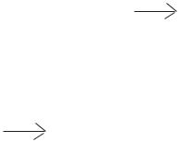
The reaction with calcium aluminate hydrate is as follows

2(3CaO . Al₂O₃ . 12H₂O) + 3(Na₂SO₄ . 10H₂O)
3CaO . Al₂O₃ . 3CaSO₄ . 31H₂O + 2Al(OH)₃ + 6NaOH + 17 H₂O Calcium sulphate attacks only calcium aluminate hydrate producing calcium sulpho aluminate (3CaO . Al₂O₃ . 3CaSO₄ . 32H₂O) known as ettringite. Molecules of water may be 32 or 31.
On the other hand magnesium sulphate has a more far reaching action than other sulphates because it reacts not only with calcium hydroxide and hydrated calcium aluminates like other sulphates but also decomposes the hydrated calcium silicates completely and makes it a friable mass.
The rate of sulphate attack increases with the increase in the strength of solution. A saturated solution of magnesium sulphate can cause serious damage to concrete with higher water cement ratio in a short time. However, if the concrete is made with low water cement ratio, the concrete can withstand the action of magnesium sulphate for 2 or 3 years. The concentration of sulphates is expressed as the number of parts by weight of SO₃ per million parts. 1000 PPM is considered moderately severe and 2000 PPM is considered very severe, especially if MgSO₄ is the predominant constituent.
Another factor influencing the rate of attack is the speed in which the sulphate gone into the reaction is replenished. For this it can be seen that when the concrete is subjected to the pressure of sulphate bearing water on one side the rate of attack is highest. Similarly, alternate wetting and drying due to tidal variation or spraying leads to rapid attack.
Methods of Controlling Sulphate Attack
Having studied the mechanism of sulphate attack on concrete it will be easy for us to deal with the methods for controlling the sulphate attack.
(a) Use of Sulphate Resisting Cement
The most efficient method of resisting the sulphate attack is to use cement with the low C₃ A content. This has been discussed in detail earlier in chapter I. In general, it has been found that a C₃ A content of 7% gives a rough division between cements of good and poor performance in sulphate waters.
(b) Quality Concrete
A well designed, placed and compacted concrete which is dense and impermeable exhibits a higher resistance to sulphate attack. Similarly, a concrete with low water/cement ratio also demonstrates a higher resistance to sulphate attack.
(c) Use of air-entrainment
Use of air-entrainment to the extent of about 6% (six per cent) has beneficial effect on the sulphate resisting qualities of concrete. The beneficial effect is possibly due to reduction of segregation, improvement in workability, reduction in bleeding and in general better impermeability of concrete.
(d) Use of pozzolana
Incorporation of or replacing a part of cement by a pozzolanic material reduces the sulphate attack. Admixing of pozzolana converts the leachable calcium hydroxide into insoluble non-leachable cementitious product. This pozzolanic action is responsible for impermeability of concrete. Secondly, the removal of calcium hydroxide reduces the susceptibility of concrete to attack by magnesium sulphate.
(e) High Pressure Steam Curing
High pressure steam curing improve the resistance of concrete to sulphate attack. This improvement is due to the change of C₃ AH₆ into a less reactive phase and also to the removal or reduction of calcium hydroxide by the reaction of silica which is invariably mixed when high pressure steam curing method is adopted.
(f) Use of High Alumina Cement
The cause of great resistance shown by high alumina cement to the action of sulphate is still not fully understood. However, it is attributed in part to the absence of any free calcium hydroxide in the set cement, in contrast to Portland cement. High alumina cement contains approximately 40% alumina, a compound very susceptible to sulphate attack, when in normal portland cement. But this percentage of alumina present in high alumina cement behaves in a different way. The primary cause of resistance is attributed to formation of protective films which inhibit the penetration or diffusion of sulphate ions into the interior. It should be remembered that high alumina cement may not show higher resistance to sulphate attack at higher temperature.
A comprehensive study of concrete exposed to natural sulphate soils and to pure sulphate solution in the laboratory for periods ranging upto 25 years, was reported by Miller and Manson. The conclusions derived from this extensive study is given below.
(a ) There was a definite correlation between the sulphate resistance of Portland cement and the amount of tricalcium aluminate (C₃ A) it contained. High resistance was found for Portland cements containing not more than 5.5 per cent C₃ A.
(b ) There was no indication that the finer grinding of the cements had any influence on sulphate resistance.
(c ) The resistance of seven Portland-pozzolana cements varied over nearly as wide a range as was observed for the 122 Portland cements.
(d ) Four calcium aluminate cements (Cement Fondu or similar-non Portland cement) consistently showed a very high resistance to the sulphate bearing water. There was however, some indication that these cements are not completely stable at temperatures above 21 to 38°C.
(e ) Specimens cured in steam at temperatures of 100°C and especially at 176°C were highly resistant. The degree of improvement was greatest for those cements originally not highly resistant, that is, those with relatively high C₃ A.
(f ) Few of the 40 admixtures tried gave markedly improved resistance; many had no effect and some were deleterious. The most effective were linseed, soyabean, and tung oils.
A large scale study of resistance of concrete to sulphate soils formed a part of the long-time study of cement performance in concrete. This was carried out by the Portland Cement Association (USA) under the general supervision of an Advisory committee. About 1000 concrete beams of size 15 x 13 x 86 cm were embedded horizontally to half their 15 cm depth in soils containing about 10 per cent soluble sulphates. For half of the specimens the sulphate was principally sodium sulphate. For the other half, 2/3 number of specimen it was sodium sulphate and 1/3 magnesium sulphate. The soil in each basin was alternately made wet and dry. The prevailing temperature was above 0°C.
Twenty-seven different Portland cements including all five ASTM type, were used in three concrete mixtures containing cement 223, 307, 390 kg/m³.
A report of results to 20 years was published in 1965. With respect to sulphate attack, the following conclusions were drawn.
(a ) The resistance of concrete to attack by solutions of sulphate salts increases with reduction of C₃ A content in the cement. At 6 years, a C₃ A content of 7% as calculated without correction for minor oxides provided a good separation between cements of good and poor sulphates resistance. After 20 years, it was concluded that a C₃ A content of 5.5 per cent as corrected for minor oxides and about 3.5 per cent as determined by X-ray analysis, were fairly good values for separating superior and poor resistance in the richest mix. It is interesting to note that the 10 year report (1953) observed that beams in the soil containing MgSO₄ as well Na₂SO₄ were less attacked than those in the soil containing mainly Na₂SO₄. This result is contrary to expectations based on some studies conducted with concretes and mortars continually immersed in sulphate solutions. It was tentatively ascribed to differences in the nature of the salt deposit on the beams resulting from evaporation.
Alkali-Aggregate Reaction
Alkali-aggregate reaction (AAR) is basically a chemical reaction between the hydroxyl ions in the pore water within concrete and certain types of rock minerals which sometimes occur as part of aggregates. Since reactive silica in the aggregate is involved in this chemical reaction it is often called alkali-silica reaction (ASR). Since the first paper published by Stantan during 1940’s on this subject, a considerable studies have been made and now it is recognised as one of the major causes of cracking of concrete. Primarily the reaction produces what is called alkali-silica gel of unlimited swelling type under favourable conditions of moisture and temperature in voids and cracks and further it causes disruption and pattern cracking. The crack width can range from 0.1 mm to as much as 10 mm.
What was seen as a rare case in 1940’s have been recognised now as one of the general occurrence in present day concrete to a greater or smaller magnitude. Aggregates used in large concrete construction should be suitably tested to detect tendency for alkali-aggregate reaction.
In the construction of nuclear power project at Kaiga initially they did not investigate the quality of aggregate. Later on they suspected the aggregate and as a remedial measure, they went in for low alkali cement having alkali content of less than 0.4.
As the concrete technologists are now more conscious about AAR, the cement manufactures are more careful about alkali content (K₂O and Na₂O) or what is called soda equivalent. This is calculated as the actual Na₂O content plus 0.658 times the K₂O content of the clinker. It should be less than 0.6 per cent by mass of cement. Alkali content of 0.6 could be considered as a threshold point of high alkali cement.
It is to be pointed out that alkali-silica reaction takes place only at high concentrations of OH–, that is at high pH value in the pore water. The pH of the pore water depends on the alkali content of cement. Heigh alkali cement may lead to a pH of about 13.5 to 13.9 and low alkali cement results in a pH of about 12.7 to 13.1. An increase in pH of 1.0 represents a ten fold increase in hydrogen ion concentration. Therefore low alkali cement which produces low pH value in the pore water is safe against potentially reactive aggregate.
Alkalis not only comes from cement but also comes from sand containing sodium chloride, admixtures, mixing water, sea water penetration, fly ash, blast furnace slag and deicing salt getting into concrete. Alkalis from all these sources must be included in finding the total alkalis. British standard 5328 : part 1 : 1091 specifies a maximum of 3.0 kg of alkalis (expressed as soda equivalent) in 1 m³ of concrete in case of alkali reactive aggregates are used.
Acid Attack
Concrete is not fully resistant to acids. Most acid solutions will slowly or rapidly disintegrate portland cement concrete depending upon the type and concentration of acid. Certain acids, such as oxalic acid and phosphoric acids are harmless. The most vulnerable part of the cement hydrate is Ca(OH)₂, but C-S-H gel can also be attacked. Silicious aggregates are more resistant than calcareous aggregates.
Concrete can be attacked by liquids with pH value less than 6.5. But the attack is severe only at a pH value below 5.5. At a pH value below 4.5, the attack is very severe. As the attack proceeds, all the cement compounds are eventually broken down and leached away, together with any carbonate aggregate material. With the sulphuric acid attack, calcium sulphate formed can proceed to react with calcium aluminate phase in cement to form calcium sulphoaluminate, which on crystallisation can cause expansion and disruption of concrete.
If acids or salt solutions are able to reach the reinforcing steel through cracks or porosity of concrete, corrosion can occur which will cause cracking.

Unit –V

SPECIAL CONCRETES

Part-A (2 Marks)

1. Define Aerated Concrete

Aerated concrete (AAC), also known as autoclaved cellular concrete (ACC) or autoclaved lightweight concrete (ALC), was invented in the mid-1920s by the Swedish architect and inventor Johan Axel Eriksson. It is a lightweight, precast building material that simultaneously provides structure, insulation, and fire and mold resistance. AAC products include blocks, wall panels, floor and roof panels, and lintels

2. What is the general use of Shotcrete?

While most shotcrete placed is the traditional dry-mix and wet-mix shotcrete, the Use of specialty shotcretes has become common. The addition of accelerators, fibers, and silica fume can provide shotcrete with significantly enhanced performance.

3. What is meant by No fine concrete?

Concrete produced from a mix of solid or porous (mainly uniform-fraction) gravel or crushed stone, a binder (Portland cement or slag Portland cement), and water. The absence of sand in the mix and the limited consumption of cement (not more than 280

kg/m³) account for the honeycomb structure of the concrete, the reduced density, and the low heat conduction.

The compressive strength of concrete with solid fillers does not exceed 10 MN/m². No-fines concrete is used mainly for erecting cast or large-block exterior walls of buildings in regions rich in local gravel or rock for crushed rock in the absence of other inexpensive wall materials. Walls made from this type of concrete are plastered on both sides to prevent air drafts. No-fines concrete made from a porous filler (keramzit gravel or sifted slag) is also used as an insulating material in the sandwich enclosing structures of buildings.

4. What do you mean by Fibre Reinforced Concrete?

Fiber-reinforced concrete (FRC) is concrete containing fibrous material which increases its structural integrity. It contains short discrete fibers that are uniformly distributed and randomly oriented. Fibers include steel fibers, glass fibers, synthetic fibers and natural fibers – each of which lend varying properties to the concrete. In addition, the character of fiber-reinforced concrete changes with varying concretes, fiber materials, geometries, distribution, orientation, and densities.

5. Define ferro-cement. (MAY/JUNE 2016)

The term ferro-cement implies the combination of ferrous product with cement. Generally this combination is in the form of steel wires meshes embedded in a portland cement mortar. Wire mesh is usually of 0.8 to 1.00 m diameter steel wires at 5 mm to
50 mm spacing and the cement mortar is of cement sand ratio of 1:2 or 1:3. 6 mm diameter bars are also used at large spacing, preferably in the corners. Sand may be replaced by baby jelly. The water cement ratio used is between 0.4 to 0.45

6. What is self-compacting concrete?

Self-compacting concrete is a non-segregating concrete that is placed by means of its own weight. The importance of self-compacting concrete is that is maintains all concrete’s durability and characteristics, meeting expected performance requirements.
- State the effects of concrete in cold weather Slower Strength Gain

- Cracking Freezing

- Extended Setting Times

- What are the functions of formwork?

Formwork is a classic temporary structure in the sense that it is erected quickly, highly loaded for a few hours during the concrete placement, and within a few days disassembled for future reuse. Also classic in their temporary nature are the connections, braces, tie anchorages, and adjustment devices which forms need.

- Define hot weather concreting.

- Hot weather may be defined as any period of high temperature in which special precautions need to be taken to ensure proper handling, placing, finishing and curing of concrete.

- Hot weather problems are most frequently encountered in the summer, but the associated climatic factors of high winds and dry air can occur at any time, especially in arid or tropical climates.

- Hot weather conditions can produce a rapid rater of evaporation of moisture from the surface of the concrete, and accelerated setting time, among other problems. Generally high relative humidity tends to reduce the effects of high temperature.

.

10. Define cold weather concreting.

Concrete placed during cold weather will develop sufficient strength and durability to satisfy intended service requirements only if it is properly produced, placed and protected. ACI 306 “Cold Weather Concreting” defines cold weather concreting as a period when for more than three (3) consecutive days, the following conditions exist:

- The average daily air temperature is less than 5°C (40°F) and,

- The air temperature is not greater than 10°C (50°F) for more than one-half of any 24 hour period.

- What are the methods used for consolidating concrete?

Consolidation is the process of removing entrapped air from freshly placed concrete. Several methods and techniques are available, the choice depending
mainly on the workability of the mixture, placing conditions, and degree of air removal desired. Some form of vibration is usually employed.

12. What are the uses of polymer concrete?

Polymer concrete may be used for new construction or repairing of old concrete. The adhesion properties of polymer concrete allow patching for both polymer and cementitious concretes. The low permeability of polymer concrete allows it to be used in swimming pools, sewer pipes, drainage channels, electrolytic cells for base metal recovery, and other structures that contain liquids. It can also be used as a replacement for asphalt pavement, for higher durability and higher strength.

- What are the advantages of using high-strength concrete?

Concrete is defined as “high-strength concrete” solely on the basis of its compressive strength measured at a given age.

14. What are the various parameters affecting the strength of concrete?

Many factors influence the rate at which the strength of concrete increases after mixing.

- Concrete porosity: voids in concrete can be filled with air or with water is critical.

- Cement-related parameters: many parameters relating to the composition of the individual cement minerals and their proportions in the cement can affect the rate of strength growth and the final strengths achieved.

Part –B (16 Marks)

- What are the various methods of underwater construction? Explain.

TREMIE METHOD OF UNDER WATER CONCRETING
Tremie method is the most acceptable method of concreting under water.
In this method a tremie pipe is inserted in the water up to the point where concrete is going to be placed. Generally the diameter of a tremie pipe varies from 20 cm to 30 cm. Depending upon the depth of concreting under water we can add more tremie pipe by coupling it with one another.
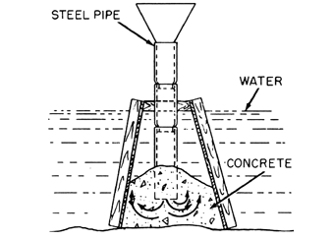

Before inserting the tremie pipe into the water, the bottom end of the tremie pipe must be closed with a plug or thick polythene sheet or other suitable material.
After tremie pipe reaches at the desired depth, a funnel is fitted to the top end of the tremie pipe, to facilitate pouring of concrete.
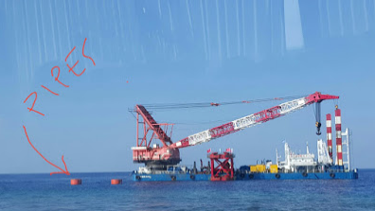
Then concrete having a very high slump of about 150 mm to 200 mm is poured into the funnel, until the whole length of tremie pipe is filled up with concrete.
Then the tremie pipe is lifted up and given a slight jerk by a winch & pulley arrangement. Due to application of jerk and weight of the concrete inside the pipe, the bottom plug fall and the concrete gets discharged.
At this stage, make sure that the end of the tremie pipe remains inside the concrete, because this will prevent entering of water into the pipe from the bottom.
When all of the concrete inside the pipe gets discharged, the tremie pipe is again completely filled with concrete and the process is repeated. This process of filling and discharging of concreting is repeated, without any interruption, until the concrete level comes above the water table

- What are the effects of cold weather concreting and hot weather concreting?

Cold Weather Concreting
The normal procedure adopted for concreting in fair weather will not be valid for concreting when the temperature is low or below the freezing point. In India, such areas are fairly small when compared to fair weather regions. The production of concrete in cold weather introduces special and peculiar problems, such as delay in setting and hardening, damage to concrete in plastic condition when exposed to below freezing point owing to the formation of ice lenses. Therefore, it is essential to maintain the temperature of the concrete positively above 0°C, possibly at much higher temperature.
Effects of Cold Weather on Concrete
(a) Delay in setting and hardening: Rate of hydration depends upon the temperature. If temperature is low, concrete takes a long time to set and a longer time to harden i.e., for the development of strength. Fig. 12.9 shows the effect of ambient temperature on setting time. The delay in setting time makes concrete vulnerable to frost attack and other disturbances. Delay in hardening period does not facilitate removal of formwork in a short period. Also the rate of progress of work will be very slow, all of which affects economy.
(b) Freezing of concrete at early age: When the temperature goes below freezing point, the free water contained in the plastic concrete freezes. Freezing of water, not only prevents the hydration of cement but also makes the concrete expand. This expansion causes disruption of concrete due to which irrepairable loss of strength and quality takes place.
(c) Freezing and Thawing: It is likely that due to varied behaviour of climatic conditions in the cold weather regions, the fresh concrete or hardened concrete gets subjected to freezing and thawing cycles. The durability of concrete gets greatly impaired due to this alternate freezing and thawing. Freezing and thawing may also exert fatigue in the concrete.
In dealing with the aspect of cold weather concerting, the following conditions may be discussed.
(a) Low temperature, but above 0°C at the time of concreting and later during hardening period.
(b) Low temperature at the time of concreting but below 0°C during the hardening period.
(c) Temperature below 0°C at the time of concreting and during hardening period.
(d) Hardened concrete subjected to alternate freezing and thawing.
It is necessary to deal with the above four conditions to understand the behaviour of concrete clearly and to take appropriate steps to offset the harmful effects of such conditions for the successful placing of concrete.
Low Temperature but above 0°C
If the temperature is only low but always above the freezing point, it only retards the rate of development of strength as shown in the maturity equations stated earlier. There is no other bad effect on the fresh concrete or hardening concrete. As a matter of fact, the ultimate strength of the concrete cured at 9°C has been found to be of a higher order than that of the concrete cured at higher temperature. This may be due to the surperiority of gel structure on account of slow growth. No other precautions are necessary except recognition of the fact of delayed strength for stripping the formwork or for putting the concrete into service.
Low Temperature at the Time of Concreting but Below 0°C after Concreting
The first condition has been discussed in the above para. But after concreting, if the temperature falls below 0°C, it is again necessary to view the conditions under the following two catagories:
(a) Temperature falling below 0°C when the concrete is still green.
(b) Temperature prevailing below 0°C after the concrete is sufficiently hardened.
Many times it may so happen that the concrete will have been mixed and placed when the ambient temperature is above freezing point. But before the concrete has attained sufficient strength, the temperature of the air and also temperature within the concrete may fall below freezing point, in which case the free water still available in the concrete to freeze and form ice lenses in microscopic scale. These ice lenses formed in the capillary cavities may cause capillary suction of water from the ground, if the ground is saturated, and become bigger to disrupt the mass which disturbs the compaction of concrete. Ice formations may also appear as ice needles in the contact surfaces between aggregates and cement paste. Fig. 9.18 shows the increase in volume of concrete as a function of age at which freezing starts. Fig. 9.19 also shows the increase in volume against number of cycles of freezing and thawing. After thawing these ice needles will melt forming cavities. Therefore, it can be concluded that freezing of freshly laid concrete seriously impair the structural integrity of concrete and results in considerable loss of strength.
In extreme cases, it may make the concrete an absolutely useless friable mass.
On the other hand if the concrete is sufficiently hardened when freezing takes place, there will not be much harm to the structural integrity of the concrete. If the concrete has sufficiently hardened, the water that has been mixed for making concrete will have been lost either being used up in hydration process or lost by evaporation. Due to the formation of cement gels, the capillary cavities also will have been very much reduced, with the results that there exists very little of free water in the body of concrete to freeze. Therefore, firstly the magnitude of volume change due to the formation of microscopic ice lens is much less. Secondly, the concrete at this stage is strong enough to resist whatever osmotic pressure resulting from the freezing. Therefore, there is no immediate danger to the concrete.
Temperature Below 0°C at the Time of Concreting and During Hardening Period
Certain precautions are absolutely necessary for concreting when the temperature is below 0°C, so that the fresh concrete does not get frozen. The consequences of freezing of fresh concrete and the effect of sub-zero temperature on the hardened but not fully matured concrete has been explained in the above para. Precautions to be taken and methods for carrying out concreting operations will be explained later.
Hardened Concrete subjected to Alternate Freezing and Thawing
Concrete pavements constructed at high altitude is normally subjected to alternate freezing and thawing. The interval of cycles may be between season to season or between day and night or even a couple of times in a day. It has been found that the durability of hardened concrete is reduced to 1/3 to 1/7 when it is subjected to alternate freezing and thawing depending on the quality of concrete.
It is to be noted that concrete is a pervious material. Degree of porosity is depending upon the Gel/space ratio. A concrete member is likely to get saturated due to the absorption of moisture from surface or from bed. The free water that has filled the capillary cavities of concrete will get frozen with the fall of temperature. Subsequently when the temperature goes above 0°C, the ice lens melts. Due to this alternate freezing and thawing, concrete is subjected to distress and surface scaling. The distress of concrete can be measured by the loss of weight against number of cycles of freezing as shown in Fig. 5.18.
Concreting Methods at Sub-zero Temperature
Having discussed the effect of sub zero-temperature on fresh concrete, hardening concrete and hardened concrete, it is clear that fresh concrete should not be subjected to freezing condition till such time it attains a certain amount of strength. This time interval is known as ‘Pre-hardening Period’.
The precautions to be taken and methods adopted for concreting in sub-zero temperature is listed below:
(a) Utilisation of the heat developed by the hydration of cement and practical methods of insulation.
(b) Selection of suitable type of cement.
(c) Economical heating of materials of concrete.
(d) Admixtures of anti-freezing materials.
(e) Electrical heating of concrete mass.
(f )Use of air-entraining agents.

- How can high-strength concrete be classified? Explain.

High Strength Concrete
Concrete is generally classified as Normal Strength Concrete (NSC), High Strength Concrete (HSC) and Ultra High Strength Concrete (UHSC). There are no clear cut boundary for the above classification. Indian Standard Recommended Methods of Mix Design denotes the boundary at 35 MPa between NSC and HSC. They did not talk about UHSC. But elsewhere in the international forum, about thirty years ago, the high strength lable was applied to concrete having strength above 40 MPa. More recently, the threshold rose to 50 to 60 MPa. In the world scenario, however, in the last 15 years, concrete of very high strength entered the field of construction, in particular construction of high-rise buildings and long span bridges. Concrete strengths of 90 to 120 MPa are occasionally used. Table 7.8 shows the kind of high strength produced in RMC plant.
The advent of Prestressed Concrete Technology Techniques has given impetus for making concrete of higher strength. In India, there are cases of using high strength concrete for prestressed concrete bridges. The first prestressed concrete bridge was built in 1949 for the
Ready Mixed Concrete has taken its roots in India now. The manufacture of high strength concrete will grow to find its due place in concrete construction for all the obvious benefits. In the modern batching plants high strength concrete is produced in a mechanical manner. Of course, one has to take care about mix proportioning, shape of aggregates, use of supplementary cementitious materials, silica fume and superplasticizers. With the modern equipments, understanding of the role of the constituent materials, production of high strength concrete has become a routine matter.
(g ) Use of cementitious aggregates.
Seeding: This involves adding a small percentage of finely ground, fully hydrated Portland cement to the fresh concrete mix. The mechanism by which this is supposed to aid strength development is difficult to explain. This method may not hold much promise.
Revibration: Concrete undergoes plastic shrinkage. Mixing water creates continuous capillary channels, bleeding, and water accumulates at some selected places. All these reduce the strength of concrete. Controlled revibration removes all these defects and increases the strength of concrete.
High Speed slurry mixing:This process involves the advance preparation of cement-water mixture which is then blended with aggregate to produce concrete. Higher compressive strength obtained is attributed to more efficient hydration of cement particles and water achieved in the vigorous blending of cement paste.
Use of Admixtures: Use of water reducing agents are known to produce increased compressive strengths.
Inhibition of cracks: Concrete fails by the formation and propagation of cracks. If the propagation of cracks is inhibited, the strength will be higher. Replacement of 2– 3% of fine aggregate by polythene or polystyrene “lenticules” 0.025 mm thick and 3 to 4 mm in diameter results in higher strength. They appear to act as crack arresters without necessitating extra water for workability. Concrete cubes made in this way have yielded strength upto 105 MPa.
Sulphur Impregnation: Satisfactory high strength concrete have been produced by impregnating low strength porous concrete by sulphur. The process consists of moist curing the fresh concrete specimens for 24 hours, drying them at 120°C for 24 hours, immersing the specimen in molten sulphur under vacuum for 2 hours and then releasing the vacuum and soaking them for an additional ½ hour for further infiltration of sulphur. The sulphur-infiltrated concrete has given strength upto 58 MPa.
Use of Cementitious aggregates: It has been found that use of cementitious aggregates has yielded high strength. Cement fondu is kind of clinker. This glassy clinker when finely ground results in a kind of cement. When coarsely crushed, it makes a kind of aggregate known as ALAG. Using Alag as aggregate, strength upto 125 MPa has been obtained with water/cement ratio 0.32.
Ultra High Strength Concrete
As technology advances, it is but natural that concrete technologists are directing their attention beyond high strength concrete to ultra high strength concrete. The following techniques are used for producing ultra high strength concrete.

(a) Compaction by pressure (b ) Helical binding;
(c ) Polymerisation in concrete (d ) Reactive powder concrete.

Compaction by Pressure: It has been pointed out earlier that cement paste derives strength due to the combined effect of friction and bond. In ceramic material, grain size and porosity would be the most important parameters affecting friction and bond and hence the strength. It has been attempted to reduce grain size and porosity by the application of tremendous pressure at room temperature and also at higher temperature.
Unusually high strength have been generated in materials by employing “hot pressing” techniques and intermediate ranges of strengths have been achieved by applying high pressure at room temperature to Portland cement pastes. Strengths as high as 680 MPa (compressive), 66 MPa (indirect tensile) have been obtained by subjecting cement pastes to 357 MPa pressure under a temperature of 250°C. The water/cement ratio used was 0.093. It was also seen that hot pressed materials are volume stable. The micro structure of such materials are very compact, consisting of intergrowth of dense hydrated cement gel surrounding residual unhydrated cement grain cores. The lowest porosity of the materials measured was approximately 1.8%.

- What are the various quality to ensure good performance of polymer concrete? (MAY/JUNE 2016)

Polymer Concrete
Continuous research by concrete technologists to understand, improve and develop the properties of concrete has resulted in a new type of concrete known as, “Polymer Concrete”. It is referred time and again in the earlier chapters that the concrete is porous. The porosity is due to air-voids, water voids or due to the inherent porosity of gel structure itself. On account of the porosity, the strength of concrete is naturally reduced. It is conceived by many research workers that reduction of porosity results in increase of strength of concrete.
Therefore, process like vibration, pressure application spinning etc., have been practised mainly to reduce porosity. All these methods have been found to be helpful to a great extent, but none of these methods could really help to reduce the water voids and the inherent porosity of gel, which is estimated to be about 28%. The impregnation of monomer and subsequent polymerisation is the latest technique adopted to reduce the inherent porosity of the concrete, to improve the strength and other properties of concrete.
The development of concrete-polymer composite material is directed at producing a new material by combining the ancient technology of cement concrete with the modern technology of polymer chemistry.
Type of Polymer Concrete
Four types of polymer concrete materials are being developed presently. They are:
(a) Polymer Impregnated Concrete (PIC).
(b) Polymer Cement Concrete (PCC).
(c)Polymer Concrete (PC).
(d) Partially Impregnated and surface coated polymer concrete.
Polymer Impregnated Concrete (PIC)
Polymer impregnated concrete is one of the widely used polymer composite. It is nothing but a precast conventional concrete, cured and dried in oven, or by dielectric heating from which the air in the open cell is removed by vacuum. Then a low viscosity monomer is diffused through the open cell and polymerised by using radiation, application of heat or by chemical initiation.
Mainly the following types of monomer are used:
(a) Methylmethacrylate (MMA),
(b) Styrene,
(c)Acrylonitrile,
(d) t-butyl styrene,
(e) Other thermoplastic monomers.
The amount of monomer that can be loaded into a concrete specimen is limited by the amount of water and air that has occupied the total void space. It is necessary to know the concentration of water and air void in the system to determine the rate of monomer penetration. However, the main research effort has been towards obtaining a maximum monomer loading in concrete by the removal of water and air from the concrete by vacuum or thermal drying, the latter being more practicable for water removal because of its rapidity.
Another parameter to consider is evacuation of the specimen prior to soaking in monomer. This eliminates the entrapment of air towards the centre of the specimen during soaking which might otherwise prevent total or maximum monomer loading. The application of pressure is another technique to reduce monomer loading time.

- What are the basic properties of fibre – reinforced concrete which can be advantageously made use of in the design of structural elements?

Fibre Reinforced Concrete
Plain concrete possesses a very low tensile strength, limited ductility and little resistance to cracking. Internal microcracks are inherently present in the concrete and its poor tensile strength is due to the propagation of such microcracks, eventually leading to brittle fracture of the concrete.
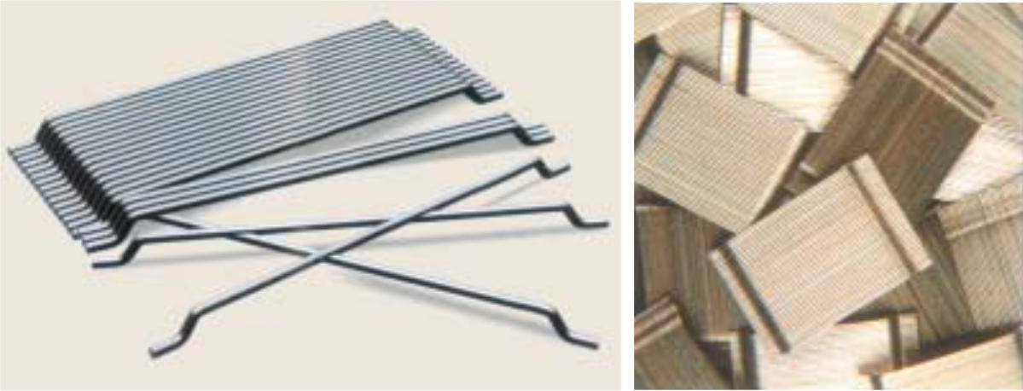
In the past, attempts have been made to impart improvement in tensile properties of concrete members by way of using conventional reinforced steel bars and also by applying restraining techniques. Although both these methods provide tensile strength to the concrete members, they however, do not increase the inherent tensile strength of concrete itself.

In plain concrete and similar brittle materials, structural cracks (micro-cracks) develop even before loading, particularly due to drying shrinkage or other causes of volume change. The width of these initial cracks seldom exceeds a few microns, but their other two dimensions may be of higher magnitude.
When loaded, the micro cracks propagate and open up, and owing to the effect of stress concentration, additional cracks form in places of minor defects. The structural cracks proceed slowly or by tiny jumps because they are retarded by various obstacles, changes of direction in bypassing the more resistant grains in matrix. The development of such microcracks is the main cause of inelastic deformations in concrete.
It has been recognised that the addition of small, closely spaced and uniformly dispersed fibres to concrete would act as crack arrester and would substantially improve its static and dynamic properties. This type of concrete is known as Fibre Reinforced Concrete.
Fibre reinforced concrete can be defined as a composite material consisting of mixtures of cement, mortar or concrete and discontinuous, discrete, uniformly dispersed suitable fibres. Continuous meshes, woven fabrics and long wires or rods are not considered to be discrete fibres.
Fibres Used
Although every type of fibre has been tried out in cement and concrete, not all of them can be effectively and economically used. Each type of fibre has its characteristic properties and limitations. Some of the fibres that could be used are steel fibres, polypropylene, nylons, asbestos, coir, glass and carbon.
Fibre is a small piece of reinforcing material possessing certain characteristic properties. They can be circular or flat. The fibre is often described by a convenient parameter called “aspect ratio”. The aspect ratio of the fibre is the ratio of its length to its diameter. Typical aspect ratio ranges from 30 to 150.
Steel fibre is one of the most commonly used fibre. Generally, round fibres are used. The diameter may vary from 0.25 to 0.75 mm. The steel fibre is likely to get rusted and lose some of its strengths. But investigations have shown that the rusting of the fibres takes place only at the surface. Use of steel fibre makes significant improvements in flexural, impact and fatigue strength of concrete, It has been extensively used in various types of structures, particularly for overlays of roads, airfield pavements and bridge decks. Thin shells and plates have also been constructed using steel fibres.Polypropylene and nylon fibres are found to be suitable to increase the impact strength. They possess very high tensile strength, but their low modulus of elasticity and higher elongation do not contribute to the flexural strength.
Asbestos is a mineral fibre and has proved to be most successful of all fibres as it can be mixed with Portland cement. Tensile strength of asbestos varies between 560 to 980 N/mm². The composite product called asbestos cement has considerably higher flexural strength than the Portland cement paste. For unimportant fibre concrete, organic fibres like coir, jute, canesplits are also used.
Glass fibre is a recent introduction in making fibre concrete. It has very high tensile strength 1020 to 4080 N/mm². Glass fibre which is originally used in conjunction with cement was found to be effected by alkaline condition of cement. Therefore, alkali-resistant glass fibreby trade name “CEM-FIL” has been developed and used. The alkali resistant fibre reinforced concrete shows considerable improvement in durability when compared to the conventional E-glass fibre.
Carbon fibres perhaps posses very high tensile strength 2110 to 2815 N/mm² and Young’s modulus. It has been reported that cement composite made with carbon fibre as reinforcement will have very high modulus of elasticity and flexural strength. The limited studies have shown good durability. The use of carbon fibres for structures like clading, panels and shells will have promising future.
Factors Effecting Properties of Fibre Reinforced Concrete
Fibre reinforced concrete is the composite material containing fibres in the cement matrix in an orderly manner or randomly distributed manner. Its properties would obviously, depend upon the efficient transfer of stress between matrix and the fibres, which is largely dependent on the type of fibre, fibre geometry, fibre content, orientation and distribution of the fibres, mixing and compaction techniques of concrete, and size and shape of the aggregate. These factors are briefly discussed below:
Relative Fibre Matrix Stiffness
The modulus of elasticity of matrix must be much lower than that of fibre for efficient stress transfer. Low modulus of fibers such as nylons and polypropylene are, therefore, unlikely to give strength improvement, but they help in the absorption of large energy and, therefore, impart greater degree of toughness and resistance to impact. High modulus fibres such as steel, glass and carbon impart strength and stiffness to the composite.
Interfacial bond between the matrix and the fibres also determine the effectiveness of stress transfer, from the matrix to the fibre. A good bond is essential for improving tensile strength of the composite. The interfacial bond could be improved by larger area of contact, improving the frictional properties and degree of gripping and by treating the steel fibres with sodium hydroxide or acetone.
Volume of Fibres
The strength of the composite largely depends on the quantity of fibres used in it. Fig. 12.5 and Fig. 12.6 show the effect of volume on the toughness and strength. It can be seen from Fig. 12.6 that the increase in the volume of fibres, increase approximately linearly, the tensile strength and toughness of the composite^{12.7}. Use of higher percentage of fibre is likely to cause segregation and harshness of concrete and mortar.
Aspect Ratio of the Fibre
Another important factor which influences the properties and behaviour of the composite is the aspect ratio of the fibre. It has been reported that upto aspect ratio of 75, increase in the aspect ratio increases the ultimate strength of the concrete linearly. Beyond 75, relative strength and toughness is reduced. Table 12.10 shows the effect of aspect ratio on strength and toughness.
Orientation of Fibres
One of the differences between conventional reinforcement and fibre reinforcement is that in conventional reinforcement, bars are oriented in the direction desired while fibres are randomly oriented.
To see the effect of randomness, mortar specimens reinforced with 0.5 per cent volume of fibres were tested.
In one set specimens, fibres were aligned in the direction of the load, in another in the direction perpendicular to that of the load, and in the third randomly distributed.
It was observed that the fibres aligned parallel to the applied load offered more tensile strength and toughness than randomly distributed or perpendicular fibres.
Workability and Compaction of Concrete
Incorporation of steel fibre decreases the workability considerably. This situation adversely affects the consolidation of fresh mix. Even prolonged external vibration fails to compact the concrete.
The fibre volume at which this situation is reached depends on the length and diameter of the fibre.
Another consequence of poor workability is non-uniform distribution of the fibres. Generally, the workability and compaction standard of the mix is improved through increased water/cement ratio or by the use of some kind of water reducing admixtures.

- Explain in detail the method of design of light weight concreting.

Light-weight Aggregate Concrete
Very often light-weight concrete is made by the use of light weight aggregates. We have seen that different light-weight aggregates have different densities. Naturally when this aggregate is used, concrete of different densities are obtained. By using expanded perlite or vermiculite, a concrete of density as low as 300 Kg/m³ can be produced, and by the use of expanded slag, sintered fly ash, bloated clay etc., a concrete of density 1900 kg/m³ can be obtained. The strength of the light-weight concrete may also vary from about 0.3 N/mm² to 40 N/mm². A cement content of 200 kg/m³ to about 500 kg/m³ may be used. Fig. 12.1 shows typical ranges of densities of concrete made with different light-weight aggregates, and Table 12.3 gives the typical properties of light-weight aggregate concrete. Strength of light-weight concrete depends on the density of concrete. Less porous aggregate which is heavier in weight produces stronger concrete particularly with higher cement content. The grading of aggregate, the water/cement ratio, the degree of compaction also effect the strength of concrete
Most of the light-weight aggregate with the exception of bloated clay and sintered fly ash are angular in shape and rough in texture. They produce a harsh mix. Particular care should be taken to improve workability with the addition of excess of fine material, pozzolanic material or some other plasticizing admixtures. The strength of aggregate will also be influenced by the type of fine aggregates. For increasing the strength, for improving the workability and for reducing the water requirement, sometimes natural sand is used instead
of crushed sand made out of light-weight aggregate. Use of air-entrainment will greatly improve the workability, and the tendency for bleeding in the light-weight concrete. But the use of air-entrainment will result in further reduction in strength also.
Most of the light-weight aggregates have a high and rapid absorption quality. This is one of the important difficulties in applying the normal mix design procedure to the light-weight concrete. But it is possible to water-proof the light-weight aggregate by coating it with Bitumen or such other materials by using a special process. The coating of aggregate by Bitumen may reduce the bond strength between aggregate and paste. Coating of aggregate by silicon compounds does not impair the bond characteristics but at the same time makes it non-absorbant.
Light-weight concrete being comparatively porous, when used for reinforced concrete, reinforcement may become prone to corrosion. Either the reinforcement must be coated with anticorrosive compound or the concrete must be plastered at the surface by normal mortar to inhibit the penetration of air and moisture inside. Some of the aggregates like clinker or cinder which has more sulphur in themselves cause corrosion of reinforcement. In such cases coating of steel by corrosion inhibiting admixtures is of vital importance.
Structural Light Weight Concrete
The structural light weight concrete is going to be one of the important materials of construction. A concrete which is light in weight and sufficiently strong to be used in conjunction with steel reinforcement will be a material which is more economical than the conventional concrete. Therefore, a concrete which combines strength and lightness will have the unquestionable economic advantage.
Structural light-weight aggregate concrete is a concrete having 28 day compressive strength more than 17 MPa and 28 day air dried unit weight not exceeding 1850 kg/m³. The concrete may consist entirely of light-weight aggregates (all light-weight concrete) or combination of light weight and normal-weight aggregates. For practical reasons, it is common practice to use normal sand as fine aggregate and light-weight coarse aggregate of maximum size 19 mm. Such light-weight concrete is termed as “sanded light-weight concrete”, in contrast to “all light-weight concrete”.
Workability
Considerable attention is required to be given to the workability aspect for structural light weight concrete. In case of high slump and overvibration, the mortar goes down and aggregate tends to float. This phenomenon is reverse of that of normal weight concrete. In case of floor, or deck slab, the finishing operation will be difficult. To avoid this difficulty it is usual to limit the maximum slump to 100 mm. It should be remembered that there is going to be higher slump loss on account of continued absorption of water by aggregate.
Light-weight concrete exhibits higher moisture movement than the normal weight concrete. Concrete while wetting swells more and the concrete while drying shrinks more. The higher magnitude of drying shrinkage coupled with lower tensile strength makes the light weight aggregate concrete to undergo shrinkage cracks. But the higher extensibility and lower modulus of elasticity help to reduce the tensile cracks.
Since light-weight concrete contains large per cent of air, it is naturally a better material with respect to sound absorption, sound proofing and for thermal insulations.
The coefficient of thermal expansion of concrete made with light-weight aggregate is generally much lower than ordinary concrete.

Light-weight aggregate concrete exhibits a higher fire resistance property than the normal concrete. Light weight concrete particularly made with slag or pumice or brick bats as aggregate shows higher fire resistance property.
Design of Light -weight Aggregate Concrete Mix
Mix design methods applying to normal weight concrete are generally difficult to use with light weight aggregate concrete. The lack of accurate value of absorption, specific gravity, and the free moisture content in the aggregate make it difficult to apply the water/cement ratio accurately for mix proportioning.
Light-weight concrete mix design is usually established by trial mixes. The proportions of fine to coarse aggregate and the cement and water requirement are estimated based on the previous experiences with particular aggregate. Various degree of water absorption by different light-weight aggregates is one of the serious difficulties in the design of mix proportions. A reliable information of saturated, surface-dry bulk specific gravity becomes difficult.
Sometimes the aggregate is saturated before mixing so that it does not take up the water used for mixing. The quality of concrete does not get altered on account of absorption by aggregate. It has been seen that the strength of the resulting concrete is about 5 to 10 per cent lower than when dry aggregate is used for the same content and workability. This is due to the fact that in the latter case some of the mixing water is absorbed prior to setting.
This water having contributed to the workability at the time of placing gets absorbed later, thus reducing the bad effect of excess of water. Moreover, the density of concrete made with saturated aggregate is higher and the durability of such concrete, especially its resistance to frost is lower.
On the other hand, when aggregate with high absorption is used, it is difficult to obtain a sufficiently workable and yet cohesive mix, and generally aggregates with absorption of over 10 per cent are presoaked.
Mixing Procedure
Mixing procedure for light-weight concretes may vary with different types of aggregates. The general practice for structural light-weight concrete is to mix the aggregate and about 2/3 of the mixing water for a period upto one minute prior to the addition of cement and the balance mixing water.
Mixing is done continuously as required for homogeneity. Usually 2 or more minutes are required to get uniform mixing. In case of some insulating concrete, the aggregate is added at the end of mixing to minimise degradation.
Mix design data have been prepared for several, proprietary light-weight aggregates available in the United Kingdom. The parameters obtained from these charts cannot be taken as final answers. However, they may give information for first trial

- Describe the procedure of Shotcrete. (MAY/JUNE 2016)

The Gunite or Shotcrete
Gunite can be defined as mortar conveyed through a hose and pneumatically projected at a high velocity on to a surface. Recently the method has been further developed by the introduction of small sized coarse aggregate into the mix deposited to obtain considerably greater thickness in one operation and also to make the process economical by reducing the cement content. Normally fresh material with zero slump can support itself without sagging or peeling off. The force of the jet impacting on the surface compact the material. Sometimes use of set accelerators to assist overhead placing is practised. The newly developed “Redi-set cement” can also be used for shotcreting process.
There is not much difference between guniting and shotcreting. Gunite was first used in the early 1900 and this process is mostly used for pneumatical application of mortar of less thickness, whereas shotcrete is a recent development on the similar principle of guniting for achieving greater thickness with small coarse aggregates.
There are two different processes in use, namely the “Wet-mix” process and the “dry-mix” process. The dry mix process is more successful and generally used.
Dry-mix Process
The dry mix process consists of a number of stages and calls for some specialised plant. A typical small plant set-up is shown in Fig. 12.18.
The stages involved in the dry mix process is given below:
(a) Cement and sand are thoroughly mixed.

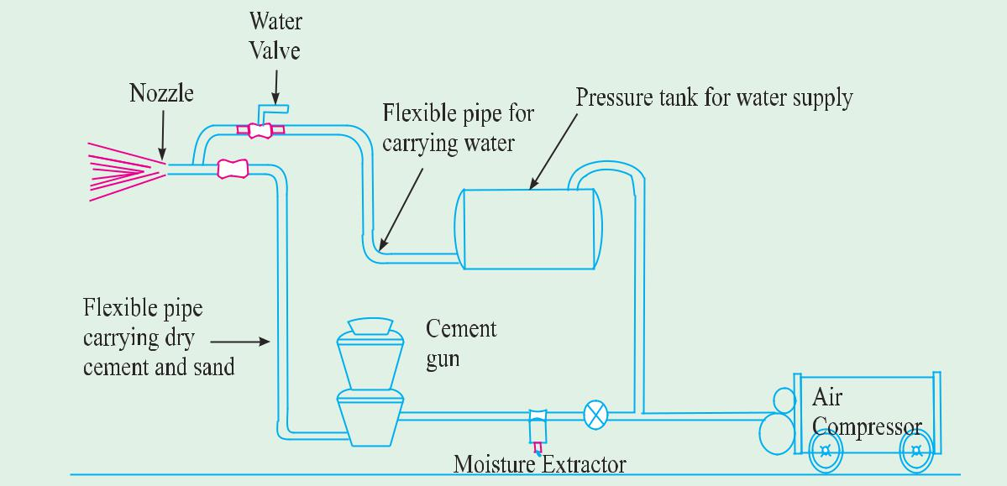

(b) The cement/sand mixture is fed into a special air-pressurised mechanical feeder termed as ‘gun’.
(c) The mixture is metered into the delivery hose by a feed wheel or distributor within the gun.
(d) This material is carried by compressed air through the delivery hose to a special nozzle. The nozzle is fitted inside with a perforated manifold through which water is sprayed under pressure and intimately mixed with the sand/cement jet.
(e) The wet mortar is jetted from the nozzle at high velocity onto the surface to be gunited.
The Wet-mix Process
In the wet-mix process the concrete is mixed with water as for ordinary concrete before conveying through the delivery pipe line to the nozzle, at which point it is jetted by compressed air, onto the work in the same way, as that of dry mix process.
The wet-mix process has been generally discarded in favour of the dry-mix process, owing to the greater success of the latter.
The dry-mix methods makes use of high velocity or low velocity system. The high velocity gunite is produced by using a small nozzle and a high air pressure to produce a high nozzle velocity of about 90 to 120 metres per second. This results in exceptional good compaction. The lower velocity gunite is produced using large diameter hose for large output. The compaction will not be very high.
Advantages of Wet and Dry Process
Some of the advantages and disadvantages of the wet and dry processes is discussed below. Although it is possible to obtain more accurate control of the water/cement ratio with the wet process the fact that this ratio can be kept very low with the dry process largely overcomes the objection of the lack of accurate control. The difficulty of pumping light-weight aggregate concrete makes the dry process more suitable when this type of aggregate is used. The dry process on the other hand, is very sensitive to the water content of the sand, too wet a sand causes difficulties through blockade of the delivery pipeline, a difficulty which does not arise with the wet process.
The lower water/cement ratio obtained with the dry process probably accounts for the lesser creep and greater durability of concrete produced in this way compared with concrete deposited by the wet process, but air-entraining agents can be use to improve the durability of concrete deposited by the latter means. Admixtures generally can be used more easily with the wet process except for accelerators. Pockets of lean mix and of rebound can occur with the dry process. It is necessary for the nozzelman to have an area where he can dump unsatisfactory shotcrete obtained when he is adjusting the water supply or when he is having trouble with the equipment. These troubles and the dust hazard are less with the wet process, but wet process does not normally give such a dense concrete as the dry process. Work can be continued in more windly weather with the wet process than with the dry process, Owing to the high capacities obtainable with concrete pumps, a higher rate of laying of concrete can probably be achieved in the wet process than with the dry process.
General Use of Shotcrete
The high cost of shotcrete limits its application to certain special circumstances where considerable savings are accrued and where its peculiar adaptability and technical advantages render it more suitable than conventional placing methods.
Shuttering and formwork need be erected only on one side of the work and it does not have to be so strong as the shuttering for poured concrete.
The saving in shuttering costs makes it particularly applicable for thin sections and although there is no technical reason why unlimited thicknesses cannot be deposited in horizontal and vertical work.
The cost generally limits it to a thickness of 200 mm.
The possible rate of application is low particularly with the dry process. Normally not more than 80 mm thickness can be deposited in overhead work in one day and the possibility of this will depend on the use of a suitable accelerator.
The fact that it can be conveyed over a considerable distance in a small diameter pipe makes this process suitable for sites where access is difficult. The other method that can be adopted in such situation is pumping techniques. It cannot, however, be used in confined spaces as the expansion of the compressed air will cause air turbulences which make accurate placing difficult. Sufficient room is required to hold the nozzle, say 1 m from the work. To accommodate a large radius bend of the delivery hose also requires considerable space. It will bond extremely well to the existing concrete, to masonry and to exposed rock. Suitably prepared steel surface also can be covered with gunited concrete.
The quality of the finished product is liable to be variable and particularly in the dry process the quality is very much dependent on the skill of the nozzleman. Quality control is very difficult and it is not possible to cast reliable test cubes or cylinders. The only way of testing the strength of the work deposited is by taking drill cores or by making a parallel slab by guniting with identical mix. It is difficult to remove rebound material as this tends to collect inside corners and behind reinforcing bars or other obstructions. Pockets of rebound formed as above and due to lack of skill of the nozzleman form weak and porous patches in the finished work. The proportions of the concrete deposited are affected by variation of the water supply and variations in the amount of rebound caused by this and other reasons. Too low an air pressure and surges in the air and water supply also can cause patches of relatively dry material. Defects of this type can result in porous concrete and also contribute to high permeability.
The amount of rebound greatly affects the economics of the shotcrete process as it has all to be discarded and involves labour in collection and disposal. The area surrounding the work will be heavily coated with mortar particularly in windy weather.
It is difficult to obtain a satisfactory surface finish with Shotcrete, particularly with the dry process, because it is almost impossible to trowel due to the low water content. Often it becomes necessary to apply a screed of about 2 cm over the gunited surface.
The application of the shotcrete process is limited to exceptional areas and that too when good nozzleman having the required skill are available. The nozzleman’s job is a very strenuous one. It is, therefore, necessary to have relief nozzelmen and for high rates of application some mechanical means of holding the nozzle is required.
The maximum rate of deposition is about 15 m³. hr for the dry process but this can be exceeded with the wet process.
The low water/cement ratio, the thinness of the section deposited and the fact that normally only one side of the concrete is covered, necessitates careful attention to curing more than with normal concrete.
The normal specifications with respect to cement, aggregate and water, also apply for shotcrete but it is desirable that the aggregate should be rather harder than normal to allow for attrition due to the action of the process. Any cement, provided it does not set too quickly, can be used.
Admixtures can be used in shotcrete to produce the same effects as in ordinary concrete. They should be added to the water in the dry process, but some difficulty may be experienced in obtaining correct proportioning due to variations in the rate of feed of the dry materials. On account of the difficulty of precise control, admixtures whose effects are very sensitive to the proportion added should not be used. Great caution should be exercised in using accelerators in the wet process but accelerators causing an initial set within 30 seconds are used in the dry process. This enable the process to be used in very wet conditions and for sealing leakages. But deficulties have sometime been experienced in obtaining adhesion of the concrete to very set surfaces and these very rapid accelerators are very expensive.
There is not much information on the drying shrinkage and creep of shotcrete. The drying shrinkage will depend on the water content and may, therefore, be expected to be fairly low for the dry process. The creep of dry shotcrete is similar to that of high quality normally placed concrete. But shrinkage and creep of wet shotcrete is likely to be high.
The durability or resistance to frost action and other agencies of dry shotcrete is good. It is not so good for wet shotcrete but can be improved to a satisfactory degree by the use of air-entraining agents. About half of the entrained air is likely to be lost while spraying.

- Explain the properties of polymer Impregnated Concrete.

Polymer Impregnated Concrete (PIC)
Polymer impregnated concrete is one of the widely used polymer composite. It is nothing but a precast conventional concrete, cured and dried in oven, or by dielectric heating from which the air in the open cell is removed by vacuum. Then a low viscosity monomer is diffused through the open cell and polymerised by using radiation, application of heat or by chemical initiation.
Mainly the following types of monomer are used:
(a) Methylmethacrylate (MMA),
(b) Styrene,
(c) Acrylonitrile,
(d) t-butyl styrene,
(e) Other thermoplastic monomers.
The amount of monomer that can be loaded into a concrete specimen is limited by the amount of water and air that has occupied the total void space. It is necessary to know the concentration of water and air void in the system to determine the rate of monomer penetration. However, the main research effort has been towards obtaining a maximum monomer loading in concrete by the removal of water and air from the concrete by vacuum or thermal drying, the latter being more practicable for water removal because of its rapidity.
Another parameter to consider is evacuation of the specimen prior to soaking in monomer. This eliminates the entrapment of air towards the centre of the specimen during soaking which might otherwise prevent total or maximum monomer loading. The application of pressure is another technique to reduce monomer loading time.
Polymer Cement Concrete (PCC)
Polymer cement concrete is made by mixing cement, aggregates, water and monomer. Such plastic mixture is cast in moulds, cured, dried and polymerised. The monomers that are used in PCC are:
(a) Polyster-styrene.
(b) Epoxy-styrene.
(c) Furans.
(d) Vinylidene Chloride.
However, the results obtained by the production of PCC in this way have been disappointing and have shown relatively modest improvement of strength and durability. In many cases, materials poorer than ordinary concrete are obtained. This behaviour is explained by the fact that organic materials (monomers) are incompatible with aqueous systems and sometimes interfere with the alkaline cement hydration process.
Recently Russian authors have reported the production of a superior Polymer cement concrete by the incorporation of furfuryl alcohol and aniline hydrochloride in the wet mix. This material is claimed to be specially dense and non-shrinking and to have high corrosion resistance, low permeability and high resistance to vibrations and axial extension.
Polymer Concrete (PC)
Polymer concrete is an aggregate bound with a polymer binder instead of Portland cement as in conventional concrete.
The main technique in producing PC is to minimise void volume in the aggregate mass so as to reduce the quantity of polymer needed for binding the aggregates. This is achieved by properly grading and mixing the aggregates to attain the maximum density and minimum void volume. The graded aggregates are prepacked and vibrated in a mould. Monomer is then diffused up through the aggregates and polymerisation is initiated by radiation or chemical means. A silane coupling agent is added to the monomer to improve the bond strength between the polymer and the aggregate. In case polyester resins are used no polymerisation is required.
An important reason for the development of this material is the advantage it offers over conventional concrete where the alkaline Portland cement on curing, forms internal voids. Water can be entrapped in these voids which on freezing can readily crack the concrete. Also the alkaline Portland cement is easily attacked by chemically aggressive materials which results in rapid deterioration, whereas polymers can be made compact with minimum voids and are hydrophobic and resistant to chemical attack. The strength obtained with PC can be as high as 140 MPa with a short curing period.
However, such polymer concretes tend to be brittle and it is reported that dispersion of fibre reinforcement would improve the toughness and tensile strength of the material. The use of fibrous polyester concrete (FPC) in the compressive region of reinforced concrete beams provides a high strength, ductile concrete at reasonable cost. Also polyester concretes are viscoelastic in nature and will fail under sustained compressive loading at stress levels greater than 50 per cent of the ultimate strength. Therefore, polyester concrete should be considered for structures with a high ratio of live load to dead load and for composite structures in which the polymer concrete may relax during long-term loading. Experiments conducted on FPC composite beams have indicated that they are performance effective when compared to reinforced concrete beam of equal steel reinforcement percentage. Such beams utilise steel in the region of high tensile stress, fibrous polyester concrete (FPC) with its favourable compressive behaviour, in the regions of high compressive stress and Portland cement concrete in the regions of relatively low flexural stress.
Partially Impregnated (or Coated in Depth CID) and Surface Coated (SC) Concrete
Partial impregnation may be sufficient in situations where the major requirement is surface resistance against chemical and mechanical attack in addition to strength increase. Even with only partial impregnation, significant increase in the strength of original concrete has been obtained. The partially impregnated concrete could be produced by initially soaking the dried specimens in liquid monomer like methyl methacrylate, then sealing them by keeping them under hot water at 70°C to prevent or minimise loss due to evaporation. The polymerisation can be done by using thermal catalytic method in which three per cent by weight of benzoyl peroxide is added to the monomer as a catalyst. It is seen that the depth of monomer penetration is dependent upon following:
(a) Pore structure of hardened and dried concrete.
(b) The duration of soaking, and
(c) The viscosity of the monomer.
The potential application of polymer impregnated concrete surface treatment (surface coated concrete, SC) is in improving the durability of concrete bridge decks. Bridge deck deterioration is a serious problem everywhere, particularly due to a abrasive wear, freeze-thaw deterioration, spalling and corrosion of reinforcement. Excellent penetration has been achieved by ponding the monomer on the concrete surface. Due care should be taken to prevent evaporation of monomer when ponded on concrete surface. A 5 cms thick slab, on being soaked by MMA for 25 hours produced a polymer surface coated depth of 2.5 cms. Significant increases in the tensile and compressive strengths, modulus of elasticity and resistance to acid attack have been achieved.
The application of monomer for field application like in bridge decks poses more problems than laboratory application. A typical surface treatment in the field can be done in the following manner.
(a) The surface is dried for several days with electrical heating blanket.
(b) Remove the heating blanket and cover the slab with 0.64 m³ oven-dried light-weight aggregate per 100 sq.m.
(c) Apply initially 2,000 to 3,000 ml of the monomer system per square metre.
(d) Cover the surface with polyethylene to retard evaporation.
(e) Shade the surface to prevent temperature increase which might initiate polymerisation prematurely, that may reduce penetration into the concrete.
(f) Add periodically additional monomer to keep the aggregate moist for minimum soak time of 8 hours.
(g) Apply heat to polymerise the monomer. Heating blanket, steam or hot water can be used for this purpose.
Some of the promising monomer systems for this purpose are:
(a) Methylmethacrylate (MMA), 1% Benzoyl peroxide (BP), 10% Trimethylopropane trimethacrylate (TMPTMA).
(b) Isodecyl methacrylate (IDMA), 1% BP, 10% TMPTMA.
(c) Isobutyl methacrylate (IBMA), 1% BP, 10% TMPTMA.
BP acts as a catalyst and TMPTMA is a cross linking agent which helps in polymerisation at low temperature of 52%C.
Properties of Polymer Impregnated Concrete
Since Polymer impregnated concrete (PIC) is one of the most important category of polymer concrete, the properties of PIC is discussed below.
Stress-Strain Relationship
There is very little departure from linearity upto 90 per cent of ultimate strength and there is no abrupt change at the proportional limit. The stress strain curves for Styrene-TMPTMA impregnated concrete also show the same characteristics as for MMA impregnated concrete. The modulus of elasticity increased from 27 GPa for unimpregnated specimen to 49 GPa for MMA impregnated specimens.
Compressive Strength
The effect of polymer loading on the compressive strength in PIC is given in Fig. 12.8 Using methylemethacrylate as monomer and with a polymer loading of 6.4%, strength of the order of 144 MPa have been obtained using radiation technique of polymerisation. (The control specimen had compressive strength of 38 MPa). The compressive strength obtained with thermal catalytic process was 130 MPa.
Styrene impregnated specimens exhibited similar trends, except that the strength levels were somewhat lower. The polymerisation by radiation method produced a concrete of higher strength than that produced by thermal catalytic method.
Perlite concrete impregnated with MMA and polyester styrene have also shown considerable increases in compressive strength. It is found that higher strengths are obtained with MMA impregnated sample than with polyster styrene. The average compressive strength for a 1 : 8 non-air entrained perlite concrete samples, impregnated with MMA was 56 MPa for a polymer loading of 63% compared to a control specimen of compressive strength 1.2 MPa.
Tensile Strength
The increase in tensile strength in the case of PIC has been observed to be as high as 3.9 times that of the control specimen for a polymer loading of 6.4% MMA i.e., impregnated concrete have shown tensile strength of the order of 11.6 MPa compared to the strength of control specimen of 3 MPa using radiation process of polymerisation. Thermal catalytically initiated polymerisation, produced concrete with tensile strength 3.6 times that of the control specimen and 7.3 per cent less than that of radiation produced concrete.

- Explain the design aspects of aerated concrete.

Aerated Concrete
Aerated concrete is made by introducing air or gas into a slurry composed of Portland cement or lime and finely crushed siliceous filler so that when the mix sets and hardens, a uniformly cellular structure is formed. Though it is called aerated concrete it is really not a concrete in the correct sense of the word. As described above, it is a mixture of water, cement and finely crushed sand. Aerated concrete is also referred to as gas concrete, foam concrete, cellular concrete. In India we have at present a few factories manufacturing aerated concrete. A common product of aerated concrete in India is Siporex.
There are several ways in which aerated concrete can be manufactured.
(a) By the formation of gas by chemical reaction within the mass during liquid or plastic state.
(b) By mixing preformed stable foam with the slurry.
(c) By using finely powdered metal (usually aluminium powder) with the slurry and made to react with the calcium hydroxide liberated during the hydration process, to give out large quantity of hydrogen gas. This hydrogen gas when contained in the slurry mix, gives the cellular structure.
Powdered zinc may also be added in place of aluminum powder. Hydrogen peroxide and bleaching powder have also been used instead of metal powder. But this practice is not widely followed at present.
In the second method preformed, stable foam is mixed with cement and crushed sand slurry thus causing the cellular structure when this gets set and hardened. As a minor modification some foam-giving agents are also mixed and thoroughly churned or beaten (in the same manner as that of preparing foam with the white of egg) to obtain foam effect in the concrete. In a similar way, air entrained agent in large quantity can also be used and mixed thoroughly to introduce cellular aerated structure in the concrete. However, this method cannot be employed for decreasing the density of the concrete beyond a certain point and as such, the use of air entrainment is not often practised for making aerated concrete.
Gasification method is of the most widely adopted methods using aluminium powder or such other similar material. This method is adopted in the large scale manufacture of aerated concrete in the factory wherein the whole process is mechanised and the product is subjected to high pressure steam curing i.e., in other words, the products are autoclaved. Such products will suffer neither retrogression of strength nor dimensional instability.
The practice of using preformed foam with slurry is limited to small scale production and in situ work where small change in the dimensional stability can be tolerated. But the advantage is that any density desired at site can be made in this method.
Properties
Use of foam concrete has gained popularity not only because of the low density but also because of other properties mainly the thermal insulation property. Aerated concrete is made in the density range from 300 kg/m³ to about 800 kg/m³. Lower density grades are used for insulation purposes, while medium density grades are used for the manufacture of building blocks or load bearing walls and comparatively higher density grades are used in the manufacture of prefabricated structural members in conjunction with steel reinforcement.

