Homework 2: Foundation Concepts (2)

COMS W4111: Introduction to Databases  
Sections 002  
Spring 2025  
  
(v 1; 2025-FEB-08)

**Notes:**

* HW 2 is due on Sunday, 23-FEB at 11:59 PM.

# Overview and Submission

## Grading and Scope

Total points for homework assignments and exams determine final grade. The final point total is between 0 and 100. HW 2 is worth 5 points.

**Note:** We are releasing the HW before covering all of the material in lecture to enable students to get started on qu

The scope of material for this HW2 is:

* + The material in lectures 1, 2, 3 and 4.
  + The slides associated with the recommended textbook for
    - Chapter 1.
    - Chapter 2.
    - Chapter 3.
    - Chapter 4 slides 4.4 to 4.52, except for slide 4.35 (Transactions).
    - Chapter 6 slides 6.1 to 6.53.

## Submission

**Due date: 2025-Feb-09, 11:59 PM EDT on GradeScope.**

You submit on GradeScope. You upload a PDF of this document with your answers entered. You must [assign pages to the questions](https://guides.gradescope.com/hc/en-us/articles/21864315441677-Submitting-a-PDF-for-an-assignment) in the outline in GradeScope.

There is a [post/mega-thread](https://edstem.org/us/courses/73023/discussion/6015704) on Ed Discussions that we will use to resolve questions and issues with respect to homework 1.

## Brevity

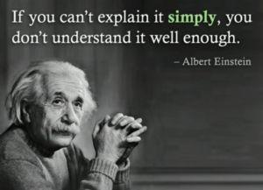

**Keep your answers focused, brief and succinct.** The answers to written questions only require 3 or 4 sentences/bullet points. If you ramble and bloviate hoping to get something correct, we will deduct more points.

# Questions

## General Knowledge Questions

1. Is data in a spreadsheet unstructured, semi-structured or structured. Briefly explain your answer?
2. Professor Ferguson can export SSOL data for his classes to a spreadsheet. Despite the data being spreadsheet-like, Columbia uses an application and database to manage the data. An alternative would be to make shared spreadsheets available to everyone and let students, faculty and staff collectively edit the spreadsheets. This would be chaos. List 4 functions/capabilities of a database management system that makes using a database and application superior to sharing spreadsheets.
3. What are the three levels of abstraction for data that a DBMS provides? What are two disadvantages of having a user or developer directly use the lowest level and directly access the data without going through the higher abstractions?
4. Is a full stack web application a two-tier or three-tier application? Is a Jupyter notebook a two-tier or three-tier application? Explain your answer. We saw an example of a two-tier application/product in lecture 1. What was the product?
5. What are the four types/categories of database users? Which type of user is most likely to use DDL?

## Entity Relationship Model

1. Consider the entity set with relationships below. Assume that the bold attribute/column is the primary key. Write the relational model schema definitions for representing the entity sets *Faculty* and *Section.*A diagram of a graph

   AI-generated content may be incorrect.
2. Using the approach for documenting relationship sets in Lecture 1’s slides, write down the relationship set *Teaches* for the diagram in question 6.
3. For the diagram in question 6, draw the *conceptual model* Crow’s Foot Diagram using [Lucidchart](https://www.lucidchart.com/pages/landing).

## Relational Alge bra

1. Using the diagram from question 6, what is the result of the relational algebra expression Π course_no, course_title (Section)?
2. Using the relation below, what is the result of the expression π b,c (σ a>3 (R))

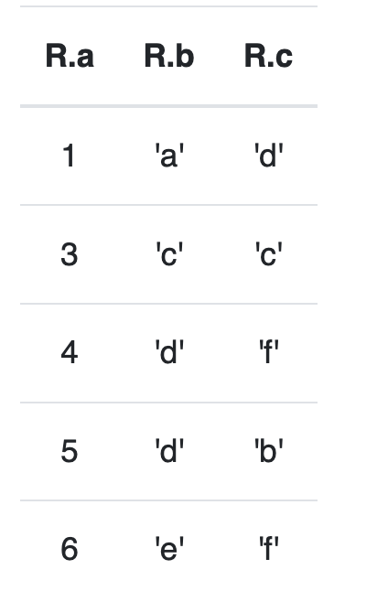

## SQL

1. What is the SQL equivalent to the relational algebra expression π name, dept_name (σ dept_name='Comp. Sci.' (instructor)).
2. Translate the following relational model definition into SQL. You may assume that the data type of all columns is TEXT.  
     
   section(courseNo, sectionNo, semester, year, courseName, enrollment)
3. Using the diagram from question 6, translate the relational algebra statement Π course_no, course_title (Section) into SQL. What is the result of executing the SQL statement?
4. Using DataGrip and the data from the recommended text book that you loaded in homework 0, write a SQL statement that selects the ID, name, dept_name and tot_cred of students. Your result should include only students that are in the ‘Comp. Sci.’ department or who have tot_cred > 50. Place the text of your query and a screen capture of the execution below.
5. Using DataGrip and the data from the recommended text book that you loaded in homework 0, write a SQL statement that returns a table containing only dept_name. The table should not have duplicated. Place the text of your query and a screen capture of the execution below.