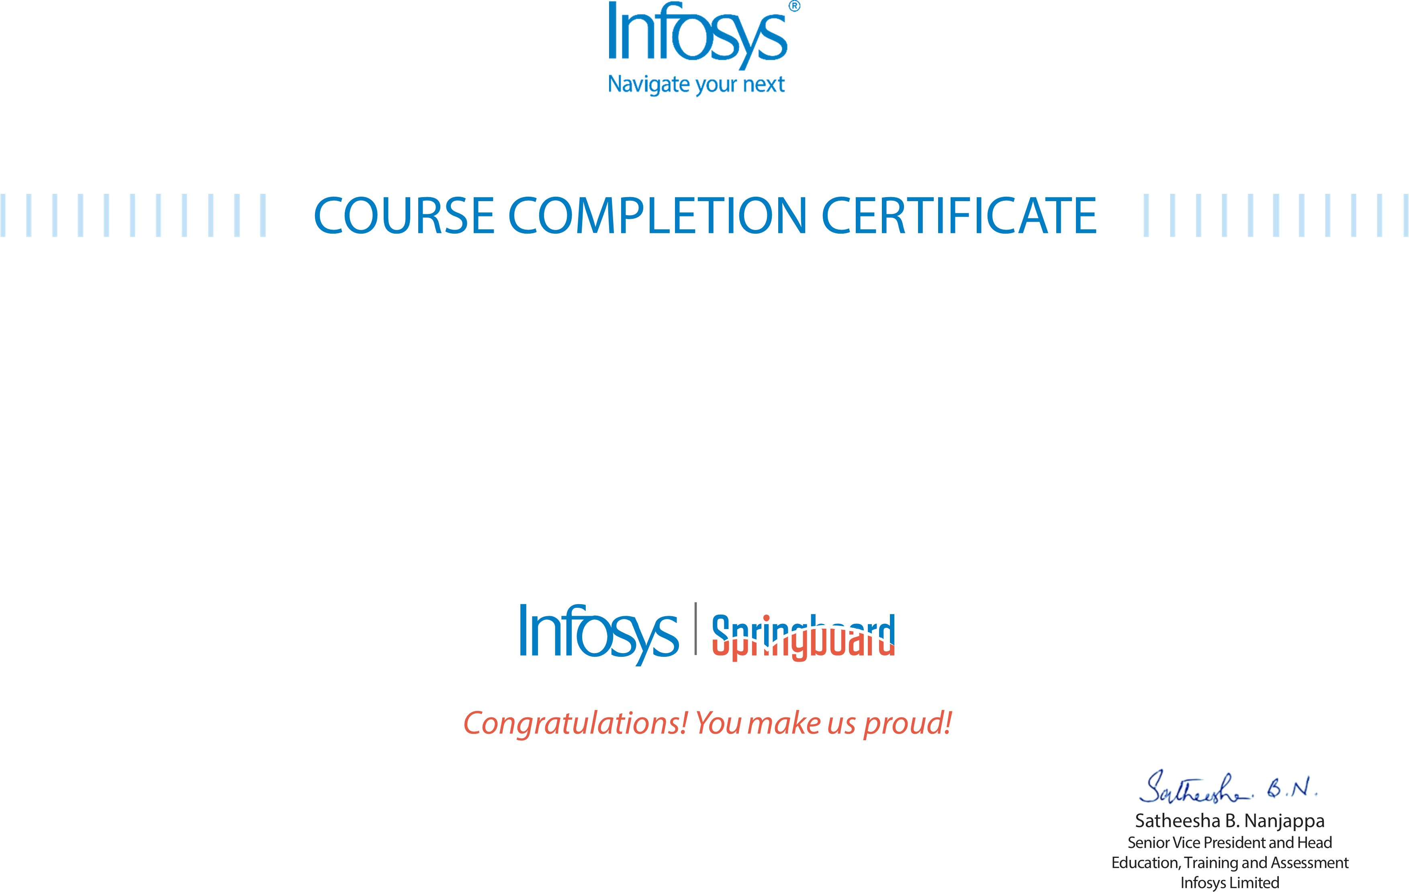
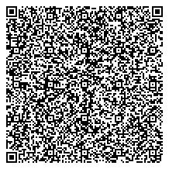

The certificate is awarded to

Sanjaikumar S.B

for successfully completing the course
NLP for ML with Python: NLP Using Python & NLTK on January 31, 2026

Issued on: Sunday, February 1, 2026
To verify, scan the QR code at https://verify .onwingspan.com

