Design of AC/DC Energy Monitoring and Protection System Demonstrating IED Behaviour
Anush K, Konduru Shyam Prasanth, Sanjai M,Senthil Kumar N

Abstract
This research explores on the design and implementation of an AC/DC Energy Monitoring and Protection System illustrating Intelligent Electronic Device (IED)-like characteristics using two ESP32-based controllers. The system architecture (Fig.1) consists of two separate AC and DC IEDs offering real-time measurement, local protection and supervisory communication over a LAN-based network with a laptop that has a SCADA-like interface (Fig.2). This laptop connects with another laptop via a pocket router to share sensor data over the network, where it will be processed to calculate tariff and map the load consumption with respect to time (Fig.3). The main objective of the work is to build a miniature version of modern substation automation, by taking inspiration from Industrial protocols.
The AC IED consists of a PZEM-004T (V4) sensor for the measurement of AC electrical parameters (voltage, current, real power, and power factor), an optocoupler (PC817), and a 2A-rated fuse. The DC IED uses a Hall-effect-based sensor for the measurement of DC voltage, DC current, and DC power. The system uses the 110% condition for overvoltage and the 125% condition for overcurrent for a threshold-based logic determination with respect to the rated value of the concerned electrical parameter.
The SCADA-like interface communicates with the two IEDs using Modbus TCP (LAN). The dashboard has been built using MATLAB App designer and has been designed to communicate with both the IEDs through IP addresses assigned to each one of them and uses Coil and Holding Modbus registers. The streamed sensor data is recorded in a CSV file in the backend using timestamps. This CSV data from both the IEDs is logged in the second laptop that connects with the first laptop through a router. The CSV data is then processed to map load consumption and calculate tariffs. The design ensures that the protection mechanism remains local and independent of the communication system to ensure a deterministic operation in the event of communication failure.
The system has been validated under controlled laboratory conditions ensuring a complete separation of protection and communication with a layered architecture. The latency and robustness of protection mechanism and communication systems are not as comparable as to what a modern-day utility-grade system can achieve but are yet acceptable for a small-scale simplified experimental framework.

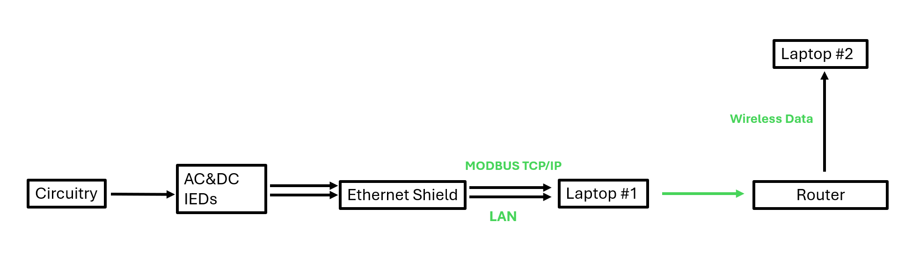
Fig.1

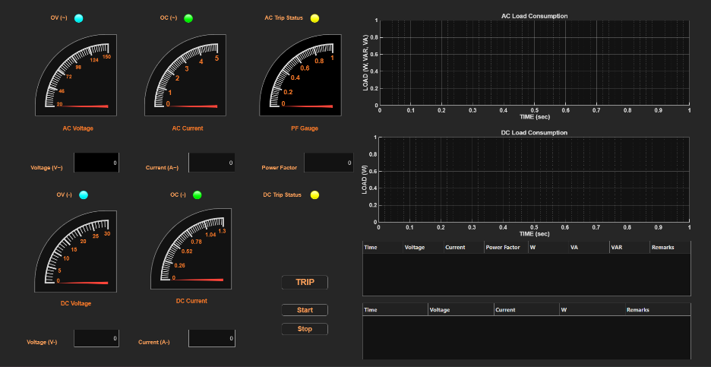

Fig.2


Fig.3

