DESIGN OF AN AC/DC ENERGY MONITORING AND PROTECTION SYSTEM DEMONSTRATING IED BEHAVIOR IN SUBSTATION AUTOMATION

A PROJECT REPORT

submitted in partial fulfillment of the requirements

for the award of the degree of

BACHELOR OF TECHNOLOGY
in
ELECTRICAL AND ELECTRONICS ENGINEERING

by
ANUSH K (22BEE1215)
KONDURU SHYAM PRASANTH (22BEE1162)
SANJAI M (22BEE1302)

under the guidance of
SENTHIL KUMAR N (For Internal Projects)

SCHOOL OF ELECTRICAL ENGINEERING
VIT CHENNAI
APRIL 2026

CERTIFICATE

This is to certify that the project work titled “DESIGN OF AN AC/DC ENERGY MONITORING AND PROTECTION SYSTEM DEMONSTRATING IED BEHAVIOR IN SUBSTATION AUTOMATION” submitted by ANUSH, SHYAM PRASANTH, SANJAI M is in partial fulfillment of the requirements for the award of the degree of BACHELOR OF TECHNOLOGY, is a record of bonafide work done under my guidance. The contents of this project work, in full or in parts, have neither been taken from any other source nor have been submitted to any other Institute or University for award of any degree or diploma and the same is certified.

Project Supervisor

The thesis is satisfactory / unsatisfactory

Internal Examiner External Examiner

Approved by

Head of the Department
B.Tech Electrical and Electronics Engineering

ACKNOWLEDGEMENT
I would like to express my sincere gratitude to our Honorable Chancellor, Dr. G. Viswanathan, as well as the Vice Presidents, Mr. Sankar Viswanathan, Dr. Sekar Viswanathan, and Dr. G. V. Selvam; Executive Director, Dr. Sandhya Pentareddy; Assistant Vice President, Ms. Kadhambari S. Viswanathan; Vice Chancellor, Dr. V. S. Kanchana Bhaaskaran; Dr.T.Thyagarajan,Pro-Vice Chancellor, VIT Chennai; and Additional Registrar, Dr. P. K. Manoharan, for creating a wonderful work environment and motivating us all throughout the course. A special thanks goes out to Dr. Lenin.N.C, Professor and Dean, School of Electrical Engineering, Vellore Institute of Technology, Chennai, for dedicating a significant amount of time and energy to knowledge sharing and providing assistance in all areas. I am ecstatic to thank the project coordinators and Dr. Angeline Ezhilarasi G., head of the department for B.Tech Electrical and Electronics Engineering, for their invaluable encouragement and support in starting and finishing this thesis. In addition, I would like to sincerely thank my mentor, Dr. N. Senthil Kumar, Professor at the School of Electrical Engineering, Vellore Institute of Technology, Chennai, for his unwavering support, understanding, and encouragement— but most importantly, for teaching me patience in my pursuits. My relationship with him extends beyond academia; working with a scholar and robotic expert has been a fantastic opportunity. I also want to express my gratitude to all of the teachers and staff at Vellore Institute of Technology in Chennai, who assisted me in gaining the necessary knowledge. I want to express my gratitude to my parents for their unwavering support and to my friends for always motivating me to take on and finish this task.

Signature of the students
Anush K (22BEE1215)
Shyam Prasanth (22BEE1162)
Sanjai M (22BEE1302)

ABSTRACT
This project presents the design and implementation of an ESP32-based AC/DC energy monitoring and protection system that demonstrates Intelligent Electronic Device (IED)-like behaviour for low-voltage applications. The system integrates real-time measurement, deterministic protection, and supervisory monitoring within a compact embedded platform, addressing the need for cost-effective solutions that replicate industrial concepts such as local protection execution and layered architecture.
The system performs continuous monitoring of electrical parameters from both AC and DC subsystems. The AC side uses a Modbus RTU-based energy module (PZEM-004T) to measure voltage, current, power, frequency, and power factor, while the DC side employs shunt/INA-type sensors for voltage and current measurement. These parameters are processed by the ESP32 microcontroller, which serves as the core processing unit.
Protection functions are implemented locally on the controller to ensure fast and reliable response. The system includes over-voltage, under-voltage, over-current, under-frequency, and power threshold detection. These conditions are evaluated using predefined thresholds with persistence logic to prevent false tripping due to noise or transient disturbances. Upon fault confirmation, relay modules are activated to isolate the load. The protection logic operates independently of communication, ensuring deterministic performance even during network failures.
A key design feature is the separation between protection and supervision. Communication via Ethernet or Wi-Fi is used only for monitoring, logging, and parameter updates through Modbus TCP. A MATLAB-based SCADA interface provides real-time visualization and data logging without influencing protection decisions.
The system emphasizes robustness by addressing measurement noise and sensor inaccuracies through filtering and validation techniques. Its modular design supports scalability and future enhancements. Overall, the project demonstrates a practical and cost-effective implementation of an IED-inspired monitoring and protection system for real-world applications

TABLE OF CONTENTS
- Certificate ......................................................... 2
- Acknowledgement ............................................ 3
- Abstract ............................................................ 4
- List of Figures .................................................. 7
- Abbreviations and Nomenclature ..................... 8

CHAPTER 1: INTRODUCTION .......................... 9
1.1 Introduction ..................................................... 9
1.2 Motivation ....................................................... 9
1.3 Literature Review…….……………………… 10
1.4 Objectives ........................................................ 10

CHAPTER 2: PROJECT DESCRIPTION .............. 17
2.1 Introduction to IED ......................................... 17
2.2 Overview of Project ........................................ 18
2.3 Working Principle ........................................... 19
2.4 Circuit Components ........................................ 21
2.5 AC Circuit Operation ...................................... 21
2.6 DC Circuit Operation ...................................... 22
2.7 Tasks and Milestones ...................................... 22
CHAPTER 3: SYSTEM DESIGN AND ANALYSIS ... 23
3.1 System hardware architecture............................. 23
3.2 Measurement units(ac/dc) .................................. 23
3.3 Protection and conftrol ...................................... 24
3.4 communication and power supply……………. 24
3.5 Design calculation……………………………. 24
3.6 Hardware (AC)………………………………. 25
3.7 Hardware (DC)……………………………….. 26

CHAPTER 4: PROJECT DEMONSTRATION.
4.1 Software Architecture ...................................... 29
4.2 Protection and control logic ............................. 29
4.3 SCADA implementation ................................... 29
4.4 Tariff calculation and cost analysis.................... 32
4.5 Functional Verification ..................................... 35
4.6 Results………………........................................ 36

CHAPTER 5: CONCLUSION ................................. 40
5.1 Scope of Work .................................................... 40
5.2 Future Work ........................................................ 41
5.3 Summary ............................................................ 42
REFERENCES ......................................................... 43

LIST OF FIGURES

- Algorithm Flow Chart……………………….…..21
- AC part of the circuit……………………….……28
- Displaying of AC parameters……………………29
- DC part of the circuit…………………………….30
- SCADA dashboard………………………………32
- Parameters in SCADA dashboard………………..32
- Load graph………………………………………..33
- Real Time streaming of data in SCADA…………33
- Tariff……………………………………………...36
- Manual trip of circuit……………………………..37
- Manual trip status in SCADA………………....….38
- Manual circuit Reset………………………...……38
- Circuit Overvoltage…………………………...…..39
- Overvoltage status in SCADA………………….....39
- Manual trip…………………………………...……40
- Overcurrent trip………………………………...….40
- Overcurrent trip status in SCADA………………....41

ABBREVIATIONS AND NOMENCLATURE

IED  SCADA  AC  DC  OV  UV  OC  UC  PF  IP  I²C  RTU  TCP | Intelligent Electronic Device  Supervisory Control and Data Acquisition  Alternating Current  Direct Current  Over Voltage  Under Voltage  Over Current  Under Current  Power Factor  Internet Protocol  Inter-Integrated Circuit Communication  Remote Terminal Unit  Transmission Control Protocol

CHAPTER I

1. INTRODUCTION

With the increasing demand for reliable and intelligent energy management at the user level, there is a growing need for compact systems that combine monitoring with fast and dependable protection. This project addresses that need by developing an ESP32-based AC/DC energy monitoring and protection system designed for low-voltage applications. Unlike conventional setups where monitoring and protection are loosely integrated, this system emphasizes deterministic, locally executed protection to ensure rapid response under fault conditions.
The system measures single-phase AC parameters using a Modbus RTU-based power module (PZEM-004T) and incorporates a DC monitoring section using shunt/INA-type sensors. Protection functions such as over-voltage, under-voltage, over-current, under-frequency, and power threshold detection are implemented directly on the ESP32, enabling reliable relay-based tripping without dependence on network communication. A SCADA-like interface using MATLAB provides supervisory control, visualization, and data logging, ensuring a clear separation between real-time protection and higher-level monitoring functions.
  - Motivation
- The motivation for this project is inspired by the structured approach of the ISA-95 standard, which emphasizes clear separation between control and supervisory layers in industrial systems.
- In many low-voltage and academic implementations, monitoring and protection are often tightly coupled or dependent on network communication, leading to delays, unreliability, and poor system design practices.
- This project aims to address that gap by adopting an industry-inspired architecture where critical protection functions are executed locally and deterministically, while higher-level monitoring and analysis are handled separately.
- By implementing fast protection logic directly on the ESP32 and restricting Ethernet/Wi-Fi communication to supervisory tasks such as visualization, logging, and setpoint updates, the system reflects a simplified version of industrial automation hierarchies.
- This approach not only improves reliability and response time but also exposes the designer to practical system engineering principles. The project is therefore motivated by the need to bridge academic prototypes with real-world industrial design philosophies in a scalable and meaningful way.
1.3 LITERATURE REVIEW
Introduction to Literature Review

The rapid evolution of power systems toward automation and intelligence has led to the development of compact and efficient monitoring and protection systems. Traditional power systems relied on separate devices for measurement, protection, and control. However, modern systems integrate these functionalities into a single unit known as an Intelligent Electronic Device (IED).
This literature review focuses on previous research and developments in the areas of:
- Intelligent Electronic Devices (IEDs)
- AC/DC energy monitoring systems
- Embedded controllers for protection systems
- Communication protocols such as Modbus
- SCADA-based supervisory systems
The objective is to analyse existing approaches and identify gaps that justify the need for the proposed system.

Intelligent Electronic Devices (IED) In Power Systems
IEDs are microprocessor-based systems widely used in substation automation for protection, control, and monitoring. According to modern power system practices, IEDs replace conventional electromechanical relays with programmable logic, enabling faster and more reliable fault detection.
Research shows that IEDs integrate:
- Measurement (voltage, current, power)
- Protection (overvoltage, overcurrent, etc.)
- Communication (Ethernet, Modbus, IEC 61850)

Many studies highlight that
- Deterministic operation is critical for protection.
- Communication delays must not affect protection logic.
However, most industrial IEDs are
- Expensive
- Complex to implement
- Not suitable for academic or low-voltage applications
This creates a need for low-cost, simplified IED models, which this project addresses.

AC Energy Monitoring Systems
Several research works focus on monitoring AC electrical parameters using embedded systems. Common approaches include:
- Use of energy metering ICs (ADE7753, ADE9153A)
- Use of external modules like PZEM-004T
- Use of current transformers (CT) and potential transformers (PT)
Studies indicate that:
- Accurate measurement is essential for protection.
- Real-time monitoring improves system reliability.
- Low-cost modules like PZEM simplify implementation.
However, limitations include:
- Lack of transparency in module internals
- Limited control over calibration
- Communication latency in Modbus RTU
Despite these drawbacks, PZEM-based systems are widely used in academic projects due to ease of integration.

DC Monitoring Systems and Sensing Techniques
DC monitoring is essential in applications such as:
- Battery systems
- Renewable energy systems
- Electric vehicles
Common sensing methods include:

Shunt Resistor Method
- High accuracy
- Low cost
- Requires direct circuit insertion
- Causes power loss

Hall-Effect Sensors (e.g., ACS37800)
- Non-intrusive measurement
- Electrical isolation
- Lower power loss
Literature suggests that Hall-effect sensors are preferred in modern systems due to
- Safety
- Isolation
- Ease of implementation
However, they are:
- Slightly less accurate at low currents
- Sensitive to noise
This project adopts ACS37800, aligning with modern practices.

Embedded Controllers for Monitoring and Protection
Embedded systems play a key role in implementing real-time monitoring and protection. Common controllers used include:
- Arduino (simple but limited)
- STM32 (high performance but complex)
- Raspberry Pi (non-deterministic)
- ESP32 (balanced solution)
Recent studies emphasize:
- Real-time capability
- Multi-tasking
- Communication support

ESP32 is widely used due to
- Built-in Wi-Fi and Ethernet support
- Adequate processing power
- Low cost
However:
- It is not fully real-time deterministic.
- Task scheduling must be carefully managed.
This system uses ESP32 effectively for balancing performance and cost.

Protection Techniques in Low-Voltage Systems
Protection systems are essential for preventing damage due to faults. Common protection functions include:
- Overvoltage (OV)
- Undervoltage (UV)
- Overcurrent (OC)
- Under-frequency (UF)
Literature highlights that:
- Protection must be fast and reliable.
- False tripping must be avoided.
Modern approaches include:
- Threshold-based logic.
- Time delay (persistence logic).
- Filtering to remove noise.
Many academic systems fail due to:
- Direct threshold comparison (causes false trips).
- Dependence on communication for decision-making.
Your project improves this by:
- Implementing local protection logic.
- Using confirmation (persistence) logic.
- Ensuring deterministic behaviour.

Communication Protocols in Power Systems
Communication plays a key role in monitoring and control. Common protocols include:

Modbus RTU
- Serial communication
- Simple and widely used
- Used in devices like PZEM
Limitations:
- Slow polling
- Not real-time deterministic

Modbus TCP
- Ethernet-based
- Faster than RTU
- Used for SCADA systems

Advanced Protocols
- CAN (real-time, robust)
- MQTT (IoT-based)
- IEC 61850 (industry standard)
Literature suggests:
- Modbus is simple but outdated
- IEC 61850 is powerful but complex
Project uses:
- Modbus RTU → measurement
- Modbus TCP → SCADA
This is a practical and widely accepted approach.

SCADA Systems for Monitoring and Control
SCADA (Supervisory Control and Data Acquisition) systems are used for:
- Real-time monitoring
- Data logging
- Visualization
Research shows that SCADA systems:
- Improve situational awareness
- Help in decision making
- Enable remote monitoring
However:
- They should not interfere with protection
- Communication delays can cause issues
Modern design principle:
Separation of Protection and Supervision
This project correctly implements:
- SCADA using MATLAB
- Read-only supervisory control
- No interference with protection logic
This aligns with industrial practices.

Identified Research Gaps
From the literature, the following gaps are identified:
- Lack of low-cost IED implementation for academic use
- Poor separation between monitoring and protection
- High dependency on communication networks
- Absence of noise-handling mechanisms
- Limited integration of AC and DC systems

Contribution of the Proposed Work
The proposed system addresses the above gaps by:
- Developing a low-cost ESP32-based IED
- Integrating both AC and DC monitoring
- Implementing deterministic local protection
- Using persistence logic to avoid false tripping
- Ensuring separation between protection and SCADA
- Providing a modular and scalable architecture

Conclusion
The literature review highlights the evolution of intelligent monitoring and protection systems in power engineering. While significant advancements have been made in industrial systems, there remains a gap in developing cost-effective and educational implementations.
The proposed project bridges this gap by combining modern concepts such as IED behavior, embedded control, Modbus communication, and SCADA-based supervision into a compact and practical system suitable for low-voltage applications.

Objectives
This project’s main objective is to design a low-voltage AC/DC energy monitoring system and to implement deterministic, locally executed protection logic along with the idea to develop a relay-based protection mechanism with clear status indication and to establish a clear separation between protection and supervision the secondary objectives of this project include implementing SCADA-like supervision using MATLAB and to ensure robust operation under noisy and practical conditions and finally to adopt an industry-inspired modular architecture.

CHAPTER II

PROJECT DESCRIPTION

  - Introduction about IED
An Intelligent Electronic Device (IED) is a microprocessor-based embedded system that integrates measurement, protection, control, and communication functions within a single unit. In the context of this project, the IED is implemented using an ESP32 platform to perform real-time monitoring and deterministic protection for both AC and DC subsystems.
The developed IED continuously acquires electrical parameters from the AC side using a Modbus-based power measurement module and from the DC side using a Hall-effect sensor. These measurements are processed locally to execute protection functions such as over-voltage, over-current, and manual trip using threshold-based logic with confirmation filtering to ensure stability and noise immunity.
A key design principle of this IED is the strict separation between protection and supervision. All protection decisions, including relay tripping and fault latching, are executed locally within the device, ensuring fast and reliable response. Communication via Modbus TCP over Ethernet is implemented solely for supervisory purposes such as monitoring, logging, and visualization through a SCADA-like interface, without influencing the protection mechanism.

2.2 OVERVIEW OF PROJECT

This project presents the development of an ESP32-based AC/DC energy monitoring and protection system designed for low-voltage applications, combining real-time measurement, deterministic protection, and supervisory control within a structured architecture. The system integrates an AC monitoring unit using the PZEM-004T via Modbus RTU, alongside a DC monitoring section employing shunt/INA-based sensing for voltage and current acquisition.
At its core, the ESP32 executes critical protection functions locally, including over-voltage, under-voltage, over-current, under-frequency, and power threshold detection. These conditions trigger relay-based tripping mechanisms, ensuring fast and reliable fault isolation without dependency on external communication. Status indication is provided through LEDs to distinguish between normal, warning, and trip states.
A key architectural feature is the separation of protection and supervision. While protection logic operates independently, Ethernet/Wi-Fi connectivity is used exclusively for monitoring, logging, and parameter configuration. A SCADA-like interface is implemented in MATLAB using Modbus TCP, enabling real-time visualization and control without compromising system reliability. The design emphasizes robustness against noise, prevention of false tripping, and adherence to industry-inspired layered system principles.

2.3 Working principle

The system operates on a continuous cycle of data acquisition, processing, decision-making, and actuation, all executed locally on the ESP32 for deterministic behavior.
Initially, electrical parameters are acquired from both AC and DC sections. The AC side uses the PZEM-004T via Modbus RTU to measure voltage, current, power, and frequency, while the DC side employs shunt/INA-based sensors for voltage and current sensing. These measurements are periodically read by the ESP32.
The acquired data is then passed through validation and conditioning stages, where noise filtering, range checking, and handling of invalid readings (e.g., NaN or communication errors) are performed to ensure reliability.
Next, the processed parameters are continuously compared against predefined threshold limits for protection functions such as over-voltage, under-voltage, over-current, under-frequency, and power limits. To avoid false tripping due to transient disturbances, persistence logic (time delay or consecutive violation checks) is applied before confirming a fault condition.
Once a fault is validated, the ESP32 triggers relay-based tripping to disconnect the load. Simultaneously, LED indicators update system status.
In parallel, non-critical data is transmitted over Modbus TCP to a MATLAB-based SCADA interface for monitoring, logging, and parameter updates—without influencing the protection mechanism.

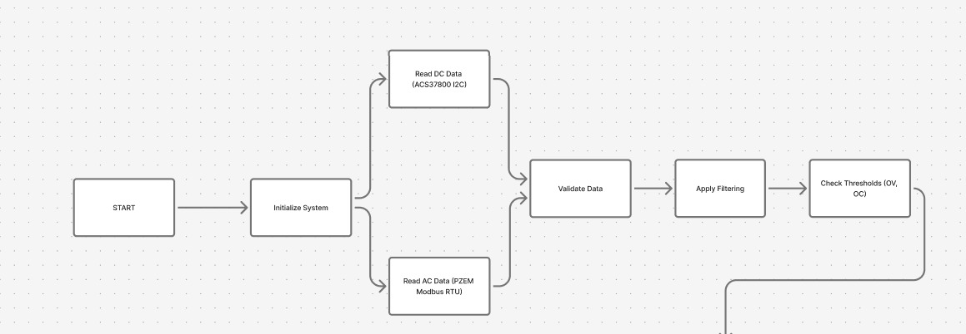

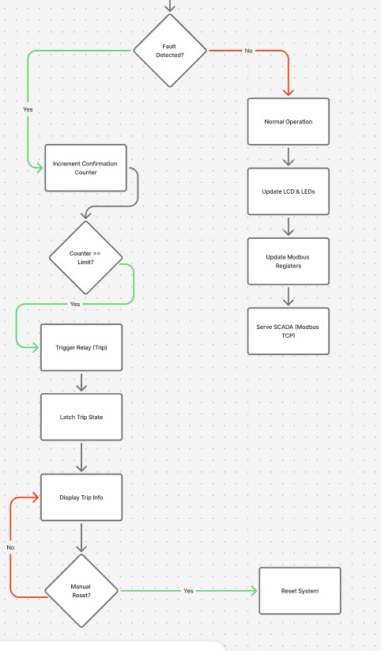

Figure 1 : The figure represents the algorithm flowchart of the entire operation from sensor to SCADA operation

2.4 Circuit Components:

- Controller Unit : ESP32 Wroom as controller circuit for deploying the code.
- AC Measurement Unit : PZEM-004T V4 for measuring Voltage , Current , Power and Power Factor.
- DC Measurement Unit : ACS37800 for DC voltage and current measurement
- Protection & Switching Unit : 5V Relay (works on trigger impulses)
- Communication Unit : ENC28J60 , TPLink Ethernet switch and Router , RJ-45
- Power Supply Unit : Auto-transformer for AC and Regulated Power Supply for DC
- Indication & User Interface : LEDs , LCDs , Laptops with MATLAB r2025a

2.5 AC Circuit Operation
In the AC section, the system begins with a single-phase AC supply, which feeds the load through a relay-controlled path. Before reaching the load, the electrical parameters are monitored using the PZEM-004T. The module is connected such that it measures line voltage directly and senses current using a current transformer placed in series with the load. This allows continuous acquisition of voltage, current, power, and frequency without interrupting the power flow.
The measured data is transmitted to the ESP32 via Modbus RTU communication. The controller periodically reads these parameters, validates them, and processes them using predefined protection logic. Each parameter is compared against set thresholds for conditions such as over-voltage and over-current. To avoid false triggering due to transient disturbances, a confirmation mechanism ensures that the abnormal condition persists over multiple sampling cycles.
Once a fault is confirmed, the ESP32 activates the relay, which interrupts the AC supply to the load. This ensures that under normal conditions, power flows uninterrupted from source to load, while under fault conditions, the system isolates the load quickly and reliably. The entire protection process is executed locally, independent of any external communication.

2.6 DC Circuit Operation

In the DC section, the operation starts with a DC power source supplying the load through a relay-controlled path. The current-carrying conductor passes through the ACS37800, which enables non-intrusive measurement of current using Hall-effect sensing while also measuring voltage. This provides isolated and continuous monitoring of DC voltage, current, and power.

The sensor communicates these measurements to the ESP32 via the I²C interface. The controller reads the data at regular intervals and applies filtering and validation techniques to ensure stability, as DC measurements are more susceptible to noise and fluctuations. The processed values are then evaluated against predefined thresholds for over-voltage, over-current, and power conditions.

Similar to the AC section, a confirmation logic is applied to ensure that only sustained faults result in a trip decision. Upon confirmation of a fault, the ESP32 energizes the relay, disconnecting the DC supply from the load. Under normal conditions, power flows continuously, while during abnormal conditions, the system ensures safe isolation of the load.

2.7 TASKS AND MILESTONES
The project progress is tracked through the following tasks and milestones:

Task Description | Status
- Literature Review and Component Selection | Completed
- AC IED Hardware | Completed
- DC IED Hardware | Completed
- Communication part | Completed
- SCADA Implementation | Completed
- MES ( Tariff Implementation ) | Completed

CHAPTER III
3. HARDWARE IMPLEMENTATION
3.1 System Hardware Architecture

The hardware architecture of the proposed system is designed to integrate sensing, processing, protection, and communication modules into a unified structure. The ESP32 microcontroller acts as the core processing unit, interfacing with both AC and DC measurement systems.

The AC measurement unit is implemented using the PZEM-004T module, which measures voltage, current, power, and frequency through Modbus RTU communication. The DC measurement unit uses the ACS37800 sensor, which provides isolated voltage and current measurement using Hall-effect sensing.

All measured data is processed by the ESP32, which executes protection logic and controls relay modules for fault isolation. The system also includes communication modules for SCADA integration and display units for local monitoring. The overall architecture ensures modularity, reliability, and ease of integration.

  - Measurement Units (AC and DC)

The system incorporates separate measurement units for AC and DC subsystems to ensure accurate and reliable data acquisition.

The AC measurement is performed using the PZEM-004T module, which provides real-time measurement of voltage, current, power, and frequency. It communicates with the ESP32 using the Modbus RTU protocol, enabling structured and efficient data transfer.

For DC measurement, the ACS37800 sensor is used. It utilizes Hall-effect sensing to measure current without direct electrical contact, providing inherent isolation and improved safety. It also measures DC voltage and calculates power.

Both measurement units are designed to operate continuously, providing real-time data to the controller for monitoring and protection purposes.

3.3 Protection and Control Hardware

The protection and control section of the system is responsible for ensuring safe operation under abnormal conditions. A relay-based switching mechanism is used to isolate the load during fault conditions such as over-voltage and over-current.

The ESP32 continuously compares measured parameters with predefined threshold values. When a fault condition is detected and confirmed through persistence logic, the controller sends a trigger signal to the relay module, disconnecting the load.

Additionally, LEDs and LCD displays are used for status indication and real-time parameter visualization. The hardware design ensures that protection actions are executed locally and independently of communication systems, improving reliability and response time.

3.4 Communication and Power Supply Setup

The system incorporates communication modules to enable supervisory monitoring and data exchange with external systems. Ethernet communication is implemented using the ENC28J60 module, allowing data transmission via Modbus TCP to a MATLAB-based SCADA interface.
A router and Ethernet switch are used to establish network connectivity between the ESP32 and the SCADA system. This setup enables real-time monitoring, data logging, and visualization without affecting protection operations.
The power supply arrangement includes an auto-transformer for AC input and a regulated power supply for DC operation. Proper isolation and grounding are maintained to ensure safe and stable operation of the system.

3.5 Design Calculations
Design calculations (AC)
- Voltage ( 110 % rule )
V_{lower_th(ac)} =120 V
V_{upper_th(ac)} = 132 V
V_{thresh(ac)} = 120 x $\frac{110}{100}$V = 132 V
Toggle range = 12 V ( 120 – 132 )V
- Current ( 125 % rule )
I_{lower_th(ac)} = 0.35 A
I_{upper_th(ac)} = 0.4375 A
I_{thresh(ac)} = 0.35 x $\frac{125}{100}$ A = 0.4375 A
Toggle range = 0.0875 A ( 0.35 – 0.4375 ) A
Design Calculations ( DC )
- Voltage ( 110 % rule )
V_{lower_th(dc)} = 24 V
V_{upper_th(dc)} = 26.4 V
V_{thresh(dc)} = 24 x $\frac{110}{100}$V = 26.4 V
Toggle range = 2.4 V ( 24 – 26.4 )V
- Current ( 125 % rule )
I_{lower_th(dc)} = 1 A
I_{upper_th(dc)} = 1.25 A
I_{thresh(dc)} = 1 x $\frac{125}{100}$ A = 1.25 A
Toggle range = 0.25 A ( 1 – 1.25 ) A

3.6 Hardware ( AC )
The AC Part’s hardware has its own challenges like choosing the supply , choosing the right load according to the specification, choosing the right modules for voltage , current , power and power factor related measurements, finally an auto-transformer was chosen for the power supply so that manual incremental voltage could be given and the changes in the model could be observed , a single phase resistive load bank was chosen as the load since it was under the current requirements specified for our model . The PZEM-004T module reads Voltage, Current Power and power factor for the AC part, The ESP32 Wroom has all the necessary codes deployed in it for the protection logic and the relay responds accordingly to the threshold logics laid out by the protection logic part. Image shows the AC setup, where the LCD displays the key parameters like the voltage, current, power and power factor and since only resistive load is used the power factor is always unity. The red button is for resetting the protection logic that is whenever the circuit trips due to overcurrent / overvoltage the voltage / current values can be brought to a safe nominal value and the red button helps in resetting the circuit, the yellow button is for manual trip, this is essential when maintenance is considered.
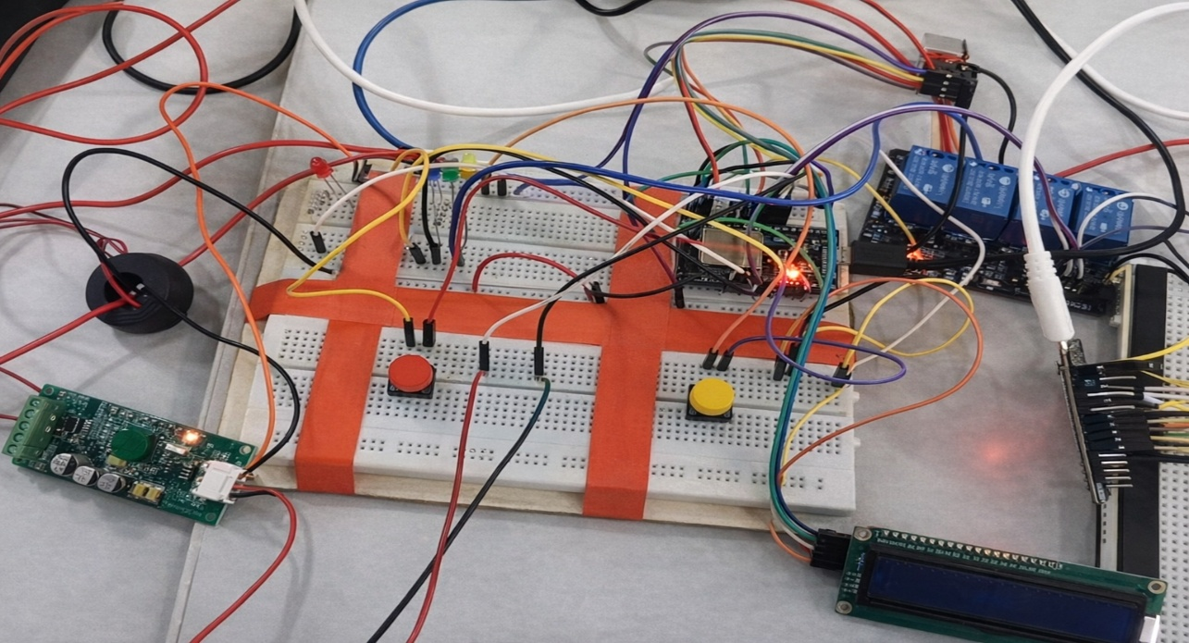
Figure 2: Image shows the working model of Ac part of the circuit
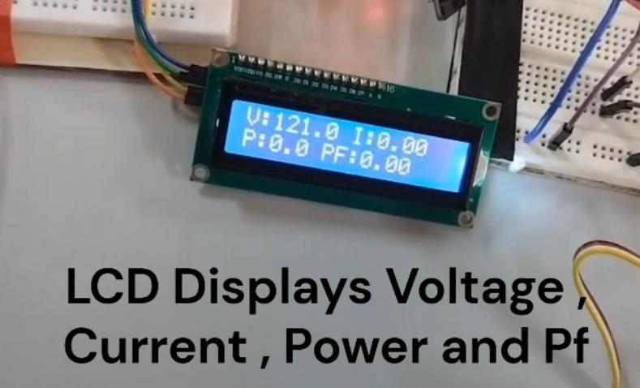

Figure 3: Image shows the LCD Display for AC Part which reads the key parameters like
the Voltage, Current, Power and Power Factor

3.7 Hardware ( DC )
The DC Part’s circuitry is not that complex since the sensor ACS37800 has done dual work of measuring both the voltage and current simultaneously without breaking the circuit , it has hall effect sensors which makes this operation possible. For the DC part , a regulated power supply is used and for the load a 370 Ω rheostat is used , for the measurement part the LCD displays the values of the Voltage, Current and Power. The two LCDs in AC and DC parts have different addresses so that they can be configured simultaneously using I²C protocol. LEDs are for indicating the problem i.e overvoltage, overcurrent and togging range. The ESP32 Wroom takes care of the logic circuit and code deployment, the red and yellow buttons are for resetting the logic circuit and manual trip for maintenance purposes. The AC and DC parts are commonly connected to a 4-channel relay for tripping purposes. Image shows the DC circuitry.
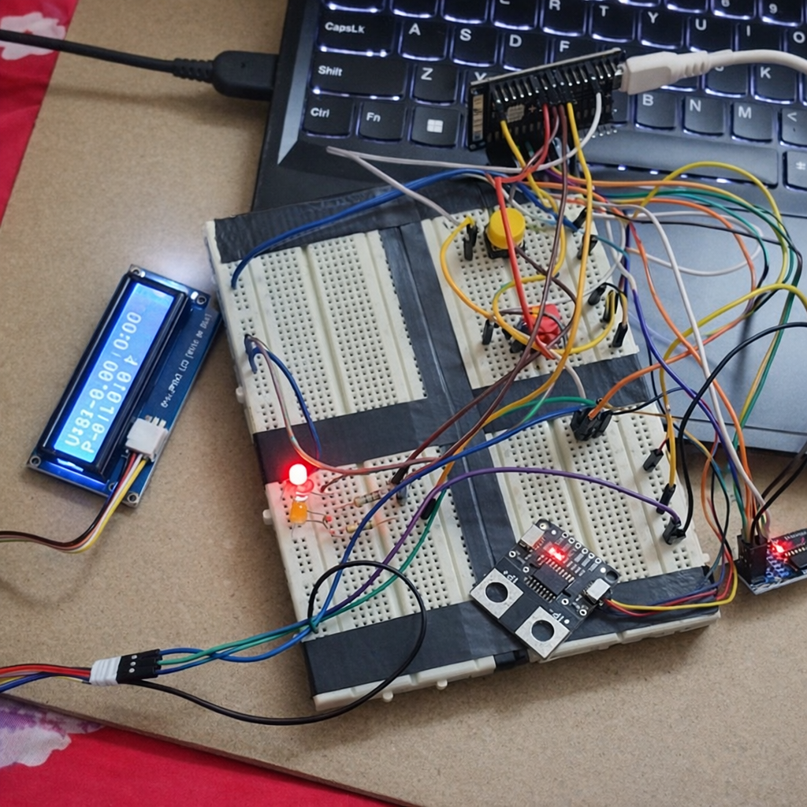
Figure 4: The image shows the working model of Dc part of the circuit

CHAPTER IV
4. SOFTWARE IMPLEMENTATION

4.1 Software Architecture and Data Acquisition
The software architecture of the system is designed to support continuous data acquisition, processing, and control. The ESP32 runs embedded firmware that periodically reads data from both AC and DC measurement units.
AC parameters are acquired via Modbus RTU communication from the PZEM-004T module, while DC parameters are obtained from the ACS37800 sensor through the I²C interface. The acquired data is validated and processed to remove noise and ensure accuracy.
The system operates in a cyclic manner, continuously updating measurement values and preparing them for further processing and transmission.
4.2 Protection Algorithm and Control Logic
The protection algorithm is implemented within the ESP32 to ensure fast and deterministic response to fault conditions. Measured parameters are continuously compared against predefined threshold limits for over-voltage, under-voltage, over-current, and power conditions.
To prevent false tripping due to transient disturbances, persistence logic is applied. This ensures that a fault condition is confirmed only after it persists for a certain duration or number of cycles.
Once a fault is confirmed, the controller activates the relay module to disconnect the load. The system also updates status indicators and logs fault information. The protection logic operates independently of communication systems, ensuring reliable operation.
4.3 SCADA Implementation
The SCADA component of this project serves as the supervisory layer responsible for real-time monitoring, data logging, and visualization of electrical parameters obtained from the developed IEDs. In this implementation, a SCADA-like interface is developed using MATLAB, which communicates with the ESP32-based IEDs over Modbus TCP through an Ethernet network.
The SCADA system continuously reads measurement data such as voltage, current, power, and protection status from the IED registers and presents them in a structured and user-friendly format. It also enables logging of historical data for analysis and performance evaluation. Importantly, the SCADA system operates in a read-only mode, meaning it does not participate in protection decision-making or issue control commands.
This design ensures a clear separation between supervision and protection, where all critical protection functions are executed locally within the IED, while SCADA provides higher-level visibility and monitoring. Such an architecture reflects real-world industrial practices, improving system reliability and preventing communication delays from affecting protection performance.
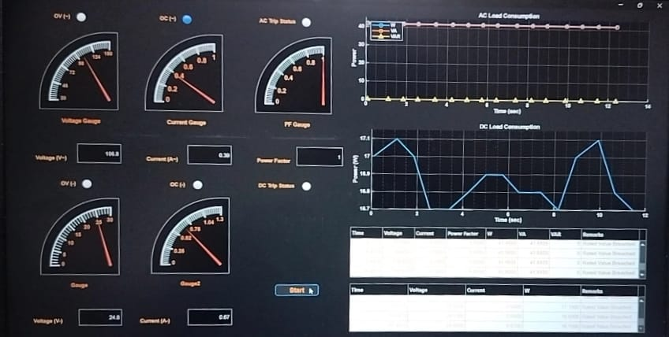

Figure 5: The image shows the SCADA dashboard in matlab
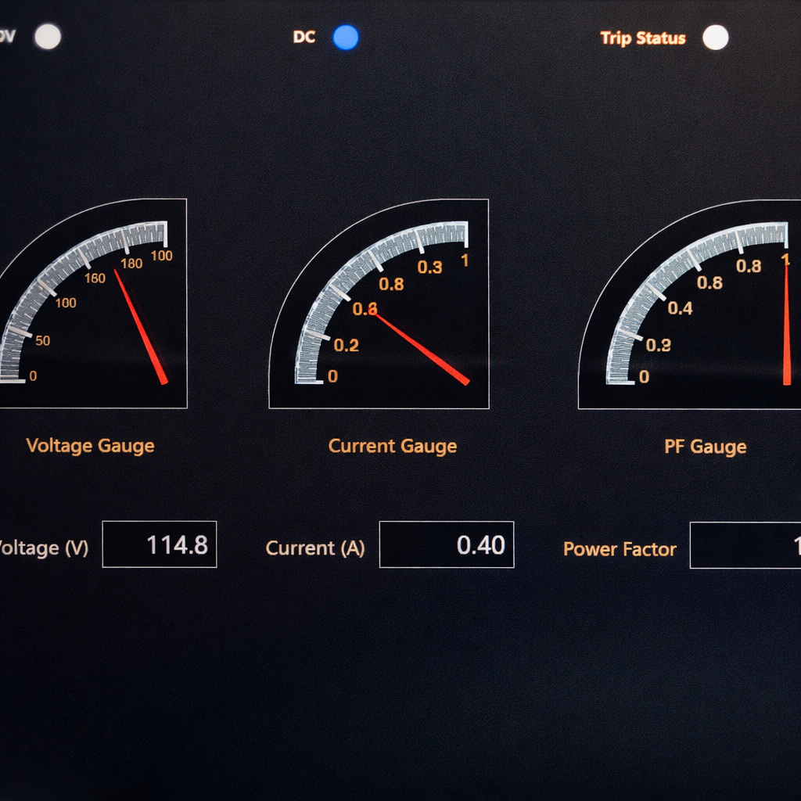
Figure 6: The image shows the SCADA dashboard with Voltage, Current and Power Factor.
The load consumption graph below shows the variation of the load with respect to time when the load is applied in stages using the resistive load bank the curve shows a change in it indicating that load has increased and the relay might trip as well if the current exceeds the threshold limit.The yellow spike is due to the stray reactive power element present at the initial stages.
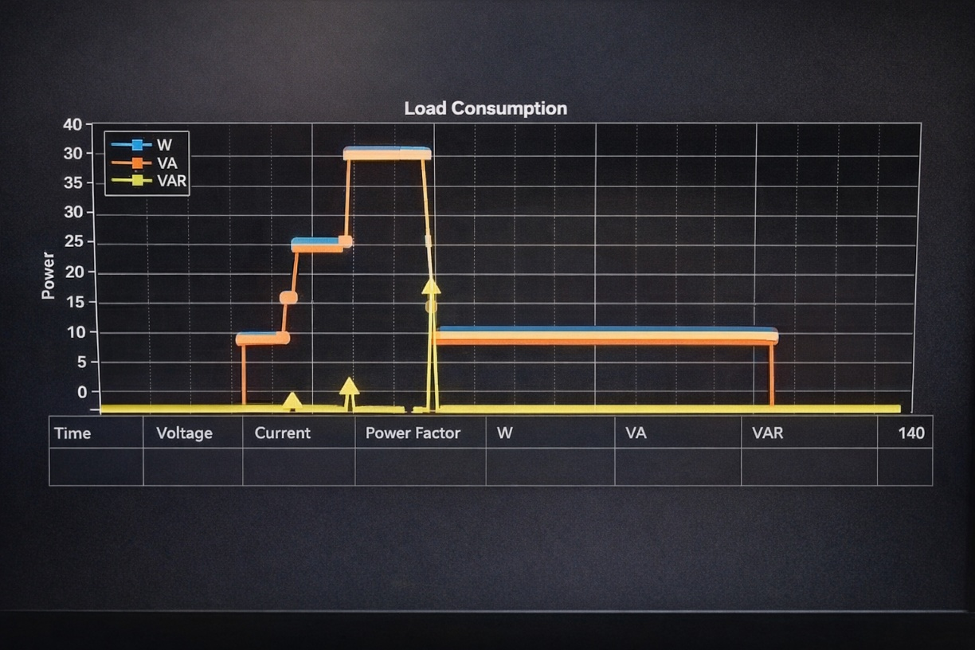
Figure 7: The image shows the load graph variation with respect to time
The SCADA part also includes real time streaming of all the data onto the laptop along with timestamps, which exactly mimics the real time SCADA systems used in industrial standards , the following image shows the real time monitoring of various parameters
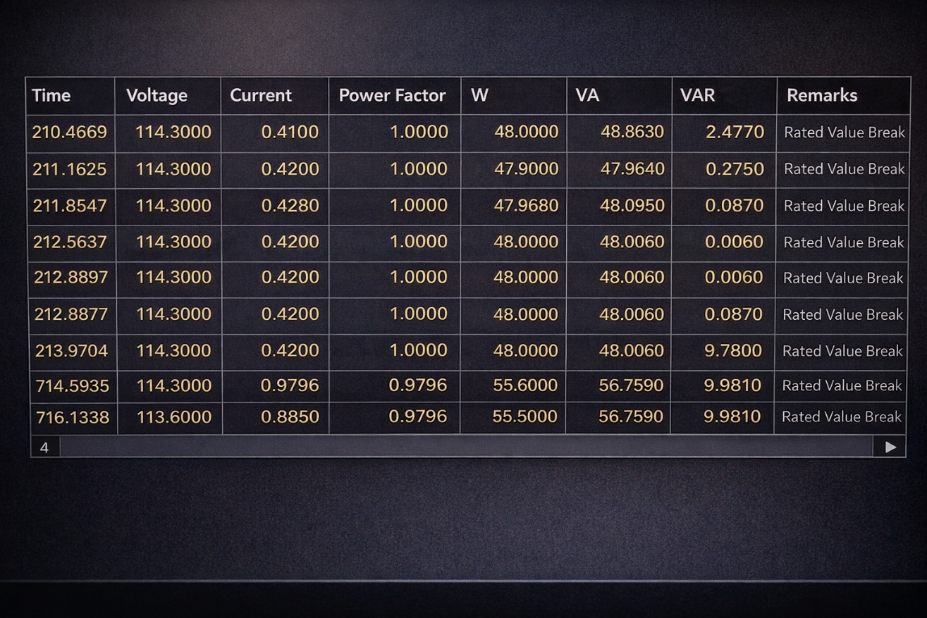
Figure 8: The image shows the real time streaming of all data with timestamps, mimics SCADA used in industries

4.4 Tariff Calculation and Cost Analysis
In addition to real-time monitoring and visualization, the SCADA system is extended to perform tariff-based cost estimation for both AC and DC energy consumption. This feature enhances the system by incorporating energy management and cost analysis capabilities, making it more practical for real-world applications.
The tariff calculation module is implemented within the MATLAB-based SCADA interface, where energy consumption data received from the ESP32 is processed to compute the corresponding cost. The system supports multiple tariff categories and time-based pricing structures, allowing dynamic cost evaluation based on usage patterns.
The total energy consumption for AC and DC loads is calculated in kilowatt-hours (kWh) using the relation:
Energy (kWh) = Power (W) × Time (hours) / 1000
The computed energy values are continuously updated and used to determine the total cost using predefined tariff rates. The system allows the user to select tariff categories such as domestic or custom-defined plans, and different pricing slabs (A, B, C) can be configured.
The system also provides flexibility for the user to select different tariff modes such as domestic, commercial, and time-of-day (ToD) pricing through the SCADA interface. Based on the selected tariff category, the cost calculation logic dynamically updates by applying the corresponding rate structure.
In domestic mode, standard slab-based tariffs are applied, whereas in commercial mode, higher and more uniform rates are considered to reflect industrial usage patterns. In time-of-day mode, the tariff varies depending on predefined time intervals such as peak and off-peak hours.
The total cost is automatically recalculated in real time whenever the user changes the tariff selection, enabling comparative analysis of different pricing schemes. This feature allows users to understand the impact of tariff structures on energy expenses and supports better energy management and cost optimization.To reflect realistic billing conditions, time-of-use (ToU) tariff logic is implemented, where different rates are applied based on the time of the day. The following tariff periods are considered:
- Morning tariff
- Afternoon tariff
- Evening tariff
- Night tariff
Each period is assigned a specific rate, and the SCADA system automatically applies the appropriate tariff based on the current system time. This enables dynamic cost calculation and helps in analyzing energy usage behavior across different time intervals.
The SCADA interface displays:
- Total energy consumption for AC and DC loads
- Total cost associated with energy usage
- Selected tariff category and active tariff slab
- Time-based tariff rates
- Real-time cost variation through graphical plots
A “Cost vs Time” graph is generated to visualize how energy cost evolves with time for both AC and DC systems. This helps in identifying peak consumption periods and optimizing energy usage.
This feature demonstrates the integration of monitoring, protection, and energy management within a single system. Although simplified, it reflects concepts used in modern smart metering and energy management systems, where tariff-based billing and demand-side analysis play a crucial role

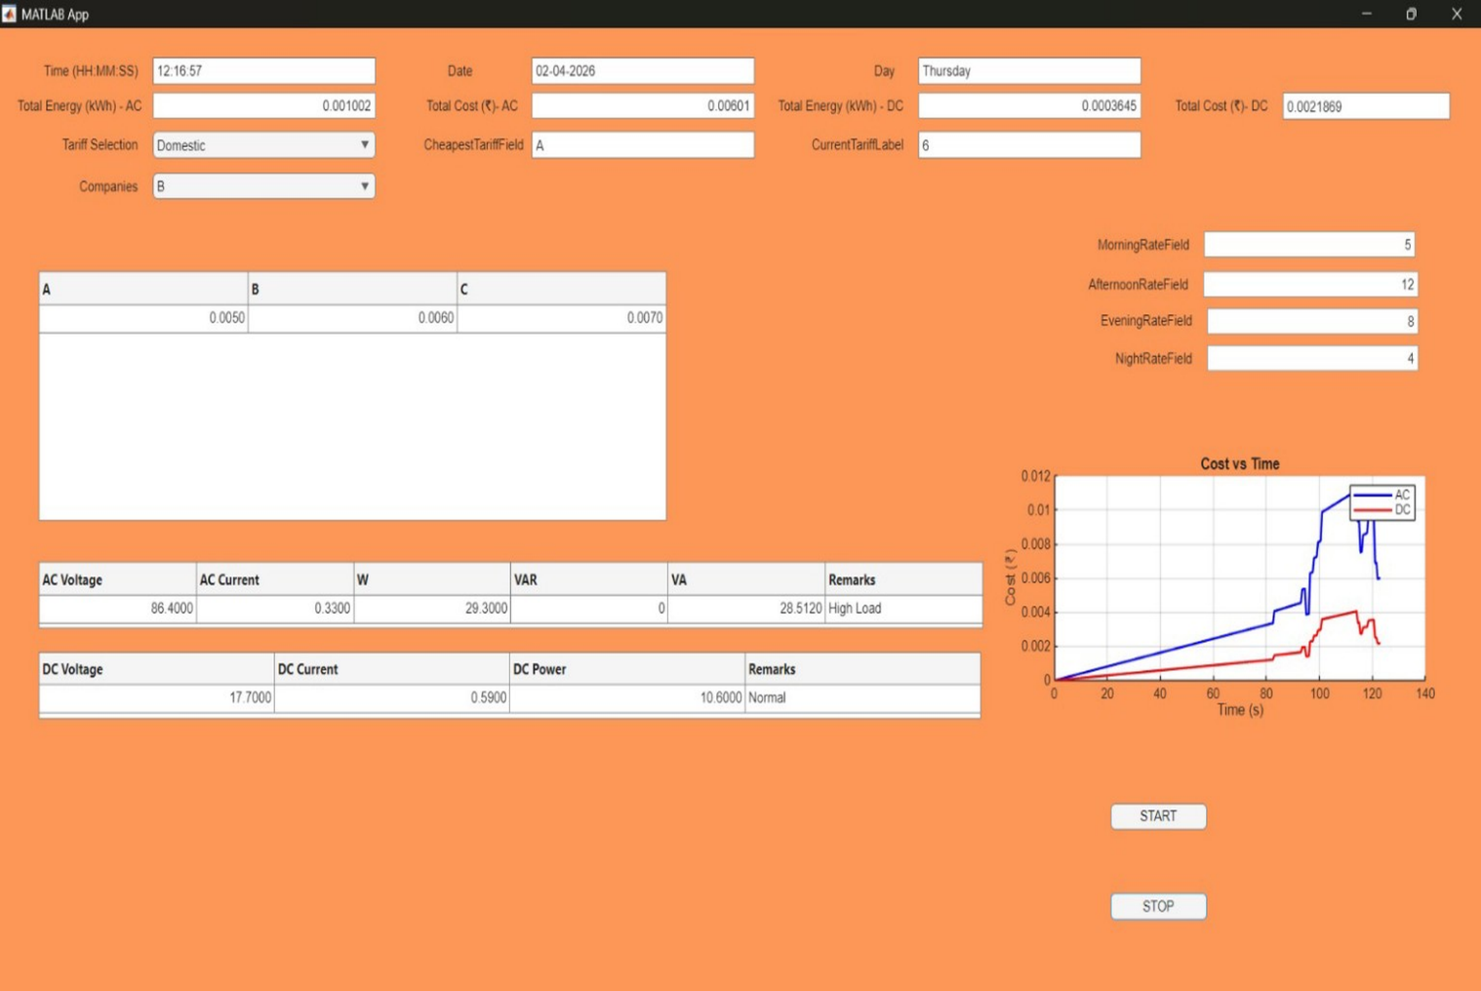
Figure 9: The figure shows the real-time monitoring of tariff as per AC/DC energy consumption
4.5 Functional verification
Functional verification of the developed IED-based AC/DC monitoring and protection system was carried out to ensure that each functional block—measurement, protection, actuation, and communication—operates as intended under both normal and fault conditions.
Initially, the measurement functionality was verified by comparing the readings obtained from the PZEM-004T (AC side) and ACS37800 (DC side) with expected values under known load conditions. The results confirmed consistent acquisition of voltage, current, and power parameters within acceptable limits.
The protection logic was then validated by introducing controlled variations in input conditions to simulate faults such as over-voltage and over-current. It was observed that the system did not react to transient disturbances immediately, but only triggered a trip after the fault persisted for a predefined number of sampling cycles, confirming the effectiveness of the implemented confirmation logic.
Relay actuation was verified by monitoring load disconnection during fault conditions and restoration only after manual reset, validating the latching behavior. LED indicators and LCD display outputs were also checked to ensure correct representation of system status and fault conditions.
Finally, communication functionality was verified by establishing a Modbus TCP connection between the IED and the MATLAB-based SCADA interface. Real-time data acquisition, correct register mapping, and consistent updates were confirmed without affecting the protection mechanism. This demonstrates that the system successfully achieves deterministic local protection with reliable supervisory monitoring.

4.6 Results
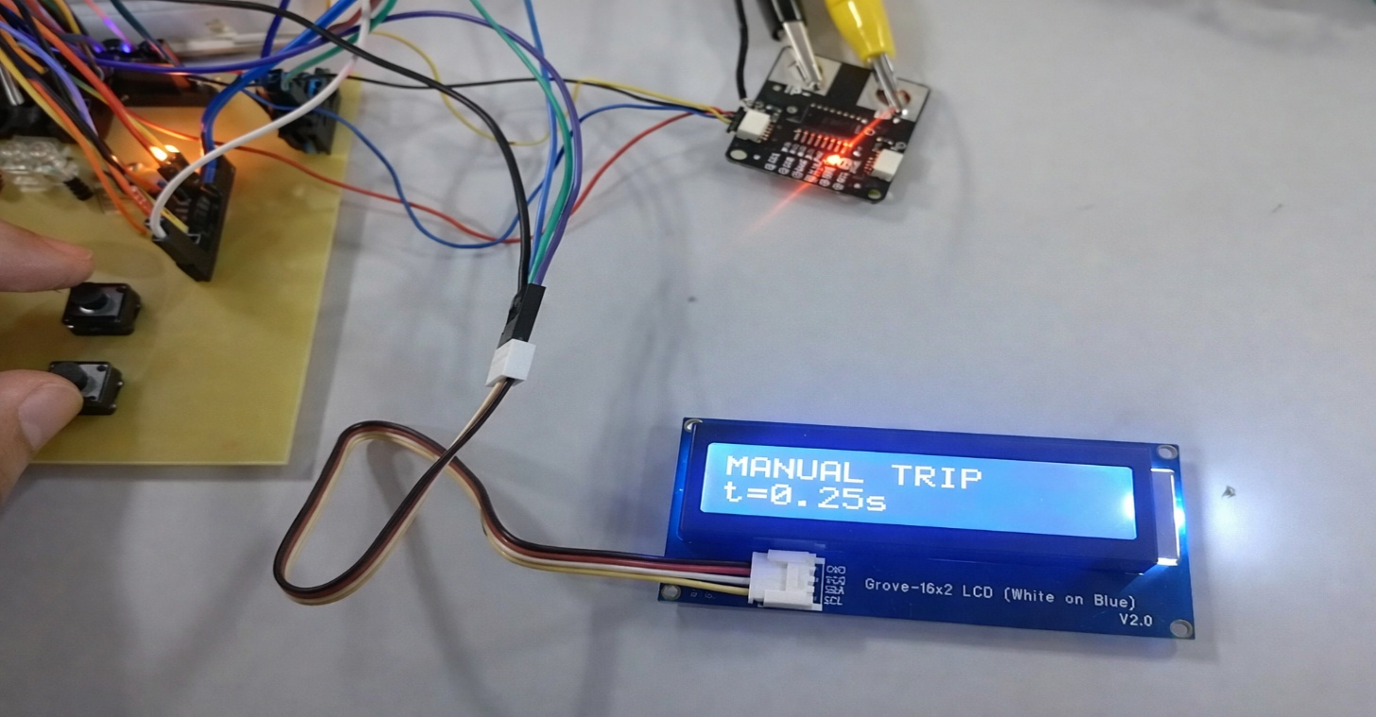
Figure 10: Represents the Manual Trip of the circuit
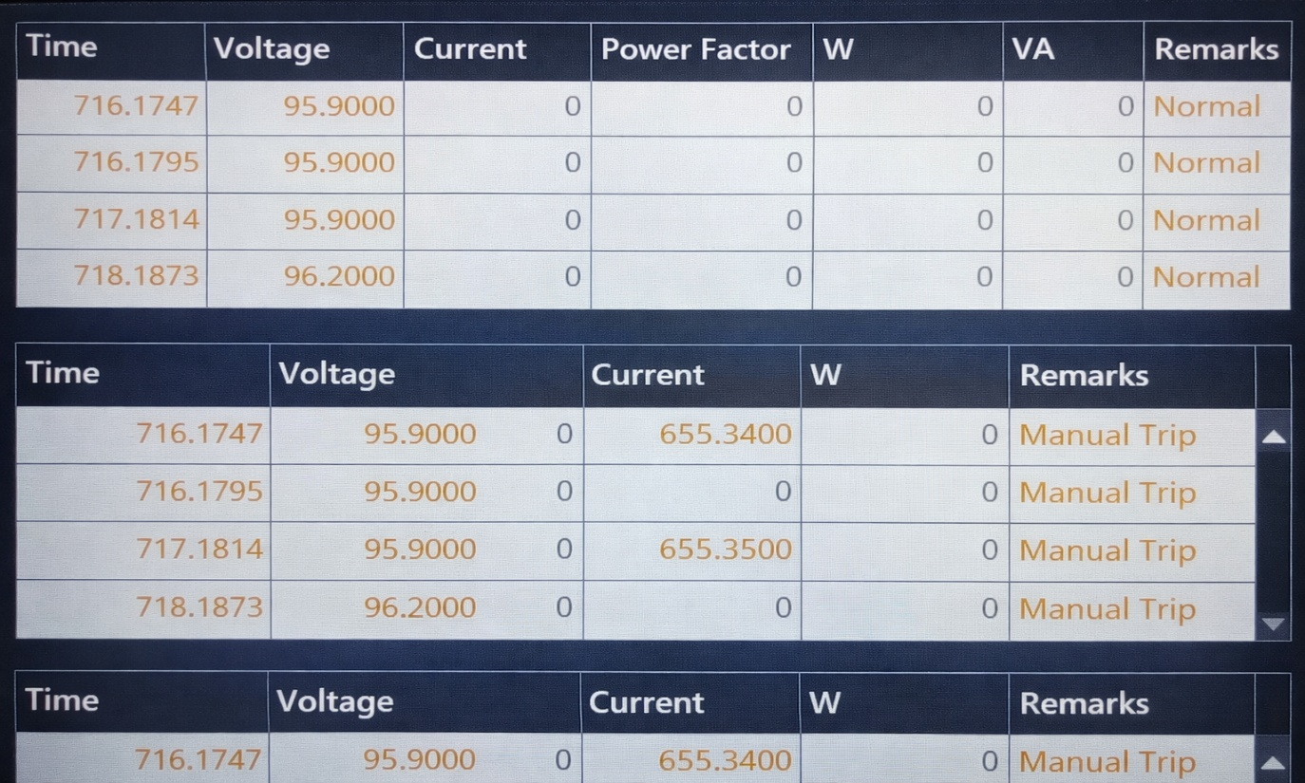
Figure 11: Represents the Scada indicating Manual Trip of the circuit

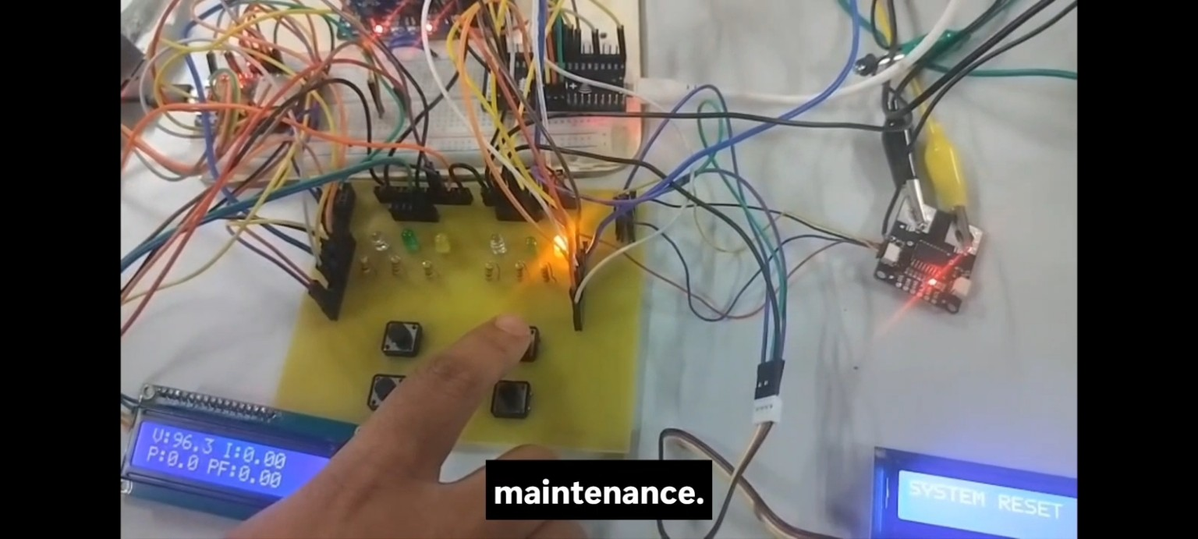

Figure 12: Represents the circuit reset after manual tripping for maintenance
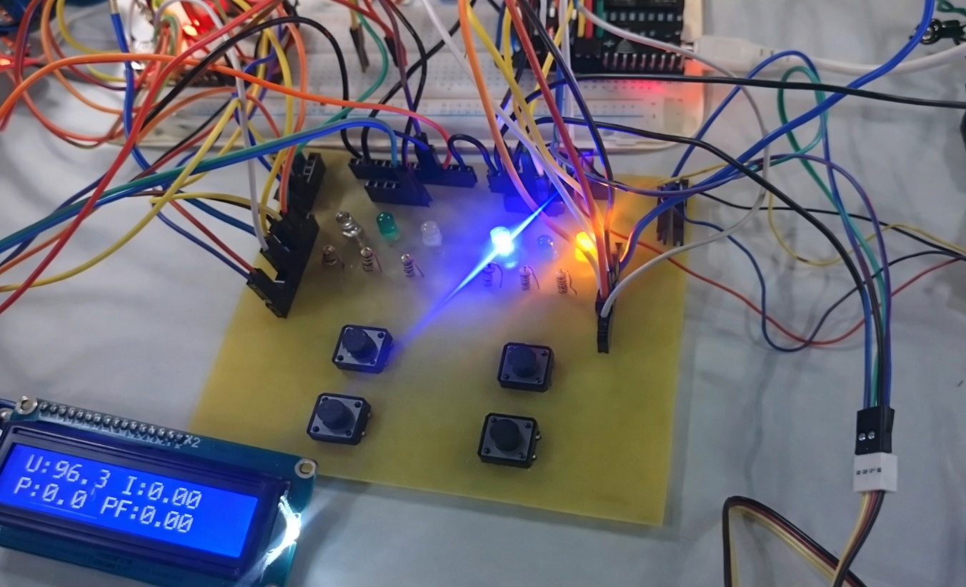

Figure 13: Blinking of LED’s indicate Overvoltage of the circuit

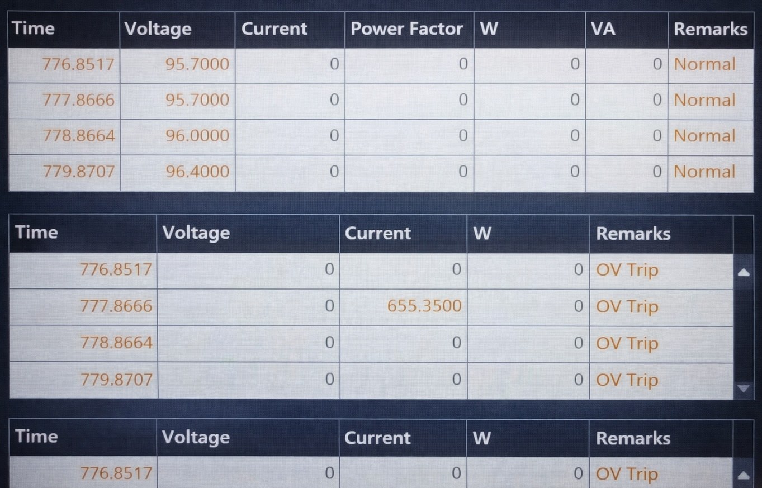

Figure 14: Represents the Overvoltage trip status in SCADA
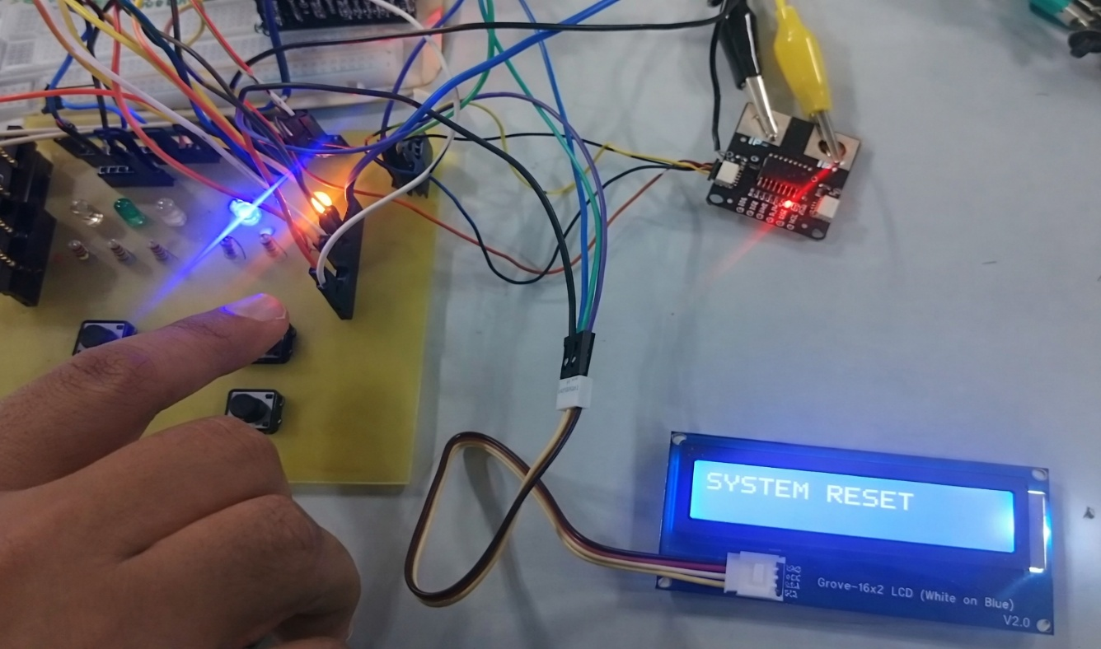

Figure 15: Represents the manual circuit rest

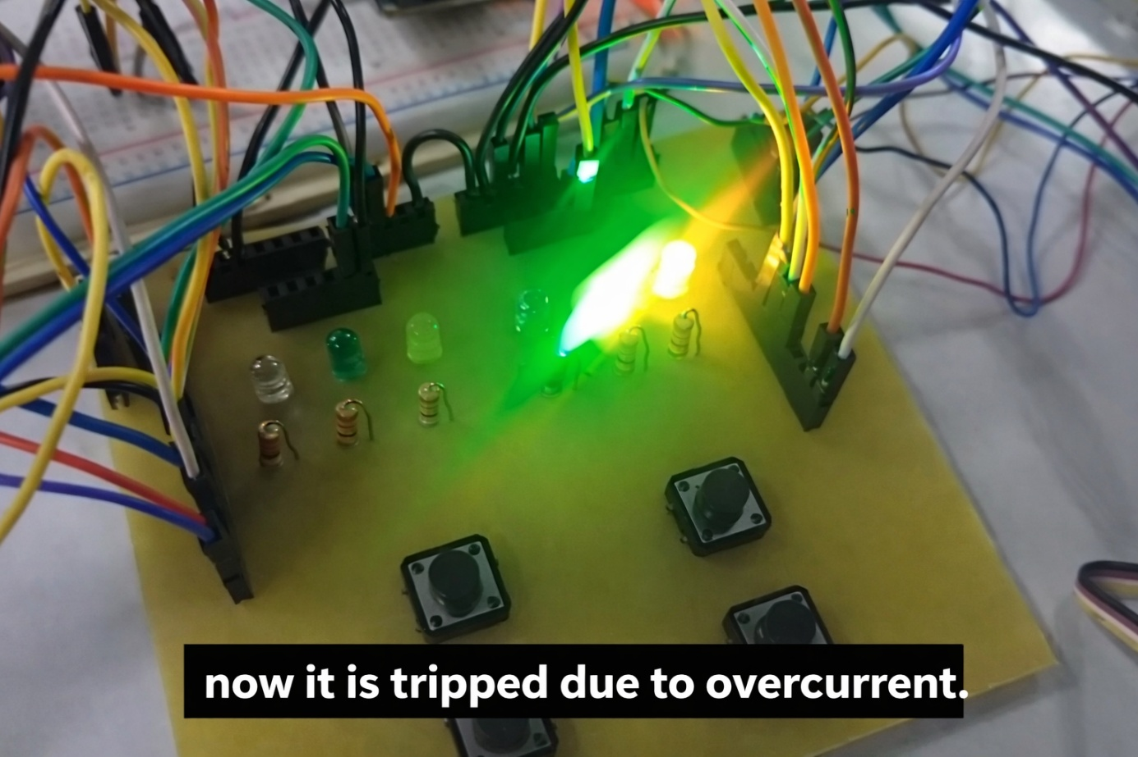

Figure 16: Represents circuit tripped due to overcurrent

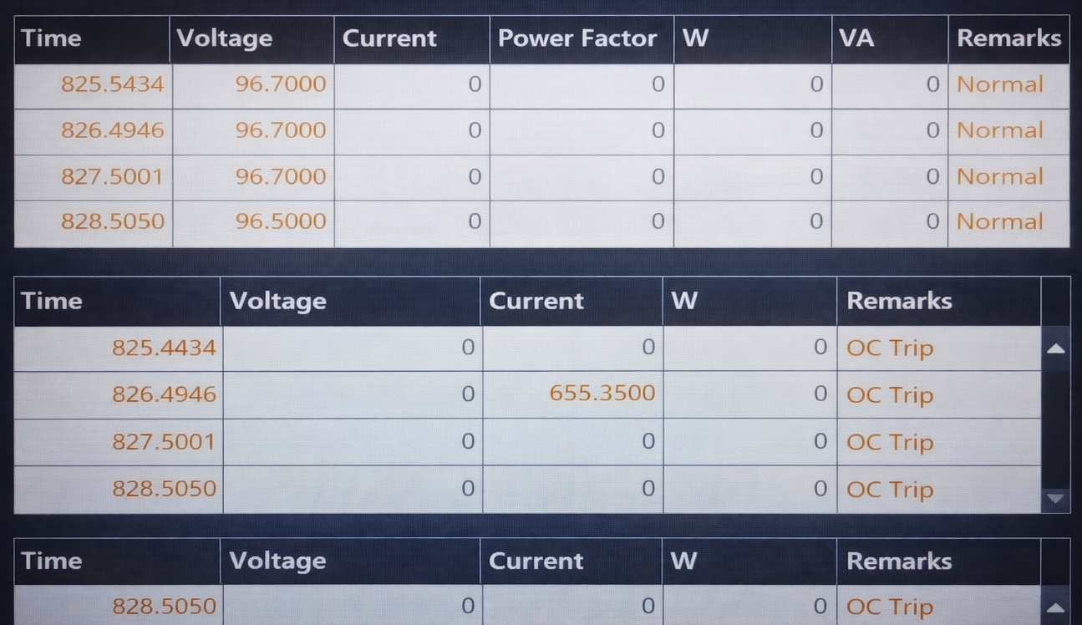

Figure 17: Represents the Overcurrent trip status in SCADA

CHAPTER V

Conclusion
5.1 Scope of work
In Scope (Present Work):
- Design and implementation of an ESP32-based Intelligent Electronic Device for low-voltage applications
- Real-time measurement of AC parameters using PZEM-004T (voltage, current, power, power factor)
- Real-time measurement of DC parameters using ACS37800 (voltage, current, power)
- Implementation of deterministic, local protection functions:
  - Over-voltage (OV)
  - Over-current (OC)
  - Manual trip
- Development of confirmation logic to prevent false tripping due to noise/transients
- Relay-based actuation for load disconnection during fault conditions
- Implementation of trip latching and manual reset mechanism
- Local Human–Machine Interface (HMI):
  - LED status indication (normal, warning, trip)
  - LCD display for real-time parameters and fault status
- Modbus RTU communication for AC measurement acquisition
- Modbus TCP communication over Ethernet for supervisory monitoring
- MATLAB-based SCADA interface for:
  - Real-time data visualization
  - Logging of electrical parameters
- Implementation of structured register mapping and scaled data transmission
- Development of cyclic, non-blocking firmware architecture using timer-based execution.

Out of Scope / Future Work :
- Inclusion of advanced protection functions:
  - Under-frequency (UF)
  - Earth fault detection
  - Short-circuit protection with high-speed response
- Replacement of modular sensors (PZEM) with dedicated metering ICs for higher accuracy
- Implementation of hardware-based protection (comparators / dedicated relays) for faster tripping
- Use of solid-state switching (SSR / MOSFET-based) instead of mechanical relays
- Integration of advanced communication protocols:
  - CAN
  - IEC 61850 (substation automation standard)
- Bidirectional SCADA control (remote trip/reset commands) with secure access control
- Implementation of data synchronization, timestamping, and event logging within the IED
- Addition of fault diagnostics and self-health monitoring features
- PCB optimization with improved isolation and EMI/EMC compliance
- Multi-phase (three-phase) system extension
- Cloud-based monitoring and analytics integration
- Calibration and accuracy enhancement for industrial-grade deployment.

5.2 Summary
This project presents the design and implementation of an ESP32-based Intelligent Electronic Device (IED) for real-time monitoring and protection of low-voltage AC and DC systems. The system integrates measurement, protection, actuation, and communication functionalities within a single embedded platform, providing a compact and efficient solution for energy monitoring applications.
Electrical parameters from the AC subsystem are acquired using the PZEM-004T, while the DC subsystem utilizes the ACS37800 for accurate and isolated sensing. The ESP32 processes these measurements to implement deterministic protection functions such as over-voltage, over-current, and manual trip using threshold-based logic with confirmation filtering to ensure stability and noise immunity.
A relay-based mechanism is employed for load disconnection, with trip conditions latched until manual reset. A SCADA-like supervisory system developed in MATLAB communicates via Modbus TCP to enable real-time monitoring, logging, and visualization. The system maintains a clear separation between protection and supervision, ensuring that all critical decisions are executed locally. Overall, the project demonstrates a structured and practical realization of modern digital protection concepts at a laboratory scale.

5.3 REFERENCES
[1] Hossain, Md. Sanwar & Rahman, Mostafizur & Sarker, Md.Tuhin & Haque, Md.Ershadul & Jahid, Abu. (2019). A Smart IoT Based System for Monitoring and Controlling the Sub-Station Equipment. Internet of Things. 7. 100085. 10.1016/j.iot.2019.100085.

[2] Pudlo, G. & Tenbohlen, Stefan & Linders, M. & Krost, G. (2002). Integration of power transformer monitoring and overload calculation into the power system control surface.
1. 470 - 474 vol.1. 10.1109/TDC.2002.1178421.

[3] S. U. Rehman, H. Mustafa, and A. R. Larik, “Iot based substation monitoring & control system using arduino with data logging,” 4th International Conference on Computing & Information Sciences, pp. 1-6, 2021.

[4] M. K. Hasan, M. M. Ahmed, B. Pandey, H. Gohel, S. Islam, and I. F. Khalid, “Internet of Things-based smart electricity monitoring and control system using usage data,” Wireless Communications and Mobile Computing, pp.1-16, 2021

[5] L. Chen, J. Tang, and X. Lu, “Safety management in substation project construction based on advanced internet of things and smart sensors technologies,” 5th International Electrical and Energy Conference, pp. 121-126, 2022.

[6] P. P. Singh, P. K. Khosla, and M. Mittal, “Energy conservation in
IoT-based smart home and its automation,” Energy Conservation for
IoT Devices: Concepts, Paradigms and Solutions, pp. 155-177, 2019.

[7] Y. Tian, Z. Pang, W. Wang, L. Liu, and D. Wang, “Substation
sensing monitoring system based on power internet of things,” 2nd Information Technology, Networking, Electronic and Automation Control Conference, pp. 1613-1617, 2017.

[8] S. Kalpana, N. Saranya, & K. Saundariya, “An IoT Based Real-Time Monitoring and Controlling of Sub-Station Equipment,” International Conference on System, Computation, Automation and Networking, pp. 1-5, 2021.

[9] M. Rajnikanth, “Substation Equipment Monitoring And Controllig Using IoT,” Journal of University of Shanghai for Science and Technology, vol. 23, no. 9, pp. 1-18, 2021.

[10] Yulia Rangelov, Nikolay Nikolaev, and Milena Ivanova, "The IEC 61850 Standard Communication Network and Automation Systems from an Electrical Engineering Point of View," 2016 19th International Symposium on Electrical Apparatus and Technologies (SIELA), pp. 1- 4, June. 2016.

[11] P.K. Wesseh, K.E. Dogah, Dynamic tariffs and climate policy interaction: an economic analysis of welfare implications in retail electricity markets, Energy Res. Social Sci. 90 (2022) 102679

.[12] P.L. Joskow, C.D. Wolfram, Dynamic pricing of electricity, Am. Econ. Rev. 102 (2012) 381–3

