IMAGE RECOGNITION WITH IBM CLOUD VISUAL RECOGNITION

**TEAM MEMBER**

**511821106003-SANJAI.S**

**PHASE-1 DOCUMENTATION SUBMISSION**

**PROJECT: IMAGE RECOGNITION**

**CLOUD COMPUTING PROJECT-IMAGE RECOGNITION WITH CLOUD VISUAL RECOGNITION**

**PROJECT:IMAGE RECOGNITION**

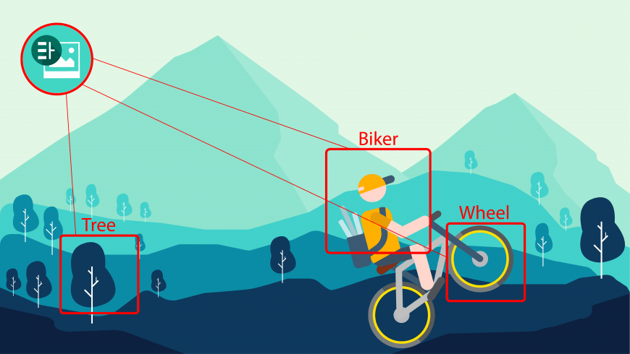

**DEFENITION:**

**Image recognition, in the context of machine vision, is the ability of software to identify objects, places, people, writing and actions in digital images. Computers can use machine vision technologies in combination with a camera and artificial intelligence (AI) software to achieve image recognition**

**Image recognition allows machines to identify objects, people, entities, and other variables in images. It is a sub-category of computer vision technology that deals with recognizing patterns and regularities in the image data, and later classifying them into categories by interpreting image pixel patterns**

**Image recognition is used to perform many machine-based visual tasks, such as labeling the content of images with bet tags, performing image content search and guiding autonomous robots, self-driving cars and accident-avoidance systems.**

**PROJECT: IMAGE RECOGNITION**

**PROBLEMS:**

**Intra-class variation :**

**Intra-class variance is the difference in images from the same class. Having flowers of various types in our dataset is an example of intra-class variance. They could be "Rose," "Lilly," or "Jasmine," for example. The problem of intra-class variation can be solved using this picture categorization method.**

**Variation in Scale:**

**This is a typical issue in image classification. Scale variance refers to having many images of the same subject at different sizes. If we have a photo of a scale variation of the same object let’s say chair, but they are all various sizes,**

**Variation in perspective:**

**We have perspective variation, which allows an item to be oriented in several dimensions depending on how it is shot. The object still remains the same regardless of the angle from which we photograph it.**

**Illumination:**

**Our picture categorization system should be able to cope with variations in illumination as well. Let's imagine we have two pictures of the same painting, each with a different amount of pixel intensity. Our picture categorization system should be able to adapt to lighting changes. So, if we offer our image classification system a picture of the same item with varying brightness levels (Illumination), the system should be able to assign them the same label.**

**CLUTTER IN THE IMAGE:**

**It signifies that the image contains a large number of things, making it difficult for the observer to locate the desired object. These photographs have a lot of "noise" to them.**

**However, we are only interested in one specific object in the photograph, which is difficult to distinguish owing to the "noise." It's a challenging assignment for a human, so think how difficult it is for a machine that has no conceptual knowledge of the image.**

**SOLUTIONS FOR THE PROBLEM:**

**BACKGROUNDNOISE:**

r[https://miro.medium.com/v2/resize:fit:720/format:webp/1*UhigdM4rnIn5b-Ebc69kVw.png](https://miro.medium.com/v2/resize:fit:720/format:webp/1*UhigdM4rnIn5b-Ebc69kVw.png)

The above image was taken from k competition to classify the plants type, and as you can see it contain a lot of background which will confuse the model whatever you did.

So the best treatment is to use any object detection code before train your model on the images or easiest solution to create a mask for certain color range

**PIXEL INTENSITY:**

blur to waive these noise a way, you have to make sure that you didn’t pick high value of blur to prevent data Due to converting the world analogue images to digital images some pixel were affected by the electrons and create a noise in the images which sometimes undetectable in high resolution,

These noise shall be treated before train your model on the images,

**A — Gaussian Blur**

So, the best solution is to use Gaussian loss

**B — Mask the object**

If there are a lot of background noise, it is better either to use any code of object detection or masking the required object using color range using HSV color type which allow you to select specific range of colors and mask it, below is the result of masking the plants color range, which improve the model performance with a big difference.

--

**[PLATFORMS:](https://medium.com/@arch.mo2men?source=post_page-----55073a182a90--------------------------------)**

**[Azure computer vision, Hive Moderation, National Instruments Vision Builder AI, FABIMAGE, ADLINK Edge Machine Vision AI Software and V7Labs.](https://medium.com/@arch.mo2men?source=post_page-----55073a182a90--------------------------------)**

**ADV** **ANTAGE:**

**Using image recognition, a computer vision system can recognize patterns and regularities in all that numerical data that correspond to things like people, or vehicles, or tumors. It essentially automates the innate human ability to look at an image, identify objects within it and respond accordingly**

**DISADVANTAGE:**

**Other challenges faced by an image recognition model include deformation, where objects do not change even if they are deformed. Another challenge faced by image recognition models is variation of objects within the same class. Arguably, the most difficult challenge to overcome is occlusion**