TNSKILL Legal Case Management System
Technical Documentation & System Specification Report
Project Title: | Legal Case Management System
Team Leader:
S SANJAI
NM ID: 004EA8C5C50D4CCAB85469FC6F7EC333
Team Members:
P VISHAL
NM ID: B168D5ACF0FC6019CF549CE679E5ED0C
L ABIKAR RAJA
NM ID:
D725A72B770A99E9C404FCA5B841A941
C. SALMON THAVA KUMAR
NM ID:
FE43B7FA100C314A2B447A2E227B6383
S. LINGESH RAJ
NM ID:
B168D5ACF0FC6019CF549CE679E5ED0C

Section 1: Project Overview & Main Interface
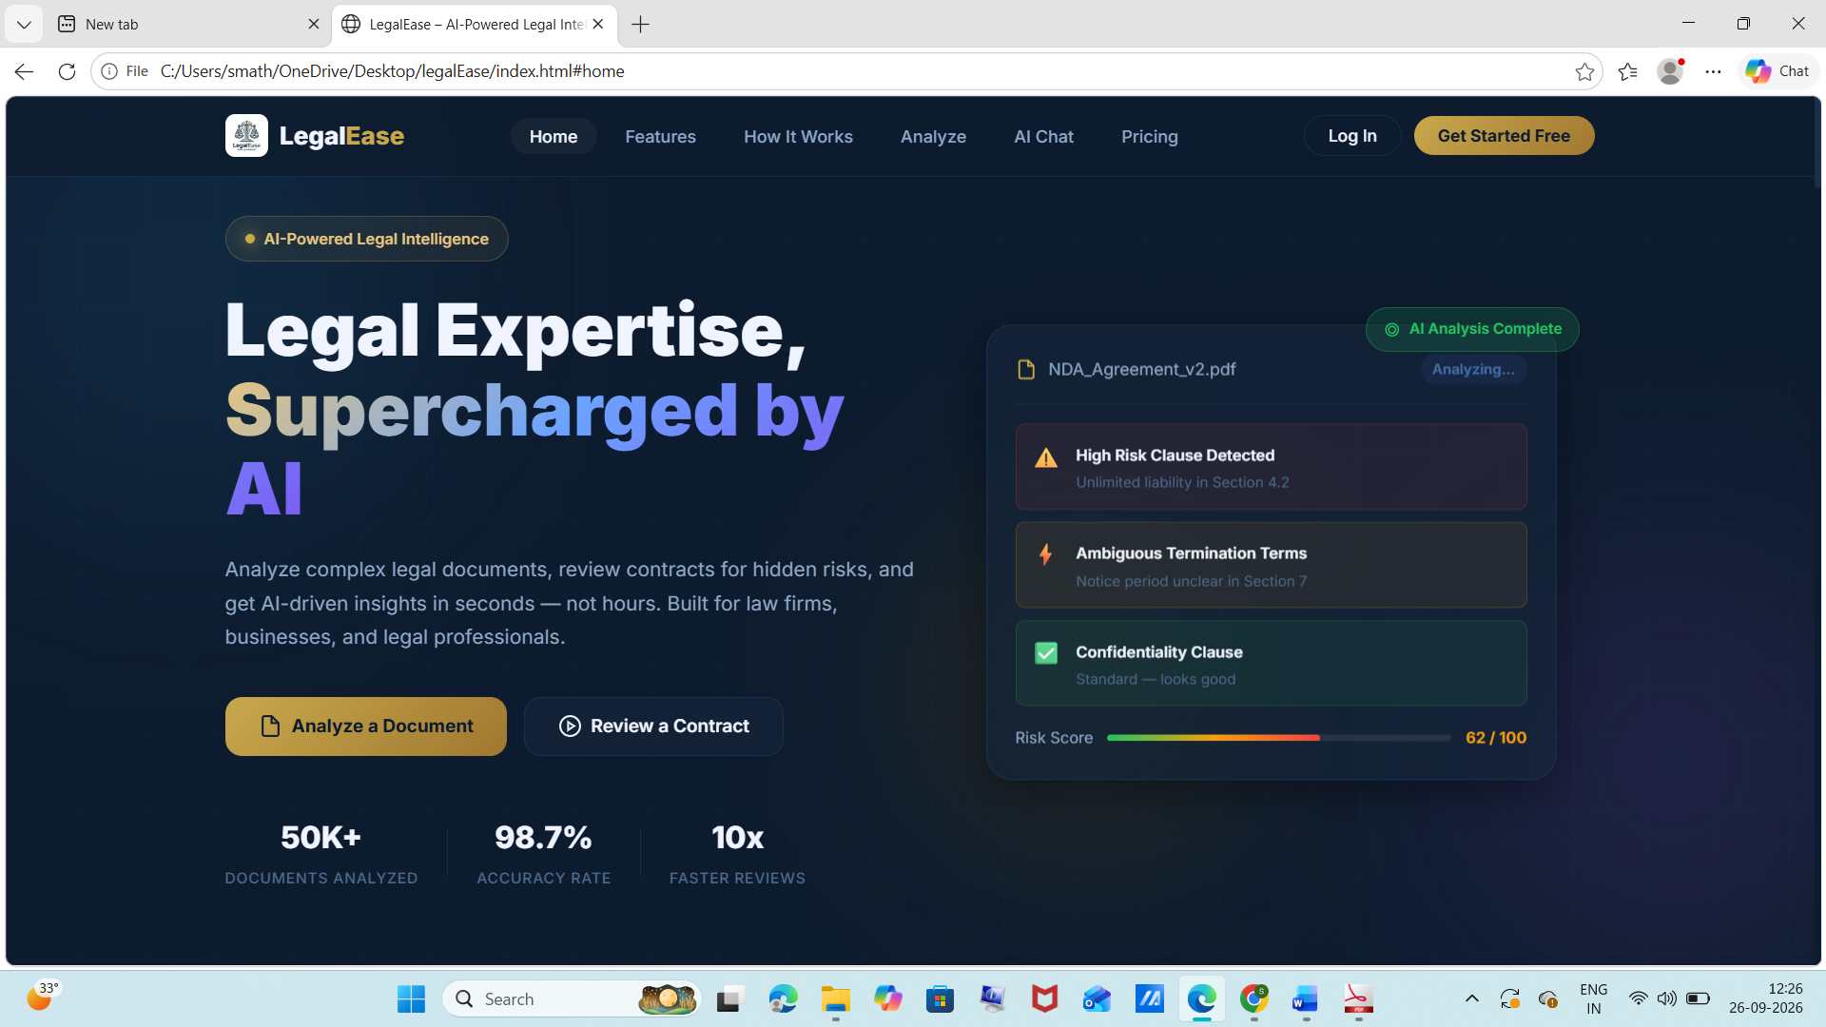
The primary landing page and main interface of LegalEase ('Legal Expertise, Supercharged by AI') serves as the central entry point for legal professionals and clients. It introduces an AI-powered legal intelligence platform designed to automate document evaluation, contract auditing, and risk detection.
- Hero Section & Value Proposition: Highlights high-efficiency metrics including 50K+ documents analyzed, a 98.7% accuracy rate, and 10x faster review speeds compared to manual legal processing.
- Primary Action Controls: Provides direct access buttons for 'Analyze a Document' and 'Review a Contract' to initiate automated document pipelines.
- Live AI Risk Assessment Preview: Displays a real-time risk scoring panel (Risk Score: 62/100) analyzing 'NDA_Agreement_v2.pdf', automatically flagging High Risk Clauses (Unlimited liability in Section 4.2), Ambiguous Termination Terms (Section 7), and verified Confidentiality Clauses.
Section 2: Module 1 / Feature Overview
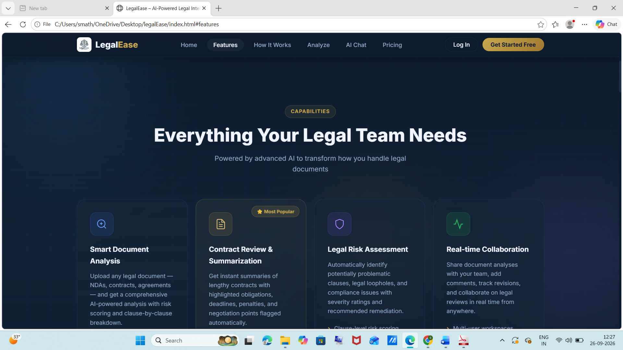
This module presents the core capabilities of the LegalEase system under the 'Everything Your Legal Team Needs' framework. It outlines the modular AI features tailored for legal document automation and analysis.
- Smart Document Analysis: Enables seamless document upload (NDAs, contracts, agreements) and generates comprehensive AI-driven analysis with risk scoring and clause breakdowns.
- Contract Review & Summarization (Most Popular): Extracts instant executive summaries from lengthy legal contracts, highlighting obligations, critical deadlines, penalties, and negotiation points.
- Legal Risk Assessment: Automatically identifies problematic clauses, legal loopholes, and compliance risks, delivering severity ratings alongside actionable remediation recommendations.
- Real-time Collaboration: Supports team-wide document analysis sharing, contextual comment threads, revision tracking, and real-time collaborative reviews.
Section 3: Module 2 / User Interface & Workflow
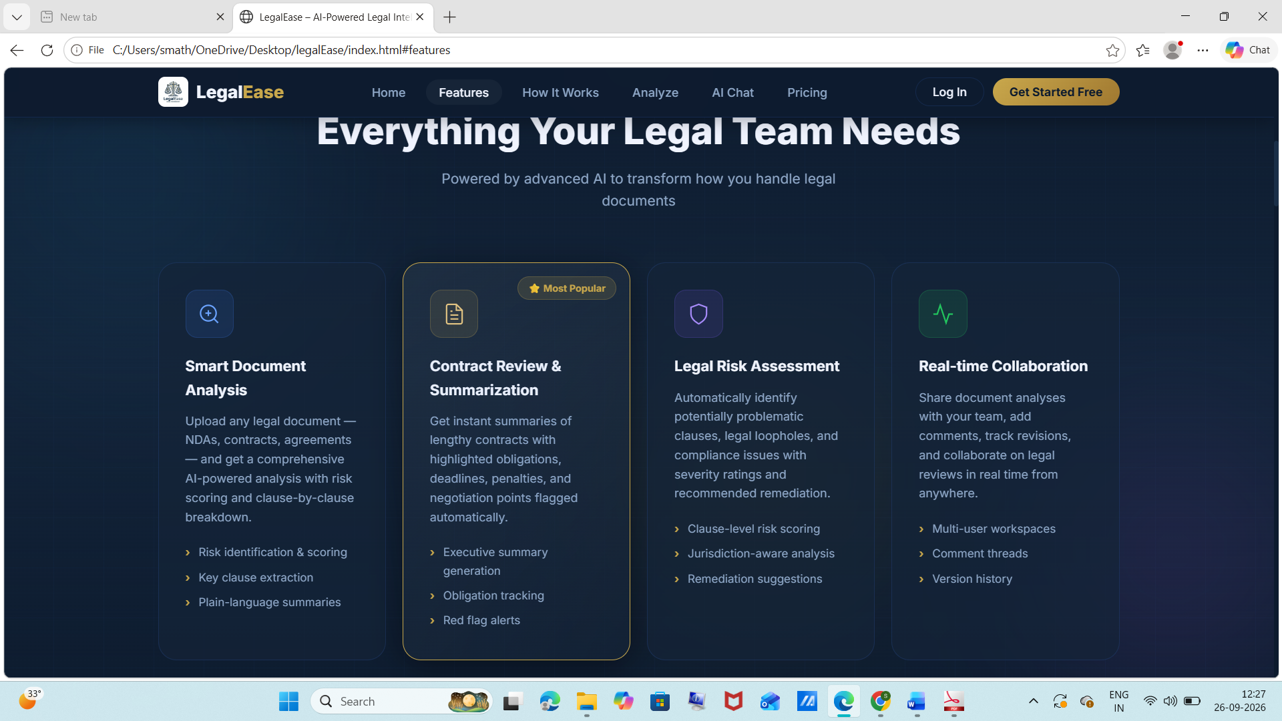
This section illustrates the interactive user workflow and feature card interactions, focusing on detailed operational capabilities within the Contract Review & Summarization module.
- Sub-Feature Functional Breakdown: Provides dedicated execution paths for Risk Identification & Scoring, Key Clause Extraction, and Plain-Language Summaries across all document types.
- Contract Management Workflow: Highlights specialized pipeline tasks such as Executive Summary Generation, Obligation Tracking, and Automated Red Flag Alerts.
- Jurisdiction & Compliance Engine: Enforces Clause-Level Risk Scoring, Jurisdiction-Aware Analysis, and automated Remediation Suggestions tailored to specific legal standard frameworks.
- Multi-User Workspace Integration: Includes shared workspace controls, threaded comment systems, and complete document version histories for enterprise governance.
Section 4: Module 3 / Case Processing & Data Handling
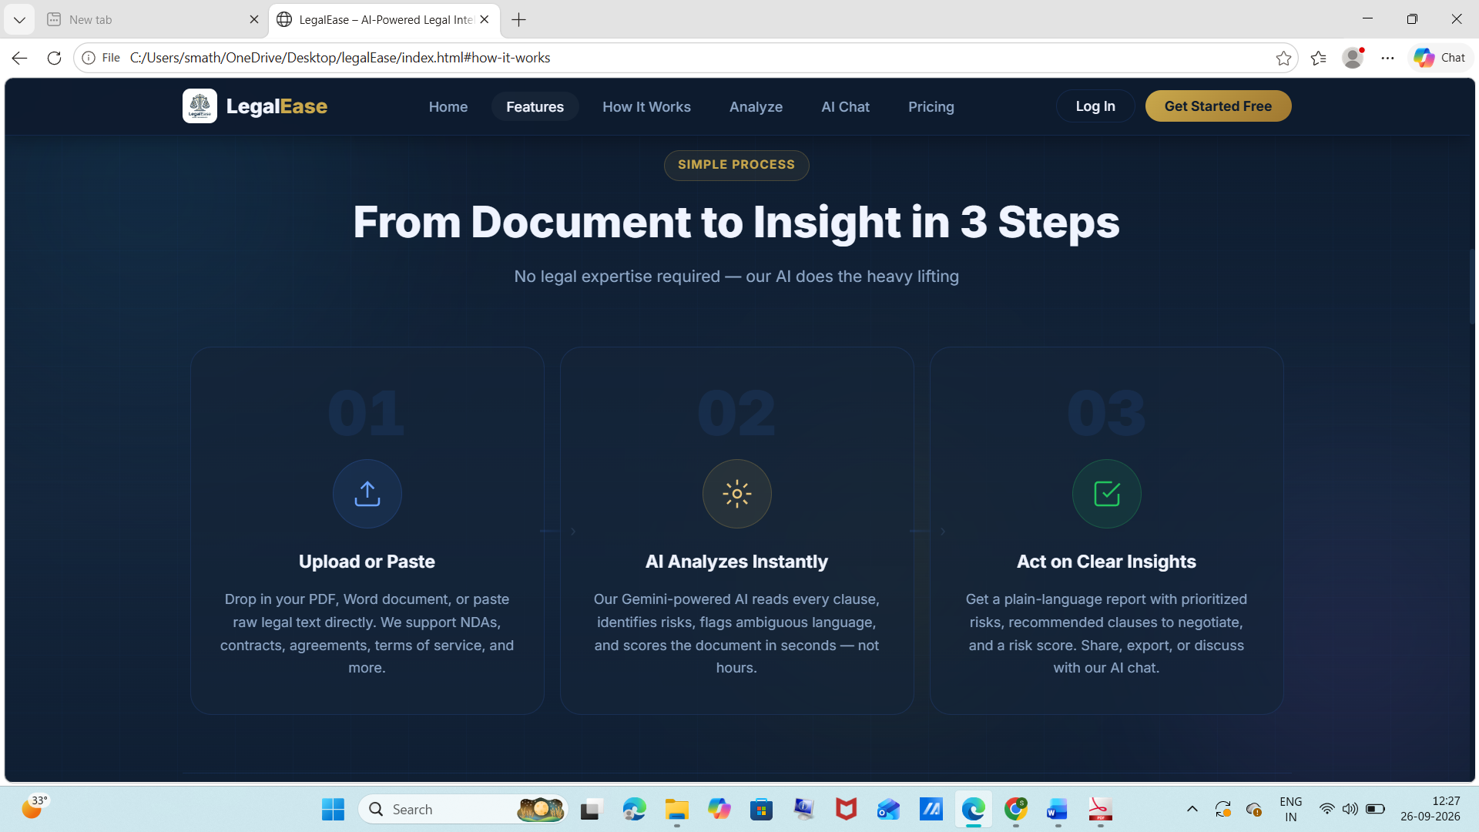
This module defines the 3-step data processing pipeline title 'From Document to Insight in 3 Steps', detailing how raw legal inputs are transformed into structured legal intelligence without requiring manual legal expertise.
- Step 01 - Upload or Paste: Accepts raw legal text or document uploads (PDF, Word) for NDAs, contracts, agreements, and terms of service.
- Step 02 - AI Analyzes Instantly: Leverages a Gemini-powered AI engine to read every clause, evaluate legal obligations, flag ambiguous phrasing, and compute numerical risk scores in seconds.
- Step 03 - Act on Clear Insights: Generates structured, plain-language legal reports with prioritized risk items, suggested clause modifications for negotiation, and direct integration with an interactive AI chat assistant.
Section 5: Module 4 / Dashboard & Analytics
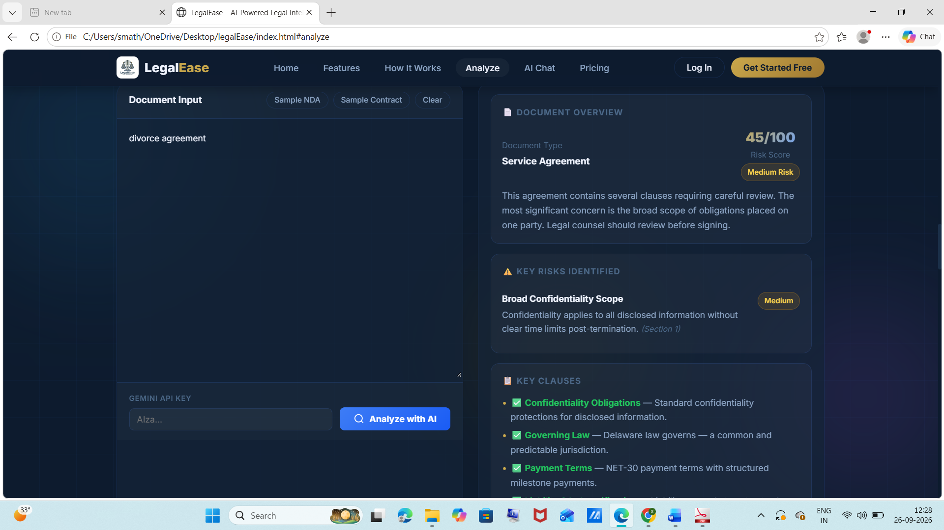
The Document Analysis & Risk Analytics Dashboard provides an interactive workbench for parsing legal documents, extracting key clauses, and reviewing automated risk evaluations.
- Document Input & API Configuration: Features a dedicated input panel supporting raw text entry (e.g., divorce agreements, service contracts), preset sample selectors (Sample NDA, Sample Contract), and Gemini API Key configuration.
- Document Overview & Risk Scoring: Computes an aggregate Risk Score (e.g., 45/100 - Medium Risk) for identified document types (Service Agreement), offering an executive summary of obligations and legal concerns.
- Key Risks Identification: Flags specific high/medium-risk clauses such as 'Broad Confidentiality Scope' where confidentiality terms lack post-termination time limits.
- Key Clauses Extraction: Categorizes and verifies standard clauses, including Confidentiality Obligations, Governing Law (e.g., Delaware law jurisdiction), and Payment Terms (e.g., NET-30 with structured milestones).
Section 6: Module 5 / Database & Case Tracking
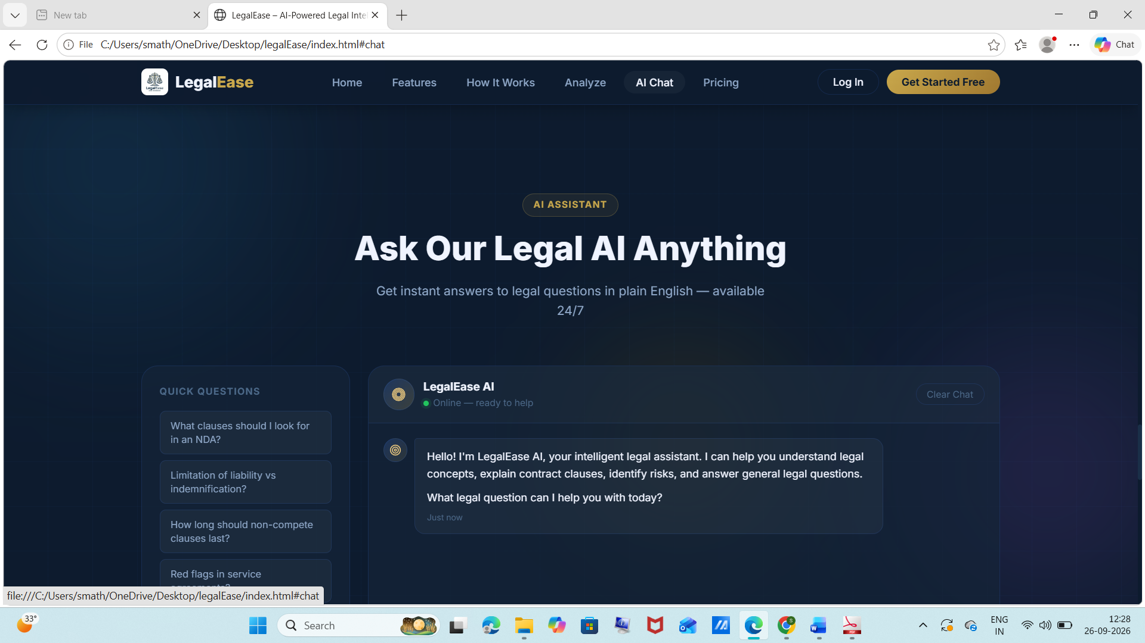
This section details the 'Ask Our Legal AI Anything' interactive assistant module, designed for dynamic case querying, legal research, and interactive clause explanations.
- Conversational Legal Assistant Interface: Provides an online 24/7 LegalEase AI chatbot capable of explaining complex legal concepts, interpreting contract clauses, and answering general legal queries.
- Quick Question Presets: Includes pre-configured legal query buttons such as 'What clauses should I look for in an NDA?', 'Limitation of liability vs Indemnification?', 'How long should non-compete clauses last?', and 'Red flags in service agreements'.
- Contextual Legal Guidance: Delivers plain-English responses to user prompts to support rapid decision-making and pre-litigation research.
Section 7: Module 7 / System Output & Reports
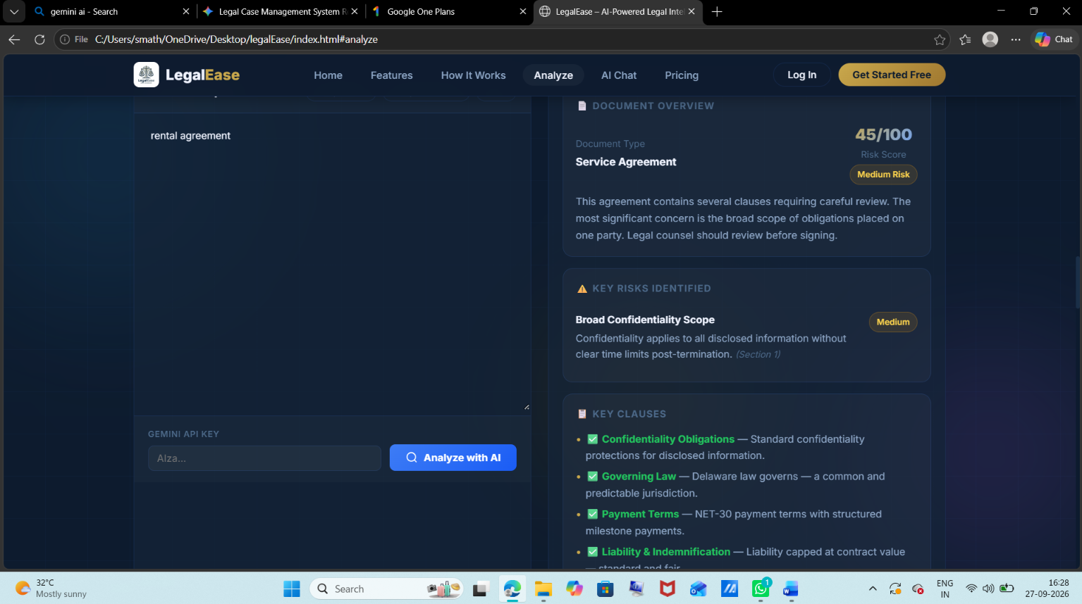
This module outlines the tiered system subscription plans, deployment options, and feature limits configured under the 'Simple, Transparent Pricing' framework.
- Starter Plan ($0/month): Tailored for individuals and small projects; includes 10 document analyses/month, 5 contract reviews/month, basic risk scoring, and plain-language summaries.
- Professional Plan ($49/month - Most Popular): Designed for legal professionals and growing teams; offers unlimited document analyses and contract reviews, advanced risk scoring, team collaboration for up to 5 users, and priority AI processing.
- Enterprise Plan ($199/month): Built for law firms and large organizations; features all Professional capabilities plus unlimited team members, custom AI fine-tuning, direct API access, and dedicated support.
Section 8: Module 8 / Final Review & Conclusion
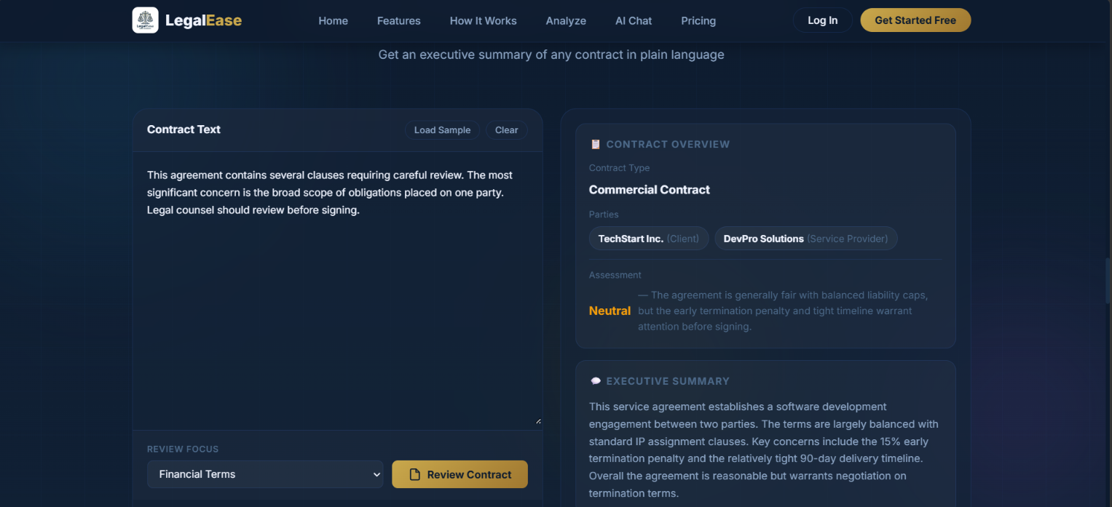
The final review stage summarizes the complete functional architecture of the Legal Case Management System (LegalEase), validating its end-to-end operational capabilities from initial document ingestion to AI-assisted risk scoring and report generation.
Formal Conclusion
The Legal Case Management System (TNSKILL Project - LegalEase) successfully integrates artificial intelligence into the legal documentation workflow. By automating risk assessment, clause extraction, contract review, and interactive legal querying, the platform drastically reduces document evaluation time while enhancing accuracy and risk mitigation. The system provides a scalable, enterprise-ready foundation for law firms, corporate legal departments, and legal professionals.

Github link
https://github.com/sanjaisanjai7040-dev/legalease.project

