

|  |  |  |  |
| --- | --- | --- | --- |
| **DEPARTMENT OF COMPUTER SCIENCE AND ENGINEERING**  **Domain Name : Applied Data Analysis**  **Project Title :** COVID Vaccines Analysis | | | |
| **1.** | **Name of the Student (s)** |  |
|  | |  |  |  |  | | --- | --- | --- | --- | | **S.No** | **Name of the Student** | **E-Mail ID** | **Phone No.** | | **1** | Balamurugan E | ebalamuruganbalamurugan@gmail.com | 8870556796 | | **2** | Karthisan M | [karthim978789@gmail.com](mailto:karthim978789@gmail.com) | 8754150560 | | **3** | Aravindhan P | Dcsearavind41@gmail.com | 6382750935 | | 4 | Thanigavel J | thanigavellovely@gmail.com | 7708345336 | | 5 | Sanjai S | Sanjaisanjaisanjai555@gmail.com | 9087943812 | | | |
| **2.** | **Name of the Guide** | : Ms.S.Suganya |
|  | **Department/ Designation** | : CSE**/**AP |
|  | **Institutional Address** | : Chettinad College of Engineering  and Technology  NH-67, Karur-Trichy Highway,  Puliyur CF, Karur |
|  | **Phone No. & Mobile No.** | : 6374527207 |

**Problem Definition :**

# COVID Vaccines Analysis:

The problem is to conduct an in-depth analysis of Covid-19 vaccine data, focusing on vaccine efficacy, distribution, and adverse effects. The goal is to provide insights that aid policymakers and health organizations in optimizing vaccine deployment strategies. This project involves data collection, data preprocessing, exploratory data analysis, statistical analysis, and visualization.

**BLOCK DIAGRAM :**

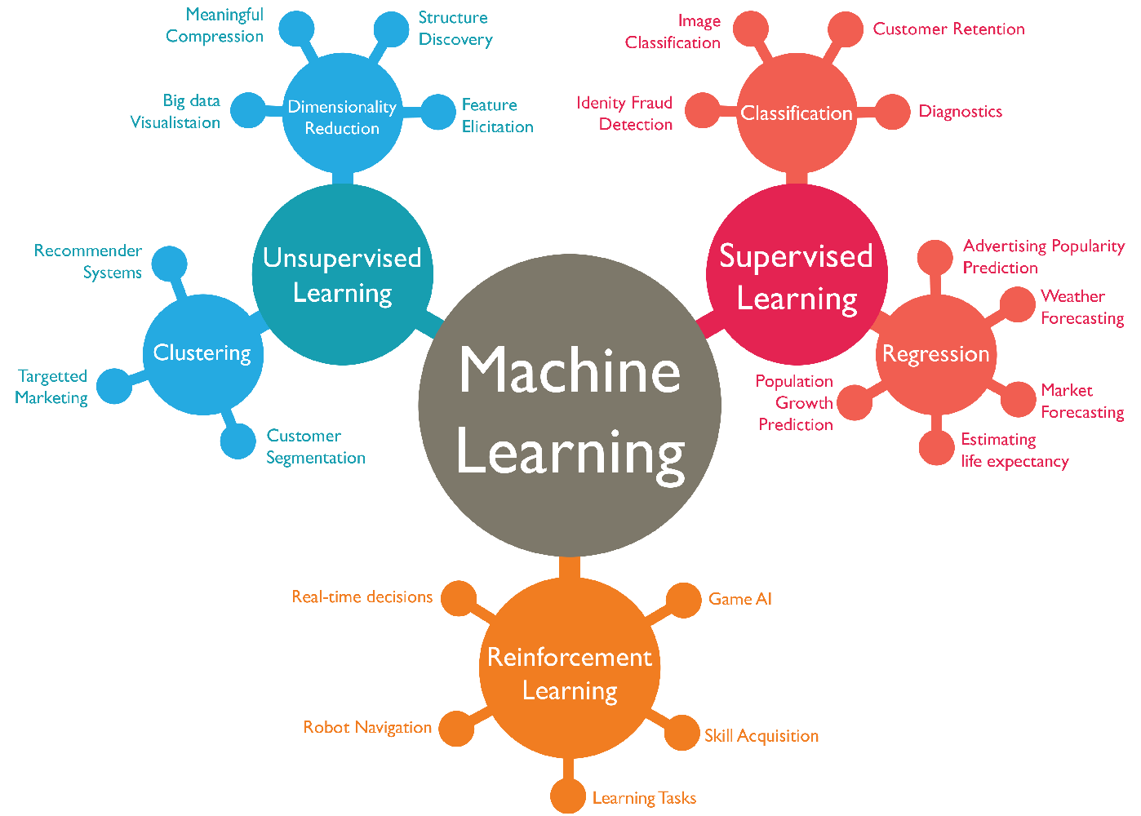

# Design Thinking:

## What is COVID Vaccines Analysis

1. Data Collection: Collect Covid-19 vaccine data from reputable sources like health organizations, government databases, and research publications.
2. Data Preprocessing: Clean and preprocess the data, handle missing values, and convert categorical features into numerical representations.
3. Exploratory Data Analysis(EDA): Explore the data to understand its characteristics, identify trends, and outliers.
4. Statistical Analysis: Perform statistical tests to analyze vaccine efficacy, adverse effects, and distribution across different populations.
5. Visualization: Create visualizations (e.g., bar plots, line charts, heatmaps) to present key findings and insights
6. Insights and Recommendations: Provide actionable insights and recommendations based on the analysis to assist policymakers and health organizations.

## PHASES of Using COVID Vaccines Analysis :

STATEMENT OF PROBLEM :

Our project will analyse the future report using current coronavirus data received from around the world. To do this, we use the concept of machine learning that you will know while reading later. Also India is running a vaccination campaign; our goal is to show in which state the vaccination is carried out and the percentage of people who are vaccinated through the graphic model.

# III. MODEL IMPLEMENTATION AND ANALYSIS:

# Our project involves the idea of machine learning. To process the data we've collected from around the world, use the concept of supervised machine learning to analyse the data and predict the future data-based situation.

**Supervised Learning:**

* Supervised learning is just an acknowledgement of the idea of learning by example. Our project is based on the same idea. We can use mapping based on input variables X and with the help of suitable algorithms we can get the output Y as a function of f(X). Y=f(X) For example, the given dataset is used to analyse how the data are connected to each other and based on the algorithm of the data, we arrive at future results.

**DATA VISUALISATION:**

To view our results or visualize the data, we obtain help from different maps, graphs, charts. These visualization tools make it easy for the reader to understand the model, trends or outliers in our project resultsThe tracking libraries we used for our project are- ● Matplotlib: low level, provides lots of freedom

● Pandas Visualization: easy to use interface, built on Matplotlib

● Seaborn: high-level interface, great default styles

● ggplot: based on R’s ggplot2, uses Grammar of Graphics

● Plotly: can create interactive plots