**IBM DATA ANALYTICS WITH COGNOS - GROUP4 PHASE II**

**1. Team Members :**

|  |  |  |  |  |  |  |  |  |  |  |  |  |  |  |  |  |  |  |  |  |  |  |  |  |  |
| --- | --- | --- | --- | --- | --- | --- | --- | --- | --- | --- | --- | --- | --- | --- | --- | --- | --- | --- | --- | --- | --- | --- | --- | --- | --- |
|  | |  |  |  |  | | --- | --- | --- | --- | | **S.No** | **Name of the Student** | **E-Mail ID** | **Phone No.** | | **1** | Thanigavel J | thanigavellovely@gmail.com | 7708345336 | | **2** | Karthisan M | [karthim978789@gmail.com](mailto:karthim978789@gmail.com) | 8754150560 | | **3** | Aravindhan P | Dcsearavind41@gmail.com | 6382750935 | | 4 | Balamurugan E | ebalamuruganbalamurugan@gmail.com | 8870556796 | | 5 | Sanjai S | Sanjaisanjaisanjai555@gmail.com | 9087943812 | |

**2. Name of the Guide** : Ms.Suganya

**Department /**

**Designation**  : CSE/AP

**Institutional Address**  : Chettinad College of Engineering and

Technology

**3. Project Title**  : COVID Vaccines Analysis

**4. Problem Statement**  :

# COVID Vaccines Analysis:

The problem is to conduct an in-depth analysis of Covid-19 vaccine data, focusing on vaccine efficacy, distribution, and adverse effects. The goal is to provide insights that aid policymakers and health organizations in optimizing vaccine deployment strategies. This project involves data collection, data preprocessing, exploratory data analysis, statistical analysis, and visualization.

**6.Block diagram**

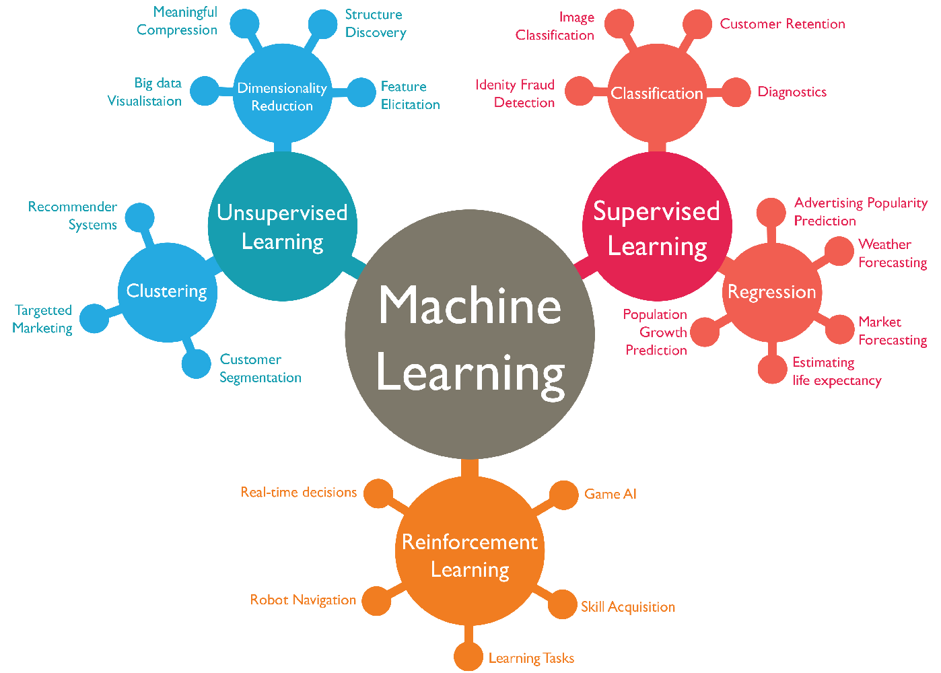

**7.Block diagram explanation :**

1. Data Collection: Collect Covid-19 vaccine data from reputable sources like health organizations, government databases, and research publications.
2. Data Preprocessing: Clean and preprocess the data, handle missing values, and convert categorical features into numerical representations.
3. Exploratory Data Analysis(EDA): Explore the data to understand its characteristics, identify trends, and outliers.
4. Statistical Analysis: Perform statistical tests to analyze vaccine efficacy, adverse effects, and distribution across different populations.
5. Visualization: Create visualizations (e.g., bar plots, line charts, heatmaps) to present key findings and insights
6. Insights and Recommendations: Provide actionable insights and recommendations based on the analysis to assist policymakers and health organizations.