Simulation of FDMA in MATHLAB date
Aim:
To simulate a Frequency Division Multiple Access (FDMA) system using MATLAB and analyze its communication performance in terms of channel bandwidth, data rate, and signal-to-noise ratio (SNR)
Objective 1
clc;
clear;
close all;

% User and Slot Configuration
Users = 1:8; % Total number of users
TotalSlots = 5; % Available TDMA slots

% Initialize slot allocation
Alloc = zeros(1, length(Users));

% Allocate slots to the first users
Alloc(1:TotalSlots) = 1;

% Identify blocked users
Blocked = 1 - Alloc;

% Display User-wise Slot Allocation
disp('User Wise Slot Allocation');

AllocationTable = table(Users', Alloc', ...
'VariableNames', {'User', 'Status'});

disp(AllocationTable);

% Create Figure
figure;

% Graph 1: Allocation per User
subplot(2,1,1);

stem(Users, Alloc, 'filled', 'LineWidth', 2);

title('TDMA Slot Allocation per User');
xlabel('User Index');
ylabel('Slot Status (1 = Allocated, 0 = Blocked)');

ylim([-0.2 1.2]);
xticks(Users);
grid on;

% Graph 2: System View
subplot(2,1,2);

plot(Users, Alloc, '-o', 'LineWidth', 2);
hold on;

plot(Users, Blocked, '-s', 'LineWidth', 2);

title('TDMA Slot Utilization Analysis');
xlabel('User Index');
ylabel('Status');

ylim([-0.2 1.2]);
xticks(Users);

legend('Allocated', 'Blocked', 'Location', 'best');
grid on;

hold off;
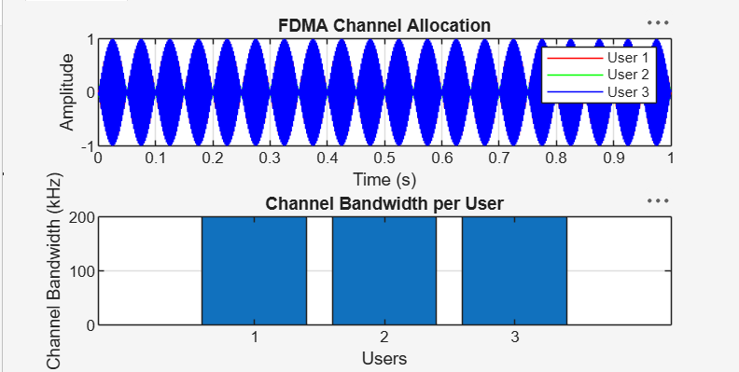

Objective 2
clc;
clear;
close all;

BW = 200; % Total Channel Bandwidth (kHz)
Users = 3; % Number of Users
M = 2; % BPSK Modulation

% Bandwidth allocated to each user
UserBW = BW / Users;

% Data rate for each user
DataRate = UserBW * log2(M);

% Data rate for all users
Rate = DataRate * ones(1, Users);

% Display results
disp('FDMA User Data Rate (kbps)');
disp([(1:Users)' Rate']);

% Plot bar graph
figure;
bar(1:Users, Rate);

xlabel('Users');
ylabel('Data Rate (kbps)');
title('FDMA Data Rate for Each User');
grid on;
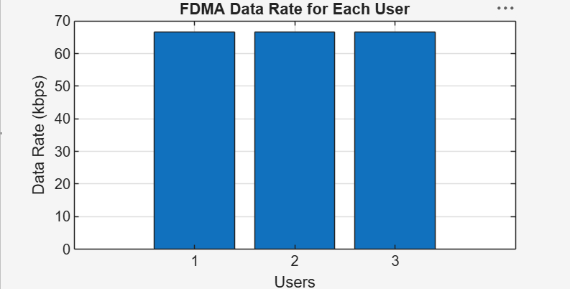

Objective 3
clc;
clear;
close all;

Ps = 1; % Signal Power (W)
Pn = [0.1 0.05 0.01]; % Noise Power for each user (W)
Users = 1:3; % Number of Users

% Calculate SNR in dB
SNR = 10 * log10(Ps ./ Pn);

% Display results
disp('User Noise Power (W) SNR (dB)');
disp([Users' Pn' SNR']);

% Plot SNR
figure;
bar(Users, SNR);

xlabel('Users');
ylabel('SNR (dB)');
title('Signal-to-Noise Ratio of FDMA Users');

grid on;

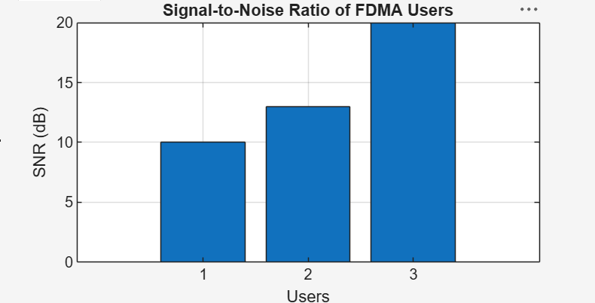
Result:
1. The FDMA system was successfully simulated by allocating separate frequency channels to three users, and the channel bandwidth assigned to each user was determined. 2. The data rate achieved by each user was successfully calculated based on the allocated channel bandwidth, demonstrating equal transmission capacity for all users. 3. The Signal-to-Noise Ratio (SNR) for different users was successfully evaluated, showing that higher SNR values provide better communication quality and reliable data transmission.

