Implementing TDMA Slot Allocation in GSM
AIM:
To implement TDMA (Time Division Multiple Access) slot allocation in GSM using MATLAB and analyze system performance in terms of time slot duration, frame utilization, and number of allocated slots.
Objective 1
clc;
clear;
close all;

FrameTime = 4.615; % Frame Time (ms)
Slots = 8; % Number of Time Slots

% Duration of each slot
SlotDuration = FrameTime / Slots;

% Time vector for 8 slots
t = 0:SlotDuration:(FrameTime - SlotDuration);

% Create figure
figure;

% TDMA Time Slot Structure
subplot(2,1,1);
stem(t, ones(size(t)), 'filled', 'LineWidth', 1.5);
title('TDMA Time Slot Structure');
xlabel('Time (ms)');
ylabel('Slot Level');
grid on;

% Continuous View of Slot Allocation
subplot(2,1,2);
plot(t, ones(size(t)), '-o', 'LineWidth', 1.5);
title('Continuous View of Slot Allocation');
xlabel('Time (ms)');
ylabel('Slot Presence');
grid on;
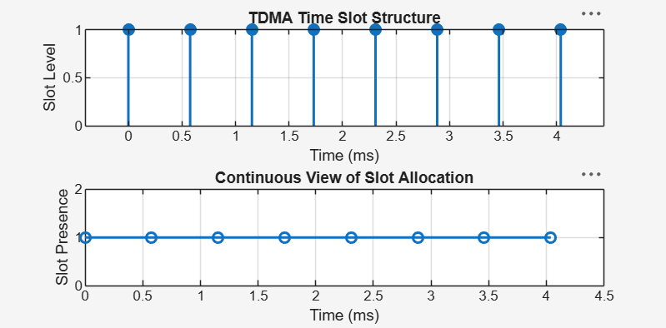

Objective 2
clc;
clear;
close all;

% GSM Frame Slot Configuration
TotalSlots = 8;
AllocatedSlots = 6;

% Calculate Free Slots
FreeSlots = TotalSlots - AllocatedSlots;

% Calculate Frame Utilization
Utilization = (AllocatedSlots / TotalSlots) * 100;

% Display Results
fprintf('Total Slots : %d\n', TotalSlots);
fprintf('Allocated Slots : %d\n', AllocatedSlots);
fprintf('Free Slots : %d\n', FreeSlots);
fprintf('Frame Utilization: %.2f%%\n', Utilization);

% Create Figure
figure;

% Graph 1: Allocated vs Free Slots
subplot(2,1,1);
plot([1 2], [AllocatedSlots FreeSlots], '-o', ...
'LineWidth', 2, 'MarkerSize', 8);

title('GSM Frame Utilization (Allocated vs Free)');
xlabel('Slot Type Index (1 = Allocated, 2 = Free)');
ylabel('Number of Slots');

xticks([1 2]);
xticklabels({'Allocated', 'Free'});
grid on;

% Graph 2: Pie Chart
subplot(2,1,2);
pie([AllocatedSlots FreeSlots]);

title('Slot Distribution in GSM Frame');
legend('Allocated', 'Free', 'Location', 'best');

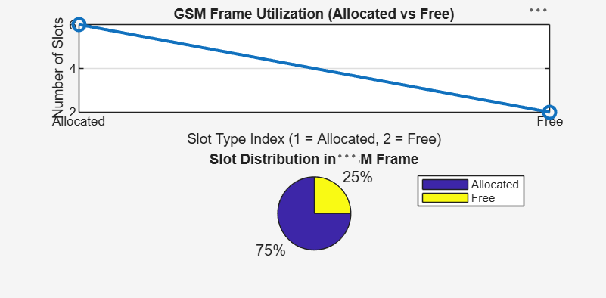

Objective 3
clc;
clear;
close all;

% User and Slot Configuration
Users = 1:8; % Total number of users
TotalSlots = 5; % Available TDMA slots

% Initialize slot allocation
Alloc = zeros(1, length(Users));

% Allocate slots to the first users
Alloc(1:TotalSlots) = 1;

% Identify blocked users
Blocked = 1 - Alloc;

% Display User-wise Slot Allocation
disp('User Wise Slot Allocation');

AllocationTable = table(Users', Alloc', ...
'VariableNames', {'User', 'Status'});

disp(AllocationTable);

% Create Figure
figure;

% Graph 1: Allocation per User
subplot(2,1,1);

stem(Users, Alloc, 'filled', 'LineWidth', 2);

title('TDMA Slot Allocation per User');
xlabel('User Index');
ylabel('Slot Status (1 = Allocated, 0 = Blocked)');

ylim([-0.2 1.2]);
xticks(Users);
grid on;

% Graph 2: System View
subplot(2,1,2);

plot(Users, Alloc, '-o', 'LineWidth', 2);
hold on;

plot(Users, Blocked, '-s', 'LineWidth', 2);

title('TDMA Slot Utilization Analysis');
xlabel('User Index');
ylabel('Status');

ylim([-0.2 1.2]);
xticks(Users);

legend('Allocated', 'Blocked', 'Location', 'best');
grid on;

hold off;
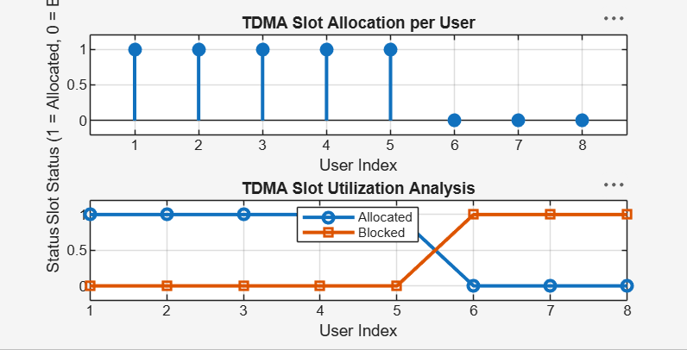
Result:
1. The time slot duration in the GSM TDMA frame was successfully calculated, confirming equal division of the frame into fixed time intervals. 2. The frame utilization was effectively analyzed, showing the proportion of allocated and free slots in the TDMA system. 3. The slot allocation per user was successfully implemented, demonstrating that limited slots are assigned to users while excess users are blocked due to resource constraints.

