**Pewlett-Hackard-Analysis**

**Overview of the analysis:**

Performing Pewlett-Hackard-Analysis to find how many employees are going to retirement and who will retired from which department with employee title.

**Results:**

* Following image show retiring_titles.csv. from this deliverable1 analyze following-
* More than 50000 employees with title as a senior engineer or senior staff are going to retire.
* We can say that company have young manager staff because only two managers in retirement list.

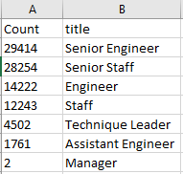

* Following image show mentorship_eligibilty.csv. from this deliverable2 analyze following:-

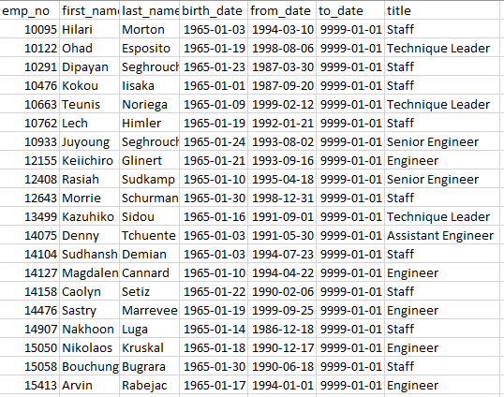

* We selected current employees who born in year 1965 for mentorship programme.
* Total 1549 employees selected for mentorship programme from different department with different title.

**Summary:**

* + In Pewlett-Hackard database especially senior staff and senior engineer position need to be filled with more employees.
  + Total 1549 qualified employees for mentoring next generation for Pewlett Hackard.
* In our analysis additionally we can add following table for more impact
* We can create dep_retire table to count employees who are ready for retirement by department.