**PyBer_Analysis**

**Overview of the analysis:**

The main objective behind analysis is find the average fare by ride and by driver for each type of city and also find fare for each city type for day by day and week by week.

**Results:**

* Results from summary data frame as follow: -

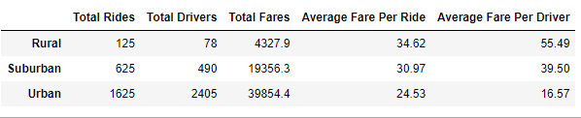

* Obviously highest rides count in urban city due to more drivers compare to suburban and rural cities.
* Also, highest total fares in urban cities due to more rides.
* Average fare per ride and average fare per driver is high in rural cities because of few available drivers.
* The main conclusion is that ride is expensive in rural cities compare to suburban and urban cities.
* Results from summary data frame as follow: -

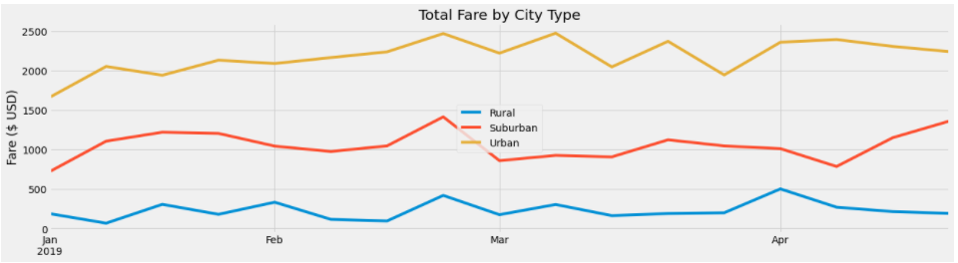

From above multi-line chart we conclude following:

* Urban cities have 3 times more total fare compare to rural cities and approximately double fare compare to suburban cities for between dates "2019-01-01" to "2019-04-28" due to more rides and more available drivers.

**Summary:**

Based on above analysis following recommendations requested to CEO :-

1. Hire more drivers in rural and suburban cities to reduce average fare by driver.
2. Increase total rides in rural and suburban cities to reduce average fare by ride.
3. More drivers and more rides in rural and suburaban cities also increase total fares.