**Kickstarting With Excel**

**Overview of Project:-**

Performing analysis on kickstarter dataset based on different factor and organize, sort and visualize data and results to make louise campaign successful.

**Analysis and Challenges: -**

Analysis: -

Performing following analysis to fulfill project objective:-

1. First analysis for outcome based on launch date means how many campaigns successful based on time (particular year and month). Following images shows the outcome analysis based on launch date.

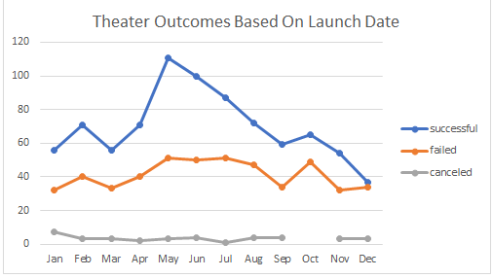

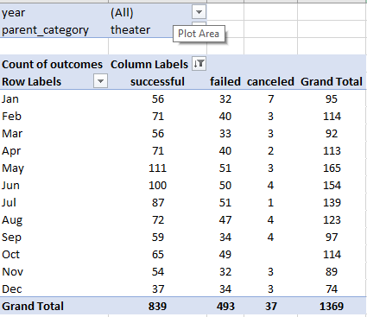

1. Second analysis for outcome based on goal. It shows how much possibility for campaign to be a successful based on funding amount.

Following images shows analysis result.

Challenges: -

I faced following challenges during analysis.

* Use time conversion function and create two more column to convert unix timestamp in to readable time.
* Categorized goal amount to performing outcome analysis based on goal date.
* Use TEXT function to separate “month” and use YEAR function to separate “year” in different column to performing outcome analysis based on launch date.
* Rearrange goal row in pivot table as per requirement by moving up and down cell.

**Results: -**

* Following conclusions based on Theater Outcomes by Launch Date

1. Theater campaign more successful in summer time specially in MAY and JUNE months due to good weather and school vacation for childerns.
2. Almost 55% theater campaign successful.

* Following conclusions based on Outcomes based on goal

1. There is no any canceled campaign for “plays” subcategory.
2. More hance for campaign successful if goals amount is less.

* limitations of this dataset: -
* currency field in kickstarter dataset need to single country currency instead of multiple country currency for accurate and perfect analysis.
* Possible tables and/or graphs that we could create: -

Here we can also create pivot table and pivot chart for our outcome analysis based on country and based on pledge amount.