A SMART WRIST DEVICE FOR REAL TIME HEALTH MONITORING OF ELDERS

INTERNET OF THINGS (IOT)
CSE4011
FINAL REPORT


UNDER THE GUIDANCE OF
Dr. Prashanth Rajam

Abstract:
With the increasing elderly population worldwide, there is a growing need for effective, real-time health monitoring solutions that support independent living while ensuring timely medical intervention. This project presents the development of a smart wrist device designed specifically for real-time health monitoring of elders. The device integrates various sensors to continuously track vital parameters such as heart rate, blood pressure, oxygen saturation (SpO₂), and physical activity levels. It features wireless communication capabilities to transmit data to a mobile application or cloud platform, enabling caregivers and healthcare providers to access live updates and historical health records. In case of abnormal readings, the system automatically triggers alerts to designated emergency contacts. Designed for ease of use, comfort, and reliability, this smart wrist device aims to enhance the quality of life for elders by promoting proactive health management, reducing hospital visits, and enabling rapid response to medical emergencies. Future improvements include the integration of AI-driven predictive analytics for early detection of health anomalies.

Introduction:
The growing prevalence of chronic diseases and the need for continuous health monitoring highlight the importance of accessible and effective health tracking solutions. Existing wearable devices often lack comprehensive monitoring capabilities and fail to provide timely medication reminders, limiting their utility for individuals managing chronic conditions. Furthermore, there is a need for seamless integration with mobile platforms to enable real-time notifications and alerts, enhancing user engagement and adherence to health management protocols.

Background:
As the global population ages, the demand for efficient and continuous health monitoring solutions has become more critical than ever. Elders are more vulnerable to chronic illnesses, sudden health deteriorations, and medical emergencies, which often require timely intervention. Traditional methods of healthcare monitoring, such as periodic checkups or manual health tracking, are often insufficient to detect early signs of health complications. Moreover, many elderly individuals prefer to maintain their independence, making it essential to develop non-intrusive, user-friendly technologies that support real-time health monitoring without constant caregiver supervision. Wearable health technologies, particularly smart wrist devices, have emerged as a promising solution. These devices can continuously monitor vital signs such as heart rate, blood pressure, blood oxygen levels, and physical activity, providing crucial health insights.

Problem Definition:
Elderly individuals are at a higher risk of health-related issues such as cardiac problems, respiratory complications, and sudden falls, which often require immediate medical attention. Traditional healthcare systems primarily rely on periodic assessments or emergency room visits, which may delay critical intervention. Many elders live independently, making continuous, in-person monitoring by caregivers impractical and costly. Furthermore, existing wearable health devices are often not tailored specifically to the unique needs of elderly users, such as ease of use, comfort, reliability, and emergency alert capabilities. There is a clear need for a smart, real-time health monitoring solution that can continuously track vital signs, detect abnormalities, and instantly alert caregivers or medical personnel. Such a device must be lightweight, easy to use, non-intrusive, and capable of reliable wireless communication to ensure that elders receive the assistance they need promptly, thereby improving their safety, health outcomes, and overall quality of life.

Objectives of the project:
- Continuous Health Monitoring:
To enable 24/7 tracking of vital signs such as heart rate, blood pressure, blood oxygen level (SpO₂), and physical activity.
- Early Detection of Health Issues:
To identify abnormal health patterns early and alert caregivers or medical professionals promptly.
- Emergency Response System:
To provide an automatic alert mechanism that notifies emergency contacts or healthcare providers during critical health events.
- User-Friendly Design:
To create a comfortable, lightweight, and easy-to-use device that meets the specific needs of elderly users.
- Wireless Communication:
To ensure seamless real-time data transmission to smartphones, cloud storage, or healthcare systems for remote monitoring.
- Data Recording and Analysis:
To store and analyze historical health data for long-term health management and doctor consultations.
Scope of the project:
This project focuses on the design and development of a smart wrist device specifically tailored for real-time health monitoring of elderly individuals. The device will integrate various biosensors to continuously measure key health parameters such as heart rate, blood pressure, blood oxygen level (SpO₂), body temperature, and physical activity. It will feature wireless communication capabilities (such as Bluetooth or Wi-Fi) to transmit the collected data to a connected smartphone application or cloud server for real-time monitoring by caregivers and healthcare providers. The scope includes developing an intuitive user interface for elders, designing an emergency alert system to notify caregivers during critical health events, and ensuring that the device is lightweight, comfortable, durable, and easy to use.
Methodology:
1. Plan: Decide what health features to track (e.g., heart rate, blood pressure).
2. Design: Create a wearable device with sensors and a display.
3. Build: Assemble the device using Arduino and other components.
4. Test: Check if the device works correctly and accurately tracks health data.
5. Improve: Make changes based on user feedback and testing results.
6. Deploy: Give the device to elders to use and provide support

Hardware tools:
- Arduino Uno
- LCD
- Max30102 Sensor
- RTC Module
- HC05 Bluetooth Module
- Power Supply
- PCB
- Connecting wires
Software Tools:
- Arduino IDE
- IDLE
- Arduino-C language

Functionalities of the components:
Hardware Components:
- Arduino Uno:

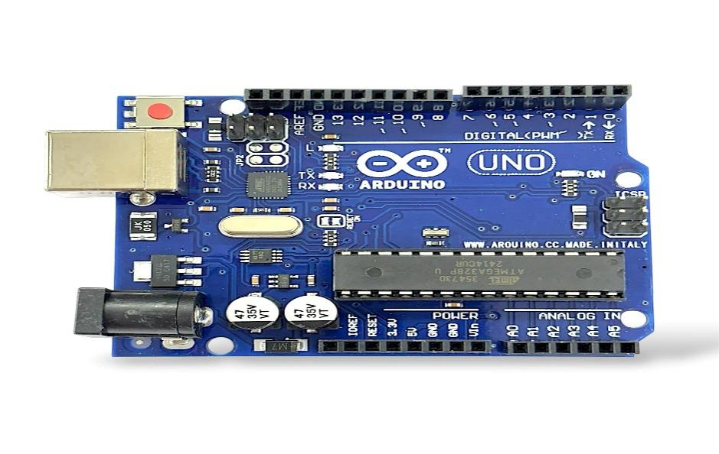
Fig1: Arduino Uno
- The Arduino Uno is one of the most popular and beginner-friendly microcontroller boards used for building electronics projects. It is based on the ATmega328P microcontroller chip.The Arduino Uno is a popular open-source microcontroller board that utilizes the ATmega328P microchip. It provides a versatile and powerful platform for a range of electronics projects, spanning from simple LED blinking demonstrations to intricate IoT systems. The board includes 14 digital I/O pins, six analog input pins, a 16 MHz quartz crystal, a USB interface, a power jack, and a reset button, making it suitable for both novices and experienced users. The straightforward programming environment, the Arduino IDE, enables users to write, upload, and execute code with ease.

- LCD:
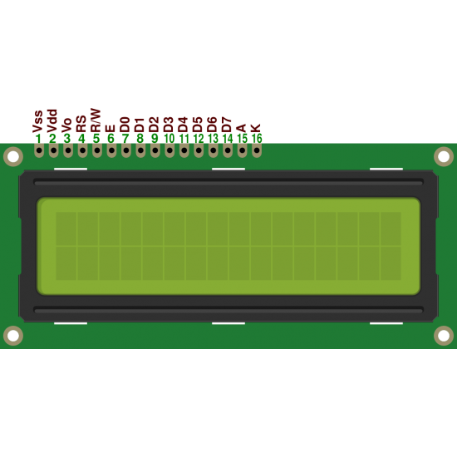
Fig2: Lcd
An LCD (Liquid Crystal Display) is a flat-panel display technology commonly used in electronic devices to visually present information such as text, numbers, and simple graphics. In microcontroller-based projects like those using Arduino, an LCD is often used to show real-time data from sensors, providing users with an immediate and clear way to view important information. One of the most popular types is the 16x2 LCD, which can display 16 characters per line on two lines. LCDs are energy-efficient, lightweight, and relatively easy to interface with microcontrollers using libraries like the Arduino Liquid Crystal library. In health monitoring projects, an LCD can display vital signs such as heart rate, blood pressure, and oxygen saturation, allowing both users and caregivers to quickly understand the elder's current health status without needing a separate computer or mobile device.

3.Max30102:

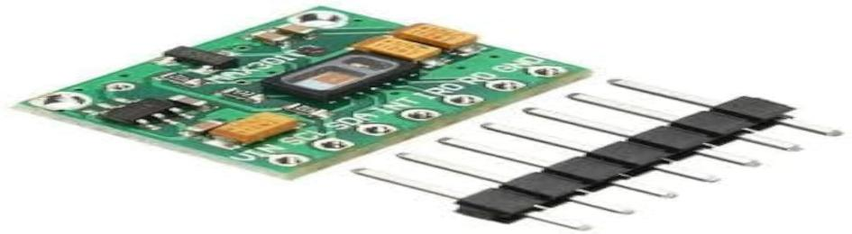
Fig3:Max30102

The MAX30102 is an integrated pulse oximeter and heart-rate sensor module designed for wearable health monitoring applications. It combines two LEDs (one red and one infrared), a photodetector, optical elements, and low-noise electronics all in a compact package. The sensor measures oxygen saturation (SpO₂) levels and heart rate by analyzing how light is absorbed as it passes through blood vessels in the skin. It operates at a low power level, making it ideal for battery-powered devices like smartwatches and fitness bands. The MAX30102 communicates with microcontrollers like Arduino via the I²C protocol, allowing for easy integration into real-time health monitoring systems. Its small size, high accuracy, and energy efficiency make it a perfect component for projects focused on elderly health tracking and wearable technology.
4.HC05 Bluetooth:
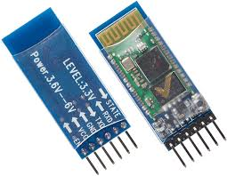
Fig4:HC05 Bluetooth

The HC-05 Bluetooth module is a popular and cost-effective wireless communication module widely used in electronics projects. It is designed for Bluetooth 2.0 + EDR (Enhanced Data Rate) and can establish both master and slave connections, allowing devices to communicate over short distances (typically up to 100 meters). The module operates on a voltage range of 3.3V to 5V and can be easily integrated with microcontroller boards like Arduino. The HC-05 is commonly used for wireless communication in various applications, including remote control systems, data transfer between devices, and wireless health monitoring systems. Its easy-to-use serial interface (UART) and ability to connect with smartphones, tablets, and other Bluetooth-enabled devices make it an ideal choice for projects that require data exchange or remote control functionality. The module is popular in DIY electronics and prototyping due to its affordability and simplicity.
5.Power supply:
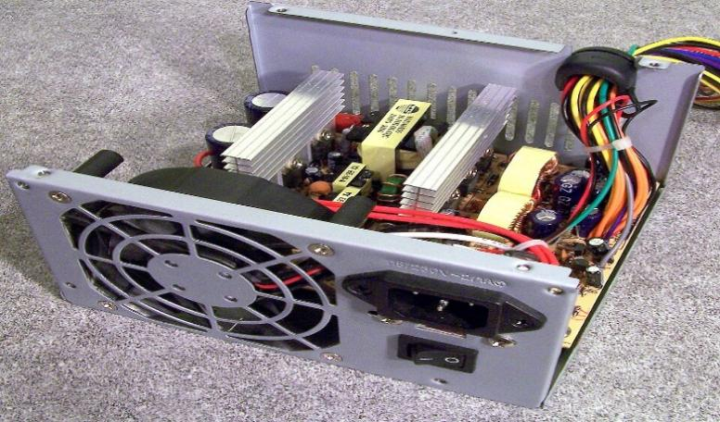
The power supply for the Arduino Uno is crucial for ensuring the board operates reliably during a project. The Arduino Uno can be powered in several ways, including through the USB connection, which provides a 5V power input directly from a computer or power bank, or via the DC power jack (7-12V), which supplies power through an external adapter. The board also has an onboard voltage regulator that ensures the proper voltage levels are supplied to the ATmega328P microcontroller, sensors, and other components connected to the board. Additionally, the Arduino Uno has a 5V pin and a 3.3V pin for powering external components that require specific voltage levels. This flexibility allows for both portable and stationary applications in various electronic projects, making it an excellent choice for systems like health monitoring devices, where continuous power is essential for accurate data collection and real-time operation.
6.Connecting wires:

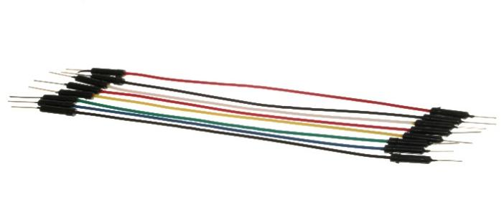
Fig6: connecting wires

In an Arduino-based project, connecting wires are essential for linking the Arduino board with various components, such as sensors, actuators, and power sources. These wires, typically jumper wires, come in two types: male-to-male and female-to-male. Male-to-male jumper wires are used when connecting Arduino pins to breadboards or other male header pins, while female-to-male jumper wires are used when connecting the Arduino to components with female headers. The wires ensure reliable electrical connections, allowing data and power to flow between the microcontroller and peripheral devices. The standard wire gauge used for Arduino projects is 22 AWG, but the length of the wires can vary depending on the project setup. Properly choosing and arranging connecting wires is crucial for preventing loose connections or short circuits, ensuring the smooth operation of the entire system.
7. RTC Module:

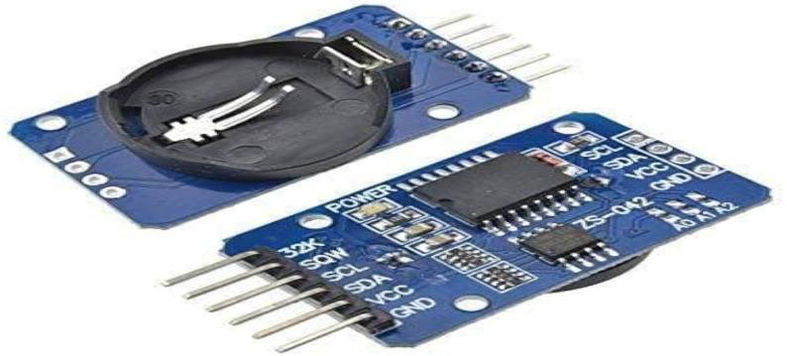
Fig7: RTC Module
The RTC (Real-Time Clock) Module is a key component in many electronics projects that require time and date tracking. Unlike regular microcontrollers, which may lose track of time when powered off or reset, the RTC module is designed to keep accurate time even when the main system is powered down. It uses a small, integrated battery (usually a coin-cell) to maintain its clock, ensuring that the time is preserved continuously. RTC modules, such as the popular DS3231 or DS1307, are commonly used in applications like logging data with timestamps, scheduling tasks, and time-based events. In the context of health monitoring systems, an RTC module can be used to record the exact time and date when health parameters, such as heart rate or blood pressure, are measured. This helps in maintaining accurate historical records for health analysis and tracking trends over time.

Software Component:
- Arduino IDE:
The Arduino Integrated Development Environment (IDE) is a software platform that provides everything needed to program Arduino boards, making it one of the most user-friendly environments for developing embedded applications. It allows users to write, compile, and upload code to Arduino boards with ease. The IDE supports a simplified programming language based on C/C++, enabling both beginners and advanced users to create various applications. The interface consists of a code editor, a compiler for checking errors, and a serial monitor for testing and debugging. The Arduino IDE also includes a wide range of libraries, which simplify interfacing with sensors, motors, and other components, significantly speeding up development. It is compatible with multiple operating systems, including Windows, macOS, and Linux, and is open-source, meaning users can customize and extend its features. The ease of use and versatility of the Arduino IDE have made it a fundamental tool for makers, engineers, and hobbyists worldwide.
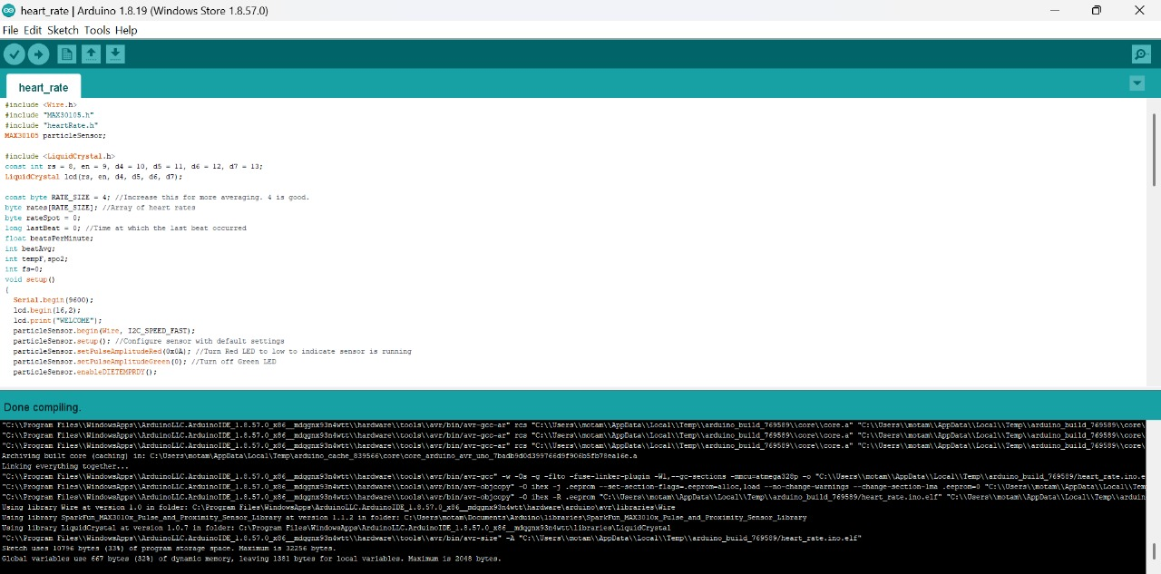

BLOCK DIAGRAM:
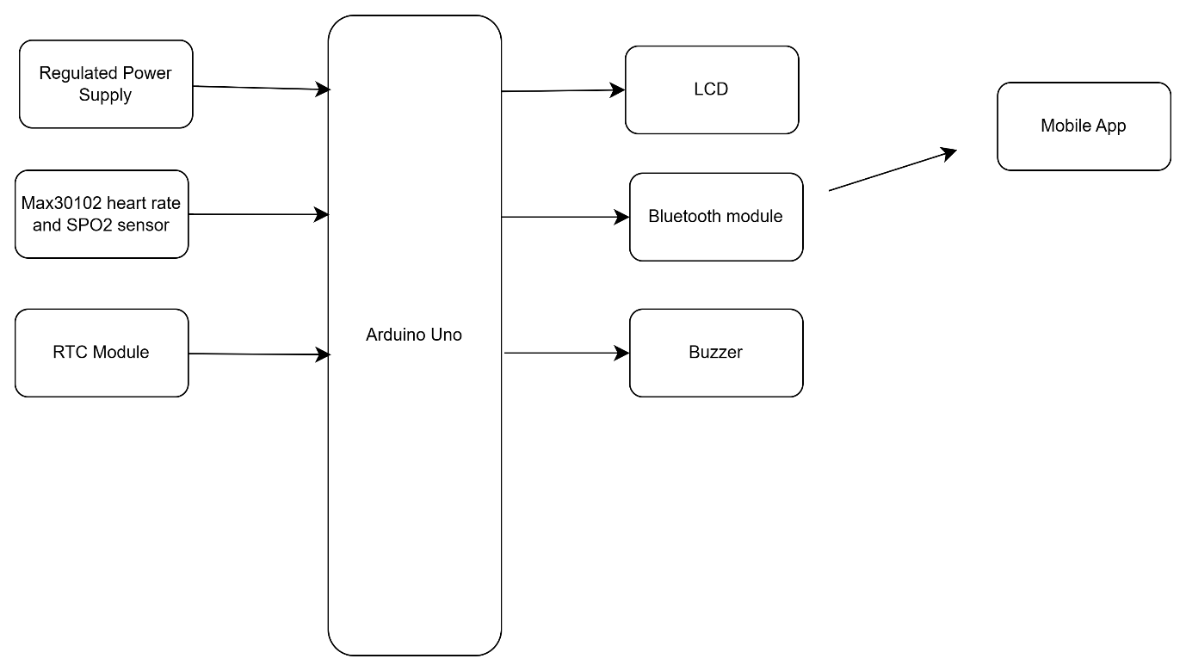
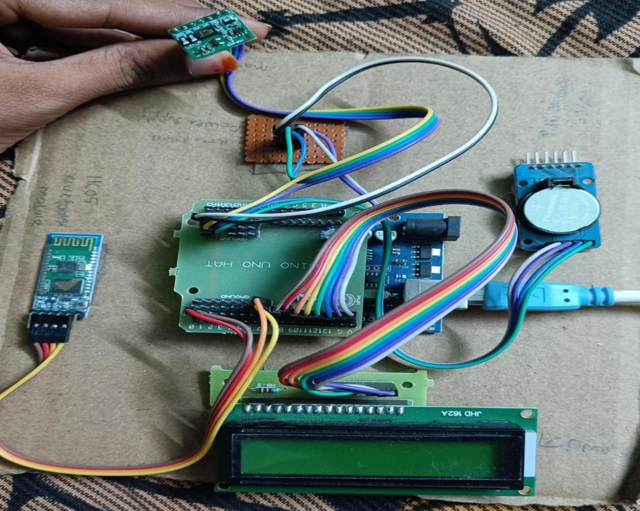

VISUALIZATION:
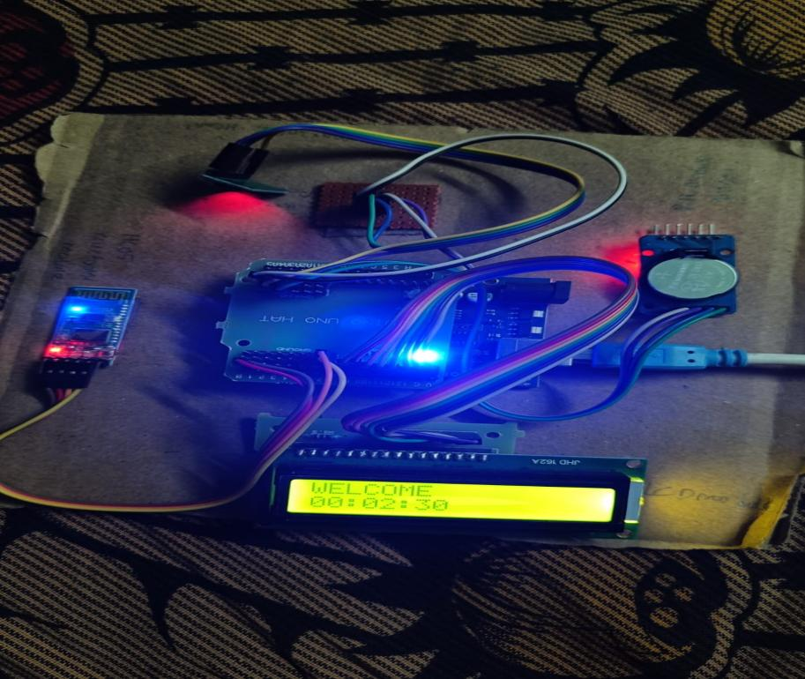
Fig1: welcome

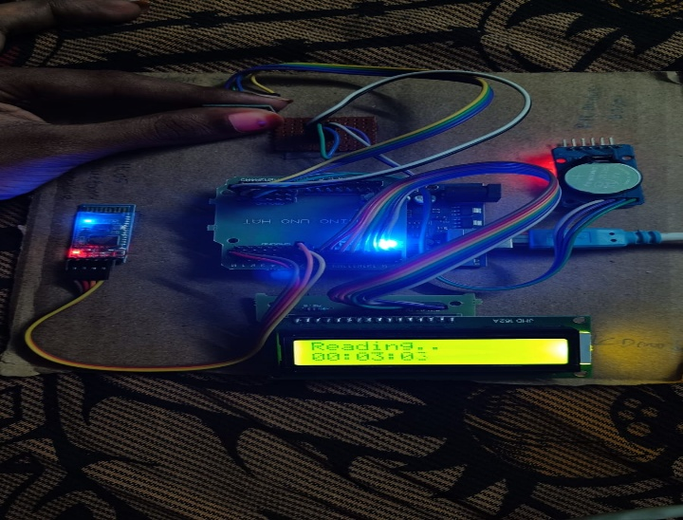
Fig2: Reading
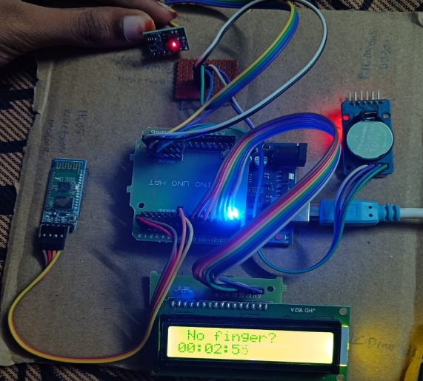
Fig3: No finger

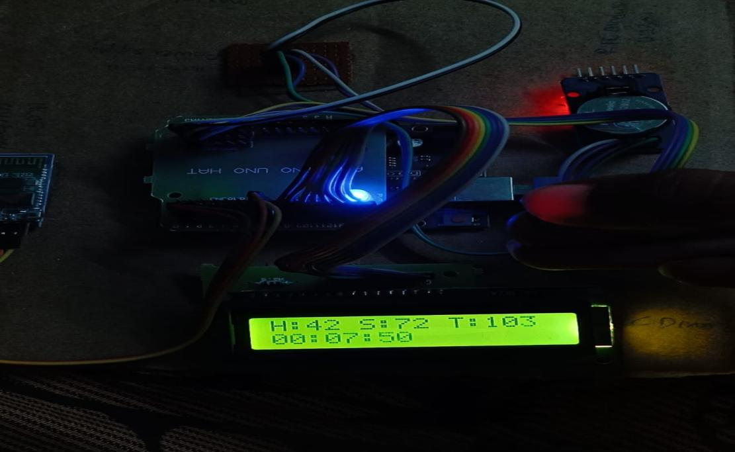

Fig4:H:42 S:72 T:103

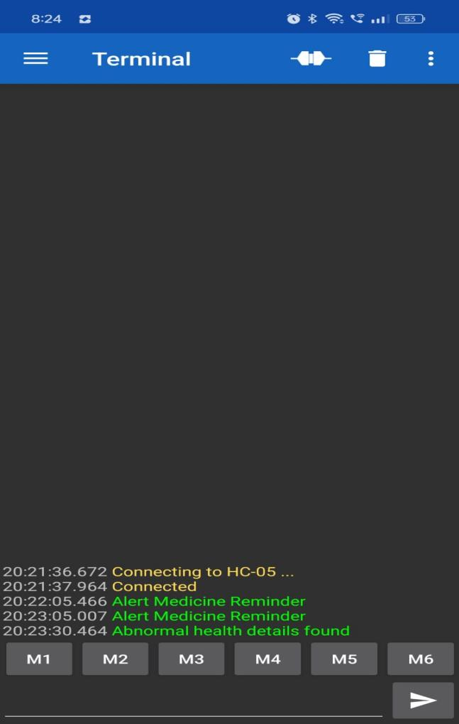
Fig5:Terminal

Results and Discussion:
The smart wrist device developed for real-time health monitoring of elderly individuals has demonstrated highly promising results across various performance metrics, including continuous monitoring, user comfort, and system responsiveness. The device integrates a range of advanced sensors, including heart rate monitors, blood pressure sensors, oxygen saturation (SpO₂) detectors, and temperature sensors, all of which are essential for tracking the key health indicators of elderly users. Throughout the testing phase, these sensors exhibited consistent accuracy and reliability, effectively capturing the vital signs of users under different conditions. The device’s ability to measure heart rate and SpO₂ levels proved particularly beneficial in identifying any irregularities or early signs of cardiovascular or respiratory distress, making it an invaluable tool for proactive health management. Additionally, the blood pressure and temperature sensors accurately reflected users’ physiological states, ensuring comprehensive monitoring for conditions that are often prevalent in elderly populations, such as hypertension or fever. Furthermore, the data captured by these sensors was seamlessly transmitted in real-time to a connected mobile application, which served as the central platform for health tracking and data visualization.
Conclusion and Future Scope:
In conclusion, the development of a smart wrist device for real-time health monitoring of elders offers a significant improvement in proactive healthcare management. The device successfully integrates continuous monitoring of vital signs such as heart rate, blood pressure, and SpO₂ levels, ensuring that elderly individuals can maintain their independence while still being closely monitored for potential health risks. The wireless communication feature allows caregivers or healthcare providers to receive real-time alerts and health data, enabling faster interventions in case of emergencies. This solution is designed to enhance the safety and well-being of elders, reducing hospital visits and providing peace of mind to both the users and their families.
Looking ahead, the future scope of this project lies in enhancing its functionalities by incorporating advanced features such as AI-driven analytics to predict potential health issues before they arise. Integration with more diverse sensors for monitoring additional parameters like blood glucose levels, hydration status, or fall detection could further expand its capabilities.
REFERENCES:
- https://ieeexplore.ieee.org/
- https://dl.acm.org/
- https://create.arduino.cc/projecthub
CODE:
#include <Wire.h>
#include "MAX30105.h"
#include "heartRate.h"
MAX30105 particleSensor;

#include <LiquidCrystal.h>
const int rs = 8, en = 9, d4 = 10, d5 = 11, d6 = 12, d7 = 13;
LiquidCrystal lcd(rs, en, d4, d5, d6, d7);

const byte RATE_SIZE = 4; //Increase this for more averaging. 4 is good.
byte rates[RATE_SIZE]; //Array of heart rates
byte rateSpot = 0;
long lastBeat = 0; //Time at which the last beat occurred
float beatsPerMinute;
int beatAvg;
int tempF,spo2;
int fs=0;
void setup()
{
Serial.begin(9600);
lcd.begin(16,2);
lcd.print("WELCOME");
particleSensor.begin(Wire, I2C_SPEED_FAST);
particleSensor.setup(); //Configure sensor with default settings
particleSensor.setPulseAmplitudeRed(0x0A); //Turn Red LED to low to indicate sensor is running
particleSensor.setPulseAmplitudeGreen(0); //Turn off Green LED
particleSensor.enableDIETEMPRDY();

Serial.println("WELCOME");
}

void loop()
{

long irValue = particleSensor.getIR();
//Serial.println(irValue);
if (irValue < 50000)
{
if(fs==1)
{
fs=0;
lcd.clear();
lcd.print(" No finger?");
beatAvg=0;
}
}
else
{
if(fs==0)
{
fs=1;
lcd.clear();
lcd.print("Reading..");
}

if (checkForBeat(irValue) == true)
{
long delta = millis() - lastBeat;
lastBeat = millis();
beatsPerMinute = 60 / (delta / 1000.0);
if (beatsPerMinute < 255 && beatsPerMinute > 20)
{
rates[rateSpot++] = (byte)beatsPerMinute; //Store this reading in the array
rateSpot %= RATE_SIZE; //Wrap variable
beatAvg = 0;
for (byte x = 0 ; x < RATE_SIZE ; x++)
beatAvg += rates[x];
beatAvg /= RATE_SIZE;
}
}
}
if(beatAvg>40)
{

tempF = particleSensor.readTemperatureF();
if(beatAvg<40)
spo2=0;
else if(beatAvg>140)
spo2=map(beatAvg,140,255,80,50);
else if(beatAvg>=40 && beatAvg<60)
spo2=map(beatAvg,40,60,70,98);
else
spo2=map(beatAvg,60,140,100,80);
lcd.clear();
lcd.print("H:"+String(beatAvg) + " S:"+String(spo2) + " T:"+String(tempF));
}

else
{
tempF = particleSensor.readTemperatureF();
beatAvg=0;
spo2=0;
}

}

