Results for the test cases of the migrations
The tests run inside a transaction that rolls back, so no test data is left behind, and the script is at db/tests/01_lifecycle_tests.sql. All tests were run on the Neon production branch.
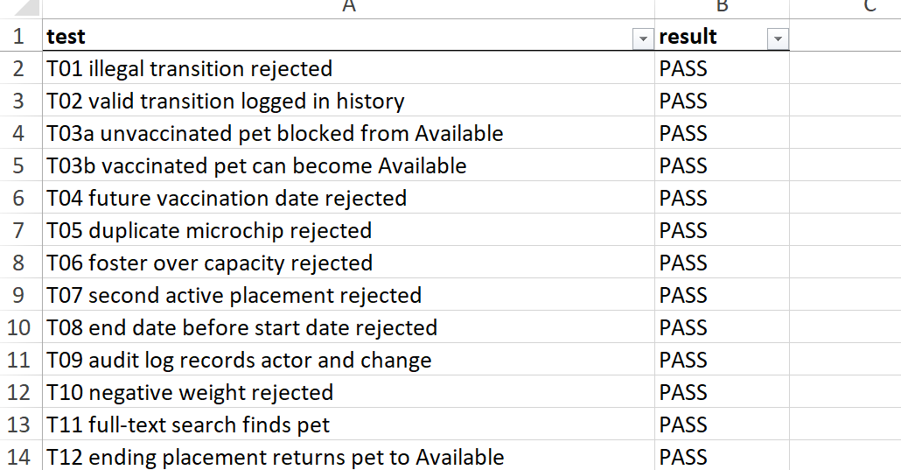
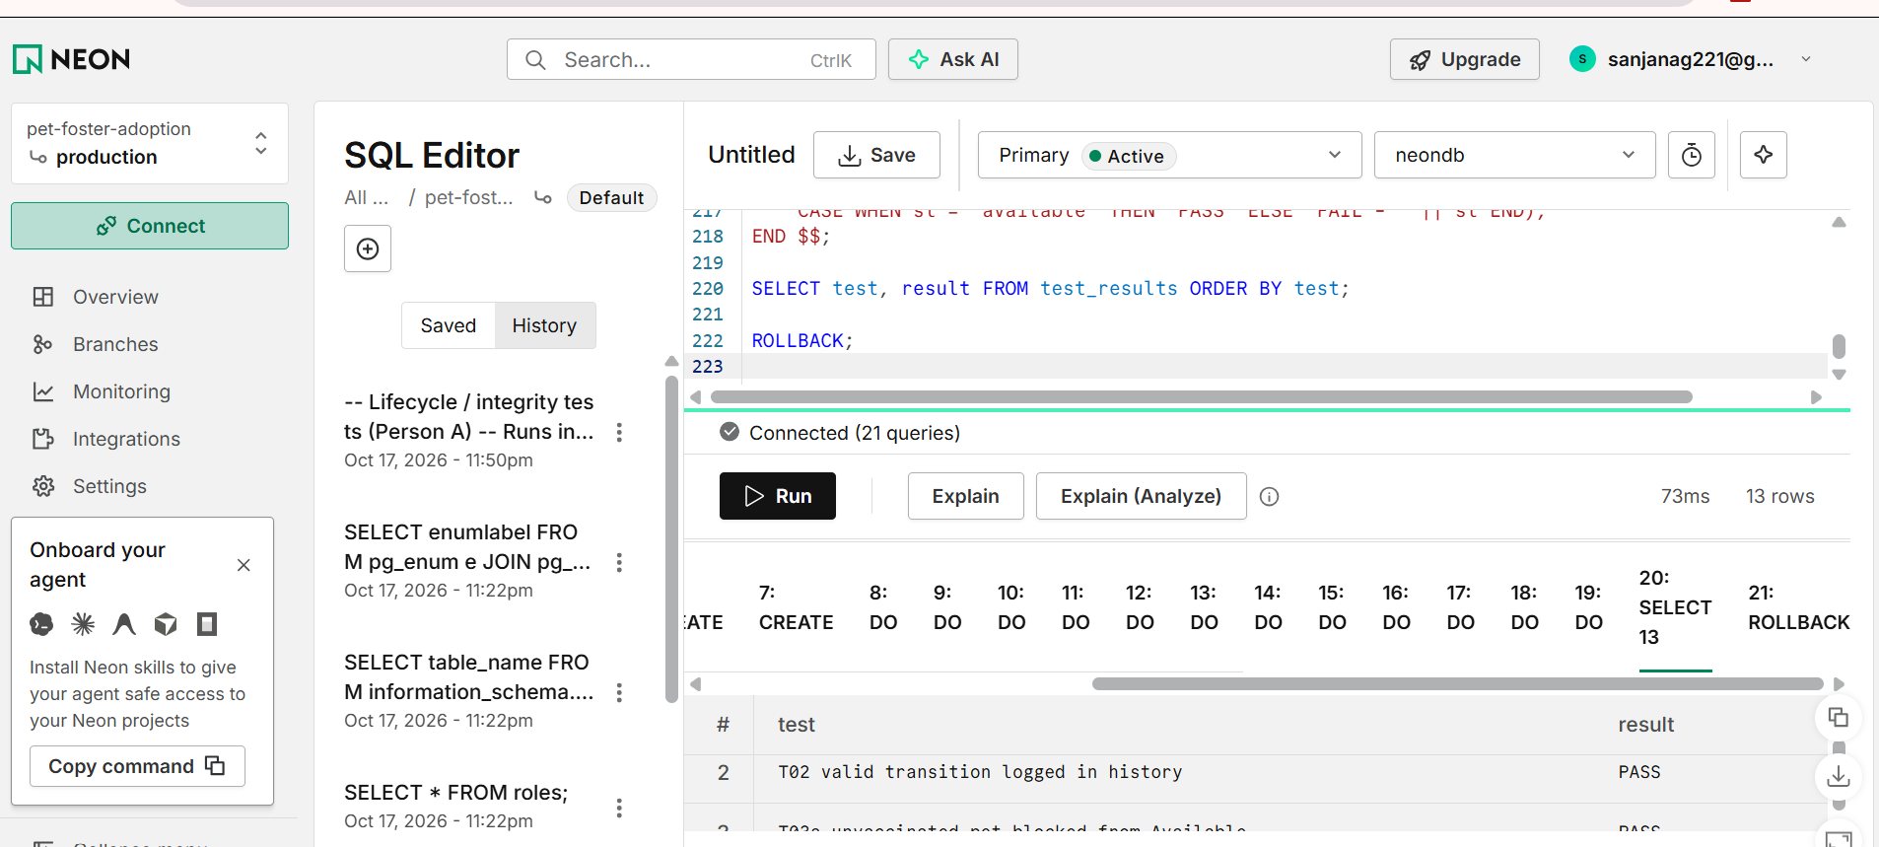

Detailed test cases (database layer)
Error codes: PT001 illegal status or transition, PT002 vaccination gate, PT003 foster capacity exceeded. 23514 = check violation, 23505 = unique violation (PostgreSQL standard codes).
ID | Area | Rule tested | Test steps | Expected result | Actual result | Mechanism | Status
T01 | Lifecycle | Illegal status transition is rejected | Create a pet (status intake), then update its status directly to adopted | Error PT001, status unchanged | Rejected with PT001 | Trigger trg_pets_status_transition + table pet_status_transitions | PASS
T02 | Lifecycle | Valid transition succeeds and is logged | Create a pet, move intake → medical_hold | Status changes, and 2 history rows exist (creation + change) | 2 history rows found | Triggers trg_pets_status_transition, trg_pets_status_history | PASS
T03a | Integrity | Unvaccinated pet cannot become Available | Create a dog with no vaccinations, move intake → available | Error PT002 naming the missing vaccines | Rejected with PT002 | Trigger trg_pets_status_gate + table required_vaccines | PASS
T03b | Integrity | Vaccinated pet can become Available | Add Rabies and DHPP vaccinations to the same dog, retry available | Status becomes available | Status is available | Trigger trg_pets_status_gate | PASS
T04 | Validation | Vaccination date cannot be in the future | Insert a vaccination dated 5 days ahead | Check-constraint violation (23514) | Rejected | CHECK chk_vacc_date_not_future | PASS
T05 | Validation | Microchip number must be unique | Insert two pets with the same microchip number | Unique violation (23505) on the second insert | Rejected | UNIQUE uq_pets_microchip | PASS
T06 | Foster | Foster capacity cannot be exceeded | Foster with capacity 1 takes pet 1, then try to place pet 2 | Error PT003 | Rejected with PT003 | Trigger trg_placements_capacity + procedure sp_place_in_foster (row lock) | PASS
T07 | Foster | A pet can have only one active placement | Place a pet with foster A, then directly insert an active placement for the same pet with foster B | Unique violation (23505) | Rejected | Partial unique index uq_one_active_placement_per_pet | PASS
T08 | Validation | Placement end date cannot be before start date | Insert a placement with end_date 5 days before start_date | Check-constraint violation (23514) | Rejected | CHECK chk_placement_end_after_start | PASS
T09 | Audit | Audit log records who made the change | Set the current user to an admin, update a pet’s description | One UPDATE audit row with the admin’s id, old and new values | 1 matching row found | Trigger trg_audit_pets + fn_current_actor() | PASS
T10 | Validation | Weight must be positive | Insert a pet with weight -5 | Check-constraint violation (23514) | Rejected | CHECK chk_pets_weight_positive | PASS
T11 | Search | Full-text search finds a pet | Insert a Labrador with a description containing “gentle”, then search “gentle labrador” | The pet is returned | Pet found | search_vector + trigger + GIN index idx_pets_search_vector | PASS
T12 | Foster | Ending a placement returns the pet to Available | Place a pet in foster, then call sp_end_placement with reason foster_request | Placement completed, pet status available | Status is available | Procedure sp_end_placement | PASS

