Task 4
TITLE
The effect of perfectionism on exhaustion at different levels of rumination: A latent variable analysis
- RESEARCH QUESTIONS
The study aims to calculate perfectionism on exhaustion within academics, moderated by rumination. It seeks to answer whether the mediated model fits the data, and the size, direction, and statistical significance of the paths. The null hypothesis is that there is no relationship between perfectionism and exhaustion. The second null hypothesis is that rumination does not significantly mediate the effect of perfectionism on exhaustion.
- DATA ANALYSIS METHOD AND JUSTIFICATION
First, we build and fit the CFA model. The data for each variable had to be turned to composite scores by averaging item-level responses of participants in order to run a confirmatory factor analysis. It was used to identify how well the items loaded on their latent variables (Goretzko et al., 2024). The error free covariance was measured against the aggregated variables. The composite reliability of the latent variables confirmed the reliability of the measure.
Then a full latent variable SEM was built by creating full and partially mediated models. Model fit refers to how well the predicted model covariance matrix matches the empirical covariance matrix (Schermelleh-Engel et al., 2003). The fit of the model was assessed by bootstrapping the sample 5000 times to identify the confidence intervals. Perfectionism is the predictor variable, rumination is the mediator, and exhaustion was chosen as the outcome variable. Lastly, the R² values were calculated to calculate the amount of variance explained by each factor in the SEM model.
- PRELIMINARY ANALYSES
The model included three latent variables (perfectionism, rumination, exhaustion) identified using the marker variable approach, where I fixed one item loading per factor to 1.0. Maximum likelihood estimation was employed. Model fit was evaluated using multiple indices: CFI, TLI, SRMR, and RMSEA, following established guidelines (Hu & Bentler, 1999)
- PRIMARY ANALYSES
Table 4.1 Standardized Factor Loadings and Composite Reliability for Measurement Model
Latent Variable | Indicator | Standardized Loading (β) | Composite Reliability (ρ)
Perfectionism | Item 1 | .71*** | .84
 | Item 2 | .75***
 | Item 3 | .80***
Rumination | Item 1 | .79*** | .89
 | Item 2 | .85***
 | Item 3 | .90***
Exhaustion | Item 1 | .72*** | .91
 | Item 2 | .77***
 | Item 3 | .81***
All the latent factors loaded significantly well onto their variables (perfectionism β range = .71 to .80; rumination β range = .79 to .90; exhaustion β range = .72 to .81). When tested for composite reliability, all the factors loaded well onto their respective latent variables (perfectionism ρ = .84; rumination ρ = .89; exhaustion ρ = .91). The measurement model exhibited an acceptable fit to the data: χ² = 60.541 (32), p < .05; TLI = .96; CFI = .97; SRMR = .05; RMSEA = .07 (90% CI = .04 to .09). Despite the significant chi-square, the goodness and badness of fit indices show excellent fit for the overidentified model. Correlations between perfectionism and rumination (B = .74, β = .57, p < .001), and rumination and exhaustion (B = .28, β = .33, p < .001) were positive and significant. However, the correlation between perfectionism and exhaustion was non-significant (B = .11, β = .13, p = .132).

Figure 4.1
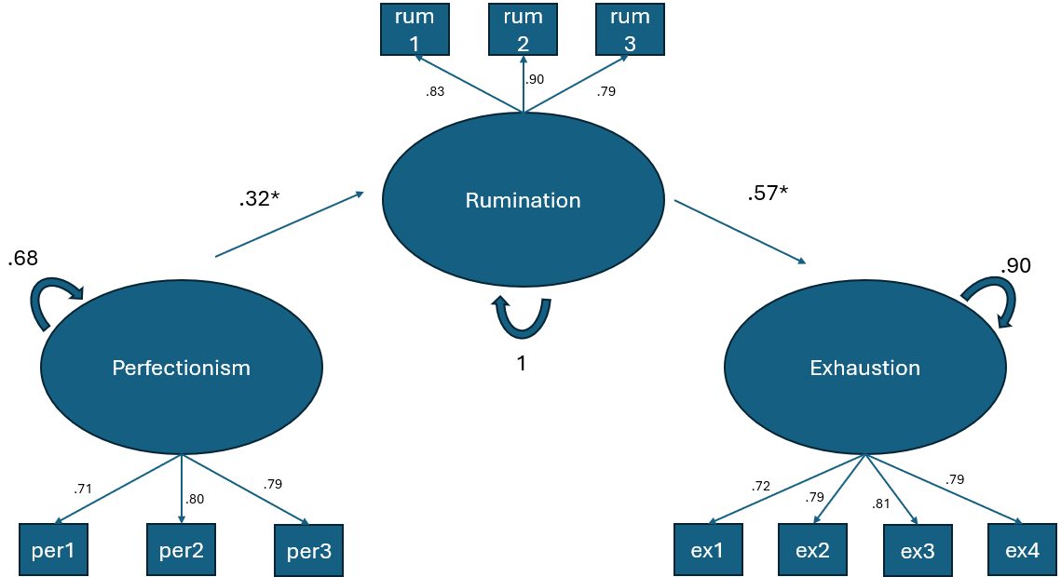

Partial mediation models were compared; the overidentified model was preferred for parsimony. Fit indexes from this model suggest good fit: TLI = .96; CFI = .97; SRMR = .05; RMSEA = .06. Rumination positively predicted exhaustion (β = .32, 95% CI = .09,.35). Subsequently, perfectionism positively predicted rumination (β = .57, 95% CI = .37,.75). The direct path from perfectionism to exhaustion was non-significant but positive (β = .34, p = .043) in the partial mediation model. This model accounted for 32% of the variance in rumination and 10% of the variance in exhaustion. The indirect effect with 5000 bootstrapped resamples were significant (β = .18, 95% CI = .05,.21).
It is also interesting to note that in the just-identified mediated model, the c’ path is non-significant, but negative (β = -.09, 95% CI = -.22,.06). This also causes an insignificant total effect (path c). The potential causes for the same are elaborated below.
- INTERPRETATIONS
Measures of fit remain accurate and significant even with an overidentified model. Factor loadings were reliable and fit onto their respective latent variables. Rumination appears to be the critical mechanism through which perfectionism leads to exhaustion
We can conclude full mediation based on a significant ab path. Although Baron & Kenny (1986) dictate that if path c is not significant, one should not proceed further in analysis, Hayes (2009) notes that the mediation effect may continue even without a significant path c. It can be concluded that the above mediation is an indirect mediation where the path entirely goes through the mediator. If the c’ path was significant, a competing mediation would have described the above model better (Zhao et al., 2010). Possible interpretations for the suppression effect include maladaptive perfectionism. Lastly, although perfectionism and rumination explained substantial variance, other predictors are worth exploring.

References
Baron, R. M., & Kenny, D. A. (1986). The moderator–mediator variable distinction in social psychological research: Conceptual, strategic, and statistical considerations. Journal of Personality and Social Psychology, 51(6), 1173–1182. https://doi.org/10.1037/0022-3514.51.6.1173
Goretzko, D., Siemund, K., & Sterner, P. (2024). Evaluating Model Fit of Measurement Models in Confirmatory Factor Analysis. Educational and Psychological Measurement, 84(1), 123–144. https://doi.org/10.1177/00131644231163813
Hayes, A. F. (2009). Beyond Baron and Kenny: Statistical mediation analysis in the new millennium. Communication Monographs, 76(4), 408–420. https://doi.org/10.1080/03637750903310360
Schermelleh-Engel, K., Moosbrugger, H., & Müller, H. (2003). Evaluating the Fit of Structural Equation Models: Tests of Significance and Descriptive Goodness-of-Fit Measures. Methods of Psychological Research Online, 8(2), 23–74.
Zhao, X., Lynch Jr., J. G., & Chen, Q. (2010). Reconsidering Baron and Kenny: Myths and truths about mediation analysis. Journal of Consumer Research, 37(2), 197–206. https://doi.org/10.1086/651257

