Task 3
TITLE
The effect of openness on subjective wellbeing amongst college students controlling for self-compassion: a mediated analysis
- RESEARCH QUESTIONS
The study aims to understand whether openness affect subjective wellbeing when self-compassion levels are mediated. The null hypothesis assumes no relationship between openness and subjective wellbeing. The second null hypothesis assumes the self-compassion does not mediate any relationship between openness and subjective wellbeing.
- DATA ANALYSIS METHOD AND JUSTIFICATION
To test the hypothesis that self-compassion mediates the relationship between openness and subjective well-being, I conducted a causal mediation analysis using Hayes (2018b)’s approach because researchers are trying to understand how variations in X cause variations in M, which in turn cause variations in Y. Thus, M is ‘causally located’ between X and Y.
Prior to analysis, composite scores were created for each construct by averaging participants' item-level responses. Preliminary data screening included visual inspection of histograms and Q-Q-plots for normality. Correlation was examined using Pearson's to provide preliminary support to the hypothesis. The model specified openness as predictor (X), self-compassion as mediator (M), and subjective well-being as outcome (Y), estimating the indirect effect (a×b path) and direct effect (c' path). Bootstrap confidence intervals (5,000 resamples) tested indirect effect significance. A just-identified and overidentified model were both run. The goal of which was to test if the parsimonious model performed better without sacrificing an additional degree of freedom.
- PRELIMINARY ANALYSES
Responses on the three above variable was measured on a 7-point Likert scale with 1 indicating ‘Not at all True’ to 7 indicating ‘Very true.’

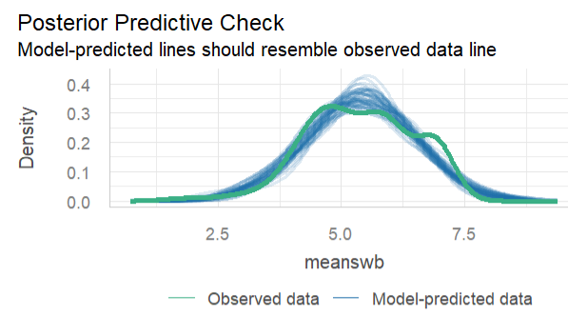
Figure 3.1

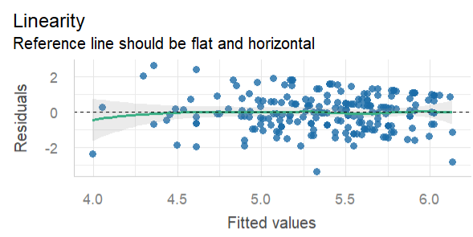
Figure 3.2

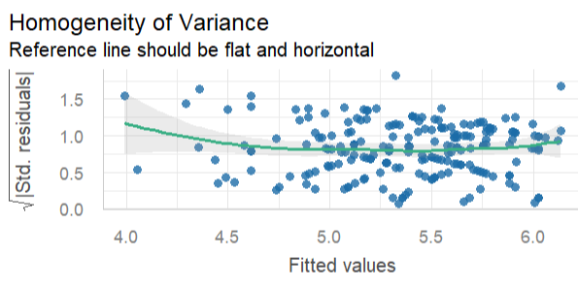
Figure 3.3

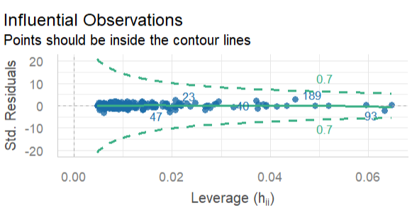
Figure 3.4

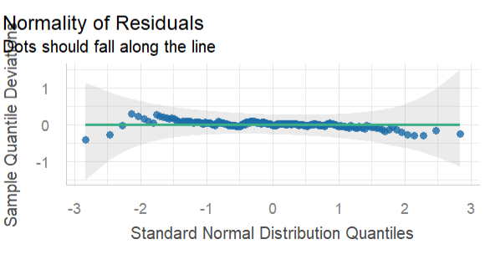
Figure 3.5

The normality checks fit the linear model assumptions to run a multiple regression model which acts as the a, b and c’ paths for the mediation model.
- PRIMARY ANALYSES
Correlational analysis showed a positive and significant relationship between all variables. Self-confidence and openness showed the highest relationship (r = 0.63, p<0.05). Self-confidence and wellbeing showed medium correlation (r = 0.29, p<0.05) as did openness and wellbeing (r = 0.39, p<0.05).
Two simple regressions were run to identify the a and c paths. The a path was significant ( B= 0.42, β= 0.62, p <0.05) which indicates that openness predicts self-compassion. Openness also predicts subjective wellbeing (B= 0.25, β= 0.28, p <0.05). However, the multiple regression model yielded a non-significant relationship between openness and wellbeing when controlling for self-compassion (B= 0.06, β= 0.07, p >0.05).

Table 4.1 Mediation Analysis Results with Nonparametric Bootstrap Confidence Intervals
Effect | Estimate | 95% CI Lower | 95% CI Upper | p
ACME | 0.191 | 0.096 | 0.292 | < .001
ADE | 0.062 | -0.070 | 0.200 | .37
Total Effect | 0.254 | 0.130 | 0.385 | < .001
Proportion Mediated | 0.755 | 0.40 | 1.424 | < .001
Results of the mediation analysis, confirm the role of self-compassion on in the relation between openness and subjective well-being (ab = .19; 95% CI = .09 to .29). In addition, results indicated that the direct effect of openness on wellbeing is non-significant (c’ = .06, 95% CI = -0.07 to 0.20, p = .344) when controlling for self-compassion, suggesting full mediation. Approximately 75.5% of the total effect of openness on subjective well-being operated through self-compassion.
The overidentified model demonstrated excellent fit to the data (CFI = 1.00, TLI = 1.06, RMSEA = 0.00, SRMR = 0.02), providing strong support for the hypothesized mediation structure. While these indices support the hypothesized structure, near-perfect fit may indicate oversimplification and warrants replication.
Further, the model explains 15.3% of the variance in self-compassion (R² = .153), while explaining 39.3% of the variance in subjective well-being (R² = .393).

Figure 4.1 Mediation Model
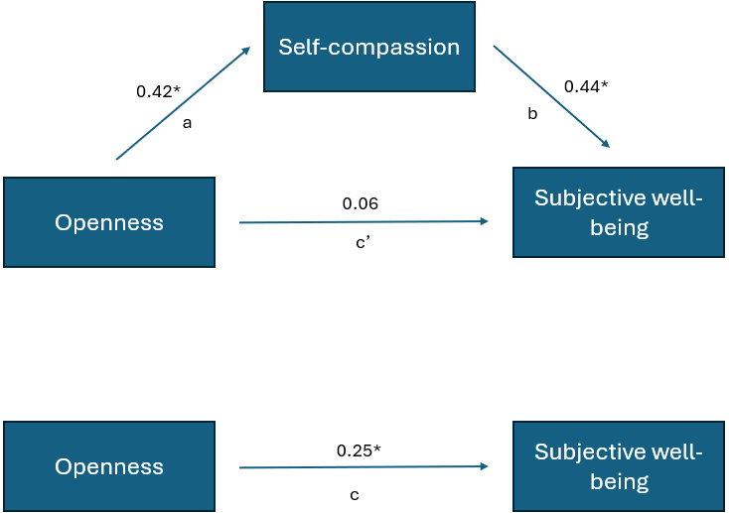

Figure 4.2: Overidentified Mediation Model
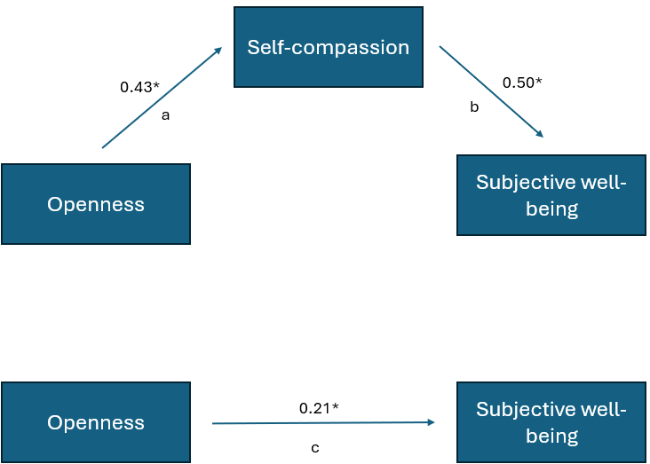

- INTERPRETATIONS
The results indicated full mediation. Full mediation suggests openness facilitates well-being exclusively through self-compassion. The overidentified model maintained excellent fit, constrained the non-significant direct path, and provided a more parsimonious representation of the data. However, the near-perfect scores may suggest oversimplification of the model. Shi et al. (2019) suggest that TLI increased with population when nonzero residual correlations were ignored. Therefore, both the overidentified and just-identified models are required to draw an appropriate conclusion to the study. Generalizations from this model must also be cautiously drawn and a replication study is recommended.
References
Hayes, A. F. (2018). Fundamentals. In Introduction to mediation, moderation, and conditional process analysis: A regression-based approach (2nd edn, p. 7). Guilford Publications.
Shi, D., Lee, T., & Maydeu-Olivares, A. (2019). Understanding the Model Size Effect on SEM Fit Indices. Educational and Psychological Measurement, 79(2), 310–334. https://doi.org/10.1177/0013164418783530

