Task 1
TITLE
The effect of music choice on employee productivity
- RESEARCH QUESTIONS AND HYPOTHESES
This study looks at research pertaining to difference in productivity amongst employees with and without entertainment while they work. Recent meta-analyses have found increase in productivity with music, and its applications in companies has been widely studied (Lisa & Dwiyanti, 2022). The null hypothesis states there is no statistically significant difference in productivity between the three conditions.
- DATA ANALYSIS METHOD AND JUSTIFICATION
First, a regression model was built with productivity as the outcome variable. Each condition (no music, music without choice, music with choice) was dummy-coded for regression analysis. In regression analysis, an n-1 approach is utilised and the coefficient tells us how much the variable increases or decreases with reference to the intercept (no music). Partitioning the variances assessed variance explained by the model.
Then, an ANOVA was run with the conditions and a pairwise t test adjusted the values with Bonferroni’s correction. Although multiple t tests provide the same results as an ANOVA, it’s better to run the one-way ANOVA because it simultaneously compares group means using the omnibus F-test (CHEN et al., 2018). The Bonferroni correction controls error at α/n. Though Tukey's HSD was also computed, Bonferroni offers greater power with few groups (Zweifach, 2025).
Regression coefficients quantify specific contrasts while ANOVA provides an omnibus test of any condition differences, hence both analyses are reported.
- PRELIMINARY ANALYSES
Productivity was measured in terms of the "average number of packages processed per hour."

Table 3.1: Descriptive Statistics
Condition | n | M | SD | Min | Max
Music Choice | 50 | 202.96 | 36.53 | 130.90 | 285.35
Music No Choice | 50 | 177.14 | 32.70 | 104.67 | 252.85
No Music | 50 | 174.50 | 39.86 | 110.74 | 276.61
On average, employees who could choose their music processed 202.96 (SD = 36.53) packages an hour. Employees who could listen to music but could not choose the music packed 177.14 (SD = 32.70) packages an hour. Employees in the control ‘no music’ condition packaged 174.50 (SD = 39.86) packages an hour.
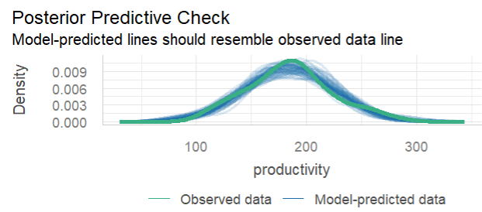
Figure 3.1

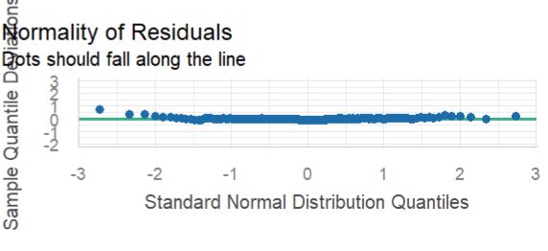
Figure 3.2

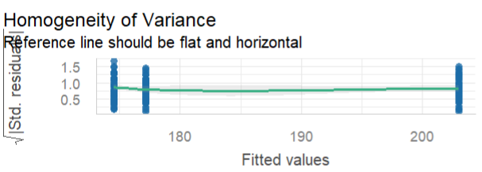
Figure 3.3

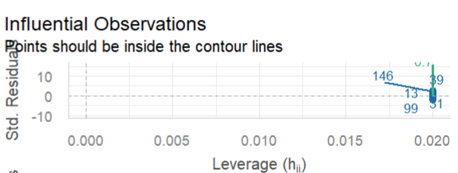
Figure 3.4

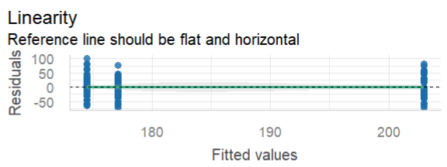
Figure 3.5

A global check confirmed the assumptions of a linear model were met. Image 3.1 indicates normality of residuals; Image 3.2 satisfies the assumption of linearity while Image 3.4 confirms homoscedasticity and Image 3.5 visualises normality of residuals. Image 3.3 under homogeneity of variance might be slightly deviant from the assumption, but considering the rest of the assumptions are met, it does not concern the data enough to run a Kruskal-Wallis test. The clustering pattern in the homogeneity and linearity plot is expected when one has categorical predictors with different group means.

- PRIMARY ANALYSES
The results of the above analyses are presented below.
Table 4.1: Regression Coefficients for Music Condition Predicting Productivity
Predictor | B | SE B | β | t | p
Intercept (No Music) | 174.50 | 5.16 | — | 33.81 | <.001
Music No Choice | 2.65 | 7.30 | .02 | 0.36 | .717
Music Choice | 28.47 | 7.30 | .31 | 3.90 | <.001
Table 4.2 Analysis of Variance
Source | SS | df | MS | F | p
Model (error reduced) | 24,733.98 | 2 | 12,366.99 | 9.29 | .0002
condition_music_no_choice | 175.01 | 1 | 175.01 | 0.13 | .7174
condition_music_choice | 20,258.40 | 1 | 20,258.40 | 15.22 | .0001
Error (from model1) | 195,660.63 | 147 | 1,331.03
Total (empty model) | 220,394.61 | 149 | 1,479.16
Multiple regression results show significant increase in productivity only with choice of music (β=.31, p<0.05). The one-way ANOVA yielded a significant effect of music condition on productivity (F(2, 147) = 9.29, p = .001). The music choice condition was able to explain 9.3% of the variance in the model (PRE=0.093).

Table 4.3 Pairwise Comparisons of Productivity Across Music Conditions
Comparison | Mean Difference | p (Bonferroni) | p (Tukey HSD)
Music Choice vs. Music No Choice | 25.82 | .00162 | .002
Music Choice vs. No Music | 28.47 | .00044 | <.001
Music No Choice vs. No Music | 2.65 | 1.00000 | .930
To mitigate the effect of a false positive, I used a Post-hoc pairwise comparisons using the Bonferroni correction which indicated that the Music Choice condition (M = 202.96, SD = 36.53) resulted in significantly higher productivity than both the Music No Choice condition (M = 177.14, SD = 32.70, p = .002) and the No Music condition (M = 174.50, SD = 39.86, p < .001). No significant difference was found between the Music No Choice and No Music conditions (p = 1.00).
Image 4.1

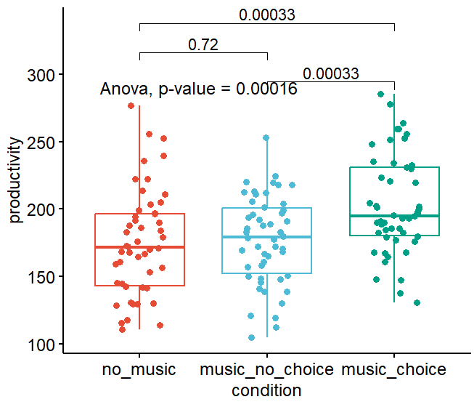

As shown by the boxplots, visualising the difference in means reiterates the above results. The plot for the music choice condition has a more prominent difference in both mean and median compared to the control and treatment 1 conditions.
- INTERPRETATIONS
To answer the first question, there is a statistically significant difference in productivity. To answer the second question, there was a significant difference between employees who chose their music versus who didn't choose as well as between employees who chose their music versus employee who had no music. But employees who couldn't choose their music did not differ in productivity as significantly as employees who didn't have music. It can thus be concluded that allowing employees to choose their own music, increases productivity of employees. The researcher must analyse the role of autonomy in improving productivity as a broader psychological tool. One can also look at how entertainment can also improve subjective well-being of employees.

References
CHEN, T., XU, M., TU, J., WANG, H., & NIU, X. (2018). Relationship between Omnibus and Post-hoc Tests: An Investigation of performance of the F test in ANOVA. Shanghai Archives of Psychiatry, 30(1), 60–64. https://doi.org/10.11919/j.issn.1002-0829.218014
Lisa, S. N., & Dwiyanti, E. (2022). LITERATURE STUDY OF WORK ACCOMPANIMENT MUSIC EFFECT ON EMPLOYEE PRODUCTIVITY IN SEVERAL COMPANIES. Journal of Public Health Research and Community Health Development, 5(2), 73. https://doi.org/10.20473/jphrecode.v5i2.26528
Zweifach, A. (2025). Bonferroni’s method, not Tukey’s, should be used to control the total number of false positives when making multiple pairwise comparisons in experiments with few replicates. SLAS Discovery, 35, 100253. https://doi.org/10.1016/j.slasd.2025.100253

