Task 2
TITLE
Negative emotions about the impact of global warming on support for government climate change policy amongst the youth
- RESEARCH QUESTIONS AND HYPOTHESES
The study seeks to answer three research questions. The first is whether negative emotions about the impact of global warming relate to support for governments’ climate change policy. The second is whether these emotions can predict support for policies. And the third question adds nuance by controlling for egalitarianism and individualism, as well as age and gender. The null hypothesis states ‘Negative emotions about the impact of global warming do not correlate with support for government policies.’
- DATA ANALYSIS METHOD AND JUSTIFICATION
The main analyses used for this study are correlations and linear regressions. First, I ran the descriptives for the data to understand the characteristics of the data. Despite a slight skew in the data, I went ahead with the Pearson’s r method for calculating covariance and correlation, as Bishara & Hittner (2012) have empirically proven that it remains robust even for non-normal data. I then built a linear model to understand the predictive power of negative emotions on government support. The values were standardized to measure the predictive power of negative emotion for better interpretation. The variance was then partitioned to identify how much of government support was explained by negative emotion.
A multiple regression model was drawn to control for confounding variables. Extending from the simple regression, its aim is to provide a more holistic understanding of the predictors leading to an outcome (Schroeder et al., 2017).
- PRELIMINARY ANALYSES
Respondents answered two questionnaires that measured support for government policies to mitigate global warming and negative emotion about global warming. Each was coded from 1 to 7 with 1 indicating ‘Not at all True’ to 7 indicating ‘Very true.’

Table 3.1: Descriptive Statistics Table
Statistic | Policy Support | Negative Emotions
Minimum | 1.89 | 1.00
1st Quartile (Q1) | 4.22 | 4.33
Median | 4.78 | 5.67
3rd Quartile (Q3) | 5.67 | 6.33
Maximum | 7.00 | 7.00
Mean | 4.95 | 5.27
Standard Deviation | 1.21 | 1.31
Sample Size (n) | 212 | 212
Missing Values | 0 | 0

Descriptive statistics indicate moderate support is (M=4.95, SD = 1.21). Negative emotions are medium to high (M = 5.27, SD = 1.31). There are no missing values.
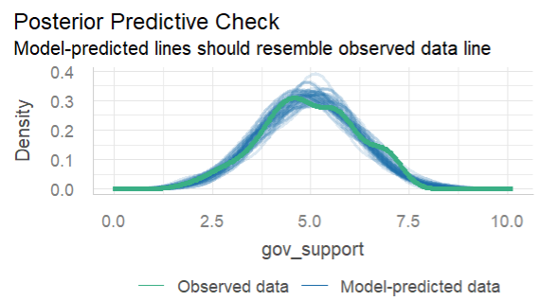
Figure 3.1

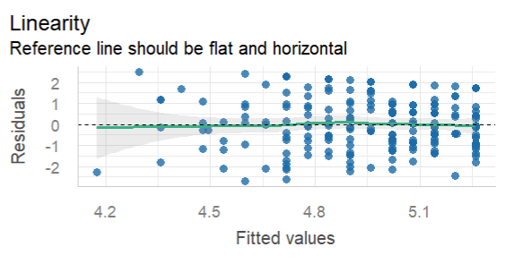
Figure 3.2

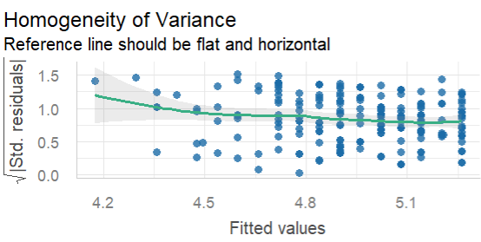
Figure 3.3

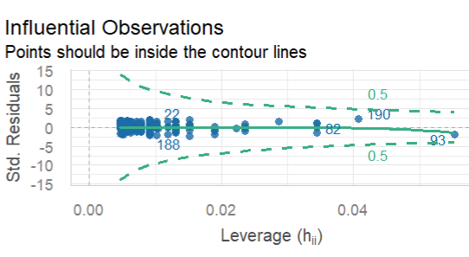
Figure 3.4

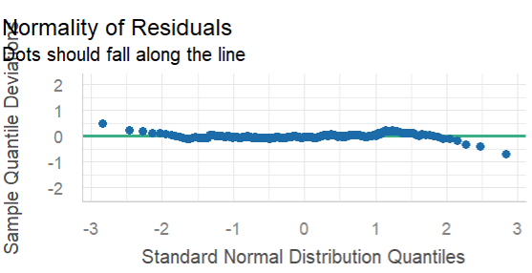
Figure 3.5

A global check confirmed the assumptions of a linear model were met. Image 3.1 shows a normally distributed dataset. Image 3.2 and Image 3.4 satisfies the assumption of linearity and homoscedasticity. Image 3.5 shows that most of the residuals are normally distributed. Image 3.3 shows slight variation in homogeneity of variance but doesn’t require a non-parametric approach.
- PRIMARY ANALYSES
Support for climate change policies has a low positive correlation with negative emotions (r= 0.2, p <.05).
Table 4.1 Simple Regression Analysis
Predictor | B | SE | t | p | 95% CI
(Intercept) | 3.99 | 0.34 | 11.81 | < 2e-16 | [3.33, 4.66]
Negative Emotions | 0.18 | 0.06 | 2.91 | 0.00407 | [0.06, 0.30]
A standardised regression model predicts an increase in 0.19 units of governmental support with every 1 SD unit increase in negative emotion. Upon partitioning the variance, we can see that adding the predictor for negative emotion explains only about 3% of the whole model.

Table 4.2 Multiple Regression Analysis Predicting Government Support for Climate Action
Predictor | B | SE | t | p | F | PRE
(Intercept) | 6.26 | 1.61 | — | < .001 | — | —
Negative Emotions | 0.08 | 0.08 | 0.95 | .342 | 0.91 | .004
Egalitarianism | 0.31 | 0.11 | 2.73 | .007 | 7.46 | .035
Individualism | 0.07 | 0.08 | 0.87 | .386 | 0.76 | .004
Age | -0.13 | 0.07 | -2.05 | .042 | 4.21 | .020
Gender | -0.35 | 0.20 | -1.74 | .083 | 3.03 | .014
A similar correlation model was run with the personality, age and gender predictors. It is noted the individualism and governmental support is not significantly correlated (p>0.05); however, the other predictors have a significant correlation. Negative emotion is positively correlated with government support and egalitarianism (r = 0.2, r = 0.59, p<0.05) but negatively correlated with individualism (r = -0.49, p <0.05). Individualism has negative correlation with negative emotion and egalitarianism.
The results of the multiple regression model show that holding other factors constant, the impact of negative emotion on government support is not significant (B=.08, p>.05). Partitioning the variance, we can see that gender explains 1.4% of the model, age explains 2%, individualism explain 0.4%, egalitarianism explains 3.5% and negative emotion explains 0.4%. In summary, neither of these factors majorly explain support for government climate change policies.
- INTERPRETATION
The study looked at understanding the effect of different predictor variables on support for governmental climate change policies. From the above results, it can be inferred that the negative emotions correlate with policy support, however its strength may not be as the researchers expected. The effect of negative emotion on policy support was lower when controlled for personality, age and gender factors. This attenuation suggests that the bivariate relationship may reflect epiphenomenal association, which threaten causal claims between negative emotion and policy support (Hayes, 2018a). An epiphenomenal association refers to a relationship between two variables that appears to exist but may be superficial. This reasoning is further strengthened by the low PRE values suggesting that the variable sunder analysis do not accurately explain the variance. This analysis can be taken forward by building a path model to identify and eliminate further confounds that may drive the relationship between emotion and support for policy.

References
Bishara, A. J., & Hittner, J. B. (2012). Testing the significance of a correlation with nonnormal data: Comparison of Pearson, Spearman, transformation, and resampling approaches. Psychological Methods, 17(3), 399–417. https://doi.org/10.1037/a0028087
Hayes, A. F. (2018). Causal steps, confounding and causal order. In Introduction to mediation, moderation, and conditional process analysis: A regression-based approach (2nd edn, p. 123). Guilford Publications.
Schroeder, L. D., Sjoquist, D. L., & Stephan, P. E. (2017). Multiple Linear Regression. In Understanding Regression Analysis: An Introductory Guide (pp. 21–30). SAGE Publications, Inc. https://doi.org/10.4135/9781506361628

