Testing Document and Specification
Test Reports

Priyanka Adhikari
Sanjana alaham

Test case -1:
Ability for a user to login via username and password.

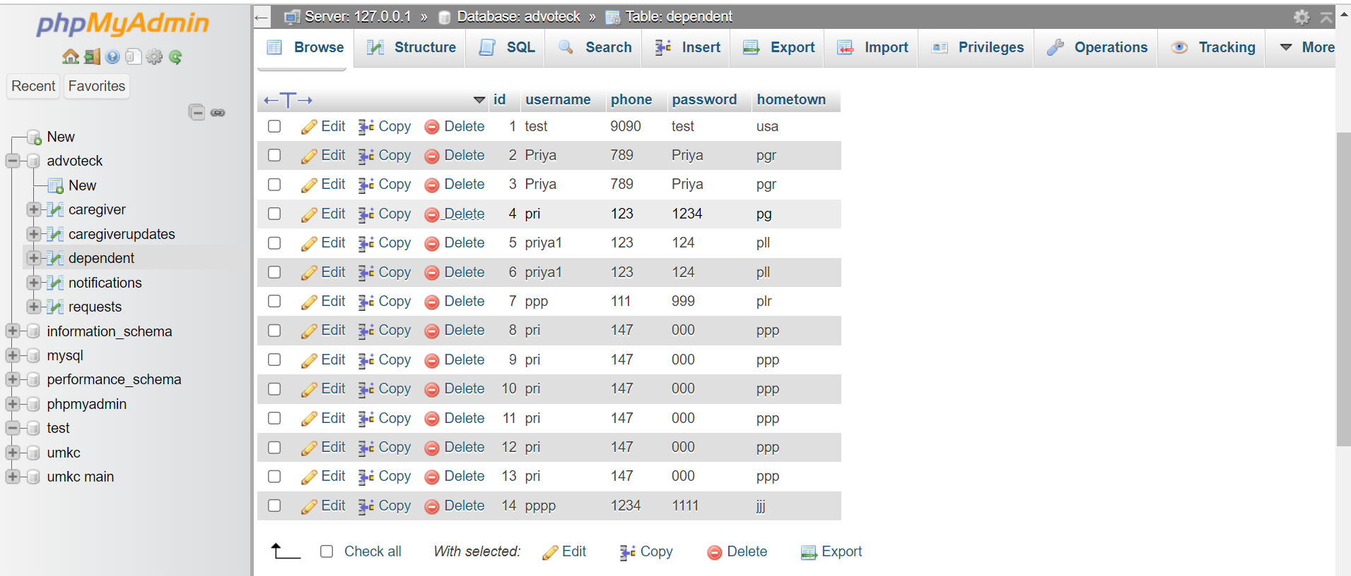

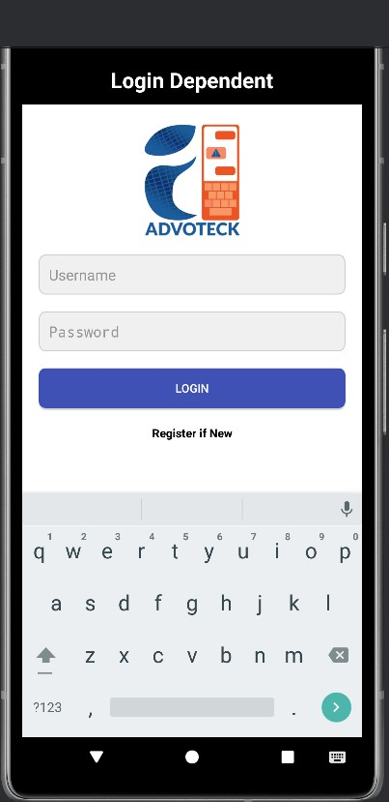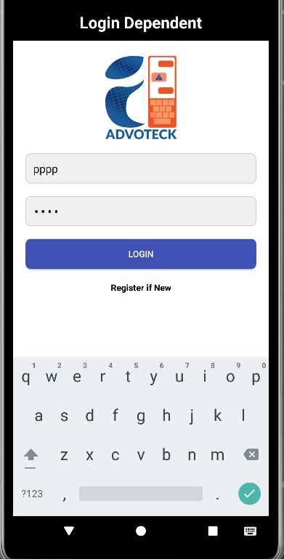
Ability of the user to Register if using for the first time.

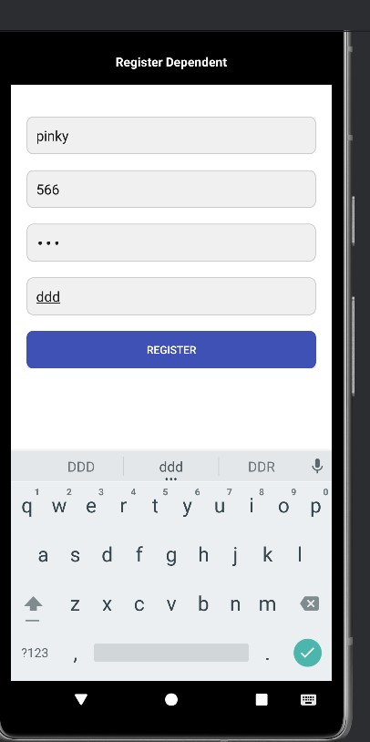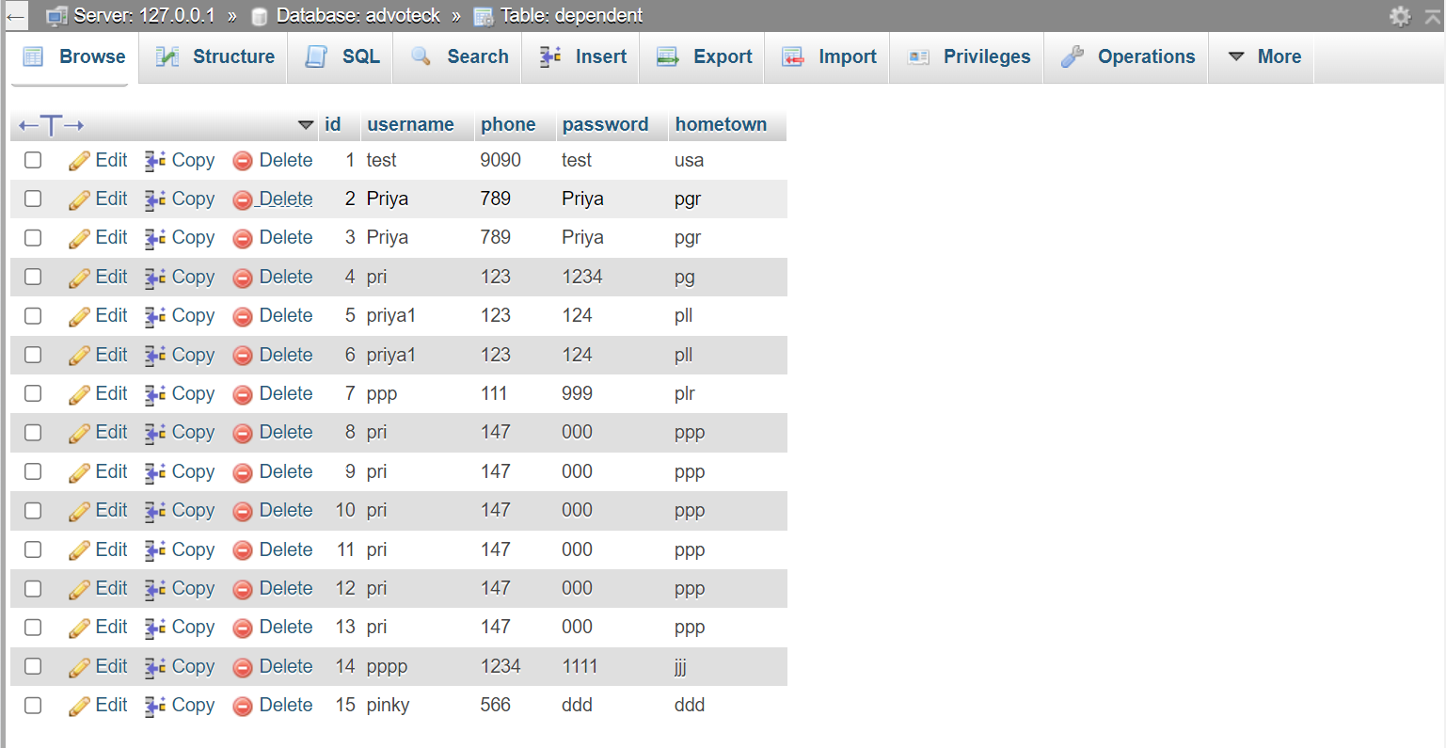

Ability of the Dependent to successfully send the request message to the caregiver.

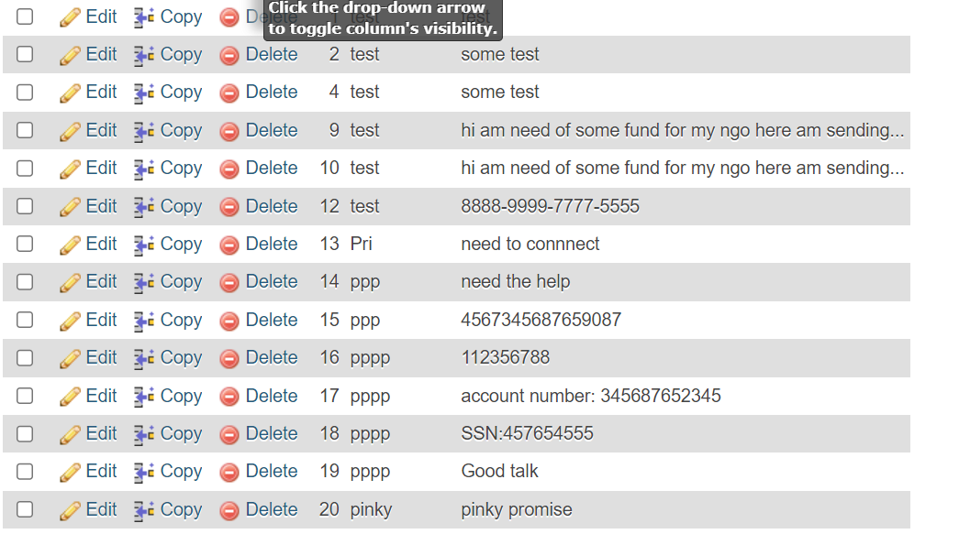

- Ability of the Caregiver to check all the messages that the dependent has sent in the Dashboard with Dependent information and messages.

- Ability of the Caregiver to receive all the alert messages regarding sensitive information.
