**FILE SYSTEM**

**1. Input / Output Basics**

Java programs perform I/O operations through **streams**.

**What is a sream ?**

A stream is an abstraction for reading/writing a sequence of data.

However, stream does not represent data, instead stream is linked to a physical device by the Java I/O system to read and write data.

Two types of streams (based on direction of data flow)

1. **input** stream : A stream from which data is read from data end points.

2. **output** stream : A stream to which data is written to data end points.

The data end points are

- Keyboard/Console

- File

- Network

**Stream Classes in Java**

The **java.io** package contains all the classes required for input and output operations.

Java defines two types of streams (based on data type) for IO operation.

- B**yte** stream

- C**harater** stream

**Byte Streams**: reading/writing data as **bytes**. These streams are used for any kind of data, including text, images, audio, etc as 1 byte ASCII characters (English letters, numbers, etc).

**Character streams:** reading/writing data as **2-byte unicode characters** which means they can process not just ASCII characters but also characters from **international languages** (e.g., Chinese, Japanese, Arabic, Hindi...etc).

**Byte Stream Classes**

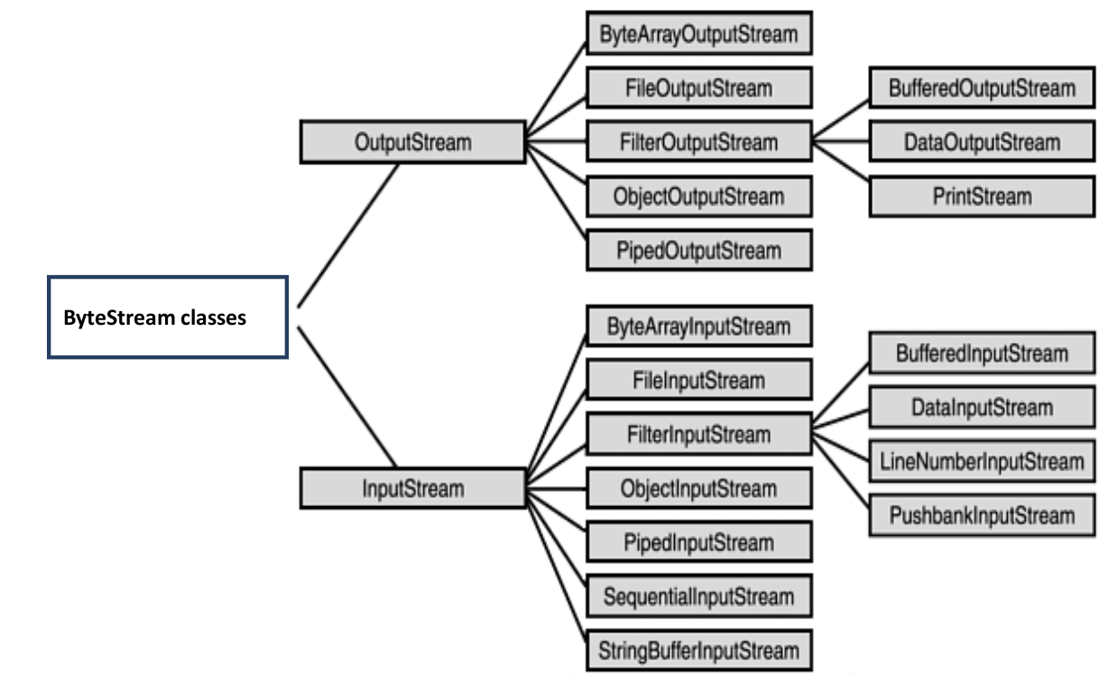

Byte streams are defined by using two class hierarchies as given below

1. **InputStream** – Used to read data from data end points.

2. **OutputStream** – Used to write data to data end points.

*Both these classes are* ***abstract classes****, that is programmer can not instantiate objects.*

As in diagram, each abstract classes got concreate subclasses to handle different data end points, devices such as Files, Network, Memory buffers.

Two of the most important are **read( )** and **write( )**,

– These methods are overridden by derived stream classes.

**InputStream Hirarchy**

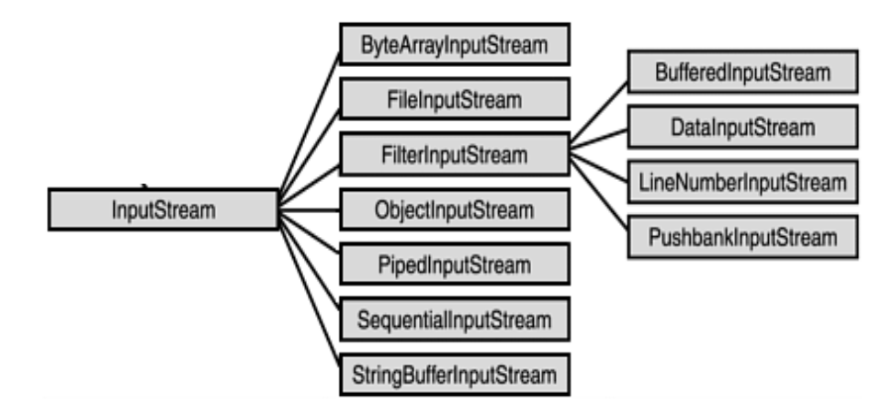

Some important classes in the hirarchy are discussed below

**1. FileInputStream:** One of the few classes that can directly **read data** from Disk File.

Constructor and Description

**FileInputStream(File file) :**

Creates a FileInputStream by opening a connection to an actual file, the file named by the File object file in the file system.

**Eg. opens a file input.txt to read**

*// create File object*

*File file = new File( "input.txt");*

*FileInputStream fis = new FileInputStream(file);*

**FileInputStream(String name)**

Creates a FileInputStream by opening a connection to an actual file, the file named by the path name name in the file system

Eg. opens a file input.txt using file name to read instead of File object.

*FileInputStream fis = new FileInputStream("input.txt");*

Read functions and Description

**int read()**

Reads a byte of data from this input stream.

Eg. read data using above created fis object

*int data = 0;*

*while ((data = fis.read()) != -1) {*

*System.out.print((char) data);*

*}*

**int read(byte[] byteArray)**

Reads up to **byteArray.length** bytes of data from this input stream

into an array of bytes.

Eg. read data using above created fis object

*byte[] buffer = new byte[1024];*

*int bytesRead;*

*while ((bytesRead = fis.read(buffer)) != -1) {*

*System.out.print(new String(buffer, 0, bytesRead));*

*}*

**int read(byte[] b, int off, int len)**

Reads up to **len** bytes of data from this input stream into an array of bytes.

Eg. read data using above created fis object

*byte[] buffer = new byte[1024]; // Define a buffer to hold the data*

*int bytesRead;*

*int offset = 0;*

*int length = 20; // Set the length to read*

*while ((bytesRead = fis.read(buffer, offset, length)) != -1) {*

*// Convert the read bytes to a string and print them*

*String output = new String(buffer, 0, bytesRead);*

*System.out.println(output);*

*}*

***Important Note:***

*1. There is NO function available in FileInputStrean to read a* ***String data****.*

2. Classes like ***BufferedInputStream****,* ***DataInputStream****,* ***ObjectInputStream etc*** *are not capable of reading* data directly from Disk file. Hence these classes **wrap** a FileInputStream object to do **File** I/O operation on respective requirements.

**2. BufferedInputStream:**

Wraps another InputStream, such as FileInputStream, to improve efficiency by buffering input data (reading larger chunks at once and reducing disk access).

It does not read from the disk directly but uses FileInputStream as its underlying source to get data from Disk file.

Constructor and Description

Eg Create Object of BufferedInputStream

*FileInputStream fis = new FileInputStream("input.txt");*

*// wrap FileInputStream with BufferedInputStream*

*BufferedInputStream bis = new BufferedInputStream(fis);*

Read functions and Description

Can use any of the read functions given below

int read()

int read(byte[] byteArray)

int read(byte[] b, int off, int len)

Eg. read data using above created **bis** object.

**int read()**

while ((data = bis.read()) != -1) {

System.out.print((char) data);

bos.write(data);

}

**3. DataInputStream:**

So far, the data is read as bytes. But some binary files ( .bin or .dat extensions) need to read data as primitive data types (e.g., int, float, double, etc.). DataInputStream is ueed to fullfil such requiremets. DataInputStream also be used to read from Network (sockets).

It does not read from the disk directly but uses FileInputStream as its underlying source to get data from Disk file.

Eg Create Object of DataInputStream

*FileInputStream fis = new FileInputStream("binary_data.dat");*

*DataInputStream din = new DataInputStream(fis);*

Can use any of the read functions given below

int read()

int read(byte[] byteArray)

int read(byte[] b, int off, int len)

boolean readBoolean()

byte readByte()

char readChar()

double readDouble()

float readFloat()

int readInt()

**Eg. read data using above created din object.**

*// read double value*

*double dVal = din.readDouble();*

*// read int value*

*int iVal = din.readInt();*

*// read boolean value*

*boolean bVal = din.readBoolean();*

*// read char value*

*char cVal = din.readChar();*

*System.out.println("dVal = " + dVal);*

*System.out.println("iVal = " + iVal);*

*System.out.println("bVal = " + bVal);*

*System.out.println("cVal = " + cVal);*

**4. ObjectInputStream:**

ObjectOutputStream is used to serialize objects (save them in byte form).

ObjectInputStream is used to deserialize objects (read them back into their original form).Both streams are typically used for persistent storage or object transfer in Java.

*FileInputStream fileInputStream = new FileInputStream("serialized_object.dat");*

*ObjectInputStream objectInputStream = new ObjectInputStream(fileInputStream);*

*// Read and deserialize the object from the file*

*Person person = (Person) objectInputStream.readObject();*

**5. PipedInputStream** : Used to create a **data pipe**.

It facilitates communication between two threads in the same program by creating a data pipe. One thread writes data to the pipe using a PipedOutputStream, and another thread reads the data from the pipe using a PipedInputStream

*PipedOutputStream outputStream = new PipedOutputStream();*

*PipedInputStream inputStream = new PipedInputStream(outputStream);*

*String message = "Hello from the producer!";*

*outputStream.write(message.getBytes());*

*int data;*

*while ((data = inputStream.read()) != -1) {*

*System.out.print((char) data);*

*}*

**6. ByteArrayInputStream:**  allows an application to create an input stream from a byte array. It is used when you want to **read data from memory** (i.e., a byte array) **rather than** from an external data source like a file, socket, or pipe**.**

*FileInputStream fileInputStream = new FileInputStream("firmware.bin");*

*byte[] fileData = new byte[fileInputStream.available()];*

*fileInputStream.read(fileData);*

*ByteArrayInputStream input = new ByteArrayInputStream(fileData);*

*// Calculate the SHA-256 checksum of the data*

*MessageDigest md = MessageDigest.getInstance("SHA-256");*

*byte[] buffer = new byte[4096];*

*int bytesRead;*

*while ((bytesRead = input.read(buffer)) != -1) {*

*md.update(buffer, 0, bytesRead);*

*}*

**OutputStream Hirarchy**

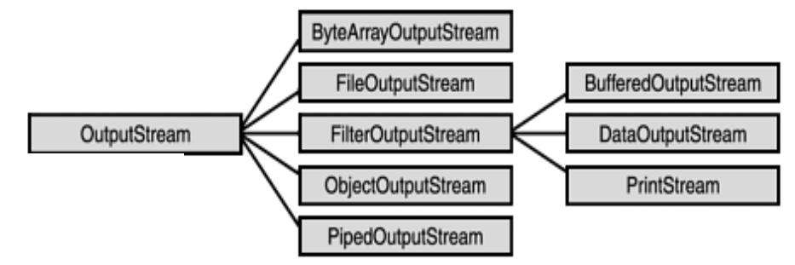

Some important classes in the hirarchy are discussed below

**1. FileOutputStream:** One of the few classes that can directly **write data** from Disk File.

Constructor and Description

**FileOutputStream(File file)**

Creates a file output stream to write to the file represented by the specified File object.

Open in write mode

*File file = new File( "output.txt");*

*FileOutputStream fos = new FileOutputStream(file);*

**FileOutputStream(File file, boolean append)**

Open in write mode, if boolean append = false

Open in append mode, if boolean append = true

*File file = new File( "output.txt");*

*FileOutputStream fos = new FileOutputStream(file, append);*

**FileOutputStream(String name)**

Creates a file output stream to write to the file represented by the specified f**ile name**.

*FileOutputStream fos = new FileOutputStream(“output.txt”);*

**FileOutputStream(String name, boolean append)**

Creates a file output stream to write to the file with the specified **file name**.

Open in write mode, if boolean append = false

Open in append mode, if boolean append = true

*FileOutputStream fos = new FileOutputStream("output.txt", append);*

***If file doesnt exists, this will create an empty file with the given fine name.***

Write functions and Description

Eg: Write data using above created **fos** object

**void write(int b)**

Writes the specified byte to this file output stream.

*FileOutputStream fos = new FileOutputStream("output.txt"));*

*fos.write(65); // Writes the byte for ASCII 'A'*

*System.out.println("Single byte (A) written to the file.");*

**void write(byte[] b)**

Writes b.length bytes from the specified byte array to this file output stream.

*FileOutputStream fos = new FileOutputStream("output.txt"));*

*String message = "Genesis 1:1 In the beginning God created the heavens and the earth";*

*byte[] byteArray = message.getBytes();*

*fos.write(byteArray);*

**void write(byte[] b, int offset, int len)**

Writes len bytes from the specified byte array starting at offset off to this file output stream.

*FileOutputStream fos = new FileOutputStream("output.txt"));*

*String message = "Genesis 1:1 In the beginning God created the heavens and the earth";*

*byte[] byteArray = message.getBytes();*

*fos.write(byteArray, 12, message.length());*

offset = 12, len = message.length() = 74

Therefore bytes between 12 to 74 will be written into the file.

That is “ In the beginning God created the heavens and the earth”

**2. BufferedOutputStream:**

Wraps another OutputStream, such as FileOutputStream, to improve efficiency by buffering output data (reading larger chunks at once and reducing disk access).

It does not wrte to disk directly but uses FileOutputStream as its underlying source to write data to Disk file.

Eg Create Object of BufferedOutputStream

*FileOutputStream fos = new FileOutputStream("output.txt");*

*BufferedOutputStream bos = new BufferedOutputStream(fos);*

Can use any of the read functions given below

int read()

int read(byte[] b, int off, int len)

Eg. read data using above created ***bos*** object.

**Using int write()**

// Example 1: Write a single byte using write(int b)

int singleByte = 65; // ASCII value of 'A'

bos.write(singleByte);

**Using int write(byte[] byteArray)**

// Example 2: Write a byte array using write(byte[] b, int off, int len)

String data = "Genesis 1:1 In the beginning God created the heavens and the earth";

byte[] byteArray = data.getBytes();

int offset = 0; // Start writing from beginning

int length = data.length(); // Write till end

bos.write(byteArray, offset, length);

**3. DataOutputStream:**

So far, the data is written as bytes. But some binary files ( .bin or .dat extensions) need to write data as primitive data types (e.g., int, float, double, etc.). DataOutputStream is ueed to fullfil such requiremets. DataOutputStream also be used to write data to Network (sockets).

It does not write to the disk directly but uses FileOutputStream as its underlying source to write data to Disk file.

Constructor

public DataOutputStream([OutputStream](https://docs.oracle.com/javase/8/docs/api/java/io/OutputStream.html) out)

Write Functions

void write(byte[] b, int off, int len)

void write(int b)

void writeBoolean(boolean v)

void writeByte(int v)

void writeBytes(String s)

void writeChar(int v)

void writeChars(String s)

void writeDouble(double v)

void writeFloat(float v)

void writeInt(int v)

void writeLong(long v)

void writeShort(int v)

*//Eg, write to a binary file*

*FileOutputStream fos = new FileOutputStream("binary_data.dat");*

*DataOutputStream dout = new DataOutputStream(fos);*

*dout.writeDouble(3.14);*

*dout.writeInt(100);*

*dout.writeBoolean(true);*

*dout.writeChar('A');*

**4. ObjectOutputStream:**

ObjectOutputStream is used to serialize objects (save them in byte form).

ObjectInputStream is used to deserialize objects (read them back into their original form).Both streams are typically used for persistent storage or object transfer in Java.

Eg: Serialize object of class Person

*FileOutputStream fileOutputStream = new FileOutputStream("serialized_object.dat");*

*ObjectOutputStream objectOutputStream = new ObjectOutputStream(fileOutputStream);*

*// Create an object to serialize*

*Person person = new Person("Alice", 30);*

*// Serialize and write the object to the file*

*objectOutputStream.writeObject(person);*

**5. ByteArrayOutputStream**

This itself does not write directly to the file system. It writes data into an in-memory byte array (buffer). However, you can take the byte data stored in the ByteArrayOutputStream and manually write it to a file using other classes like FileOutputStream.

*// Data to be written into ByteArrayOutputStream*

*String message = "Genesis 1:1 In the beginning God created the heavens and the earth";*

*ByteArrayOutputStream baos = new ByteArrayOutputStream()) {*

*// Convert the string message to a byte array*

*byte[] byteArray = message.getBytes();*

*// Write the byte array into the ByteArrayOutputStream*

*baos.write(byteArray);*

*// Convert the ByteArrayOutputStream to byte array*

*byte[] outputBytes = baos.toByteArray();*

*// Now write the byte array to a file*

*FileOutputStream fos = new FileOutputStream("output.txt")*

*fos.write(outputBytes);*

**Character Stream Classes**

**Character streams** are defined by using two class hierarchies.

At the **top are two abstract** classes,

- Reader class

- Writer class .

Java has several concrete subclasses of each of these, as given in belo diagram

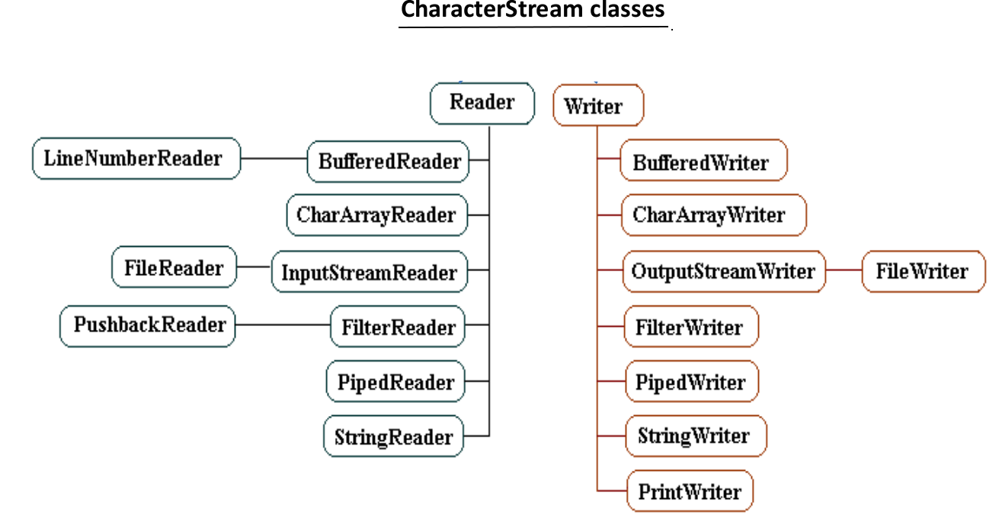

**Reader Class Hiratchy**

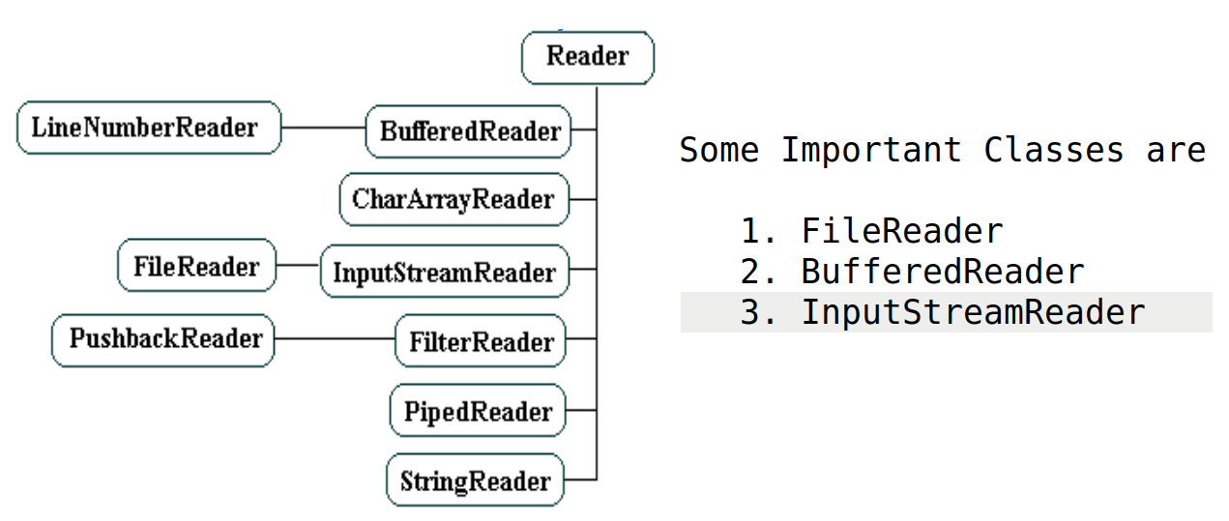

**1. FileReader**

**Only class capable of reading a disk file directly.**

It read data as a sequence of 16 bit (2-byte) unicode characrer.

Suitable for reading languages other than English, for eg Chinese, Arabic etc.

Constructors

**FileReader(File file) :**

Creates a FileReader object by opening a connection to an actual file, the file named by the File object file in the file system.

Eg. opens a file input.txt to read

// create File object

*File file = new File( "input.txt");*

*FileReader fin = new FileReader(file);*

**FileReader(String name)**

Creates a FileReader by opening a connection to an actual file, the file named by the path name name in the file system

Eg. opens a file input.txt using file name to read instead of File object.

*FileReader fin = new FileReader("input.txt");*

Read functions and Description

*All below functions use* ***fin*** *object created above.*

**int read()**

Reads a character of data from this file reader.

Eg. read data using above created fis object

*int data;*

*while ((data = fin.read()) != -1) {*

*System.out.print((char)data);*

*}*

**int read(char[] cbuf)**

*char arr[] = new char[20];*

*int charRead = 0;*

*while ((charRead = fin.read(arr)) != -1) {*

*System.out.println(new String(arr));*

*}*

Reads up to **charRead** bytes of data from this file reader

into an array of bytes.

**int read(char[] b, int off, int len)**

Reads up to **len** characters of data from this file reader into an array of bytes.

Eg. read data using above created fis object

*char [] buffer = new char[1024]; // Define a buffer to hold the data*

*int charRead;*

*int offset = 0;*

*int length = 20; // Set the length to read*

*while (( charRead = fin.read(buffer, offset, length)) != -1) {*

*// Convert the read bytes to a string and print them*

*String output = new String(buffer, 0, charRead);*

*System.out.println(output);*

*}*

**2. BufferedReader**

is a Java class that reads text from an file, for eg, efficiently buffering the characters to improve performance. It's used to read data in large chunks rather than one character at a time, which can significantly speed up input operations, especially when reading from slower sources like files or network streams.

It does not read from the disk directly but uses **FileReader** as its underlying source to get data from Disk file.

**Line-by-Line Reading:** Provides a method **readLine()** that reads a full line of text at a time, making it easy to handle text input.

**Note:**

This is the **only class** that support **reading** as a **String** class , **String** **readLine()**

Constructors

*BufferedReader(FileReader in)*

Creates a buffering character-input stream that uses a default-sized input buffer.

*BufferedReader(FileReader in, int sz)*

Creates a buffering character-input stream that uses an input buffer of the specified size.

**BufferedReader(FileReader in)**

FileReader fis = new FileReader("malayalam.txt");

BufferedReader **reader** = new BufferedReader(fis);

Read functions and Description

*All below functions use* ***reader*** *object created above.*

int read()

int read(char[] array)

int read(char[] b, int off, int len)

**String readLine()**

Reads a line of text/String.

Eg, reads a malayalam file as lines/String.

*String line;*

*while ((line = reader.readLine()) != null) {*

*String str = line + "\n";*

*System.out.println(str);*

*}*

**3. InputStreamReader**

is a class in Java that serves as a **bridge between Byte streams and Character streams**. It reads bytes from an input source and decodes them into characters using a specified charset or the platform's default charset.

Converts byte streams (e.g., data from a file or network) into character streams.

**Eg, reading a ASCII file, decoding into unicode character**

*//create construcor*

*// FileInputStream is byte stream*

*InputStream inputStream = new FileInputStream("input.txt");*

*// its converted into Char stream, Specify character encoding UTF8*

*InputStreamReader inputStreamReader = new InputStreamReader(inputStream, "UTF-8");*

*// Char Stream is wrapped by BufferReader*

*BufferedReader reader = new BufferedReader(inputStreamReader);*

*// reading file*

*String line;*

*while ((line = reader.readLine()) != null) {*

*System.out.println(line);*

*}*

**Writer Class Hiratchy**

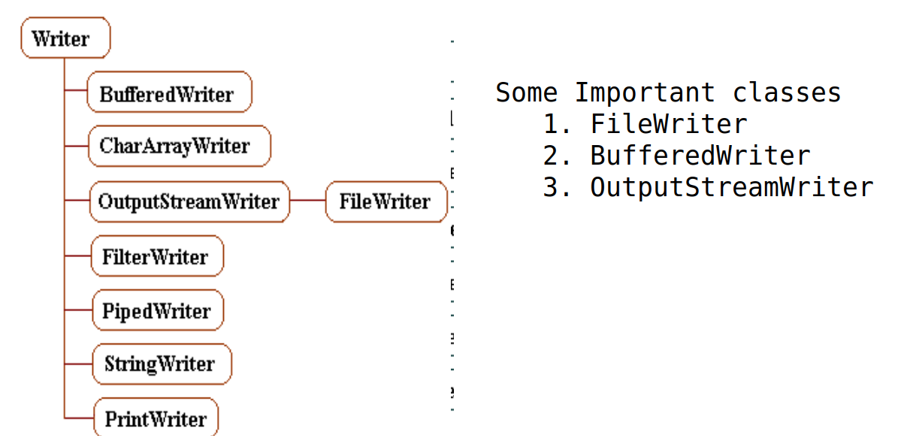

**1. FileWriter**

**Only class capable of writing a disk file directly.**

It writes data as a sequence of 16 bit (2-byte) unicode characrer.

Suitable for writing Non ASCII languages, for Eg Chinese, Arabic etc.

Constructors

**FileWriter(File file)**

Creates a file output stream to write to the file represented by the specified File object. Open in write mode

*File file = new File( "malayalam.txt");*

*FileWriter fw = new FileWriter(file);*

**FileWriter(File file, boolean append)**

Open in write mode, if boolean append = false

Open in append mode, if boolean append = true

*File file = new File( "malayalam.txt");*

*FileWriter fw = new FileWriter(file, append);*

**FileWriter(String name)**

Creates a file output stream to write to the file represented by the specified file name.

*FileWriter fw = new FileWriter(“malayalam.txt”);*

**FileWriter(String name, boolean append)**

Creates a file output stream to write to the file with the specified file name.

Open in write mode, if boolean append = false

Open in append mode, if boolean append = true

*FileWriter fw = new FileWriter("malayalam.txt", append);*

**If file doesnt exists, this will create an empty file with the given fine name.**

write functions and Description

*All below functions use* ***fw*** *object created above.*

void write(int c)

void write(char[] cbuf)

void write(char[] cbuf, int off, int len)

void write(String cbuf)

**void write(int c)**

*// Example 1: Write a single character using write(int c)*

*// int singleChar = 'ആ'; // Unicode for Malayalam character 'ആ'*

*//// also you can use corresponding hex values*

*int singleChar = 0x0D06; // Hexadecimal representation of ആ*

*fw.write(singleChar); // Writes the single character 'ആ'*

*fw.write('\n'); // Newline for clarity*

**void write(char[] cbuf)**

*// Example 2: Write an array of characters using write(char[] cbuf)*

*char[] verse1Array = "ആദിയിൽ ദൈവം ആകാശവും ഭൂമിയും സൃഷ്ടിച്ചു.*

*n".toCharArray();*

*// also you can use array of corresponding hex values*

*fw.write(verse1Array); // Writes the first verse as a char array*

**void write(char[] cbuf, int off, int len)**

*// Example 3: Write a portion of the character array using write(char[] cbuf, int off, int len)*

*// Writes first 10 characters of the first verse*

*fw.write(verse1Array, 0, 10);*

*fw.write('\n');*

**void write(String cbuf)**

*// Example 4: Write a full string using write(String str)*

*String verse2 = "ഭൂമി ശൂന്യവും പെരുപ്പും ആയിരുന്നു; അതിന്റെ മേൽ ഇരുട്ടും ആഴങ്ങളുടെ മേൽ ദൈവത്തിന്റെ ആത്മാവും ഉണ്ടായിരുന്നു.\n";*

*// also you can use array of corresponding hex values*

*// Writes the full string of verse 2*

*fw.write(verse2);*

**2. BufferedWriter**

is a Java class that writes text from an file, for eg, efficiently buffering the characters to improve performance. It's used to write data in large chunks rather than one character at a time, which can significantly speed up input operations, especially when writing to slower sources like files or network streams.

It does not write tothe disk directly but uses **FileWriter** as its underlying source to purt data into Disk file.

Constructors

***BufferedWriter(FileWriter in)***

Creates a buffering character-input stream that uses a default-sized input buffer.

***BufferedWriter( FileWriter in, int sz)***

Creates a buffering character-input stream that uses an input buffer of the specified size.

***BufferedWriter*( *FileWriter* in)**

FileWriter fir = new FileWriter("malayalam.txt");

BufferedWriter **writer** = new BufferedReader(fis);

write functions and Description

*All below functions use* ***writer*** *object created above.*

*void write(int c*) : Writes a single character.

*void write(String s): w*rites a String.

*void write(String s, int off, int len): w*rites a portion of a String.

*void write(char[] cbuf, int off, int len) :* Writes a portion of an array of characters.

Eg. Write/append unicode char to a file.

**void append(String str)**

*// Create a BufferedWriter wrapped around a FileWriter*

*BufferedWriter writer = new BufferedWriter(new FileWriter(fileName));*

*// Write a line of text*

*writer.write("Hello, World!");*

*writer.newLine(); // Using newLine() method to add a newline*

*// Write multiple lines using the append method*

*writer.append("This is a line added with append()").append("\n");*

*writer.write("This is another line.");*

**3. OutputStreamWriter**

is a class in Java that bridges byte streams and character streams. It is used to write characters to an output stream by converting them into bytes using a specified character encoding.

Eg Program, char array encoded into UTF 8 and write unicode file

String fileName = "output.txt";

*char[] charArray= "Genesis1:1ആദിയിൽ ദൈവം ആകാശവും ഭൂമിയും സൃഷ്ടിച്ചു”;*

*String textToWrite = charArray.toCharArray();*

*// Create a FileOutputStream to write to the file*

*FileOutputStream fos = new FileOutputStream(fileName);*

*// Create an OutputStreamWriter with UTF-8 encoding*

*OutputStreamWriter osw = new OutputStreamWriter(fos, "UTF-8");*

*// Write the text to the file*

*osw.write(textToWrite);*

***WORKING WITH FILES***

**1. Tiny Editor**

Create a editor, that echows the keybord inputs and exit when “quit” is typed.

*import java.io.*;*

*public class TinyEditor {*

*public static void main(String[] args) {*

*try {*

*BufferedReader br = new BufferedReader(*

*new InputStreamReader(System.in));*

*System.out.println("Enter a line of text");*

*System.out.println("Enter a quit to stop");*

*String str[] = new String[100];*

*for (int i = 0; i < 100; i++) {*

*str[i] = br.readLine();*

*if (str[i].equalsIgnoreCase("quit") == true) {*

*break;*

*}*

*}*

*System.out.println("Exit...!");*

*} catch (IOException e) {*

*e.printStackTrace();*

*}*

*}*

*}*

**2, Read an ASCII file and write to another file – Use byte stream classes**

*import java.io.*;*

*public class BytesStremTest {*

*public static void main(String[] args) {*

*try {*

*FileInputStream fis = new FileInputStream("input.txt");*

*FileOutputStream fos = new FileOutputStream("output.txt");*

*byte[] bArr = new byte[50];*

*int b = 0;*

*while ( (b = fis.read(bArr)) != -1) {*

*System.out.println(new String(bArr));*

*fos.write(bArr);*

*}*

*} catch (IOException e) {*

*e.printStackTrace();*

*}*

*}*

*}*

**3. Read any file and write to another file – Use char stream classes**

*import java.io.*;*

*public class CharStreamTest {*

*public static void main(String[] args) {*

*try {*

*FileReader fis = new FileReader("malayalam.txt");*

*BufferedReader reader = new BufferedReader(fis);*

*FileWriter fos = new FileWriter("utf_output.txt");*

*BufferedWriter writer = new BufferedWriter(fos);*

*while ((line = reader.readLine()) != null) {*

*System.out.println(line);*

*writer.write(line);*

*}*

*writer.close();*

*fos.close();*

*reader.close();*

*fis.close();*

*} catch (IOException e) {*

*e.printStackTrace();*

*}*

*}*

*}*

**4. Test DataInputStream & DataOutputStream**

*import java.io.*;*

*public class DataStreams {*

*public static void main (String[] s) {*

*try {*

*//1. open a file*

*File f1 = new File("out.dat");*

*if (f1.exists() == false) {*

*f1.createNewFile();*

*}*

*//2. create FileInputStream wrapped by DataInputStream*

*FileOutputStream fos = new FileOutputStream(f1);*

*DataOutputStream dout = new DataOutputStream(fos);*

*//3. write primitive data (float, int, boolean, char)*

*dout.writeDouble(3.14);*

*dout.writeInt(100);*

*dout.writeBoolean(true);*

*dout.writeChar('A');*

*// read data from the same file out.data*

*//1. create FileOutputStream wrapped by DataOutputStream*

*// using same file object f1*

*FileInputStream fis = new FileInputStream(f1);*

*DataInputStream din = new DataInputStream(fis);*

*//2 Read data*

*double dVal = din.readDouble();*

*int iVal = din.readInt();*

*boolean bVal = din.readBoolean();*

*char cVal = din.readChar();*

*System.out.println("dVal = " + dVal);*

*System.out.println("iVal = " + iVal);*

*System.out.println("bVal = " + bVal);*

*System.out.println("cVal = " + cVal);*

*dout.close();*

*fos.close();*

*din.close();*

*fis.close();*

*} catch (IOException e) {*

*System.out.println(e.getMessage());*

*}*

*}*

*}*

**5. University exam question...!**

**Enter a string via command line argument. Write the string into a file. Read it from the file and verify is it a palindrome. ?**

**// using Character stream class**

*import java.io.*;*

*public class PalindromeCheck {*

*public static void checkPalindrome(String fname) {*

*boolean flag = true;*

*try {*

*BufferedReader reader = new BufferedReader(new FileReader(fname));*

*if(reader != null) {*

*String line = reader.readLine();*

*if (line != null) {*

*int len = line.length();*

*for (int i=0; i<len/2; i++) {*

*if (line.charAt(i) != line.charAt(len-1-i)) {*

*flag = false;*

*break;*

*}*

*}*

*}*

*reader.close();*

*}*

*} catch (IOException e) {*

*e.printStackTrace();*

*}*

*if (flag == true) {*

*System.out.println("Entered string is a Palindrome...!");*

*} else {*

*System.out.println("Entered string is NOT a Palindrome...!");*

*}*

*}*

*public static void writeString(String fname, String line) {*

*try {*

*BufferedWriter writer = new BufferedWriter (new FileWriter(fname));*

*if (writer != null) {*

*writer.write(line);*

*writer.close();*

*}*

*} catch (IOException e) {*

*e.printStackTrace();*

*}*

*}*

*public static void main(String[] args) {*

*String line;*

*if (args.length > 0) {*

*line = args[0];*

*System.out.println("String =" + line);*

*writeString("test.txt", line);*

*checkPalindrome("test.txt");*

*}*

*}*

*}*

*How to run*

$ java PalindromeCheck malayalam

String : malayalam

Entered string is a Palindrome...!

**6. University exam question...!**

**Enter a string via command line argument. Write the string into a file. Read it from the file and verify is it a palindrome. ? Do it using Byte stream classes.**

*import java.io.*;*

*public class PalindromeCheck {*

*public static void checkPalindromeEx(String fname) {*

*boolean flag = true;*

*try {*

*FileInputStream fis = new FileInputStream(fname);*

*if(fis != null) {*

*byte [] b = new byte [1024];*

*int bRead = fis.read(b);*

*if (bRead > 0) {*

*String line = new String(b, 0, bRead);*

*int len = line.length();*

*System.out.println("Line = " + line);*

*System.out.println("length = " + len);*

*for (int i=0; i<len/2; i++) {*

*if (line.charAt(i) != line.charAt(len-1-i)) {*

*flag = false;*

*break;*

*}*

*}*

*}*

*fis.close();*

*}*

*} catch (IOException e) {*

*e.printStackTrace();*

*}*

*if (flag == true) {*

*System.out.println("Entered string is a Palindrome...!");*

*} else {*

*System.out.println("Entered string is NOT a Palindrome...!");*

*}*

*}*

*public static void writeStringEx(String fname, String line) {*

*try {*

*FileOutputStream fos = new FileOutputStream (fname);*

*if (fos != null) {*

*fos.write(line.getBytes());*

*fos.close();*

*}*

*} catch (IOException e) {*

*e.printStackTrace();*

*}*

*}*

*public static void main(String[] args) {*

*String line;*

*if (args.length > 0) {*

*line = args[0];*

*System.out.println("String =" + line);*

*writeStringEx("test.txt", line);*

*checkPalindromeEx("test.txt");*

*}*

*}*

*}*

***Reading Console Input / Writing Console Output***

***Relevent classes***

|  |  |
| --- | --- |
| **Reading Console Input classes** | **Writing Console Output classes** |
| *Scanner* | *System.out (PrintStream)* |
| *BufferedInputSream* | *PrintWriter* |
| *DataInputStream* | *BufferedWriter* |
| *BuferedReader* |  |
| *InputStreamReader* |  |

**The Predefined Streams**

***System.in***

***System.out***

***System.err***

Package java.lang defines a class called System.

System contains three predefined stream variables

– in, out, and err

These are standard input, output, error streams.

These are difined in Syatem class.

*static InputStream in;*

*static PrintStream out;*

*static PrintStream err;*

***Reading Console Input classes***

1. **Scanner class**

package java.utils

*/*------Class 1: Scanner class------*/*

*Scanner scanner = new Scanner(System.in);*

*System.out.print("Enter your name: ");*

*// Read a line of text from the console*

*String name = scanner.nextLine();*

*// Display the input received*

*System.out.println("Hello, " + name + "!");*

*/*--------------------------------------*/*

***2. BufferedInputSream class***

***package java.io***

***/*------Class 2: BufferedReader class------*/***

*BufferedInputStream bis = new BufferedInputStream(System.in);*

*System.out.print("Enter data : ");*

*byte[] b = new byte[100];*

*bis.read(b);*

*System.out.println("You entered : " + new String(b));*

/*--------------------------------------*/

***3. BufferedReader class***

package java.io

*/*------Class 3: BufferedReader class------*/*

*InputStreamReader Isr = new InputStreamReader(System.in);*

*BufferedReader br = new BufferedReader(Isr);*

*System.out.print("Enter your name: ");*

*try {*

*name = br.readLine();*

*System.out.println("Hello, " + name + "!");*

*} catch (IOException e) {*

*System.out.println(e.getMessage());*

*}*

*/*------------------------------------------------*/*

**4. DataInputStream class**

package java.io

*/*------Class 4: DataInputStream class------*/*

*DataInputStream dis = new DataInputStream(System.in);*

*System.out.print("Enter your name: ");*

*try {*

*name = dis.readLine();*

*} catch (IOException e) {*

*System.out.println(e.getMessage());*

*}*

*System.out.println("Hello, " + name + "!");*

*/*--------------------------------------------------*/*

5. **InputStreamReader class**

package java.io

*/*------Class 5: DataInputStream class------*/*

*InputStreamReader Isr1 = new InputStreamReader(System.in);*

*char[] c = new char[20];*

*try {*

*Isr1.read(c);*

*System.out.println("Hello, " + new String(c));*

*} catch (IOException e) {*

*System.out.println(e.getMessage());*

*}*

*/*--------------------------------------------------*/*

**Note**

*Why do we* ***wrap*** *InputStreamReader in BufferedReader**as below*

*InputStreamReader* ***Isr*** *= new InputStreamReader(System.in);*

*BufferedReader br = new BufferedReader(****Isr****);*

*Ans:*

*refer*

*InputStreamReader* ***Isr*** *= new InputStreamReader(****System.in****);*

*Here* ***System.in*** *is keyboard, which* ***byte stream****, that is transfer data in* ***bytes***

*BufferedReader is used to improve efficiency, but it works with* ***Character stream****,*

*which can not process bytes.*

*Hence, InputStreamReader is* ***converts byte stream into character stream****, so that BufferedReader can be used to improve efficiently.*

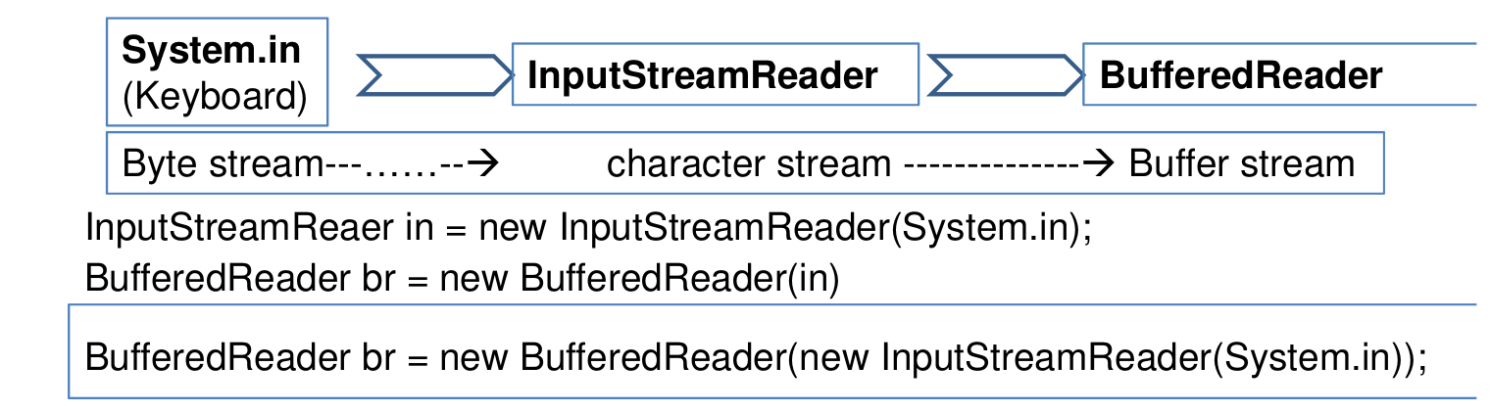

**Writing Console Output classes**

1. **System.out (PrintStream) class**

package java.utils

That is, ‘out’ is an object of PrintStream class in System class.

*/*Class 1: System.out------------*/*

*// Print with a newline*

*System.out.println("This is a message with a newline.");*

*// Print formatted text using printf*

*int number = 5;*

*System.out.printf("Formatted output: The number is %d \n", number);*

*//Print without a newline*

*System.out.print("This is a message without a newline.");*

*/*-----------------------------------*/*

2**. PrintWriter class**

package java.io

*/*Class 2: PrintWriter------------*/*

*PrintWriter pWriter = new PrintWriter(System.out, true);*

*pWriter.println("This is a message using PrintWriter.");*

*pWriter.printf("Formatted message: %d apples.%n", 5);*

*/*--------------------------------*/*

3**. BufferedWriter class**

package java.io

*/*Class 3: BufferedWriter------------*/*

*OutputStreamWriter Osw = new OutputStreamWriter(System.out);*

*BufferedWriter bWriter = new BufferedWriter(Osw);*

*try {*

*bWriter.write("BufferedWriter example: writing to console.");*

*bWriter.newLine();*

*bWriter.write("This is another line.");*

*bWriter.flush();*

*} catch (IOException e) {*

*System.out.println(e.getMessage());*

*}*

***PrintWritter Class***

***PrintWriter used for console output in Java***

***PrintWriter(System.out, true)***: This creates a PrintWriter object that wraps System.out. The second argument (true) ensures that the stream automatically flushes the buffer after each write operation (e.g., after println() or printf()).

***writer.println():*** This writes a line of text with a newline.

***writer.printf():*** This allows formatted text output (like System.out.printf()), useful for variables and formatted data.

***writer.print():*** This prints text without appending a newline at the end.

*// Create a PrintWriter that writes to the console (System.out)*

*PrintWriter writer = new PrintWriter(System.out, true); // 'true' enables auto-flush*

*// Write a simple message to the console*

*writer.println("This is a message written using PrintWriter.");*

*// Use formatted output with printf (similar to System.out.printf)*

*writer.printf("Formatted output: %d apples and %d oranges.%n", 5, 10);*

*// Use print (without newline)*

*writer.print("This is a single line printed without a newline.");*

*// Close the PrintWriter (optional when using System.out)*

*writer.close();*

***Note***

***what will happen if set auto-flush is set to false as below***

*PrintWriter writer = new PrintWriter(System.out,* ***false****); // 'true' enables auto-flush*

***Ans:***

*Without flush(), Output Will Not Appear Until Closing:*

*If you don't call* ***flush()*** *or* ***close()****, the output will remain buffered and will not appear on the console immediately.*

***System.out Vs PrintWriter***

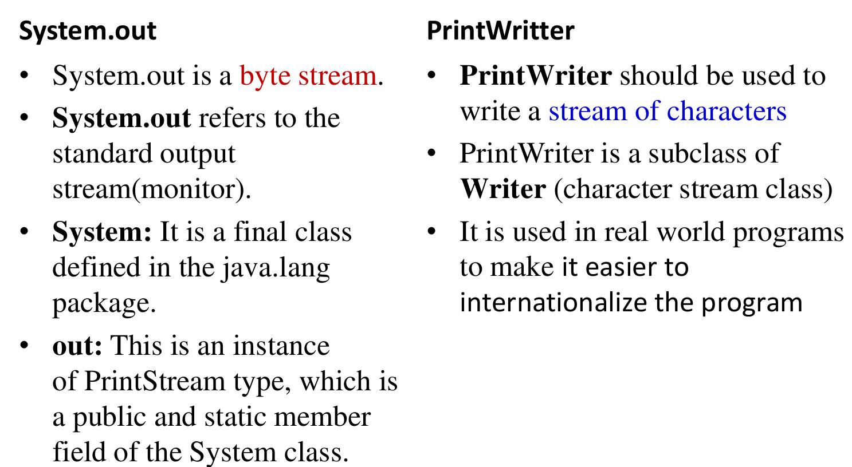

***Object Streams and Serialization***

**Serialization** is the process of writing(converting) the state/data of an object to a byte stream.

– This is useful when we want to

• save(store) the state/data of the program to file or

• when we want to send it over network.

– The ObjectOutputStream is used to serialize an object, for eg **student** object of

**Student class** and write it to a file, for eg, **student.ser**

**Deserialization.**

– Deserialization converts the stored byte streams in file to object

The ObjectInputStream is used to read the object back from the file.

The byte stream is converted back into a Person object.

The Person class implements **Serializable**, which is required for objects to be serialized in Java. The **Serializable** interface has no methods or fields and serves only to identify the semantics of being serializable

**Step 1: Create a class, for eg Sudent implementing Serializable**

*import java.io.*;*

*class* ***Student*** *implements* ***Serializable*** *{*

*private int id;*

*private String name;*

*public Student(int id, String name) {*

*this.id = id;*

*this.name = name;*

*}*

*public int getId() {*

*return id;*

*}*

*public String getName() {*

*return name;*

*}*

*}*

**Step 2: Create a test class to do serialization**

*public class SerializationExample {*

*public static void main(String[] args) {*

***// Serialize the object***

*try {*

*FileOutputStream fos = new FileOutputStream("student.ser");*

*ObjectOutputStream out = new ObjectOutputStream(fos);*

*Student student = new Student(1, "Alice");*

***out.writeObject(student);***

*System.out.println("Student object serialized and saved to student.ser");*

*}catch (IOException e) {*

*System.out.println(e.getMessage());*

*}*

***// Deserialize the object***

*try {*

*FileInputStream fis = new FileInputStream("student.ser");*

*ObjectInputStream Oin= new ObjectInputStream(fis);*

***Student deserializedStudent = (Student) Oin.readObject();***

*System.out.println("Deserialized Student: ID - " + deserializedStudent.getId());*

*System.out.println("Name - " + deserializedStudent.getName());*

*} catch(IOException e) {*

*System.out.println(e.getMessage());*

*} catch (ClassNotFoundException e) {*

*System.out.println(e.getMessage());*

*}*

*}*

*}*