Data Mining Vs Machine Learning
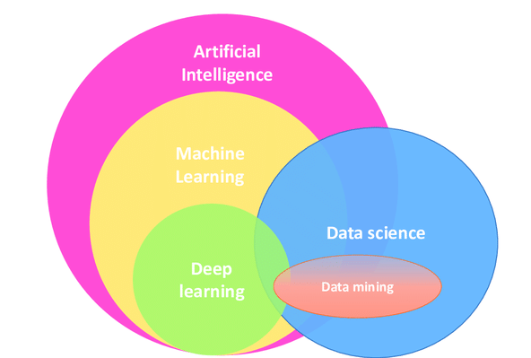
Data mining and machine learning are related fields but have distinct differences. Here's an example that illustrates the difference between the two:
Imagine you work for an e-commerce company, and your goal is to increase sales by understanding customer behavior.
Data Mining Example:
In the data mining phase, you start by collecting a vast amount of historical customer data, including purchase history, website visits, click-through rates, and demographic information. You then apply various data mining techniques to this dataset to discover patterns and insights. For instance, you might use clustering algorithms to group customers based on their browsing and purchasing habits. Data mining could reveal that customers who buy electronics often purchase accessories within a week.
Machine Learning Example:
Now, let's say you want to use machine learning to build a recommendation system. You take the insights gained from data mining and apply them to train a machine learning model. This model uses the historical data to make predictions about what products a specific customer might be interested in based on their past behavior and the behavior of similar customers. For instance, if the data mining phase identified a group of customers who frequently buy electronics and accessories together, your machine learning model can use this information to recommend accessories to customers who purchase electronics.

Data mining involves discovering patterns, trends, and insights from a large dataset without making predictions or decisions. It's about uncovering knowledge hidden in the data.
Machine learning, on the other hand, uses algorithms and models to make predictions or decisions based on data. It takes the insights from data mining and applies them to automate decision-making processes.
So, data mining is about knowledge discovery, while machine learning is about prediction and automation. They often go hand in hand, with data mining informing the feature engineering and data preparation stages of machine learning, which then leads to the development of predictive models

