Data Science vs ML,AI,DL. Differences and Why It Matters

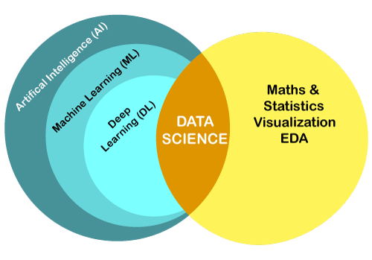

DATA SCIENCE VS MACHINE LEARNING
Data Science is an interdisciplinary field that uses various statistical and computational techniques to extract insights and knowledge from data. It encompasses a broad range of topics, such as data cleaning and processing, exploratory data analysis, data visualization, and predictive modeling. Data Scientists use their skills to interpret complex data and provide meaningful insights that can help organizations make informed decisions.

On the other hand, Machine Learning is a subset of Data Science that focuses on building algorithms that can learn from data and make predictions or decisions without being explicitly programmed. It involves using statistical models and algorithms to automatically identify patterns in data and make predictions or decisions based on those patterns. Machine Learning can be supervised, unsupervised, or semi-supervised, depending on the availability of labeled data.

Data Science is a broader field that involves extracting insights and knowledge from data using various techniques, while Machine Learning is a more specialized field that focuses on building algorithms that can learn from data to make predictions or decisions.

DATA SCIENCE VS ARTIFICIAL INTELLIGENCE (AI)
Data Science is an interdisciplinary field that uses statistical and computational techniques to extract insights and knowledge from data. It includes data processing, exploratory data analysis, data visualization, and predictive modeling. Data Scientists use their skills to interpret complex data and provide meaningful insights that can help organizations make informed decisions.

On the other hand, Artificial Intelligence (AI) refers to the creation of intelligent machines that can perform tasks that would typically require human intelligence, such as natural language processing, image recognition, and decision-making. AI encompasses several subfields, including Machine Learning, Natural Language Processing, Robotics, and Computer Vision.

Data Science is a field that focuses on extracting insights and knowledge from data, while AI is a broader field that aims to create intelligent machines capable of performing tasks that would typically require human intelligence.

DATA SCIENCE VS DEEP LEARNING
Deep learning, on the other hand, is a subset of machine learning that uses neural networks with multiple layers to learn complex representations of data. Deep learning models have achieved state-of-the-art performance in many areas, including computer vision, natural language processing, and speech recognition. Deep learning is especially useful in applications that involve large amounts of data and complex patterns.

In summary, data science is focused on extracting insights and value from data, while deep learning is focused on building models that can learn complex patterns from data using neural networks. Both fields are important in advancing artificial intelligence and solving real-world problems.

