DescentGradient

Gradient Descent, Stochastic Gradient Descent (SGD), and Mini-batch Stochastic Gradient Descent are optimization algorithms used to update the parameters (weights) of a model to minimize a loss function during the training of machine learning models, particularly in neural networks

Gradient Descent (GD):
In Gradient Descent, the model updates its parameters by computing the gradient of the loss function with respect to all training examples.

- Compute the average gradient
Calculate the gradients of the loss function with respect to the model parameters for each training example in the dataset. Then, sum up these gradients (or take their average) to obtain the overall gradient representing the average effect of all examples on the loss.

Given the function L(u)=log(u), to find its gradient or derivative, dL/du​, with respect to u, we can use differentiation rules:
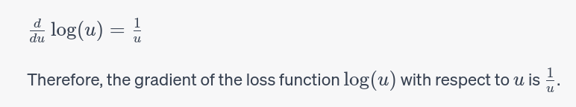
- Update the model parameters: After obtaining the average gradient, the model parameters (weights and biases) are adjusted once, in a single step, based on this averaged gradient. This update is done simultaneously for all parameters by subtracting the product of the average gradient and the learning rate from the current parameter values.
- One of the popular methods for finding an optimal learning rate in Artificial Neural Networks (ANNs) is called the "learning rate range test," which was introduced by Leslie N. Smith

- It can be computationally expensive for large datasets since it processes all training samples in each iteration.
Stochastic Gradient Descent (SGD):
- Compute the gradient
In contrast, SGD computes the gradient of the loss function for a single randomly chosen training example at each iteration.
- Update the model parameters Stochastic Gradient Descent updates the parameters by computing the gradient of the loss function for each training example individually and updating the parameters after each example.
- It uses a single training sample randomly selected from the dataset in each iteration to compute the gradient and update the parameters.

Mini-batch Stochastic Gradient Descent (mini-batch SGD):
- Gradient Descent updates parameters after computing the average gradient over the entire dataset in each iteration.
- Mini-batch Stochastic Gradient Descent updates parameters after computing the gradient for a smaller subset (mini-batch) of training examples in each iteration, striking a balance between the stability of GD and the faster convergence of SGD.

learning rate
learning rate range test

- Set Initial Learning Rate Range:
Define an initial range of learning rates, typically spanning several orders of magnitude (e.g., 1e-5 to 10).
- Gradually Increase Learning Rate:
Start training the neural network with the lowest learning rate in the defined range.
Increase the learning rate linearly or exponentially at each mini-batch or iteration.
- Monitor the Loss:
Record and monitor the loss (or another metric) as training progresses.
Continue until the learning rate becomes too large, causing the loss to diverge or become unstable.
- Plot Learning Rate against Loss:
Plot the learning rates against the recorded losses.
Look for a range of learning rates where the loss is decreasing steadily and most significantly.
- Select Learning Rate:
Choose a learning rate within the identified range where the loss is decreasing and stable.

