Diagram: Percpton without bias and with bias
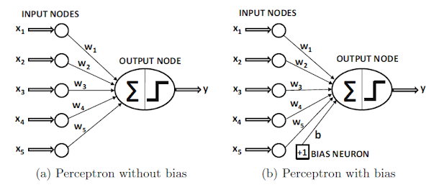
- A perceptron is the simplest form of a neural network, often considered a single-layer neural network.
- Proposed by Frank Rosenblatt in 1957, it serves as the foundational unit in neural network architectures.
- The perceptron is designed for binary classification tasks, taking multiple binary inputs and producing a single binary output.
- That is a single perceptron can be effective for linearly separable problems (problems where the data points can be separated by a straight line),.
- it has limitations. It cannot learn more complex patterns or relationships in the data

In a neural network, particularly when referring to a single-layer perceptron, the combination of a summation function and a step function (also known as an activation function) helps the perceptron make decisions or perform classification tasks by processing input data.

The summation function in a perceptron aggregates the weighted sum of input features. Each input feature is multiplied by its corresponding weight, and these products are summed together. Mathematically, it can be represented as:
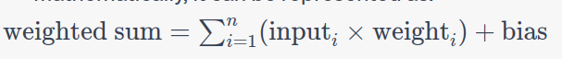
The step function (or activation function) in a perceptron determines whether the computed weighted sum (result of the summation function) should be interpreted as one class or another. The step function was traditionally used in perceptrons for binary classification tasks. It generates a binary output based on a threshold.

Components of a Perceptron:

- Inputs: Each input represents a feature or attribute of the input data. Associated with each input is a weight, signifying the strength of the connection.
- Weights: Weights are assigned to each input, reflecting the importance of that input. During the learning process, these weights are adjusted to minimize errors in the output.
- Bias: A bias term is introduced, acting as a constant that allows the perceptron to learn an offset or threshold. If the weighted sum of inputs plus the bias exceeds a certain threshold, the perceptron activates and outputs 1; otherwise, it outputs 0.
- Activation Function: The weighted sum of inputs and the bias is passed through an activation function, typically a step function. If the threshold is surpassed, the perceptron activates and outputs 1; otherwise, it outputs 0.
Modern neural networks utilize more complex activation functions (like ReLU, sigmoid, tanh, etc.) and multiple layers (multilayer perceptrons or deep neural networks) to handle more complex relationships in data.

Perceptron Algorithm:
- Initialize Weights and Bias: Assign random values to the weights and bias.
- Calculate Weighted Sum: Multiply each input by its corresponding weight, sum these products, and add the bias.
- Apply Activation Function: Pass the weighted sum through the activation function to obtain the perceptron's prediction.
- Update Weights and Bias: If the prediction is incorrect, adjust the weights and bias to minimize the error, typically using a learning rate.
- Repeat: Continue the process for multiple iterations or until the model performs well on the training data.

It's important to note that a single perceptron can only learn linearly separable functions, limiting its capacity for more complex tasks. For addressing such complexities, multilayer perceptrons (MLPs), consisting of one or more hidden layers with non-linear activation functions, are employed.

The process of optimizing and adjusting the parameters (such as weights and biases) in the perceptron algorithm was done in a heuristic way. "Heuristic" refers to a practical approach or method that may not be guaranteed to be optimal but is effective in practice

The optimizations were implemented using actual hardware circuits. In the early days of artificial intelligence and machine learning, computations were often performed using specialized hardware designed for specific tasks.

The optimization process for the perceptron algorithm was NOT formally expressed in terms of the sophisticated optimization frameworks and algorithms that are common in machine learning today. Concepts like gradient descent, backpropagation, and formal optimization techniques were NOT as established during that time.

They used approaches like
1. Manual weight adjustments
2. hardware circuits would perform computations and updates on weights in a parallel and distributed manner.

Despite the lack of formal optimization terminology, the overarching goal of using the perceptron algorithm was always to minimize the error in predictions. The focus was on adjusting the parameters in a way that improved the accuracy of the perceptron's binary classification predictions.

Algo to minimize loss function ....!
