Simple Linear Regression
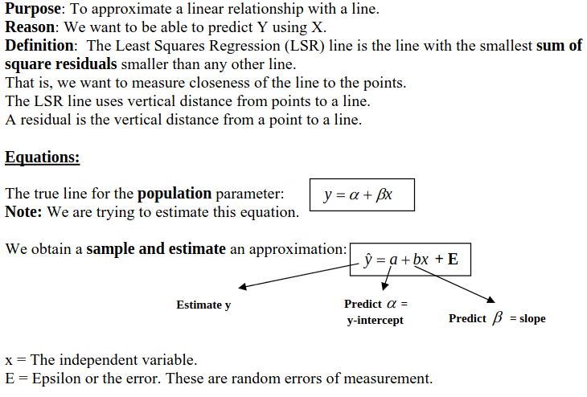

The linear model tells us that each observed Y is composed of two parts, (1) a linear function of X, and (2) an error. We can use the regression line to predict values of Y given values of X. For any given value of X, we go straight up to the line, and then move horizontally to the left to find the value of Y. The predicted value of Y is called the predicted value of Y, and is denoted Y'. The difference between the observed Y and the predicted Y (Y-Y') is called a residual. The predicted Y part is the linear part. The residual is the error.

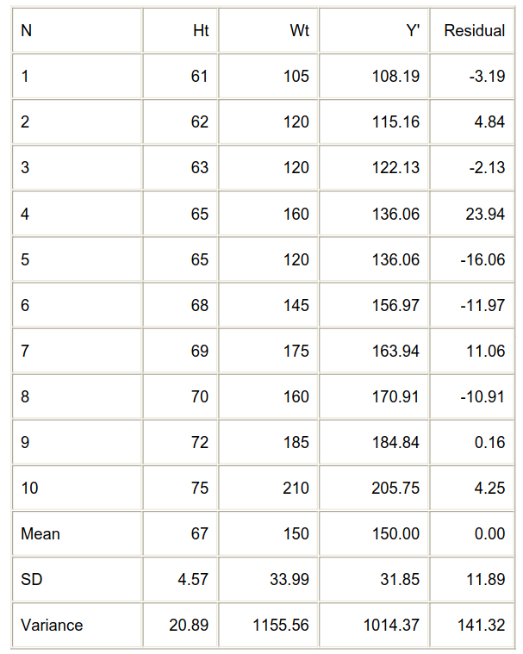

Multiple Linear Regression
We consider the problem of regression when the study variable depends on more than one explanatory or independent variables, called a multiple linear regression model. This model generalizes the simple linear regression in two ways. It allows the mean function ( )E y to depend on more than one explanatory variables and to have shapes other than straight lines, although it does not allow for arbitrary shapes.

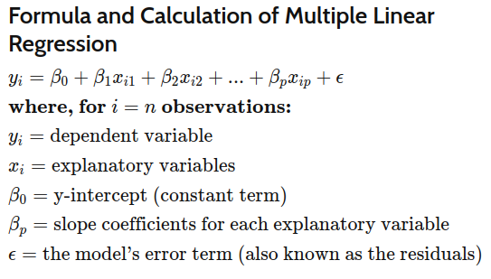

What Multiple Linear Regression Can Tell You
Simple linear regression is a function that allows an analyst or statistician to make predictions about one variable based on the information that is known about another variable. Linear regression can only be used when one has two continuous variables—an independent variable and a dependent variable. The independent variable is the parameter that is used to calculate the dependent variable or outcome. A multiple regression model extends to several explanatory variables.

Polynomial Linear Regression
he polynomial models can be used in those situations where the relationship between study and explanatory variables is curvilinear.

