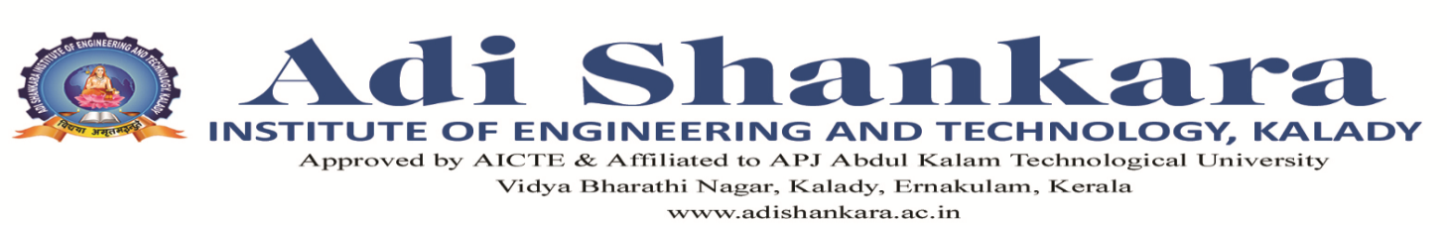

**DEPARTMENT: CSE(AI)**

**RESULT ANALYSIS**

Name of Examination : MODULE TEST 1

BATCH : 21-25 CS(AI)

No of students passed in all subjects: 13

**SUBJECT WISE ANALYSIS**

|  |  |  |  |  |  |  |  |
| --- | --- | --- | --- | --- | --- | --- | --- |
| SUBJECT NAME | FACULTY NAME WITH DEPT | NO OF STUDENTS | NO OF STUDENTS APPEARED | NO OF STUDENTS PASS | NO OF STUDENTS FAILED | % OF PASS | NO OF ABSENTEES |
| DESIGN ENGINEERING | Prof Shyama R(CSE) | 63 | 52 | 43 | 9 | 82.69% | 11 |
| CONSTITUTION OF INDIA | Prof Revathy Prasannan(CSE) | 63 | 52 | 46 | 6 | 88.46% | 11 |
| COMPUTER ORGANIZATION AND ARCHITECTURE | Prof Rosemary(CSE)  Prof Teena George(CSE)  Remya R (CSE) | 63 | 57 | 47 | 10 | 82.45% | 6 |
| DATABASE MANAGEMENT SYSTEMS | Prof Sumesh C Raman (CSE) | 63 | 50 | 38 | 12 | 76.00% | 13 |
| OPERATING SYSTEMS | Prof Sabitha M G (CSE) | 63 | 56 | 30 | 26 | 53.57% | 7 |
| MATHEMATICS FOR AI | Dr Misha (BSH) | 63 | 54 | 49 | 5 | 90.74% | 9 |

**TUTOR HOD PRINCIPAL**