Constraints
are various restrictions on data that can be specified on a relational database in the form of constraints. Constraints on databases can generally be divided into three main categories:

1. inherent model-based constraints or implicit constraints
2. schema-based constraints or explicit constraints
3. application-based or semantic constraints or business rules.

1. Implicit constraints
Constraints of the relational model and belong to this category.
No need to explicitely specify using DDL in Schema definition.
These are inherent in data model
For example,
the constraint that a relation cannot have duplicate tuples is an inherent constraint

2. Explicit constraints
These are Specified using DDL in schema.
Need to specify explicitely using DDL in schema definition.

2.1 Domain constraints,
2.2 Key constraints
2.3 Entity integrity constraints, and
2.4 Referential integrity constraints

2.1 Domain constraints
The value of each attribute A must be an atomic value from the domain dom(A).
The data types associated with domains typically include standard datatypes.
( The cell must be atomic, derived from domain)

2.2 Key constraints,
No two tuples can have the same combination of values for all their attributes.
Or corresponding to one Super Key, there should NOT be more than one tuple
That is
t1[SK] ≠ t2[SK]

2.3 Entity integrity constraints
The entity integrity constraint states that no primary key value can be NULL

2.4 Referential integrity constraints
To define referential integrity , first we define the concept of a foreign key.

Foreign key specifies and enforce a referential integrity constraint between the two relation schemas R1 and R2.

Definition of Foreign key:
is an attribute or a set of attributes in relation schema R1 that references relation R2. It shall be considered as Foreign key (FK) if it satisfies the following rules:

1. The attributes in FK in relation R1 have the same domain(s) as the primary key attributes PK of R2; the attributes FK in R1 are said to reference or refer to the relation R2.

2. A value of FK in a tuple t1 of the current state r1(R1) either occurs as a value of PK for some tuple t2 in the current state r2(R2) or is NULL.

3. application-based or semantic constraints or business rules.
Cannot be directly expressed in the schemas of the data model, and hence must be expressed and enforced by the application programs. Eg,
The Manager’s Saslary should be greater than employee salary.

Referential Integrity Constrints : Implementation in SQL

CREATE TABLE Employee(
fname varchar(15),
minit char,
lname varchar(15),
ssn char(9) PRIMARY KEY,
bdate date,
address varchar(30),
sex char,
salary number(10,2),
super_ssn char(9),
dno number(4)
);

CREATE TABLE Department (
dnumber number(4) PRIMARY KEY,
dname varchar(15),
mgrssn char(9),
mgrstartdate date
);

Setting Foreign Key of Employee table (dno) referencing from Department (dnumber)

ALTER TABLE Employee
ADD FOREIGN KEY (dno) references Department(dnumber)

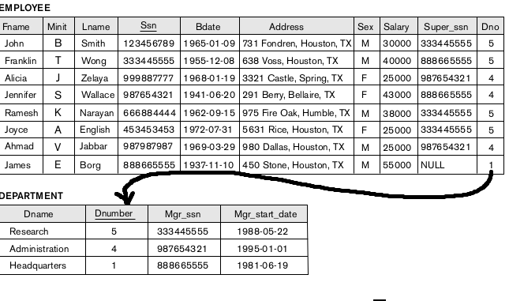

Actions on Constrint violations
Additionally, actions can be specified for what happens when the referenced key is updated or deleted, such as:
  - CASCADE: Automatically update or delete the rows in the foreign key table to match the change in the parent table.
  - SET NULL: Set the foreign key value to NULL if the corresponding row in the parent table is deleted (assuming the column can accept NULLs).
  - NO ACTION or RESTRICT: Prevent the deletion or update in the parent table if there are dependent rows in the foreign key table.

1. Insertion Rule:
When inserting data into a child table, any foreign key value must match an existing primary key value in the parent table or be null if the foreign key allows null values.

That is in our example, the Employee table should not add any tule with Dno which is not defined in Department table.

If we try to insert such a tuple, contraint violation will be raised and insert command will fail and databse will throw ERROR.

2. Deletion Rule:
When attempting to delete a record from the parent table, the DBMS checks if any foreign key references in the child table exist.

If so, the delete operation can be restricted, cascaded, or set to nullify the foreign keys, depending on the defined referential integrity constraints.

Cascade Delete Behavior: If a row in the Department table is deleted, ON DELETE CASCADE will automatically trigger the deletion of all rows in the Employee table that have a foreign key (dno) referencing the deleted dnumber.

In other words, when a department is removed from the Department table, all employees belonging to that department will also be removed from the Employee table.

CREATE TABLE Employee (
emp_id INT PRIMARY KEY,
emp_name VARCHAR(255) NOT NULL,
dno INT,
FOREIGN KEY (dno) REFERENCES Department(dnumber) ON DELETE CASCADE
);

On Delete set null Behavior:
In the context of your Employee table creation statement with ON DELETE SET NULL, this action means that when a row in the Department table is deleted, the dno value in any referencing Employee table rows will be set to NULL.
This effectively removes the link between the deleted department and its employees, leaving the employee records in the database but indicating that they are no longer associated with any department.

CREATE TABLE Employee (
emp_id INT PRIMARY KEY,
emp_name VARCHAR(255) NOT NULL,
dno INT,
FOREIGN KEY (dno) REFERENCES Department(dnumber) ON DELETE SET NULL
);

On Delete restrict Behavior:
If there's an attempt to delete a row in the Department table (the parent table), and that Department's dnumber is referenced by one or more Employee entries in their dno field (the child table), the delete operation will fail, and an ERROR will be thrown.

CREATE TABLE Employee (
emp_id INT PRIMARY KEY,
emp_name VARCHAR(255) NOT NULL,
dno INT,
FOREIGN KEY (dno) REFERENCES Department(dnumber) ON DELETE RESTRICT
);

Update Rule:
When updating a foreign key in the child table, its new value must match an existing primary key in the parent table or be null if the foreign key permits null values.

On Update Cascade Behavour

When you set a foreign key constraint with ON UPDATE CASCADE, it means that if the primary key value in the parent table ( Department in this example) is updated, any matching foreign keys in the child table(s) (Employee table in this eample) will be automatically updated to the new value.

CREATE TABLE Employee (
emp_id INT PRIMARY KEY,
emp_name VARCHAR(255) NOT NULL,
dno INT,
FOREIGN KEY (dno) REFERENCES Department(dnumber) ON UPDATE CASCADE );

On Update Set Null Behavour

If the referenced primary key value is updated in parent table (Here Department table) , the corresponding foreign keys in the child table (Employee table) are set to NULL, assuming that nulls are allowed in the foreign key column.

CREATE TABLE Employee (
emp_id INT PRIMARY KEY,
emp_name VARCHAR(255) NOT NULL,
dno INT,
FOREIGN KEY (dno) REFERENCES Department(dnumber) ON UPDATE SET NULL);

On Update restrict Behavior:

This constraint prevents the update of a primary key value in the parent table (Department) if there are any corresponding foreign key references in a child table (EMloyee).

CREATE TABLE Employee (
emp_id INT PRIMARY KEY,
emp_name VARCHAR(255) NOT NULL,
dno INT,
FOREIGN KEY (dno) REFERENCES Department(dnumber) ON UPDATE RESTRICT);

