### **Exercise 1**

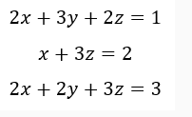Find the solution of the following System of Linear Equations using Cramer’s Rule.

### **Exercise 2**

Find the solution of the following System of Equations using Gaussian Elimination and Gauss Jordan method.

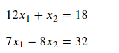

2x + 3y + 2z = 1

x + 3z = 2

2x + 2y + 2z = 3

12x1 + x2 = 18

7x1 - 8x2 = 32