Pandas is an open-source library for real world data analysis in python. It is built on top of Numpy. Using Pandas, data can be cleaned, transformed, manipulated, and analyzed. It is suited for different kinds of data including tabular as in a SQL table or a Excel spreadsheets, time series data, observational or statistical datasets.
The steps involved to perform data analysis using Pandas are as follows:
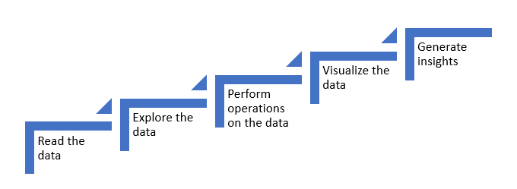
So far you have learnt, how Pandas can be used in for data analysis of real world data. You also learnt to perform the following tasks:
- Reading the data
- Exploring the data
- Performing operations on the data
- Combining data from different tables
- Generating quick insights with simple plots
Let us now proceed on to get acquainted with more powerful library for plotting and generating even deeper insights from the provided data.

