**PREPARED BY:**

* ANUJA SATAPATHY (L3733)
* ARATI BEHERA (L3824)
* DOLESWARI BADAIK (L3719)
* MANASHI PATTNAIK (L3772)
* SANJANA SETHI (L3734)
* SUBHASMITA JENA (L3727)

**UNDER THE GUIDENCE OF :**

**Mr. KISHAN SHARMA**

**CONTENTS**

* ACKNOWLEDGMENT
* CERTIFICATE
* INTRODUCTION
* CLASS HIERARCHY
* FLOW CHART
* SOURCE CODE
* OUTPUT
* CONCLUSION
* BIBLIOGRAPHY

**ACKNOWLEDGEMENT**

First of all, we would like to show our gratitude towards the contribution of Seenet Consultancy Services Pvt, Ltd. for the development and application domain.

We specially thank to Mr. Kishan Sharma Sir for providing us a wonderful opportunity to do the project work in Seenet giving us all support and guidance which made us complete the Project work.

We also would like to thank each and every member of our group for their valuable participation, support and guidance which helped us in completing our project work successfully.

**CERTIFICATE**

This to certify the following students: -

* **ANUJA SATAPATHY (L3733)**
* **ARATI BEHERA (L3824)**
* **DOLESWARI BADAIK (L3719)**
* **MANASHI PATTNAIK (L3772)**
* **SANJANA SETHI (L3734)**
* **SUBHASMITA JENA (L3727)**

Has been successfully carried out a bonfire out a work titles **“Hospital Management System”** during the academic year **2022-23** towards partial fulfillment of requirement for the computer science project evaluation for intern–al assessment have been incorporated the project.

The project is genuine and doesn’t indulge in plagiarism of any king the reference taken in this project has been declared at the end.

[Student’s project Co-Ordinate]

Seenet Consultancy Pvt. Ltd.

**INTRODUCTION**

Hospital requires a management system to control its various operations such as maintaining accounts of all the people in its domain of services attending to various needs of its patients and also achieving higher efficiency in the overall working quality of hospital itself.

Makes simpler and stall integration with the various module of the hospital and easy the processes of acquiring the information and providing services.

In this system we will make extensive use of the file system in **C++**.

We have used the functions for: -

**ADD RECORD SECTION:**

In this menu we have added the access to add patient’s full details.

**SEARCH RECORD SECTION:**

This allows you to search patient’s full details through their ID.

**DISPLAY RECORD SECTION:**

This allows you to display records of all patients at once.

**MODIFY RECORD SECTION:**

This allows you to modify any details of a patient of your choice.

**DELETE RECORD SECTION:**

This allows you to delete full details of any patient of your choice.

**BILLS GENERATION SECTION:**

This allows you to create an entire bill of a patient’s admission expenses in the hospital.

**ABOUT US:**

This allows you to read detailed information about this hospital and its facilities.

**EXIT:**

This allows you to exit from the program.

**CLASS HIERARCHY**

The main class “HOSPITAL” & its child class “PATIENTS” has been declared having the following data members.

**PROTECTED DATA MEMBERS**

Ch (Select Option choice)

Choice (While loop continuation choice)

**PRIVATE DATA MEMBERS**

* pid_ Patient ID
* bn_ Bed No.
* doa_ Date of Admit
* toa_ Time of Admit
* dod_ Date of Discharge
* tod_ Time of Discharge
* pn_ Patient Name
* dob _Date of Birth
* age _Age
* g_ Gender
* bg_ (Blood Group)
* ms_ (Marital Status)
* ads_ (Address)
* cn_ (Contact No.)
* eid_ (Email ID)
* po_ (Patient Occupation)
* n_ (Patient Nationality)
* aho_ (Patient Adhar card No)
* gn_ (Patient Guardian’s Name)
* gage_ (Guardian’s Age)
* gch_ (Guardian’s Contact No.)
* go_ (Guardian’s Occupation)
* an_ (Attendant Name )
* ar_ (Attendant Relationship)
* acn_ (Attendant contact No.)
* coa_ (Couse of Admit)
* dn_ (Doctor Name)
* gads_ (Guardian Address)
* b_ bill (Bed bill)
* f_ bill (food bill)
* m_ bill (Medicine bill)
* d_ bill (Doctor bill)
* t_ bill (Treatment bill)
* total bill (total bill)
* b days (No. of days to admit)
* gw (General Ward)
* cb (cabin)
* Ew (Emergency Ward)
* ICU (ICU)
* F days (No. of days f food)
* bc (Breakfast Combo)
* lc (Lunch Combo)
* dc (Dinner Combo)
* nstrips (No. of strips)
* pt (Paracetamol 500mg tablet)
* ct (Cetirizine 10mg tablet)
* ac (Amoxicillin 500mg capsule)
* pi (Pantoprozole 40mg injection)
* mi (multivitamin 1ml injection)
* av (Avilin 2ml)
* ddays (No. of days for doctor checkup)
* dk (Dr. Debjeet Kar)
* st (Dr. Sanjay Tirkey)
* sm (Dr. Sanjeet Mohanty)
* rd (Dr. Rohit Dash)
* rp (Dr. Rupali Panda)
* sd (Dr. Sunita Das)
* tdays (No. of time of treatment)
* xray (X-ray)
* us (Ultrasound)
* cs_ (ct scan)
* bt _(blood test)
* ecg_ (ECG)
* sid_ (staff ID)
* sn_ (staff name)
* dob1_ (Date of birth)
* age1_ (age)
* g1_ (gender)
* bg1_ (blood group)
* ms1_ (marital status)
* ads1_ (address)
* cn1_ (contact no)
* eid1_ (email)
* d_ (designation)
* n1_ (nationality)
* aho1_ (adhaar card no)
* n salary_ (salary)
* bsa_ (basic salary)
* hra_ (H.R.A)
* da_ (D.A)
* ta_ (T.A)
* pf_ (P.F)
* tdud_ (total dedication)
* tall_ (total allwance)
* sid_ (staff ID)
* sn_ (staff name)
* dob1_ (date of birth)
* age1_ (age)
* g1_ (gender)
* bg1_ (blood group)
* ms1_ (marital status)
* ads1_ (address)
* cn1_ (contact no.)
* eid1_ (email)
* d_ (designation)
* n1_ (nationality)
* aho1_ (Adhaar card no.)
* n salary_ (salary)
* bsa_ (basic salary)
* hra_ (H.R.A)
* da_ (D.A)
* ta_ (T.A)
* pf_ (P.F)
* tadud_ (total deduction)
* tall_ (total allowance)

**PUBLIC MEMBER FUNCTIONS**

void add (); void word_gen (); void doctor (); void staff_ modify ();

void search (); void word_ac (); void treatment (); void staff_ del ();

void display (); void word_lux (); void about (); void staff_ salary ();

void modify (); void bed (); void staff_ add (); void s_ doctor();

void del (); void food (); void staff_ search (); void s_ nurse();

void bill (); void medicine (); void staff_ display (); void s_ compounder();

void s_ ward();

**FUNCTIONS**

system(“cls”); :- To clear the output screen

gets (); :- To input data from the user

fflush(stdin) ; :- To clear the garbage Value

size of (); :- To find the size of a variable/datatype

close (); :- To close the opened data base file

exit (); :-To stop & exit from the output screen

getch (); :-To hold the console/output screen

goto (); :-To jump from one statement to other

return (0); :-To tell the complier to stop executing the program

**LOOPS & CONTROL STATEMENTS USED**

while loop

if……. else statement

switch case statement

do while loop

**OTHER VARIABLES**

Pid: - (patient ID)

Flag: - (To find out of the condition within the patient ID exists in the database file or not)

Pid1: - (Patient ID number to search)

Ch1: - (Choice number to modify patient details)

Pid2: - (Patient ID number to modify)

Pid3: - (Patient number to delete)

Ch2: - (Choice number to select list of facilities)

Pid4: - (Patient ID number for bill generation)

Ch3: - (Choice number to select bed charges)

Ch4: - (Choice number to select for food charges)

Ch5: - (Choice number to select for medicine charges)

Ch6: - (Choice number to select for doctor charges)

Ch7: - (Choice number to select for treatment charges)

Ch8: - (Choice number to select patient record section)

Ch9: - (choice number to select staff record section)

Ch10: - (choice number to select modify staff detail)

Ch11: - (choice number to select list of staff)

Sid1: - (Staff ID number to search)

Sid2: - (staff ID number to Modify)

Sid3: - (staff ID number to delete)

Sid4: - (staff ID number for salary generation )

Pass: - (To initialize the by default PASS CODE)

Pass1: - (To get the PASS CODE from the user)

**FLOW CHART**

**If pass1==pass**

**Patient Record**

**Staff Record**

**About Our Hospital**

**Exit**

**Hospital Management System (main Menu)**

**LOGIN**

**PATIENT RECORD**

1. Add patient Record
2. Search Patient Record
3. Display Patient Record
4. Modify Patient Record
5. Delete Patient Record
6. Patient Bill Generation

Enter your choice between (1-6)

**Patient ID Patient Occupation**

**Bed No. Patient Nationality**

**Date of Admit Patient Adhar card No**

**Time of Admit Patient Guardian’s Name**

**Date of Discharge Guardian’s Age**

**Time of Discharge Guardian’s Contact No.**

**Patient Name Guardian’s Occupation**

**Date of Birth Attendant Name**

**Age Attendant Relationship**

**Gender Attendant Contact No.**

**Blood Group Cause of Admit**

**Marital Status Doctor Name**

**Address Guardian Address**

**Contact No.**

**Email ID**

Do you want to continue again press(Y/N)

If your choice is 1 then

Patient Record

Enter your Choice between (1-6)

If your choice is 2 then

1. Add patient Record
2. Search Patient Record
3. Display Patient Record
4. Modify Patient Record
5. Delete Patient Record
6. Patient Bill Generation

Enter patient ID

Display Patient ID

Do you want to continue (press ‘Y’ for menu or ‘N’ for exit)

Enter your Choice between (1-6)

If your choice is 3 then

**Patient ID Patient Occupation**

**Bed No. Patient Nationality**

**Date of Admit Patient Adhar card No**

**Time of Admit Patient Guardian’s Name**

**Date of Discharge Guardian’s Age**

**Time of Discharge Guardian’s Contact No.**

**Patient Name Guardian’s Occupation**

**Date of Birth Attendant Name**

**Age Attendant Relationship**

**Gender Attendant Contact No.**

**Blood Group Cause of Admit**

**Marital Status Doctor Name**

**Address Guardian Address**

**Contact No.**

**Email ID**

Patient Record

1. Add patient Record
2. Search Patient Record
3. Display Patient Record
4. Modify Patient Record
5. Delete Patient Record
6. Patient Bill Generation

Do you want to continue (press ‘Y’ for menu or ‘N’ for exit)

**PATIENT RECORD**

Enter your choice between (1-6)

If your choice is 4 then

Enter patient choice to be Modified

1. Add patient Record
2. Search Patient Record
3. Display Patient Record
4. Modify Patient Record
5. Delete Patient Record
6. Patient Bill Generation

Modify your Record

Do you want to continue again press (Y/N)

If your choice is 5 then

**PATIENT RECORD**

1. Add patient Record
2. Search Patient Record
3. Display Patient Record
4. Modify Patient Record
5. Delete Patient Record
6. Patient Bill Generation

Enter your choice between (1-6)

Enter patient ID to delete

If flag==1

If flag==0

Patient ID nos. not found

Patient ID deleted

Do you want to continue again press (Y/N)

Enter patient ID for Bill

Enter patient ID to generation bill

If your choice is 6 then

Bed Charges

Food Charges

Medicine Charges

Doctor Charges

Treatment Charges

General Ward

Cabin

Emergency Ward

ICU

Breakfast Combo

Lunch Combo

Paracetamol Tab

Cetirizine Tab

Amoxicillin Capsule

Pantoprazole Injection

Multivitamin Injection

Dr. Debjeet Kar

Dr. Sanjay Tirkey

Dr. Sanjeet Mohanty

Dr. Rohit Dash

Dr. Rupali Panda

Dr. Sunita Das

X-Ray

Ultrasound

CT Scan

Blood Test

ECG

**PATIENT RECORD**

1. Add patient Record
2. Search Patient Record
3. Display Patient Record
4. Modify Patient Record
5. Delete Patient Record
6. Patient Bill Generation

Do you want to continue again press(Y/N)

Avilin 2ml

Dinner Combo

Enter your Choice between (1-6)

If your choice is 1 then

**Staff ID**

**Staff Name**

**Date of Birth**

**Age**

**Gender**

**Blood Group**

**Marital Status**

**Address**

**Contact No.**

**Email ID**

**Staff Designation**

**Nationality**

**Adhaar Card No.**

**STAFF RECORD**

1. Add Staff Record
2. Search Staff Record
3. Display Staff Record
4. Modify Staff Record
5. Delete Staff Record
6. Staff salary Generation

Do you want to continue again press (Y/N)

**Patient ID**

**Bed No.**

**Date of Admit**

**Time of Admit**

**Date of Discharge**

**Time of Discharge**

**Patient Name**

**Date of Birth**

**Age**

**Gender**

**Blood Group**

**STAFF RECORD**

1. Add Staff Record
2. Search Staff Record
3. Display Staff Record
4. Modify Staff Record
5. Delete Staff Record
6. Staff salary Generation

Enter your choice between (1-6)

If your choice is 2 then

Enter staff ID

Display staff ID

Do you want to continue again press (Y/N)

**STAFF RECORD**

1. Add Staff Record
2. Search Staff Record
3. Display Staff Record
4. Modify Staff Record
5. Delete Staff Record
6. Staff salary Generation

Enter your choice between (1-6)

If your choice is 3 then

**Staff ID**

**Staff Name**

**Date of Birth**

**Age**

**Gender**

**Blood Group**

**Marital Status**

**Address**

**Contact No.**

**Email ID**

**Staff Designation**

**Nationality**

**Adhaar Card No.**

Do you want to continue again press (Y/N)

**STAFF RECORD**

1. Add Staff Record
2. Search Staff Record
3. Display Staff Record
4. Modify Staff Record
5. Delete Staff Record
6. Staff salary Generation

Enter your choice between (1-6)

If your choice is 4 then

Enter staff ID to modify

Modify your record

Do you want to continue again press (Y/N)

**STAFF RECORD**

1. Add Staff Record
2. Search Staff Record
3. Display Staff Record
4. Modify Staff Record
5. Delete Staff Record
6. Staff salary Generation

Enter your choice between (1-6)

If your choice is 5 then

Enter staff ID to Delete

If flag==1

If flag==0

Staff ID nos. not found

Staff ID deleted successfully

Do you want to continue again press (Y/N)

**STAFF RECORD**

1. Add Staff Record
2. Search Staff Record
3. Display Staff Record
4. Modify Staff Record
5. Delete Staff Record
6. Staff salary Generation

Enter your choice between (1-6)

If your choice is 6 then

Enter staff ID to generation salary

List of staff

Do you want to continue again press (Y/N)

**ABOUT US**

About our hospital

Do you want to continue again press(Y/N)

**EXIT**

Thank You. For using our project

**SOURCE CODE**

#include<iostream>

#include<fstream>

#include<conio.h>

#include<string.h>

using namespace std;

class hospital

{

int ch8,pid,b_bill,f_bill,m_bill,d_bill,t_bill,total_bill=0;

int ch9,sid,nsalary=0;

char bn[10],doa[20],toa[10],dod[20],tod[10],pn[30],dob[15],age[10],

g[20],bg[10],ms[15],ads[30],cn[15],eid[30],po[20],n[30],ano[20],

gn[30],gage[10],gcn[15],go[20],gads[30],an[30],ar[20],acn[15],coa[20],dn[30],

sn[30],dob1[15],age1[10],g1[20],bg1[10],ms1[30],ads1[30],

cn1[15],eid1[30],d[30],n1[30],ano1[15];

public:

void about();

void add();

void search();

void display();

void modify();

void del();

void bill();

void ward_gen();

void ward_ac();

void ward_lux();

void bed();

void food();

void medicine();

void doctor();

void treatment();

void staff_add();

void staff_search();

void staff_display();

void staff_modify();

void staff_del();

void staff_salary();

void s_doctor();

void s_nurse();

void s_compounder();

void s_ward();

}h;

void hospital::add()

{

system("cls");

cout<<"====================ADD PATIENT RECORD SECTION==================\n\n";

ofstream ofs("hosdata.txt",ios::app);

cout<<"\nEnter Patient ID\t\t:";

cin>>pid;

cout<<"\nEnter Bed No.\t\t\t:";

fflush(stdin);

gets(bn);

cout<<"\nEnter Date of Admit\t\t:";

gets(doa);

cout<<"\nEnter Time of Admit\t\t:";

gets(toa);

cout<<"\nEnter Date of Discharge\t\t:";

gets(dod);

cout<<"\nEnter time of Discharge\t\t:";

gets(tod);

cout<<"\nEnter Patient Name\t\t:";

gets(pn);

cout<<"\nEnter Date of Birth\t\t:";

gets(dob);

cout<<"\nEnter Age\t\t\t:";

gets(age);

cout<<"\nEnter Gender\t\t\t:";

gets(g);

cout<<"\nEnter Blood Group\t\t:";

gets(bg);

cout<<"\nEnter Marital Status\t\t:";

gets(ms);

cout<<"\nEnter Address\t\t\t:";

gets(ads);

cout<<"\nEnter Contact No.\t\t:";

gets(cn);

cout<<"\nEnter Email ID\t\t\t:";

gets(eid);

cout<<"\nEnter Patient Occupation\t:";

gets(po);

cout<<"\nEnter Nationality\t\t:";

gets(n);

cout<<"\nEnter Adhaar Card No.\t\t:";

gets(ano);

cout<<"\nEnter Guardian's Name\t\t:";

gets(gn);

cout<<"\nEnter Guardian's Age\t\t:";

gets(gage);

cout<<"\nEnter Guardian's Contact No.\t:";

gets(gcn);

cout<<"\nEnter Guardian's Occupation\t:";

gets(go);

cout<<"\nEnter Guardian's Address\t:";

gets(gads);

cout<<"\nAttendant Name\t\t\t:";

gets(an);

cout<<"\nAttendant Relationship\t\t:";

gets(ar);

cout<<"\nAttendant Contact No.\t\t:";

gets(acn);

cout<<"\nEnter Cause of Admit\t\t:";

gets(coa);

cout<<"\nEnter Doctor Name\t\t:";

gets(dn);

total_bill=0;

ofs.write((char*)&h,sizeof(hospital));

cout<<"\n===================================================";

cout<<"\n\nRecord Added Successfully!!!";

ofs.close();

}

void hospital::search()

{

int pid1,flag=0;

system("cls");

cout<<"==================SEARCH PATIENT RECORD=================\n\n";

ifstream ifs("hosdata.txt");

if(!ifs)

{

cout<<"\nFile doesn't exist";

getch();

exit(0);

}

cout<<"\nEnter Patient ID to Search:";

cin>>pid1;

while(ifs.read((char*)&h,sizeof(hospital)))

{

if(pid1==pid)

{

cout<<"\nPatient ID\t\t:"<<pid;

cout<<"\nBed No.\t\t\t:"<<bn;

cout<<"\nDate of Admit\t\t:"<<doa;

cout<<"\nTime of Admit\t\t:"<<toa;

cout<<"\nDate of Discharge\t:"<<dod;

cout<<"\nTime of Discharge\t:"<<tod;

cout<<"\nPatient Name\t\t:"<<pn;

cout<<"\nDate of Birth\t\t:"<<dob;

cout<<"\nAge\t\t\t:"<<age;

cout<<"\nGender\t\t\t:"<<g;

cout<<"\nBlood Group\t\t:"<<bg;

cout<<"\nMarital Status\t\t:"<<ms;

cout<<"\nAddress\t\t\t:"<<ads;

cout<<"\nContact No.\t\t:"<<cn;

cout<<"\nEmail ID\t\t:"<<eid;

cout<<"\nPatient Occupation\t:"<<po;

cout<<"\nNationality\t\t:"<<n;

cout<<"\nAdhaar Card No.\t\t:"<<ano;

cout<<"\nGuardian's Name\t\t:"<<gn;

cout<<"\nGuardian's Age\t\t:"<<gage;

cout<<"\nGuardian's Contact No.\t:"<<gcn;

cout<<"\nGuardian's Occupation\t:"<<go;

cout<<"\nGuardian's Address\t:"<<gads;

cout<<"\nAttendant Name\t\t:"<<an;

cout<<"\nAttendant Relationship\t:"<<ar;

cout<<"\nAttendant Contact No.\t:"<<acn;

cout<<"\nCause of Admit\t\t:"<<coa;

cout<<"\nDoctor Name\t\t:"<<dn;

cout<<"\nTotal Bill\t\t:"<<total_bill;

flag=1;

}

}

if(flag==0)

{

cout<<"Patient ID not Found";

}

ifs.close();

}

void hospital::display()

{

system("cls");

cout<<"==================DISPLAY PATIENT RECORD=================\n\n";

ifstream ifs("hosdata.txt");

if(!ifs)

{

cout<<"File doesn't Exist";

getch();

exit(0);

}

while(ifs.read((char*)&h,sizeof(hospital)))

{

cout<<"\n=================================================";

cout<<"\nPatient ID\t\t:"<<pid;

cout<<"\nBed No.\t\t\t:"<<bn;

cout<<"\nDate of Admit\t\t:"<<doa;

cout<<"\nTime of Admit\t\t:"<<toa;

cout<<"\nDate of Discharge\t:"<<dod;

cout<<"\nTime of Discharge\t:"<<tod;

cout<<"\nPatient Name\t\t:"<<pn;

cout<<"\nDate of Birth\t\t:"<<dob;

cout<<"\nAge\t\t\t:"<<age;

cout<<"\nGender\t\t\t:"<<g;

cout<<"\nBlood Group\t\t:"<<bg;

cout<<"\nMarital Status\t\t:"<<ms;

cout<<"\nAddress\t\t\t:"<<ads;

cout<<"\nContact No.\t\t:"<<cn;

cout<<"\nEmail ID\t\t:"<<eid;

cout<<"\nPatient Occupation\t:"<<po;

cout<<"\nNationality\t\t:"<<n;

cout<<"\nAdhaar Card No.\t\t:"<<ano;

cout<<"\nGuardian's Name\t\t:"<<gn;

cout<<"\nGuardian's Age\t\t:"<<gage;

cout<<"\nGuardian's Contact No.\t:"<<gcn;

cout<<"\nGuardian's Occupation\t:"<<go;

cout<<"\nGuardian's Address\t:"<<gads;

cout<<"\nAttendant Name\t\t:"<<an;

cout<<"\nAttendant Relationship\t:"<<ar;

cout<<"\nAttendant Contact No.\t:"<<acn;

cout<<"\nCause of Admit\t\t:"<<coa;

cout<<"\nDoctor Name\t\t:"<<dn;

if(total_bill!=0)

{

cout<<"\nTotal Bill\t\t:"<<total_bill;

}

cout<<"\n=================================================";

getch();

}

ifs.close();

}

void hospital::modify()

{

int pid2,flag=0,ch1;

system("cls");

cout<<"======================MODIFY RECORD SECTION=====================\n\n";

ifstream ifs("hosdata.txt");

if(!ifs)

{

cout<<"\nFile doesn't exist";

getch();

exit(0);

}

ofstream ofs("temp.txt");

cout<<"\nEnter Patient ID to modify:";

cin>>pid2;

while(ifs.read((char*)&h,sizeof(hospital)))

{

if(pid2==pid)

{

flag=1;

cout<<"\nYou can modify the following data:\n";

cout<<"\n1- Bed No.\t\t\t:";

cout<<"\n2- Date of Admit\t\t:";

cout<<"\n3- Time of Admit\t\t:";

cout<<"\n4- Date of Discharge\t\t:";

cout<<"\n5- Time of Discharge\t\t:";

cout<<"\n6- Patient Name\t\t:";

cout<<"\n7- Date of Birth\t\t:";

cout<<"\n8- Age\t\t\t\t:";

cout<<"\n9- Gender\t\t\t:";

cout<<"\n10- Blood Group\t\t\t:";

cout<<"\n11- Marital Status\t\t:";

cout<<"\n12- Address\t\t\t:";

cout<<"\n13- Contact No.\t\t\t:";

cout<<"\n14- Email ID\t\t\t:";

cout<<"\n15- Patient Occupation\t\t:";

cout<<"\n16- Nationality\t\t\t:";

cout<<"\n17- Adhaar Card No.\t\t:";

cout<<"\n18- Guardian's Name\t\t:";

cout<<"\n19- Guardian's Age\t\t:";

cout<<"\n20- Guardian's Contact No.\t:";

cout<<"\n21- Guardian's Occupation\t:";

cout<<"\n22- Guardian's Address\t\t:";

cout<<"\n23- Attendant Name\t\t:";

cout<<"\n24- Attendant Relationship\t:";

cout<<"\n25- Attendant Contact No.\t:";

cout<<"\n26- Cause of Admit\t\t:";

cout<<"\n27- Doctor Name\t\t\t:";

cout<<"\n\nEnter Your Choice (1-27):";

cin>>ch1;

fflush(stdin);

switch(ch1)

{

case 1:

cout<<"\nEnter Bed No.\t\t\t:";

gets(bn);

break;

case 2:

cout<<"\nEnter Date of Admit\t\t:";

gets(doa);

break;

case 3:

cout<<"\nEnter Time of Admit\t\t:";

gets(toa);

break;

case 4:

cout<<"\nEnter Date of Discharge\t\t:";

gets(dod);

break;

case 5:

cout<<"\nEnter time of Discharge\t\t:";

gets(tod);

break;

case 6:

cout<<"\nEnter Patient Name\t\t:";

gets(pn);

break;

case 7:

cout<<"\nEnter Date of Birth\t\t:";

gets(dob);

break;

case 8:

cout<<"\nEnter Age\t\t\t:";

gets(age);

break;

case 9:

cout<<"\nEnter Gender\t\t\t:";

gets(g);

break;

case 10:

cout<<"\nEnter Blood Group\t\t:";

gets(bg);

break;

case 11:

cout<<"\nEnter Marital Status\t\t:";

gets(ms);

break;

case 12:

cout<<"\nEnter Address\t\t\t:";

gets(ads);

break;

case 13:

cout<<"\nEnter Contact No.\t\t:";

gets(cn);

break;

case 14:

cout<<"\nEnter Email ID\t\t\t:";

gets(eid);

break;

case 15:

cout<<"\nEnter Patient Occupation\t:";

gets(po);

break;

case 16:

cout<<"\nEnter Nationality\t\t:";

gets(n);

break;

case 17:

cout<<"\nEnter Adhaar Card No.\t\t:";

gets(ano);

break;

case 18:

cout<<"\nEnter Guardian's Name\t\t:";

gets(gn);

break;

case 19:

cout<<"\nEnter Guardian's Age\t\t:";

gets(gage);

break;

case 20:

cout<<"\nEnter Guardian's Contact No.\t:";

gets(gcn);

break;

case 21:

cout<<"\nEnter Guardian's Occupation\t:";

gets(go);

break;

case 22:

cout<<"\nEnter Guardian's Address\t:";

gets(gads);

break;

case 23:

cout<<"\nAttendant Name\t\t\t:";

gets(an);

break;

case 24:

cout<<"\nAttendant Relationship\t\t:";

gets(ar);

break;

case 25:

cout<<"\nAttendant Contact No.\t\t:";

gets(acn);

break;

case 26:

cout<<"\nEnter Cause of Admit\t\t:";

gets(coa);

break;

case 27:

cout<<"\nEnter Doctor Name\t\t:";

gets(dn);

break;

default:

cout<<"\nInvalid Choice";

}

ofs.write((char*)&h,sizeof(hospital));

}

else

{

ofs.write((char*)&h,sizeof(hospital));

}

}

ifs.close();

cout<<"\n\nRecord Modified Successfully!!!";

ofs.close();

remove("hosdata.txt");

rename("temp.txt","hosdata.txt");

}

void hospital::del()

{

int pid3,flag=0;

system("cls");

cout<<"======================DELETE RECORD SECTION=====================\n\n";

ifstream ifs("hosdata.txt");

if(!ifs)

{

cout<<"\nFile doesn't exist";

getch();

exit(0);

}

ofstream ofs("temp.txt");

cout<<"\nEnter Patient ID to Delete:";

cin>>pid3;

while(ifs.read((char*)&h,sizeof(hospital)))

{

if(pid3==pid)

{

flag=1;

cout<<"\nRecord Deleted Successfully!!!";

}

else

{

ofs.write((char*)&h,sizeof(hospital));

}

}

ifs.close();

ofs.close();

remove("hosdata.txt");

rename("temp.txt","hosdata.txt");

}

void hospital::bill()

{

int ch2,flag=0,pid4,tbill=0;

system("cls");

cout<<"======================PATIENT BILL GENERATION SECTION=====================\n\n";

ifstream ifs("hosdata.txt");

if(!ifs)

{

cout<<"\nFile doesn't exist";

getch();

exit(0);

}

ofstream ofs("temp.txt");

cout<<"\nEnter Patient ID for Bill\t:";

cin>>pid4;

while(ifs.read((char*)&h,sizeof(hospital)))

{

if(pid4==pid)

{

system("cls");

flag=1;

cout<<"\n--------------List of Facilities-------------\n";

cout<<"\n1- Bed Charge";

cout<<"\n2- Food Charge";

cout<<"\n3- Medicine Charge";

cout<<"\n4- Doctor Charge";

cout<<"\n5- Treatment Charge";

cout<<"\n\nEnter Your Choice (1-5):";

cin>>ch2;

switch(ch2)

{

case 1:

bed();

goto a;

break;

case 2:

a:

food();

goto b;

break;

case 3:

b:

medicine();

goto c;

break;

case 4:

c:

doctor();

goto d;

break;

case 5:

d:

treatment();

break;

default:

cout<<"\nInvalid Choice";

}

ofs.write((char*)&h,sizeof(hospital));

}

else

{

ofs.write((char*)&h,sizeof(hospital));

}

}

if(flag==0)

{

cout<<"\nPatient ID not Found";

}

ofs.close();

ifs.close();

remove("hosdata.txt");

rename("temp.txt","hosdata.txt");

}

void hospital::bed()

{

int ch3,bdays;

int gw=700,cb=2000,ew=3000,icu=5000,b_bill;

system("cls");

cout<<"\n*************Bed Charge************\n";

cout<<"\n1- General Ward";

cout<<"\n2- Cabin";

cout<<"\n3- Emergency Ward";

cout<<"\n4- ICU";

cout<<"\n\nEnter Your Choice (1-4):";

cin>>ch3;

switch(ch3)

{

case 1:

cout<<"\nGeneral Ward Charge="<<gw;

b_bill=gw;

cout<<"\nNo. of days to admit=";

cin>>bdays;

b_bill=b_bill*bdays;

cout<<"\nBed Charges="<<b_bill;

total_bill=total_bill+b_bill;

cout<<"\nTotal Bill="<<total_bill;

break;

case 2:

cout<<"\nCabin="<<cb;

b_bill=cb;

cout<<"\nNo. of days to admit=";

cin>>bdays;

b_bill=b_bill*bdays;

cout<<"\nBed Charges="<<b_bill;

total_bill=total_bill+b_bill;

cout<<"\nTotal Bill="<<total_bill;

break;

case 3:

cout<<"\nEmergency Ward="<<ew;

b_bill=ew;

cout<<"\nNo. of days to admit=";

cin>>bdays;

b_bill=b_bill*bdays;

cout<<"\nBed Charges="<<b_bill;

total_bill=total_bill+b_bill;

cout<<"\nTotal Bill="<<total_bill;

break;

case 4:

cout<<"\nICU="<<icu;

b_bill=icu;

cout<<"\nNo. of days to admit=";

cin>>bdays;

b_bill=b_bill*bdays;

cout<<"\nBed Charges="<<b_bill;

total_bill=total_bill+b_bill;

cout<<"\nTotal Bill="<<total_bill;

break;

}

getch();

}

void hospital::food()

{

int ch4,fdays;

int bc=100,lc=200,dc=150,f_bill;

system("cls");

cout<<"\n*************Food Charge************\n";

cout<<"\n\n1- Breakfast Combo";

cout<<"\n2- Lunch Combo";

cout<<"\n3- Dinner Combo";

cout<<"\n\nEnter Your Choice (1-3):";

cin>>ch4;

switch(ch4)

{

case 1:

cout<<"\nBreakfast Combo="<<bc;

f_bill=bc;

cout<<"\nNo. of days for food=";

cin>>fdays;

f_bill=f_bill*fdays;

cout<<"\nFood Charges="<<f_bill;

total_bill=total_bill+f_bill;

cout<<"\nTotal Bill="<<total_bill;

break;

case 2:

cout<<"\nLunch Combo="<<lc;

f_bill=lc;

cout<<"\nNo. of days for food=";

cin>>fdays;

f_bill=f_bill*fdays;

cout<<"\nFood Charges="<<f_bill;

total_bill=total_bill+f_bill;

cout<<"\nTotal Bill="<<total_bill;

break;

case 3:

cout<<"\nDinner Combo="<<dc;

f_bill=dc;

cout<<"\nNo. of days for food=";

cin>>fdays;

f_bill=f_bill*fdays;

cout<<"\nFood Charges="<<f_bill;

total_bill=total_bill+f_bill;

cout<<"\nTotal Bill="<<total_bill;

break;

}

getch();

}

void hospital::medicine()

{

int ch5,nstrips;

int pt=53,ct=90,ac=120,pi=155,mi=50,av=30,m_bill;

system("cls");

cout<<"\n\n************Medicine Charge**************\n";

cout<<"\n1- Paracetamol 500mg Tablet";

cout<<"\n2- Cetrizine 10mg Tablet";

cout<<"\n3- Amoxycilin 500mg Capsule";

cout<<"\n4- Pantoprazole 40 mg Injection";

cout<<"\n5- Multivitamin 1ml Injection";

cout<<"\n6- Avilin 2ml";

cout<<"\n\nEnter Your Choice (1-6):";

cin>>ch5;

switch(ch5)

{

case 1:

cout<<"\nParacetamol 500mg Tablet="<<pt;

m_bill=pt;

cout<<"\nNo. of strips=";

cin>>nstrips;

m_bill=m_bill*nstrips;

cout<<"\nMedicine Charges="<<m_bill;

total_bill=total_bill+m_bill;

cout<<"\nTotal Bill="<<total_bill;

break;

case 2:

cout<<"\nCetrizine 10mg Tablet="<<ct;

m_bill=ct;

cout<<"\nNo. of strips=";

cin>>nstrips;

m_bill=m_bill*nstrips;

cout<<"\nMedicine Charges="<<m_bill;

total_bill=total_bill+m_bill;

cout<<"\nTotal Bill="<<total_bill;

break;

case 3:

cout<<"\nAmoxycilin 500mg Capsule="<<ac;

m_bill=ac;

cout<<"\nNo. of strips=";

cin>>nstrips;

m_bill=m_bill*nstrips;

cout<<"\nMedicine Charges="<<m_bill;

total_bill=total_bill+m_bill;

cout<<"\nTotal Bill="<<total_bill;

break;

case 4:

cout<<"\nPantoprazole 40 mg Injection="<<pi;

m_bill=pi;

cout<<"\nNo. of strips=";

cin>>nstrips;

m_bill=m_bill*nstrips;

cout<<"\nMedicine Charges="<<m_bill;

total_bill=total_bill+m_bill;

cout<<"\nTotal Bill="<<total_bill;

break;

case 5:

cout<<"\nMultivitamin 1ml Injection="<<mi;

m_bill=mi;

cout<<"\nNo. of dose=";

cin>>nstrips;

m_bill=m_bill*nstrips;

cout<<"\nMedicine Charges="<<m_bill;

total_bill=total_bill+m_bill;

cout<<"\nTotal Bill="<<total_bill;

break;

case 6:

cout<<"\nAvilin 2ml="<<av;

m_bill=av;

cout<<"\nNo. of dose=";

cin>>nstrips;

m_bill=m_bill*nstrips;

cout<<"\nMedicine Charges="<<m_bill;

total_bill=total_bill+m_bill;

cout<<"\nTotal Bill="<<total_bill;

break;

}

getch();

}

void hospital::doctor()

{

int ch6,ddays;

int dk=500,st=500,sm=500,rd=500,rp=500,sd=500,d_bill;

system("cls");

cout<<"\n\n************Doctor Charge**************\n";

cout<<"\n1- Dr. Debjeet Kar";

cout<<"\n2- Dr. Sanjay Tirkey";

cout<<"\n3- Dr. Sanjeet Mahanty";

cout<<"\n4- Dr. Rohit Dash";

cout<<"\n5- Dr. Rupali Panda";

cout<<"\n6- Dr. Sunita Das";

cout<<"\n\nEnter Your Choice (1-6):";

cin>>ch6;

switch(ch6)

{

case 1:

cout<<"\nDr. Debjeet Kar="<<dk;

d_bill=dk;

cout<<"\nNo of Days=";

cin>>ddays;

d_bill=d_bill*ddays;

cout<<"\nDoctor Charge="<<d_bill;

total_bill=total_bill+d_bill;

cout<<"\nTotal Bill="<<total_bill;

break;

case 2:

cout<<"\nDr. Sanjay Tirkey="<<st;

d_bill=st;

cout<<"\nNo of Days=";

cin>>ddays;

d_bill=d_bill*ddays;

cout<<"\nDoctor Charge="<<d_bill;

total_bill=total_bill+d_bill;

cout<<"\nTotal Bill="<<total_bill;

break;

case 3:

cout<<"\nDr. Sanjeet Mahanty="<<sm;

d_bill=sm;

cout<<"\nNo of Days=";

cin>>ddays;

d_bill=d_bill*ddays;

cout<<"\nDoctor Charge="<<d_bill;

total_bill=total_bill+d_bill;

cout<<"\nTotal Bill="<<total_bill;

break;

case 4:

cout<<"\nDr. Rohit Dash="<<rd;

d_bill=rd;

cout<<"\nNo of Days=";

cin>>ddays;

d_bill=d_bill*ddays;

cout<<"\nDoctor Charge="<<d_bill;

total_bill=total_bill+d_bill;

cout<<"\nTotal Bill="<<total_bill;

break;

case 5:

cout<<"\nDr. Rupali Panda="<<rp;

d_bill=rp;

cout<<"\nNo of Days=";

cin>>ddays;

d_bill=d_bill*ddays;

cout<<"\nDoctor Charge="<<d_bill;

total_bill=total_bill+d_bill;

cout<<"\nTotal Bill="<<total_bill;

break;

case 6:

cout<<"\nDr. Sunita Das="<<sd;

d_bill=sd;

cout<<"\nNo of Days=";

cin>>ddays;

d_bill=d_bill*ddays;

cout<<"\nDoctor Charge="<<d_bill;

total_bill=total_bill+d_bill;

cout<<"\nTotal Bill="<<total_bill;

break;

}

getch();

}

void hospital::treatment()

{

int ch7,tdays;

int xray=500,us=1000,cs=800,bt=300,ecg=800,t_bill;

system("cls");

cout<<"\n\n************Treatment Charge**************\n";

cout<<"\n1- X-Ray";

cout<<"\n2- Ultrasound";

cout<<"\n3- CT Scan";

cout<<"\n4- Blood Test";

cout<<"\n5- ECG";

cout<<"\n\nEnter Your Choice (1-5):";

cin>>ch7;

switch(ch7)

{

case 1:

cout<<"\nX-Ray="<<xray;

t_bill=xray;

cout<<"\nNo of Times=";

cin>>tdays;

t_bill=t_bill*tdays;

cout<<"\nTreatment Charge="<<t_bill;

total_bill=total_bill+t_bill;

cout<<"\nTotal Bill="<<total_bill;

break;

case 2:

cout<<"\nUltrasound="<<us;

t_bill=us;

cout<<"\nNo of Times=";

cin>>tdays;

t_bill=t_bill*tdays;

cout<<"\nTreatment Charge="<<t_bill;

total_bill=total_bill+t_bill;

cout<<"\nTotal Bill="<<total_bill;

break;

case 3:

cout<<"\nCT Scan="<<cs;

t_bill=cs;

cout<<"\nNo of Times=";

cin>>tdays;

t_bill=t_bill*tdays;

cout<<"\nTreatment Charge="<<t_bill;

total_bill=total_bill+t_bill;

cout<<"\nTotal Bill="<<total_bill;

break;

case 4:

cout<<"\nBlood Test="<<bt;

t_bill=bt;

cout<<"\nNo of Times=";

cin>>tdays;

t_bill=t_bill*tdays;

cout<<"\nTreatment Charge="<<t_bill;

total_bill=total_bill+t_bill;

cout<<"\nTotal Bill="<<total_bill;

break;

case 5:

cout<<"\nECG="<<ecg;

t_bill=ecg;

cout<<"\nNo of Times=";

cin>>tdays;

t_bill=t_bill*tdays;

cout<<"\nTreatment Charge="<<t_bill;

total_bill=total_bill+t_bill;

cout<<"\nTotal Bill="<<total_bill;

break;

}

getch();

}

void hospital::staff_add()

{

system("cls");

cout<<"====================ADD STAFF RECORD SECTION==================\n\n";

ofstream ofs("staffdata.txt",ios::app);

cout<<"\nEnter Staff ID\t\t\t:";

cin>>sid;

cout<<"\nEnter Staff Name\t\t:";

fflush(stdin);

gets(sn);

cout<<"\nEnter Date of Birth\t\t:";

gets(dob1);

cout<<"\nEnter Age\t\t\t:";

gets(age1);

cout<<"\nEnter Gender\t\t\t:";

gets(g1);

cout<<"\nEnter Blood Group\t\t:";

gets(bg1);

cout<<"\nEnter Marital Status\t\t:";

gets(ms1);

cout<<"\nEnter Address\t\t\t:";

gets(ads1);

cout<<"\nEnter Contact No.\t\t:";

gets(cn1);

cout<<"\nEnter Email ID\t\t\t:";

gets(eid1);

cout<<"\nEnter Staff Designation\t\t:";

gets(d);

cout<<"\nEnter Nationality\t\t:";

gets(n1);

cout<<"\nEnter Adhaar Card No.\t\t:";

gets(ano1);

nsalary=0;

ofs.write((char*)&h,sizeof(hospital));

cout<<"\n===================================================";

cout<<"\n\nRecord Added Successfully!!!";

ofs.close();

}

void hospital::staff_search()

{

int sid1,flag=0;

system("cls");

cout<<"=========================SEARCH STAFF RECORD========================\n\n";

ifstream ifs("staffdata.txt");

if(!ifs)

{

cout<<"\nFile doesn't exist";

getch();

exit(0);

}

cout<<"\nEnter Staff ID to Search:";

cin>>sid1;

while(ifs.read((char*)&h,sizeof(hospital)))

{

if(sid1==sid)

{

cout<<"\nEnter Staff Name\t\t:"<<sn;

cout<<"\nEnter Date of Birth\t\t:"<<dob1;

cout<<"\nEnter Age\t\t\t:"<<age1;

cout<<"\nEnter Gender\t\t\t:"<<g1;

cout<<"\nEnter Blood Group\t\t:"<<bg1;

cout<<"\nEnter Marital Status\t\t:"<<ms1;

cout<<"\nEnter Address\t\t\t:"<<ads1;

cout<<"\nEnter Contact No.\t\t:"<<cn1;

cout<<"\nEnter Email ID\t\t\t:"<<eid1;

cout<<"\nEnter Designation\t\t:"<<d;

cout<<"\nEnter Nationality\t\t:"<<n1;

cout<<"\nEnter Adhaar Card No.\t\t:"<<ano1;

cout<<"\nSalary\t\t\t\t:"<<nsalary;

flag=1;

}

}

if(flag==0)

{

cout<<"Staff ID not Found";

}

ifs.close();

}

void hospital::staff_display()

{

system("cls");

cout<<"=============================DISPLAY STAFF RECORD==========================\n\n";

ifstream ifs("staffdata.txt");

if(!ifs)

{

cout<<"File doesn't Exist";

getch();

exit(0);

}

while(ifs.read((char*)&h,sizeof(hospital)))

{

cout<<"\n=================================================================";

cout<<"\nStaff ID\t\t\t:"<<sid;

cout<<"\nEnter Staff Name\t\t:"<<sn;

cout<<"\nEnter Date of Birth\t\t:"<<dob1;

cout<<"\nEnter Age\t\t\t:"<<age1;

cout<<"\nEnter Gender\t\t\t:"<<g1;

cout<<"\nEnter Blood Group\t\t:"<<bg1;

cout<<"\nEnter Marital Status\t\t:"<<ms1;

cout<<"\nEnter Address\t\t\t:"<<ads1;

cout<<"\nEnter Contact No.\t\t:"<<cn1;

cout<<"\nEnter Email ID\t\t\t:"<<eid1;

cout<<"\nEnter Staff Designation\t\t:"<<d;

cout<<"\nEnter Nationality\t\t:"<<n1;

cout<<"\nEnter Adhaar Card No.\t\t:"<<ano1;

if(nsalary!=0)

{

cout<<"\nNet Salary\t\t\t:"<<nsalary;

}

cout<<"\n=================================================================";

getch();

}

ifs.close();

}

void hospital::staff_modify()

{

int sid2,flag=0,ch10;

system("cls");

cout<<"========================MODIFY RECORD SECTION=======================\n\n";

ifstream ifs("staffdata.txt");

if(!ifs)

{

cout<<"\nFile doesn't exist";

getch();

exit(0);

}

ofstream ofs("temp1.txt");

cout<<"\nEnter Staff ID to modify:";

cin>>sid2;

while(ifs.read((char*)&h,sizeof(hospital)))

{

if(sid2==sid)

{

flag=1;

cout<<"\nYou can modify the following data:\n";

cout<<"\n1- Enter Staff Name\t\t:"<<sn;

cout<<"\n2- Enter Date of Birth\t\t:"<<dob1;

cout<<"\n3- Enter Age\t\t\t:"<<age1;

cout<<"\n4- Enter Gender\t\t:"<<g1;

cout<<"\n5- Enter Blood Group\t\t:"<<bg1;

cout<<"\n6- Enter Marital Status\t:"<<ms1;

cout<<"\n7- Enter Address\t\t:"<<ads1;

cout<<"\n8- Enter Contact No.\t\t:"<<cn1;

cout<<"\n9- Enter Email ID\t\t:"<<eid1;

cout<<"\n10- Enter Staff Designation\t:"<<d;

cout<<"\n11- Enter Nationality\t\t:"<<n1;

cout<<"\n12- Enter Adhaar Card No.\t:"<<ano1;

cout<<"\n\nEnter Your Choice (1-12):";

cin>>ch10;

fflush(stdin);

switch(ch10)

{

case 1:

cout<<"\nEnter Staff Name\t\t:";

gets(sn);

break;

case 2:

cout<<"\nEnter Date of Birth\t\t:";

gets(dob1);

break;

case 3:

cout<<"\nEnter Age\t\t\t:";

gets(age1);

break;

case 4:

cout<<"\nEnter Gender\t\t\t:";

gets(g1);

break;

case 5:

cout<<"\nEnter Blood Group\t\t:";

gets(bg1);

break;

case 6:

cout<<"\nEnter Marital Status\t\t:";

gets(ms1);

break;

case 7:

cout<<"\nEnter Address\t\t\t:";

gets(ads1);

break;

case 8:

cout<<"\nEnter Contact No.\t\t:";

gets(cn1);

break;

case 9:

cout<<"\nEnter Email ID\t\t\t:";

gets(eid1);

break;

case 10:

cout<<"\nEnter Staff Designation\t:";

gets(d);

break;

case 11:

cout<<"\nEnter Nationality\t\t\t:";

gets(n1);

break;

case 12:

cout<<"\nEnter Adhaar Card No.\t\t:";

gets(ano1);

break;

default:

cout<<"\nInvalid Choice";

}

ofs.write((char*)&h,sizeof(hospital));

}

else

{

ofs.write((char*)&h,sizeof(hospital));

}

}

ifs.close();

cout<<"\n\nRecord Modified Successfully!!!";

ofs.close();

remove("staffdata.txt");

rename("temp1.txt","staffdata.txt");

}

void hospital::staff_del()

{

int sid3,flag=0;

system("cls");

cout<<"======================DELETE RECORD SECTION=====================\n\n";

ifstream ifs("staffdata.txt");

if(!ifs)

{

cout<<"\nFile doesn't exist";

getch();

exit(0);

}

ofstream ofs("temp1.txt");

cout<<"\nEnter Staff ID to Delete:";

cin>>sid3;

while(ifs.read((char*)&h,sizeof(hospital)))

{

if(sid3==sid)

{

flag=1;

cout<<"\nRecord Deleted Successfully!!!";

}

else

{

ofs.write((char*)&h,sizeof(hospital));

}

}

ifs.close();

ofs.close();

remove("staffdata.txt");

rename("temp1.txt","staffdata.txt");

}

void hospital::staff_salary()

{

int sid4,flag=0,ch11;

system("cls");

cout<<"========================STAFF SALARY GENERATION=======================\n\n";

ifstream ifs("staffdata.txt");

if(!ifs)

{

cout<<"\nFile doesn't exist";

getch();

exit(0);

}

ofstream ofs("temp1.txt");

cout<<"\n\nEnter Staff ID to generate salary:";

cin>>sid4;

while(ifs.read((char*)&h,sizeof(hospital)))

{

if(sid4==sid)

{

flag=1;

cout<<"\n\nList of Staff:-";

cout<<"\n1- Doctor";

cout<<"\n2- Nurse";

cout<<"\n3- Compounder";

cout<<"\n4- Ward boy/girl";

cout<<"\n\nEnter Your Choice(1-4):";

cin>>ch11;

switch(ch11)

{

case 1:

h.s_doctor();

break;

case 2:

h.s_nurse();

break;

case 3:

h.s_compounder();

break;

case 4:

h.s_ward();

break;

default:

cout<<"\nInvalid Choice";

}

ofs.write((char*)&h,sizeof(hospital));

}

else

{

ofs.write((char*)&h,sizeof(hospital));

}

}

if(flag==0)

{

cout<<"\nStaff ID not found";

}

ifs.close();

ofs.close();

remove("staffdata.txt");

rename("temp1.txt","staffdata.txt");

}

void hospital::s_doctor()

{

int bsa=50000,hra,da,ta,tall,pf,it,tdud;

system("cls");

cout<<"====================SALARY GENERATION FOR DOCTOR=======================\n\n";

cout<<"Staff ID:"<<sid;

cout<<"\nStaff Name:"<<sn;

cout<<"\n\n\nBasic Salary:\t"<<bsa;

hra=bsa*0.10;

cout<<"\nHRA(10%):\t"<<hra;

da=bsa*0.08;

cout<<"\nD.A(8%):\t"<<da;

ta=bsa*0.05;

cout<<"\nT.A(5%):\t"<<ta;

tall=hra+da+ta;

pf=bsa*0.06;

cout<<"\nP.F(6%):\t"<<pf;

it=bsa*0.10;

cout<<"\nI.T(10%):\t"<<it;

tdud=pf+it;

nsalary=(bsa+tall)-tdud;

cout<<"\n\nNet Salary:\t"<<nsalary;

}

void hospital::s_nurse()

{

int bsa=30000,hra,da,ta,tall,pf,it,tdud;

system("cls");

cout<<"====================SALARY GENERATION FOR NURSE=======================\n\n";

cout<<"Staff ID:"<<sid;

cout<<"\nStaff Name:"<<sn;

cout<<"\n\n\nBasic Salary:"<<bsa;

hra=bsa*0.10;

cout<<"\nHRA(10%):"<<hra;

da=bsa*0.08;

cout<<"\nD.A(8%):"<<da;

ta=bsa*0.05;

cout<<"\nT.A(5%):"<<ta;

tall=hra+da+ta;

pf=bsa*0.06;

cout<<"\nP.F(6%):"<<pf;

it=bsa*0.10;

cout<<"\nI.T(10%):"<<it;

tdud=pf+it;

nsalary=(bsa+tall)-tdud;

cout<<"\n\nNet Salary:"<<nsalary;

}

void hospital::s_compounder()

{

int bsa=15000,hra,da,ta,tall,pf,it,tdud;

system("cls");

cout<<"====================SALARY GENERATION FOR COMPOUNDER=======================\n\n";

cout<<"Staff ID:"<<sid;

cout<<"\nStaff Name:"<<sn;

cout<<"\n\n\nBasic Salary:"<<bsa;

hra=bsa*0.10;

cout<<"\nHRA(10%):"<<hra;

da=bsa*0.08;

cout<<"\nD.A(8%):"<<da;

ta=bsa*0.05;

cout<<"\nT.A(5%):"<<ta;

tall=hra+da+ta;

pf=bsa*0.06;

cout<<"\nP.F(6%):"<<pf;

it=bsa*0.10;

cout<<"\nI.T(10%):"<<it;

tdud=pf+it;

nsalary=(bsa+tall)-tdud;

cout<<"\n\nNet Salary:"<<nsalary;

}

void hospital::s_ward()

{

int bsa=8000,hra,da,ta,tall,pf,it,tdud;

system("cls");

cout<<"====================SALARY GENERATION FOR WARD BOY/GIRL=======================\n\n";

cout<<"Staff ID:"<<sid;

cout<<"\nStaff Name:"<<sn;

cout<<"\n\n\nBasic Salary:"<<bsa;

hra=bsa*0.10;

cout<<"\nHRA(10%):"<<hra;

da=bsa*0.08;

cout<<"\nD.A(8%):"<<da;

ta=bsa*0.05;

cout<<"\nT.A(5%):"<<ta;

tall=hra+da+ta;

pf=bsa*0.06;

cout<<"\nP.F(6%):"<<pf;

it=bsa*0.10;

cout<<"\nI.T(10%):"<<it;

tdud=pf+it;

nsalary=(bsa+tall)-tdud;

cout<<"\n\nNet Salary:"<<nsalary;

}

void hospital::about()

{

system("cls");

cout<<"\n\n\t\t\t\t================================ABOUT OUR HOSPITAL===============================\n";

cout<<"\n\n\n\t\t\t\tHospital is a place where thye sick and the injured are taken for treatment.";

cout<<"\n\t\t\t\tThe doctor and nurse are readily available there for admitting and attending";

cout<<"\n\t\t\t\ton their patients.";

cout<<"\n\t\t\t\tThe dedicated teams of doctor and nurse delivers the message of hope to their";

cout<<"\n\t\t\t\tpatients in the hospital.";

cout<<"\n\t\t\t\tAll over the world, hospital are built to treat and cure thousand of the sick";

cout<<"\n\t\t\t\tpatients.";

cout<<"\n\t\t\t\tAs these hospitals, there are very twell-equipped facilities and expert doctors.";

cout<<"\n\t\t\t\tThese hospitals are considered the best places for effective treatment.";

cout<<"\n\t\t\t\tThe doctors and nurse do their work with a dedication and maintains the pleasant";

cout<<"\n\t\t\t\tatmosphere of the";

cout<<"\n\t\t\t\thospital so that the patients feel comfortable and better.";

cout<<"\n\n\n\t\t\t\tADDRESS:\n\t\t\t\tCommunity Welfare Society Hospital,Jagda";

cout<<"\n\n\t\t\t\tPO: Rourkela 76902 Odisha.";

cout<<"\n\n\t\t\t\tPhone: 0661 2473931\t\t\t\t\t Email:cwsrkl@yahoo.com";

cout<<"\n\t\t\t\t\t0826 0246020\t\t\t\t\t Website:www.cwshospital.org";

}

int main()

{

int ch,ch8,ch9,pass=1234,pass1;

char choice;

cout<<"\n\n\n\n\n\t\t\t\t\t\t\tEnter a Valid Password:";

cin>>pass1;

if(pass!=pass1)

{

cout<<"\n\t\t\t\t-----Invaild Password,Try Again Later-----";

getch();

exit(0);

}

else

{

cout<<"\n\n\n\t\t\t\t\t\t\tDesigned By:\n";

cout<<"\n\t\t\t\t\t\t\tAnuja Satapathy\t\t(L3733)";

cout<<"\n\t\t\t\t\t\t\tArati Behera\t\t(L3824)";

cout<<"\n\t\t\t\t\t\t\tDoleswari Badaik\t(L3719)";

cout<<"\n\t\t\t\t\t\t\tManashi Pattnaik\t(L3772)";

cout<<"\n\t\t\t\t\t\t\tSanjana Sethi\t\t(L3734)";

cout<<"\n\t\t\t\t\t\t\tSubhasmita Jena\t\t(L3727)";

cout<<"\n\n\n\t\t\t\t\t\t\tUnder the Guidance of:";

cout<<"\n\n\t\t\t\t\t\t\tKishan Sharma ";

cout<<"\n\n\n\t\t\t\t\t\t\tPress Any key...";

getch();

do

{

system("cls");

cout<<"==================WELCOME TO HOSPITAL MANAGEMENT SYSTEM================\n\n";

cout<<"1- Patient Record\n";

cout<<"2- Staff Record\n";

cout<<"3- About Our Hospital\n";

cout<<"4- Exit";

cout<<"\n\nEnter Your Choice (1-4):";

cin>>ch;

switch (ch)

{

case 1:

system("cls");

cout<<"\n=======================PATIENT RECORD SECTION======================\n\n";

cout<<"1- Add New Patient Record\n";

cout<<"2- Search Patient Record\n";

cout<<"3- Display All Patient Record\n";

cout<<"4- Modify Patient Record\n";

cout<<"5- Delete Patient Record\n";

cout<<"6- Patient Bill Generation\n";

cout<<"\n\nEnter Your Choice (1-6):";

cin>>ch8;

switch (ch8)

{

case 1:

h.add();

break;

case 2:

h.search();

break;

case 3:

h.display();

break;

case 4:

h.modify();

break;

case 5:

h.del();

break;

case 6:

h.bill();

break;

case 7:

cout<<"\n\nThank You for Using Our Project\n";

exit(0);

break;

default:

cout<<"\nInvalid Choice";

}

break;

case 2:

system("cls");

cout<<"\n=======================STAFF RECORD SECTION======================\n\n";

cout<<"1- Add New Staff Record\n";

cout<<"2- Search Staff Record\n";

cout<<"3- Display All Staff Record\n";

cout<<"4- Modify Staff Record\n";

cout<<"5- Delete Staff Record\n";

cout<<"6- Staff Salary Generation\n";

cout<<"\n\nEnter Your Choice (1-6):";

cin>>ch9;

switch (ch9)

{

case 1:

h.staff_add();

break;

case 2:

h.staff_search();

break;

case 3:

h.staff_display();

break;

case 4:

h.staff_modify();

break;

case 5:

h.staff_del();

break;

case 6:

h.staff_salary();

break;

case 7:

cout<<"\n\nThank You for Using Our Project\n";

exit(0);

break;

default:

cout<<"\nInvalid Choice";

}

break;

case 3:

h.about();

break;

case 4:

cout<<"\n\nThank You for Using Our Project\n";

exit(0);

break;

default:

cout<<"\nInvalid Choice";

}

cout<<"\n\n\n\n\n\t\t\t\tWant to continue again (Press 'Y'for Menu or Press'N'for Exit):";

fflush(stdin);

cin>>choice;

}while(choice=='Y'||choice=='y');

}

}

**OUTPUT SCREENSHOT**

* **LOGIN TO HOSPITAL MANAGRMENT SYSTEM**

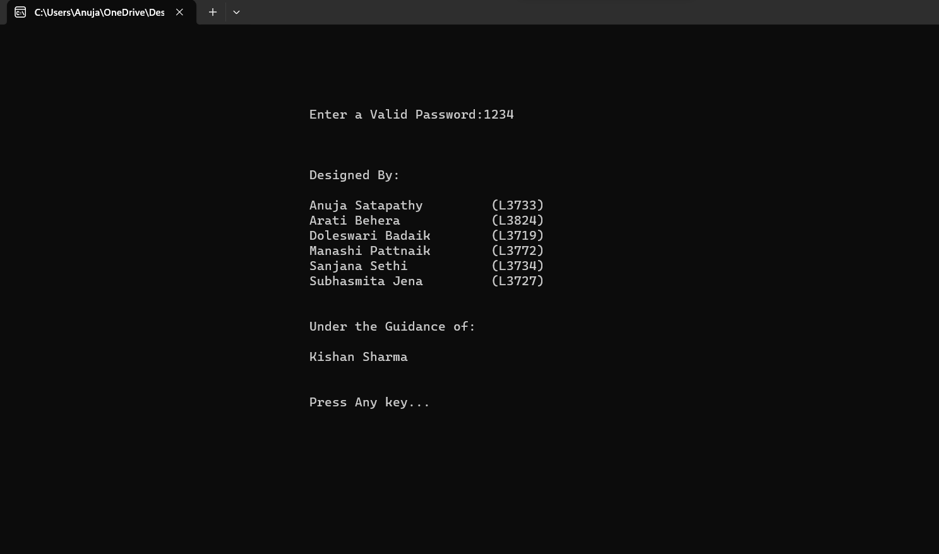

* **MAIN MENU**

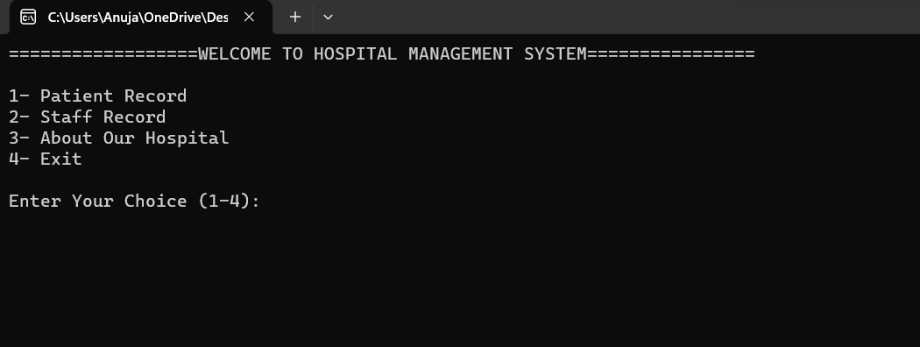

* **PATIENT RECORD SECTION**

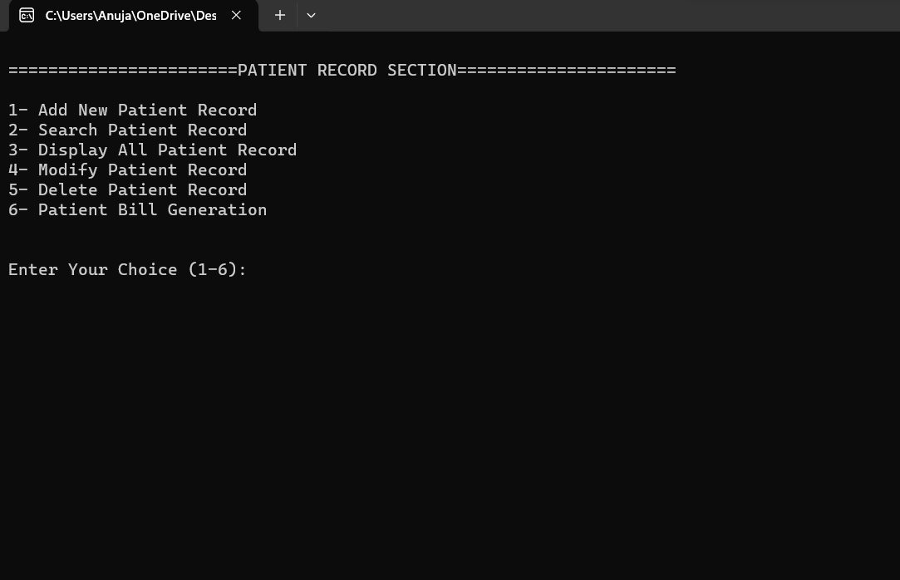

* **ADD PATIENT RECORD SECTION**

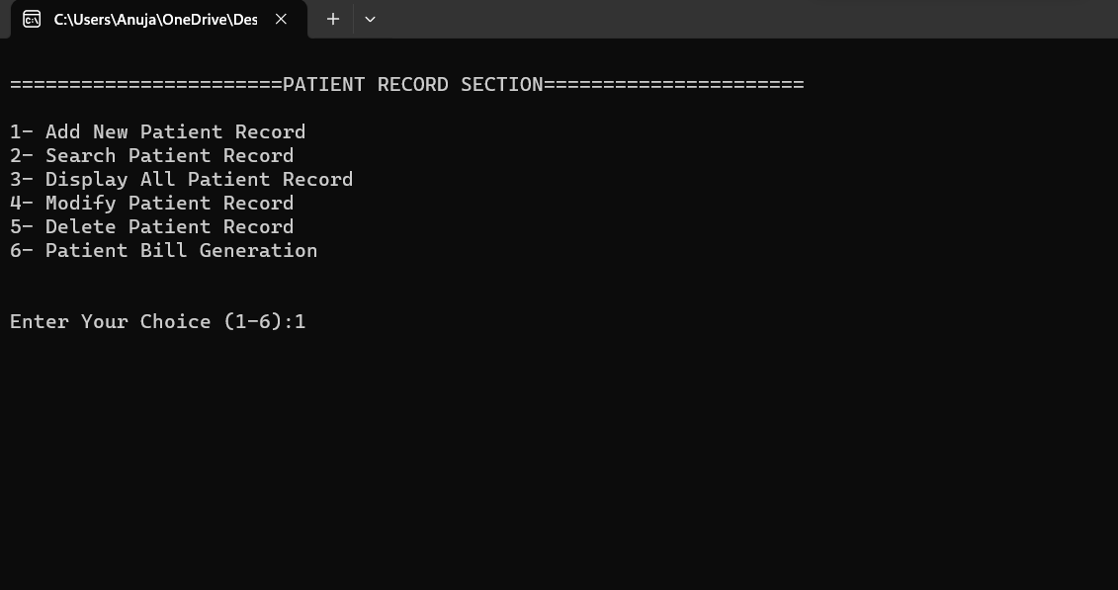

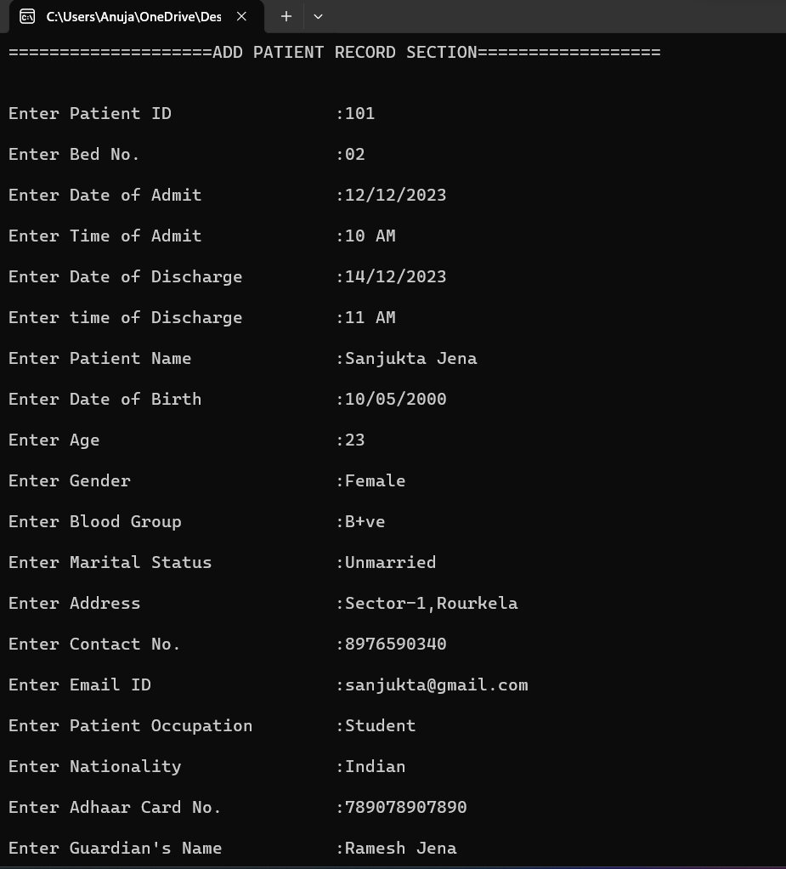

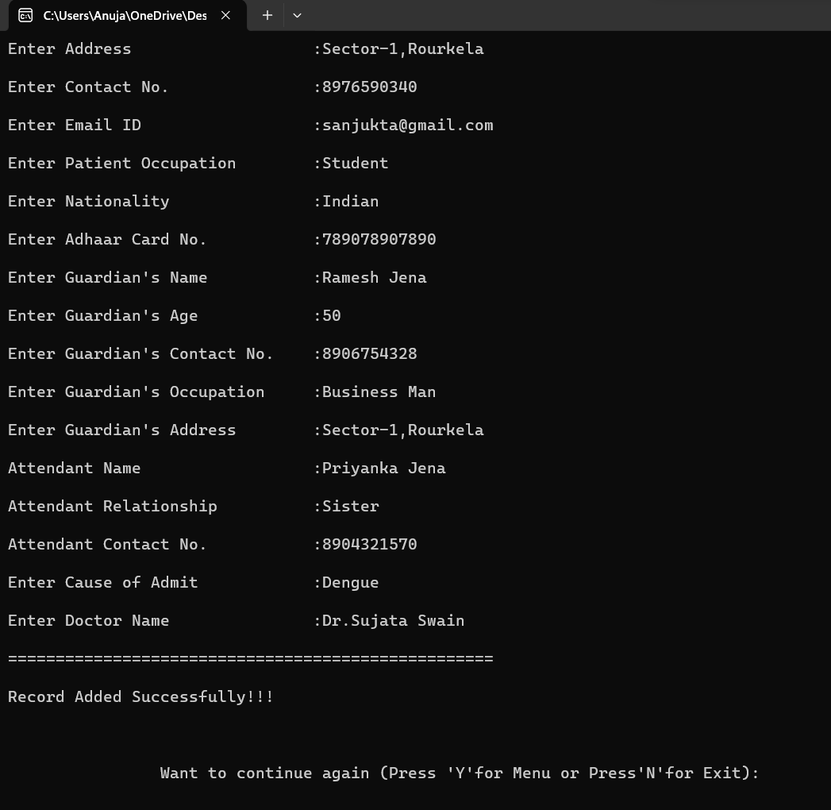

* **SEARCH PATIENT RECORD SECTION**

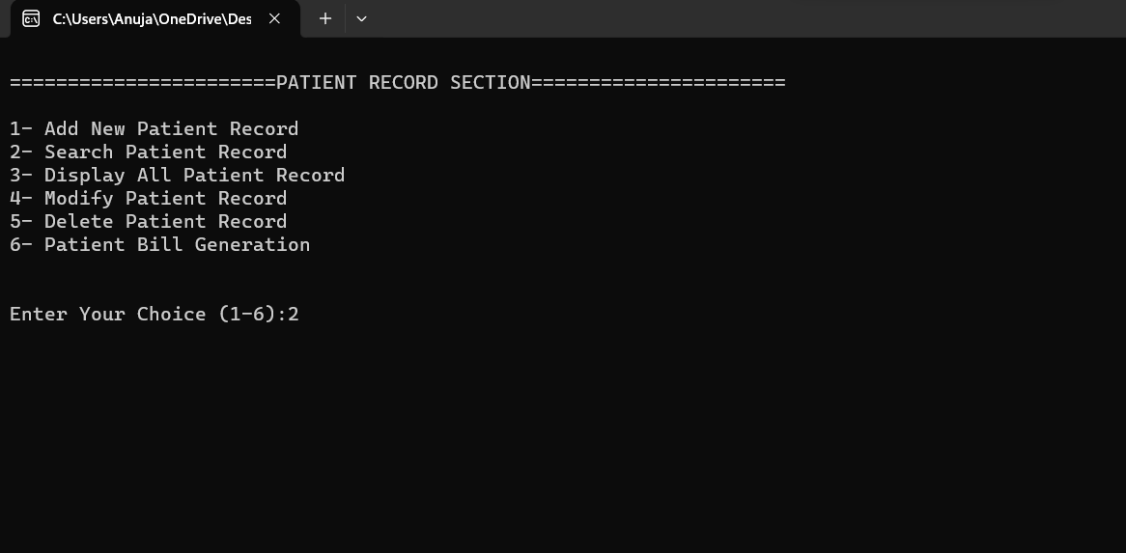

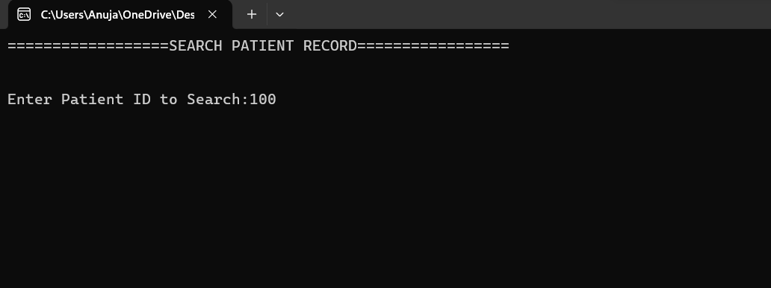

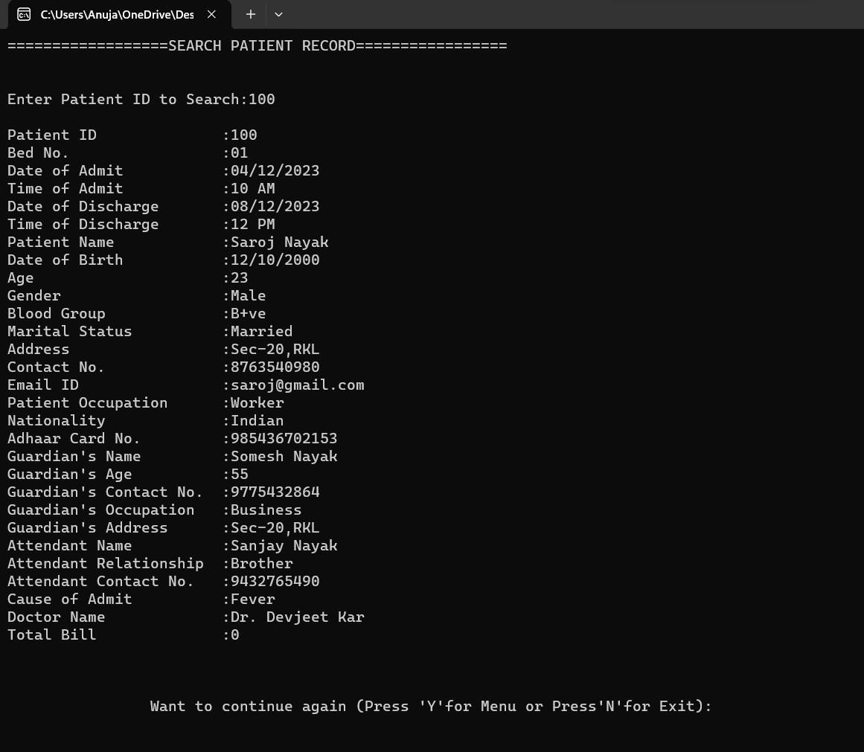

* **DISPLAY PATIENT RECORD SECTION**

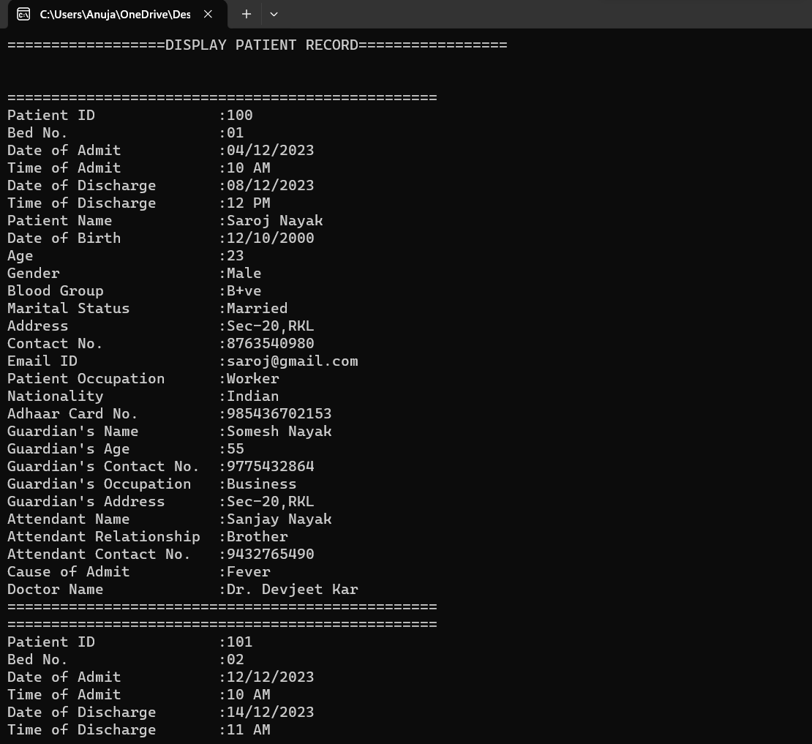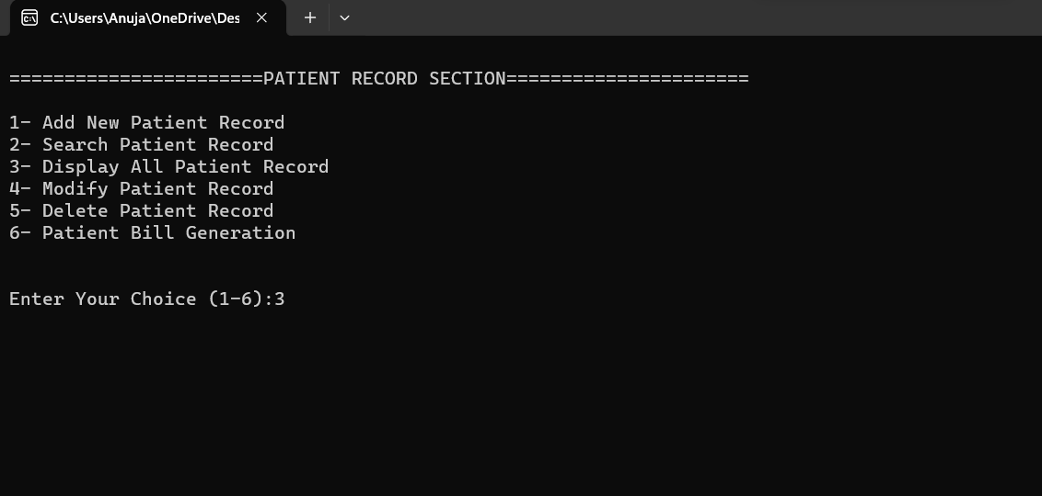

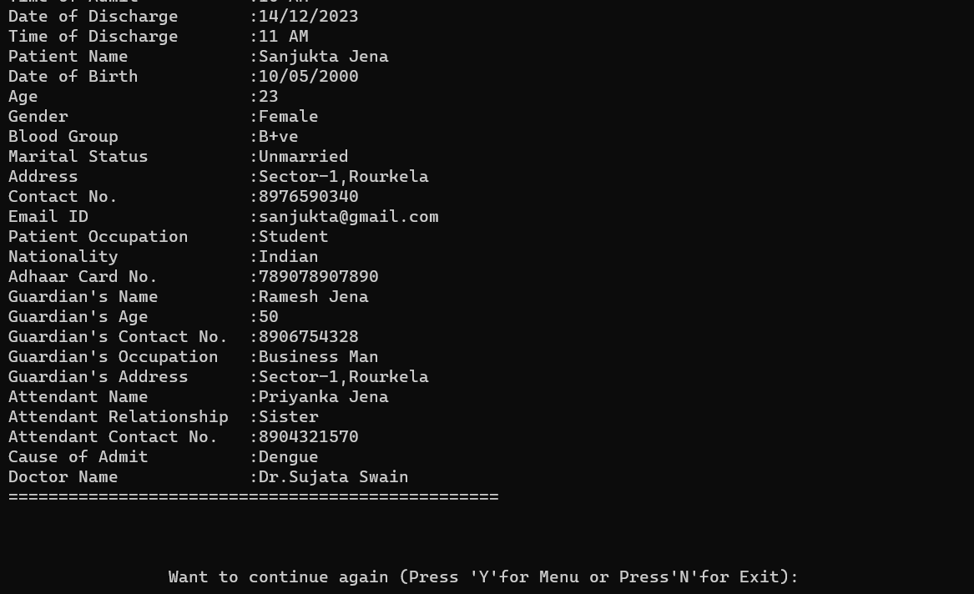

* **MODIFY PATIENT RECORD SECTION**

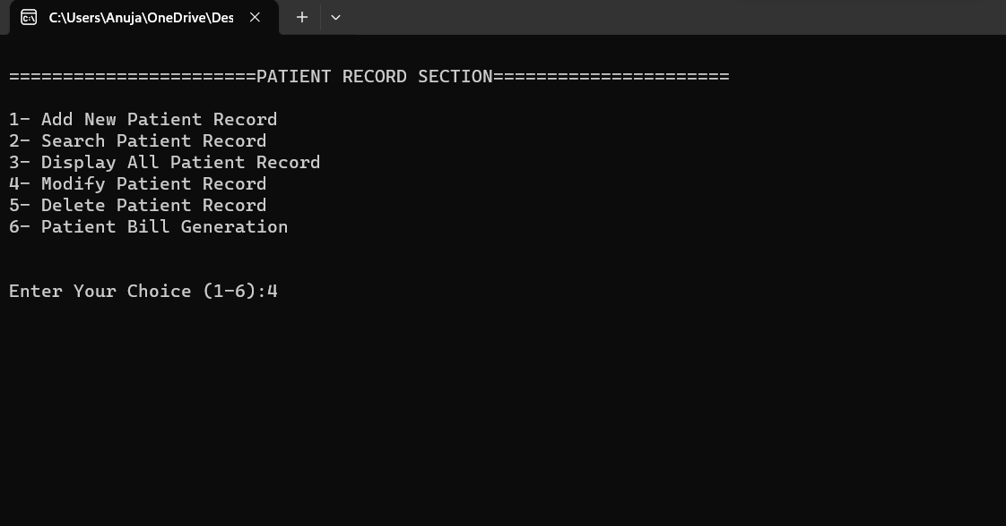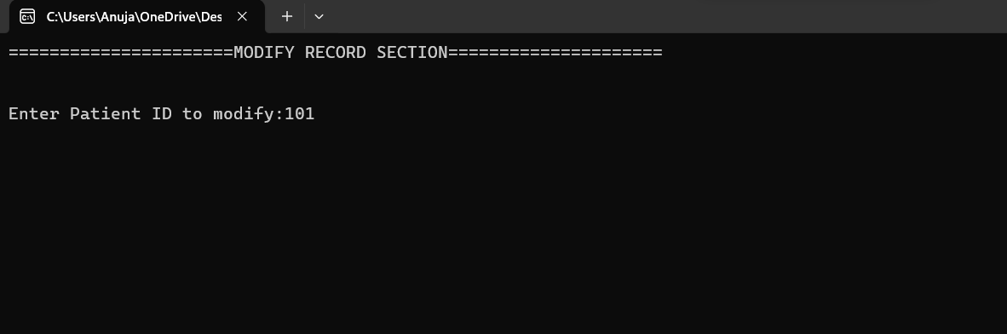

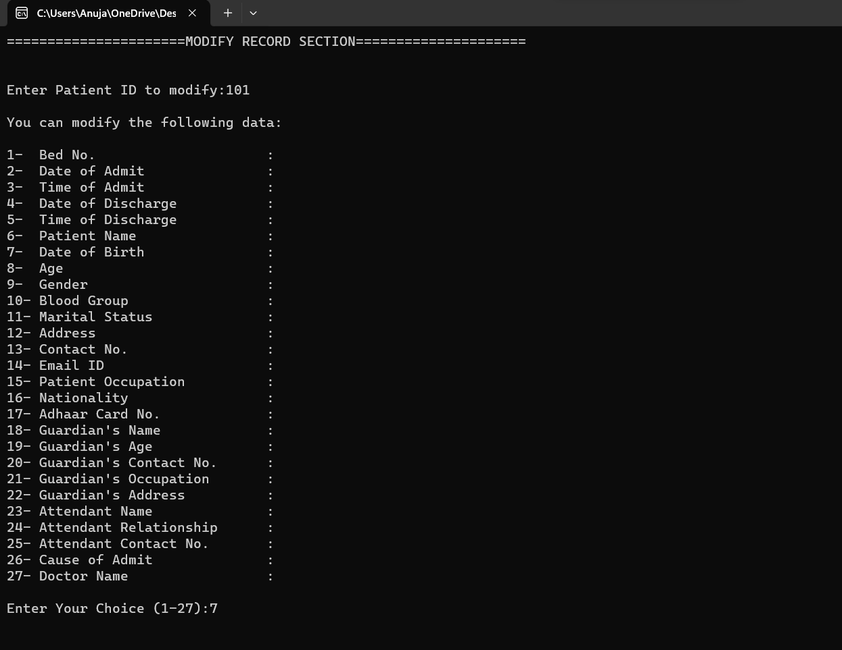

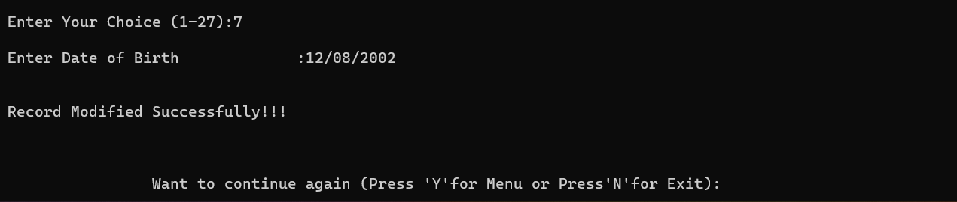

* **DELETE PATIENT RECORD SECTION**

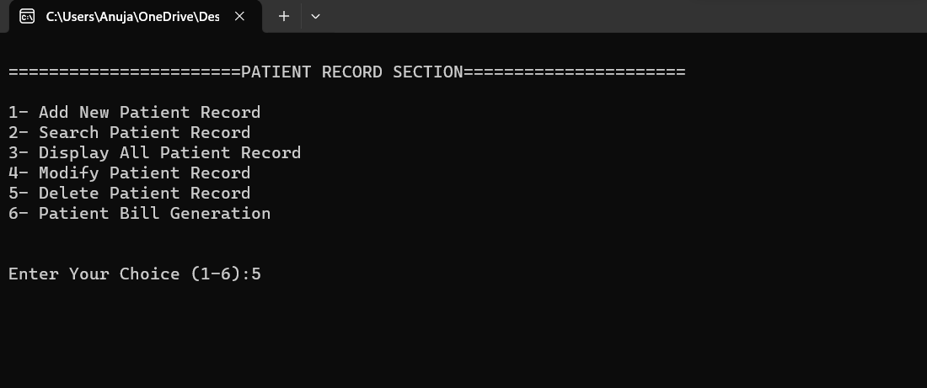

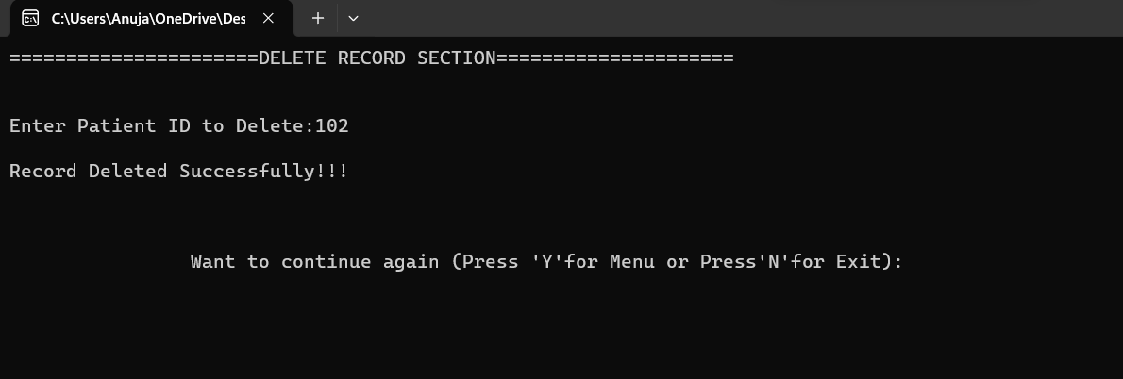

* **BILL GENERATION FOR PATIENT**

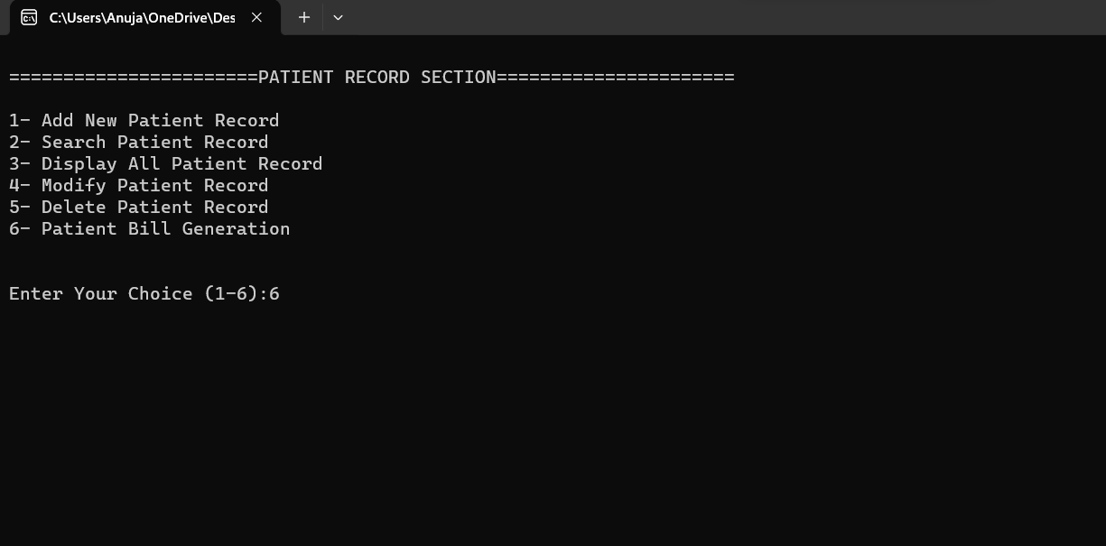

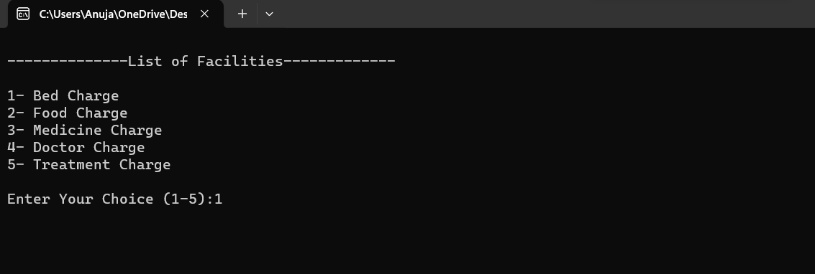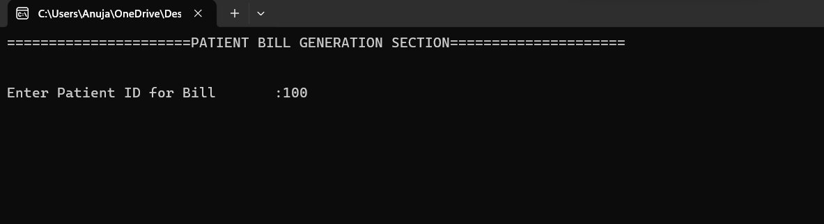

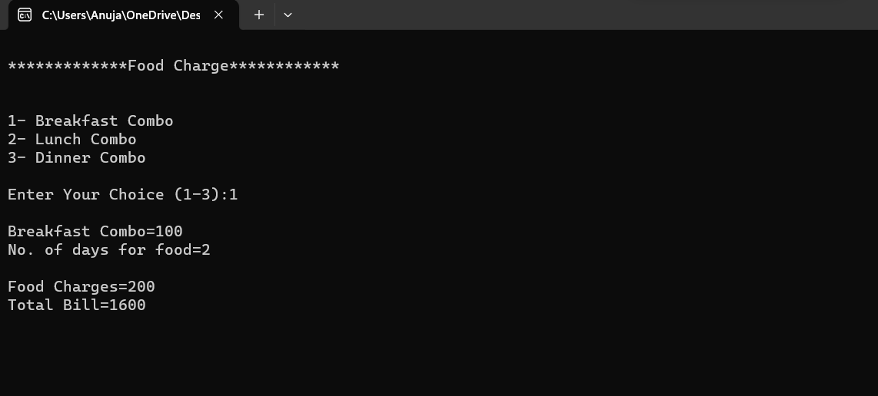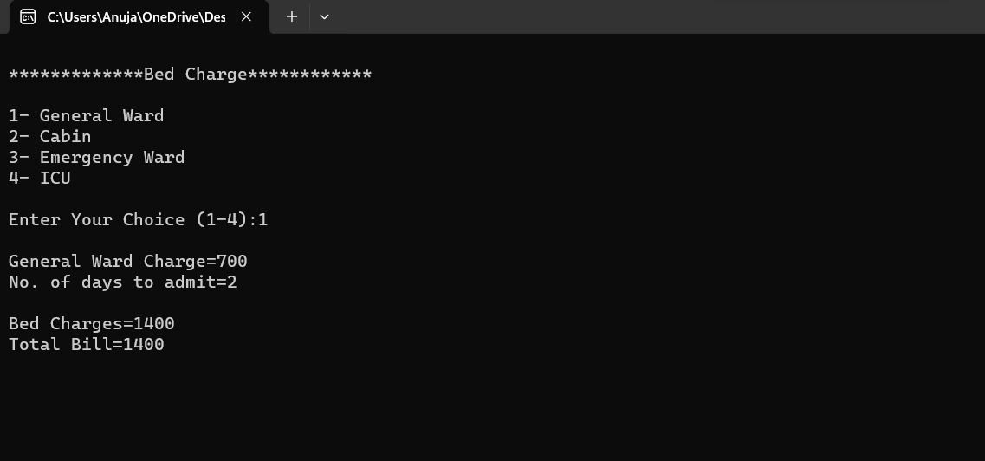

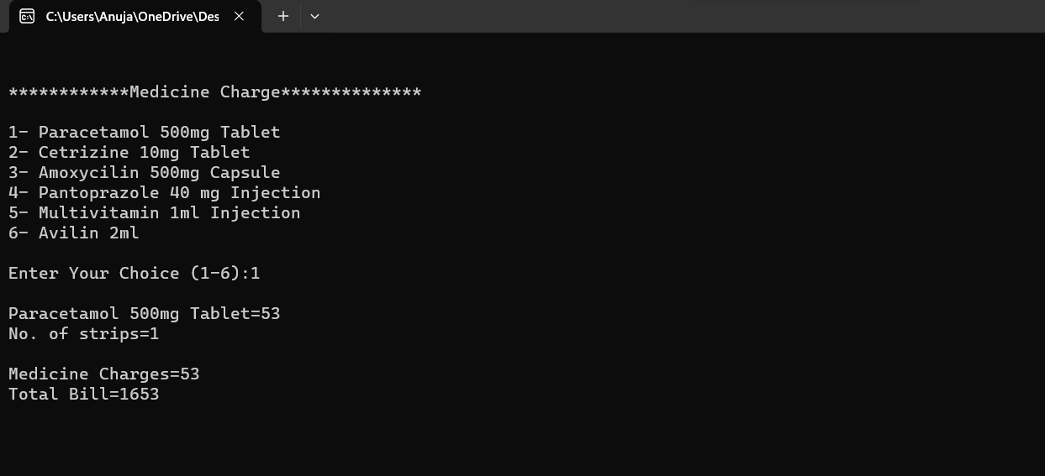

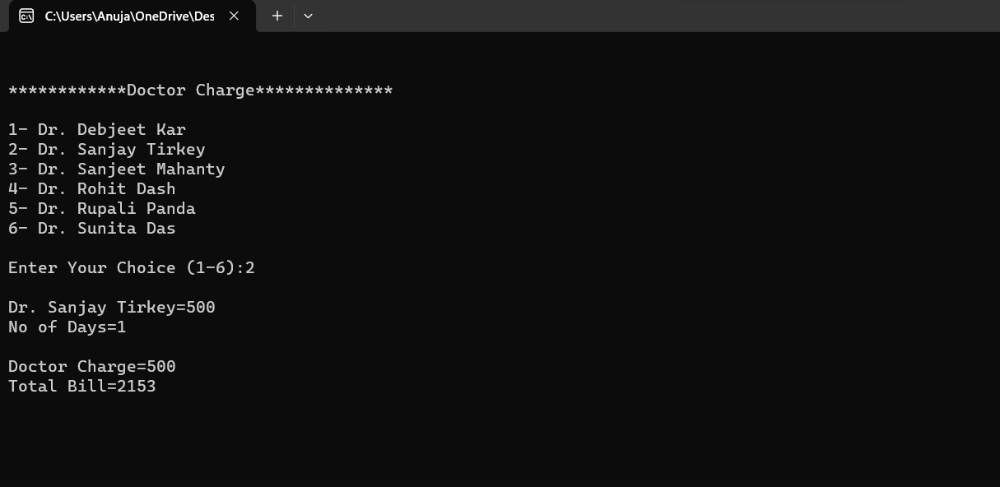

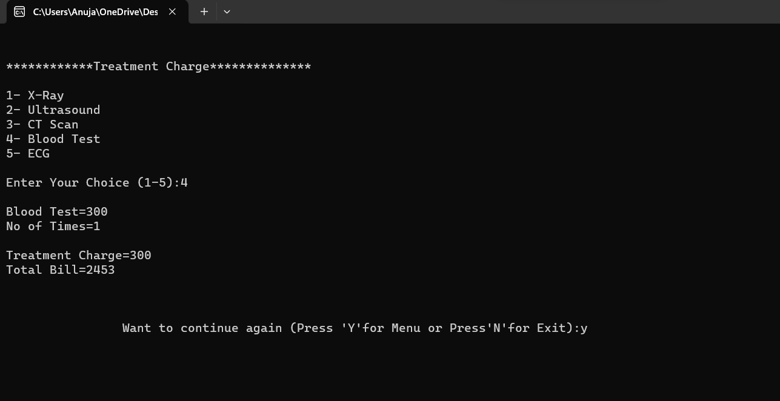

* **STAFF RECORD SECTION**

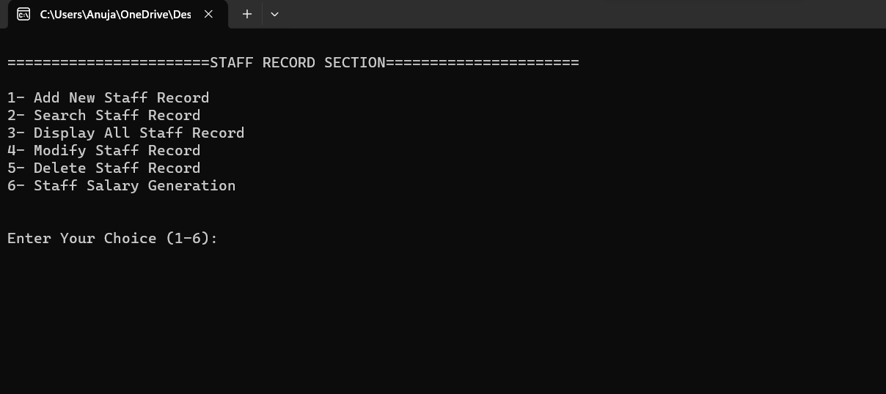

* **ADD NEW STAFF RECORD**

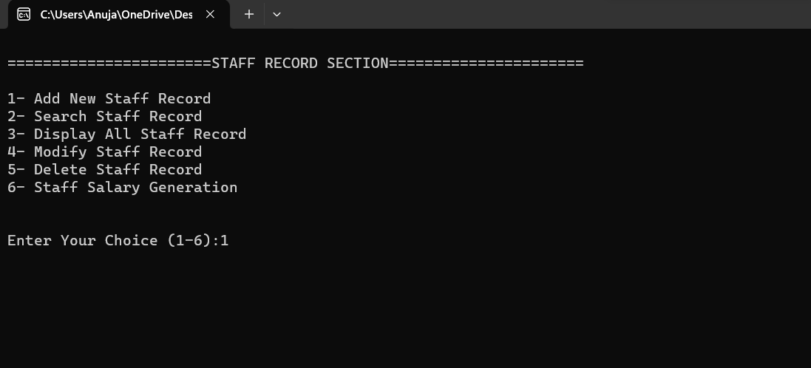

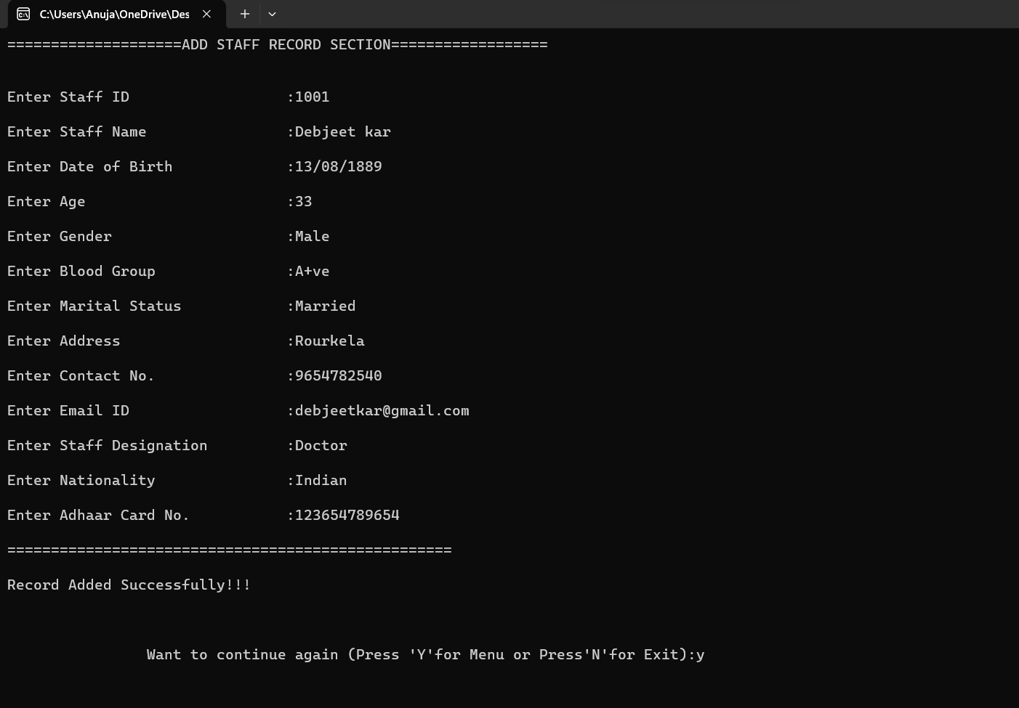

* **SEARCH STAFF RECORD**

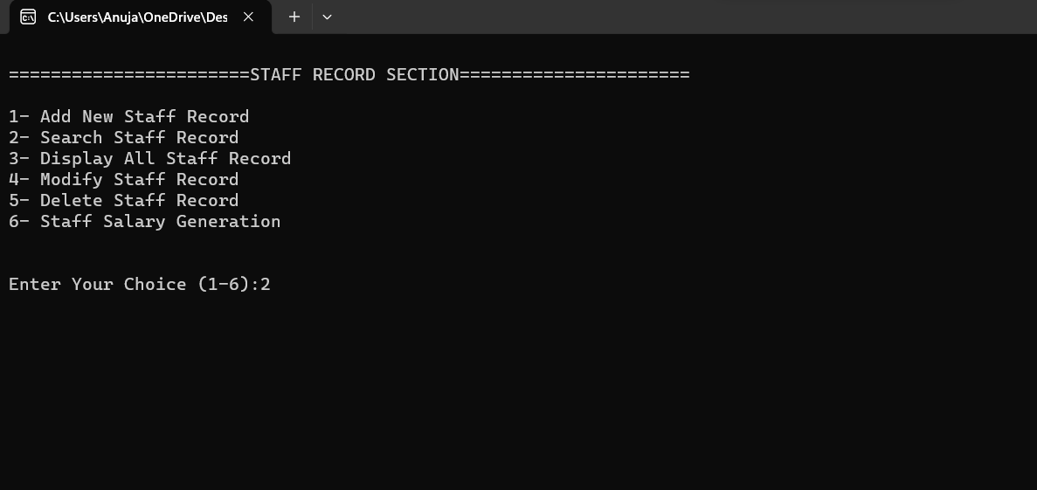

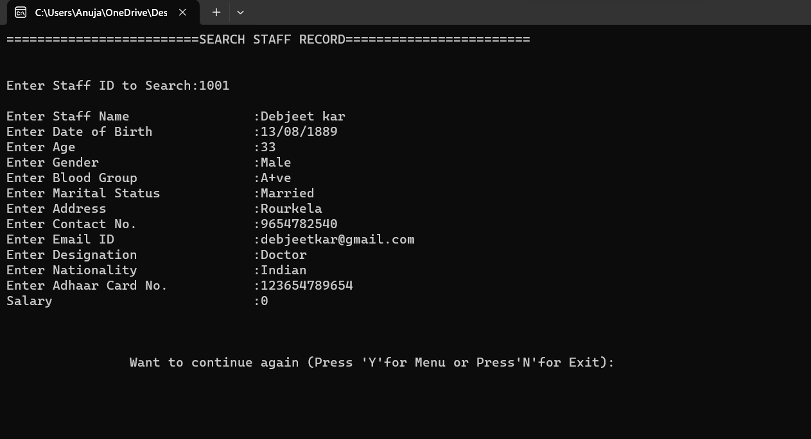

* **DISPLAY STAFF RECORD**

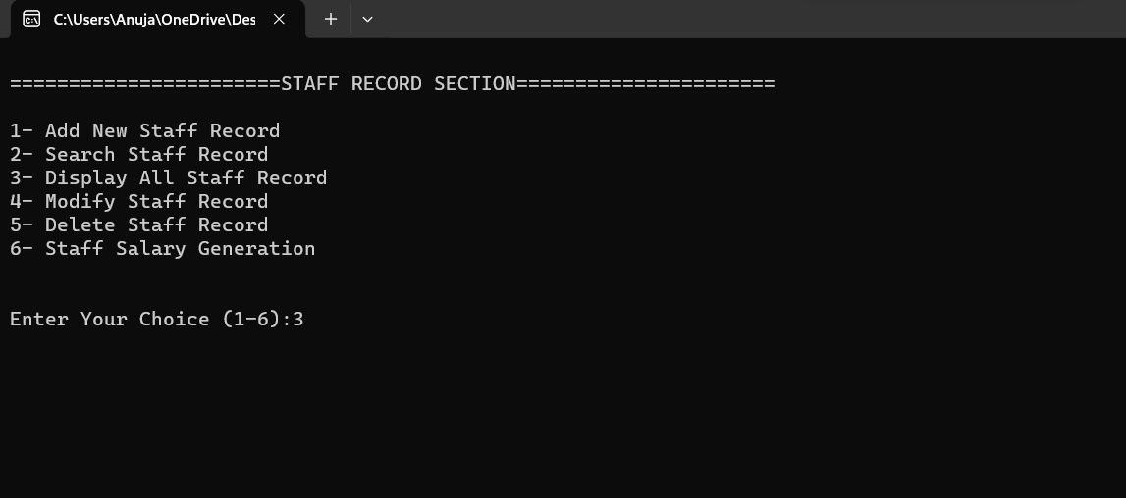

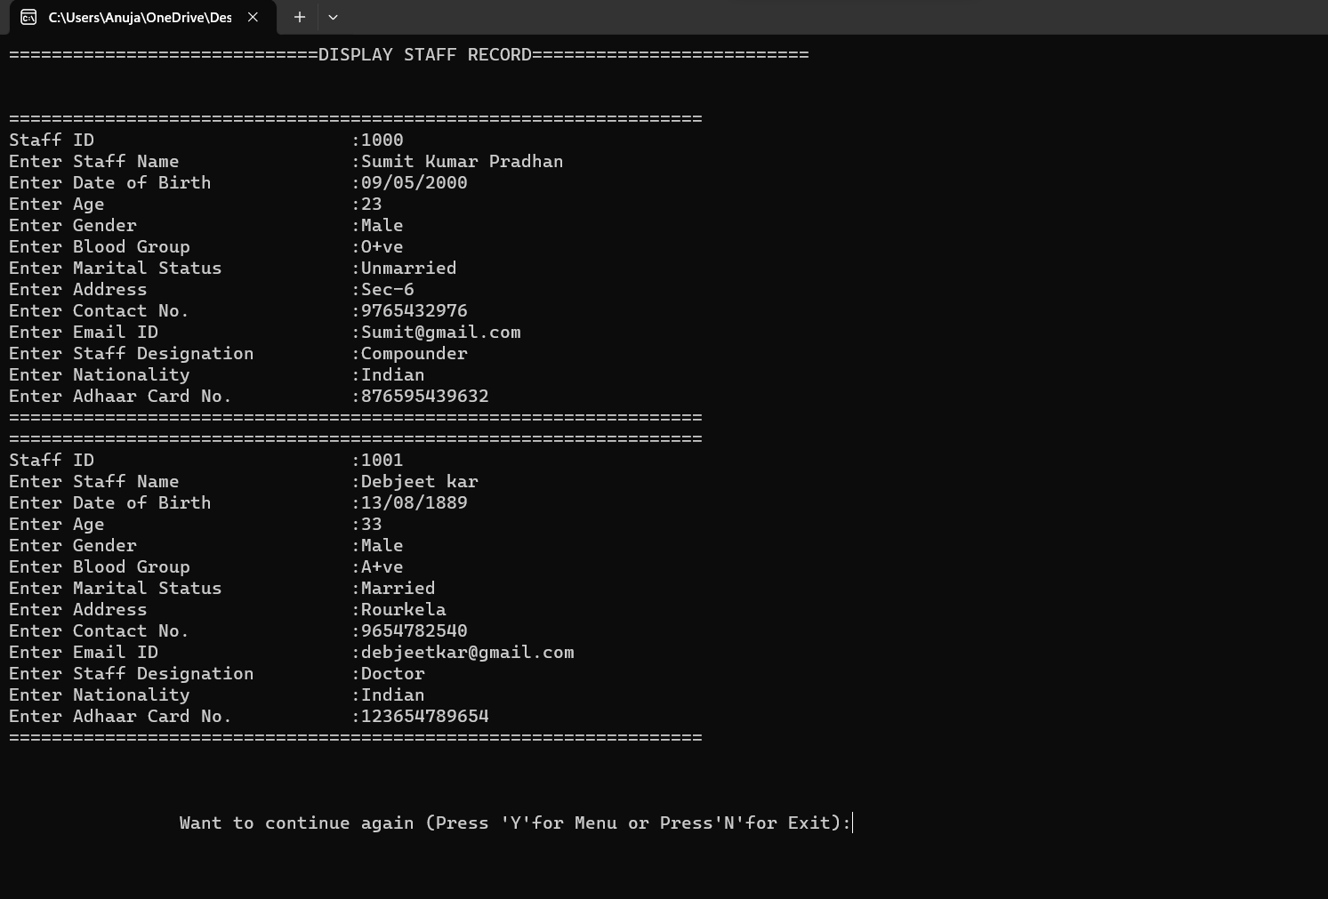

* **MODIFY STAFF RECORD**

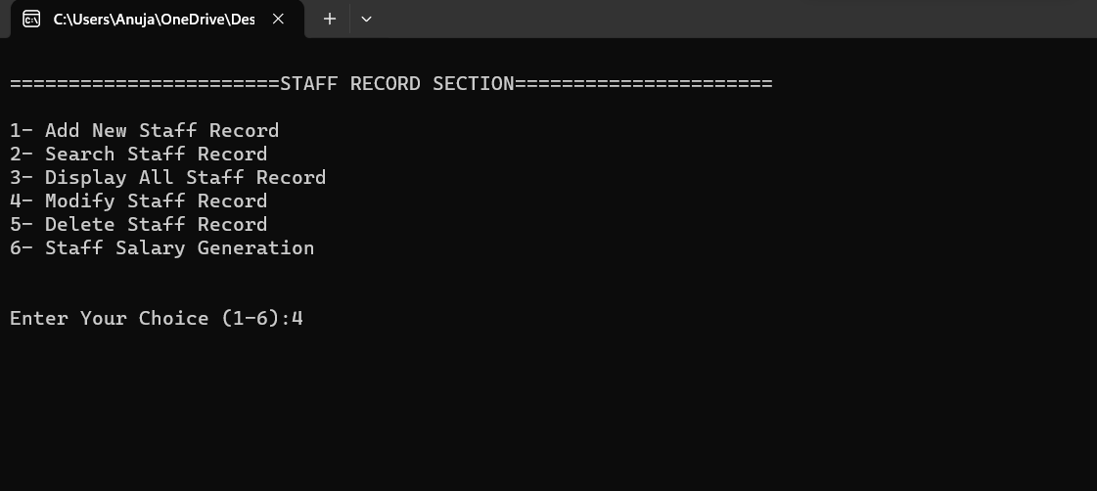

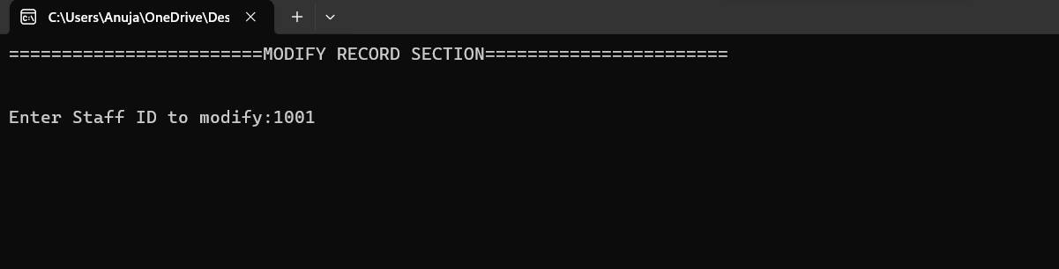

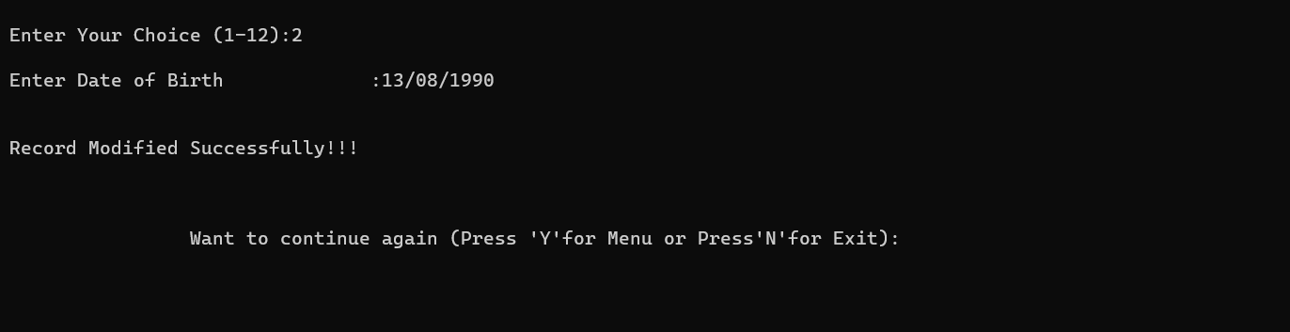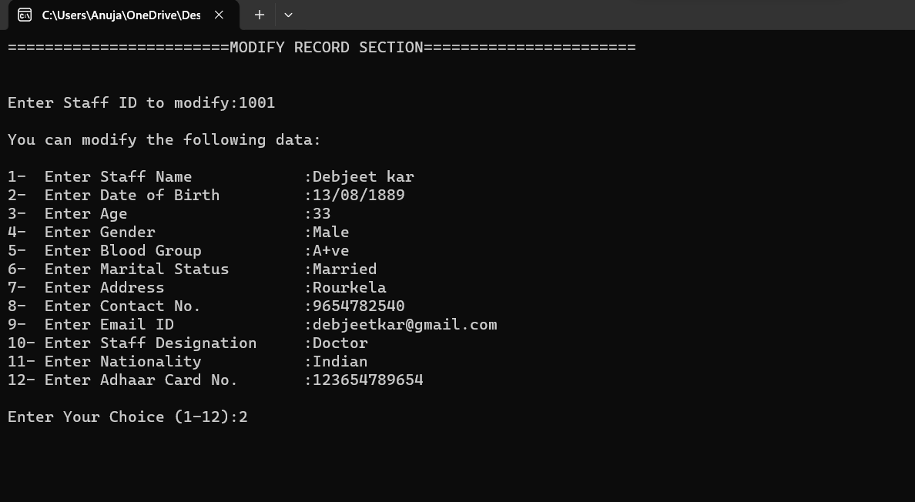

* **DELETE STAFF RECORD**

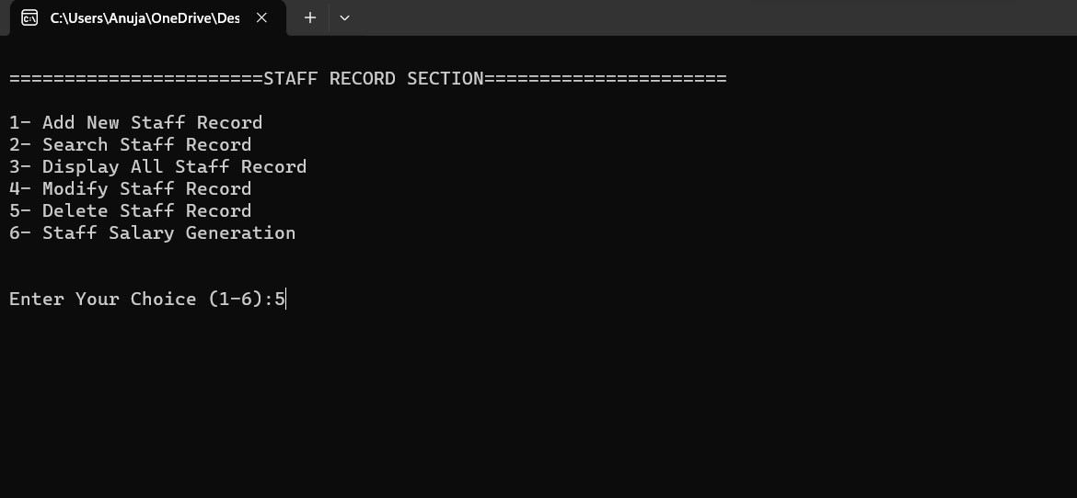

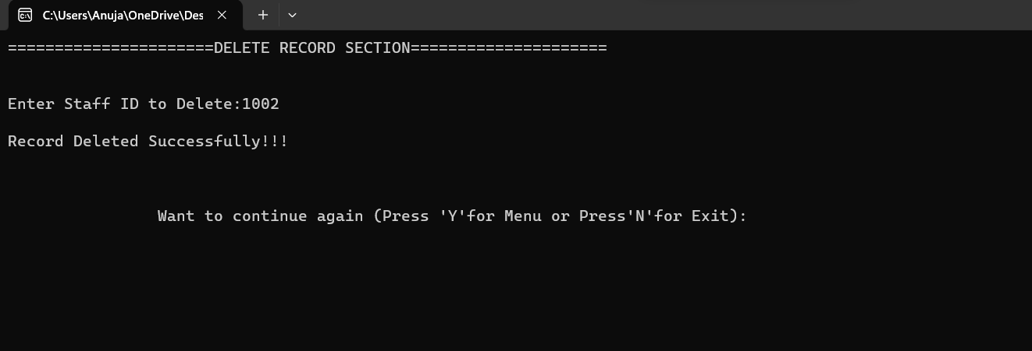

* **STAFF SALARY GENERATION**

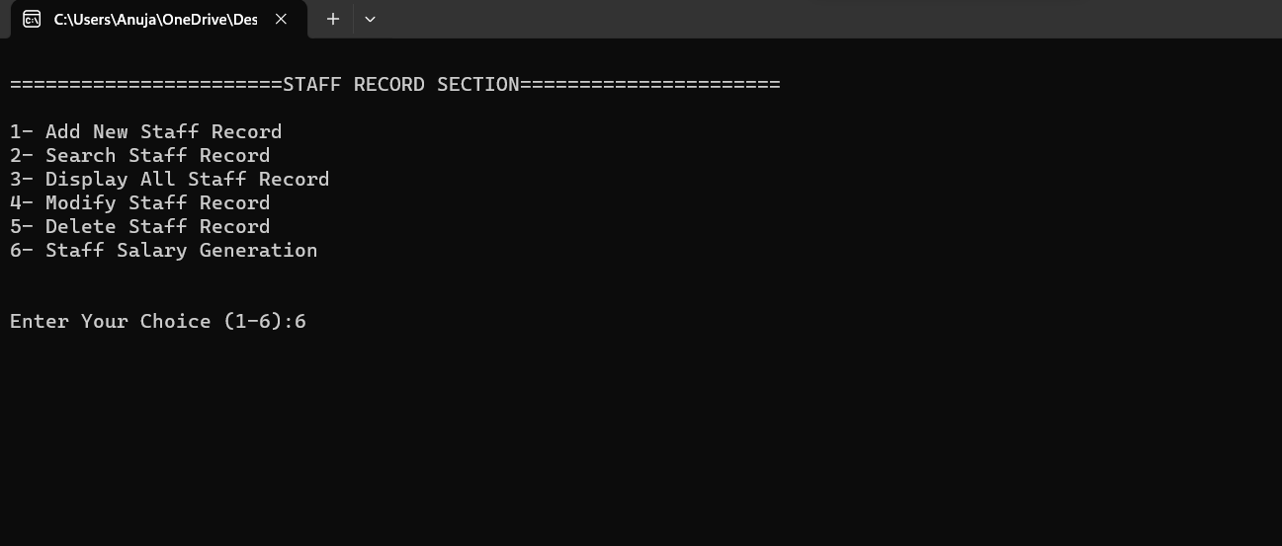

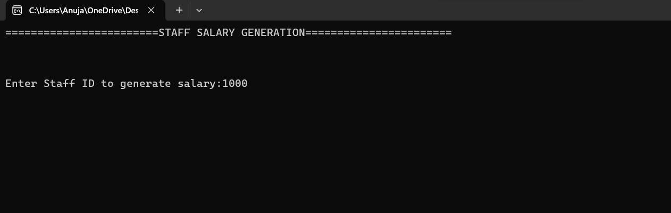

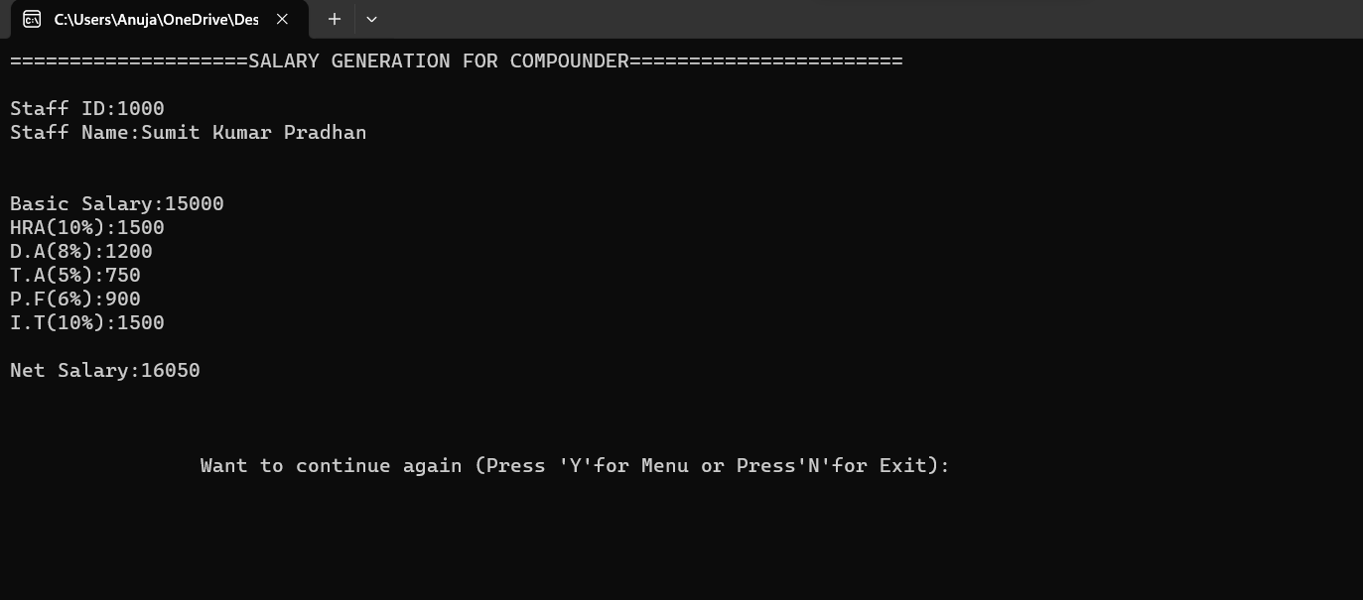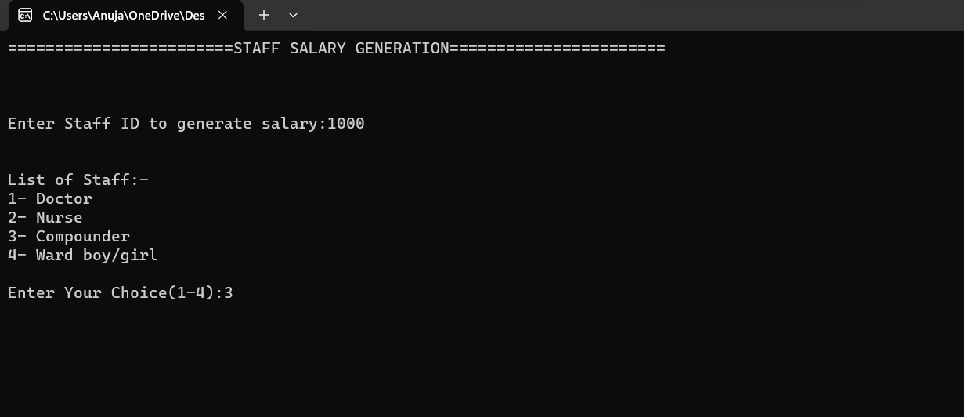

* **ABOUT OUR HOSPITAL**

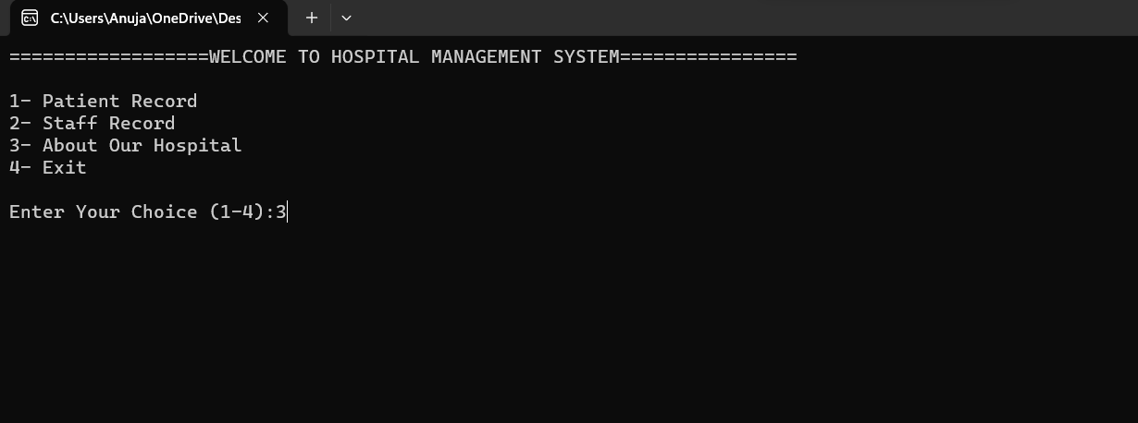

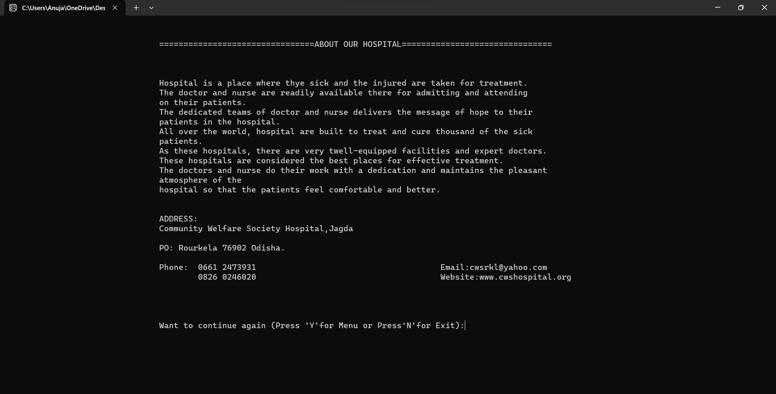

* **EXIT**

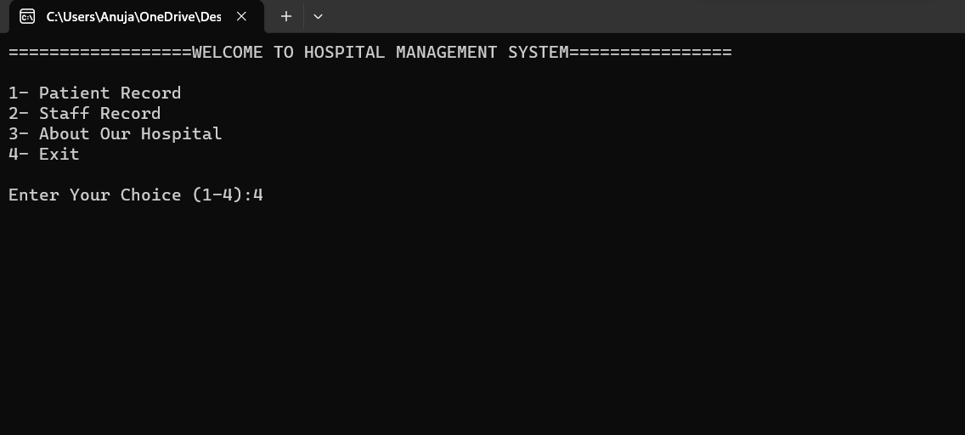

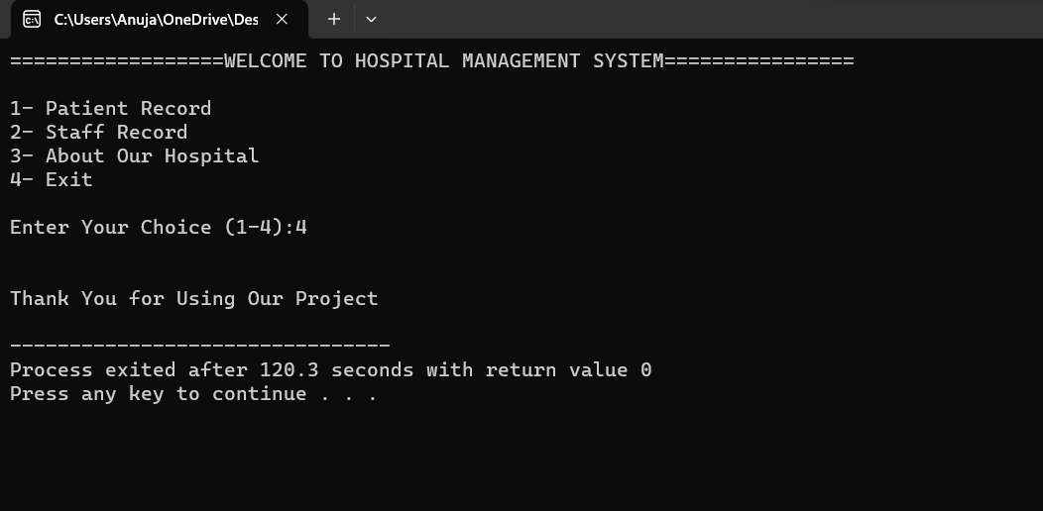

**CONCLUSION**

It has been a matter of immense pleasure, honor and challenge to have this project and complete it successfully,

While developing this project we learnt a lot about “Hospital Management System” and also learnt how to make it user friendly by hiding the completed parts of it from the users. During the development process, we also realized the importance of maintaining a minimum margin of errors.

This will be very much helpful to the Hospital Management System to keep their data up-to-data and can edit or modify the patient’s record.

And with help of this project we learnt various header files, functions etc. This project was very helpful for us to increase our knowledge.

Thus, the project on “HOSPITAL MANAGEMENT SYSTEM” is submitted herewith.

**BIBLIOGRAPHY**

While working on this project, we got know more about C&C++ programming

from various sources.

**SOURCES USED FOR PROJECT:**

* C&C++ Notes provide by SeeNet
* Sample Project provided by SeeNet
* [**www.wikipedia.org**](http://www.wikipedia.org)
* [**www.github.com**](http://www.github.com)
* [**www.geeksforgeeks.org**](http://www.geeksforgeeks.org)
* [**www.youtube.com**](http://www.youtube.com)

**SYSTEM REQUIRMENTS:**

* Operating system: Windows 11
* Processor : Intel Core 2 Dual
* Memory : 4GB
* System : 64bit
* Platform : Dev C++
* Application Used: MS Word, Notepad, Snipping Tool, Google Chrome.