Global Superstore Project (MySQL → Power BI)

1. How many transaction records are available?
SQL Query:
SELECT COUNT(*) AS Total_Records
FROM orders;
Result:
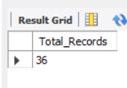
Business Insight:
The total number of transaction records confirms dataset size and completeness. It provides confidence that the dataset is large enough for meaningful business analysis and serves as the baseline for all subsequent KPIs.
Recommended Power BI Visual: KPI Card

2. Is the imported dataset accurate and ready for analysis?
SQL Query:
SELECT *
FROM orders LIMIT 10;
Result: 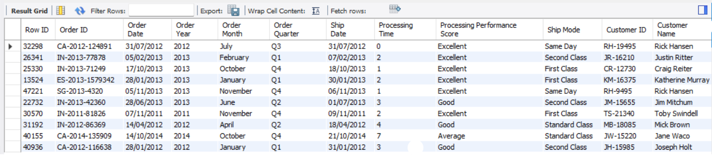
Business Insight:
Previewing sample records verifies successful import, correct column mapping, and data consistency before analysis.
Recommended Power BI Visual: Table

3. Are there any missing Postal Codes?
SQL Query:
SELECT COUNT(*) AS Missing_PostalCode
FROM orders
WHERE `Postal Code` IS NULL;
Result:
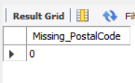
Business Insight:
Identifies data quality issues. Missing postal codes are documented but have minimal impact because regional analysis uses City, State, and Region.
Recommended Power BI Visual: Card

4. Are any Sales values missing?
SQL Query:
SELECT COUNT(*) AS Missing_Sales
FROM orders
WHERE Sales IS NULL;
Result:
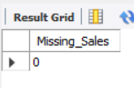
Business Insight:
Confirms revenue data is complete for reliable sales analysis.
Recommended Power BI Visual: Card

5. Are any Profit values missing?
SQL Query:
SELECT COUNT(*) AS Missing_Profit
FROM orders
WHERE Profit IS NULL;
Result:
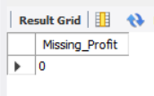
Business Insight:
Ensures profitability analysis can be performed accurately.
Recommended Power BI Visual: Card

6. Are there duplicate transaction records?
SQL Query:
SELECT `Row ID`, COUNT(*) AS Duplicate_Count
FROM orders
GROUP BY `Row ID` HAVING COUNT(*)>1;
Result:
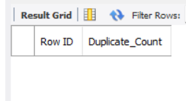
Business Insight:
Validates data integrity by ensuring each Row ID is unique.
Recommended Power BI Visual: Table

7. What are the total sales?
SQL Query:
SELECT ROUND(SUM(Sales),2) AS TotalSales
FROM orders;
Result:
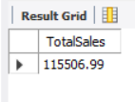
Business Insight:
Measures total revenue generated across all transactions and acts as a primary KPI.
Recommended Power BI Visual: KPI Card

8. What is the total profit?
SQL Query:
SELECT ROUND(SUM(Profit),2) AS TotalProfit
FROM orders;
Result:
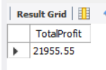
Business Insight:
Shows overall profitability after all sales.
Recommended Power BI Visual: KPI Card

9. How many unique orders were placed?
SQL Query:
SELECT COUNT(DISTINCT `Order ID`) AS Total_Orders
FROM orders;
Result:
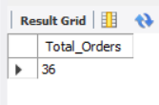
Business Insight:
Counts actual customer orders instead of line items.
Recommended Power BI Visual: KPI Card

10. How many unique customers purchased?
SQL Query:
SELECT COUNT(DISTINCT `Customer ID`) AS Total_Customers
FROM orders;
Result:
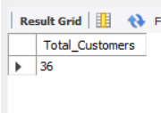
Business Insight:
Represents the active customer base.
Recommended Power BI Visual: KPI Card

11. What is the average order value?
SQL Query:
SELECT ROUND(SUM(Sales)/COUNT(DISTINCT `Order ID`),2) AS Average_Order_Value FROM orders;
Result:
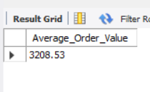
Business Insight:
Shows average customer spending per order and supports upselling strategies.
Recommended Power BI Visual: KPI Card

12. How have sales changed over the years?
SQL Query:
SELECT `Order Year`, ROUND(SUM(Sales),2) AS Total_Sales
FROM orders
GROUP BY `Order Year`
ORDER BY `Order Year`;
Result:
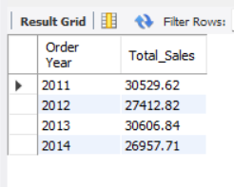
Business Insight:
Reveals long-term sales trends and business growth.
Recommended Power BI Visual: Line Chart

13. Which month generates the highest sales?
SQL Query:
SELECT `Order Month`, ROUND(SUM(Sales),2) AS Sales
FROM orders
GROUP BY `Order Month`
ORDER BY Sales DESC;
Result:
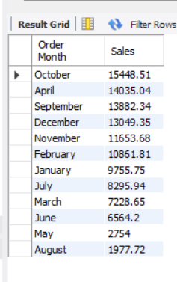
Business Insight:
Highlights seasonality and peak demand periods.
Recommended Power BI Visual: Column Chart

14. Which quarter performs best?
SQL Query:
SELECT `Order Quarter`, ROUND(SUM(Sales),2) AS Sales
FROM orders
GROUP BY `Order Quarter`
ORDER BY Sales DESC;
Result:
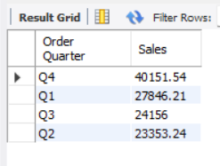
Business Insight:
Supports quarterly planning and forecasting.
Recommended Power BI Visual: Column Chart

15. Which region generates the highest sales?
SQL Query:
SELECT Region, ROUND(SUM(Sales),2) AS Sales
FROM orders
GROUP BY Region
ORDER BY Sales DESC;
Result:
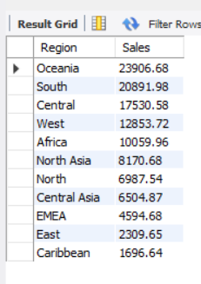
Business Insight:
Identifies top-performing regions.
Recommended Power BI Visual: Bar Chart

16. Which region generates the highest profit?
SQL Query:
SELECT Region, ROUND(SUM(Profit),2) AS Profit
FROM orders
GROUP BY Region
ORDER BY Profit DESC;
Result:
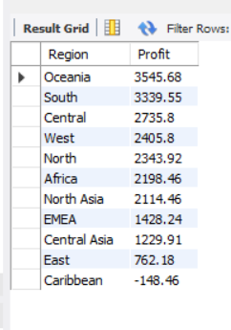
Business Insight:
Shows the most profitable region.
Recommended Power BI Visual: Bar Chart

17. Which state contributes the highest sales?
SQL Query:
SELECT State, ROUND(SUM(Sales),2) AS Sales
FROM orders
GROUP BY State
ORDER BY Sales DESC
LIMIT 10;
Result:
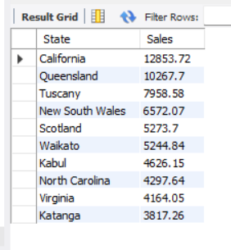
Business Insight:
Identifies high-revenue states.
Recommended Power BI Visual: Map/Bar

18. Which city contributes the highest sales?
SQL Query:
SELECT City, ROUND(SUM(Sales),2) AS Sales
FROM orders
GROUP BY City
ORDER BY Sales DESC
LIMIT 10;
Result:
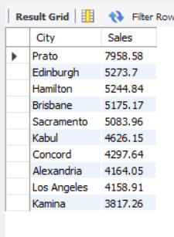
Business Insight:
Highlights strongest city markets.
Recommended Power BI Visual: Map

19. Which category generates the highest sales?
SQL Query:
SELECT Category, ROUND(SUM(Sales),2) AS Sales
FROM orders
GROUP BY Category
ORDER BY Sales DESC;
Result:
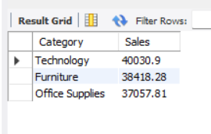
Business Insight:
Identifies best-selling category.
Recommended Power BI Visual: Bar

20. Which category generates the highest profit?
SQL Query:
SELECT Category, ROUND(SUM(Profit),2) AS Profit
FROM orders
GROUP BY Category
ORDER BY Profit DESC;
Result:
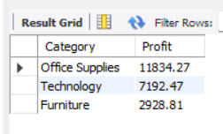
Business Insight:
Shows most profitable category.
Recommended Power BI Visual: Bar

21. Which sub-category performs best?
SQL Query:
SELECT `Sub-Category`, ROUND(SUM(Sales),2) AS Sales
FROM orders
GROUP BY `Sub-Category`
ORDER BY Sales DESC;
Result:
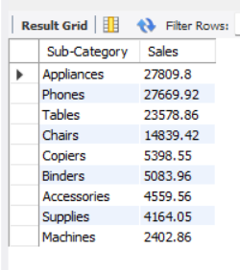
Business Insight:
Highlights leading product groups.
Recommended Power BI Visual: Bar

22. Which products generate the highest sales?
SQL Query:
SELECT `Product Name`, ROUND(SUM(Sales),2) AS Sales
FROM orders
GROUP BY `Product Name`
ORDER BY Sales DESC
LIMIT 10;
Result:
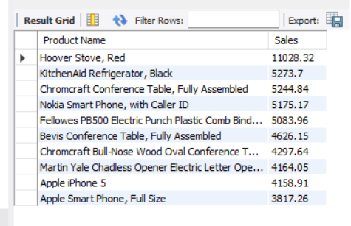
Business Insight:
Identifies best-selling products.
Recommended Power BI Visual: Bar

23. Which products generate the highest profit?
SQL Query:
SELECT `Product Name`, ROUND(SUM(Profit),2) AS Profit
FROM orders
GROUP BY `Product Name`
ORDER BY Profit DESC
LIMIT 10;
Result:
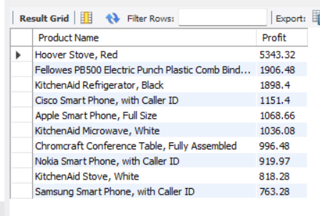
Business Insight:
Highlights products driving profitability.
Recommended Power BI Visual: Bar

24. Who are the top customers by sales?
SQL Query:
SELECT `Customer Name`, ROUND(SUM(Sales),2) AS Sales
FROM orders
GROUP BY `Customer Name`
ORDER BY Sales DESC
LIMIT 10;
Result:
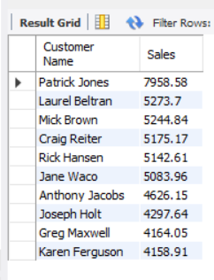
Business Insight:
Identifies high-value customers.
Recommended Power BI Visual: Bar

25. Which customer segment contributes the most sales?
SQL Query:
SELECT Segment, ROUND(SUM(Sales),2) AS Sales
FROM orders
GROUP BY Segment
ORDER BY Sales DESC;
Result:
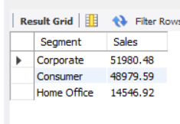
Business Insight:
Shows most valuable customer segment.
Recommended Power BI Visual: Donut

26. What is the average processing time?
SQL Query:
SELECT ROUND(AVG(`Processing Time`),2) AS AvgProcessingTime
FROM orders;
Result:
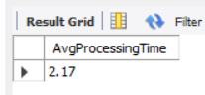
Business Insight:
Measures delivery efficiency.
Recommended Power BI Visual: Card

27. Which shipping mode is the fastest?
SQL Query:
SELECT `Ship Mode`, ROUND(AVG(`Processing Time`),2) AS AvgDays
FROM orders
GROUP BY `Ship Mode`
ORDER BY AvgDays;
Result:
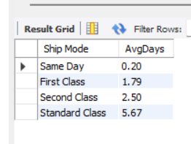
Business Insight:
Compares logistics performance.
Recommended Power BI Visual: Column

28. How many orders were returned?
SQL Query:
SELECT
CASE
WHEN r.Returned = 'Yes' THEN 'Returned'
ELSE 'Not Returned'
END AS Return_Status,
COUNT(DISTINCT o.`Order ID`) AS Total_Orders
FROM orders o
LEFT JOIN returns r
ON o.`Order ID` = r.`Order ID`
GROUP BY Return_Status;
Result:
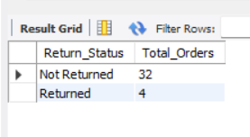
Business Insight:
Shows distribution of returned and non-returned orders.
Recommended Power BI Visual: Donut

29. What is the return rate?
SQL Query:
SELECT
ROUND(
(COUNT(DISTINCT r.`Order ID`) * 100.0) /
COUNT(DISTINCT o.`Order ID`),
2
) AS Return_Rate_Percentage
FROM orders o
LEFT JOIN returns r
ON o.`Order ID` = r.`Order ID`;
Result:
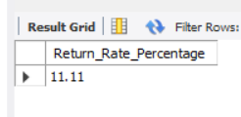
Business Insight:
Measures return performance and customer satisfaction.
Recommended Power BI Visual: Gauge

30. How do discount categories impact sales and profit?
SQL Query:
SELECT `Discount Category`, ROUND(SUM(Sales),2) AS Sales, ROUND(SUM(Profit),2) AS Profit
FROM orders
GROUP BY `Discount Category`;
Result:
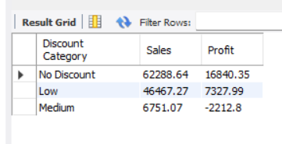
Business Insight:
Evaluates whether discounts improve revenue without hurting profitability.
Recommended Power BI Visual: Clustered Column

