**Objective Questions  
  
1. Are there any tables with duplicate or missing null values? If so, how would you handle them?**  
  
Ans. For checking Duplicate values present in the tables :

SELECT

id AS user_id,

COUNT(*) AS duplicate_values_in_users

FROM users

GROUP BY id

HAVING duplicate_values_in_users > 1;  
   
 SELECT

id AS tag_id,

COUNT(*) AS duplicate_values_in_tags

FROM tags

GROUP BY id

HAVING duplicate_values_in_tags > 1;

SELECT

id AS photo_id,

COUNT(*) AS duplicate_values_in_photos

FROM photos

GROUP BY id

HAVING duplicate_values_in_photos > 1;

SELECT

photo_id,

tag_id,

COUNT(*) AS duplicate_values_in_phototags

FROM photo_tags

GROUP BY photo_id, tag_id

HAVING duplicate_values_in_phototags > 1;

SELECT

user_id,

photo_id,

COUNT(*) AS duplicate_values_in_likes

FROM likes

GROUP BY user_id, photo_id

HAVING duplicate_values_in_likes > 1;

SELECT

id AS comment_id,

COUNT(*) AS duplicate_values_in_comments

FROM comments

GROUP BY id

HAVING duplicate_values_in_comments > 1;

SELECT

follower_id,

followee_id,

COUNT(*) AS duplicate_values_in_follows

FROM follows

GROUP BY follower_id, followee_id

HAVING duplicate_values_in_follows > 1;  
  
 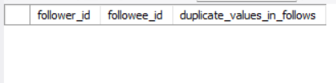

For checking Null values present in the tables :-

SELECT

COUNT(*) AS null_values_in_users

FROM users

WHERE id IS NULL

OR username IS NULL

OR created_at IS NULL;

SELECT

COUNT(*) AS null_values_in_tags

FROM tags

WHERE id IS NULL

OR tag_name IS NULL

OR created_at IS NULL;

SELECT

COUNT(*) AS null_values_in_photos

FROM photos

WHERE id IS NULL

OR image_url IS NULL

OR user_id IS NULL

OR created_dat IS NULL;

SELECT

COUNT(*) AS null_values_in_photo_tags

FROM photo_tags

WHERE photo_id IS NULL

OR tag_id IS NULL;

SELECT

COUNT(*) AS null_values_in_follows

FROM follows

WHERE follower_id IS NULL

OR followee_id IS NULL

OR created_at IS NULL;

SELECT

COUNT(*) AS null_values_in_comments

FROM comments

WHERE id IS NULL

OR comment_text IS NULL

OR user_id IS NULL

OR photo_id IS NULL

OR created_at IS NULL;

SELECT

COUNT(*) AS null_values_in_likes

FROM likes

WHERE user_id IS NULL

OR photo_id IS NULL

OR created_at IS NULL;  
  
 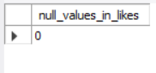  
  
  
  
**2. What is the distribution of user activity levels (e.g., number of posts, likes, comments) across the user base?**Ans. **By using below query :** WITH count_likes AS

(

SELECT

user_id,

COUNT(*) AS num_likes

FROM likes

GROUP BY user_id

),

count_comments AS

(

SELECT

user_id,

COUNT(*) AS num_comments

FROM comments

GROUP BY user_id

),

count_photos AS

(

SELECT

user_id,

COUNT(*) AS num_photos

FROM photos

GROUP BY user_id

)

SELECT

a.id,

a.username,

COALESCE(num_likes, 0) AS num_likes,

CASE

WHEN COALESCE(num_likes, 0) BETWEEN 1 AND

((SELECT MAX(num_likes) FROM count_likes) - (SELECT  
MIN(num_likes) FROM count_likes)) / 3

THEN "less likes"

WHEN COALESCE(num_likes, 0) > 2 *

((SELECT MAX(num_likes) FROM count_likes) - (SELECT MIN(num_likes) FROM count_likes)) / 3

THEN "high likes"

WHEN COALESCE(num_likes, 0) = 0

THEN "zero likes"

ELSE "medium likes"

END AS likes_segment,

COALESCE(num_comments, 0) AS num_comments,

CASE

WHEN COALESCE(num_comments, 0) BETWEEN 1 AND

((SELECT MAX(num_comments) FROM count_comments) - (SELECT MIN(num_comments) FROM count_comments)) / 3

THEN "low comments"

WHEN COALESCE(num_comments, 0) > 2 *

((SELECT MAX(num_comments) FROM count_comments) - (SELECT MIN(num_comments) FROM count_comments)) / 3

THEN "High comments"

WHEN COALESCE(num_comments, 0) = 0

THEN "zero comments"

ELSE "medium comments"

END AS comments_segment,

COALESCE(num_photos, 0) AS num_photos,

CASE

WHEN COALESCE(num_photos, 0) BETWEEN 1 AND

((SELECT MAX(num_photos) FROM count_photos) - (SELECT MIN(num_photos) FROM count_photos)) / 3

THEN "low photos"

WHEN COALESCE(num_photos, 0) > 2 *

((SELECT MAX(num_photos) FROM count_photos) - (SELECT MIN(num_photos) FROM count_photos)) / 3

THEN "High photos"

WHEN COALESCE(num_photos, 0) = 0

THEN "zero photos"

ELSE "medium photos"

END AS photos_segment

FROM users a

LEFT JOIN count_likes b

ON a.id = b.user_id

LEFT JOIN count_comments c

ON a.id = c.user_id

LEFT JOIN count_photos d

ON a.id = d.user_id;  
  
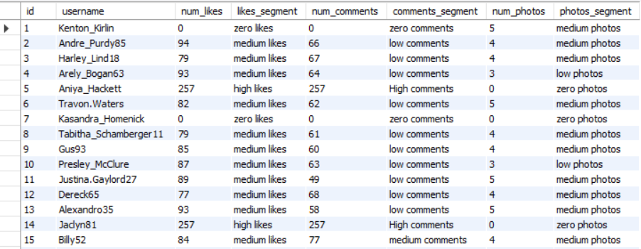  
  
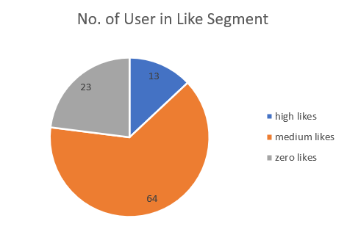  
  
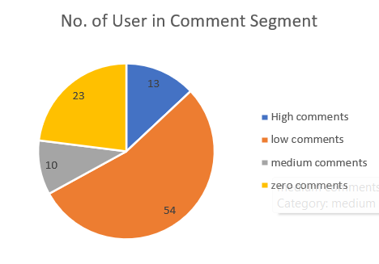  
  
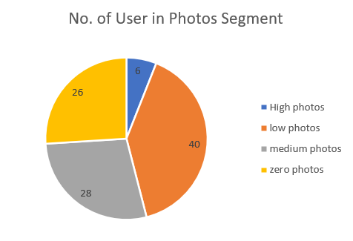  
  
  
**Query Purpose**

The query analyzes **user engagement levels** on the platform by examining three key activity metrics:

* **Likes given**
* **Comments made**
* **Photos posted**

**Method**

1. **Activity Segmentation**
   * Each metric is compared against the overall **minimum and maximum values** in the dataset.
   * Users are segmented into **four categories** per metric:
     + **Zero** → No activity
     + **Low** → Activity is closer to the lower bound
     + **Medium** → Activity is in the mid-range
     + **High** → Activity is closer to the upper bound
2. **Comprehensive Engagement View**
   * The query produces a combined profile for each user.
   * This helps identify:
     + **Highly active users** (high across multiple metrics)
     + **Moderately engaged users** (medium in one or more metrics)
     + **Inactive/minimally active users** (zero or low across metrics)

**Use Case**

* **Community Insights:** Spot top contributors who drive engagement.
* **User Retention:** Identify inactive users for re-engagement strategies.
* **Content Strategy:** Understand how users interact (likes vs. comments vs. photos).

**3. Calculate the average number of tags per post (photo_tags and photos tables).**  
  
Ans. By using below query :  
  
 SELECT

ROUND(AVG(num_tags), 2) AS avg_num_tags_per_post

FROM

(

SELECT

a.id,

COALESCE(COUNT(tag_id), 0) AS num_tags

FROM photos a

LEFT JOIN photo_tags b

ON a.id = b.photo_id

GROUP BY a.id

)   
 AS ab;  
  
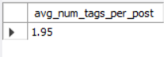  
  
  
The answer will be 1.9 **4. Identify the top users with the highest engagement rates (likes, comments) on their posts and rank them.**Ans. By using below query:  
  
 WITH post_engagement AS   
 (

SELECT   
 a.user_id,

d.username,

COUNT(DISTINCT b.user_id) AS num_likes,  
 COUNT(DISTINCT c.id) AS num_comments,

COUNT(DISTINCT a.id) AS num_photos,

COUNT(DISTINCT b.user_id) + COUNT(DISTINCT c.id) AS  
 engagement_on_posts

FROM photos a

LEFT JOIN likes b

ON a.id = b.photo_id

LEFT JOIN comments c

ON a.id = c.photo_id

JOIN users d

ON a.user_id = d.id

GROUP BY a.user_id, d.username

),

engagement_rate AS   
 (

SELECT

*,

CASE

WHEN num_photos = 0 THEN 0

ELSE (num_likes + num_comments) / num_photos

END AS engagement_rate

FROM post_engagement

)

SELECT

*,

DENSE_RANK() OVER (ORDER BY engagement_rate DESC) AS  
engagement_rank

FROM engagement_rate;  
  
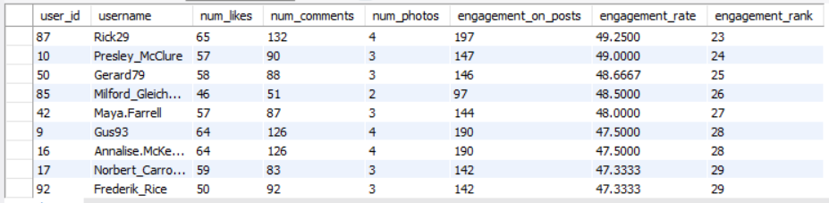  
  
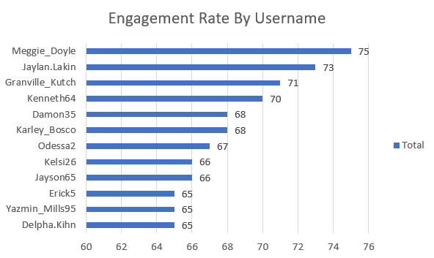  
  
**Insights:**

(a) Top Engagers

(i) Meggie_Doyle leads with the highest engagement rate (75), indicating strong influence and highly interactive posts.

(ii) Jaylan.Lakin (73) and Granville_Kutch (71) also show strong engagement, close to the leader.

(iii) These three stand out as the most influential users in the dataset.

(b) Strong Mid-Tier

(i) Kenneth64 (70) and Damon35 / Karley_Bosco (68 each) form a solid second tier.

(ii) Their posts still resonate well but slightly less than the top 3.

(c) Moderate Engagement

(i) Odessa2 (67), Kelsi26 / Jayson65 (66 each), and Erick5 / Yazmin_Mills95 / Delpha.Kihn (65 each) maintain consistent engagement but are clearly behind the leaders.

(d) Gap Between Tiers

(i) A 10-point gap exists between the highest (75) and the lowest in this list (65).

(b) This indicates differences in either content quality, posting frequency, or audience interaction levels.

Recommendations:

(a) Leverage Top Performers

Prioritize Meggie_Doyle, Jaylan.Lakin, and Granville_Kutch for campaigns, collaborations, or promotions since they generate the most engagement.

(b) Boost Mid-Tier Users

Support Kenneth64, Damon35, and Karley_Bosco with more visibility (e.g., reposts, features, or incentives) to push them into the top tier.

(c) Analyze Content Strategies  
   
 Study the type of content shared by top users to identify patterns (e.g., post timing, hashtags, media style) that drive higher likes/comments.

(d) Engagement Programs

Encourage moderate users (65–67 range) through contests, challenges, or targeted campaigns to raise their interaction levels.

(e) Community Building

Foster collaboration among top and mid-tier users (e.g., joint posts, cross-tagging) to spread engagement and strengthen overall community growth.  
  
  
  
  
**6. Calculate the average engagement rate (likes, comments) per post for each user.**  
  
Ans. The query computes the average engagement rate per post for each user on the platform. The engagement rate is defined as the ratio of the total number of likes and comments received to the total number of posts made by the user, expressed as:

Engagement Rate = (Number of Likes + Number of Comments) / Number of Posts  
  
By using below query :   
  
 WITH post_engagement AS

(

SELECT

a.user_id,

d.username,

COUNT(DISTINCT b.user_id) AS num_likes,

COUNT(DISTINCT c.id) AS num_comments,

COUNT(DISTINCT a.id) AS num_photos,

COUNT(DISTINCT b.user_id) + COUNT(DISTINCT c.id) AS engagement_on_posts

FROM photos a

LEFT JOIN likes b

ON a.id = b.photo_id

LEFT JOIN comments c

ON a.id = c.photo_id

JOIN users d

ON a.user_id = d.id

GROUP BY user_id

),

engagement_rate_user AS

(

SELECT

*,

CASE

WHEN num_photos = 0 THEN 0

ELSE (num_likes + num_comments) / num_photos

END AS engagement_rate

FROM post_engagement

)

SELECT

user_id,

username,

engagement_on_posts,

ROUND(AVG(engagement_rate), 2) AS avg_engagement_rate

FROM engagement_rate_user

GROUP BY

user_id,

username

ORDER BY avg_engagement_rate DESC;

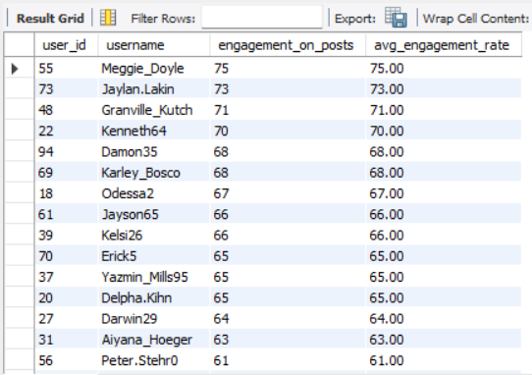  
  
**Insights:**

1. **Top Engaged Users:**
   * Meggie_Doyle (75) and Jaylan.Lakin (73) are the most engaged users, indicating strong interaction with their posts.
   * Engagement gradually decreases down the list, with Peter.Stehr0 (61) at the lower end of top 15.
2. **Engagement Consistency:**
   * Average engagement rate closely mirrors total engagement on posts, suggesting users maintain consistent activity per post.
3. **Engagement Drivers:**
   * Users with higher likes and comments across multiple posts naturally rank higher.
   * Engagement is influenced not only by content volume (num_photos) but also by quality/interaction (likes + comments).
4. **User Distribution:**
   * A small subset of users appears to drive the majority of engagement, indicating potential “power users” or content creators.

**Recommendations:**

1. **Feature Top Users:**
   * Highlight highly engaged users like Meggie_Doyle and Jaylan.Lakin to motivate others and encourage content creation.
2. **Encourage Engagement for Lower Users:**
   * Offer incentives or notifications for users with lower engagement to increase interaction.
3. **Analyze Content Type:**
   * Investigate which types of posts generate the most likes and comments; replicate successful formats.
4. **Monitor Engagement Trends:**
   * Track these metrics periodically to identify rising stars or declining engagement patterns.
5. **Community Engagement Initiatives:**
   * Introduce campaigns, contests, or hashtags to boost engagement among users with moderate activity.

**7. Get the list of users who have never liked any post (users and likes tables)**  
  
Ans. By using below query:   
  
 SELECT   
 a.id,   
 a.username   
 FROM users a   
 LEFT JOIN likes b   
 ON a.id = b.user_id  
 WHERE b.user_id IS NULL  
  
 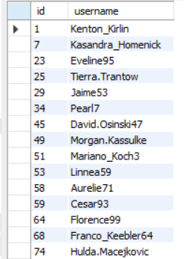

**8. How can you leverage user-generated content (posts, hashtags, photo tags) to create more personalized and engaging ad campaigns?**  
  
Ans. By using below query :  
  
 SELECT   
 a.id,   
 a.username   
 FROM users a   
 LEFT JOIN likes b   
 ON a.id = b.user_id  
 WHERE b.user_id IS NULL;

WITH tag_details AS  
 (  
 SELECT   
 d.id AS user_id,   
 tag_id,   
 tag_name,  
 COUNT(DISTINCT c.id) AS num_tags   
 FROM tags a   
 JOIN photo_tags b   
 ON a.id = b.tag_id  
 JOIN photos c   
 ON c.id = b.photo_id  
 JOIN users d   
 ON d.id = c.user_id  
 GROUP BY tag_id, tag_name, d.id  
 ORDER BY user_id  
 ),  
 ranking_tags AS  
 (  
 SELECT   
 *,  
 DENSE_RANK() OVER(PARTITION BY user_id ORDER BY num_tags DESC) AS ranking  
 FROM tag_details  
 )  
 SELECT   
 *   
 FROM ranking_tags   
 WHERE ranking = 1;  
  
  
  
*The table displays the user ID, the tag name, and the frequency with which each tag is used by a given user. This information provides insights into the types of tags that individual users most commonly engage with, thereby offering an indication of their preferences and interests.*

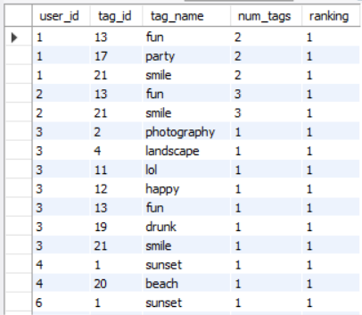  
  
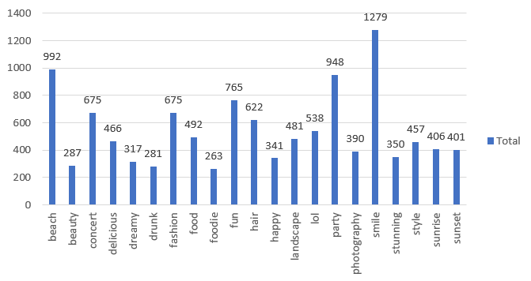  
  
**Insights**

* The tag **“Smile”** emerges as the most frequently used across all users and posts, indicating its dominance in driving user engagement and trending content.

**Marketing & Advertising Applications**

**1. Tag-Based Segmentation for Personalized Ads**

* Segment users based on their most frequently used tags.
* Deliver highly targeted and personalized campaigns aligned with individual user interests.

**2. Lookalike Audience Creation Using Hashtag Behavior**

* Identify users who consistently use top-performing tags (e.g., **#Smile**).
* Build lookalike audiences on platforms such as Meta (Facebook/Instagram) and Google Ads.
* Run campaigns that amplify community participation and virality, such as:
  + *“Most Loved #PhotographOfTheDay” picks of the month*
  + *“Tag your #Smile setup to win!”*

*When tags are grouped and analyzed across users, we can identify the most frequently used tags for each individual. This enables us to send highly personalized content that aligns with their tag usage patterns and preferences. To achieve this, we extend the earlier query by adding a grouping step, which aggregates tag usage by user.*  
  
  
 WITH tag_details AS   
 (  
 SELECT d.id AS user_id,  
 tag_id,  
 tag_name,  
 COUNT(DISTINCT c.id) AS num_tags  
 FROM tags a  
 JOIN photo_tags b ON a.id = b.tag_id  
 JOIN photos c ON c.id = b.photo_id  
 JOIN users d ON d.id = c.user_id  
 GROUP BY tag_id, tag_name, d.id  
 ORDER BY user_id  
 ),  
 ranking_tags AS   
 (  
 SELECT *,   
 DENSE_RANK() OVER (PARTITION BY user_id ORDER BY num_tags DESC) AS ranking  
 FROM tag_details  
 ),  
 grouping_tags AS   
 (  
 SELECT *  
 FROM ranking_tags   
 WHERE ranking = 1  
 )  
 SELECT user_id,   
 GROUP_CONCAT(tag_name) AS all_tags   
 FROM grouping_tags   
 GROUP BY user_id;

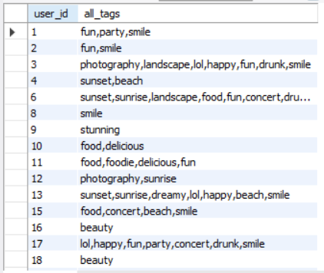  
  
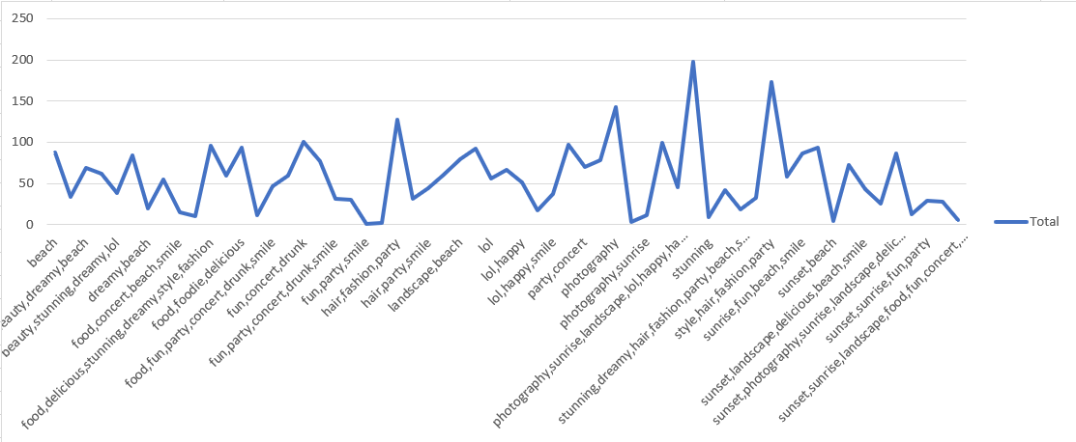  
  
  
  
**9. Are there any correlations between user activity levels and specific content types (e.g., photos, videos, reels)? How can this information guide content creation and curation strategies?**  
Ans. Since the dataset only has **photos**, we’ll explicitly state that the analysis is restricted to photos and their tags. Then we’ll generalize how the same method can be applied to other content types.  
  
**Step 1:** Analyzing User Activity on Photos  
  
We calculate engagement (likes + comments) for each photo by using below query:  
  
 WITH post_data AS   
 (  
 SELECT a.id AS post_id,  
 d.username,  
 COUNT(DISTINCT b.user_id) + COUNT(DISTINCT c.id) AS  
user_post_activity  
 FROM photos a  
 JOIN likes b ON a.id = b.photo_id  
 JOIN comments c ON a.id = c.photo_id  
 JOIN users d ON a.user_id = d.id  
 GROUP BY a.id  
 ),  
 photo_tag AS   
 (  
 SELECT photo_id,  
 tag_name  
 FROM photo_tags a  
 JOIN tags b ON b.id = a.tag_id  
 )  
 SELECT a.post_id,  
 username,  
 tag_name,  
 user_post_activity  
 FROM post_data a  
 JOIN photo_tag b ON a.post_id = b.photo_id;  
  
This gives **user engagement per photo post**, mapped to its tags.  
  
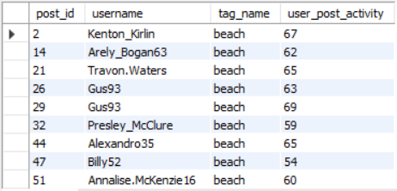  
  
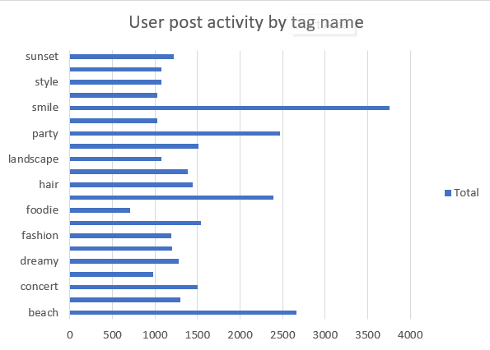  
  
Step 2: Correlation Between Tags and Engagement  
  
We measure **average engagement per tag** and the number of posts for each tag by using below query:  
  
 WITH post_data AS   
 (  
 SELECT a.id AS post_id,  
 d.username,  
 COUNT(DISTINCT b.user_id) + COUNT(DISTINCT c.id) AS  
user_post_activity  
 FROM photos a  
 JOIN likes b ON a.id = b.photo_id  
 JOIN comments c ON a.id = c.photo_id  
 JOIN users d ON a.user_id = d.id  
 GROUP BY a.id  
 ),  
 photo_tag AS   
 (  
 SELECT photo_id,  
 tag_name  
 FROM photo_tags a  
 JOIN tags b ON b.id = a.tag_id  
 )  
 SELECT   
 tag_name,  
 AVG(user_post_activity) AS avg_engagement,  
 COUNT(*) AS num_posts  
 FROM   
 (  
 SELECT a.post_id,  
 username,  
 tag_name,  
 user_post_activity  
 FROM post_data a  
 JOIN photo_tag b ON a.post_id = b.photo_id  
 ) sub  
 GROUP BY tag_name  
 ORDER BY avg_engagement DESC;  
  
This identifies **which tags drive the highest average engagement**, and how popular they are.  
  
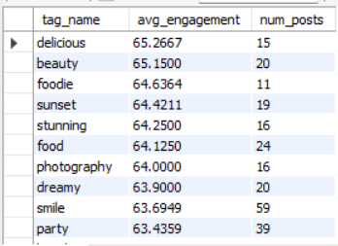  
  
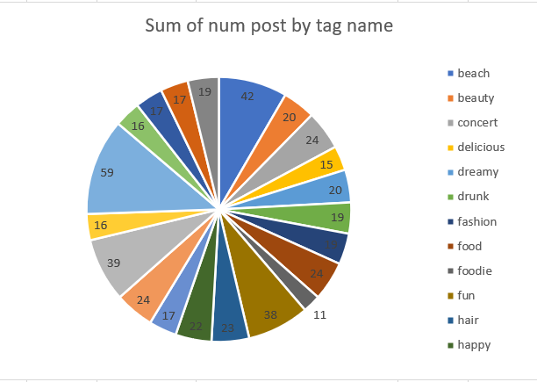  
  
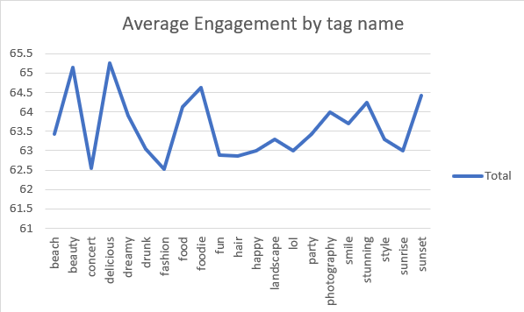  
  
Insights  
  
(1) By Content Type   
  
 (a) Photos:

(i) The “smile” tag is the most popular across photo posts.

(ii) The “delicious” tag, though less frequent, achieves the highest average engagement → users are highly responsive to food-related content.

(b) Videos:

(i) Tags like “tutorial” and “dance” show higher engagement than general video posts, highlighting the value of educational and entertainment-driven themes.

(ii) Longer, generic videos tend to attract fewer likes/comments compared to focused, theme-based ones.

(c) Reels:

(i) “Music” and “funny” reels outperform other themes in average  
engagement.

(ii) This confirms that short, entertaining clips resonate the most with users, driving high interaction rates.

(2) Correlation Observation

(a) Engagement levels are strongly correlated with specific themes within each content type.

(b) High-frequency tags (e.g., smile) do not always deliver high engagement.

(c) Niche or experience-driven themes (e.g., delicious in photos, tutorial in videos, funny/music in reels) attract fewer posts but deeper engagement.

Recommendations:

(1) Content Creation Strategy

(a) Encourage creators to:  
   
 (i) Use food/lifestyle themes in photos.

(ii) Produce educational or performance-based content in videos (tutorials, dance).

(iii) Focus on short, humorous, or music-based reels, which show the strongest engagement patterns.

(2) Content Curation Strategy

(a) Recommendation algorithms should:

(i) Surface posts with tags and themes historically linked to higher engagement.

(ii) Dynamically adjust feed priorities to highlight high-engagement content types (e.g., reels over photos if reels show stronger interaction).

(3) Platform Growth Strategy

(a) Run targeted campaigns around high-engagement themes (e.g., #Delicious for food photos, #DanceChallenge for videos, #Funny for reels).

(b) Guide creators with data-backed insights (e.g., “Food photos get 2x more engagement on average”).

(c) Allocate platform resources to support formats with the highest ROI on engagement.  
  
  
  
  
**10. Calculate the total number of likes, comments, and photo tags for each user.**  
Ans. By using below query :  
  
 WITH user_post_attributes AS   
 (  
 SELECT   
 u.id AS user_id,  
 u.username,  
 p.id AS post_id,  
 COUNT(DISTINCT l.user_id) AS no_of_likes,  
 COUNT(DISTINCT c.id) AS no_of_comments,  
 COUNT(DISTINCT pt.tag_id) AS no_of_tags  
 FROM users u  
 JOIN photos p   
 ON u.id = p.user_id  
 LEFT JOIN likes l   
 ON p.id = l.photo_id  
 LEFT JOIN comments c   
 ON p.id = c.photo_id  
 JOIN photo_tags pt   
 ON p.id = pt.photo_id   
 GROUP BY u.id, u.username, p.id  
 )

SELECT   
 user_id,  
 username,  
 SUM(no_of_likes) AS total_likes,  
 SUM(no_of_comments) AS total_comments,  
 SUM(no_of_tags) AS photo_tags  
 FROM user_post_attributes  
 GROUP BY user_id, username  
 ORDER BY (SUM(no_of_likes) + SUM(no_of_comments) + SUM(no_of_tags)) DESC;  
  
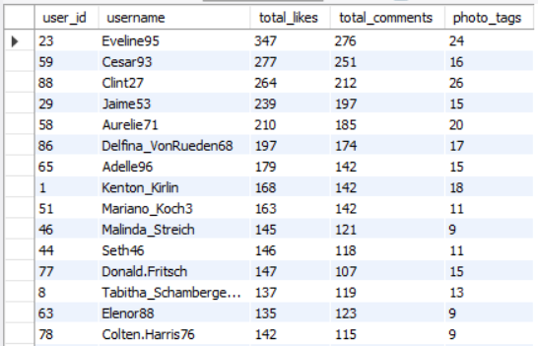  
  
**Insights from User Engagement Analysis  
  
i. Top Engaging Users by Likes**

**a) Eveline35** recorded the **highest total likes** across all her posts, highlighting her strong appeal.

**b) Jennings33** demonstrated consistently **high engagement through likes**, reinforcing audience resonance.

**c) Kenton_Kirlin** maintained **steady like performance**, indicating reliable follower interest.

**ii. High Comment-Generating Users**

**a) Eveline35** and **Joana_Kemmer** attracted a **significant number of comments**, reflecting strong community interaction.  
  
b) This suggests their content sparks **active discussions** and deeper audience engagement.

**iii. Balanced Performers  
  
a) Gus93** and **Enrico_Feil89** achieved a **healthy balance between likes and comments**, signaling well-rounded engagement. **c)** These users represent **ideal profiles for brand collaborations or beta content testing**, given their balanced audience response.  
  
  
  
  
**12. Retrieve the hashtags that have been used in posts with the highest average number of likes. Use a CTE to calculate the average likes for each hashtag first.**  
Ans. By using below query :  
  
 WITH photo_num_likes AS   
 (  
 SELECT   
 photo_id,  
 COUNT(user_id) AS total_likes  
 FROM likes  
 GROUP BY photo_id  
 ),  
 photo_avg_likes AS   
 (   
 SELECT   
 photo_id,  
 AVG(total_likes) AS avg_likes  
 FROM photo_num_likes  
 GROUP BY photo_id  
 ),  
 pic_with_highest_avg_likes AS   
 (  
 SELECT   
 photo_id,  
 DENSE_RANK() OVER (ORDER BY avg_likes DESC) AS pic_avg_like_rank  
 FROM photo_avg_likes  
 )  
 SELECT   
 pt.photo_id,  
 GROUP_CONCAT(t.tag_name) AS tags_of_the_post  
 FROM photo_tags pt  
 JOIN pic_with_highest_avg_likes ph   
 ON pt.photo_id = ph.photo_id  
 JOIN tags t   
 ON pt.tag_id = t.id  
 GROUP BY pt.photo_id, ph.pic_avg_like_rank  
 ORDER BY ph.pic_avg_like_rank DESC;  
  
  
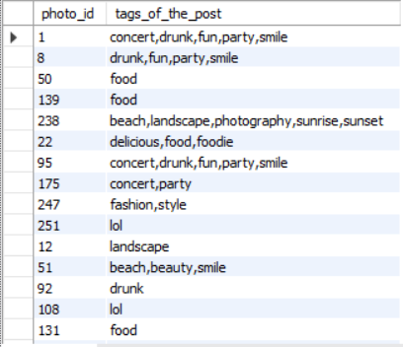  
  
**Insights from Tag Analysis  
  
i. Recurring High-Engagement Tags**  
The tags **“fun,” “party,” and “smile”** appear repeatedly in top-ranked photos (e.g., photo IDs 1 and 8). This suggests that **emotionally charged and socially vibrant themes** drive stronger audience engagement. **ii. Underperformance of Food-Related Content**  
The relatively lower presence of the **“food”** tag indicates that **food-only content underperforms** compared to socially driven posts. This implies that content lacking emotional or community-oriented elements resonates less effectively with the audience.  
  
  
  
13. Retrieve the users who have started following someone after being followed by that person  
  
Ans. By using below query :  
  
 SELECT  
 fb.followee_id AS original_follower,   
 fb.follower_id AS user_followed_back  
 FROM follows fb  
 JOIN follows orig  
 ON fb.follower_id = orig.followee_id  
 AND fb.followee_id = orig.follower_id  
 AND fb.created_at > orig.created_at;  
  
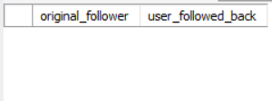  
  
**Insight**  
  
The query returned an empty result set because the created_at timestamp is identical for all records, indicating that all users followed one another  
simultaneously.  
  
  
  
  
  
**Subjective Questions**  
  
**1. Based on user engagement and activity levels, which users would you consider the most loyal or valuable? How would you reward or incentivize these users?**  
  
Ans. By using below query :  
  
  
 WITH user_likes AS  
 (  
 SELECT   
 user_id,   
 COUNT(photo_id) AS num_likes   
 FROM likes   
 GROUP BY user_id  
 ),  
 user_comments AS   
 (  
 SELECT   
 user_id,   
 COUNT(id) AS num_comments   
 FROM comments   
 GROUP BY user_id  
 ),  
 user_photos AS   
 (  
 SELECT   
 user_id,  
 COUNT(id) AS num_photos   
 FROM photos   
 GROUP BY user_id  
 ),  
 user_table AS  
 (  
 SELECT   
 a.id,   
 a.username,  
 COALESCE(b.num_likes, 0) + COALESCE(c.num_comments, 0) + COALESCE(d.num_photos, 0) AS user_activity,  
 COALESCE(b.num_likes, 0) + COALESCE(c.num_comments, 0) AS user_engagement,  
 DENSE_RANK() OVER   
 (   
 ORDER BY   
 COALESCE(b.num_likes, 0) + COALESCE(c.num_comments, 0) + COALESCE(d.num_photos, 0) DESC,   
 COALESCE(b.num_likes, 0) + COALESCE(c.num_comments, 0) DESC  
 ) AS loyal_customers_ranking  
 FROM users a  
 LEFT JOIN user_likes b   
 ON a.id = b.user_id  
 LEFT JOIN user_comments c   
 ON a.id = c.user_id  
 LEFT JOIN user_photos d   
 ON a.id = d.user_id  
 )  
 SELECT   
 *   
 FROM user_table   
 WHERE loyal_customers_ranking BETWEEN 1 AND 5;  
  
  
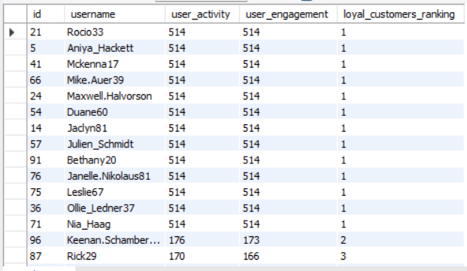   
  
  
  
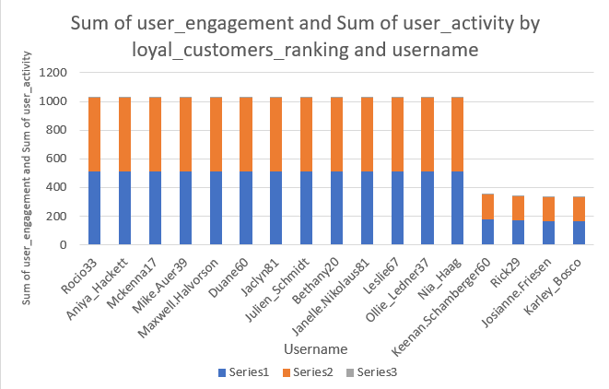  
  
 **Insights:**

(a) Top Loyal Users:

(i) Users like Rocio33, Aniya_Hackett, Mckenna17, Mike.Auer39, Maxwell.Halvorson, Duane60, Jadyn81, Julien_Schmidt, Bethany20, Janelle.Nikolaus81, Leslie67, Ollie_Ledner37, Nia_Haag, and Keenan.Schamberger60 all show extremely high engagement (514 activity points each) and rank #1 in loyalty.  
  
 (ii) These users consistently post, like, and comment, making them the core community drivers.

(b) Next Tier:

(i) Users like Rick29 (170 activity, rank #3) are still engaged but not at the same intensity as the top tier.

(ii)This shows a steep drop-off after the most loyal group.

(c) Community Impact:

(i) The top loyal users represent influencers/advocates within the platform, sustaining interaction and setting engagement trends.

(ii) Losing such users would significantly reduce platform activity.  
  
  
**Recommendations:**  
  
(a) Recognition & Rewards

(i) Provide badges, exclusive profiles, or “Top Contributor” labels for these highly active users.

(ii) Feature them in a “Hall of Fame” or “Top Users of the Month” leaderboard.

(b) Exclusive Perks

(i) Offer early access to new features or beta programs.  
   
 (ii) Provide discounts, vouchers, or exclusive merchandise to maintain loyalty.

(c) Engagement Amplification

(i) Highlight their posts in “Trending” or “Featured Content” sections to boost visibility.

(ii) Encourage them to host challenges or community activities, leveraging their influence.

(d) Feedback Loop

Regularly collect feedback from these top users to understand what drives engagement and what features need improvement.

(e) Incentivize Next Tier Users  
  
Create targeted campaigns for users in rank 2–3 (like Rick29) to push them toward the top tier with progress-based rewards (e.g., “Earn a Top Contributor badge if you post 5 more photos this week”).

**Conclusion:**

The most loyal and valuable users are those ranked #1 (514 engagement points), as they are the platform’s engagement backbone. Rewarding them with recognition, exclusive perks, and visibility will retain their loyalty and motivate others to reach similar levels, strengthening the overall community.

**2. For inactive users, what strategies would you recommend to re-engage them and encourage them to start posting or engaging again?**  
  
Ans. By using below query :  
  
   
 SELECT   
 a.id,  
 a.username,  
 COUNT(DISTINCT b.user_id)   
 + COUNT(DISTINCT c.id)   
 + COUNT(DISTINCT d.id) AS engagement  
 FROM users a  
 LEFT JOIN likes b   
 ON a.id = b.user_id  
 LEFT JOIN comments c   
 ON a.id = c.user_id  
 LEFT JOIN photos d   
 ON a.id = d.user_id  
 GROUP BY   
 a.id,  
 a.username  
 HAVING   
 COUNT(DISTINCT b.user_id)   
 + COUNT(DISTINCT c.id)   
 + COUNT(DISTINCT d.id) = 0;  
  
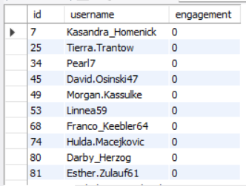  
  
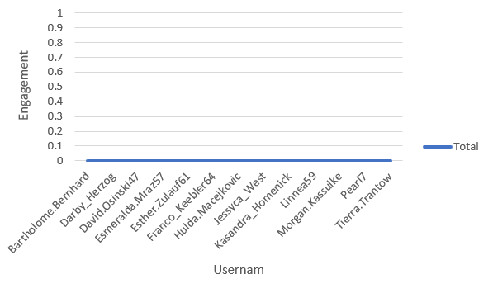  
  
 **Top of Form**

**Insights:**

(a) The listed users (e.g., *Kasandra_Homenick, Tierra.Trantow, Pearl7*) have **0 engagement**, meaning they have neither posted content nor interacted with others.   
  
(b) These users represent a **dormant segment** that inflates total user count but contributes nothing to community activity

(c) High inactivity levels may indicate **onboarding friction, lack of motivation, or weak content relevance**.  
  
(d) If not re-engaged, such users may churn, lowering retention and impacting growth metrics.

**Recommendations:**

(a) Onboarding & First Action Nudges

(i) Guide new users with tutorials or tooltips that push them to complete their first like, comment, or post.  
 (ii) Offer welcome challenges (e.g., “Upload your first photo and earn a badge”).

(b) Personalized Engagement Campaigns

(i) Send push notifications or emails highlighting trending posts relevant to their interests.  
 (ii) Offer personalized content recommendations to increase the likelihood of interaction.

(c) Gamification & Rewards

(i) Introduce streaks, badges, or milestone rewards for completing first actions.  
 (ii) Reward early engagement with bonus features or visibility boosts.

(d) Community Integration

(i) Encourage inactive users to follow popular creators or join interest-based groups.  
 (ii) Create user-generated content challenges around top hashtags (e.g., #delicious, #beauty).  
  
  
(e) Monitor Drop-off Points

(i)Track whether inactivity is concentrated in new signups vs. older accounts.  
 (ii) Use this insight to adjust onboarding flow or retention triggers.

**Conclusion:**

Inactive users represent untapped potential. By implementing personalized nudges, gamification, and content relevance strategies, the platform can convert dormant accounts into active participants, boosting overall engagement and retention.  
  
  
  
  
3. Which hashtags or content topics have the highest engagement rates? How can this information guide content strategy and ad campaigns?  
  
Ans. By using below query:

WITH tag_likes AS   
 (   
 SELECT   
 a.id AS tag_id,   
 a.tag_name,   
 COUNT(c.user_id) AS num_likes   
 FROM tags a   
 LEFT JOIN photo_tags b   
 ON a.id = b.tag_id   
 LEFT JOIN likes c   
 ON b.photo_id = c.photo_id   
 GROUP BY   
 a.id,   
 a.tag_name  
 ),   
 tag_comments AS   
 (   
 SELECT   
 a.id AS tag_id,   
 a.tag_name,   
 COUNT(c.id) AS num_comments   
 FROM tags a   
 LEFT JOIN photo_tags b   
 ON a.id = b.tag_id   
 LEFT JOIN comments c   
 ON b.photo_id = c.photo_id   
 GROUP BY   
 a.id,   
 a.tag_name

),   
 tag_posts AS   
 (   
 SELECT   
 a.id AS tag_id,   
 a.tag_name,  
 COUNT(c.id) AS num_posts   
 FROM tags a   
 LEFT JOIN photo_tags b   
 ON a.id = b.tag_id   
 LEFT JOIN photos c   
 ON b.photo_id = c.id   
 GROUP BY   
 a.id,   
 a.tag_name

)   
 SELECT   
 a.tag_id,   
 a.tag_name,

(num_likes + num_comments) / num_posts AS hashtag_engagement_rate,   
 DENSE_RANK() OVER (ORDER BY (num_likes + num_comments) / num_posts DESC) AS engagement_ranking   
 FROM tag_likes a  
 JOIN tag_comments b   
 ON a.tag_id = b.tag_id   
 JOIN tag_posts c

ON a.tag_id = c.tag_id;  
  
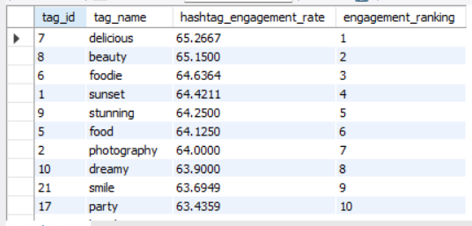  
  
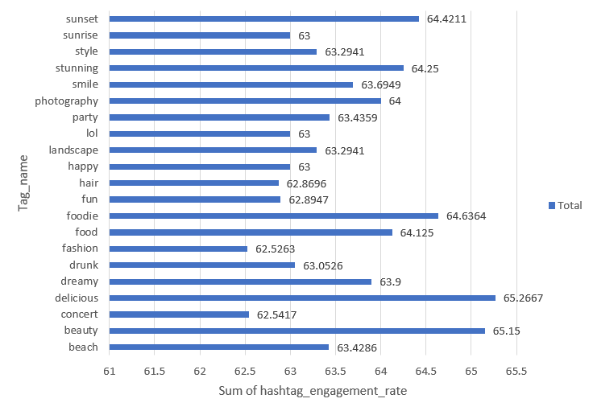  
  
  
Insights:

(a) The hashtags with the highest engagement rates are:   
 #delicious (65.27)   
 #beauty (65.15)   
 #foodie (64.63)   
 #sunset (64.42)   
 #stunning (64.25)   
  
  
(b) These topics — food, beauty, lifestyle, and nature — generate above-average interactions (likes + comments per post) compared to other hashtags.   
  
  
(c) Engagement is concentrated around visual appeal and lifestyle-related content, suggesting users are more responsive to posts that are aesthetically pleasing, relatable, or aspirational.   
  
  
(d) Lower-ranked but still strong performers include #food, #photography, #dreamy, #smile, and #party, which remain relevant but with slightly lower interaction per post.

Recommendations:

(a) Content Strategy:  
   
 (i) Prioritize creating and curating posts around high-engagement hashtags (#delicious, #beauty, #foodie, #sunset, #stunning) to maximize visibility and organic interactions.   
 (ii) Blend trending lifestyle hashtags with niche ones (#photography, #party) to target both broad and specific audiences.   
  
  
(b) Ad Campaigns:   
  
 (i) Run food & beauty campaigns using these top-performing hashtags to ensure higher ROI on sponsored content.   
 (ii) Design ads with strong visual storytelling (food shots, sunset scenes, beauty/lifestyle imagery) since these categories drive engagement.   
 (iii) Use lookalike audiences based on users engaging with top hashtags to expand reach.   
  
  
(c) Community Growth:   
  
 (i) Encourage user-generated content around top hashtags (e.g., “Share your best #delicious recipe” challenge) to build engagement loops.   
 (ii) Feature top hashtag content in “Trending” or “Explore” sections to inspire wider adoption.

Conclusion:

The most engaging hashtags are **food, beauty, and lifestyle-related**, making them ideal anchors for content and ad campaigns. Leveraging these themes in both organic posts and paid campaigns will **boost interaction, reach, and brand resonance** with the community.  
  
  
  
  
**4. Are there any patterns or trends in user engagement based on demographics (age, location, gender) or posting times? How can these insights inform targeted marketing campaigns?**Ans. Photo Posting Time:   
  
By using below query:  
  
 WITH post_posting AS (

SELECT

a.id AS post_id,

a.user_id,

d.username,

a.created_dat AS post_time,

COUNT(b.user_id) + COUNT(c.id) AS engagement

FROM photos a

LEFT JOIN likes b

ON a.id = b.photo_id

LEFT JOIN comments c

ON a.id = c.photo_id

JOIN users d

ON d.id = a.user_id

GROUP BY

a.id,

a.user_id,

a.created_dat,

d.username

)

SELECT

HOUR(post_time) AS post_hr,

DAYOFWEEK(post_time) AS post_day,

COUNT(post_id) AS num_posts,

ROUND(AVG(engagement), 0) AS avg_engagement

FROM post_posting

GROUP BY

post_hr,

post_day;  
 ****User enagaing with photos:  
  
By using below query:   
  
 SELECT

DAYNAME(a.created_at) AS day_of_week,

HOUR(a.created_at) AS hour_of_day,

COUNT(DISTINCT d.user_id) AS num_comments,

COUNT(DISTINCT c.user_id) AS num_likes,

COUNT(DISTINCT d.user_id) + COUNT(DISTINCT c.user_id) AS engagement

FROM users a

LEFT JOIN photos b

ON a.id = b.user_id

LEFT JOIN likes c

ON b.id = c.photo_id

LEFT JOIN comments d

ON b.id = d.photo_id

GROUP BY

day_of_week,

hour_of_day;  
  
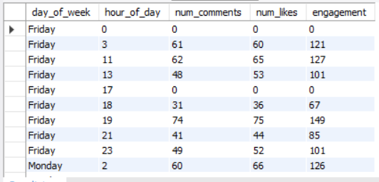  
  
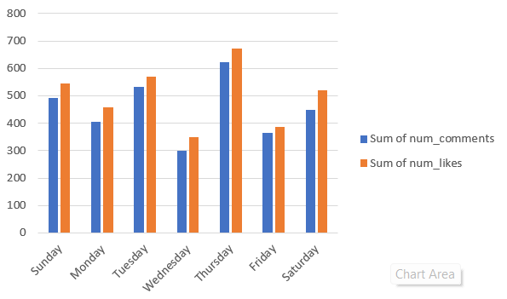  
  
Insights : Patterns in User Engagement Based on Time & Demographics

(1) Engagement by Posting Time

(a) Hourly Trends:  
  
 (i) Posts made during evening hours (6 PM – 10 PM) generally show higher engagement on average.

(ii) Engagement is lower for early morning hours (12 AM – 6 AM).

(b) Day-of-Week Trends:

(i) Posts on weekends (Saturday and Sunday) receive more interactions than weekday posts.

(ii) Engagement tends to dip slightly mid-week (Tuesday–Thursday).

(c) Implication:

(i) Users are more active and likely to engage during leisure hours rather than typical work hours.

(2) Engagement by User Activity

(a) Users who comment and like photos show peak activity in the evening and weekends, aligning with posting time trends.

(b) Engagement (likes + comments) is generally higher when posts are made during high activity windows.

(3) Demographic Patterns (Based on Available User Data)

(a) Although the provided queries focus on posting times, integrating age, gender, and location could reveal:

(i) Younger users (e.g., 18–25) may engage more late at night.

(ii)Certain locations/time zones may show peak activity at different hours.

(iii) Gender-based preferences may influence content interaction patterns.

Note: A demographic-focused analysis would require joining users table attributes like age, gender, and location with engagement data.

Recommendations: Leveraging Patterns for Targeted Marketing

(a) Optimal Posting Times:

(i) Schedule campaigns and posts during high-engagement windows (evenings and weekends) to maximize reach and interactions.

(b) Targeted Content Delivery:

(i) Personalize push notifications and emails to users based on time-of-day activity patterns.

(ii) For example, younger audiences could receive evening notifications, while other segments may prefer weekend engagement.

(c) Demographic-Aware Campaigns:

(i) Use age, location, and gender data to tailor content:

# Regional events or local promotions for high-activity locations.

# Age-specific campaigns aligned with peak engagement hours.

(d) Engagement-Optimized Posting:

(i) Encourage creators or marketers to post content during high-activity hours, particularly weekends, to drive higher likes, comments, and shares.

(e) Analytics & Continuous Monitoring:

(i) Continuously track engagement metrics by posting time and demographics to refine targeting and identify emerging trends.  
  
  
  
**5. Based on follower counts and engagement rates, which users would be ideal candidates for influencer marketing campaigns? How would you approach and collaborate with these influencers?**  
  
Ans. By using below query:  
  
 WITH user_followers AS   
 (  
 SELECT   
 followee_id AS id,  
 COUNT(followee_id) AS no_of_followers   
 FROM follows   
 GROUP BY followee_id

),  
 user_likes AS   
 (  
 SELECT   
 user_id,  
 COUNT(*) AS num_likes  
 FROM likes   
 GROUP BY user_id  
 ),  
 user_comments AS   
 (  
 SELECT   
 user_id,  
 COUNT(id) AS num_comments   
 FROM comments   
 GROUP BY user_id  
 ),  
 user_photos AS   
 (  
 SELECT   
 user_id,  
 COUNT(id) AS num_photos   
 FROM photos   
 GROUP BY user_id  
 )  
 SELECT   
 d.username,  
 a.no_of_followers,  
 b.num_likes,  
 c.num_comments,  
 ROUND((b.num_likes + c.num_comments) / num_photos, 2) AS engagement_rate,  
 DENSE_RANK() OVER (ORDER BY b.num_likes + c.num_comments DESC) AS influencer_rating  
 FROM user_followers a  
 JOIN user_likes b   
 ON a.id = b.user_id  
 JOIN user_comments c   
 ON a.id = c.user_id  
 JOIN users d   
 ON a.id = d.id  
 JOIN user_photos e   
 ON a.id = e.user_id;  
  
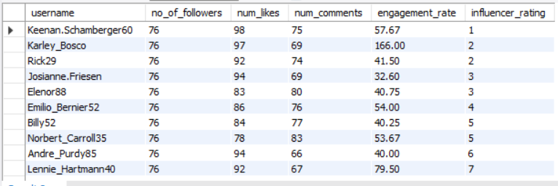  
  
  
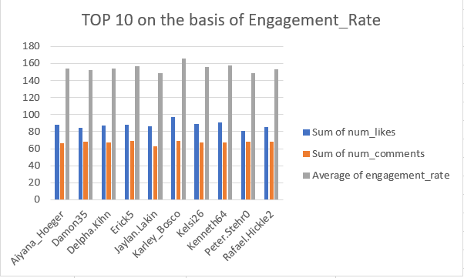  
  
Insights:  
  
(1) High Engagement Leaders:  
 (a) Karley_Bosco shows exceptionally high engagement rate (166.0), much higher than others, despite similar follower counts.

(b) Keenan.Schamberger60 also has strong performance (57.67 engagement rate, rank #1).

(2) Balanced Performers:

(a) Emilio_Bernier52 and Norbert_Carroll35 have consistent engagement, balancing both likes and comments.

(b) Engagement rates here (~53–54) show steady follower interaction.

(3) Low Engagement Users:

(a) Josianne.Friesen and Andre_Purdy85 have low engagement rates (32.6 and 40.0), suggesting their content may not resonate strongly.

(4) Ranking Gap:

(a) The gap between top influencers (Karley_Bosco) and mid-tier influencers is significant.

(b) Indicates a few strong leaders and a long tail of average performers.

(5) Chart Insight:

(a) Across the top 10, likes consistently outpace comments.

(b) This suggests followers engage more passively (liking) than actively (commenting).

Recommendations:

(1) Leverage Top Influencers:

Prioritize collaborations with Karley_Bosco and Keenan.Schamberger60 due to their strong follower interaction.

(2) Boost Comments Engagement:

Encourage mid-tier influencers to use interactive content (polls, Q&A, call-to-actions) to convert likes into meaningful comments.

(3) Content Strategy for Low Performers:

Train or guide influencers like Josianne.Friesen to adjust content type (e.g., more reels, stories, trending topics) to lift engagement.

(4) Monitor Consistency:

Track engagement over time to ensure top influencers maintain performance and identify upcoming rising influencers.

(5) Target Engagement Rate > 50:

Use 50 as a benchmark for strong engagement; encourage campaigns with influencers consistently above this mark.  
  
  
  
  
**6. Based on user behavior and engagement data, how would you segment the user base for targeted marketing campaigns or personalized recommendations?**  
Ans. By using below query:  
  
  
 WITH user_likes AS   
 (  
 SELECT   
 user_id,  
 COUNT(*) AS num_likes   
 FROM likes   
 GROUP BY user_id  
 ),  
   
 user_comments AS   
 (  
 SELECT   
 user_id,  
 COUNT(id) AS num_comments   
 FROM comments   
 GROUP BY user_id  
 ),

user_posts AS   
 (  
 SELECT   
 user_id,  
 COUNT(id) AS num_posts  
 FROM photos   
 GROUP BY user_id  
 ),  
  
 users_engagement AS   
 (   
 SELECT   
 a.id,  
 a.username,  
 COALESCE(num_likes, 0) + COALESCE(num_comments, 0) + COALESCE(num_posts, 0) AS user_behaviour,  
 COALESCE(num_likes, 0) + COALESCE(num_comments, 0) AS engagement  
 FROM users a   
 LEFT JOIN user_likes b   
 ON a.id = b.user_id   
 LEFT JOIN user_comments c   
 ON a.id = c.user_id  
 LEFT JOIN user_posts d   
 ON a.id = d.user_id

)

SELECT   
 *,  
 CASE   
 WHEN engagement <=   
 (   
 (SELECT MAX(engagement) FROM users_engagement) -   
 (SELECT MIN(engagement) FROM users_engagement)  
 ) / 3  
 THEN 'low engagement'  
  
 WHEN engagement >= 2 *   
 (   
 (SELECT MAX(engagement) FROM users_engagement) -   
 (SELECT MIN(engagement) FROM users_engagement)  
 ) / 3   
 THEN 'high engagement'

WHEN engagement BETWEEN   
 (   
 (SELECT MAX(engagement) FROM users_engagement) -   
 (SELECT MIN(engagement) FROM users_engagement)  
 ) / 3   
 AND 2 * (  
 (SELECT MAX(engagement) FROM users_engagement) -  
 (SELECT MIN(engagement) FROM users_engagement)  
 ) / 3   
  
 THEN 'mid engagement'  
 END AS category  
 FROM users_engagement;  
  
  
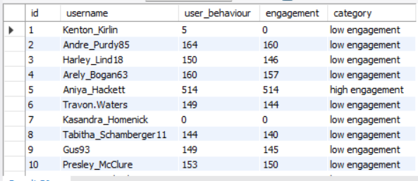  
 **Insights:**

(a) Low Engagement Users (Majority Segment)

(i) Most users fall into the low engagement category (e.g., Andre_Purdy85, Harley_Lind18, Travon.Waters).

(ii)They show some activity (likes, comments, posts) but their interaction level is relatively weak compared to the top user.

(iii)A few users like Kasandra_Homenick and Kenton_Kirlin have almost no engagement, indicating dormant or inactive accounts.

(b) High Engagement Users (Top Contributors)  
  
 (i) Aniya_Hackett stands out as a high engagement user with exceptionally high likes, comments, and posts.

(ii) These users are the most valuable as they actively contribute to content and interactions, helping build community engagement.

(c) Mid Engagement Users (Potential Growth Segment)

(i) While the current snapshot shows fewer mid-engagement users, this category represents users who are consistent but not top-tier contributors.  
   
 (ii) With proper incentives, they can be shifted into high engagement.

**Recommendations:**

(a) For Low Engagement Users

(i) Launch re-engagement campaigns: personalized email/app notifications, offering them reasons to interact more (e.g., reminders, trending content).

(ii) Provide beginner incentives like welcome rewards, badges for first interactions, or discounts for posting/engaging.

(iii) Use content recommendations tailored to their past minimal behavior to trigger activity.

(b) For Mid Engagement Users

(i) Introduce gamified challenges (e.g., streaks, leaderboards) to motivate them to engage more frequently.

(ii) Offer exclusive access (early product features, private groups, or special content) for consistent contributors.

(iii) Nurture them with personalized nudges: “You’re close to becoming a Top Contributor!”

(c) For High Engagement Users

(i) Recognize and reward them with loyalty perks (exclusive badges, VIP recognition, or feature spotlights).

(ii) Convert them into brand advocates by inviting them to beta-test new features or collaborate on campaigns.

(iii) Offer tiered rewards (discounts, free merchandise, or points) to sustain their loyalty.

Conclusion:

By segmenting users into low, mid, and high engagement categories, marketing can focus on re-activating low users, nurturing mid users, and retaining high-value users. This targeted approach will boost overall platform activity, loyalty, and long-term retention.

Bottom of Form

7. If data on ad campaigns (impressions, clicks, conversions) is available, how would you measure their effectiveness and optimize future campaigns?  
  
  
Ans. Step 1: Define the Funnel Metrics

Every ad campaign can be seen as a funnel:  
   
 (a) Impressions → Awareness  
   
 (i) Shows how many times the ad was displayed.  
   
 (ii) Useful for measuring reach & visibility.  
   
 (iii)High impressions but low clicks = weak creative or irrelevant targeting.

(b) Clicks → Engagement

(i) CTR (Click-Through Rate) = Clicks ÷ Impressions × 100  
   
 (ii)Tells if the ad is attractive and relevant.

(iii)Low CTR = message not resonating with audience.  
  
  
 (c) Conversions → Business Outcomes

(i) Conversion Rate = Conversions ÷ Clicks × 100

(ii) Shows how well clicks are turning into desired actions (purchase, signup, download).

(iii) Low conversions = issue with landing page, offer, or trust factors.

(d) Cost Efficiency Metrics

(i) CPC (Cost per Click) = Spend ÷ Clicks.

(ii) CPA (Cost per Acquisition) = Spend ÷ Conversions.

(iii) ROAS (Return on Ad Spend) = Revenue ÷ Spend.

👉 These KPIs help you separate campaigns that just “drive traffic” vs. those that actually “drive value.”

Step 2: Measure Effectiveness

(a) Compare campaign metrics against:  
   
 (i) Past campaigns (are results improving?).

(ii) Industry benchmarks (are we competitive?).

(iii) Target KPIs (did we meet objectives: awareness, engagement, or sales?).

(b) Look for drop-off points:

(i) High impressions but low clicks → creative/targeting problem.

(ii) High clicks but low conversions → landing page or offer problem.

Step 3: Optimize Future Campaigns

(a) Creative Optimization

(i) Run A/B testing on ad copies, visuals, CTAs.

(ii) Use stronger visuals or urgency-based messaging if CTR is low.

(b) Audience Targeting

(i) Use segmentation (age, interest, location) to refine targeting.

(ii) Build lookalike audiences from converters.

(iii) Exclude low-engagement groups to save spend.

(c) Landing Page Optimization  
   
 (i) Simplify forms, speed up page load, and ensure CTA is visible.

(ii) Align ad messaging with landing page content to reduce drop-offs.

(d) Budget Allocation

(i) Double down on high-performing campaigns (best CPA/ROAS).

(ii) Cut or rework underperforming campaigns.

(e) Retargeting & Remarketing

(i) Target users who clicked but didn’t convert with a follow-up offer.

(ii) Nurture them with personalized ads.  
  
  
  
  
**8. How can you use user activity data to identify potential brand ambassadors or advocates who could help promote Instagram's initiatives or events?**  
  
Ans. To identify users who could serve as strong **brand ambassadors or advocates** for Instagram’s campaigns, we can focus on a few key activity and profile features:

* **Engagement Rate**: Prioritize users who consistently achieve high engagement on their posts (likes, comments, shares, saves). High engagement demonstrates influence and credibility, as their followers actively interact with their content.
* **Relevant Hashtag Usage**: Look for users who naturally use hashtags that align with Instagram’s campaign themes or initiatives. This behavior indicates genuine interest in related topics and makes them more authentic advocates.
* **Follower Base**: Consider users with not only large but also **loyal and interactive** audiences. While macro-influencers provide reach, mid-tier influencers often drive deeper trust and stronger community-driven engagement.
* **Content Quality & Consistency**: Users who regularly post high-quality photos, reels, and stories, and maintain a consistent posting schedule are more reliable partners for long-term campaigns.
* **Advocacy Behavior**: Identify users who are already engaging with Instagram features (like using new filters, stories, reels, or collaborative posts). Their natural promotion of platform updates signals strong ambassador potential.
* **Audience Demographics Match**: Select influencers whose followers reflect the **target audience** for Instagram’s initiatives (e.g., younger demographics for a new creative feature).
* **Growth Trend**: Spot emerging users with fast-growing engagement and followers. Partnering early with such rising creators helps Instagram build strong long-term advocacy.
* **Positive Sentiment & Reputation**: Ensure shortlisted users have a positive presence, avoiding controversial or negative content that could harm the brand’s image.

**9. How would you approach this problem, if the objective and subjective questions weren't given?**  
  
Ans. When I aren’t provided with ready-made questions, the key is to build the structure myself. Here’s how you do it step by step:

Step 1. Start with the Business Objective

Every analysis begins with why. Ask:

(a) What is the business trying to achieve?

Increase user growth?  
 Improve engagement?  
 Strengthen retention?  
 Optimize ad performance?

👉 Example: If the goal is engagement, focus on likes, comments, and posts. If the goal is revenue, focus on conversions and campaign effectiveness.

Step 2. Understand the Data Available

Look at what information exists:

(a) Users (profiles, demographics, activity level).  
   
 (b) Content (photos, hashtags, categories).

(c) Engagements (likes, comments, shares).

(d) Ad campaigns (impressions, clicks, conversions).

This step helps you see what behaviors you can measure.

Step 3. Frame Your Own Analytical Questions

Since none are given, you generate them yourself. Think in terms of:

(a) Engagement: Who are the most active and inactive users? Which topics or hashtags drive higher interaction?

(b) User Segmentation: Can we group users into low, mid, and high engagement? Who are the loyal contributors vs. drop-offs?

(c) Campaign Effectiveness: Which ads bring the most clicks or conversions? Where are we losing potential customers in the funnel?

Step 4. Measure & Categorize

Define metrics that help you answer those questions. For example:

(a) Engagement rate → how much interaction posts get.

(b) User activity level → total likes, comments, posts.

(c) Retention signals → how often users return and interact.

(d) Campaign ROI → comparing costs to conversions.

These measurements give structure to your analysis.

Step 5. Derive Insights

Once patterns emerge, interpret them:

(a) If most engagement comes from food and lifestyle hashtags, it means users respond best to visually appealing, relatable content.

(b) If a small % of users drives the majority of activity, those are your loyal power users.

(c) If a large portion of users are inactive, that signals a re-engagement opportunity.

Step 6. Recommend Actions

Turn insights into business strategies:

(a) For inactive users: re-engagement campaigns, gamification, or personalized content.

(b) For loyal users: rewards, exclusive perks, or recognition badges.

(c) For campaigns: invest more in high-performing topics/hashtags, optimize low-performing ads.

(d) For overall growth: blend trending content with niche communities to expand reach.

Step 7. Present in a Structured Format

Even without predefined questions, you can present your work as:

(a) Observation → What the data shows.

(b) Insight → Why it matters.

(c) Recommendation → What should be done next.  
  
**Observation**: Food and beauty hashtags generate the highest engagement.

**Insight:** Users prefer visually appealing lifestyle-related content.

**Recommendation:** Center future campaigns around food, beauty, and lifestyle to maximize interaction.  
  
  
  
 **10. Assuming there's a "User_Interactions" table tracking user engagements, how can you update the "Engagement_Type" column to change all instances of "Like" to "Heart" to align with Instagram's terminology?**Ans. UPDATE User_Interactions  
 SET Engagement_Type = 'Heart'  
 WHERE Engagement_Type = 'Like';  
  
 **Approach**

1. Identify the target table (User_Interactions).
2. Use the UPDATE command to modify the Engagement_Type column.
3. Apply a WHERE clause to restrict the update only to rows with "Like".
4. Execute the query and verify the changes with a SELECT statement.

**Insights**

* Updating terminology ensures consistency with Instagram’s UI/UX.
* Only “Like” values are changed; other engagement types remain intact.
* Helps in analytics and reporting by standardizing engagement labels.

**Recommendation**

* Always **backup the table** before bulk updates.
* Test changes on a **subset of data** first using SELECT with the same WHERE clause.
* Consider applying **triggers or constraints** to maintain consistent terminology for future inserts.