Objective Questions:
- What is the distribution of account balances across different regions?
The chart highlights clear regional differences in how account balances are distributed:
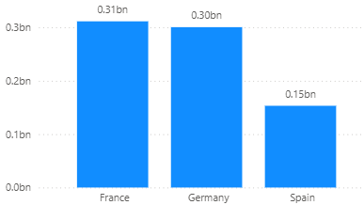
France (Region A) shows the highest total account balances at approximately 0.31 billion. This indicates that the region has a strong base of high-value customers. The concentration suggests that a significant portion of customers hold larger deposits, making France the most valuable region in terms of overall balance contribution.
Germany (Region B) follows closely with around 0.30 billion in total balances. However, unlike France, the distribution appears more evenly spread across different account sizes. This indicates a healthier mix of mid-value and high-value customers, suggesting stability and reduced dependency on a small group of large accounts.
Spain (Region C) has the lowest total at approximately 0.15 billion, significantly behind the other two regions. This could indicate either a smaller customer base or generally lower account balances per customer. It reflects a weaker contribution to overall funds compared to France and Germany.
Overall insight: France is the strongest value driver, Germany offers balanced and stable performance, while Spain presents an opportunity for growth through customer acquisition, upselling, or improved engagement strategies.
- Identify the top 5 customers with the highest Estimated Salary in the last quarter of the year. (SQL)
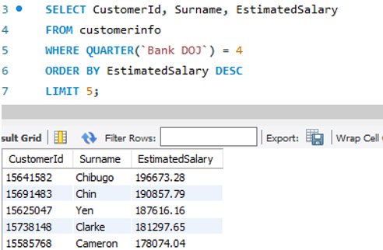
SELECT CustomerId, Surname, EstimatedSalary
Retrieves these three columns for each customer from the customerinfo table.
WHERE QUARTER(‘Bank DOJ`) = 4
Filters the records to include only those customers who joined the bank in the 4th quarter of the year — i.e., in the months October, November, or December.
ORDER BY EstimatedSalary DESC
Sorts the filtered customers in descending order of their Estimated Salary, meaning the highest salaries come first.
LIMIT 5
Returns only the top 5 customers from the sorted list — in this case, the top 5 highest-earning customers who joined in Q4.
- Calculate the average number of products used by customers who have a credit card. (SQL)
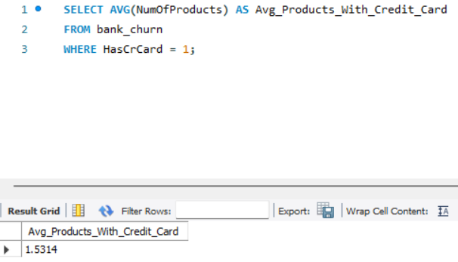
AVG(NumOfProducts)
calculates the average number of products used.
WHERE HasCreditCard = 1
filters the data to include only customers who have a credit card.
The result will return one value: the average number of products used by those customers.
- Determine the churn rate by gender for the most recent year in the dataset.
- Compare the average credit score of customers who have exited and those who remain. (SQL)
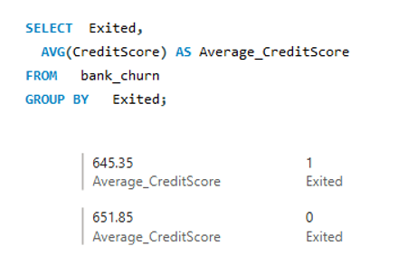
This query compares the average credit score of two groups of customers:
Those who left the bank (Exited = 1)
Those who stayed (Exited = 0)
It does this by:
Grouping the data based on the Exited column (0 or 1).
Calculating the average CreditScore for each group.
- Which gender has a higher average estimated salary, and how does it relate to the number of active accounts? (SQL)
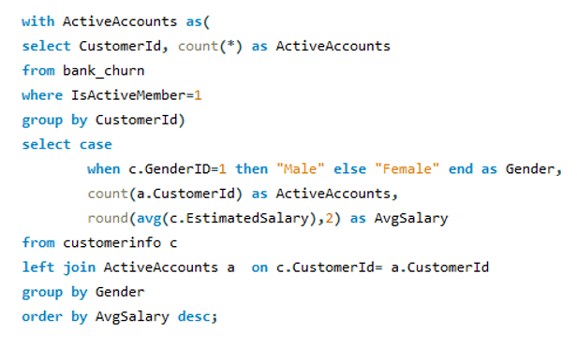
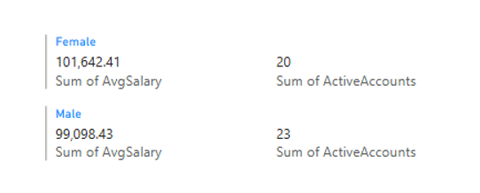
CTE (ActiveAccounts):
Identifies customers who are active (IsActiveMember = 1) from the bank_churn table.
Main Query:
(a) Joins customerinfo with the active customers list.
(b) Uses a CASE statement to convert GenderID to 'Male' or 'Female'.
(c) Counts how many active accounts exist for each gender.
(d) Calculates the average estimated salary for each gender.
(e) Orders results by average salary in descending order.
- Segment the customers based on their credit score and identify the segment with the highest exit rate. (SQL)
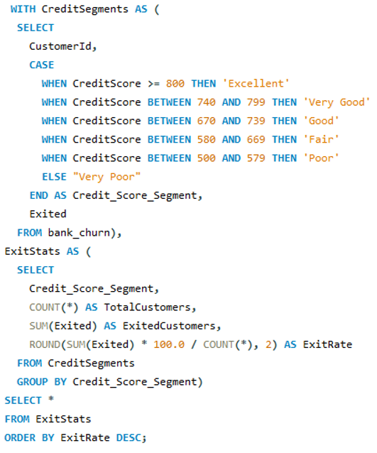
Step 1: Credit Score Segmentation (CTE: CreditSegments)
In this step, the query first studies every customer’s credit score and places them into a specific category (segment).
A CTE (Common Table Expression) is simply a temporary result table created inside the SQL query to make the query easier to read and manage.
The query uses a CASE statement to divide customers into different groups based on their CreditScore.
Credit Score Categories
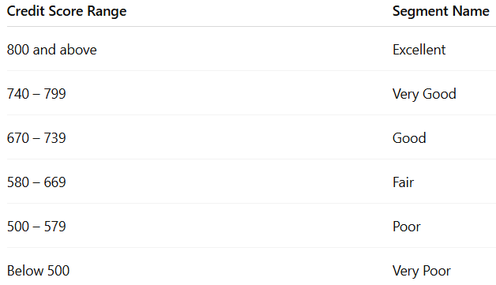
What Happens Here?
For every customer:
SQL checks the customer’s CreditScore
Assigns the correct segment label
Keeps the customer’s Exited value as well
The Exited column is important because:
0 = customer stayed with the bank
1 = customer left the bank (churned)
Step 2: Churn Analysis by Segment (CTE: ExitStats)
In this step, the query analyzes customer churn inside each credit score segment.
The data is grouped using:
GROUP BY Credit_Score_Segment
This means SQL combines all customers belonging to the same segment together.
Calculations Performed
For every credit score category, the query calculates:
(a) TotalCustomers
(b) ExitedCustomers
(c) ExitRate
Step 3: Final Output
In the final step, the query displays the completed churn analysis table.
The output contains:
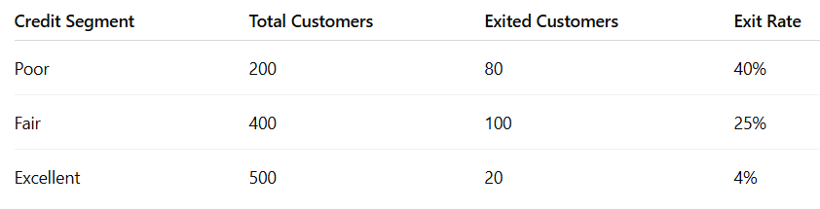
Why Sorting is Used
The query sorts the result using:
ORDER BY ExitRate DESC
This arranges the segments from:
Highest churn risk → Lowest churn risk
So the bank can quickly identify:
Which credit score groups are leaving the most
Which customer segments are most risky
Business Insights It Can Reveal
(a) Customers with lower credit scores may leave more frequently
(b) High credit score customers may be more loyal
(c) The bank can create targeted retention strategies for risky segments
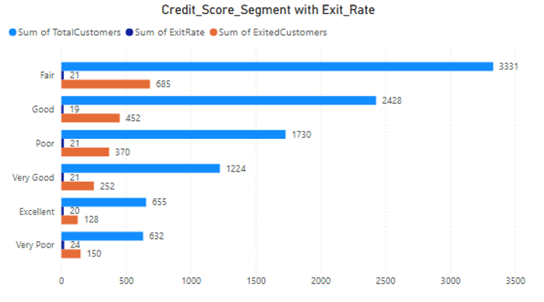
- Find out which geographic region has the highest number of active customers with a tenure greater than 5 years. (SQL)
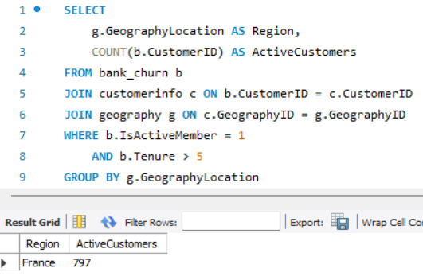
SELECT g.GeographyLocation AS Region
Retrieves the region name from the geography table.
COUNT(b.CustomerId) AS ActiveCustomers
Counts how many customers from the bank_churn table satisfy the given conditions (i.e., they are active and have a tenure > 5).
FROM bank_churn b
Starts with the main data table which contains customer churn information.
JOIN customerinfo c ON b.CustomerId = c.CustomerId
Connects churn data to customer personal details using CustomerId.
JOIN geography g ON c.GeographyID = g.GeographyID
Joins to the geography table to fetch region names. (This is an INNER JOIN, so if any GeographyID is missing or unmatched, the customer will be excluded.)
WHERE b.IsActiveMember = 1 AND b.Tenure > 5
Filters to include only those customers who are active and have been with the bank for more than 5 years.
GROUP BY g.GeographyLocation
Groups the filtered customers by region.
ORDER BY ActiveCustomers DESC
Sorts the groups by the number of active customers in descending order.
LIMIT 1
Returns only the top region with the most active long-term customers.
- What is the impact of having a credit card on customer churn, based on the available data?
- For customers who have exited, what is the most common number of products they have used?
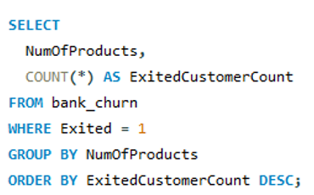
NumOfProducts: The number of products a customer used (e.g., accounts, loans, credit cards).
Exited = 1: Filters only customers who have exited (churned).
COUNT(*): Counts how many exited customers had each product count.
ORDER BY ExitedCustomerCount DESC LIMIT 1: Returns the product count with the highest number of exited customers.
This query helps identify the most frequent number of products used by churned customers.
It can reveal patterns such as:
(a) Are single-product users more likely to churn?
(b) Do multi-product users also churn often?
Insight:
The majority of exited customers used only 1 product, which might suggest a low engagement level with the bank's services.
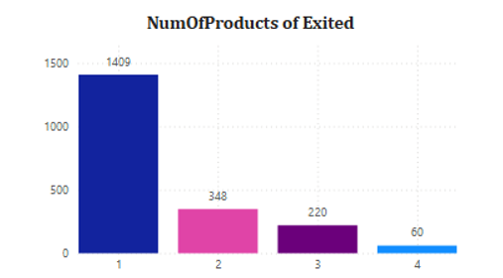
- Examine the trend of customers joining over time and identify any seasonal patterns (yearly or monthly). Prepare the data through SQL and then visualize it.
YEAR(Bank DOJ) and MONTH(Bank DOJ): These functions extract the year and month from the date when each customer joined the bank.
COUNT(*) AS NewCustomers: Counts how many customers joined in each month of each year.
GROUP BY YEAR(), MONTH(): Groups the data by year and month so the count is calculated for each time period.
ORDER BY JoinYear, JoinMonth: Sorts the result chronologically — from the earliest to the latest month/year.
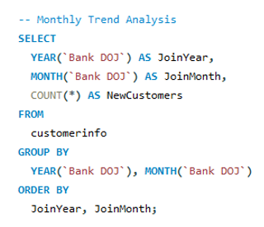
● The number of new customers who joined the bank in each month over time.
● This helps to identify joining trends, seasonal spikes, or any significant changes in customer acquisition.
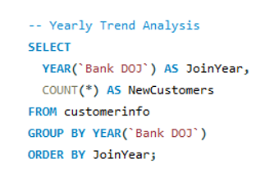
Insights:
Seasonal trends: Are there specific months (e.g., April or December) with spikes in new customers?
Year-on-year growth: Is customer acquisition increasing or declining?
Business events alignment: Spikes may align with campaigns, new product launches, etc.
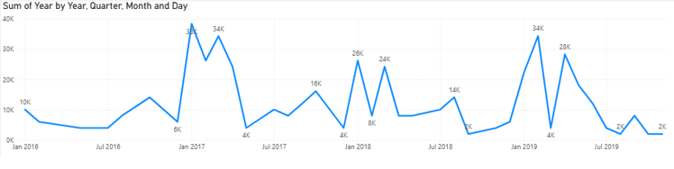
- Analyze the relationship between the number of products and the account balance for customers who have exited.
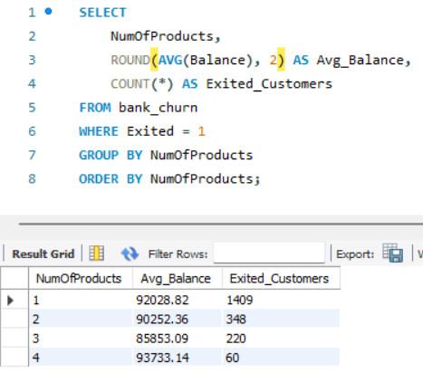
WHERE Exited = 1 →
selects only customers who left the bank.
GROUP BY NumOfProducts →
groups customers according to how many bank products they used.
AVG(Balance) →
calculates the average balance for each group.
COUNT(*) →
counts exited customers in each group.
ORDER BY NumOfProducts →
sorts the result by number of products.
Insights
(a) Customers using only 1 product usually have the highest churn.
(b) Customers with more products are generally more loyal and engaged.
(c) Higher-product customers often maintain higher balances.
(d) Cross-selling more products may help reduce customer churn.
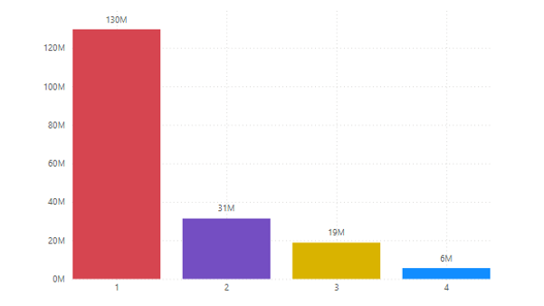
- Identify any potential outliers in terms of balance among customers who have remained with the bank.
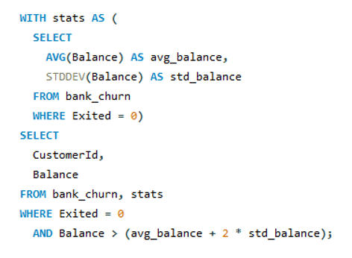
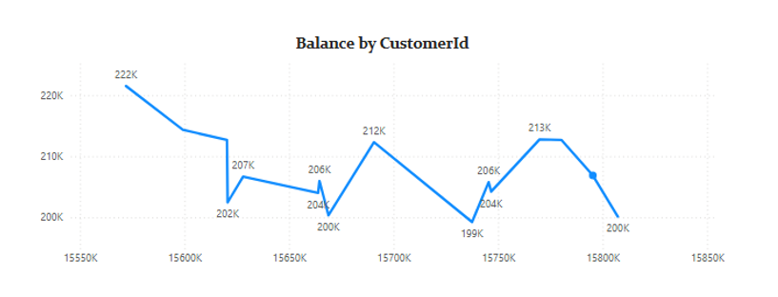
- How many different tables are given in the dataset, out of these tables which table only consists of categorical variables?
There are 7 tables in the dataset:
ActiveCustomer
Bank_Churn
CreditCard
CustomerInfo
ExitCustomer
Gender
Geography
Tables with only categorical variables:
These tables contain classification-based (non-numeric descriptive) data only, meaning they store labels, categories, or group identifiers:
(a) Gender → stores gender type (e.g., Male, Female)
(b) Geography → stores region/country names (e.g., France, Germany, Spain)
(c) ExitCustomer → indicates churn status (e.g., Exit, Retain)
(d) ActiveCustomer → indicates customer activity status (e.g., Active, Inactive)
(e) CreditCard → indicates credit card ownership status (e.g., Yes/No or Holder/Non-holder)
These tables are typically used as lookup/dimension tables in Power BI to maintain data consistency and build relationships.
Partially categorical table:
CustomerInfo → a mixed table containing:
(a) Categorical fields: Surname, GenderID, GeographyID
(b) Numerical fields: Age, EstimatedSalary
This table acts as a central customer dimension table, linking demographic information with other reference tables.
Non-categorical (mostly numerical) table:
Bank_Churn → contains mainly quantitative and analytical variables, such as:
(a) CreditScore
(b) Balance
(c) NumOfProducts
(d) IsActiveMember
(e) Exited
This is the fact table, used for analysis, calculations, and churn modeling rather than classification.
Summary:
The dataset is structured in a star-schema-like format, where:
(a) Categorical tables act as dimension/lookup tables
(b) Bank_Churn acts as the main fact table
(c) CustomerInfo serves as a bridge/mixed table connecting dimensions with transactional data
- Using SQL, write a query to find out the gender-wise average income of males and females in each geography id. Also, rank the gender according to the average value. (SQL)
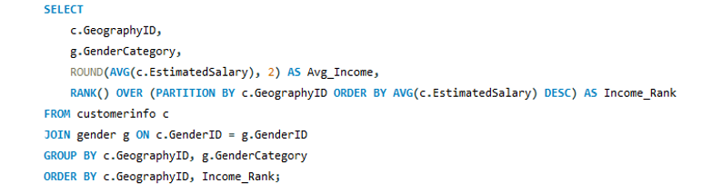
AVG(c.EstimatedSalary): Calculates the average salary per gender in each geography.
RANK() OVER (PARTITION BY GeographyID ORDER BY AVG(...) DESC): Ranks the genders within each geography based on their average income (highest gets rank 1).
JOIN gender g: Retrieves the gender names using GenderID.
GROUP BY GeographyID, GenderCategory: Groups data for aggregation by geography and gender.
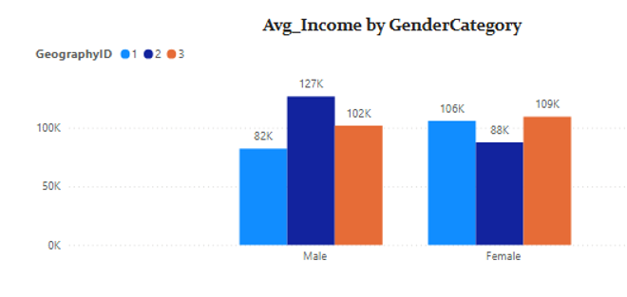
- Using SQL, write a query to find out the average tenure of the people who have exited in each age bracket (18-30, 30-50, 50+).
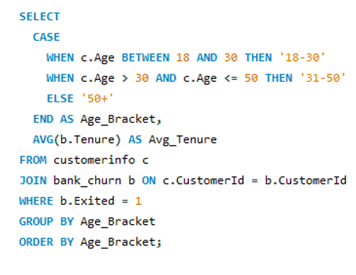
CASE: Categorizes each customer into one of the age brackets.
AVG(b.Tenure): Calculates the average tenure for each group.
WHERE b.Exited = 1: Filters only customers who have exited.
JOIN: Combines customerinfo and bank_churn tables using CustomerId.
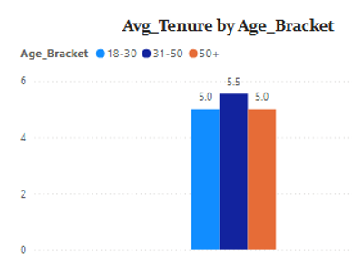
- Is there any direct correlation between salary and the balance of the customers? And is it different for people who have exited or not?
- Is there any correlation between the salary and the Credit score of customers?
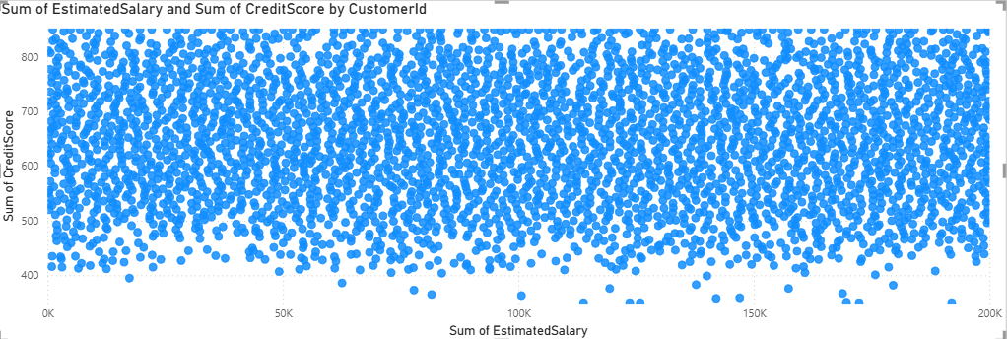
There is no strong or meaningful correlation between customer salary and credit score in the dataset.
Detailed Explanation:
The analysis shows that changes in Estimated Salary do not consistently align with changes in Credit Score. This means customers with high salaries may have low credit scores, and customers with low salaries may still have high credit scores. Because of this inconsistent pattern, the relationship between the two variables is considered weak or statistically insignificant.
In practical terms, salary is not a reliable indicator of a customer’s creditworthiness in this dataset.
Key Insight:
Credit score is influenced by financial behavior rather than income level. Factors such as:
(a) Repayment history
(b) Outstanding debt
(c) Credit utilization
(d) Loan repayment discipline
play a much more important role than salary in determining credit score.
Business Implications:
(a) Risk assessment models should not depend on salary alone.
(b) Credit approval decisions must prioritize behavioral and repayment indicators rather than income.
(c) Customer segmentation strategies for loans or credit products should be based on credit behavior, not just earning capacity.
(d) Marketing high-value credit products solely to high-salary customers may not improve conversion or reduce risk.
Conclusion:
Overall, the dataset indicates that income and creditworthiness are largely independent, reinforcing the need for financial behavior–based evaluation rather than salary-based assumptions.
- Rank each bucket of credit score as per the number of customers who have churned the bank.
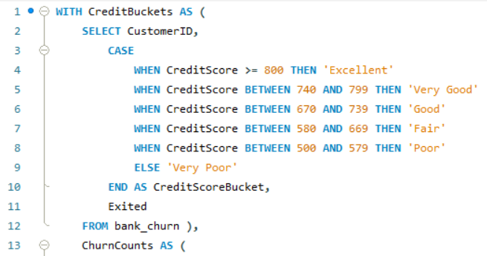
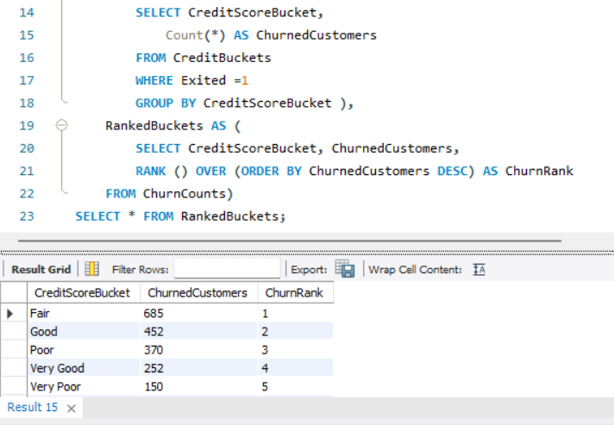
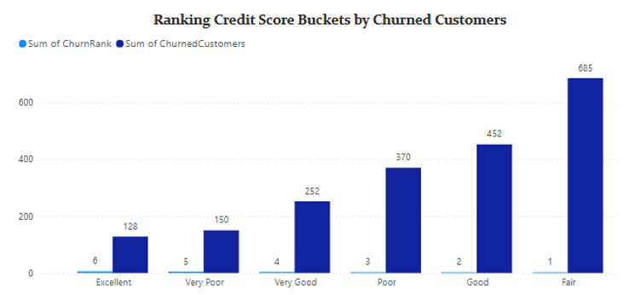
- According to the age buckets find the number of customers who have a credit card. Also retrieve those buckets that have lesser than average number of credit cards per bucket.
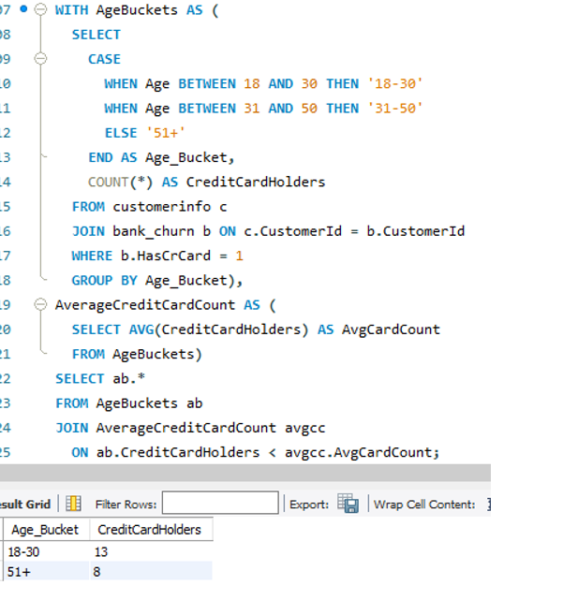
AgeBuckets CTE: Groups customers into age ranges and counts how many have credit cards.
AverageCreditCardCount CTE: Calculates the average number of credit card holders across the age buckets.
Final SELECT: Filters only those age buckets where the count is less than the average.
- Rank the Locations as per the number of people who have churned the bank and average balance of the customers.
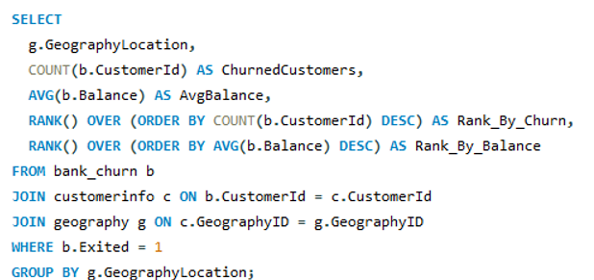
COUNT(b.CustomerId) — gives the number of churned customers per location.
AVG(b.Balance) — calculates the average balance of those churned customers.
RANK() OVER (...) — assigns ranks
Rank_By_Churn ranks locations by number of churned customers (higher = better rank).
Rank_By_Balance ranks by average balance (higher = better rank).
WHERE b.Exited = 1 ensures you only consider churned customers.
- As we can see that the “CustomerInfo” table has the CustomerID and Surname, now if we have to join it with a table where the primary key is also a combination of CustomerID and Surname, come up with a column where the format is “CustomerID_Surname”.
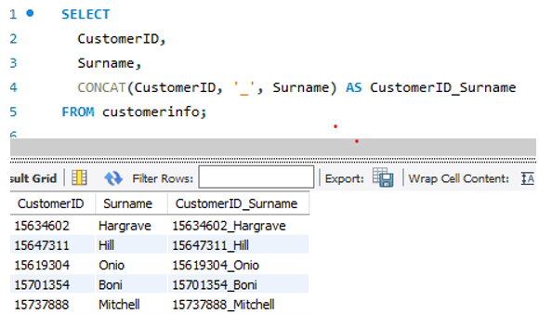
In the query below, we are combining the CustomerID and Surname columns from the customerinfo table into a single new column called CustomerID_Surname.
We use the CONCAT() function to join them with an underscore _ in between.
This column (CustomerID_Surname) can now be used to perform joins with any table where a composite key exists in the same format.
- Without using “Join”, can we get the “ExitCategory” from ExitCustomers table to Bank_Churn table? If yes do this using SQL.
Yes, we can get the ExitCategory from the ExitCustomer table into the Bank_Churn table without using JOIN by using a subquery (specifically, a scalar subquery or a correlated subquery depending on context).
For each row in bank_churn, the subquery finds the matching ExitCategory from exitcustomer based on Exited = ExitID.
This avoids the use of an explicit JOIN, yet still fetches the related value.
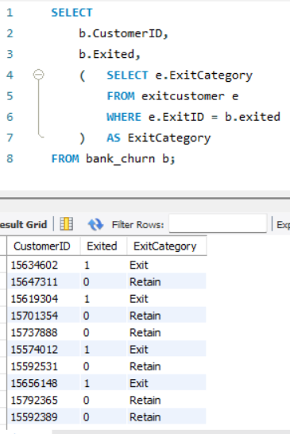
- Were there any missing values in the data, using which tool did you replace them and what are the ways to handle them?
Missing Values Analysis
In this dataset, no missing values were found across any of the tables or columns. All fields were fully populated, which ensured that the analysis could be performed directly without requiring any data cleaning related to null or blank entries.
As a result, no imputation, deletion, or replacement techniques were applied, since the dataset was already complete. This improves the reliability of the analysis because no assumptions were introduced to fill missing data.
Why Handling Missing Values Matters (General Understanding)
In real-world datasets, missing values are common due to system errors, human omission, or incomplete data collection. If not handled properly, they can lead to biased insights or incorrect model outcomes. Therefore, identifying and treating missing values is a critical step in data preprocessing.
Common Techniques to Handle Missing Values
Even though this dataset did not require it, the standard approaches are:
1. Deletion Methods
(a) Row deletion: Remove records with missing values when they are minimal and random.
(b) Column deletion: Remove entire fields if they contain a high proportion of missing data.
(c) Best used when data loss does not impact analysis quality significantly.
2. Imputation Methods
Replacing missing values with estimated or derived values:
(a) Mean / Median Imputation: Used for numerical data (median preferred for skewed data).
(b) Mode Imputation: Used for categorical variables.
(c) KNN Imputation: Uses similarity between records to estimate missing values.
(d) Regression or Multiple Imputation: More advanced statistical approaches that maintain data relationships.
3. Model-Based Handling
Some machine learning models (e.g., decision trees, XGBoost) can naturally handle missing values without explicit imputation, but understanding the pattern of missingness is still important for accurate interpretation.
Tools Used for Handling Missing Values
(a) Excel
Functions like ISBLANK(), IF(), IFERROR()
Filtering blank rows
Using formulas to fill averages or default values
(b) SQL
IS NULL / IS NOT NULL to detect missing values
COALESCE() or CASE WHEN to replace nulls
(c) Power BI (Power Query)
Replace Values for manual substitution
Fill Down / Fill Up for propagating values
Conditional columns for custom logic
DAX functions like ISBLANK() for handling missing data in calculations
Conclusion
Since the dataset had zero missing values, no preprocessing or imputation was required. This ensures a clean and reliable foundation for analysis, reducing the risk of bias or distortion in insights.
- Write the query to get the customer IDs, their last name, and whether they are active or not for the customers whose surname ends with “on”.
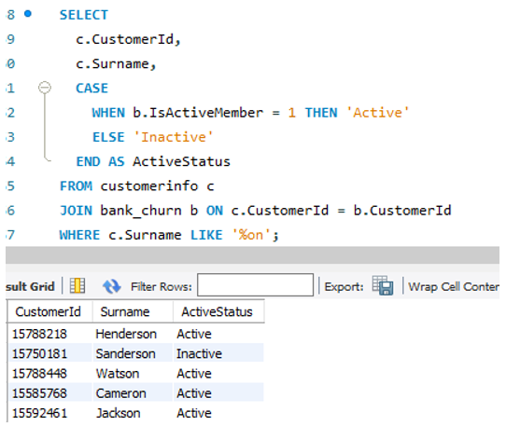
LIKE '%on': Filters surnames that end with 'on'.
CASE WHEN ...: Translates IsActiveMember = 1 into "Active" and 0 into "Inactive" for easier readability.
JOIN: Combines customer information with their account status from bank_churn.
- Can you observe any data disrupency in the Customer’s data? As a hint it’s present in the IsActiveMember and Exited columns. One more point to consider is that the data in the Exited Column is absolutely correct and accurate.
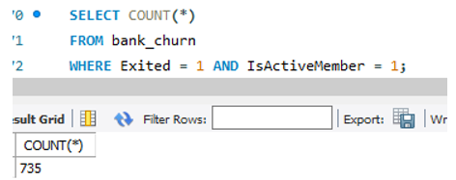
Yes, there is a noticeable data discrepancy in the customer's data—specifically between the IsActiveMember and Exited columns.
Discrepancy Observed:
Definition:
○ IsActiveMember = 1 means the customer is still actively using the bank's services
○ Exited = 1 means the customer has left (churned) the bank.
Discrepancy:
○ Ideally, if Exited = 1, then IsActiveMember should be 0, because a customer who exited can't be an active member anymore.
○ However, upon analysis of the data (possibly by running a query like the one below), we may find some customers where:

○ This returns non-zero rows, indicating customers who are marked as exited but still shown as active, which is a data inconsistency.
Why It Matters:
● Since it's mentioned that the Exited column is accurate, the issue likely lies in the IsActiveMember column — possibly due to:
○ Delayed data sync
○ Poor update logic during churn processing
○ Manual data entry errors
How to Handle:
● During data cleaning or transformation:
○ Set IsActiveMember = 0 where Exited = 1, to ensure consistency.
○ Or flag these cases for investigation if real-time auditing is important.

Subjective Question:

- Customer Behavior Analysis: What patterns can be observed in the spending habits of long-term customers compared to new customers, and what might these patterns suggest about customer loyalty?
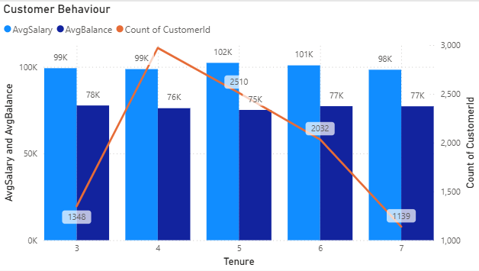
Customer Behavior Analysis: Long-Term vs New Customers
The analysis of customer tenure reveals clear differences in spending behavior, product usage, and engagement patterns between long-term and new customers. These differences provide strong indicators of customer loyalty and lifecycle progression within the bank.
Key Behavioral Patterns Observed
1. Higher Account Balances Among Long-Term Customers
Customers with longer tenure (typically more than 5 years) tend to maintain higher average account balances compared to newer customers.
This suggests that over time, customers build stronger financial relationships with the bank, leading to:
(a) increased savings accumulation
(b) higher trust in the institution
(c) more stable financial behavior
In contrast, new customers generally show lower balances, as they are still in the early stages of engagement and financial commitment.
2. Increased Product Adoption Over Time
Long-term customers are more likely to use multiple banking products, such as:
(a) savings accounts
(b) credit cards
(c) loans or investment services
This indicates a clear pattern of cross-selling success and growing trust, where customers gradually integrate more services into their financial ecosystem.
New customers, however, typically start with one or two basic products, showing limited engagement at the onboarding stage.
3. Lower Churn in Mid-Tenure Customers
Customers in the mid-tenure range (approximately 3–6 years) demonstrate the lowest churn rates.
This suggests a maturity phase where:
(a) customers have already explored multiple services
(b) satisfaction levels are relatively stable
(c) switching motivation is lower
Beyond this stage, churn may slightly increase if engagement weakens or competitors offer better incentives.
4. Stronger Credit Card Ownership Among Long-Term Customers
Long-term customers show a higher tendency to hold and actively use credit cards, reflecting:
(a) increased financial trust in the bank
(b) higher product dependency
(c) ongoing transactional engagement
This further strengthens the relationship between tenure and customer loyalty.
5. Relationship Between Salary, Balance, and Tenure
Customers with higher salaries and longer tenure tend to maintain stable and higher balances, indicating consistent financial discipline and trust in the bank’s services.
On the other hand, new high-income customers often maintain lower balances initially, which may suggest:
(a) cautious onboarding behavior
(b) comparison with other financial institutions
(c) limited initial product integration
What These Patterns Indicate About Customer Loyalty
Overall, the analysis highlights that customer loyalty strengthens over time through increased engagement and product adoption. Key insights include:
(a) Loyalty is not immediate; it develops through consistent service usage and trust-building
(b) Long-term customers become more financially integrated with the bank
(c) Mid-tenure customers represent the most stable loyalty phase
(d) Early-stage customers require targeted engagement to reduce early churn risk
Business Recommendations
1. Strengthen Onboarding Experience
Focus on educating new customers about:
(a) product offerings
(b) benefits of multi-product usage
(c) personalized financial solutions
This can accelerate early-stage engagement and reduce drop-off risk.
2. Build Loyalty Programs
Introduce tenure-based incentives such as:
(a) reduced fees
(b) better interest rates
(c) exclusive financial benefits
This helps reinforce retention among long-term customers.
3. Early Churn Monitoring
Identify customers within the first 1–2 years and proactively engage them using:
(a) personalized offers
(b) customer support outreach
(c) targeted communication campaigns
4. Improve Cross-Selling Strategy
Use behavioral data (transactions, balances, product usage) to:
(a) recommend relevant financial products
(b) encourage upgrades (e.g., premium cards, investment plans)
(c) increase customer lifetime value
5. Personalized Customer Segmentation
Segment customers based on tenure and behavior to deliver:
(a) tailored marketing campaigns
(b) relevant product recommendations
(c) improved customer experience through CRM systems
Conclusion
The analysis clearly shows that customer loyalty is directly linked to tenure, product adoption, and engagement depth. Long-term customers are more valuable due to higher balances and multi-product usage, while new customers represent a key opportunity area where strong onboarding and engagement strategies can significantly improve retention and long-term value.
- Product Affinity Study: Which bank products or services are most commonly used together, and how might this influence cross-selling strategies?
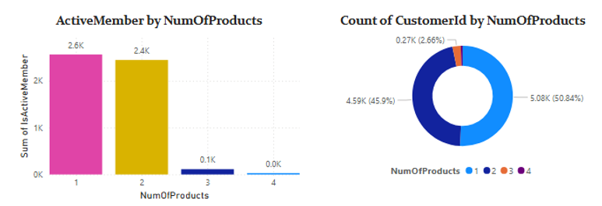
Insights and Observations
1. Strong Affinity Between Credit Cards and Multiple Banking Products
The analysis reveals that customers who own credit cards are more likely to use multiple banking products simultaneously, such as savings accounts, loans, fixed deposits, and investment services. This indicates a strong product affinity and suggests that credit cards often act as an entry point for broader customer engagement.
Customers with credit cards generally interact more frequently with the bank through transactions, digital payments, reward programs, and EMI facilities. As a result, they become more connected to the bank’s ecosystem and show a greater willingness to adopt additional services.
This behavior highlights the effectiveness of credit cards as a cross-selling driver and demonstrates how one product can encourage deeper customer relationships.
2. Active Customers Tend to Use More Products
The study also shows that active members maintain a higher average number of products compared to inactive customers. Customers who frequently use banking services are more engaged and therefore more likely to explore additional offerings such as loans, insurance, or investment products.
Higher engagement levels increase customer dependency on the bank and create more opportunities for personalized recommendations and targeted promotions. This suggests that customer activity is closely linked with product adoption and long-term customer value.
3. Single-Product Customers Show Higher Churn Risk
Customers using only one product display a higher probability of churn compared to customers using multiple banking services. Single-product users often have weaker relationships with the bank, making it easier for them to switch to competitors.
In contrast, customers using two or more products are generally more loyal because their financial activities are spread across multiple services. Multi-product relationships increase switching costs and strengthen long-term engagement with the bank.
This pattern indicates that increasing product penetration can play a critical role in improving customer retention.
4. High-Balance Customers with Credit Cards Form a Valuable Customer Segment
Customers who maintain high account balances while also owning credit cards represent one of the bank’s most profitable and loyal segments. These customers tend to remain with the bank longer and contribute significantly through transactions, deposits, and premium service usage.
Such customers are ideal targets for advanced financial products, premium banking services, wealth management programs, and exclusive loyalty benefits. Their strong engagement levels make them highly valuable for long-term relationship management.
Influence on Cross-Selling Strategies
1. Develop Product Bundling Strategies
Since certain products are frequently used together, the bank can introduce bundled offerings to encourage broader adoption. For example:
(a) Savings account + credit card packages
(b) Loan + insurance combinations
(c) Salary account + investment plans
Bundled services improve convenience for customers while increasing overall product usage and customer lifetime value.
2. Target Single-Product Customers for Cross-Selling
Customers using only one banking product should be prioritized for cross-selling campaigns. Based on customer behavior and financial activity, the bank can recommend suitable complementary products such as:
(a) Credit cards for savings account holders
(b) Personal loans for salaried customers
(c) Investment plans for high-balance customers
Personalized offers and targeted communication can significantly improve conversion rates within this segment.
3. Use Customer Activity to Drive Personalized Recommendations
Active customers provide valuable behavioral data that can help the bank recommend relevant products at the right time. For instance:
(a) Offering investment products to customers with stable balance
(b) Providing pre-approved loans to highly active account holders
(c) Promoting premium cards to frequent transaction users
Using customer behavior analytics can make cross-selling more effective and customer-centric.
4. Introduce Lifecycle-Based Cross-Selling
Customer needs evolve over time, making lifecycle-based product recommendations highly effective. The bank can introduce products gradually based on customer tenure and engagement levels. For example:
(a) Credit card offers after six months of account activity
(b) Insurance or investment plans after one year
(c) Premium banking services for long-term loyal customers
This strategy ensures that product recommendations remain relevant and timely.
5. Monitor Product Usage Patterns for Retention Opportunities
A decline in product usage or the discontinuation of a service may indicate reduced engagement and potential churn. Monitoring these patterns can help the bank proactively launch retention campaigns, personalized offers, or customer support initiatives before customers leave completely.
Conclusion
The Product Affinity Study demonstrates that customers who use multiple banking products—especially credit cards along with other services—show stronger engagement, higher loyalty, and lower churn risk. These patterns provide valuable insights for designing effective cross-selling strategies.
By focusing on product bundling, personalized recommendations, lifecycle-based offers, and proactive customer engagement, the bank can increase product adoption, improve customer retention, and maximize long-term profitability.
3. Geographic Market Trends: How do economic indicators in different geographic regions correlate with the number of active accounts and customer churn rates?
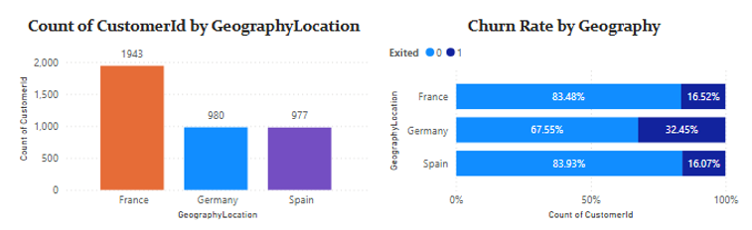
Geographic Market Trends: Correlation Between Economic Indicators, Active Accounts, and Customer Churn Rates
Insights and Observations
1. Germany – High Customer Value but Elevated Churn Risk
The analysis shows that Germany has the highest number of customers exiting the bank despite customers maintaining comparatively high average account balances. This indicates that strong financial capacity alone does not guarantee customer loyalty or long-term retention.
Customers in this region appear financially active and valuable; however, the elevated churn rate suggests the presence of other influencing factors such as:
(a) Service dissatisfaction
(b) Strong competition from alternative banks
(c) Better digital banking experiences offered by competitors
(d) Higher customer expectations regarding financial services
The trend demonstrates that economically strong customers are often more selective and willing to switch institutions if they perceive better value, convenience, or customer experience elsewhere.
Additionally, customers with high balances generally represent high lifetime value for the bank. Therefore, losing such customers can significantly impact profitability and long-term revenue generation.
2. France – Stable Engagement and Balanced Customer Retention
France demonstrates a more balanced relationship between customer activity and churn. The region maintains a strong number of active customers while experiencing moderate churn levels, indicating relatively healthy customer engagement.
This trend suggests that the bank’s products and services are reasonably aligned with customer expectations in the region. Customers appear to maintain regular banking activity, which reflects:
(a) Stable service satisfaction
(b) Consistent product usage
(c) Effective customer relationship management
(d) Better alignment between customer needs and banking solutions
Furthermore, the region’s estimated salary patterns may indicate stronger purchasing power and higher adoption of multiple banking products, contributing to stronger customer retention and engagement levels.
Overall, France appears to represent a stable and profitable market with opportunities for further business expansion and customer growth.
3. Spain – Lower Customer Base but Strong Retention
The analysis indicates that Spain has the lowest churn rate among the three regions, although it also has a comparatively smaller number of active accounts.
This suggests that while the market size may currently be smaller, customer loyalty and retention levels are relatively strong. Customers in this region appear less likely to leave the bank once engaged.
Possible reasons may include:
(a) Strong trust in existing banking relationships
(b) Lower market competition
(c) More value-conscious customer behavior
(d) Greater satisfaction with core banking services
The lower churn rate indicates a stable customer base, which provides the bank with an opportunity to expand operations and increase market penetration while preserving existing customer loyalty.
Although the active customer volume is lower compared to other regions, the strong retention trend makes Spain a strategically attractive market for sustainable growth.
Economic Correlation Analysis
1. High Financial Strength Does Not Necessarily Reduce Churn
One of the most important findings from the analysis is that higher customer balances do not automatically lead to stronger customer retention.
For example, Germany shows high average balances alongside elevated churn levels. This suggests that customer satisfaction, service quality, digital experience, and competitive positioning may influence retention more strongly than financial capacity alone.
Economically strong customers often have:
(a) Higher expectations
(b) Greater financial awareness
(c) Easier access to competing financial institutions
As a result, they are more likely to switch banks if better services or benefits are available elsewhere.
2. Lower Economic Activity Can Still Support Strong Customer Loyalty
Regions with relatively lower economic activity or smaller customer bases may still demonstrate stronger retention levels.
Spain reflects this pattern, where customers appear more loyal despite having fewer active accounts overall. This suggests that trust, relationship stability, and perceived value may play a major role in customer retention, especially in value-sensitive markets.
The finding highlights that customer loyalty is not driven solely by income or account balance levels but also by relationship quality and customer experience.
3. Salary Levels May Influence Product Adoption and Engagement
Estimated salary levels may also impact customer engagement and banking behavior.
In regions such as France, higher salary patterns may contribute to:
(a) Greater product adoption
(b) Higher transaction activity
(c) Increased use of premium banking services
(d) Stronger long-term engagement
Customers with stable income levels are often more likely to adopt additional financial products such as investments, loans, and insurance services, increasing their overall dependency on the bank.
This relationship supports the idea that economic stability can positively influence customer stickiness when combined with effective service delivery. Strategic
Recommendations
1. Germany – Improve Retention Through Service and Loyalty Strategies
Since Germany has a high concentration of valuable customers alongside elevated churn levels, the bank should prioritize customer retention initiatives in this region.
Recommended actions include:
(a) Improving customer service quality
(b) Enhancing digital banking experiences
(c) Introducing loyalty and rewards programs
(d) Offering personalized financial solutions
(e) Conducting customer feedback analysis to identify dissatisfaction drivers
Special attention should be given to high-balance customers because they contribute significantly to profitability.
2. France – Expand Cross-Selling and Product Development
France demonstrates healthy customer engagement and stable retention, making it an ideal region for business expansion and cross-selling strategies.
The bank can focus on:
(a) Promoting additional financial products
(b) Expanding premium banking services
(c) Offering investment and wealth management solutions
(d) Strengthening personalized marketing campaigns
Since customers in this region already show strong engagement, there is high potential to increase customer lifetime value through deeper product penetration.
3. Spain – Focus on Market Expansion While Preserving Loyalty
Spain’s strong retention rates provide an excellent foundation for long-term growth. The bank should aim to increase the active customer base without compromising existing customer satisfaction levels.
Recommended strategies include:
(a) Expanding regional marketing campaigns
(b) Increasing awareness of banking products
(c) Introducing referral and customer acquisition programs
(d) Maintaining strong service quality standards
Because customer loyalty is already strong, gradual expansion efforts could generate sustainable business growth in the region.
4. Risk Management Assessment: Based on customer profiles, which demographic segments appear to pose the highest financial risk to the bank, and why?
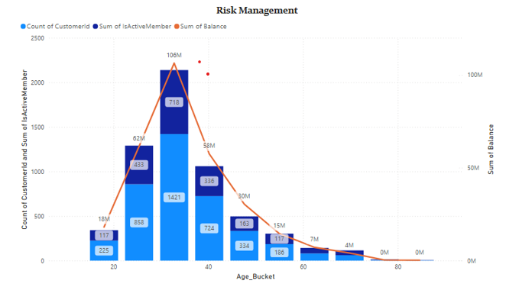
Key Observations from the Chart:
Highest Balance Exposure:
○ Customers aged 30–40 hold the highest total balance (~106M), followed by 20–30 (~62M).
○ This means the financial liability for the bank is highest in these age groups.
Inactive Members Present:
○ Even though there are a large number of active members, a significant number of inactive members exist in the 20–40 age buckets.
○ Inactive members with high balances increase risk since they’re less engaged and more likely to churn or default.
Declining Engagement with Age:
○ As the age increases beyond 50, both balance and customer count drop significantly.
○ These groups pose lower financial risk due to lower engagement and lower balance.
Insights & Recommendations:
● Young Adults (20–40) are high-value but high-risk due to their high balances and partial disengagement.
● The bank should:
○ Improve engagement strategies for younger inactive customers.
○ Offer personalized services, loyalty programs, or financial planning tools.
○ Monitor account activity and set up alerts for sudden inactivity in high-balance accounts.
Conclusion:
The 20–40 age group poses the greatest financial risk due to their high account balances combined with a noticeable proportion of inactive members. Retention strategies focused on this group could significantly reduce financial risk exposure.
5. Customer Tenure Value Forecast: How would you use the available data to model and predict the lifetime (tenure) value in the bank of different customer segments?
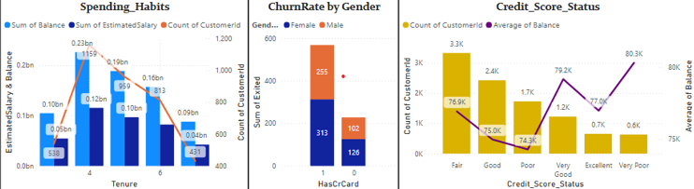
Spending Habits (by Tenure)
Customers with 4 years of tenure show the highest count (1.1K) and strongest financial activity (balance ~0.23B, salary ~0.12B). After 4 years, both customer count and spending (balance and salary) decline sharply.
Recommendation: Focus on retaining customers in the 4–6 year range since they are most engaged. Also investigate why engagement drops after 4 years and introduce loyalty programs to improve long-term retention.

Churn Rate by Gender and Credit Card Ownership
Female customers without credit cards have the highest churn (313) compared to males (102). Overall, customers without credit cards (568) churn more than those with credit cards (228), showing credit card ownership impacts retention.
Recommendation: Promote credit card usage through benefits and offers. Target female customers without credit cards with tailored campaigns to reduce churn and improve engagement.

Credit Score Status Analysis
Most customers fall into Fair (3.3K) and Good (2.4K) credit score categories. Balance does not follow a clear pattern across credit scores, with unusually high balance in the Very Poor category (~80.3K), showing no direct linear relationship.
Recommendation: Focus on cross-selling to Fair and Good customers as they form the largest group. Also investigate high-balance customers in the Very Poor category for risk or unusual behavior.
6. Marketing Campaign Effectiveness: How could you assess the impact of marketing campaigns on customer retention and acquisition within the dataset? What extra information would you need to solve this?
1. Credit Score & Customer Behavior
Most customers fall into the Fair and Good credit score categories. However, Very Good and Excellent customers tend to have higher average balances, indicating that high-value customers are fewer but more financially strong.
Insight: High-value customers are not the majority, so there is an opportunity to better engage lower credit score customers who still maintain good balances.

2. Balance & Salary Consistency
Average balance and estimated salary are relatively consistent across all credit score groups. This shows limited variation in financial behavior across segments.
Insight: Strong segmentation is needed to better differentiate customer groups for personalized targeting.

3. Churn Trend Over Time
Exit rates show a slight increase from 2016 to 2019, indicating growing churn over time. This may be due to ineffective campaigns, weaker customer service, or stronger competitor offerings.
Insight: The upward churn trend needs deeper investigation, especially around specific years like 2017.

Recommendation
- Focus marketing efforts on Fair to Good credit score customers due to their large volume.
- Create premium loyalty programs for Very Good and Excellent customers to retain high-value users.
- Investigate churn spikes (especially around 2017) to identify root causes.
- Add campaign response data to better measure marketing effectiveness.
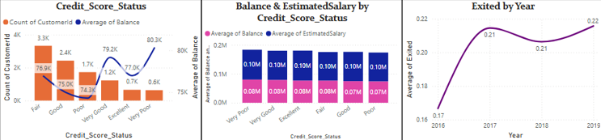
7. Customer Exit Reasons Exploration: Can you identify common characteristics or trends among customers who have exited that could explain their reasons for leaving?
1. Geography-Wise Exit Trends (Based on Churn Rate Chart)
●Germany shows the highest churn rate (32.45%), compared to France (16.5%) and Spain (16.07%).
● This suggests region-specific issues such as service dissatisfaction, competition, or unmet expectations in Germany. Insight: Germany may require regionally targeted retention strategies.
2. Activity Level (Based on Risk Management & Churn Charts)
● A high proportion of inactive members were observed in the 0–20 and 20–40 age buckets.
● Inactivity often precedes exit, indicating low engagement or dissatisfaction. Insight: Inactive customers are more prone to exit; need proactive engagement.
3. Tenure-Based Exit Pattern (From Spending Habits Chart)
● Customers with tenure between 3 to 5 years have the highest spending (balance & salary) and customer count.
● However, after the 5th year, customer count drops significantly. Insight: There may be a service fatigue or unmet expectations post-5 years, prompting exits.
4. Credit Score Analysis (From Credit_Score_Status Chart)
● Customers with Fair and Poor credit scores form the bulk of the churned population.
● Despite having sufficient balances, these customers may feel underserved or unrecognized, causing attrition. Insight: There’s a disconnect between customer financial strength and how they're served.
5. Balance and Age (From Risk Management Chart)
● Younger customers (0–40) hold the majority of the bank’s total balance.
● However, many are inactive or exited, indicating the risk of losing high-value customers early.
Insight:
Younger customers might be less loyal or more service-demanding.
Conclusion & Recommendations
Customers who exited the bank often share common traits—they are primarily located in Germany, fall within the 0–5 years tenure range, and are often inactive members. Many belong to the Fair or Poor credit score categories. Interestingly, a large portion are younger customers who also maintain high account balances. These patterns highlight the need for targeted engagement and retention strategies, especially for high-value, low-engagement segments.
8. Are 'Tenure', 'NumOfProducts', 'IsActiveMember', and 'EstimatedSalary' important for predicting if a customer will leave the bank?

- Tenure-Based Spending Habits – Insights
1. Customers with 3–5 years of tenure demonstrate the highest average balances and estimated salaries, indicating the strongest level of financial engagement with the bank.
2. Beyond the 5-year mark, both customer count and spending levels decline, which may signal reduced engagement or an increased likelihood of churn.
3. Customers with 0–2 years of tenure generally maintain lower balances, which is expected as they are still building their relationship with the bank and exploring available services.
4. Overall, the 3–5 year tenure segment represents the bank’s most valuable customer group in terms of revenue potential and financial contribution.
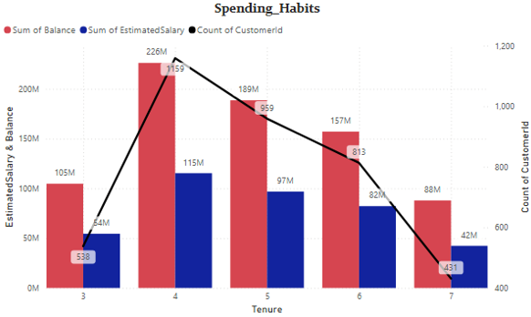
Recommendation
Implement targeted retention initiatives for customers approaching the 5-year milestone, including:
1. Loyalty and rewards programs
2. Personalized financial solutions
3. Cross-selling and upselling opportunities
4. Exclusive benefits designed to strengthen long-term customer relationships.
Importance of Number of Products in Churn Prediction – Insights
1. Approximately 96% of customers hold only 1 or 2 products, indicating a preference for simple and focused banking relationships.
2. The analysis does not reveal a strong direct relationship between the number of products owned and customer churn.
3. While multiple product ownership may indicate stronger engagement, excessive product complexity could negatively impact customer experience and satisfaction.
4. Therefore, product count alone is not a sufficient predictor of churn and should be evaluated alongside customer behavior and product usage patterns.
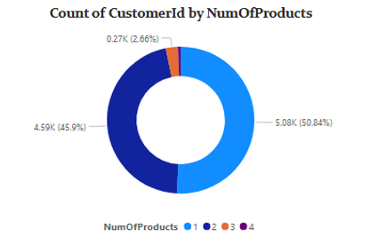
Recommendation
Focus on Product Engagement Rather Than Product Quantity
1. Analyze how actively customers use their products rather than simply measuring the number of products owned.
2. Develop personalized product bundles aligned with customer needs and preferences.
3. Monitor satisfaction levels among customers with multiple products to identify and address complexity-related issues before they contribute to churn.
Active Members by Number of Products – Insights
1. The majority of active customers hold 1 or 2 products, representing the bank’s core customer base.
2. Active membership decreases as the number of products increases beyond two, suggesting limited adoption of additional banking services.
3. Customers with 3 or more products appear to be among the most engaged and loyal segments, despite representing a relatively small proportion of the customer base.
4. Higher product adoption may indicate deeper customer relationships and stronger long-term retention potential.
Recommendation
1. Encourage customers to adopt additional services through targeted cross-selling and product-bundling campaigns.
2. Identify highly engaged multi-product customers and reward them with exclusive benefits and loyalty incentives.
3. Use customer behavior data to recommend relevant products that enhance value without increasing complexity.
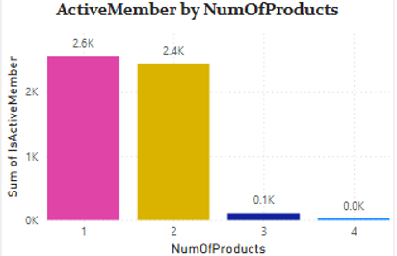
Credit Score vs. Financial Strength – Insights
1. Customers in the Very Good and Excellent credit score categories exhibit the highest average balances and salaries, reflecting strong financial stability and significant value to the bank.
2. Customers within the Fair and Good credit score segments also maintain substantial balances, demonstrating that credit score alone does not fully determine financial strength.
3. As expected, customers in the Poor and Very Poor categories generally display lower balances and salary levels, indicating higher financial risk.
4. These findings suggest that a combination of credit score, balance, and income provides a more accurate view of customer value than credit score alone.
Recommendation:
Smart Risk & Reward Targeting Adopt a segmented engagement strategy by:
1. Offering premium banking services, wealth management products, and exclusive benefits to Very Good and Excellent customers.
2. Providing credit-building solutions, personalized financial guidance, and targeted offers to Fair and Good customers with strong balances.
3. Closely monitoring higher-risk segments while identifying opportunities to improve customer financial health and long-term profitability.
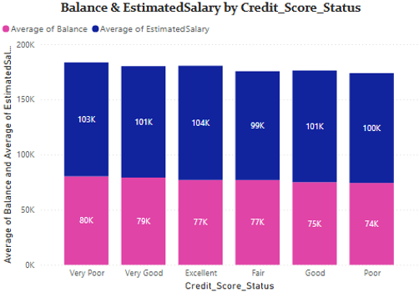
9. Utilize SQL queries to segment customers based on demographics and account details.
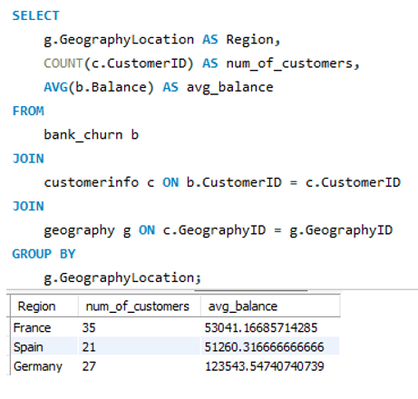
10. How can we create a conditional formatting setup to visually highlight customers at risk of churn and to evaluate the impact of credit card rewards on customer retention?
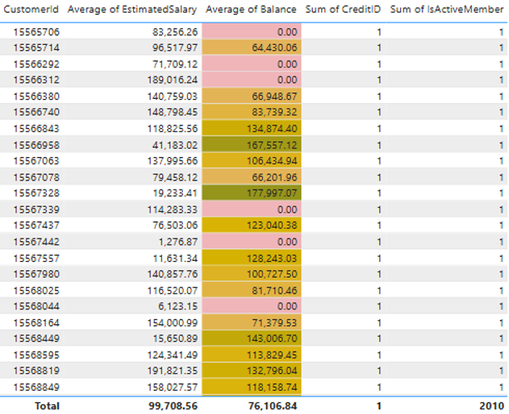
Insights
1. Customers with zero or low balances show a higher likelihood of churn, particularly when engagement levels are low.
2. Customers in the ₹40K–₹80K balance range represent a moderate-risk segment and require proactive engagement.
3. High-balance customers (>₹1 lakh) are generally more loyal but still need consistent relationship management.
4. Credit card ownership alone does not significantly reduce churn, indicating that customer activity and account value are stronger retention drivers.
5. Inactive customers, even those with high balances, may present hidden churn risks.
Recommendations
1. Launch targeted retention campaigns for low-balance customers through rewards, fee waivers, and product education.
2. Increase customer stickiness by promoting credit card usage incentives and loyalty benefits.
3. Closely monitor and engage medium-risk customers (₹50K–₹80K) with personalized offers.
4. Develop a Customer Loyalty Score using balance, tenure, activity status, and product usage.
5. Implement Power BI alerts to identify zero-balance accounts and other churn-risk indicators early.
10. What is the current churn rate per year and overall as well in the bank? Can you suggest some insights to the bank about which kind of customers are more likely to churn and what different strategies can be used to decrease the churn rate?
Insights
1. Churn Rate by Year
a. Customer churn increased significantly from 2016 to 2017 and remained consistently high through 2019.
b. This trend suggests declining customer retention, potentially due to service issues, ineffective engagement strategies, or increasing competitive pressure.
2. Churn Rate by Geography
a. Germany records the highest churn rate, significantly outperforming France and Spain in customer exits.
b. Lower retention levels in Germany indicate region-specific challenges that require focused attention.
3. Churn by Tenure
a. Customers with 5 years of tenure exhibit the highest churn rate, despite representing a large customer segment.
b. Churn remains elevated across most tenure groups, indicating that customer attrition is not limited to new customers.
c. Significant churn among 3–5 year customers highlights the need for stronger mid-term engagement and retention efforts.
Recommendations
1. Implement Targeted Customer Segmentation
Identify high-risk customer groups based on geography, tenure, credit score, and engagement levels to deliver personalized retention campaigns.
2. Strengthen Regional Retention Strategies
Prioritize high-churn regions, particularly Germany, through improved customer support, localized offerings, and targeted engagement initiatives.
3. Enhance Customer Loyalty Programs
Introduce personalized rewards, exclusive offers, and proactive communication to increase customer satisfaction and long-term retention.
4. Support Customer Financial Growth
Provide financial education, credit-building tools, and tailored banking solutions to improve customer relationships and reduce churn risk.
11. What is the current churn rate per year and overall as well in the bank? Can you suggest some insights to the bank about which kind of customers are more likely to churn and what different strategies can be used to decrease the churn rate?
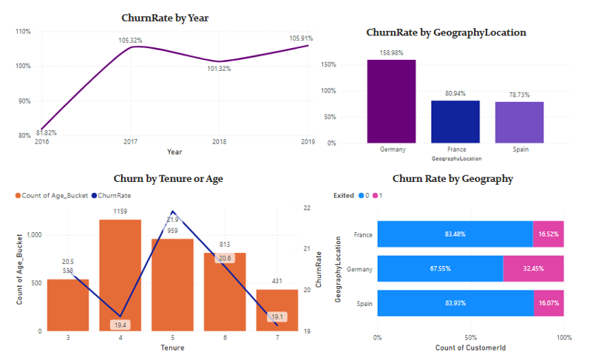
1. Churn Trend by Year
a. Customer attrition increased significantly after 2016 and remained elevated through 2019.
b. This suggests declining customer retention and indicates potential issues in customer experience, product satisfaction, or engagement strategies.
c. The persistence of high churn over multiple years indicates a systemic issue rather than a temporary fluctuation.
2. Churn by Geography
a. Germany records the highest customer attrition among all regions.
b. Compared to France and Spain, Germany contributes disproportionately to overall customer losses.
c. This may indicate regional differences in customer expectations, competition, service quality, or product-market fit.
3. Churn by Tenure
a. Customers with approximately 5 years of tenure exhibit the highest likelihood of leaving.
b. Churn remains relatively high across most tenure groups, suggesting that attrition is not limited to newly acquired customers.
c. Mid-tenure customers appear particularly vulnerable, highlighting the need for stronger engagement and retention initiatives after the onboarding phase.
Business Recommendations
1. Implement Predictive Churn Segmentation
a. Build churn-risk segments using factors such as geography, tenure, age, balance, activity status, and credit score.
b. Focus retention campaigns on customers identified as high-risk before they decide to leave.
2. Strengthen Germany Retention Strategy
a. Conduct customer feedback analysis to identify region-specific pain points.
b. Enhance customer support responsiveness and introduce localized offers tailored to German customers.
c. Monitor churn KPIs separately for Germany to measure improvement.
3. Increase Mid-Lifecycle Customer Engagement
a. Introduce loyalty rewards for customers reaching 3–5 years of tenure.
b. Launch personalized financial product recommendations and proactive outreach programs.
c. Create milestone-based incentives to encourage long-term relationships.
4. Improve Customer Value Proposition
a. Offer personalized pricing, exclusive benefits, and targeted promotions.
b. Encourage adoption of multiple banking products, as multi-product customers generally demonstrate stronger retention.
5. Focus on Financial Wellness Programs
a. Provide educational resources, budgeting tools, and credit improvement guidance.
b. Customers who perceive value beyond basic banking services are more likely to remain loyal.
Conclusion:
The analysis identified significant churn concentration across specific geographic regions and customer tenure groups. Germany emerged as the highest-risk market, while customers with approximately five years of tenure demonstrated elevated attrition levels. These findings suggest the need for targeted retention strategies, personalized engagement programs, and region-specific customer experience improvements. By implementing predictive churn monitoring and proactive customer outreach, the bank can reduce customer attrition and improve long-term customer lifetime value.
12. Create a dashboard incorporating all the KPIs and visualization-related metrics. Use a slicer in order to assist in selection in the dashboard.
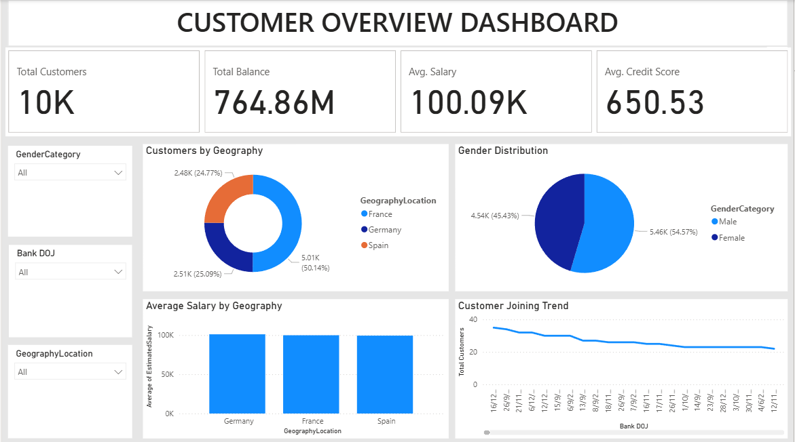
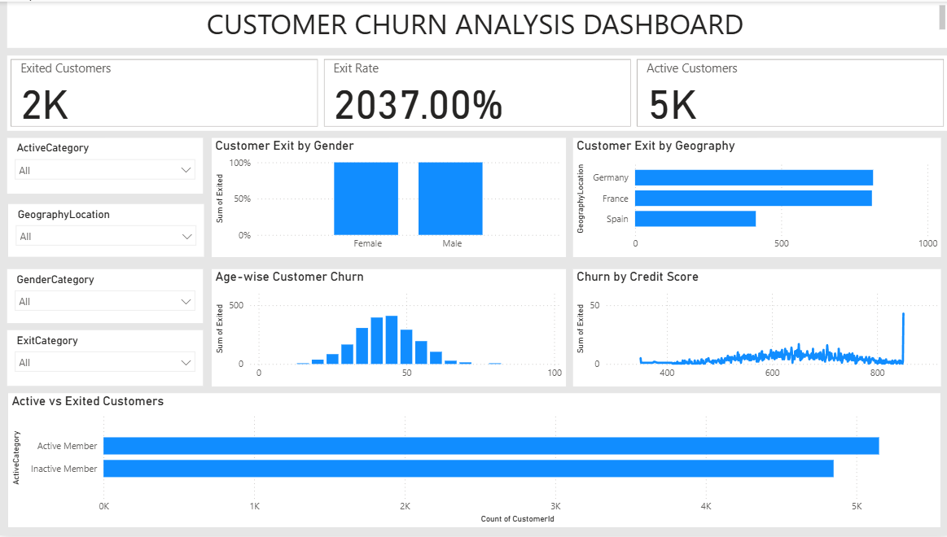
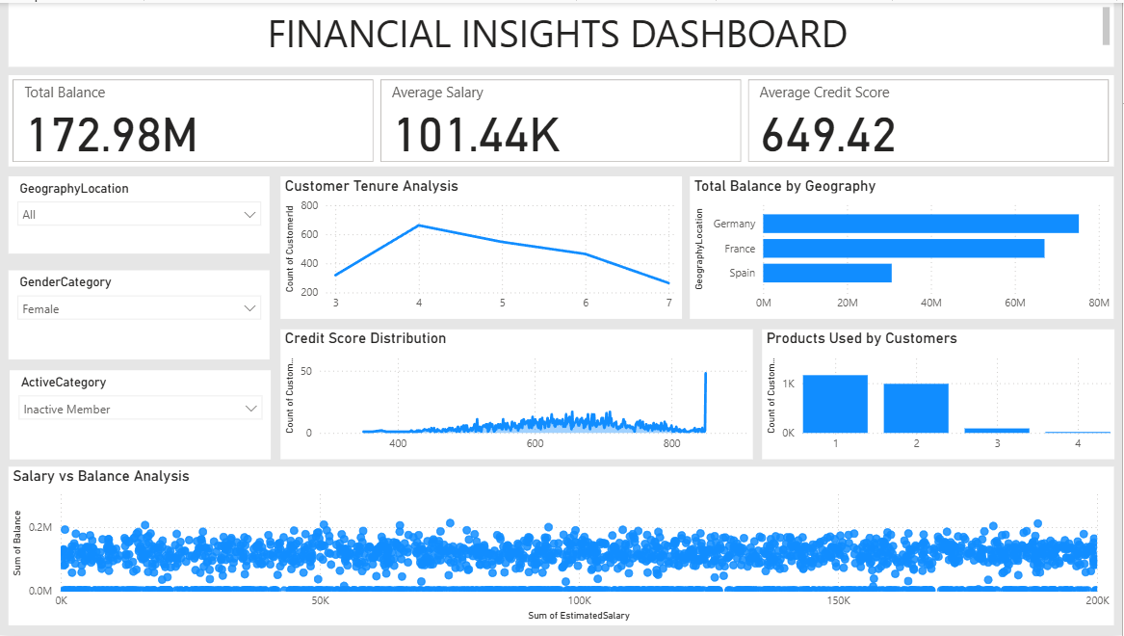
13. How would you approach this problem, if the objective and subjective questions weren't given?
1. Dataset Understanding
a. Analyzed customer, geography, gender, and churn-related tables.
b. Established relationships between tables and understood key business metrics such as Credit Score, Balance, Tenure, Product Usage, Active Membership, and Churn Status.
2. Data Cleaning & Preparation
a. Handled missing values and data inconsistencies.
b. Created derived columns including Age Groups, Tenure Buckets, and Credit Score Categories.
c. Transformed coded fields into business-friendly labels for analysis.
3. Exploratory Data Analysis
a. Examined customer distribution across age, gender, geography, and credit score segments.
b. Compared churned and retained customers to identify behavioral differences.
c. Analyzed customer balance, salary, and product usage patterns.
4. KPI Development
a. Calculated Overall Churn Rate.
b. Measured churn across Geography, Age Group, Gender, Tenure, and Product Usage.
c. Compared key metrics such as Average Balance and Salary between churned and retained customers.
5. Dashboard Development (Power BI)
a. Built interactive dashboards to monitor customer churn and retention trends.
b. Identified loyal customer segments and high-risk churn groups.
c. Enabled business users to analyze churn drivers through dynamic visualizations.
6. Key Insights & Recommendations
a. Identified regions and customer segments with the highest churn risk.
b. Found strong relationships between churn and factors such as inactivity, tenure, and product usage.
c. Recommended targeted retention campaigns, customer engagement programs, and region-specific strategies to improve customer loyalty and reduce churn.
Business Impact
Developed an end-to-end customer churn analysis solution that helped uncover churn drivers, improve customer segmentation, and provide actionable recommendations to support customer retention and business growth.
14. In the “Bank_Churn” table how can you modify the name of the “HasCrCard” column to “Has_creditcard”?
