Caesar Cipher
Program Output Screenshot
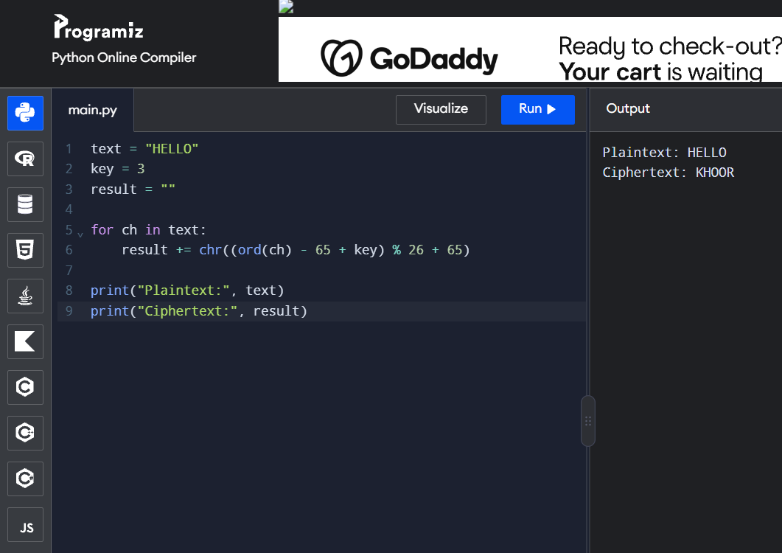
Output:
Plaintext: HELLO
Ciphertext: KHORR

