Playfair Cipher Matrix
Program Output Screenshot
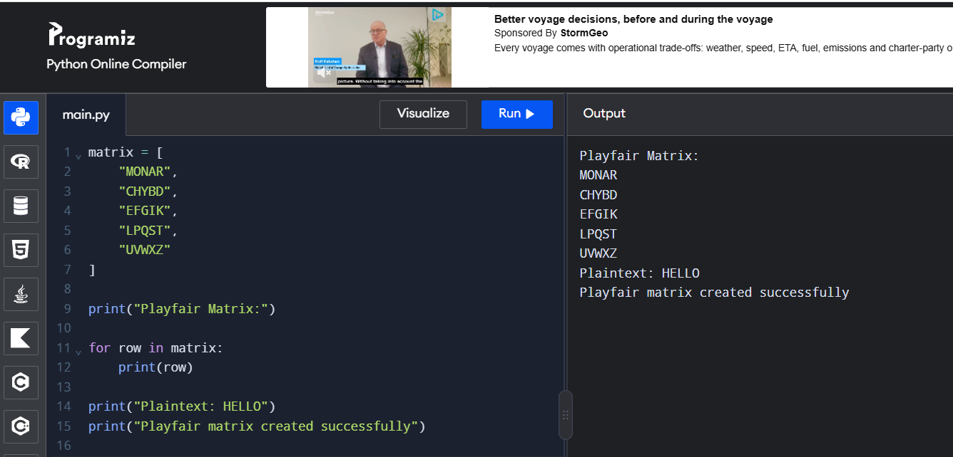
Output:
Playfair Matrix:
MONAR
CHYBD
EFGIK
LPQST
UVWXZ
Plaintext: HELLO
Playfair matrix created successfully

