Vigenère Cipher
Program Output Screenshot
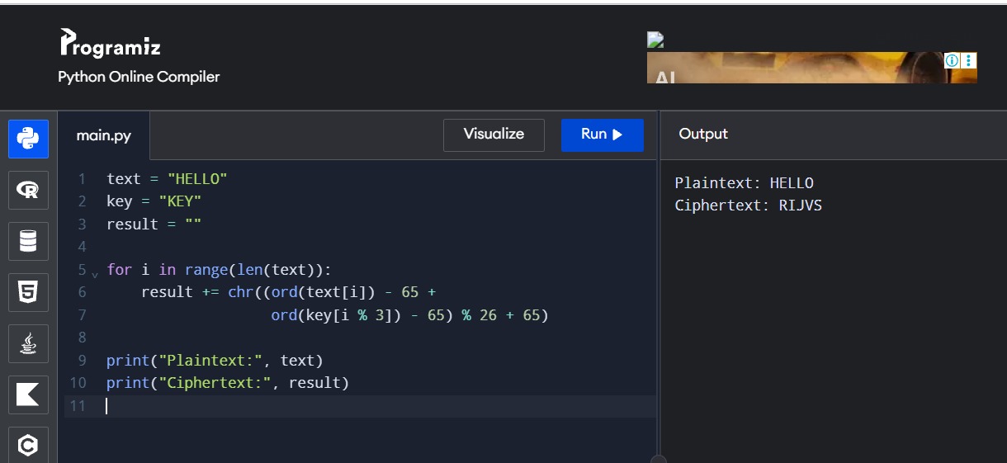
Output:
Plaintext: HELLO
Ciphertext: RIJVS

